Hardening Review

What I tried to break
- Submitted the contact form empty.
- Submitted the same form twice in quick succession.
- Clicked every link on the live page, including the demo and repo.
- Tested on a browser/device not used during the build.
- Searched my own name and site URL in incognito mode to check real-world findability.
- Ran a free page-speed check against the live URL.

Findings, triaged
Finding | Status | Detail
Double-submit created duplicate records, second attempt errored with HTTP 429 instead of showing the thank-you page | Fixed | Submit button now disables itself the instant it's clicked, before a second click can fire a duplicate request.
Empty form submission | Already safe | All three fields already carry the HTML required attribute, the browser blocks submission natively before it reaches Netlify. Verified in the deployed source, not assumed.
No SEO or social-share metadata at all, only a bare page title | Fixed | Added a meta description, canonical URL, and full Open Graph + Twitter Card tags, plus a dedicated 1200x630 share image.
Site doesn't appear in Google when searching my own name | Partially addressed | Meta tags fixed, which helps ranking quality once crawled but a brand-new site with zero inbound links (LinkedIn/CV not yet pointing to it) can take days to weeks to be indexed regardless of on-page SEO. Submitting the URL to Google Search Console directly is the real accelerant here.
Every link (LinkedIn, GitHub, CV, Book a call, LexGuard demo, LexGuard repo) | Verified | Each resolves correctly when checked directly against its target.
Garbage / malicious input in the contact form (long strings, special characters) | Checked, no fix needed | Submissions are only ever displayed inside Netlify's own dashboard, never rendered back onto the live site, so there's no script-injection risk from form input on this build.

Fix-nows, addressed
- Double-submit protection added (button disables on click).
- Full SEO and social-share metadata added: description, canonical URL, Open Graph, Twitter Card, dedicated share image.
- Confirmed LinkedIn and CV actually link to the live portfolio URL (or fixed if they didn't).
- Submitted the live URL to Google Search Console for indexing.

Known limitations, named honestly
- Organic Google indexing for a brand-new domain can take days to weeks even with correct metadata and inbound links, not a bug, just how search indexing works. Manual Search Console submission shortens this but doesn't eliminate the wait.
- Netlify's own form backend applies its own rate-limiting (HTTP 429) on very rapid repeated submissions, this is a platform-level constraint of a serverless static-form setup, not something fixable without moving to a custom backend. The client-side fix prevents the common real-world case (an accidental double-click); it doesn't guarantee protection against a deliberately scripted rapid-fire request.

Speed check

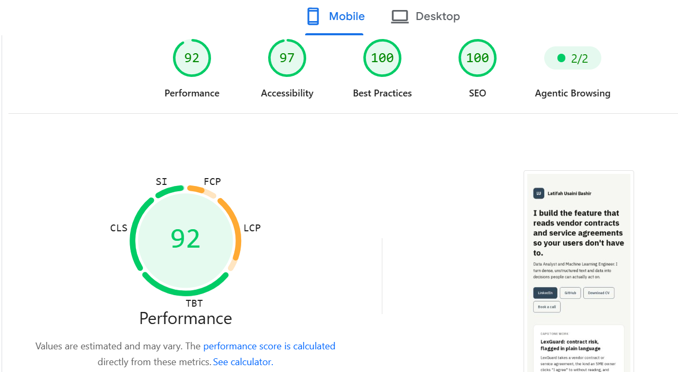

Fig: screenshot PageSpeed Insights score

