LexGuard , Image Set & Curation Notes
Decide Once: Build Your Identity Kit , Image curation deliverable

1. Content map
Every image the LexGuard case study needs, matched against the page's content, and the call on real vs. generated.
Image need | Real / Generated | Why
Hero / landing screen | Real | Shows the actual product exactly as a user would first see it.
"High Risk Detected" alert | Real | The core value moment , proof the tool actually flags risk.
Analysis results / risk breakdown | Real | Shows the payoff: clauses tagged and explained in plain language.
Risk distribution chart | Real | Shows the product thinks in data, not just single flags.
Section icons / dividers | Generated (optional) | Connective tissue only , one locked style, single accent color, restrained. See note below.
About / bio photo | Real | The subject is me , never generated.

2. Keepers: real captures
All four are unedited screen captures of the live app. Cropped to remove browser chrome and unrelated UI where needed. No AI stand-ins were used for product visuals, the interface itself is the proof.
Hero / landing screen
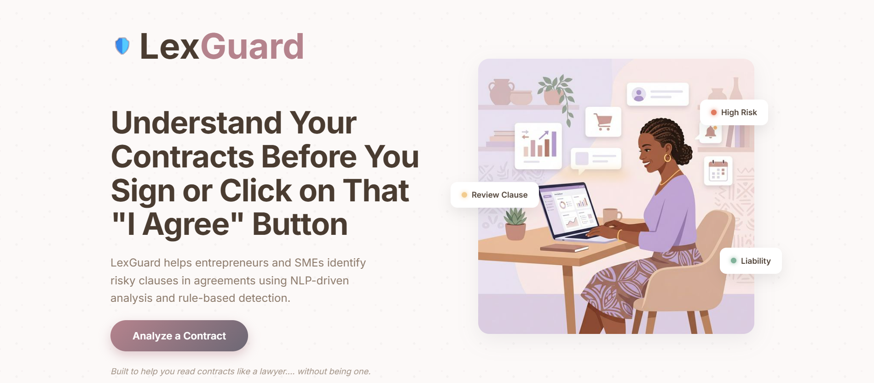
Real capture , kept as-is. Establishes the product and its value proposition in the visitor's own words.
"High Risk Detected" alert
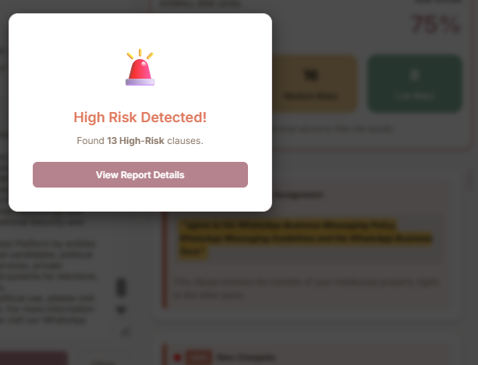
Real capture , kept as-is. This is the emotional beat of the product: the moment it proves it caught something the user would have missed.
Analysis results , risk breakdown
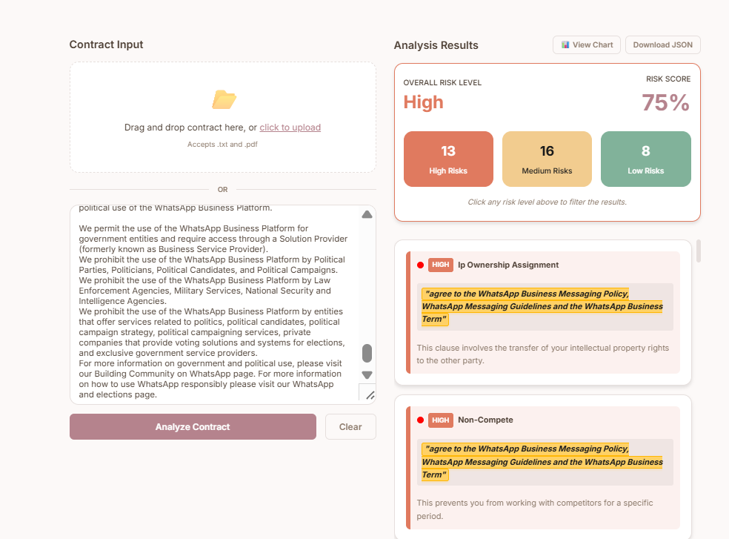
Real capture , kept as-is. Shows the actual output: risk score, counts by severity, and a flagged clause in plain language.
Risk distribution chart
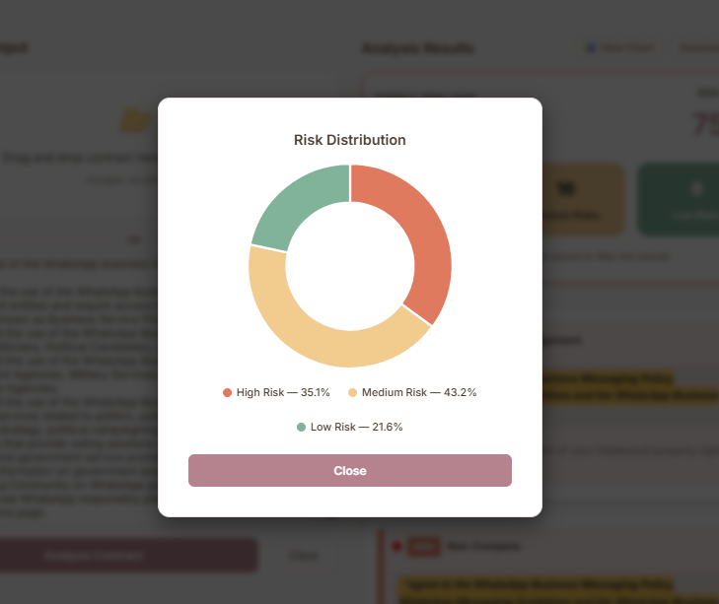
Real capture , kept as-is. Shows the product reasons in proportions, not just isolated flags , adds credibility beyond a single alert.

3. Rejected , and why
Disclaimer modal
Rejected for the portfolio image set. It matters to the product's ethics and responsible-AI framing, but as an image it's dense legal text with no visual hierarchy , it would slow a viewer down without adding to the proof. I'll reference it as a line of case-study copy ("includes a legal disclaimer step before analysis") instead of showing it.
Empty contract-input screen
Rejected. It's the same screen as the Results breakdown, before anything has happened , functionally necessary in the product, but redundant in a portfolio, which should show capability rather than a waiting state.

4. Connective tissue (generated visuals)
Section-divider icons, generated in Gemini with one locked prompt so the set reads as a system, not a pile:
"A minimal, flat vector icon of [subject], single color #33475B line art on a transparent background, 2px uniform stroke weight, no fill, no gradient, no shading, no texture, geometric and precise, generous white space, calm and understated mood , not decorative or playful."
Subject swapped three times , shield, document with magnifying glass, checkmark , prompt held fixed otherwise.
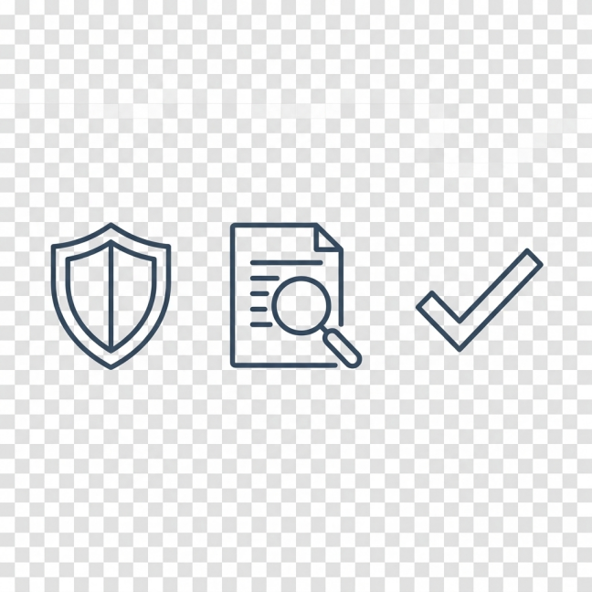
Kept all three in one pass, one style, one stroke weight, single accent color.
Rejected direction: matching LexGuard's own illustration style.
LexGuard's in-app illustration (the woman at the desk) was itself Gemini-generated, in a warm, colorful, cartoon-adjacent style. I considered generating the portfolio's connective tissue to echo that same style, so the case study would feel visually tied to the product. I rejected it: the portfolio kit's whole premise is calm and restrained so the work is the loudest thing on the page, and a cartoon-styled icon set would compete with the real product screens rather than frame them. Flat, single-color line icons stay quiet enough to let the four real captures carry the story.

5. Where a real photo is used
The about section uses a real, unedited photo of me, cropped to a headshot and framed in a navy circle so it sits calmly against the kit instead of letting the busy patterned backdrop compete with it. Cropping and framing only , no generation, no retouching of the subject.

Real capture, cropped and framed, not generated.

Portfolio identity kit (fonts, palette, mark) is separate from LexGuard's own product branding, see companion style guide. The product screens are shown as real, unaltered work; the portfolio frame around them carries the kit.

