The Through-Line: Map Content & CTAs

1. One-line claim
"I build the feature that reads contracts so your users don't have to."
Sharpened from ten AI-generated options against the proof statement from Week 1. This one was chosen because the actual audience for the claim is a product lead deciding whether to embed LexGuard, not an SME owner encountering it standalone, the claim speaks directly to that decision.

2. Content map
Built as a single page rather than a multi-page site, every section either builds belief toward the claim or restates it, and there is exactly one CTA on the page.
Page | Sections, in order | Case shown | Call to action
One page (single-page portfolio) | 1. Hero: states the one-line claim  2. Case study: LexGuard hero shot, High Risk alert, results breakdown, risk distribution chart, recall before/after  3. How it works: plain-language mechanism, including the regex-to-hybrid decision  4. About: 2–3 sentences, real photo  5. Contact: restates the claim, one CTA | LexGuard (only case, shown in full) | Section 5 (Contact): "Book a call to discuss fit": every earlier section builds toward this one action; no other CTA appears on the page

Proof: recall before vs. after the hybrid rule engine
Sits inside the case-study section. From my own evaluation notebook, testing rule-based clause detection against 510 real contracts (CUAD dataset) across 28 clause types. Regex-only and hybrid recall are each averaged from the per-clause Recall column printed by the notebook's evaluation cells (Task 4 and Task 5).
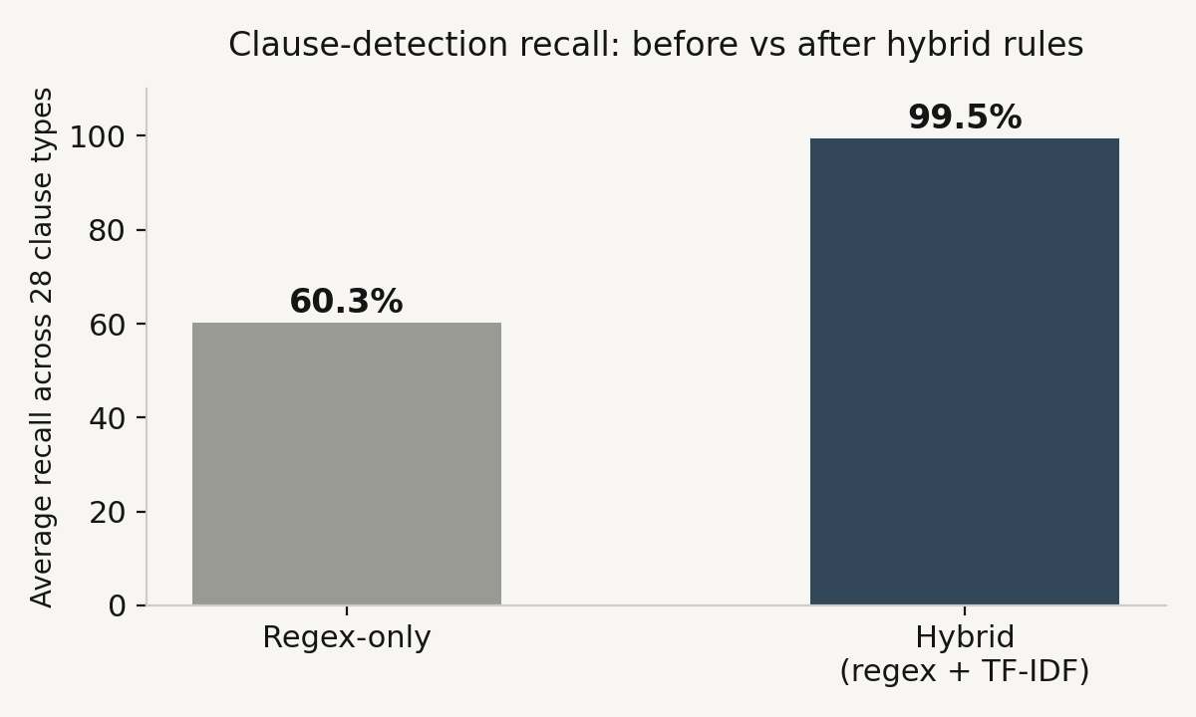
Precision held at 1.0 in both versions, the improvement is pure recall gain, not a precision/recall trade-off.

3. Still need to gather
Item | Status | Note
Screenshots | Done | Four real captures selected and curated: hero, High Risk alert, results breakdown, risk distribution chart.
Live demo link | Done | lexguard20.netlify.app
Repo | Done | github.com/Lateephah/LexGuard
Before/after numbers | Done | From my own evaluation notebook: average recall across 28 clause types rose from 60.3% (regex-only) to 99.5% (hybrid regex + TF-IDF), tested on 510 CUAD contracts. Precision held at 1.0 throughout, no false positives.
Testimonial | Still open | Don't have one yet. Noted honestly rather than delaying the build.
Internship work | Out of scope | Deliberately excluded, Week 1 and 2 both narrowed this build to one claim and one case. Not forgotten, just not part of this portfolio.

