TrustVote
A Zero-Knowledge, Blockchain-Based Voting Platform with End-to-End Verifiability
TECHNICAL SPECIFICATION & IMPLEMENTATION REPORT
Documents the system as designed and implemented — compiled, tested,
and operated end-to-end with real Groth16 proofs.

Contents
1. Introduction
2. System Overview
3. Architecture and Components
3.1 Repository layout
3.2 Smart contract (VotingPlatform.sol)
3.3 Zero-knowledge circuit (VotingCircuit.circom)
3.4 Frontend
4. Protocol Detail and Design Decisions
4.1 Registration and the commitment-based electoral roll
4.2 Public-signal layout: uint[9] and key binding
4.3 Fixed-depth Merkle tree
4.4 Result publication rules
4.5 On-chain election discovery
5. Cryptographic Primitives
6. Smart Contract Interface (as deployed)
7. Trusted Setup and Proving Pipeline
8. Frontend Implementation
9. IPFS Integration
10. Implementation Record
11. Testing
12. Technology Stack
13. Production Roadmap
14. Conclusion

1. Introduction
TrustVote is a privacy-preserving electronic voting system for EVM blockchains. A platform operator creates and manages elections for any organization — student councils, DAOs, corporate boards, community polls, government agencies — while the system provides mathematical guarantees of:
- Ballot secrecy — nobody, including the platform operator, can see how an individual voted. Ballots are ElGamal-encrypted in the voter's own browser; only ciphertext ever reaches the chain.
- One-person-one-vote — enforced cryptographically through nullifiers; a second ballot from the same voter is rejected by the contract without revealing the voter's identity.
- Eligibility without identification — voters prove membership of the electoral roll in zero knowledge. The electoral roll contains anonymous cryptographic commitments rather than wallet addresses, so ballots cannot be linked to addresses even off-chain (see §4.1).
- End-to-end verifiability — voters confirm their own ballot was recorded; any third party recomputes the entire tally from public data and verifies every proof independently.
These guarantees are achieved with zero-knowledge proofs (Groth16 proofs generated from circuits written in the Circom language), Poseidon Merkle trees, exponential ElGamal encryption on BabyJubJub, Chaum-Pedersen decryption proofs, and on-chain verification. The frontend is React (Vite); deployment targets are a local Hardhat chain, Polygon Amoy (testnet), and Polygon mainnet.
Status: every component of this document is implemented and has been exercised end-to-end, including elections run with real browser-generated Groth16 proofs verified by a real on-chain verifier produced from a completed trusted-setup ceremony.

2. System Overview
An election proceeds in five phases:
- Registration — the operator announces an Election ID. Each voter signs a fixed message with their wallet; the app derives a per-election secret key, computes the BabyJubJub public key, and produces a voter commitment Poseidon(pubKey.x). Voters submit only this commitment to the operator.
- Creation — the operator builds a fixed-depth Poseidon Merkle tree over the commitments, generates the election's ElGamal keypair (the private key is AES-encrypted client-side into a password-protected vault file), uploads the tree and metadata to IPFS, and records the election on-chain: Merkle root, voting window, ElGamal public key, and the metadata CID.
- Voting — a voter's browser re-derives the secret key from a wallet signature, rebuilds the Merkle proof, computes the nullifier, encrypts the chosen candidate, generates a Groth16 proof in a Web Worker, and submits castVote. The contract checks the public signals against stored election parameters and verifies the proof before accepting.
- Tally — after the window closes, the election authority decrypts each ballot with the vaulted key, producing a Chaum-Pedersen proof of honest decryption per ballot, publishes the results file to IPFS, and records its CID on-chain — a step the contract refuses before the end time and timestamps when it occurs.
- Audit — anyone opens the public Verifier, which re-derives everything from the chain and IPFS alone: pubkey match, nullifier uniqueness, ballot-by-ballot presence on-chain, every Chaum-Pedersen proof, and a full recount compared against the published totals, ending in a VERIFIED / NOT VERIFIED verdict.

3. Architecture and Components
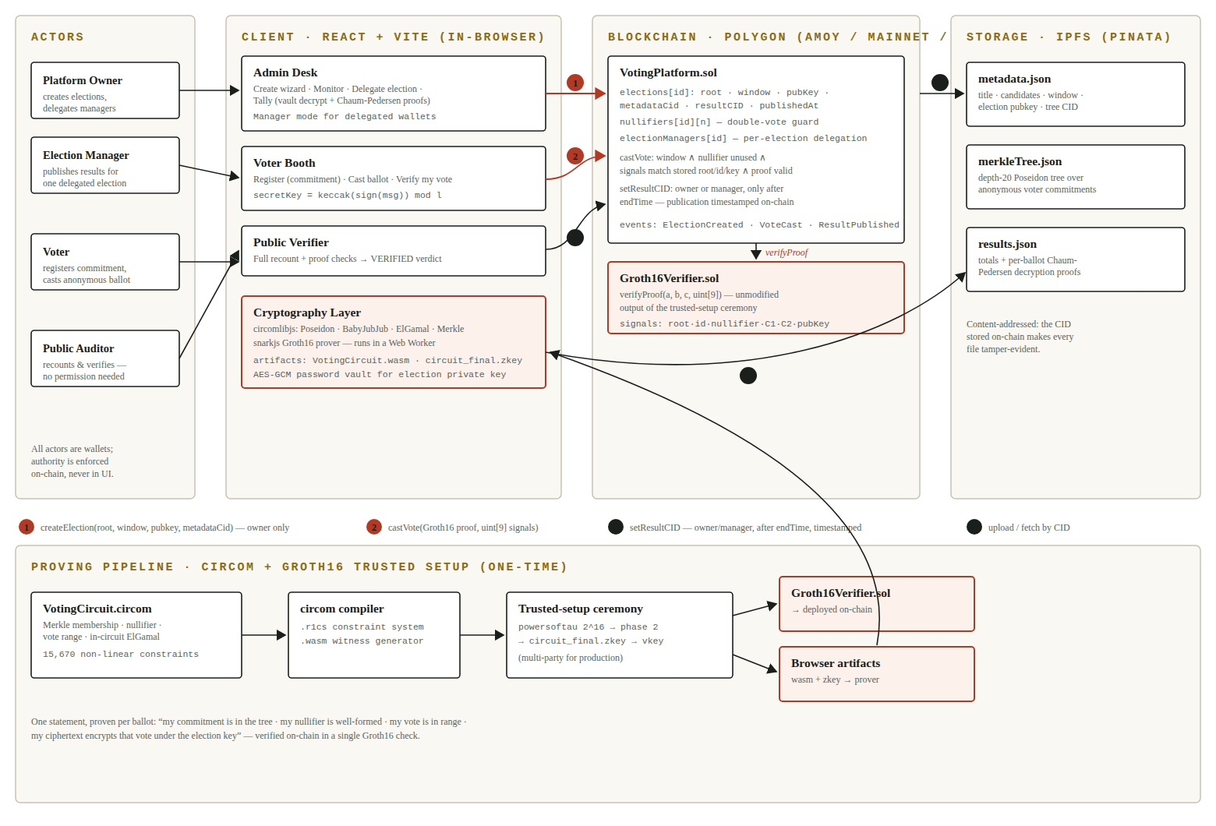
Figure 1 — System architecture: actors, in-browser client, on-chain contracts, IPFS storage, and the one-time Circom/Groth16 proving pipeline. Numbered flows are the contract's write paths.

3.1 Repository layout
trustvote/
contracts/ Hardhat · Solidity 0.8.20 · VotingPlatform.sol · Groth16Verifier.sol (ceremony output)
MockGroth16Verifier.sol (tests only) · 13-test suite · deploy script
circuits/ Circom 2.1.5 · VotingCircuit.circom · ceremony artifacts (.ptau/.zkey/vkey)
scripts/ Node ESM · deriveCommitments · generateMerkleTree · generateKeys · tally · pinata
frontend/ React 18 + Vite 5 · wagmi 2 / RainbowKit 2 / viem · snarkjs in a Web Worker

3.2 Smart contract (VotingPlatform.sol)
A single Ownable contract manages all elections. Each Election record stores: merkleRoot, startTime, endTime, pubKeyX/pubKeyY (ElGamal key), exists, resultCID, resultPublishedAt, and metadataCid. Ciphertexts are not stored — they are emitted in VoteCast events, which suffices for tallying and audit while minimising gas. Nullifier usage is tracked per election in a nested mapping.
Governance: the platform owner may delegate a single election to a manager wallet via setElectionManager(electionId, manager). The manager can publish that election's results and nothing else; authority never extends to creating elections or to other elections, and the owner can revoke or replace the manager at any time (zero address = owner-only). This supports operator-runs-the-platform / client-runs-their-election arrangements.

3.3 Zero-knowledge circuit (VotingCircuit.circom)
The circuit proves, in one Groth16 statement: knowledge of a secret key whose derived commitment is a leaf of the Merkle tree with the public root; correctness of the nullifier Poseidon(secretKey, electionId); that the vote lies in [0, nCandidates); and that the published ciphertext is a well-formed exponential-ElGamal encryption of that vote under the election public key. The ElGamal encryption is computed inside the circuit with real elliptic-curve gadgets (EscalarMulFix for g·r and g·vote, EscalarMulAny for h·r, BabyAdd for the sum), the key is validated on-curve (BabyCheck), and r = 0 is forbidden. Compiled size: 15,670 non-linear + 6,337 linear constraints, 22,028 wires.

3.4 Frontend
Four views. A landing page ("Notice of Election") states the guarantees and routes visitors. The Voter tab covers Register / Cast a ballot / Verify my vote. The Admin tab hosts the creation wizard, a live Monitor, per-election Delegation, and the in-browser Tally; non-owner wallets see a Manager mode limited to monitoring and publishing. The Verifier tab is the public audit. Proof generation runs in a Web Worker with progress streaming, a stall watchdog, and automatic fallback to mock proofs when circuit artifacts are absent.

4. Protocol Detail and Design Decisions

4.1 Registration and the commitment-based electoral roll
A design alternative — building Merkle leaves directly from wallet addresses — was considered and rejected: the circuit proves knowledge of a secret key, so an address-based leaf cannot be soundly bound to the prover, and addresses in the roll would let observers link ballots to wallets off-chain. Instead, a registration phase builds the roll from voter commitments Poseidon(BabyPbk(secretKey).x) — exactly the value the circuit derives in-circuit. Wallet addresses therefore never appear in any election artifact, removing even off-chain linkability between addresses and ballots.
Secret derivation is deterministic: secretKey = keccak256(personal_sign("TrustVote Election: <id>")) mod l, where l is the BabyJubJub subgroup order. The same wallet and election ID always re-derive the same secret, so voters need to store nothing.

4.2 Public-signal layout: uint[9] and key binding
The proof exposes nine public signals, consumed by the contract as uint[9]:
Index | Signal | Contract check
0 | merkleRoot | == election.merkleRoot
1 | electionId | == electionId argument
2 | nullifier | == nullifier argument; unused before
3–6 | c1x, c1y, c2x, c2y | emitted in VoteCast
7–8 | pubKeyX, pubKeyY | == stored election key

Signals 7–8 bind the encryption key inside the proof, checked by the contract against on-chain storage. Without this binding a prover could encrypt under an arbitrary key of their own, producing a permanently undecryptable ("spoiled") ballot that would still verify — a subtle attack that a narrower signal layout cannot prevent.

4.3 Fixed-depth Merkle tree
The tree is a fixed depth-20 Poseidon tree padded with the zero-hash cascade zeros[0] = 0, zeros[i+1] = Poseidon(zeros[i], zeros[i]); level i pads missing right-siblings with zeros[i]. Tree construction, proof extraction, and the in-circuit verifier share this layout exactly (validated across sizes 1–100 in simulation), so real proofs verify against the on-chain root.

4.4 Result publication rules
setResultCID is callable by the owner or the election's manager, reverts until block.timestamp > endTime, records resultPublishedAt on-chain, and emits ResultPublished(electionId, cid, publishedAt, publishedBy). Observers can therefore prove results were not announced early, and exactly when — and by which authority — they appeared.

4.5 On-chain election discovery
createElection stores the metadata CID in the election record (and event). Any client can reconstruct an election from its ID alone: read metadataCid from the chain, fetch metadata from IPFS, fetch the Merkle tree by the CID inside it. No off-chain registry is required (a local registry remains as a fallback for pre-upgrade elections).

5. Cryptographic Primitives
Primitive | Role in TrustVote
Poseidon hash | Merkle leaves/nodes; nullifier = Poseidon(sk, electionId); SNARK-friendly
BabyJubJub | Embedded curve for all in-circuit elliptic-curve arithmetic
Exponential ElGamal | Ballot encryption: C1 = g·r, C2 = h·r + g·vote; decryption by discrete-log table
Groth16 (snarkjs) | Succinct proof of the full voting statement; verified on-chain (~few 100k gas)
Chaum-Pedersen | Per-ballot proof that decryption used the real key: g·s = R1 + pk·c and C1·s = R2 + shared·c
Fiat-Shamir | keccak256 transcript hash makes the CP proofs non-interactive
AES-GCM + PBKDF2 | Password vault for the election private key (client-side, 200k iterations)

6. Smart Contract Interface (as deployed)
createElection(uint256 id, bytes32 merkleRoot, uint256 start, uint256 end,
uint256 pubKeyX, uint256 pubKeyY, string metadataCid) onlyOwner
setElectionManager(uint256 id, address manager) onlyOwner
castVote(uint256 id, uint256 nullifier, uint256[4] ciphertext,
uint256[2] a, uint256[2][2] b, uint256[2] c, uint256[9] input)
setResultCID(uint256 id, string cid) owner or manager; after endTime
getElection(uint256 id) -> Election struct electionManagers(id) -> address

castVote enforces, in order: election exists; window open; nullifier unused; input[0] = stored root; input[1] = id; input[2] = nullifier; input[7..8] = stored ElGamal key; and finally verifier.verifyProof(a, b, c, input). Groth16Verifier.sol is the unmodified snarkjs export from the ceremony; a MockGroth16Verifier exists strictly for unit tests and is never deployed.

7. Trusted Setup and Proving Pipeline
The circuit was compiled with Circom and taken through a full Groth16 ceremony (Powers of Tau 2^16, phase-2 contribution, verification key and Solidity verifier export). Proving artifacts (VotingCircuit.wasm, circuit_final.zkey) are served from the frontend; artifact presence is detected by content (WASM magic bytes), not HTTP status, so dev-server SPA fallbacks cannot fool the client. When artifacts are present the browser generates real proofs and submits the prover's own public signals verbatim; when absent, the client falls back to mock proofs for development.
The ceremony was performed by a single participant, which is appropriate for demonstration but not production: a solo participant could theoretically retain the toxic waste and forge proofs. A production deployment must re-run phase 2 as a multi-party ceremony (one honest participant suffices for soundness).

8. Frontend Implementation
React 18 on Vite 5, wagmi 2 + RainbowKit 2 + viem for wallet and chain access, snarkjs + circomlibjs in-browser for all cryptography. Supported networks: Hardhat local (31337), Polygon Amoy (80002), Polygon mainnet (137); the app follows the wallet's network and links receipts to the matching block explorer.
Design system ("the counting room at night"): ballot-paper cream on ballot-box green-black, wax-seal vermilion, brass foil; Fraunces display, Public Sans body, IBM Plex Mono for serials; a rotating official seal as the signature element; cards rendered as perforated ballot slips; receipts and audit verdicts stamped. Accessibility floor: visible brass focus rings, reduced-motion support, keyboard-reachable controls.

9. IPFS Integration
Election artifacts (Merkle tree, metadata, results) are stored on IPFS via Pinata, addressed by CID from the chain. Without a Pinata key the system runs in an explicit mock mode (deterministic pseudo-CIDs stored locally) that supports full single-machine demonstrations; supplying VITE_PINATA_JWT / PINATA_JWT switches to the real network with no code changes. Known limitation: the browser holds the Pinata JWT, so a public deployment should proxy uploads through a minimal backend.

10. Implementation Record
Milestones reached, in order: full monorepo authored; contracts compiled (solc 0.8.20) with all unit tests passing; circuit compiled cleanly on first attempt with the expected 2-public-input / 7-output shape; complete mock election operated end-to-end (register → create → vote → tally → VERIFIED audit); trusted-setup ceremony completed and the real verifier deployed; complete election operated with real browser-generated Groth16 proofs accepted on-chain — after the same verifier was observed rejecting all fabricated proofs; governance (delegation, publication rules) and on-chain discovery added with tests; UI system and landing page completed.
Integration defects found and fixed during bring-up, recorded for honesty and regression awareness: a JavaScript hex-literal address coerced to floating point (now caught by startup validation); an admin gate that failed open when the contract was unreachable (now fails closed); artifact detection fooled by SPA fallbacks (now content-sniffed, with a proving watchdog); a stale uint[7] ABI (now uint[9]); and the localStorage-only election registry (now on-chain metadataCid).

11. Testing
Thirteen Hardhat unit tests cover the contract: ownership and creation rules; duplicate rejection; valid vote acceptance with event emission; double-vote rejection; window enforcement; root/ID public-signal mismatches; wrong-pubkey binding rejection; early-publication rejection; timestamped publication; manager delegation, its per-election boundary, and non-authority rejection. Circuit/JS consistency was validated by structural simulation of the tree/proof/selector logic across roll sizes 1–100 and, decisively, by the acceptance of real proofs on-chain — which exercises every constraint against the JavaScript implementations bit-for-bit.

12. Technology Stack
Layer | Choice | Rationale
Chain | Polygon Amoy / mainnet + local Hardhat | Sub-cent votes on Polygon; contracts are chain-agnostic EVM
Contracts | Solidity 0.8.20 · Hardhat · OpenZeppelin | Battle-tested toolchain; Ownable for platform governance
ZK | Circom 2 · circomlib · snarkjs · Groth16 | Smallest proofs / cheapest on-chain verification
Frontend | React 18 · Vite 5 · wagmi/RainbowKit/viem | Modern wallet UX; in-browser proving via WASM
Storage | IPFS (Pinata) | Content-addressed: on-chain CIDs make artifacts tamper-evident

13. Production Roadmap
- Multi-party phase-2 ceremony to eliminate single-participant trust in the proving keys.
- Independent security audit of the circuit and contracts.
- Threshold (multi-custodian) election keys, so no single vault file can lose or leak an election.
- Backend upload proxy so the Pinata credential leaves the browser bundle.

14. Conclusion
TrustVote delivers a working election system in which ballot secrecy, one-person-one-vote, and public verifiability are enforced by mathematics rather than policy. Every ballot accepted on-chain carries a real zero-knowledge proof checked by a real verifier; every published result carries decryption proofs and an on-chain timestamp; and any third party, on any machine, can recount the election from public data and reach an independent verdict. The remaining distance to a public production deployment is process and infrastructure — ceremony, audit, custody — not code.

