Name :- Rishi Sampat Enrollment No. :- 92400133169 Class :- 4EK1

Experiment-4
Aim: Hands-on experimentation of ATMega32Timer with interrupt programming in C.
Objectives: After successfully completion of this experiment students will be able to,
- Use C language for ATMega32 microcontroller programming on AVRStudio.
- Experiment with timer with interrupt of ATMega32 on ATMega32 AVR Development Board.

Equipment required:
- Windows7 or later based host computer
- ATMega32 Development board
- USBasp Programmer
- Jumper Wires
- LED
Software required:

- AVR Studio7 installation setup
- USBasp driver installation setup
Theory:

AVR Interrupt Timer programming Basics

In this section, we'll take a look at interrupts, how we deal with them under AVR, their impact on scheduling and real time.
The first thing we need to ask is, “What's an interrupt?”

An interrupt is exactly what it sounds like — an interruption of whatever was going on and a diversion to another task.
For example, suppose you're sitting at your desk working on job “A.” Suddenly, the phone rings. A Very Important Customer (VIC) needs you to immediately answer some

skill-testing question. When you've answered the question, you may go back to working on job “A,” or the VIC may have changed your priorities so that you push job “A” off to the side and immediately start on job “B.”
In most microcontrollers, there is something called interrupt. This interrupt can be fired whenever certain conditions are met. Now whenever an interrupt is fired, the AVR stops and saves its execution of the main routine, attends to the interrupt call (by executing a special routine, called the Interrupt Service Routine, ISR) and once it is done with it, returns to the main routine and continues executing it.

For example, in the condition of counter overflow, we can set up a bit to fire an interrupt whenever an overflow occurs. Now, during execution of the program, whenever an overflow occurs, an interrupt is fired and the CPU attends to the corresponding ISR. Now it’s up to us what we want to do inside the ISR. We can toggle the value of a pin, or increment a counter, etc etc.

If you didn’t get the concept of interrupts and ISR, behold for sometime till we discuss it how to implement it in hardware.

TCNT0 Register

The Timer/Counter Register – TCNT0 is as follows:

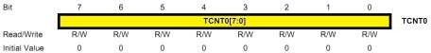

TCNT0 Register

This is where the uint 8-bit counter of the timer resides. The value of the counter is stored here and increases/decreases automatically. Data can be both read/written from this register.

Now we know where the counter value lies. But this register won’t be activated unless we activate the timer! Thus we need to set the timer up. How? Read on…

TCCR0 Register

The Timer/Counter Control Register – TCCR0 is as follows:

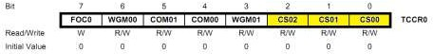

TCCR0 Register

Right now, we will concentrate on the highlighted bits. The other bits will be discussed as and when necessary. By selecting these three Clock Select Bits, CS02:00, we set the timer up by choosing proper prescaler. The possible combinations are shown below.
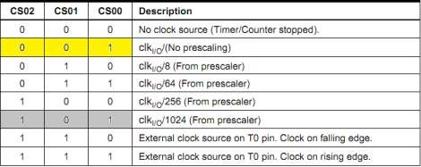

Clock Select Bit Description

we choose No Prescaling. Ignore the bits highlighted in grey. Thus, we initialize the counter as:

TCCR0 |= (1 << CS00);

Please note that if you do not initialize this register, all the bits will remain as zero and the timer/counter will remain stopped.

Methodology – Using Interrupts

So now, we have to flash the LED every 1000 ms. With CPU frequency 1 MHz, even a maximum delay of 1.024 ms can be achieved using a 1024 prescaler. So what do we do now? Well, we use interrupts.

The concept here is that the hardware generates an interrupt every time the timer overflows. Since the required delay is greater than the maximum possible delay, obviously the timer will overflow. And whenever the timer overflows, an interrupt is fired. Now the question is how many times should the interrupt be fired?

For this, let’s do some calculation. Let’s choose a prescaler, say 256. Thus, as per the calculations, it should take 65.280 ms for the timer to overflow. Now as soon as the timer overflows, an interrupt is fired and an Interrupt Service Routine (ISR) is executed. Now,

1000 ms ÷ 65.280 ms = 15.3186ms

Thus, in simple terms, by the time the timer has overflown 15 times, 979.2 ms would have passed. After that, when the timer undergoes 16th iteration, it would achieve a delay of 979.2 ms. Thus, in the 16th iteration, we need a delay of 1000 – 979.2 = 20.8 ms. At a frequency of 3.90 kHz (prescaler = 256), each tick takes 0.256 ms. Thus to achieve a delay of 20.8 ms, it would require 81 ticks. Thus, in the 16th iteration, we only allow the timer to count up to 81, and then reset it. All this can be achieved in the ISR as follows:

// global variable to count the number of overflows volatile uint8_t tot_overflow;s

// TIMER0 overflow interrupt service routine
// called whenever TCNT0 overflows ISR(TIMER0_OVF_vect)
{
// keep a track of number of overflows tot_overflow++;
}

int main(void)
{
// connect led to pin PC0 DDRC |= (1 << 0);

// initialize timer timer0_init();

// loop forever while(1)
{
// check if no. of overflows = 15
if (tot_overflow >= 15) // NOTE: '>=' is used
{
// check if the timer count reaches 81 if (TCNT0 >= 81)
{
PORTC ^= (1 << 0); // toggles the led TCNT0 = 0; // reset counter tot_overflow = 0; // reset overflow counter
}
}
}
}

Please note that the code is not yet ready. Not until you learn how to enable the interrupt feature. For this, you should be aware of the following registers.

TIMSK Register

The Timer/Counter Interrupt Mask – TIMSK Register is as follows. It is a common register for all the three timers. For TIMER0, bits 1 and 0 are allotted. Right now, we are interested in the 0th bit TOIE0. Setting this bit to ‘1’ enables the TIMER0 overflow interrupt.

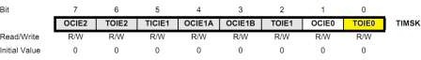

TIMSK Register

TIFR Register

The Timer/Counter Interrupt Flag Register– TIFR is as follows. Even though we are not using it in our code, you should be aware of it.

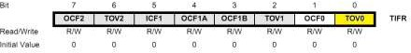

TIFR Register

This is also a register shared by all the timers. Even here, bits 1 and 0 are allotted for TIMER0. At present we are interested in the 0th bit TOV0 bit. This bit is set (one) whenever TIMER0 overflows. This bit is reset (zero) whenever the Interrupt Service Routine (ISR) is executed. If there is no ISR to execute, we can clear it manually by writing one to it.

In this example, since we are using ISR, we need not care about this bit (thus this register as a whole).

Enabling Global Interrupts

In the AVRs, there’s only one single bit which handles all the interrupts. Thus, to enable it, we need to enable the global interrupts. This is done by calling a function named sei(). Don’t worry much about it, we simply need to call it once, that’s all.

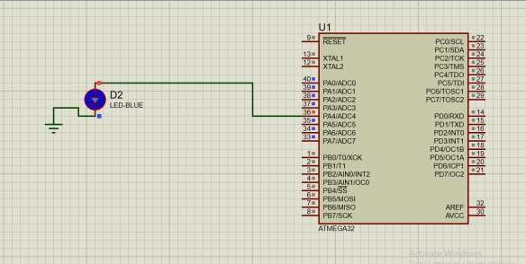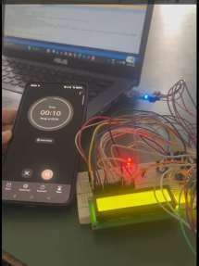

#include <avr/io.h> #include <avr/interrupt.h>

// global variable to count the number of overflows volatile uint8_t tot_overflow;

// initialize timer, interrupt and variable void timer0_init()
{
// set up timer with prescaler = 256 TCCR0 |= (1 << CS02);

// initialize counter TCNT0 = 0;

// enable overflow interrupt TIMSK |= (1 << TOIE0);

// enable global interrupts sei();

// initialize overflow counter variable tot_overflow = 0;
}

// TIMER0 overflow interrupt service routine
// called whenever TCNT0 overflows ISR(TIMER0_OVF_vect)
{
// keep a track of number of overflows tot_overflow++;
}

int main(void)
{
// connect led to pin PC0 DDRC |= (1 << 0);

// initialize timer timer0_init();

// loop forever while(1)
{
// check if no. of overflows = 15
if (tot_overflow >= 15) // NOTE: '>=' is used
{
// check if the timer count reaches 81 if (TCNT0 >= 81)

{
PORTC ^= (1 << 0); // toggles the led TCNT0 = 0; // reset counter tot_overflow = 0; // reset overflow counter
}
}
}
}
OUTPUT:
#define F_CPU 1000000UL #include <avr/io.h> #include <avr/interrupt.h>

#define LED PD4

volatile uint8_t overflowCount = 0;

// ISR for Timer0 Overflow ISR(TIMER0_OVF_vect)
{
overflowCount++;

if (overflowCount >= 38)
{
PORTD ^= (1<<LED); // Toggle LED
overflowCount = 0;
}
}

int main(void)
{
DDRD = 0xFF; // PORTD as output

TCNT0 = 0x00; // Initial value

// Enable Timer0 overflow interrupt TIMSK = (1<<TOIE0);

// Start timer with prescaler 1024 TCCR0 = (1<<CS00) | (1<<CS02);

sei(); // Enable global interrupts

while (1)
{
// Main loop does nothing
// CPU is free for other tasks
}
}

CONCLUSION:
By setting up Timer0 and turning on overflow interrupts with the TIMSK register, along with enabling global interrupts using sei(), we generated periodic events without needing constant CPU attention. The Interrupt Service Routine (ISR) managed overflow conditions and controlled LED blinking at exact intervals. This experiment showed how important interrupts are in real-time embedded systems, allowing for efficient multitasking and better CPU use.

Experiment-4 Post Lab Exercise

Student Name: Rishi Sampat Enrollment No: 92400133169

Answer the following questions:
- What is the role of TIMSK register?
The TIMSK (Timer Interrupt Mask Register) is used to enable or disable specific timer interrupts. (for writing/monitorinng)
For example, setting the TOIE0 bit enables Timer0 overflow interrupt.
- What is the role of TIFR register?
The TIFR (Timer Interrupt Flag Register) indicates whether a timer interrupt event has occurred. (for monitoring only)
The TOV0 bit is set when Timer0 overflows. It is cleared automatically when ISR executes or manually by writing 1 to it.
- OCF1A comes in which mode Normal mode or CTC mode? In the above code of interrupt, which mode we have used normal or CTC?
OCF1A is used in CTC (Clear Timer on Compare Match) mode. In the given code, Normal Mode is used because it relies on timer overflow interrupt (TIMER0_OVF_vect) instead of compare match.
- Assume the XTAL = 8 MHz. Find the TCNT0 value needed to generate a time delay of 5000 ms. Use normal mode and the largest prescaler possible.
Frequency = 8 MHz, Prescaler = 1024, Timer is 8-bit---max count = 256 Time per tick = 1024 / 8,000,000 = 0.000128 sec = 0.128 ms
Max delay per overflow = 256 × 0.128 ms = 32.768 ms Number of overflows required = 5000 / 32.768 ≈ 153 overflows TCNT0 can be initialized as 0 (normal full overflow counting) Therefore, TCNT0 = 0, and ~153 overflows required.
- Assume the XTAL = 1 MHz. Find the OCR0 value needed to generate a time delay of 20 ms. Use CTC mode, no prescaler.
Time per tick = 1 / 1,000,000 = 1 µs Required delay = 20 ms = 20,000 µs
𝑶𝑪𝑹𝟎 = 𝟐𝟎𝟎𝟎𝟎 − 𝟏
But Timer0 is 8-bit (max 255)
So this value is not possible in one cycle

Therefore:
We must use multiple cycles or prescaler
OCR0 ≈ 19999 (not feasible in 8-bit timer, so use prescaler or multiple interrupts)

