**Title**

Assessing the impact of first steps intervention program to reduce low birth weight in King County Area

**Authors**

Latera Tesfaye1,2, Mary Emond PhD2, Eardi Lila2; Anand Hemmady2

**Authors’ affiliations**

1University of Washington, International Health Metrics and Evaluation, Seattle, WA, USA

2National Data Management and Analytics Centre for health, Ethiopian Public Health Institute, Addis Ababa, Ethiopia

2University of Washington, Department of Biostatistics, Seattle, WA, USA

**Correspondence to**: Mr. Latera Tesfaye, University of Washington, International Health Metrics and Evaluation, Seattle, WA, USA. Email: latera@uw.edu

**Abstract**

*Background:*Low birth weight (LBW) is one of the main predictors of infant and neonatal mortality. Low birth weight is a public health issue that can be prevented. It is an important determinant of child survival and development, as well as long-term consequences like the onset of non-communicable disease. Addressing the factors of low birth weight can avert a significant amount of mortality and morbidity. The main objective this study was to show the relationship between a newly introduced intervention program, called ‘First Steps,’ and birth weight in Seattle and King County. In addition this of this study was to identify key risk factors impacting low birth weight

*Method:* In this study we used a data (N=2500) extracted from King County area, which was intended to collect information on the impact of First Step intervention program on low birthweight in that area. The data contains information of birthweight for live births, key risk factors of low birthweight and some socio-demographic factors. We assessed association between First step intervention and these variables using summary statistics, t-test and Chi-squared tests.

*Results:* The data in general has 2500 observations. 2097 of which did participate in the First Step intervention program. Whereas, 403 did not participated in the intervention program. Mother’s age, ethnicity, prior birth history, marital status, child’s birthweight, daily smoking habits (frequency and intensity of smoking), welfare beneficiary, smoking status, pre-pregnancy weight, and education were associated with the participation of First Step (P <0.05). Since all of these variables are also associated with low birthweight those who are not in casual pathway, ethnicity, age, daily smoking habits, welfare beneficiary, smoking habits and education, were labeled as cofounders. We found that the First Step participants had significant mean difference of 95 [6.6 -125.8] grams low birthweight as compared to non-participants.

*Conclusion:* Globally, we are seeing an increased use of social and behavioral interventions in bridging health gaps, including overcoming low birthweight. To this end, assessing whether the interventions are generating a desired outcome in minimizing risk and reducing disease burden is imperative. The inherently unbalanced data and targeted inclusion (non-random) of study group might have impacted the results of this study. We highly recommend conducting a larger scale randomized study to accurately identify the risk-factors of low birth weight and on how that could be amenable by First Step intervention.

**Keywords:** Low birth weight, first steps intervention, risk factors, King County

**Introduction**

Center for disease control (CDC) defines Low birth weight (LBW) as babies born weighing less than 2,500 grams or 5 lbs. 8oz [1]. LBW is one of the major maternal and child health indicators [2]. It is an important indicator, which interlinks a wide array of health disciplines with other sectors, such as, health status, health care delivery, nutrition and poverty. In children LBW in the long-term increases the potential risks of developing cognitive deficits, motor delays, cerebral palsy and other cardiovascular diseases as well [3-7]. Globally, the incidence of LBW is measured to be around 17%, with 5-7% being in developed countries. A 2020 data from CDC shows that around 8.14% of children in United States (US) are born LBW [1]. For the state of Washington (WA) it was estimated to be 6.7%, relatively on of the states with smallest LBW percentage.

Studying and accurately identifying the etiology of LBW, socio-demographic risk factors, medical risks before pregnancy, risks of the current pregnancy, health care services before, during and after pregnancy, environmental and behavioral risks have a significant implications in improving the health status of children [9]. Multifaceted interventions, such as clinical interventions in preventing hypothermia at birth [10] and non-clinical interventions like health educations, behavioral change communications and counseling to overcome some of behavioral and socio-economic risk factors like First Step program, are required to reduce or properly cope with the risk factors and mitigate the overall prevalence and incidence of LBW. The First step intervention is designed to help individuals who are pregnant and parents for combating LBW [11]. The program was offered by Public Health – Seattle and King County as two part interventions. First, in the Maternity Support Services (MSS) program, individuals received health education and counseling during your pregnancy and two months after your pregnancy ends (miscarriage, termination, or childbirth). Second, Infant Case Management (ICM) program, parents were provided education on the use of medical, social, educational, and other resources to help infants thrive.

The main objective this study was to show the relationship between a newly introduced intervention program, called ‘First Steps,’ and birth weight in King County. In addition this study tried to assess the relationship of risk factors with low birth weight and participation of First Steps intervention.

**Method**

In this study we used a data (N=2500) extracted from King County area, which was intended to collect information on the impact of First Step intervention program on low birthweight in that area. The data contains information of birthweight for live births, key risk factors of low birthweight and some socio-demographic factors. The full lists of the variables used are indicated on Table 1. We followed the following analytics steps:

**Step 1 is data processing**. As the variable for multiplicity of birth (‘plural’) had only a single discrete value, which was 1, it was removed. Gender, smoker, drinker, and race variables were recoded to change their values from character representation to numeric. Prior number of children in family is given as a discrete number. Depending on the count of each number and using the fact that in Seattle area the number of children per house household is two [11], 0: No prior children, 1-2: Moderate prior children and 3+: multiple prior children categorization was added. Similarly, for a discrete value, number of cigarettes per day during pregnancy, we categorized it as: 0 cigarette: No smoking, 1-5 cigarette: Significant smoking and 6+ cigarette: Serious smoking [12]. Since, we did not find an exact evidence on the impact of frequency and intensity of alcohol consumption, the categorization was done depending on prior knowledge of the author (0: No alcohol, 1-2: High drinking, 3+: Extremely high drinking). Premature birth is one risk factor for low birth weight [9]. Infants born at a gestational age of less than 38 weeks are considered premature and are susceptible to increased risks of illness and death, including low birth weight. Even though, the gestational week variable is continues, we created a dichotomous category, as in, 1: for gestational week less than 38 and 0: for gestational week greater than 38 weeks. The first category (coded as 0) had higher risk of being low birth weight due to their prematurity as compared to the second group. Years of education of the mother was treated as a continuous variable. Rosner’s test and simple box-plot were used to detect outliers for continuous variables. Once detected, to check for extreme outliers, we checked for any data values which lie more than 3.0 times the interquartile range below the first quartile or above the third quartile. In order to test for skewness in low birth weight variable, we generated moment skewness coefficient. All the variables listed in Table 1 were used.

**Step 2 is assessing factors impacting the intervention**. We compared percentage differences across the two First Step groups for all categorical variables to identify association. Similarly, for continues variables we compared their mean for the two First Step groups. We also performed statistical tests to find associations which are beyond any chance. For continuous variables we used T-test, whereas, for dichotomous and other categorical variables we used Chi-squared and Fisher tests. Fisher test was used if any cell of the contingency table has a value less than 5. All analysis were performed on R software (version 4.0.2) and Microsoft excel 2016.

**Results**:

The data in general has 2,500 observations. 2,097 of which did participate in the First Step intervention program. Whereas, 403 did not participated in the intervention program. In age variable no outlying value was observed. For low birth weight variable 58 outliers were detected. Of this outliers none were found to be extreme outliers. Accordingly, we decided to use these points in subsequent analysis as well. For mother’s pre-pregnancy weight variables 122 outliers were detected, none of which are extreme outliers. Finally, for education variable, 15 points were identified as outliers, none of which are extreme outliers. In addition to the absence of extreme outliers, across all variables there is a justifiable reason behind why a given value for certain variable might unexpectedly high or low. Accordingly, with the absence of errors, for instance data entry error, all values were used for further analysis (see supplementary material, Figures 1-4). The moment skewness coefficient was estimated to be -0.67, implying heavily left skewed distribution. The main reason for the skewness towards lower values would be women at high risk for low birthweight babies are encouraged to participate in the program. This might result in inclusion of more mother’s with low birth weight.

[Figure 1 goes around here]

204 (50.6%) of First Step participants were single. Whereas, 340 (16.2%) of non-participants were single. This significant difference (p<0.001) shows an association between marital status and First Step participation. 21 (5.2%) of First Step participants were on welfare. However, only 1% of non-participants were on welfare. This different was estimated to be significant (p<0.001). We also observed a significant difference (p<0.001) in number of smokers, 51 (12.7%) and 124 (5.9%), for First Step participants and non-participants, respectively. The mean age of First Step participants was estimated to be 30.1 (SD=5.7) and for non-participants 25.4 (6.03). The First Step participants are older as compared to that of non-participants (p<0.001). The average years of education for First Step participants were estimated to be 14.5 (SD=2.44). Whereas, for non-participants we observed a decrease in years of education, i.e., 12.1(SD=2.65). For non-participants the race composition was, 1488 (71.0%) - White, 339 (16.2%) - Asian, 132 (6.3%) - Hispanic, and 118 (5.6%) - Black. However, we observed a significant participation in the First Step program across Black and Hispanic community (supplementary material, Figure 5). In addition to the above significant variables, prior birth history (p=0.0313), daily smoking (p<0.001), and pre-pregnancy weight (p=0.015) were found to be statistically associated with participation of First Step program. The mean weight gain during pregnancy did not significantly vary across First Step groups (p = 0.247). 32.1 (SD=12.9) for non-participants, whereas, for participants 33.0 (SD= 15.6). Generally, mother’s age, ethnicity, prior birth history, marital status, child’s birthweight, daily smoking habits (frequency and intensity of smoking), welfare beneficiary, smoking status, pre-pregnancy weight, and education were associated with the participation of First Step. Since all of these variables are also associated with low birthweight those who are not in casual pathway, ethnicity, age, daily smoking habits, welfare beneficiary, smoking habits and education, were labeled as cofounders.

[Table 1 goes here]

The observed birth weight mean of babies whose mothers were enrolled in First Step program was estimated to be 3360 (SD=611) grams. Whereas it was estimated to be 3420 (548) grams for non-participants. The 95% confidence interval for the difference in mean in birth weight across First Step groups was [6.6 -125.8]. To complement the p-value of 0.02958, the 95% confidence interval does not include the null value, implying there is statistically meaningful or statistically significant difference between the groups. We selected smoking as one of the risk factors amenable for modification. As shown in Table 2, the mean birthweight of children for smoking mothers and who’s participated in First Step program was 3138. For non-participants is was estimated to be 3205. The 95% confidence interval for the difference these means was [-124 - 259], with a p-value of 0.488, implying non-significant associations. Similarly, the mean birthweight difference between participants and non-participants for non-smoking mothers was estimated 50.0 [95% CI: -14.8 - 110.8] (p = 0.134). Figure 2, shows the boxplot for mean birthweight for smoking status, welfare, and marital status. As indicated in figure 3, despite the participation in First Step program the mean birthweight showed a decrease for Black, White and other races. For White and other races the difference was estimated to be significant, whereas for Black participants it was not. For Asian and Hispanic race we observed an increase in birthweight mean, -43.14 [95% CI: -195.0 - 108.7] and -12.3 [95% CI: -168.0 – 143.0], with 0.5768 and 0.876 p-values, respectively. We observed a varying trend on the impact of First Step participation across different races.

[Table 2 goes here]

[Figure 2 goes here]

[Figure 3 goes here]

As shown on Table 3, 6 (1.5%) and 19 (4.7%) of Fist Step program participants were labeled as very low birth weight and low birth weight, respectively. Similarly, 11 (0.5%) and 91 (4.3%) of non-participants were identified as very low birth weight and low birth weight, respectively. The proportion of individuals for each birthweight level across First Step groups is fairly balanced.

**Discussion:**

Low birthweight has multifaceted impact on the wellbeing of the child both in short-term and long-term. Therefore, it is a critical health problem, which requires a multifaceted response and interventions. Globally, we are seeing an increased use of social and behavioral interventions in bridging health gaps. To this end, assessing whether the interventions are generating a desired outcome in minimizing risk and reducing disease burden is imperative. In this study we assessed the impact of First Step intervention program in increasing birthweight across different demographic and risk groups.

The birthweight significantly (p = 0.02958) showed a decrease for First Step participants as compared with non-participants. To eliminate the possible impact of outliers, the separate T-test returned a less significant difference (46 grams [95% CI: -6.5 - 98]) where the mean birthweight of First Step participants is still lower than the non-participants.

Women at high risk of low birth weight were encouraged to participate and the proportion of participation across these presumed risk groups remained unbalanced. Women with smoking habit and those on welfare showed higher participation proportion. The participation of women in the First Step program across smoking habit groups showed no impact in changing the birth weight significantly (See supplementary material, Figure 8).

**Limitation:**

All statistical tests and analysis were performed without making any correction for outliers and skewness. Skewed data tends to have extremely unusual values (outliers). In variables were skewness is more prevalent the use of non-parametric tests is highly advised. Another limitation is, if the categorical-level value in certain group is small, the level containing this small value has to be merged with other levels. However, in this study we simply used fisher test for assessing association regardless of categorical-level values. Third limitation, the artificial categorization of some variables will also contribute to the change in their association with the primary outcome, in addition to effecting their interaction with other independent variables.

**Web appendix 1: Results table and figures**

Table 1. Summary statistics of the data

|  | **Not Participated (N=2097)** | **Participated (N=403)** | **Total (N=2500)** | **P-values** |
| --- | --- | --- | --- | --- |
| **Sexd** |  |  |  | 0.914* |
| Male | 1079 (51.5%) | 212 (52.6%) | 1291 (51.6%) |  |
| Female | 1018 (48.5%) | 191 (47.4%) | 1209 (48.4%) |  |
| **Age (years)c** |  |  |  | <0.001** |
| Mean (SD) | 30.1 (5.70) | 25.4 (6.03) | 29.3 (6.00) |  |
| Median [Min, Max] | 30.0 [14.0, 46.0] | 24.0 [15.0, 43.0] | 30.0 [14.0, 46.0] |  |
| 25% Quartile | 26.0 | 20.5 | 25.0 |  |
| 75% Quartile | 34.0 | 30.0 | 34.0 |  |
| **Raceca** |  |  |  | <0.001* |
| Asian | 339 (16.2%) | 53 (13.2%) | 392 (15.7%) |  |
| Black | 118 (5.6%) | 60 (14.9%) | 178 (7.1%) |  |
| Hispanic | 132 (6.3%) | 88 (21.8%) | 220 (8.8%) |  |
| White | 1488 (71.0%) | 191 (47.4%) | 1679 (67.2%) |  |
| Other | 20 (1.0%) | 11 (2.7%) | 31 (1.2%) |  |
| **Prior birthca** |  |  |  | 0.0313* |
| No prior children | 974 (46.4%) | 192 (47.6%) | 1166 (46.6%) |  |
| Moderate prior children | 1004 (47.9%) | 172 (42.7%) | 1176 (47.0%) |  |
| Multiple prior children | 119 (5.7%) | 39 (9.7%) | 158 (6.3%) |  |
| **Marriage statusd** |  |  |  | <0.001* |
| No | 340 (16.2%) | 204 (50.6%) | 544 (21.8%) |  |
| Yes | 1757 (83.8%) | 199 (49.4%) | 1956 (78.2%) |  |
| **Birth weight (gm)c** |  |  |  | 0.02958** |
| Mean (SD) | 3420 (548) | 3360 (611) | 3410 (559) |  |
| Median [Min, Max] | 3460 [255, 5180] | 3400 [788, 4930] | 3440 [255, 5180] |  |
| 25% Quartile | 3118 | 2991 | 3096 |  |
| 75% Quartile | 3770 | 3742 | 3766 |  |
| **Daily Smokingca** |  |  |  | <0.001* |
| No smoking | 1973 (94.1%) | 352 (87.3%) | 2325 (93.0%) |  |
| Significant smoking | 53 (2.5%) | 27 (6.7%) | 80 (3.2%) |  |
| Serious smoking | 71 (3.4%) | 24 (6.0%) | 95 (3.8%) |  |
| **Daily Drinkingca** |  |  |  | 0.7486^ |
| No alcohol | 2072 (98.8%) | 399 (99.0%) | 2471 (98.8%) |  |
| High drinking | 19 (0.9%) | 4 (1.0%) | 23 (0.9%) |  |
| Extremely high drinking | 6 (0.3%) | 0 (0%) | 6 (0.2%) |  |
| **Welfare beneficiaryd** |  |  |  | <0.001* |
| No | 2076 (99.0%) | 382 (94.8%) | 2458 (98.3%) |  |
| Yes | 21 (1.0%) | 21 (5.2%) | 42 (1.7%) |  |
| **Smoking statusd** |  |  |  | <0.001* |
| Not Smoking | 1973 (94.1%) | 352 (87.3%) | 2325 (93.0%) |  |
| Smoking | 124 (5.9%) | 51 (12.7%) | 175 (7.0%) |  |
| **Drinking statusd** |  |  |  | 0.4876^ |
| Not drinking | 2072 (98.8%) | 399 (99.0%) | 2471 (98.8%) |  |
| Drinking | 25 (1.2%) | 4 (1.0%) | 29 (1.2%) |  |
| **Pregnancy weight (points)c** |  |  |  | 0.015** |
| Mean (SD) | 146 (33.4) | 151 (40.0) | 147 (34.6) |  |
| Median [Min, Max] | 140 [75.0, 350] | 140 [80.0, 300] | 140 [75.0, 350] |  |
| 25% Quartile | 125.0 | 125.0 | 125.0 |  |
| 75% Quartile | 160.0 | 169.0 | 160.0 |  |
| **Pregnancy weight gain(lbs)c** |  |  |  | 0.247** |
| Mean (SD) | 32.1 (12.9) | 33.0 (15.6) | 32.3 (13.4) |  |
| Median [Min, Max] | 31.0 [0, 149] | 32.0 [0, 138] | 31.0 [0, 149] |  |
| 25% Quartile | 25.0 | 24.0 | 25.0 |  |
| 75% Quartile | 40.0 | 40.0 | 40.0 |  |
| **Educationc** |  |  |  | <0.001** |
| Mean (SD) | 14.5 (2.44) | 12.1 (2.65) | 14.1 (2.63) |  |
| Median [Min, Max] | 15.0 [0, 17.0] | 12.0 [3.00, 17.0] | 14.0 [0, 17.0] |  |
| 25% Quartile | 12.0 | 11.0 | 12.0 |  |
| 75% Quartile | 16.0 | 14.0 | 16.0 |  |
| **Prematurityd** |  |  |  | 0.976* |
| Premature | 732 (34.9%) | 143 (35.5%) | 875 (35.0%) |  |
| Not Premature | 1365 (65.1%) | 260 (64.5%) | 1625 (65.0%) |  |

*Note: * CHI square test, ** T-test, ^ fisher test. d: Dichotomous, c: Continuous, ca: Categorical variables. Significance level p < 0.005*

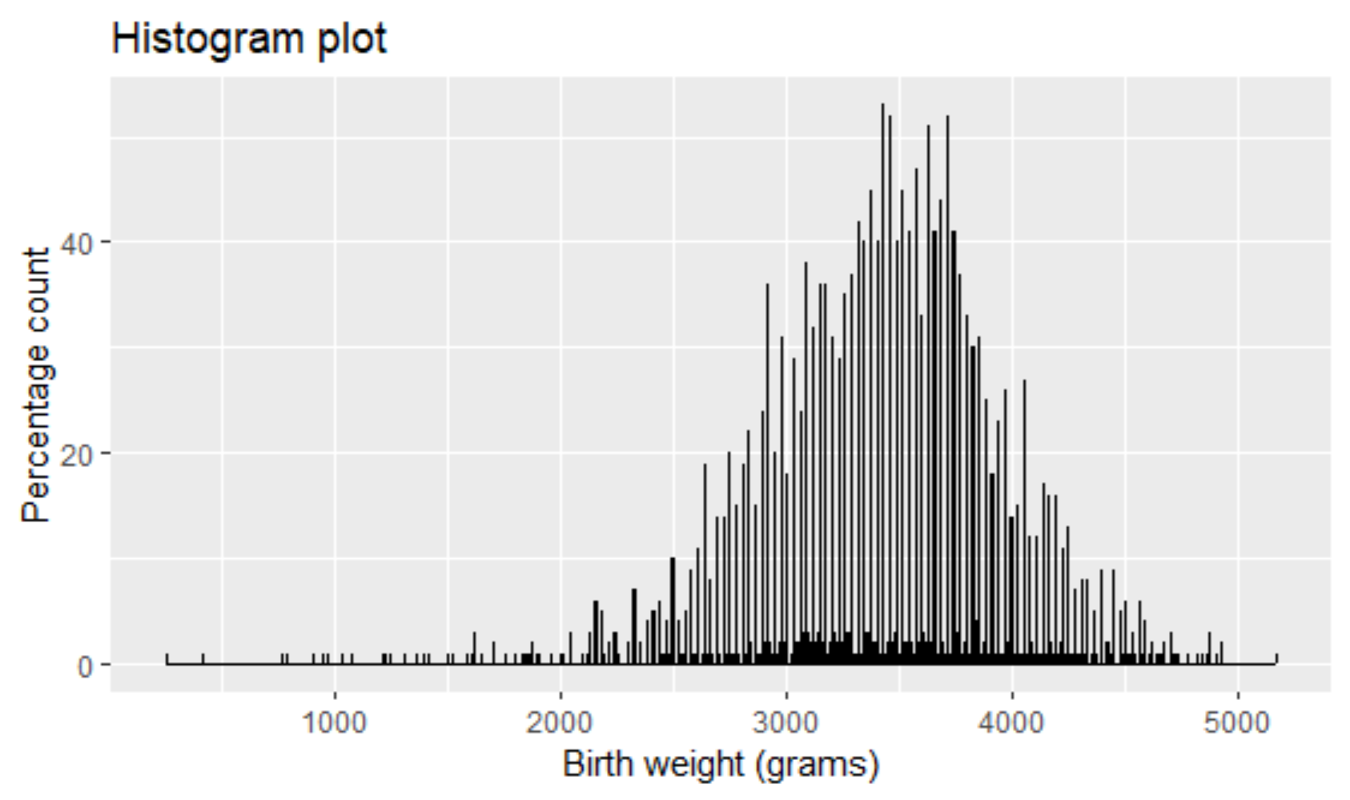

Figure 1. Histogram plot to assess for skewness

Table 2: Effect on birth weight

| **Married** | | | |
| --- | --- | --- | --- |
| **Birth weight (gm)** | **No (N=544)** | **Yes (N=1956)** | **Total (N=2500)** |
|  |  |  |  |
| Mean (SD) | 3300 (641) | 3450 (530) | 3410 (559) |
| Median [Min, Max] | 3370 [255, 4880] | 3460 [414, 5180] | 3440 [255, 5180] |
| **Welfare Participation** | | | |
|  | No (N=2458) | Yes (N=42) | Total (N=2500) |
|  |  |  |  |
| Mean (SD) | 3420 (556) | 3140 (661) | 3410 (559) |
| Median [Min, Max] | 3450 [255, 5180] | 3280 [1240, 4550] | 3440 [255, 5180] |
| **Smoked** | | | |
|  | No (N=2325) | Yes (N=175) | Total (N=2500) |
|  |  |  |  |
| Mean (SD) | 3430 (554) | 3190 (583) | 3410 (559) |
| Median [Min, Max] | 3460 [255, 5180] | 3280 [414, 4510] | 3440 [255, 5180] |

Figure 2B: Birth weight across First Step groups stratified by welfare. *Note: No – not on welfare, Yes: On welfare*

Figure 2A: Birth weight across First Step groups stratified by smoking habit

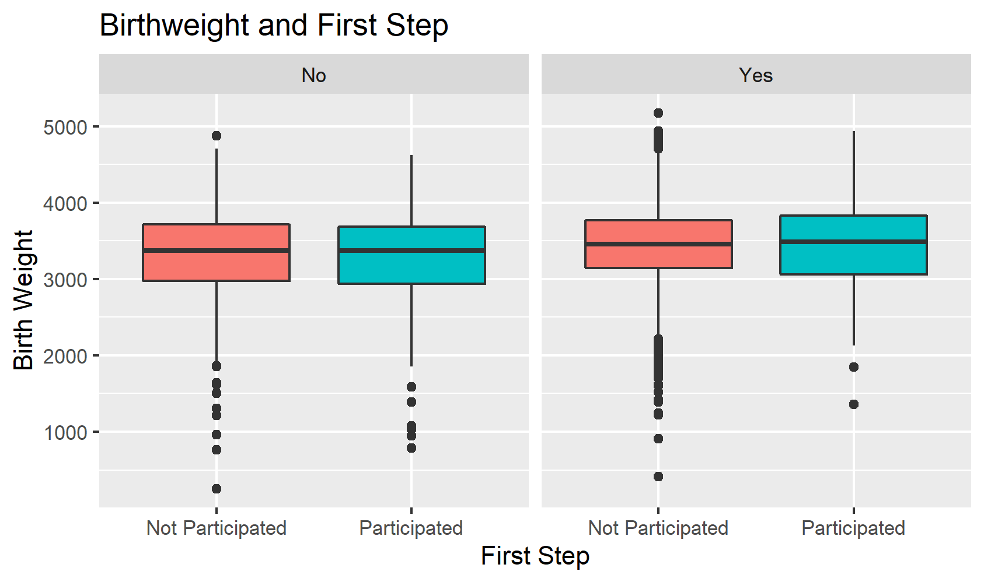

Figure 2C: Birth weight across First Step groups stratified by marital status. *Note: No – not married, Yes: married*

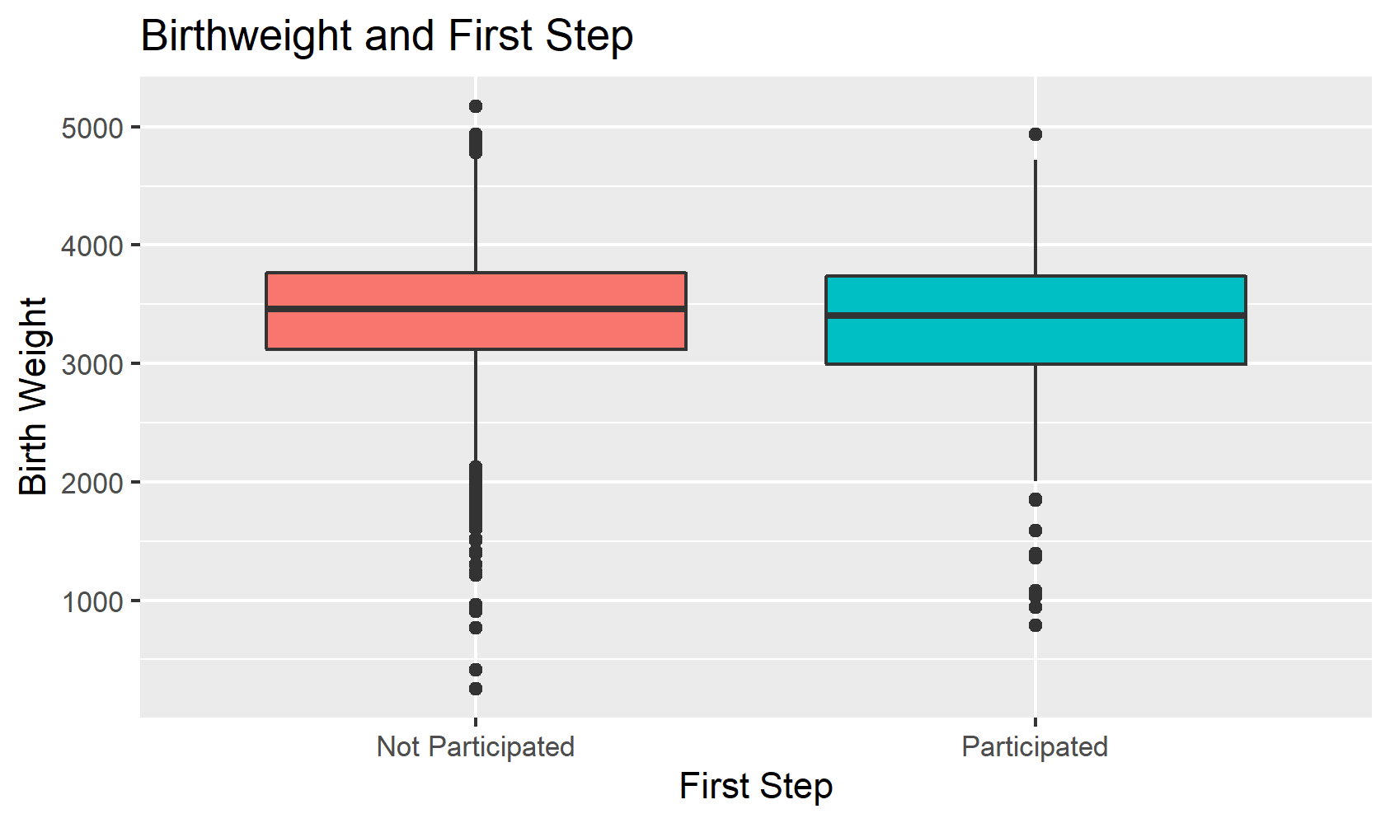

Figure 2D: Comparing overall birth weight across First Step groups

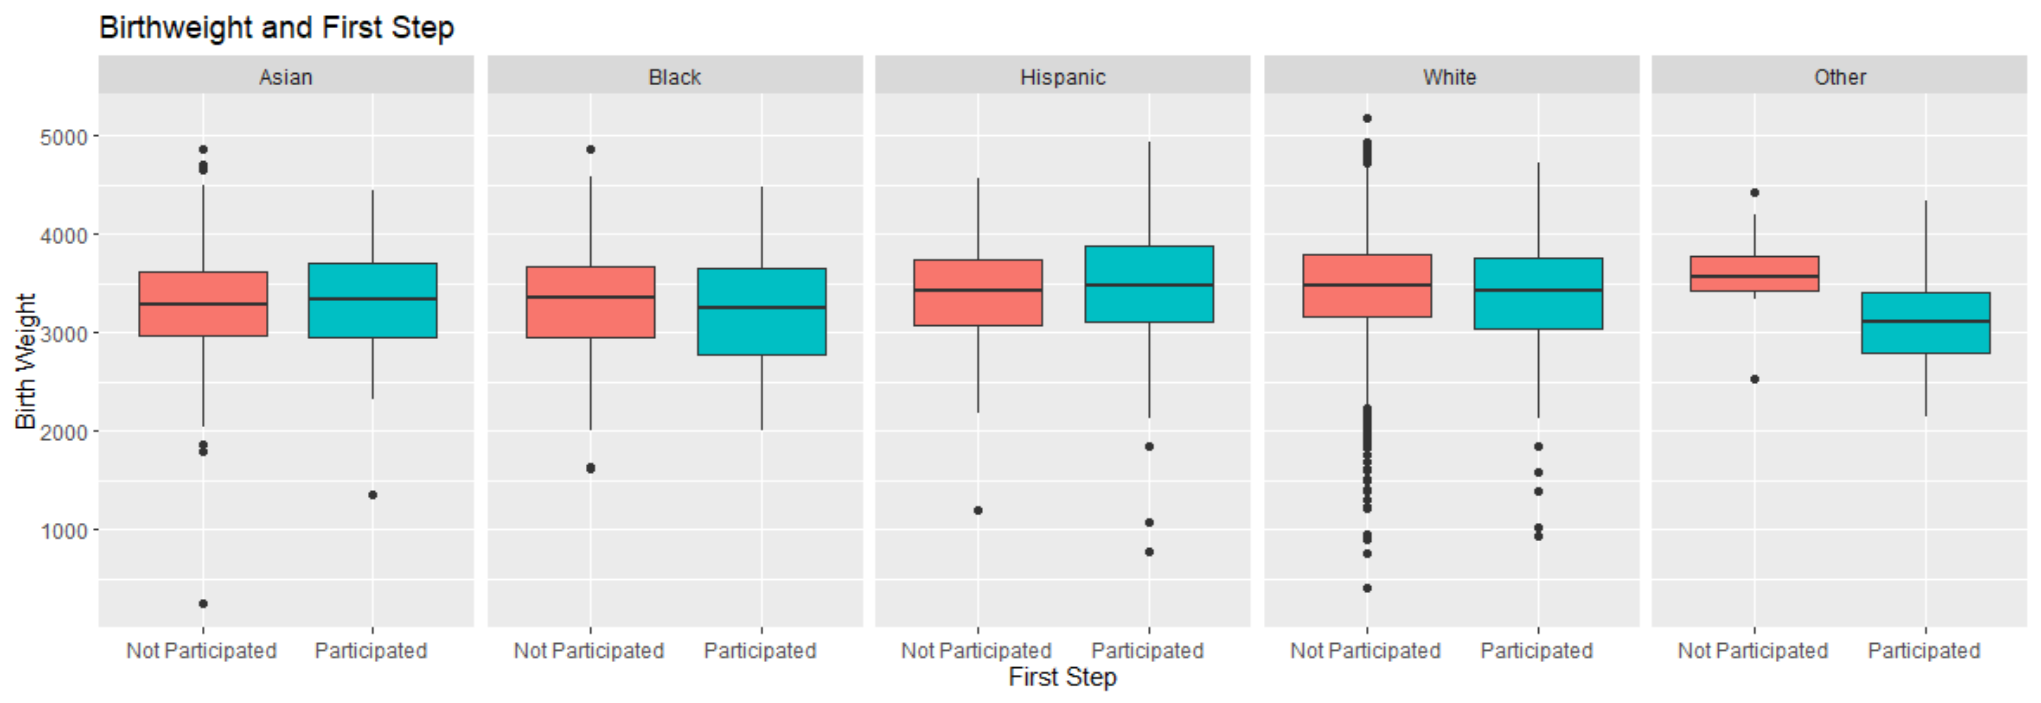

Figure 3: Mean birthweight across First Step groups stratified by Race.

Table 3. First Step groups for different groups of birthweights

|  | **Not Participated (N=2097)** | **Participated (N=403)** | **Total (N=2500)** | **P-value** |
| --- | --- | --- | --- | --- |
| **Birth Weight** |  |  |  |  |
| Very low | 11 (0.5%) | 6 (1.5%) | 17 (0.7%) | 0.08296* |
| low | 91 (4.3%) | 19 (4.7%) | 110 (4.4%) |  |
| Normal | 1995 (95.1%) | 378 (93.8%) | 2373 (94.9%) |  |

Note: * Pearson's Chi-squared test

**References**

1. CDC website <https://www.cdc.gov/nchs/pressroom/sosmap/lbw_births/lbw.htm>, accessed on November 18, 2022
2. K C A, Basel PL, Singh S. Low birth weight and its associated risk factors: Health facility-based case-control study. PLoS One. 2020 Jun 22;15(6):e0234907. doi: 10.1371/journal.pone.0234907. PMID: 32569281; PMCID: PMC7307746.
3. Mathewson KJ, Chow CH, Dobson KG, Pope EI, Schmidt LA, Van Lieshout RJ. Mental health of extremely low birth weight survivors: A systematic review and meta-analysis. Psychological bulletin. 2017;143(4):347–83. 10.1037/bul0000091
4. Al Hazzani F, Al-Alaiyan S, Hassanein J, Khadawardi E. Short-term outcome of very low-birth-weight infants in a tertiary care hospital in Saudi Arabia. Annals of Saudi Medicine. 2011;31(6):581–5. 10.4103/0256-4947.87093
5. Chang H-Y, Sung Y-H, Wang S-M, Lung H-L, Chang J-H, Hsu C-H, et al. Short- and Long-Term Outcomes in Very Low Birth Weight Infants with Admission Hypothermia. PloS one. 2015;10(7):e0131976 10.1371/journal.pone.0131976
6. Fitzgibbons SC, Ching Y, Yu D, Carpenter J, Kenny M, Weldon C, et al. Mortality of necrotizing enterocolitis expressed by birth weight categories. Journal of Pediatric Surgery.44(6):1072–6. 10.1016/j.jpedsurg.2009.02.013
7. Fan RG, Portuguez MW, Nunes ML. Cognition, behavior and social competence of preterm low birth weight children at school age. Clinics. 2013;68(7):915–21. 10.6061/clinics/2013(07)05
8. Javier Valero de Bernabé, Trinidad Soriano, Romana Albaladejo, Margarita Juarranz, Marı́a Elisa Calle, David Martı́nez, Vicente Domı́nguez-Rojas,
9. Risk factors for low birth weight: a review, European Journal of Obstetrics & Gynecology and Reproductive Biology, ISSN 0301-2115, <https://doi.org/10.1016/j.ejogrb.2004.03.007>.
10. McCall EM, Alderdice F, Halliday HL, Vohra S, Johnston L. Interventions to prevent hypothermia at birth in preterm and/or low birth weight infants. Cochrane Database Syst Rev. 2018 Feb 12;2(2):CD004210. doi: 10.1002/14651858.CD004210.pub5. PMID: 29431872; PMCID: PMC6491068.
11. Public Health – Seattle and King County, <https://kingcounty.gov/depts/health/locations/wic-first-steps.aspx> accessed on November 18/2022
12. Seattle API - <https://www.seattlepi.com/seattlenews/article/Seattle-household-family-size-15117398.php#:~:text=The%20Seattle%20metro%20area%20ranked,children%20in%20households%20with%20kids>. Accessed 11/22/2022
13. Lam E, Giovino GA, Shin M, Lee KA, Rolle I, Asma S. Relationship between frequency and intensity of cigarette smoking and TTFC/C among students of the GYTS in select countries, 2007-2009. J Sch Health. 2014 Sep;84(9):549-58. doi: 10.1111/josh.12185. PMID: 25117888; PMCID: PMC4536900.