***Mobile application Homepage:***

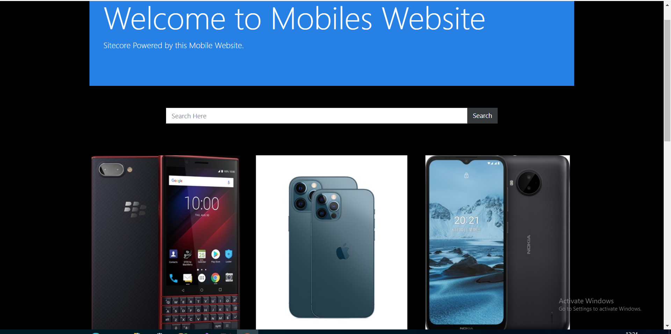

***After searching result will be displayed as shown in the below:***

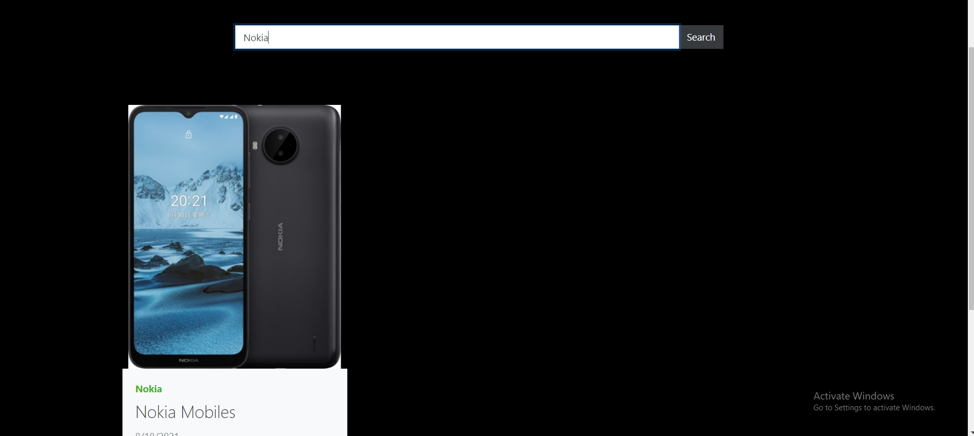

***When I click on ReadOn button it will go to the DetailPage as shown in the below:***

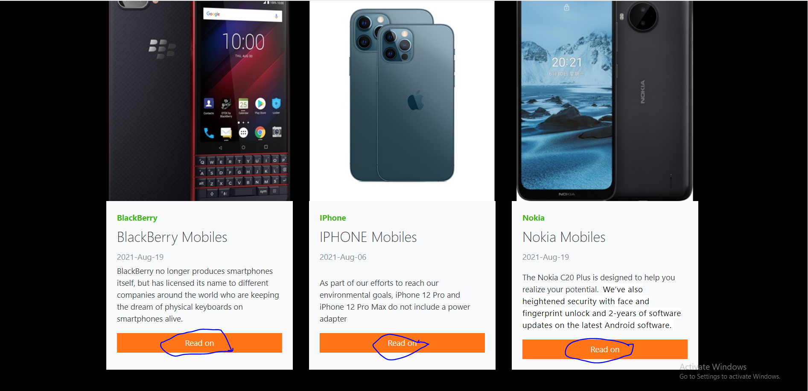

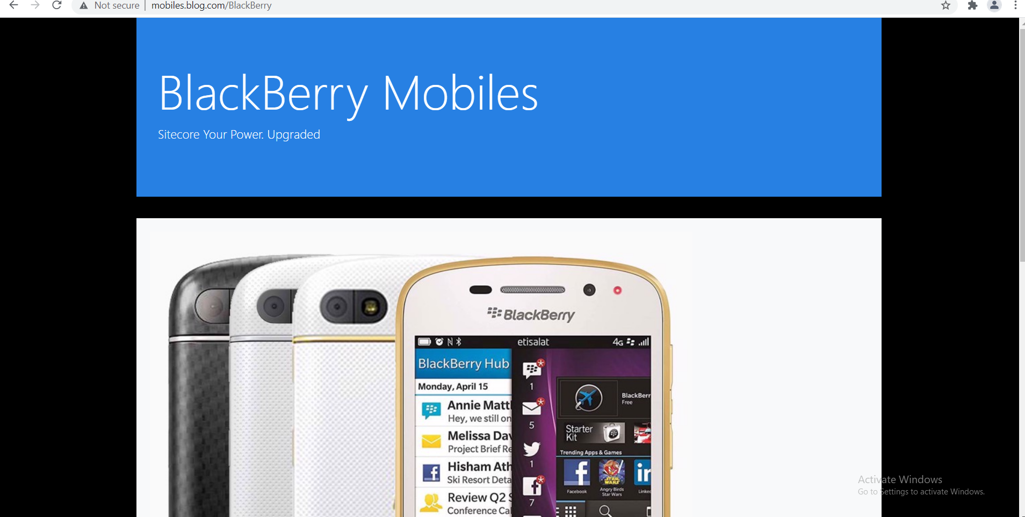

***In the DetailPage When We Click on tags It will go to another Website In my case it will go to Flipcart.***

