MW Campaign Assessment Project

# Flow Diagram:

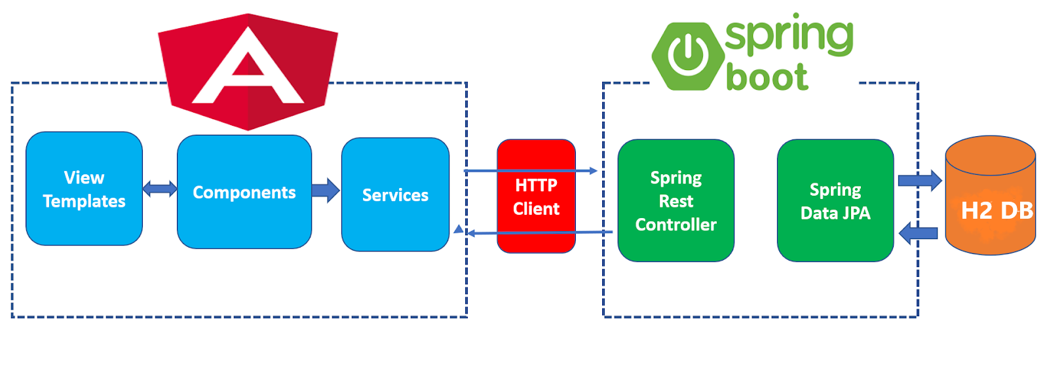

# Java Web Token :

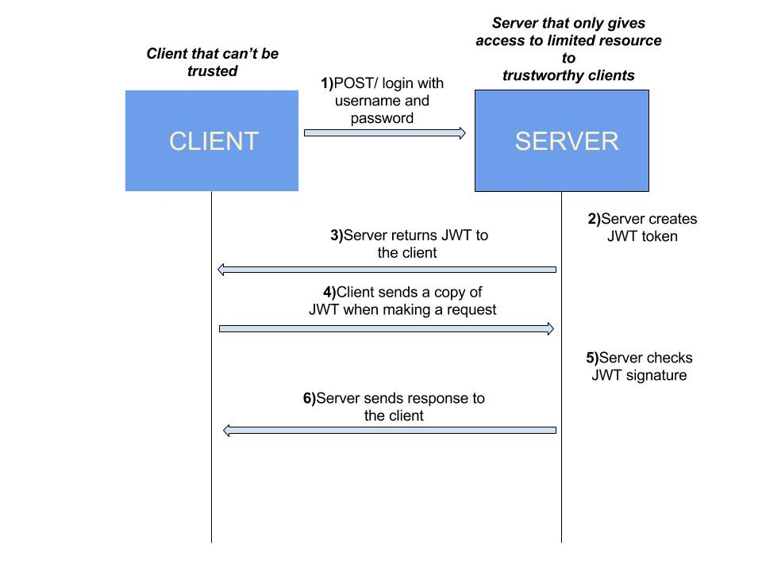

# MWCampaign Application Flow with JWT:

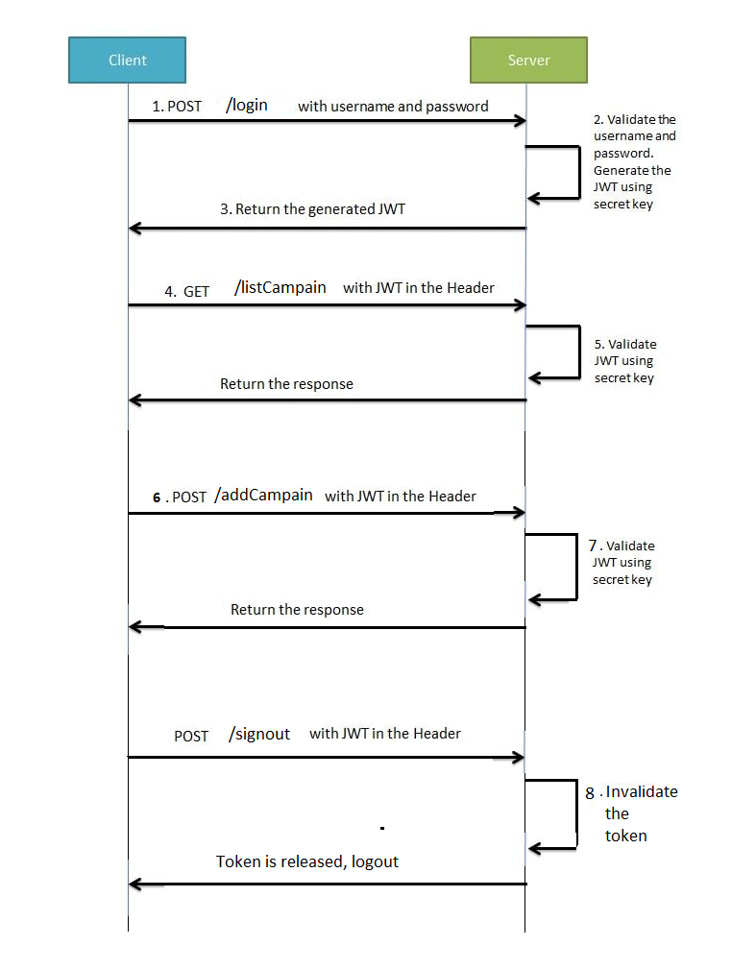

# Technology Stack :

MWCampaign is a web application, which enables registered users to login and access the spring secured (with Java Web Token) application at the backend. We could see list of added Campaigns also we can add new Campaigns to the list by passing attributes such as name, duration and status.

## Version control:

* **Github:**<https://github.com/LathaSriram/MWCampaign>

GitHub is a web-based hosting service for software development projects that use the Git revision control system. We decided for it mainly because of git. It is really good tool for source control and also team work. We have really good experience with it and we recommended it!

Client-Side Programming

* Angular 8 is an open-source, client-side TypeScript based JavaScript framework. It is written in TypeScript and complied into JavaScript. Angular 8 is used to create dynamic web applications.

Server-Side Programming

* Spring Boot v2.4.0

Spring Boot is an open source Java-based framework used to create a Micro Service. It is developed by Pivotal Team. It is easy to create a stand-alone and production ready spring applications using Spring Boot.

Authentication

* JWT is a token based stateless authentication mechanism. Since it is a client-side based stateless session, server doesn’t have to completely rely on a datastore(database) to save session information.

Database

* **H2 Database (**SQL) provides a fast in-memory database that supports JDBC API and R2DBC access, with a small (2mb) footprint. Supports embedded and server modes as well as a browser based console application.

Documentation

* Swagger UI to generate interactive API documentation that lets your users try out the API calls directly in the browser
* Swagger reference: <https://app.swaggerhub.com/apis/LathaSriram/mwdecisions/1.0.0#/>

Deployment

* Amazon Elastic Compute Cloud (Amazon EC2) is a web service that provides secure, resizable compute capacity in the cloud. It is designed to make web-scale cloud computing easier for developers. Amazon EC2's simple web service interface allows you to obtain and configure capacity with minimal friction.

IP: ec2-3-135-228-77.us-east-2.compute.amazonaws.com