Lokh Sabha Election Analysis
Contents
1. Total Seats Available 2
2. Total Number of Seats available for each state 2
3. Total Seats Won By NDA Alliance 3
4. Seats Won by NDA Alliance 3
5. Total Seats Won by I.N.D.I.A Alliance 4
6. Seats Won by INDIA Alliance Parties 4
7. Adding new column in partywise_results to get the Party Alliance 5
8. Which party alliance NDA, I.N.D.I.A or Other won the most seats across all states 6
9. Winning candidates name, their party name, total votes and the margin of victory for a specific state and consistency 7
10. Which parties won the most seats in s State, and how many seats did each party win? 7
11. What is the total number of seats won by each party alliance (NDA, I.N.D.I.A, and OTHER) in each state for the India Elections 2024 8
12. Which candidate won and which candidate was the runner-up in each constituency of State for the 2024 elections? 9

Total Seats Available
Output:
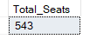

Total Number of Seats available for each state
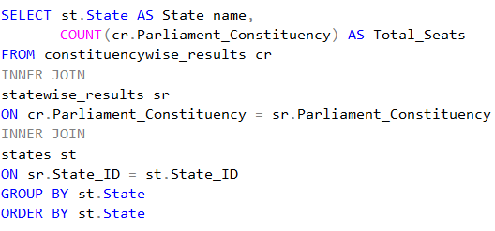
Output:
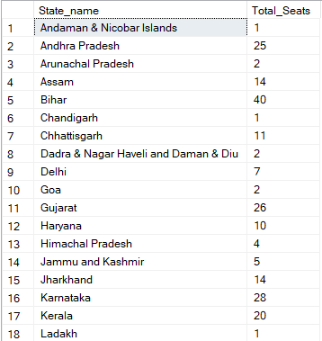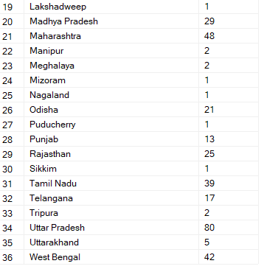

Total Seats Won By NDA Alliance
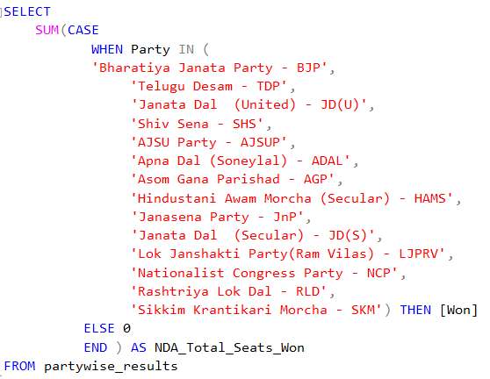
Output:
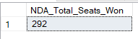

Seats Won by NDA Alliance
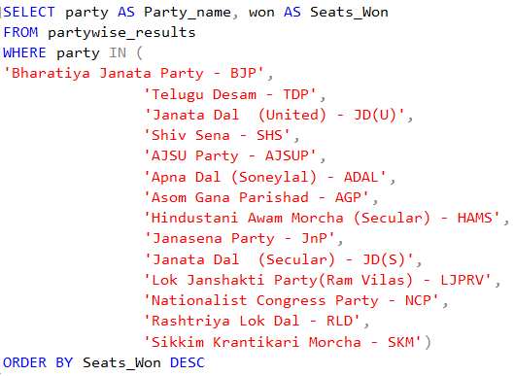
Output:
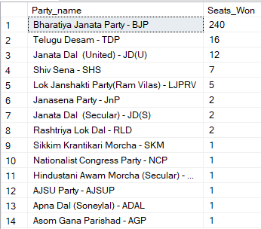

Total Seats Won by I.N.D.I.A Alliance
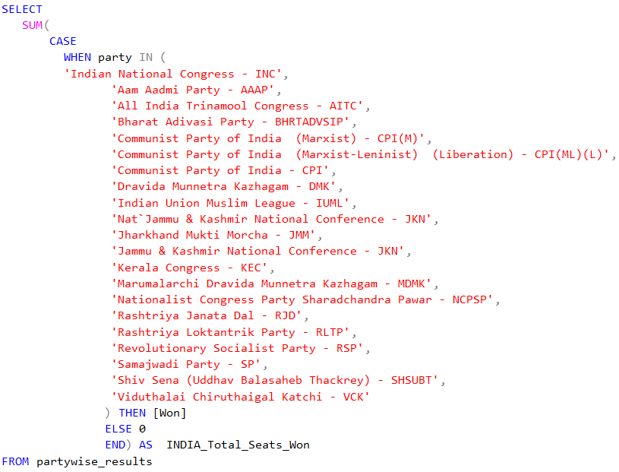
Output:
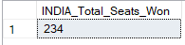

Seats Won by INDIA Alliance Parties
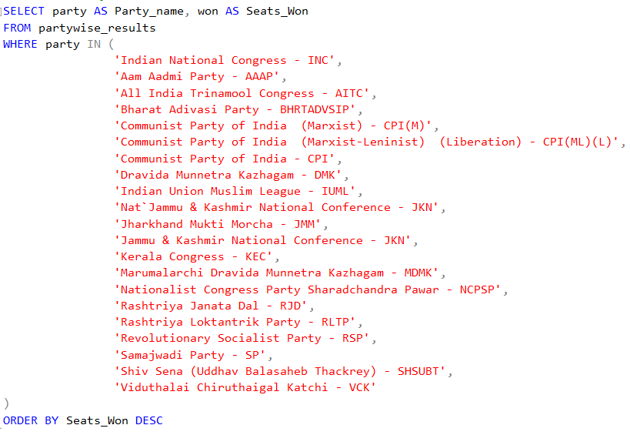

Output:
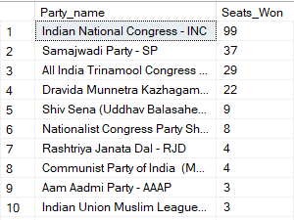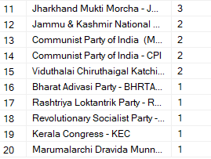

Adding new column in partywise_results to get the Party Alliance
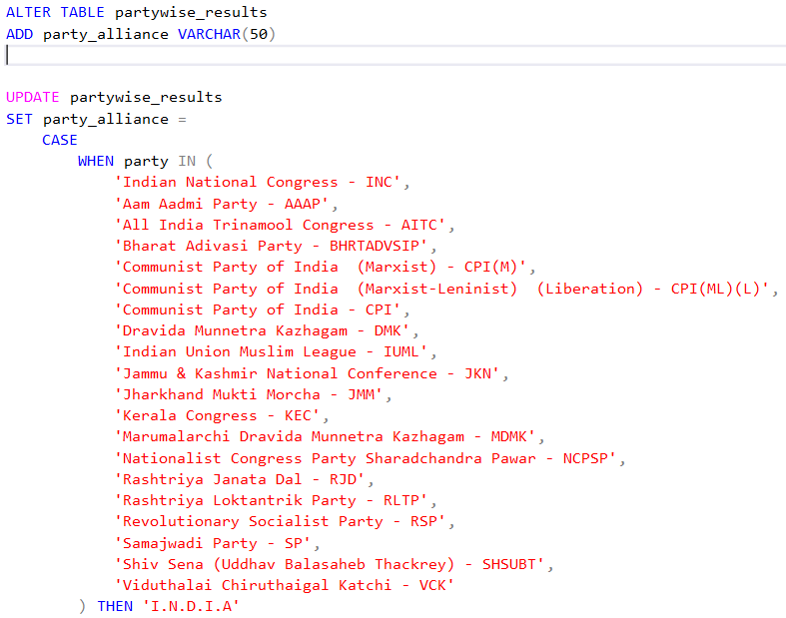
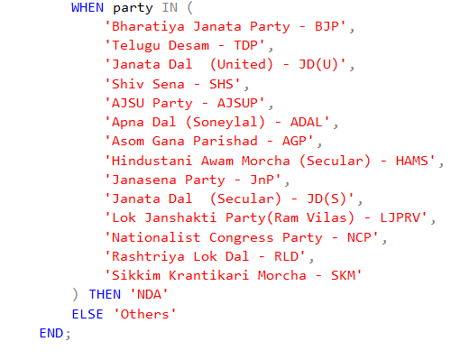

Output:
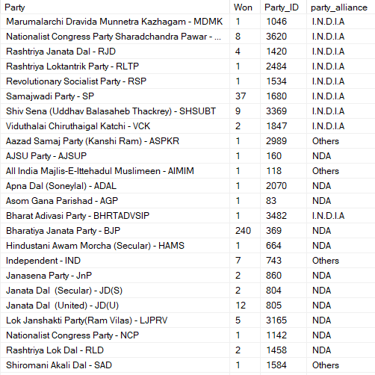

Which party alliance NDA, I.N.D.I.A or Other won the most seats across all states
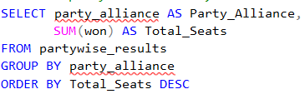
Output:
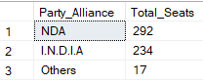

Winning candidates name, their party name, total votes and the margin of victory for a specific state and consistency
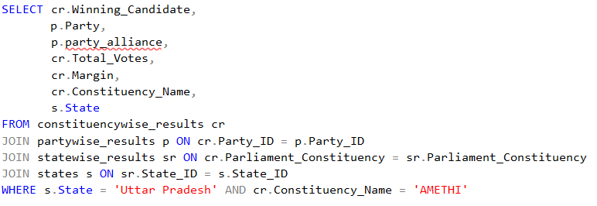
Output:

Which parties won the most seats in s State, and how many seats did each party win?
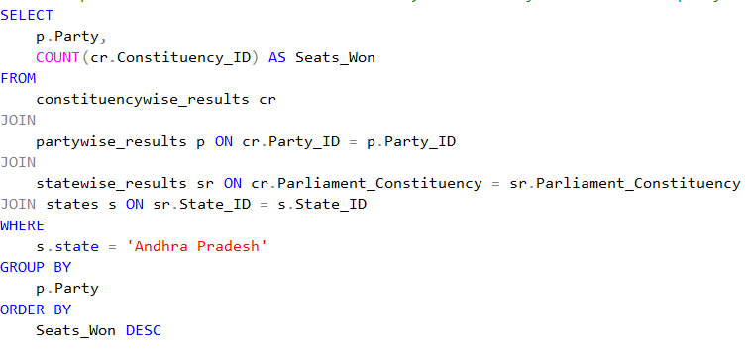
Output:
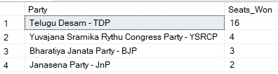

What is the total number of seats won by each party alliance (NDA, I.N.D.I.A, and OTHER) in each state for the India Elections 2024
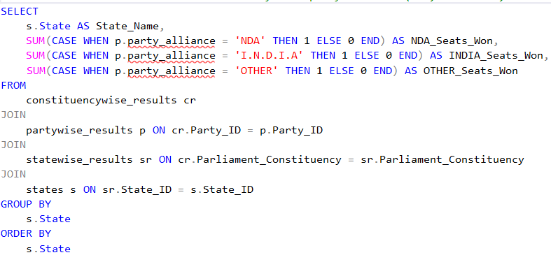
Output:
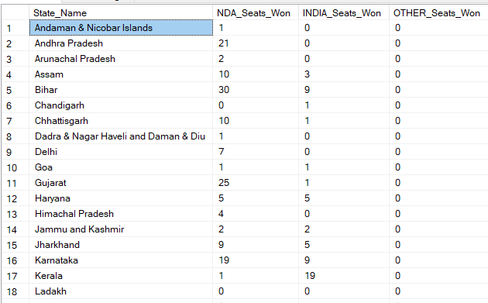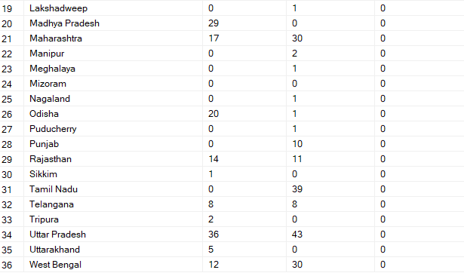

Which candidate won and which candidate was the runner-up in each constituency of State for the 2024 elections?
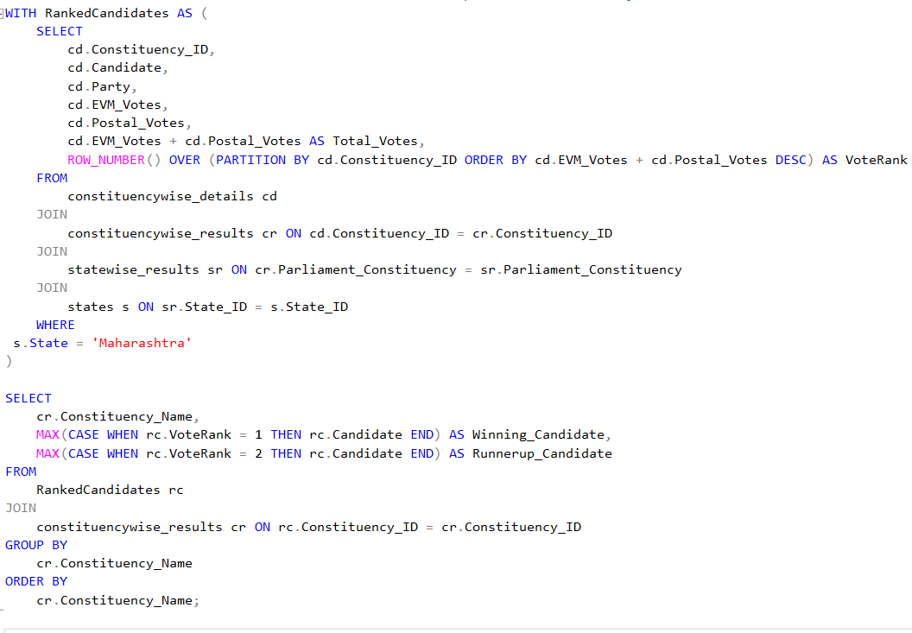
Output:
