
Programming of Data Science
(BCSE207L)

Project Title
Automated Epileptic Seizure Detection from EEG Signals

Submitted by
Pasumarthi Abhigna — 24BDS1016

Faculty In-Charge
Prof. Vijayalaksmi A

Slot – G2
2026–27 Fall Semester

Digital Assignment 1 (DA1)
Project Proposal & Data Preparation
Automated Epileptic Seizure Detection from EEG Signals

1. Problem Statement and Objectives
Continuous EEG monitoring for epilepsy diagnosis generates large volumes of time-series data that require manual review by clinicians, making seizure detection slow, inconsistent across reviewers, and impractical for real-time or outpatient monitoring. This project aims to build a machine learning system that automatically classifies EEG segments as seizure or non-seizure activity, using both engineered signal features and raw-sequence deep learning approaches, to support faster and more consistent seizure detection.
Objectives:
- Preprocess raw EEG time-series data into meaningful time-domain and frequency-domain features.
- Compare classical machine learning models (feature-based) against deep learning models (raw-sequence-based) for seizure classification.
- Evaluate models using clinically relevant metrics, prioritizing recall/sensitivity since missing a true seizure is more costly than a false alarm.
- Interpret which signal characteristics (frequency bands, amplitude patterns) most strongly drive seizure predictions, using feature importance / SHAP analysis.

2. Dataset Identification and Justification
The UCI Epileptic Seizure Recognition dataset (Andrzejak et al., 2001) is used for this project. It contains 11,500 samples of 1-second EEG recordings, each represented by 178 raw signal amplitude values sampled across that window, across 5 original classes: seizure activity, tumor-region EEG, healthy-region EEG (same patient, opposite side from the tumor), eyes-closed baseline, and eyes-open baseline. These can be collapsed into a binary seizure / non-seizure task or retained as a multi-class problem.
This dataset was chosen over more common tabular clinical datasets (e.g. heart disease, diabetes) because it is raw physiological time-series signal rather than pre-summarized tabular features. This requires genuine signal-processing-based feature engineering rather than direct model application, which more meaningfully demonstrates the preprocessing and feature engineering skills this course evaluates. The dataset is publicly available with no credentialing barrier, is well documented, and has an established base of academic literature using this exact benchmark for direct comparability of results.

3. Literature Review
Five recent papers were reviewed to position this project within the current state of EEG-based seizure detection research, spanning the original dataset paper, two recent deep-learning benchmarks on this same data, and two review papers that keep the clinical deployment context in view.
Andrzejak et al. (2001) is the original paper behind this dataset. The authors introduced nonlinear, chaos-theory-based measures (such as correlation dimension and largest Lyapunov exponent) to distinguish EEG recorded from different brain states and regions, and their five recording conditions — seizure activity, tumor-adjacent tissue, the healthy hemisphere opposite a tumor, and eyes-closed/eyes-open resting states — are exactly the five classes retained in the UCI mirror of this data. This paper matters here because it is the reason the “non-seizure” classes are not a single uniform category, which this project accounts for by allowing both a binary and a multi-class framing.
Kashefi Amiri, Zarei, and Daliri (2025) proposed a 1D CNN-LSTM model that first decomposes the raw EEG signal using Discrete Wavelet Transform (DWT) into frequency sub-bands, then passes the concatenated coefficients through a 1D convolutional layer for spatial feature extraction and an LSTM layer for temporal modelling. Evaluated across three benchmarks, the model reached 97.24% accuracy on the same Bonn dataset used in this project, alongside 94.32% on TUSZ and 96.94% on CHB-MIT. This paper is directly useful as a performance ceiling to compare against once the raw-signal deep learning models are built in DA2, and its DWT-based preprocessing is a candidate addition to this project’s feature engineering pipeline.
Cao, Zheng, Zhang, Chen, and Du (2025) took a related but distinct approach: a five-level DWT decomposition followed by Support Vector Machine–Recursive Feature Elimination (SVM-RFE) to select the most informative time-frequency and nonlinear features, which are then fused and classified using a hybrid CNN-BiLSTM network. This is the closest match to the “engineered features + classical/hybrid model” half of this project’s planned comparison, and their use of a feature-selection step is a useful precedent for handling the fairly large engineered feature set (21–23 features) produced in this project’s own preprocessing stage.
Moutonnet et al. (2024) reviewed the field from a different angle: rather than proposing a new model, their systematic review notes that published seizure-detection algorithms have reported accuracies as high as 100% on benchmark datasets, yet very few of these have been shown to translate to real clinical use. The review evaluates published work against criteria such as generalisability across patients and EEG hardware, computational run-time, and explainability, and finds that most benchmark-driven papers stop short of addressing them. This is a useful check on this project’s own ambitions: it is one reason this project prioritizes recall/sensitivity over raw accuracy and plans to keep the model’s limitations explicit in DA3, rather than presenting benchmark accuracy alone as the final result.
Aziz et al. (2025) conducted a scoping review of 67 studies on wearable, AI-driven epilepsy monitoring devices, finding that research in this space has grown quickly since 2021 and that most existing systems are built for detecting seizures after they start rather than predicting them in advance. The review also flags a lack of standardized validation methodology and a need for more energy-efficient on-device algorithms before wearable seizure detection can be deployed at scale. This paper grounds the “why automated detection matters in outpatient settings” argument made in Section 7 of this report in actual review evidence, rather than treating it as a self-evident claim.
Read together, these five papers trace a path from the original signal-analysis foundations of this exact dataset (Andrzejak et al.), through two recent deep-learning and feature-fusion approaches benchmarked on comparable data (Kashefi Amiri et al.; Cao et al.), to two reviews that keep this project honest about the gap between benchmark performance and real clinical or wearable deployment (Moutonnet et al.; Aziz et al.). This is the structure this project follows: build and compare feature-engineered and raw-sequence models against these published benchmarks, but evaluate and report them with the clinical-translation gap explicitly in mind.

4. Dataset Understanding and Feature Description
Each sample consists of 178 raw EEG amplitude values (the recorded signal at 178 time points within a 1-second window) plus one class label. The data is numeric and largely clean, though raw EEG can contain artifacts from muscle movement or electrode contact noise, which is checked during preprocessing. No demographic or missing-value fields are present, since this is raw sensor signal rather than tabular patient records.
Beyond the raw signal columns (X1–X178), the dataset provides a single multi-class label (1–5) that this project also collapses into a binary seizure / non-seizure target for the primary classification task, while retaining the 5-class version for a secondary, more fine-grained comparison. A Python feature extraction script auto-detects the raw signal columns versus any ID column present, so the same pipeline works regardless of which public mirror of the dataset is used. From the 178-point raw signal, 21–23 features are engineered per sample, split into time-domain descriptors (mean, standard deviation, variance, skewness, kurtosis, peak-to-peak amplitude, zero-crossing rate, RMS, and mean absolute difference) and frequency-domain descriptors obtained via FFT (absolute and relative power in the delta, theta, alpha, beta, and gamma bands, dominant frequency, and spectral entropy). Confirmed on the real 11,500-sample dataset, each class contains exactly 2,300 samples, which rules out class imbalance as a confound in this dataset.

5. Data Preprocessing Plan
- Inspect and handle signal artifacts / outlier amplitude spikes.
- Normalize/scale raw signal values prior to feature extraction.
- Engineer time-domain features: mean, variance, skewness, kurtosis, zero-crossing rate, peak-to-peak amplitude.
- Engineer frequency-domain features via FFT: power within delta (0.5–4 Hz), theta (4–8 Hz), alpha (8–13 Hz), beta (13–30 Hz), and gamma (30+ Hz) bands.
- Optionally extract discrete wavelet transform (DWT) coefficients for multi-resolution time-frequency features, following the approach used by Kashefi Amiri et al. (2025) and Cao et al. (2025).
- Encode target labels (binary seizure / non-seizure, or retain multi-class).

6. Exploratory Data Analysis
Five visualizations were produced in R to understand the dataset before modelling begins. Each is discussed below with what it actually showed on the real 11,500-sample dataset.
6.1 Class Distribution
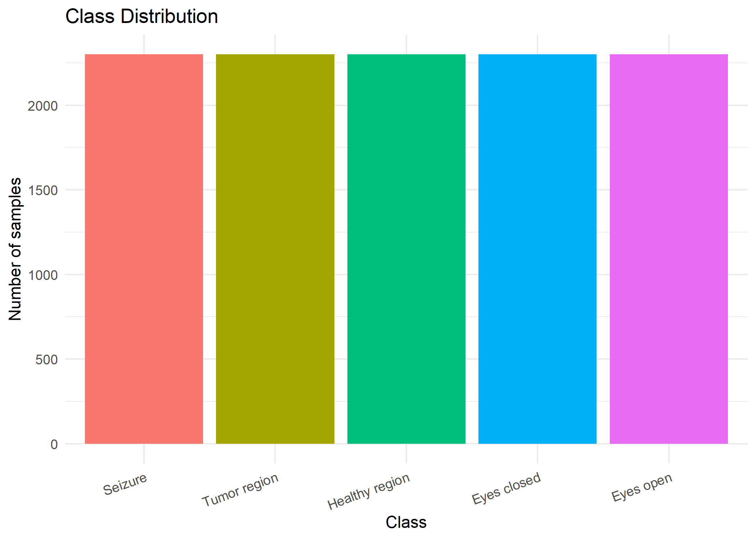
Figure 1. Class distribution across the 5 original labels.
Every class contains exactly 2,300 samples. This confirms the dataset is perfectly balanced and that class imbalance is not something this project needs to correct for at the preprocessing stage — stratified train/test splitting will be sufficient.
6.2 Raw Waveform Comparison
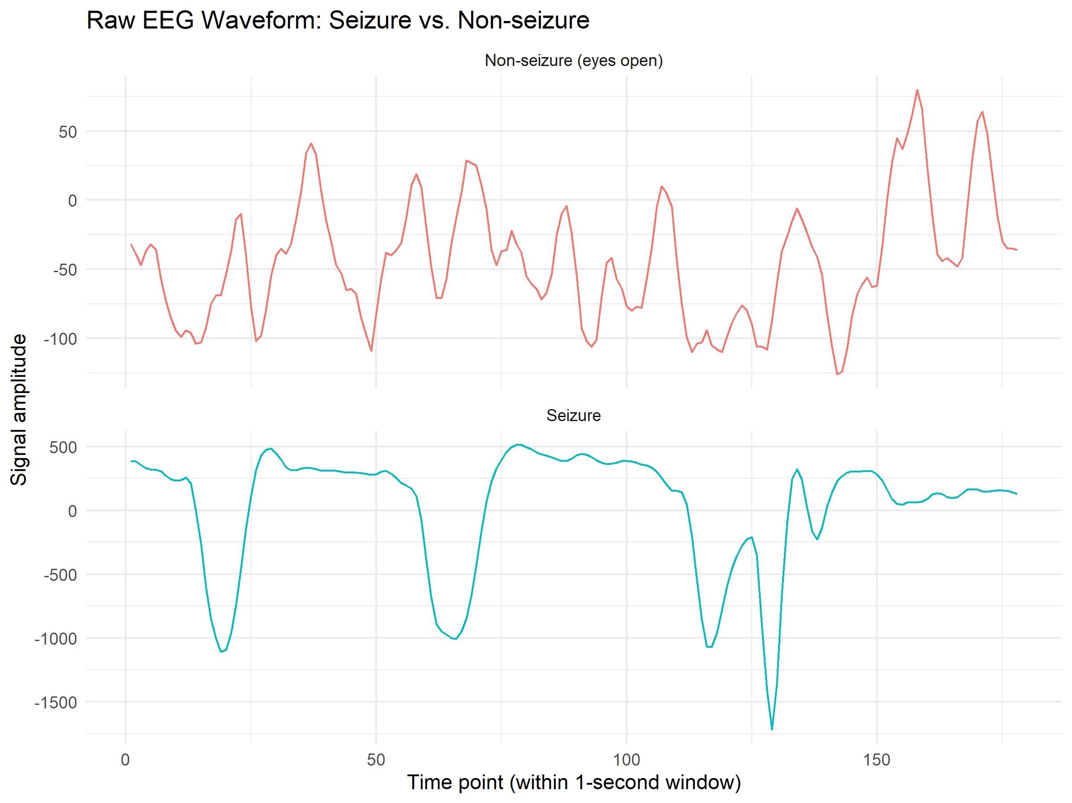
Figure 2. Raw EEG waveform: a non-seizure (eyes-open) sample vs. a seizure sample.
The seizure waveform swings roughly between –1500 and +500 in amplitude, compared to roughly –140 to +80 for the non-seizure sample shown — an amplitude range 10–15 times larger. This single plot is arguably the most visually obvious justification for why raw amplitude-based features (variance, peak-to-peak, RMS) turn out to be strong seizure predictors.
6.3 Engineered Feature Distributions by Class
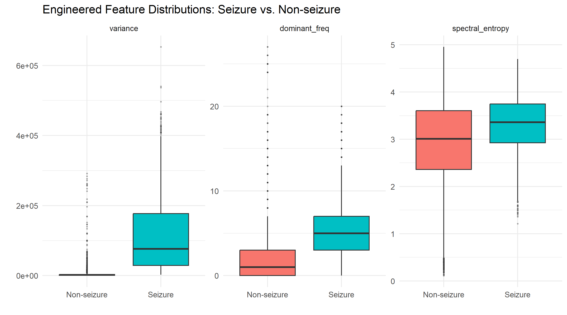
Figure 3. Boxplots of variance, dominant frequency, and spectral entropy, seizure vs. non-seizure.
Variance cleanly separates the two groups, with the seizure class showing a far higher median and wider spread. Dominant frequency is also clearly higher for seizure samples. The spectral entropy panel is the most interesting result: entropy is higher, not lower, for seizure samples. Going in, the expectation was that a seizure would concentrate energy narrowly in one frequency band and so should show lower entropy. The FFT spectrum in Figure 5 explains why this expectation was wrong: seizure activity is both elevated and spread across a broad 0–20 Hz range, whereas non-seizure classes have power concentrated almost entirely in a single low-frequency bin. A signal with power spread across many bands has higher entropy even when its total energy is much larger — concentrated total energy is not the same as concentrated relative energy. This distinction is being written up as a deliberate finding rather than an assumed result.
6.4 Correlation Between Engineered Features
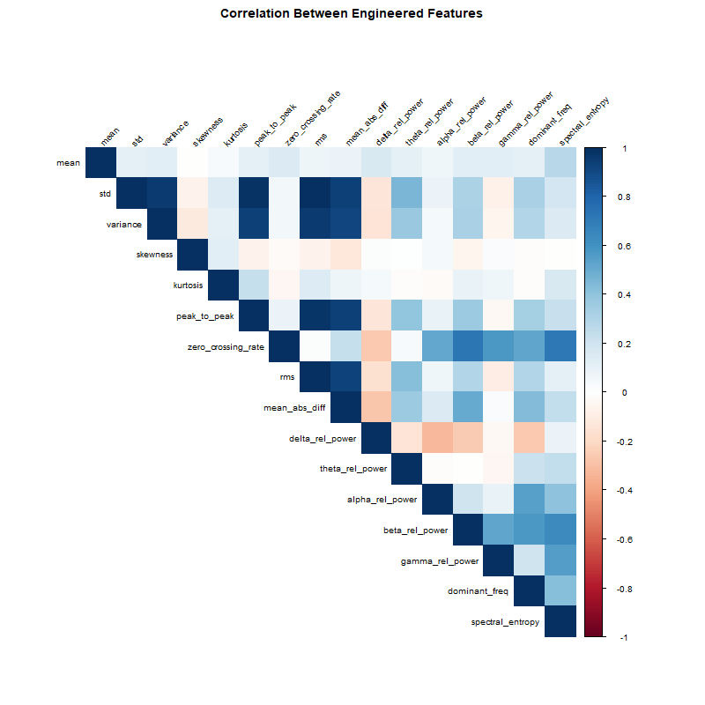
Figure 4. Correlation heatmap across the 16 engineered features.
Amplitude/magnitude-related features — standard deviation, variance, peak-to-peak, RMS, and mean absolute difference — form a tightly correlated cluster, as expected since they are all different summaries of the same signal magnitude. The frequency-band relative power features (particularly beta, gamma, and dominant frequency) form a separate, moderately correlated cluster. Notably, delta relative power correlates negatively with beta, gamma, and dominant frequency, which makes physical sense: relative power is a fixed budget across bands, so a signal dominated by low-frequency (delta) energy has proportionally less room left for higher-frequency energy. This redundancy within each cluster is worth keeping in mind for feature selection in DA2, since including every magnitude-based feature may add limited additional information over just one or two of them.
6.5 FFT Power Spectrum by Class
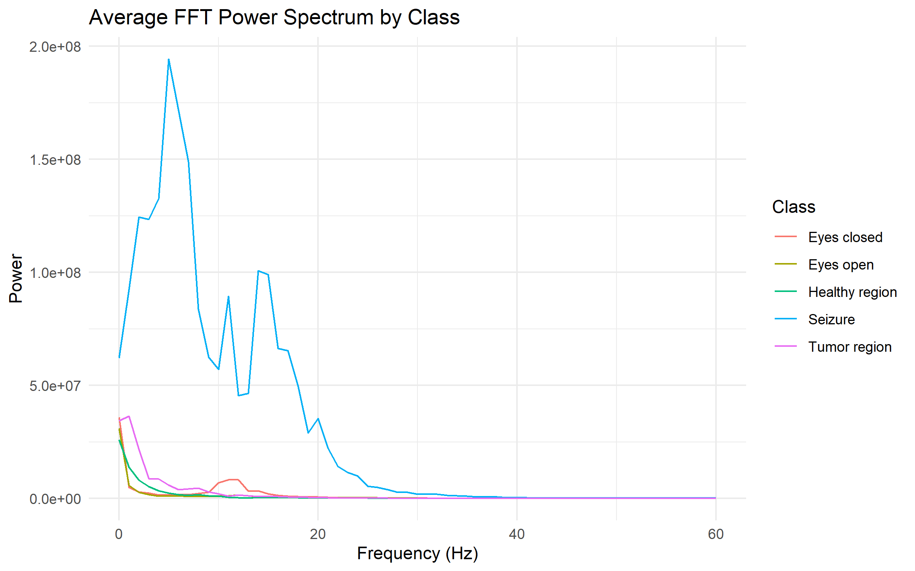
Figure 5. Average FFT power spectrum (0–60 Hz) for each of the 5 classes.
This is the clearest single piece of evidence in the whole EDA: seizure-class power sits dramatically above all four other classes across nearly the entire 0–20 Hz range, peaking sharply around 5–6 Hz with a secondary rise near 13–15 Hz. All four non-seizure classes, by contrast, show a sharp spike concentrated only in the very lowest frequency bin before decaying to near zero. One small but genuine detail worth noting: the eyes-closed class shows a small secondary bump around 10–12 Hz that the other non-seizure classes do not, which lines up with the well-documented posterior alpha rhythm that appears specifically when eyes are closed — a small but reassuring sign that the FFT features are picking up real, physiologically meaningful signal rather than noise.

7. Clinical Significance
Although abnormal EEG activity is visible on a monitor in real time, this does not make automated detection redundant. Continuous EEG monitoring can span many hours, and seizures are often brief, making manual review by a clinician impractical at scale. Interpretation of subtle seizure patterns also shows real variability between human readers. Automated detection enables consistent, real-time alerting rather than after-the-fact review, which is critical for prolonged seizure events, and is the only practical option for continuous outpatient or wearable EEG monitoring, where no clinician is watching the signal live — a gap that Aziz et al. (2025) document is already the fastest-growing area of epilepsy AI research, even as most current systems remain limited to after-the-fact detection rather than prediction. The goal of this system is triage, not replacement of clinical judgment: flagging the small fraction of a large recording that warrants a clinician’s attention, while keeping in mind, per Moutonnet et al. (2024), that a high benchmark accuracy is not the same as a clinically deployable system.

8. Evaluation Criteria Reference
The table below maps each DA1 rubric item to the section of this report where it is addressed, as a quick reference for evaluation.

Rubric Item | Marks | Covered In
Problem statement and objectives | 1 | Section 1
Dataset identification and justification | 2 | Section 2
Literature review (min. 5 recent papers) | 1 | Section 3
Dataset understanding and feature description | 2 | Section 4
Data preprocessing (missing values, encoding, normalization) | 2 | Section 5
Exploratory Data Analysis (min. 5 visualizations in R) | 1 | Section 6
Documentation and presentation | 1 | Overall report
Total | 10

References
Andrzejak, R. G., Lehnertz, K., Mormann, F., Rieke, C., David, P., & Elger, C. E. (2001). Indications of nonlinear deterministic and finite-dimensional structures in time series of brain electrical activity: Dependence on recording region and brain state. Physical Review E, 64(6), 061907.
Kashefi Amiri, H., Zarei, M., & Daliri, M. R. (2025). Epileptic seizure detection from electroencephalogram signals based on 1D CNN-LSTM deep learning model using discrete wavelet transform. Scientific Reports, 15, 32820.
Cao, X., Zheng, S., Zhang, J., Chen, W., & Du, G. (2025). A hybrid CNN-Bi-LSTM model with feature fusion for accurate epilepsy seizure detection. BMC Medical Informatics and Decision Making, 25(1), Article 6.
Moutonnet, N., White, S., Campbell, B. P., Sanei, S., Tanaka, T., Ji, H., Mandic, D., & Scott, G. (2024). Clinical translation of machine learning algorithms for seizure detection in scalp electroencephalography: A systematic review. arXiv:2404.15332.
Aziz, S., Ali, A. A. M., Aslam, H., Ain, N. U., Tariq, A., Sohail, Z., Murtaza, S., Mahmood, H. I., Wazeer, M. I., Murtaza, F., Abd-alrazaq, A., Alsahli, M., Damseh, R., AlSaad, R., Shahzad, T., Ahmed, A., & Sheikh, J. (2025). Wearable artificial intelligence for epilepsy: A scoping review. Journal of Medical Internet Research, 27, e73593.

