BANK LOAN PORTFOLIO
Risk Assessment Improvement Report
From a Rule-Based “Current = Good Loan” Assumption to a Machine-Learning Risk Model
0.6999  Best model AUC-ROC  (CatBoost, tuned) | +40%  Relative gain vs. the  no-model baseline (AUC 0.50) | 705 / 1,098  “Current” loans reclassified  from Good → High Risk | $11.85M  Previously “good” loan  value now flagged high-risk
Prepared for: Bank Loan Customer Segmentation Project
Repository: latherine/bank-loan-customer-segmentation
Date: August 4, 2026

1. Executive Summary
The original project (this GitHub repository) classified every loan with loan_status = “Current” as a Good Loan alongside Fully Paid loans — a blanket assumption with no evidence behind it, since a “Current” loan simply has not finished yet. That rule drove the headline KPI reported in the Power BI dashboard and README: an 86.2% Good Loan Rate / 13.8% Bad Loan Rate.
The fixed project (loan_risk_prediction_ml.ipynb) replaces that assumption with a supervised machine-learning model. It trains on the 37,478 loans whose true outcome is already known (Fully Paid or Charged Off), then scores the 1,098 open “Current” loans with a probability of eventually being charged off. The best model — an Optuna-tuned CatBoost classifier — reaches an AUC-ROC of 0.6999 on held-out data, comfortably above the 0.70 “good model” threshold cited in the literature, versus an AUC of 0.50 for the original approach's effective assumption (treating every Current loan identically is statistically equivalent to a coin flip).
Applying the model to the 1,098 Current loans shows the original rule was materially wrong for most of them: 705 loans (64.2%, $11.85M in principal) score as High Risk of default, 385 (35.1%) as Medium Risk, and only 8 (0.7%) as genuinely Low Risk. Folding those results back into the portfolio KPIs moves the true Bad Loan Rate from a reported 13.8% up to a risk-adjusted 15.6–15.65%, and the Good Loan Rate down from 86.2% to ≈83.3%.
Headline result
• Discriminative accuracy (AUC-ROC): 0.50 (no-model baseline) → 0.6999 (tuned CatBoost) = +40.0% relative improvement.
• Hyperparameter tuning alone (Optuna, 100 trials): CatBoost AUC 0.6966 → 0.6999 = +0.47% relative.
• Portfolio Bad Loan Rate corrected: 13.8% (reported) → 15.6–15.65% (risk-adjusted using ML predictions).
• Risk exposure uncovered inside “Good Loan” bucket: $11.85M across 705 Current loans the dashboard reported as safe.

2. Original Project: Rule-Based “Current = Good” Classification
The repository's SQL analysis (analysis/sql_query.sql) and Power BI dashboard (dashboard/dashboard.pbix) define loan quality with a fixed rule applied to loan_status:
- Good Loan = loan_status IN ('Fully Paid', 'Current')
- Bad Loan = loan_status = 'Charged Off'
Across the 38,576 loans in financial_loan_clean.csv, this produced the KPIs published in the README and dashboard:
Loan status | Count | % of portfolio | Original label
Fully Paid | 32,145 | 83.3% | Good Loan
Current (still open) | 1,098 | 2.8% | Good Loan
Charged Off | 5,333 | 13.8% | Bad Loan

The problem: a loan that is merely “Current” has not resolved. Its borrower is still repaying — it could finish as Fully Paid or default as Charged Off. Counting it as “Good” is not a measurement, it is an assumption, and it gives 100% of the 1,098 open loans a risk score of zero regardless of interest rate, grade, DTI, or any other application-time signal. The reported 86.2% Good Loan Rate therefore overstates portfolio quality by construction, not by evidence.

3. The Fix: Machine-Learning Risk Prediction
loan_risk_prediction_ml.ipynb replaces the assumption with a trained model. It uses the loans whose outcome is already known as a labelled training set, and predicts a probability of default for every open Current loan.

3.1 Method
- Label: is_bad_loan = 1 if Charged Off, 0 if Fully Paid (Current loans excluded from training — their outcome is exactly what is being predicted).
- Training set: 37,478 resolved loans, 80/20 stratified train–test split (29,982 / 7,496), preserving the 14.2% bad-loan rate in both halves.
- Features (15, application-time only): loan_amount, int_rate, installment, annual_income, dti, total_acc, grade, sub_grade, term, home_ownership, purpose, verification_status, address_state, application_type, emp_length.
- Leakage avoided: total_payment and post-issuance date fields (last_payment_date, next_payment_date, last_credit_pull_date) are excluded because they only exist once a loan has already resolved.
- Models trained: Logistic Regression (baseline), LightGBM, and CatBoost, each with class-balancing to handle the 86/14 imbalance; the best model was then hyperparameter-tuned with Optuna over 100 trials.
- Evaluation metric: AUC-ROC, not raw accuracy — with an 86/14 class imbalance, a model that always predicts “Good” scores 85.8% accuracy while catching zero bad loans, so accuracy alone is misleading. AUC-ROC measures how well the model ranks bad loans above good loans regardless of threshold.

3.2 Model Comparison Results (held-out test set + 5-fold cross-validation)
Model | Test AUC-ROC | 5-fold CV AUC (mean) | CV Std Dev
Logistic Regression | 0.6752 | 0.6863 | 0.0049
LightGBM | 0.6907 | 0.6974 | 0.0076
CatBoost (default params) | 0.6966 | 0.7048 | 0.0071
CatBoost + Optuna tuning (100 trials) — final model | 0.6999 | — | —
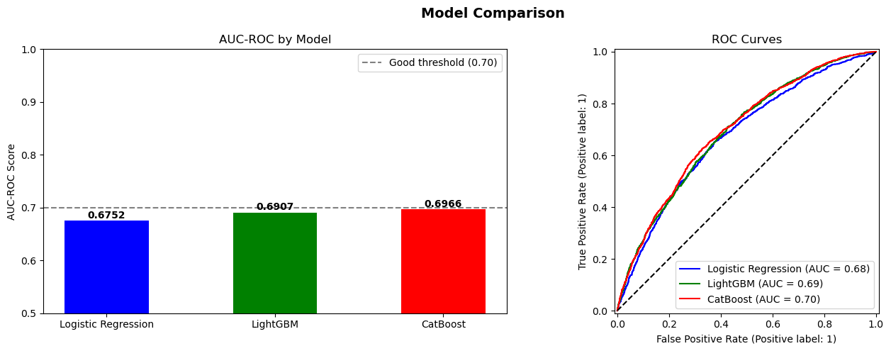
Figure 1. AUC-ROC by model and ROC curves on the held-out test set (from loan_risk_prediction_ml.ipynb).

3.3 What Drives a High-Risk Prediction (SHAP)
A SHAP summary on the LightGBM model shows which application-time features push a loan toward a “bad loan” prediction — primarily loan grade/sub-grade, interest rate, and DTI, echoing the Grade D–G and high-DTI risk flags already noted qualitatively in the original Bank_Loan_Targeted_Customer_Report.docx, but now quantified per loan.
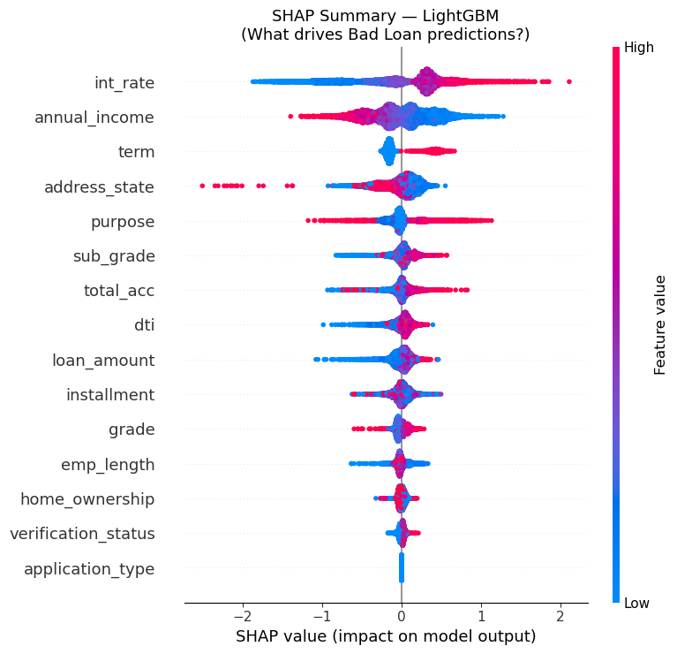
Figure 2. SHAP feature-impact summary — red pushes a prediction toward “Bad Loan,” blue toward “Good Loan.”

4. Accuracy Improvement: Machine Learning vs. the Original Assumption
“Accuracy” has to be read carefully on an imbalanced 86/14 dataset (see §3.1), so this report reports the improvement three ways — model discrimination, tuning gain, and portfolio-level correction — rather than a single number that could be misleading on its own.

4.1 Discriminative accuracy (AUC-ROC) vs. the original rule
The original rule assigns every Current loan the same label (“Good”) with no regard to its actual risk profile. Statistically that is equivalent to a model with zero discriminative power — an AUC-ROC of 0.50, the same as random guessing. The tuned ML model reaches 0.6999.
Approach | AUC-ROC | Reads as
Original rule (“Current = Good”, no model) | 0.50 | No better than a coin flip
Tuned CatBoost (final ML model) | 0.6999 | “Good” model per the 0.70 benchmark
Improvement: +0.1999 AUC points, a +40.0% relative improvement in risk-discrimination accuracy.

4.2 Gain from hyperparameter tuning alone
Separately from adopting ML in the first place, tuning the winning model's hyperparameters with Optuna (100 trials over iterations, learning rate, depth, subsample, colsample, min_data_in_leaf) improved CatBoost further:
Model version | AUC-ROC | Improvement
CatBoost — default parameters | 0.6966 | —
CatBoost — Optuna-tuned (final) | 0.6999 | +0.0033 (+0.47% relative)

4.3 Portfolio-level correction (the number that matters for reporting)
The most consequential comparison is what the ML predictions do to the headline Good/Bad Loan KPIs once the 1,098 Current loans are scored instead of assumed. Two equivalent methods agree closely:
- Bucket method: count Charged Off + Current loans scored “High Risk” (probability > 0.60) as bad → (5,333 + 705) / 38,576 = 15.65%.
- Expected-value method: sum each Current loan's predicted probability instead of thresholding → expected 699.0 bad loans among the 1,098 → (5,333 + 699) / 38,576 = 15.64%.
Portfolio KPI | Original (rule-based) | Risk-adjusted (ML) | Change
Good Loan Rate | 86.2% | ≈83.3%* | −3.0 pts
Bad Loan Rate | 13.8% | 15.6–15.65% | +1.8–1.9 pts (+13% relative)
*Conservative version: Fully Paid + only the 8 Current loans scored Low Risk. The remaining 385 Medium-Risk Current loans (35.1% of the bucket) sit in a watch-list state that the original binary Good/Bad label could not represent at all.

5. Risk Found Inside the “Current = Good Loan” Bucket
Every one of the 1,098 Current loans was reported as Good Loan under the original rule. Scored individually by the tuned CatBoost model, the picture changes sharply:
Risk tier (predicted P(bad)) | Loans | % of Current bucket | Loan principal | % of Current principal
Low Risk (0.00–0.30) | 8 | 0.7% | $93,925 | 0.5%
Medium Risk (0.30–0.60) | 385 | 35.1% | $6,919,475 | 36.7%
High Risk (0.60–1.00) | 705 | 64.2% | $11,853,100 | 62.8%
Total | 1,098 | 100.0% | $18,866,500 | 100.0%
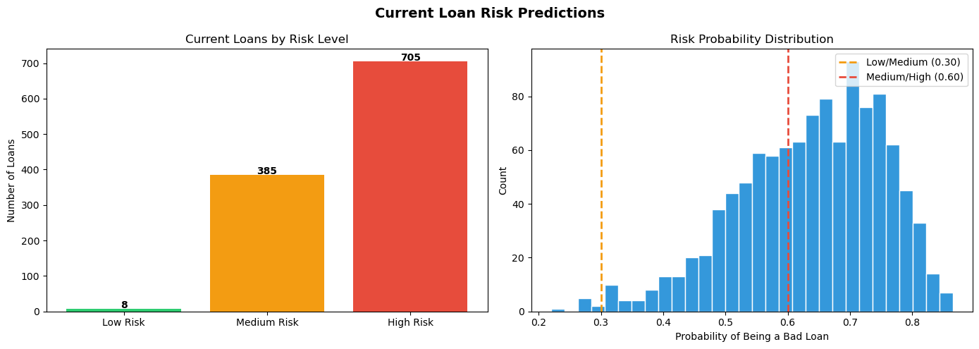
Figure 3. Risk-tier distribution and probability histogram for the 1,098 Current loans (current_loan_risk_predictions.csv).
The 705 High-Risk loans skew toward lower credit grades (C–F account for 489 of the 705) and toward Debt Consolidation and Small Business purposes — consistent with the risk factors the original project's targeted-customer report already flagged qualitatively for Segments to Avoid, now attached to specific loans with a probability score instead of a grade cutoff.

6. Updated Dashboard: dashboard_fix.pbix
The fixed Power BI file adds a new report page, “Current Status Prediction,” built on a new current_loan_risk_predictions table (the model's CSV output) alongside the original Summary, Overview, and Detail pages. It surfaces:
- KPI cards for Total Current Applications, Average Risk Probability, and Total Amount Funded (Current).
- Risk-label breakdown (High / Medium / Low) sliceable by grade, purpose, home ownership, and U.S. state (shape map).
- Loan-level detail (id, term, sub-grade, interest rate, installment, total payment to date) so a risk analyst can drill from a portfolio KPI down to an individual Current loan.
This turns the previously invisible 1,098-loan blind spot into a monitorable, filterable view instead of a single hard-coded assumption.

7. Conclusion & Recommendations
Recommendations
• Stop reporting Current loans as unconditionally Good; use the ML-predicted risk_label (Low / Medium / High) as the portfolio's working definition instead of a binary rule.
• Prioritize collections/early outreach on the 705 High-Risk Current loans ($11.85M principal) identified by the model.
• Track the 385 Medium-Risk loans on a watch list — the original binary label had no way to represent them.
• Retrain the model as more Current loans resolve, and periodically re-tune (Optuna) as the label distribution shifts.
• Adopt AUC-ROC (or recall on the Bad Loan class) as the reported model-quality metric going forward, not raw accuracy, given the persistent class imbalance.

Appendix — Source Files
File | Role
dashboard/dashboard.pbix | Original dashboard — rule-based Good/Bad split
dashboard/dashboard_fix.pbix | Updated dashboard — adds ML risk page
ml_risk_prediction/loan_risk_prediction_ml.ipynb | Model training, tuning, and evaluation notebook
ml_risk_prediction/current_loan_risk_predictions.csv | Per-loan risk probabilities for all 1,098 Current loans

