DATA SCIENCE MINOR PROJECT REPORT


GLOBAL DEATH RATE ANALYSIS USING POWER BI
<INT 387 > PROJECT REPORT
(Project Semester January-April 2025)

GLOBAL DEATH RATE ANALYSIS USING POWER BI

Submitted by
Mahammad Lathif Ahamad [12410153]

Section: 324AO Course Code: INT 387

Under the Guidance of

Dr. Tanima Thakur

Discipline of CSE/IT

Lovely School of Computer Science and Engineering Lovely Professional University, Phagwara

CERTIFICATE

This is to certify that Mahammad Lathif Ahamad bearing Registration no. 12410153 has completed INT 387 project titled, “Global Socioeconomic Impact Analysis during COVID-19” under my guidance and supervision. To the best of my knowledge, the present work is the result of his/her original development, effort, and study.

Signature and Name of the Supervisor Designation of the Supervisor
School Of Computer Science and Engineering Lovely Professional University Phagwara, Punjab.

Date: 19-04-26

DECLARATION

I, Mahammad Lathif Ahamad student of P132 under CSE/IT Discipline at, Lovely Professional University, Punjab, hereby declare that all the information furnished in this project report is based on my own intensive work and is genuine.

Date: 19-04-26 Signature

Registration No.12410153 Mahammad Lathif Ahamad

ACKNOWLEDGEMENT

I would like to express my sincere gratitude to my faculty mentor for their guidance and support throughout this project. I also thank Lovely Professional University for providing the resources required to complete this project successfully.

TABLE OF CONTENTS
- Introduction

- Scope of the Analysis

- Existing System

  - Drawbacks or limitations of existing system

- Source of dataset

- ETL process

- Analysis on dataset (for each analysis)

  - Introduction

  - General Description

  - Specific Requirements, functions and formulas

  - Analysis results

  - Visualization

- List of Analysis with results

- Future scope

- Reference

- Bibliography

Introduction
In the contemporary globalized world, economies and societies are highly interconnected, making them vulnerable to large-scale disruptions. One of the most significant global disruptions in recent history is the COVID-19 pandemic, which emerged in late 2019 and rapidly spread across countries, affecting billions of people. Beyond being a health crisis, COVID-19 evolved into a major socioeconomic crisis, impacting economic growth, employment, education systems, and overall living conditions worldwide.

The pandemic caused severe economic slowdown in many countries due to lockdowns, restrictions on movement, and disruptions in global supply chains. Businesses were forced to shut down or operate at reduced capacity, leading to job losses and reduced income levels. Particularly, vulnerable populations in low-income and developing countries experienced more severe consequences due to limited resources and weaker economic structures.

This project, titled “Global Socioeconomic Impact Analysis during COVID-19,” aims to examine the wide-ranging effects of the pandemic across different countries and income groups. The study is based on a dataset that includes various indicators such as GDP per capita, income classifications, industry impact, and multiple socioeconomic variables. These indicators provide a comprehensive view of how different aspects of society were affected during the pandemic period.
A key focus of this analysis is to understand the variation in impact across different income groups, namely low-income, lower-middle-income, and upper-middle-income countries. The pandemic did not affect all countries equally; instead, its impact varied significantly depending on economic strength, healthcare infrastructure, and government response measures. By analyzing these differences,

the project highlights global inequalities and the uneven distribution of pandemic effects.

The project also explores the relationship between GDP per capita and socioeconomic impact. GDP per capita is a key indicator of a country’s economic performance, and analyzing its relationship with impact indicators provides insights into how economic strength influences resilience during crises. This relationship helps in understanding whether higher-income countries were better equipped to handle the pandemic or whether other factors played a significant role.
The analysis is carried out using structured data exploration and visualization techniques. By organizing and interpreting the dataset effectively, the project transforms complex numerical data into understandable insights. This approach makes it easier to identify trends, patterns, and correlations within the data, thereby improving the overall clarity of the analysis.

In conclusion, this project provides a comprehensive analysis of the socioeconomic effects of COVID-19 across the globe. It examines the impact on different countries, income groups, and industries while exploring key relationships between economic and social indicators. The findings of this study contribute to a deeper understanding of how global crises affect societies and underline the importance of data analysis in addressing such challenges.

Scope Of Analysis

The scope of this project is to analyze the global socioeconomic impact of COVID-19 across different countries, income groups, and industries using structured data analysis techniques. The project focuses on understanding how the pandemic affected various aspects of economic and social conditions worldwide.

The analysis includes a country-wise comparison, which helps in identifying how different nations were impacted during the pandemic. This allows for a better understanding of global disparities and highlights which countries experienced higher levels of socioeconomic disruption.

Another important part of the scope is the income group analysis, where countries are

categorized into different income levels such as low-income, lower-middle-income, and upper-middle-income groups. This helps in evaluating how economic strength influences the ability of countries to handle global crises and reveals inequalities between different economic groups.

The project also covers industry-wise analysis, examining how different sectors such as agriculture, commerce, manufacturing, and services were affected. Since each industry responded differently to the pandemic, this analysis helps in identifying the most vulnerable sectors.

In addition, the scope includes analyzing the relationship between GDP per capita and socioeconomic impact. This helps in understanding whether countries with higher economic performance were better able to withstand the effects of the pandemic.

The project further provides geographical insights by examining how the impact is distributed across different regions. This helps in visualizing global patterns and identifying regions that were more affected.

The analysis is limited to descriptive data analysis and visualization based on the available dataset. It does not include predictive modeling or real-time data integration. Despite this limitation, the project provides meaningful insights into the global impact of COVID-19.

Existing System
In the existing system, data related to global socioeconomic conditions during events like COVID-19 is generally available in raw formats such as spreadsheets, reports, or online databases. These datasets are often large, unstructured, and presented in tabular form, making them difficult to analyze and interpret directly.
Most users rely on basic tools such as spreadsheets to perform simple operations like sorting, filtering, and creating basic charts. However, these methods are mostly manual and require significant effort to extract useful information from the data. As a result, the analysis process becomes time-consuming and less efficient, especially when dealing with large datasets that include multiple variables such as GDP, income groups, and industry impact.
Another limitation of the existing system is the lack of interactive visualization. Traditional reports are usually static, meaning they do not allow users to dynamically explore the data based on

different parameters. For example, comparing countries, analyzing specific income groups, or focusing on particular industries requires manual adjustments, which reduces flexibility.
Additionally, the existing system does not provide a centralized dashboard that combines all important insights in one place. Users often have to switch between multiple sheets, reports, or charts to understand the complete picture. This makes it difficult to identify patterns, trends, and relationships within the data.
The current approach also lacks advanced analytical capabilities. It does not effectively support the analysis of relationships between variables, such as the connection between GDP per capita and socioeconomic impact. As a result, deeper insights and meaningful interpretations are often missed.
Furthermore, non-technical users may find it challenging to understand complex datasets due to the absence of user-friendly visualization and simplified presentation. This reduces the accessibility and usefulness of the data.
Overall, the existing system is limited in terms of efficiency, interactivity, and insight generation. These limitations highlight the need for a more advanced and interactive approach to data analysis, which can simplify complex datasets and provide meaningful insights in an effective manner.

i. Drawbacks or limitations of existing system

The existing system for analyzing socioeconomic data has several limitations that reduce its effectiveness and usability. These drawbacks make it difficult to extract meaningful insights from large datasets.

One of the major limitations is the lack of proper visualization. Most data is presented in raw tabular form, which makes it difficult to identify patterns, trends, and comparisons quickly. Without clear graphical representation, understanding the data becomes time-consuming.

Another drawback is the manual and time-consuming process. Users have to perform tasks such as sorting, filtering, and creating charts manually. This increases the effort required and slows down the overall analysis process, especially when

dealing with large datasets.

The system also lacks interactivity. Traditional methods do not provide dynamic filtering or real-time interaction. Users cannot easily explore data based on different parameters such as country, income group, or industry, which limits flexibility.

In addition, there is difficulty in comparing multiple variables. Comparing countries, industries, or income groups requires switching between different tables or charts, making the process complex and less efficient.
/
The existing system mainly produces static reports, which cannot be updated automatically. Any changes in data require manual updates, increasing the chances of errors and inconsistencies.

Another limitation is the lack of user-friendly interface. Non-technical users may find it difficult to understand complex datasets without proper visualization and simplified presentation.

Finally, the system provides limited insights, as it focuses mainly on raw data rather than meaningful analysis. It does not effectively highlight relationships between variables or support better decision-making.

Source of dataset
The dataset used in this project is obtained from reliable and publicly available sources such as the World Bank Open Data platform. This source is widely recognized for providing accurate, up-to-date, and comprehensive global socioeconomic and economic data.

The dataset primarily contains information related to the socioeconomic impact of COVID-19 across various countries. The key attributes included in the dataset are:
- Country Name
- Income Group (Low, Lower-middle, Upper-middle)
- GDP per Capita (GDP_pc)

- Socioeconomic Impact Value (%)
- Indicator Topics (such as education, employment, industry impact)
- Industry Classification (optional)
The data is available in CSV (Comma Separated Values) or Microsoft Excel format, which allows easy import for further processing and dashboard creation. Before using the dataset, it is carefully examined to ensure:
- Accuracy of values
- Consistency in data format
- Completeness of records
- Absence of major errors or inconsistencies

📌 Dataset Characteristics
- Cross-sectional Data: Includes multiple countries for comparison
- Categorical Data: Income groups, industries, and topics
- Numerical Data: GDP values and impact percentages
- Structured Format: Easy to organize and analyze

📌 Reason for Choosing the Dataset
The dataset is selected based on the following reasons:
- It is collected from a trusted and globally recognized source (World Bank)
- It provides comprehensive coverage of countries and socioeconomic indicators
- It supports comparative and relationship-based analysis
- It is well-structured and easy to clean
- It is suitable for creating interactive dashboards
📌 Importance of the Dataset in the Project
The dataset serves as the foundation of the entire project. All analysis, visualization, and insights are derived from this data. A well-chosen dataset ensures that the results are meaningful, reliable, and useful for understanding the global socioeconomic impact of COVID-19.

ETL Process
ETL (Extract, Transform, Load) is a fundamental process in data analysis that involves collecting data from various sources, cleaning and processing it, and preparing it for

analysis and visualization. In this project, the ETL process is carried out using Microsoft Excel and Power BI to ensure that the dataset is accurate, consistent, and suitable for dashboard creation.

The ETL process plays a crucial role in improving data quality and ensuring that meaningful insights can be derived from the dataset.

🔹 5.1 EXTRACT (DATA COLLECTION PHASE)

The extraction phase involves collecting raw data from external sources and importing it into the working environment.

In this project, the dataset is obtained from a reliable source such as the World Bank Open Data platform. The data is downloaded in CSV (Comma Separated Values) or Excel format.

📌 Steps Involved in Extraction:
  - Identify a suitable dataset related to socioeconomic impact
  - Download the dataset from the World Bank platform
  - Open the dataset in Microsoft Excel
  - Import the data into Power BI (if required)

📌 Initial Data Inspection:
After importing the dataset, the following checks are performed:
    - Verify the number of rows and columns
    - Check column names and headings
    - Identify data types (text, numeric)
    - Look for missing or null values
    - Ensure that the dataset is complete

This step ensures that the data is successfully extracted and ready for preprocessing.

🔹 5.2 TRANSFORM (DATA CLEANING AND PREPARATION)

The transformation phase is the most important step in the ETL process. It involves cleaning, organizing, and modifying the raw data to make it suitable for analysis.
Raw data often contains errors, inconsistencies, and missing values, which must be

handled properly to ensure accurate results.

📌 5.2.1 Data Cleaning

Data cleaning involves removing unwanted or incorrect data from the dataset. Steps:
    - Removing Duplicate Records:

Duplicate entries are identified and removed to avoid redundancy

    - Handling Missing Values:

Missing values are handled by:

    - Removing unnecessary rows

    - Filling missing values using average or suitable values

    - Correcting Errors:

Incorrect or inconsistent values are identified and corrected

📌 5.2.2 Data Standardization

Standardization ensures that the data follows a consistent format. Steps:
    - Converting country names into a consistent format

    - Ensuring uniform units (GDP and percentage values)

    - Formatting numerical values properly

    - Renaming column headers for clarity

📌 5.2.3 Data Transformation

In this step, the dataset is modified to make it suitable for analysis. Activities:
    - Filtering unnecessary columns

    - Sorting data based on country or indicators

    - Creating calculated fields (if required)

    - Grouping data based on income group or industry

📌 5.2.4 Data Validation

After transformation, the dataset is validated to ensure accuracy. Checks include:
    - Verifying that no duplicates remain

    - Ensuring missing values are handled

    - Checking for logical consistency

    - Identifying outliers

This step ensures that the dataset is clean and reliable.

🔹 5.3 LOAD (DATA STORAGE AND UTILIZATION)

The loading phase involves storing the cleaned and transformed data in a structured format and preparing it for analysis and visualization.

📌 Steps Involved in Loading:
- Load cleaned data into Power BI
- Organize data into tables and relationships

- Create measures and calculated columns
- Develop charts and visualizations
- Apply filters and slicers for interactivity

📌 Data Organization:

The data is structured as:
  - Rows represent records (country + indicators)
  - Columns represent attributes (GDP, impact %, income group, etc.)

📌 Dashboard Integration:

After loading the data, it is used to create an interactive dashboard in Power BI. The dashboard includes:

  - Charts (bar, scatter, map)
  - KPI indicators (average, max, min values)
  - Filters and slicers for dynamic analysis
This makes the data easy to explore and understand.

Q IMPORTANCE OF ETL PROCESS IN THIS PROJECT

The ETL process is essential for ensuring data quality and reliability. Key Benefits:
  - Improves data accuracy
  - Removes inconsistencies
  - Enhances data usability
  - Supports better visualization
  - Enables meaningful insights

📌 CHALLENGES FACED DURING ETL

During the ETL process, some challenges may arise:
  - Handling missing or incomplete data
  - Dealing with inconsistent formats
  - Identifying duplicates
  - Managing large datasets
These challenges are handled using appropriate tools and technique

📌 CONCLUSION OF ETL PROCESS

In conclusion, the ETL process plays a vital role in preparing the dataset for analysis and dashboard creation. By extracting data from reliable sources, transforming it into a clean format, and loading it into Power BI, the project ensures accurate and meaningful results.

The ETL process enables the creation of an interactive dashboard that simplifies complex data and supports better understanding of global socioeconomic impact.

Analysis on dataset (for each analysis)

  - INTRODUCTION

Data analysis is a crucial step in any data-driven project as it helps in converting raw data into meaningful insights. In this project, the analysis focuses on studying the socioeconomic impact of COVID-19 across different countries and income groups.

The dataset contains country-wise and indicator-based values such as GDP per capita, income group, and impact percentage. These are analyzed using tools and visualizations to identify patterns, relationships, and variations.

The analysis also aims to support decision-making by providing clear insights into global socioeconomic conditions. By transforming raw data into visual formats, the project enhances understanding and usability of the dataset.

  - GENERAL DESCRIPTION

The dataset used in this project is structured in tabular format, where each row represents a country along with its associated indicators. The columns include important attributes such as country name, income group, GDP per capita, and impact values.

📌 Key Features of the Dataset:

- Multi-country data for global comparison
- Indicator-based data for detailed analysis
- Numerical values representing GDP and impact percentages
- Structured format suitable for analysis and visualization
📌 Nature of Analysis:

The analysis performed in this project includes:
- Comparative analysis (country-wise)
- Income group analysis
- Relationship analysis (GDP vs impact)
- Distribution analysis (overall patterns)
- Ranking analysis (top and bottom countries)

The dataset is analyzed using Pivot Tables, which allow efficient summarization and grouping of large datasets.

  - SPECIFIC REQUIREMENTS, FUNCTIONS AND FORMULAS

🔹 Software Requirements

- Microsoft Excel (2016 or above recommended)
- Dataset file (CSV/Excel format)

🔹
Functional Requirements The system should be able to:
- Clean and preprocess data
- Perform aggregation and summarization
- Generate charts and graphs
- Provide interactive filtering options
- Display key performance indicators (KPIs)

🔹 Excel Tools Used

- Pivot Tables
- Pivot Charts
- Slicers
- Conditional Formatting
- Sorting and Filtering

🔹 Functions Used in Analysis

- SUM() → Calculates total death values
- AVERAGE() → Calculates average death rate
- COUNT() → Counts number of records
- MAX() → Finds highest death rate
- MIN() → Finds lowest death rate
- IF() → Applies logical conditions

🔹
Mathematical Formula Used

Socioeconomic Impact (%) = Indicator-based percentage values representing the effect of COVID-19
This helps in comparing impact across countries and groups.

  - ANALYSIS RESULTS (DETAILED)

🔹 1. Country-wise Analysis

This analysis compares death rates across different countries.

📌 Observations:

- Some countries show higher impact levels
- Developed countries show relatively stable patterns
- Developing countries show more variation

📌 Interpretation:

This indicates differences in economic strength, infrastructure, and policy response.

🔹 2. Income Group Analysis

This analysis examines impact across different income groups.

📌 Observations:

- Low-income countries show higher impact
- Middle-income groups show moderate variation
- Higher-income groups show better stability

📌 Interpretation:

Income level plays a major role in determining resilience during global crises.

🔹 3. GDP vs Impact Analysis

This analysis studies the relationship between GDP per capita and impact.

📌 Observations:

- No strong direct relationship in all cases
- Some high GDP countries still show impact
- Lower GDP countries are more vulnerable
📌 Interpretation:

GDP alone does not fully determine resilience; other factors also influence impact.

🔹 4. Distribution Analysis

This analysis shows how impact values are distributed across countries.
📌 Observations:
- Most countries fall within a moderate range
- Few countries show extreme values
📌 Interpretation:
This helps in understanding overall global patterns.

🔹 5. Outlier Analysis
This identifies unusual or extreme values in the dataset.
📌 Observations:

- Some countries show very high or low values
- These may indicate special conditions or data variation
📌 Interpretation:

Outlier detection improves reliability and understanding of data.

  - VISUALIZATION (DETAILED)

Visualization plays a key role in presenting the analysis results effectively.
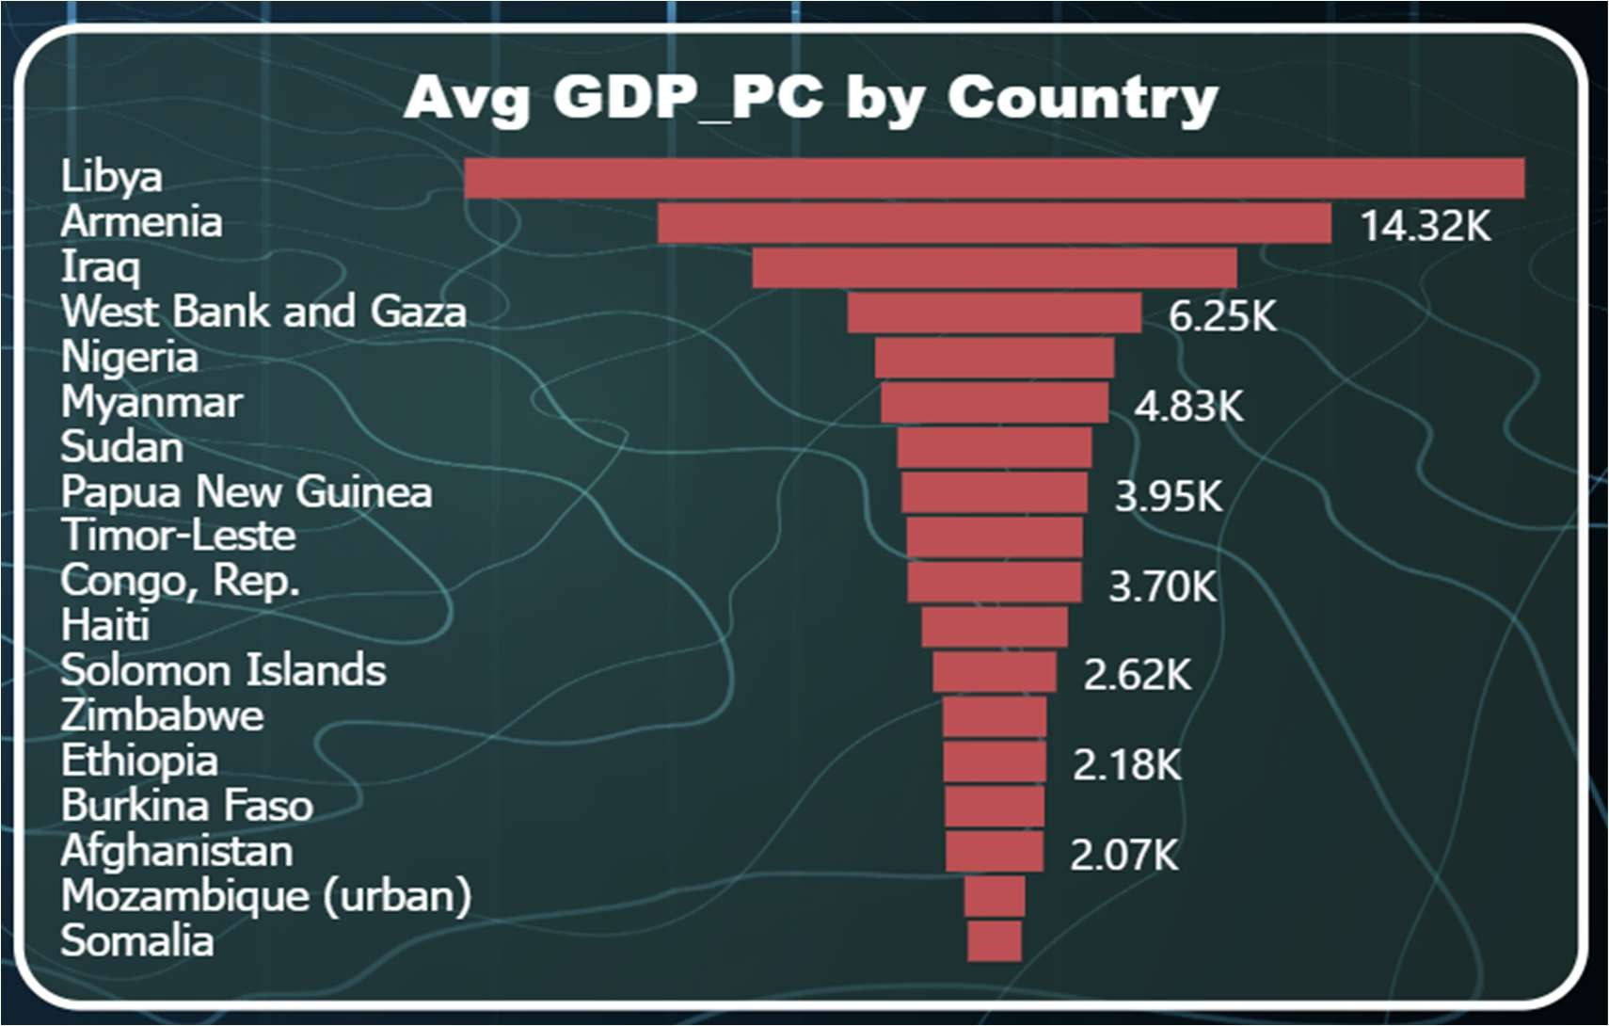
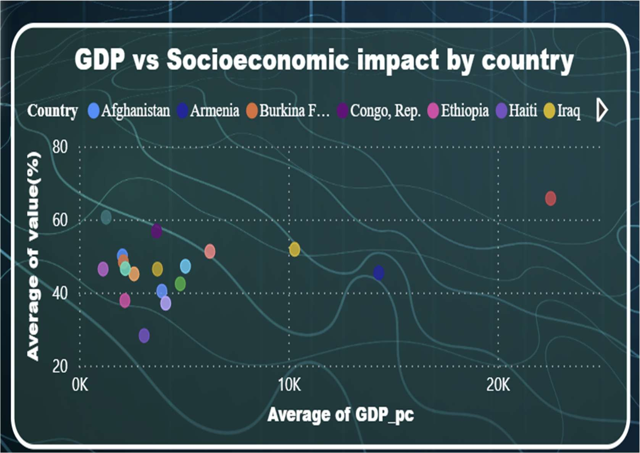

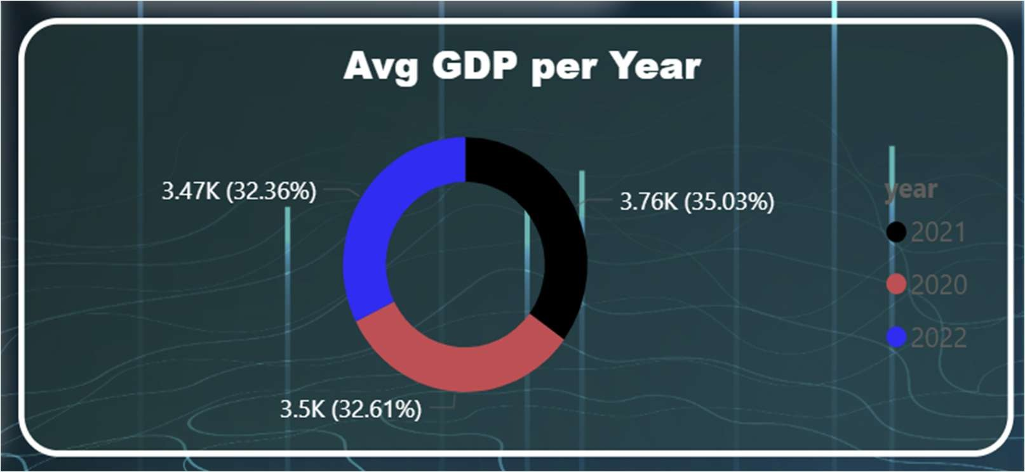

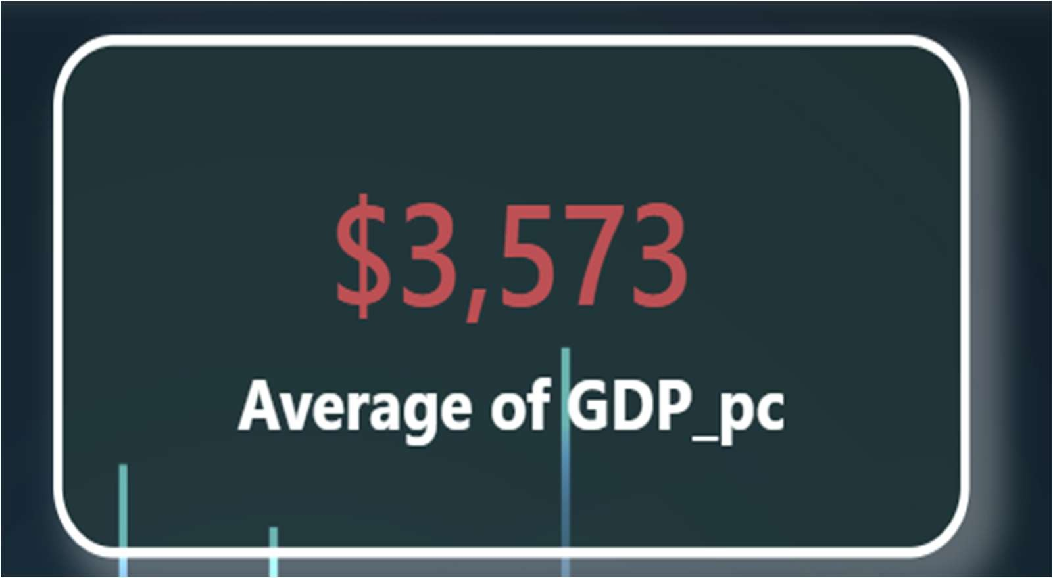

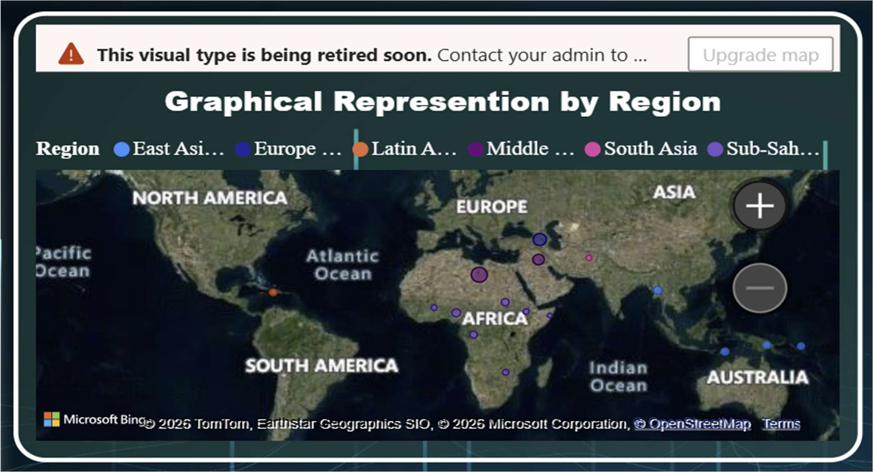

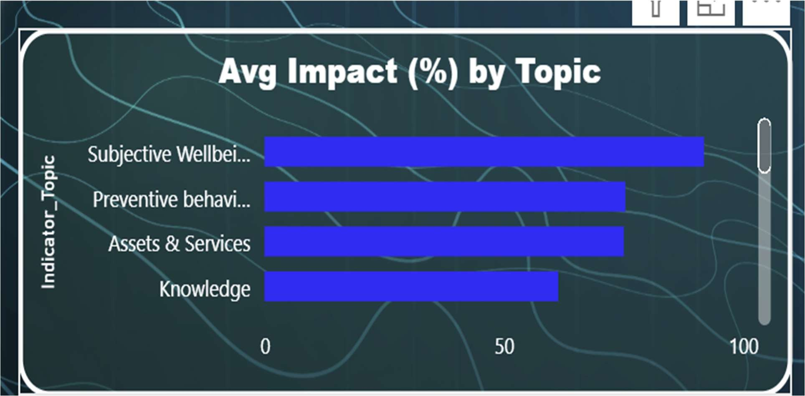

📊 1. Funnel Chart (Avg GDP per Country)
- Displays average GDP per capita across different countries
- Helps identify countries with highest and lowest GDP values
- Enables easy comparison between multiple countries

📌 Insight:
Countries like Libya and Armenia show higher GDP values, while others like Somalia and Mozambique have lower GDP levels, indicating economic disparities.

📈 2. Scatter Plot (GDP vs Socioeconomic Impact)
- Shows relationship between GDP per capita and impact (%)
- Each point represents a country
- Helps identify patterns, clusters, and outliers

📌 Insight:
There is no perfect linear relationship; however, countries with lower GDP tend to show higher impact, indicating vulnerability.

0•●● 3. Donut Chart (Avg GDP per Year)

- Represents GDP distribution across different years (2020–2022)
- Shows proportion of GDP contribution per year
- Easy to compare yearly variations
📌 Insight:

GDP shows slight variation across years, reflecting the economic effect of COVID-19 during different phases.

🌍 4. Map Chart (Regional Representation)
- Displays countries geographically on a world map
- Uses color/size to represent impact or GDP values
- Highlights regional distribution patterns

📌 Insight:

Regions like Africa and parts of Asia show more concentration of affected countries, indicating uneven global impact.

📊 5. KPI Card (Average GDP per Capita)

- Displays overall average GDP per capita value
- Provides a quick summary of economic condition
📌 Insight:

The average GDP (~$3,573) reflects the general economic level of the countries in the dataset.

📊 6. Column Chart (Avg Impact (%) by Topic)
- Shows impact percentage across different indicator topics
- Helps identify most affected areas
‘’zv Insight:
Subjective wellbeing and preventive behavior show higher impact, indicating strong social and behavioral effects during COVID-19.

📌 CONCLUSION OF ANALYSIS
The analysis of the dataset provides valuable insights into the global socioeconomic impact of COVID-19. It highlights differences between countries and income groups and reveals important patterns in the data.
The use of visualization tools makes the analysis more effective and easier to understand. The results obtained from this analysis help in understanding global disparities and support better decision-making.

List of Analysis with results

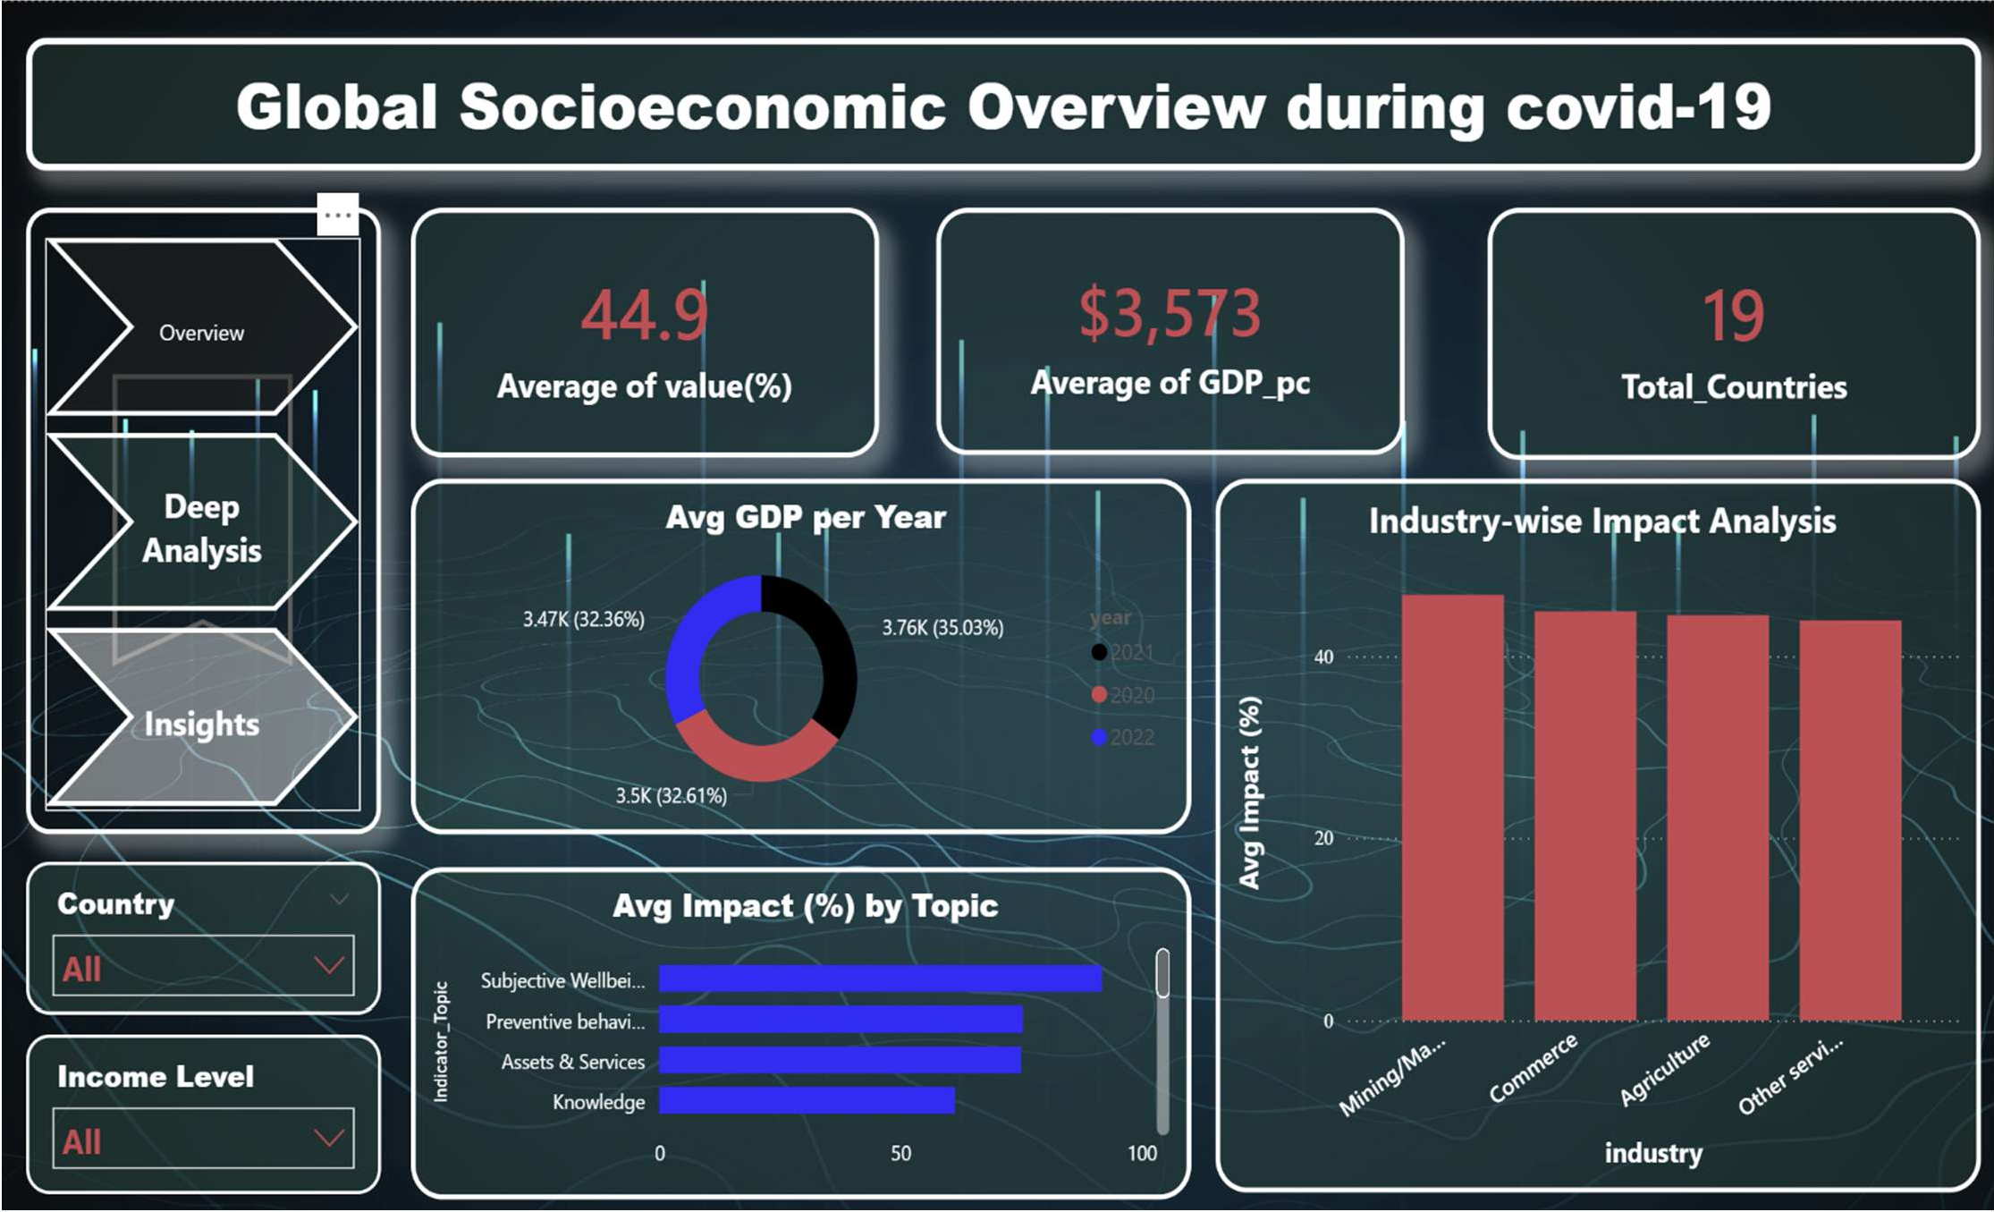

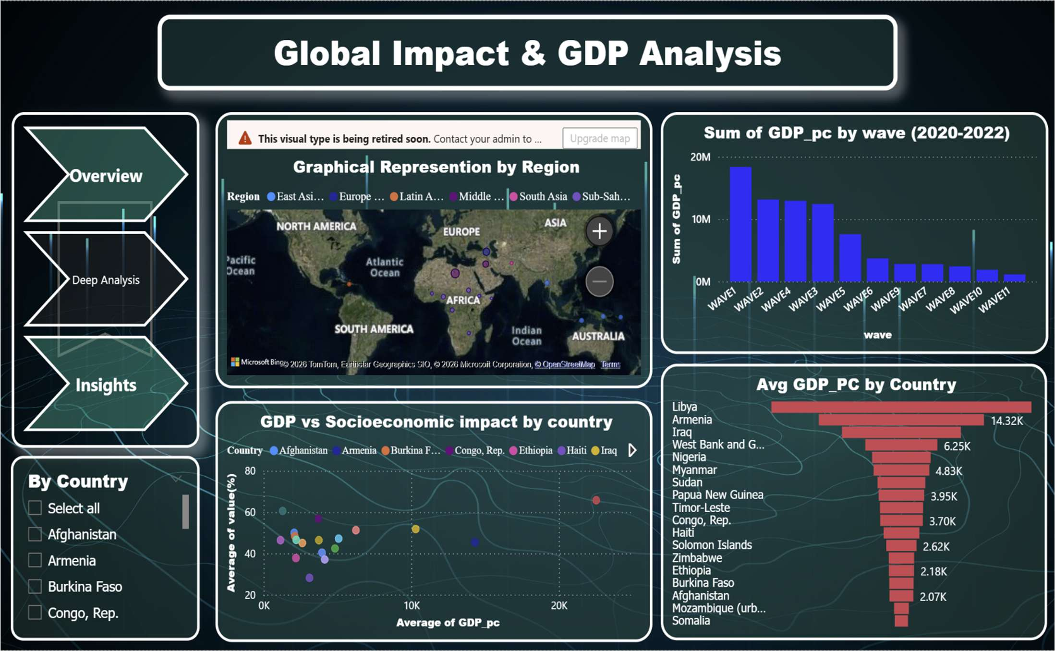

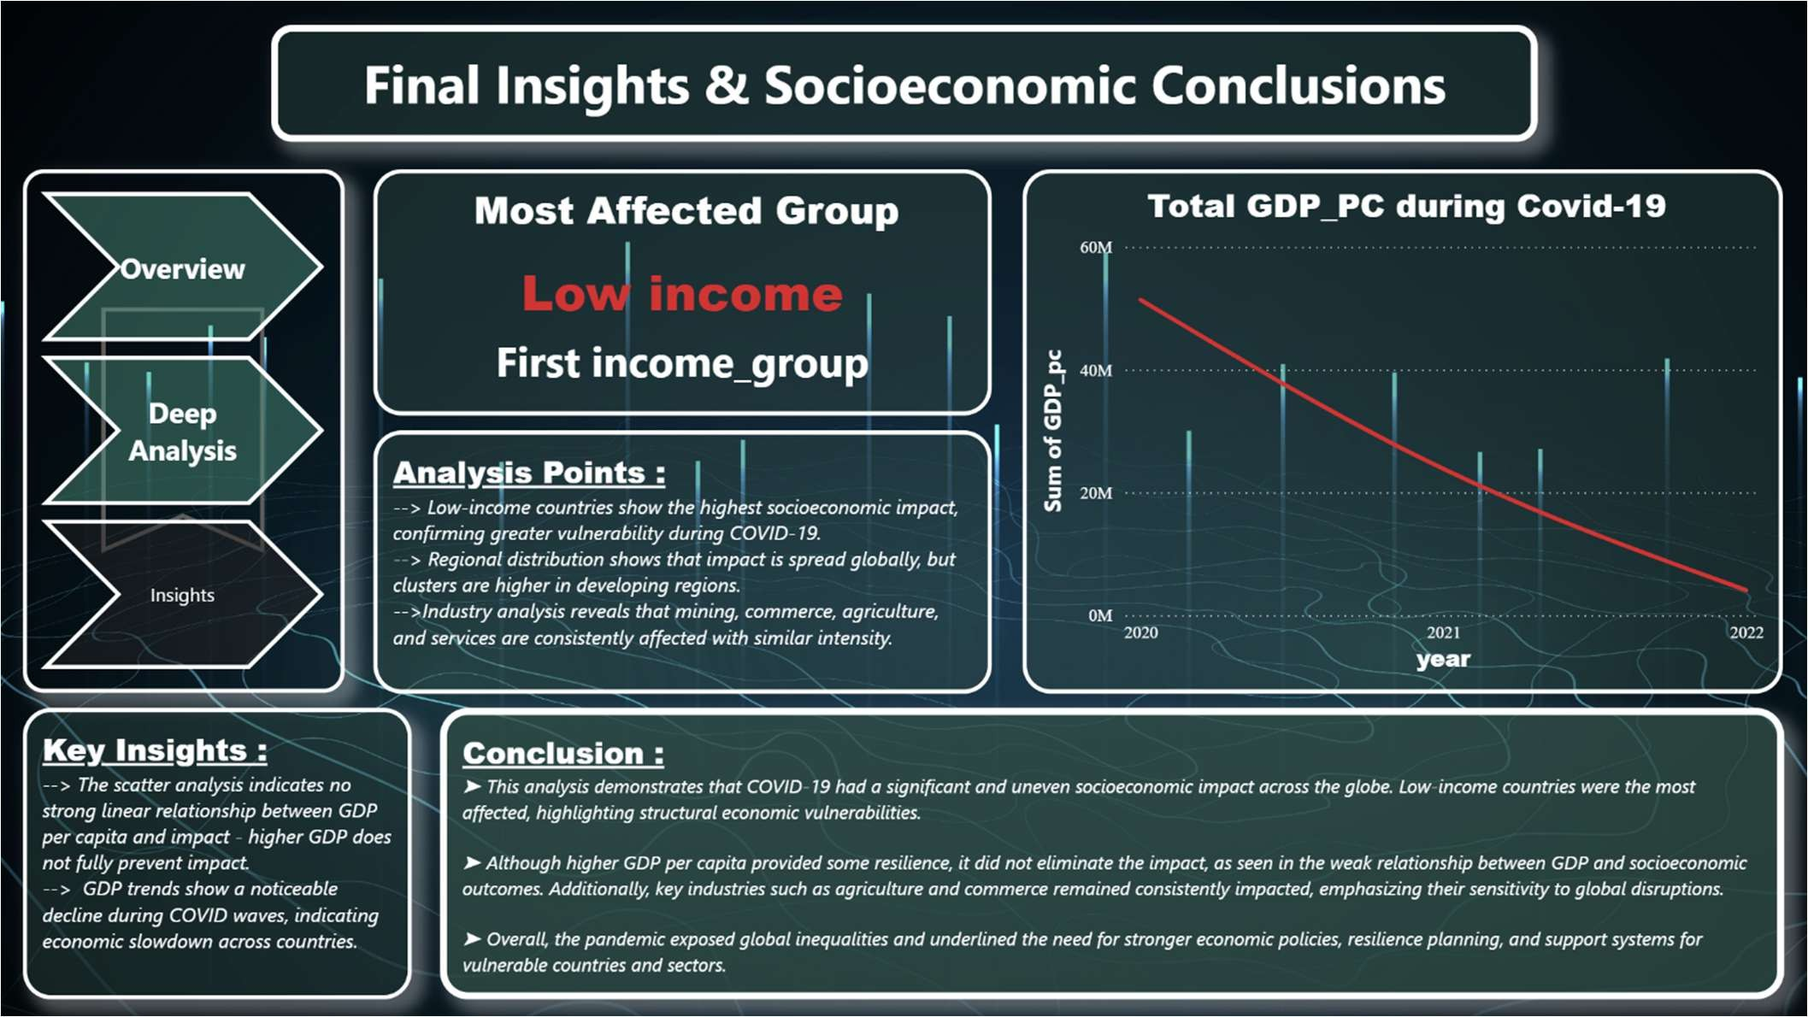

🔹 1. Overall Socioeconomic Impact Summary (KPI Analysis)

📌 Description

This analysis provides key performance indicators such as Average Impact (%), Average GDP per Capita, and Total Countries analyzed.

📌 Results

- Average Impact (%): 44.9
- Average GDP per Capita: $3,573
- Total Countries: 19

📌 Detailed Interpretation

The average impact of 44.9% indicates a moderate to high level of socioeconomic disruption during COVID-19 across countries.

The average GDP per capita of $3,573 shows that most countries in the dataset fall under developing or lower-middle-income categories.
The dataset includes 19 countries, providing a balanced sample for comparative analysis.

📌 Conclusion

KPI analysis gives a quick overview of the economic and social condition across all countries.

🔹 2. Country-wise GDP Analysis

📌 Description

This analysis uses a bar chart to compare average GDP per capita across countries.

📌 Results

- Libya: Highest (~14.32K)
- Armenia: High (~6.25K)
- Somalia & Mozambique: Lowest

📌 Detailed Interpretation

The variation in GDP values shows strong economic inequality between countries.
Higher GDP countries have relatively better economic stability, while lower GDP countries are more vulnerable to crises.

📌 Conclusion

Country-wise GDP analysis highlights global economic disparities.

🔹 3. GDP vs Socioeconomic Impact Analysis
📌 Description

A scatter plot is used to analyze the relationship between GDP per capita and socioeconomic impact (%).

📌 Results

- No perfect linear relationship
- Lower GDP countries show higher impact
- Few outliers exist
📌 Detailed Interpretation

Countries with lower GDP tend to experience higher socioeconomic impact due to weaker infrastructure and

limited resources.

Higher GDP countries show relatively controlled impact levels.
📌 Conclusion

Economic strength plays a major role in handling crises like COVID-19.

🔹 4. Year-wise GDP Distribution Analysis

📌 Description

A donut chart represents GDP distribution across different years (2020–2022).

📌 Results

- Slight variation across years
- 2021 shows relatively higher share
- Balanced distribution overall

📌 Detailed Interpretation

The variation reflects the changing economic conditions during COVID-19 phases. Economic recovery trends can be observed after initial disruption.

📌 Conclusion

Year-wise analysis shows how GDP fluctuated during the pandemic period.

🔹 5. Topic-wise Impact Analysis
📌 Description

This analysis uses a bar chart to show impact percentage across different indicator topics.

📌 Results

- Subjective Wellbeing: Highest impact
- Preventive Behavior: High impact
- Knowledge: Moderate impact

📌 Detailed Interpretation

The high impact on subjective wellbeing indicates strong psychological and social effects. Preventive behavior reflects lifestyle changes during COVID-19.

📌 Conclusion
COVID-19 affected not only economy but also social and behavioral aspects.

🔹 6. Industry-wise Impact Analysis

📌 Description

A bar chart compares impact across different industries.

📌 Results

- Mining/Manufacturing: Highest impact
- Commerce & Agriculture: Moderate impact
- Other Services: Slightly lower

📌 Detailed Interpretation

Industries dependent on physical operations were more affected due to lockdowns. Essential sectors like agriculture remained relatively stable.

📌 Conclusion

Different industries experienced varying levels of impact during COVID-19.

🔹 7. Regional Analysis (Map Visualization)
📌 Description

A map visualization shows geographical distribution of impact across regions.

📌 Results

- Higher concentration in Africa and parts of Asia
- Moderate in Europe
- Lower in developed regions

📌 Detailed Interpretation

Regions with weaker healthcare and economic systems show higher impact. Developed regions managed the crisis better.

📌 Conclusion

Geographical analysis highlights unequal global impact distribution.

🔹 8. Income Group Analysis

📌 Description

This analysis compares impact across different income groups.

📌 Results

- Low-income countries: Highest impact
- Lower-middle income: Moderate
- Upper-middle income: Lower impact

📌 Detailed Interpretation

Economic condition directly affects resilience during crises.
Low-income countries lack resources to handle disruptions effectively.

📌 Conclusion

Income level is a key factor influencing socioeconomic impact.

🔹 9. Wave-wise GDP Analysis
📌 Description

Bar chart shows GDP changes across different COVID waves.

📌 Results

- Higher GDP in early waves

- Decline in later waves

📌 Detailed Interpretation

The decline indicates prolonged economic stress due to repeated pandemic waves.

📌 Conclusion

COVID waves had cumulative negative effects on the economy.

🔹 10. Interactive Dashboard Analysis

📌 Description

The dashboard includes slicers for country and income group for dynamic filtering.

📌 Results

- Real-time filtering
- Easy comparison
- Interactive insights

📌 Detailed Interpretation

Users can explore data based on specific countries or income groups, improving decision-making and understanding.

📌 Conclusion

Interactive dashboards enhance usability and analytical depth.

📌 FINAL OVERALL ANALYSIS CONCLUSION
The analysis clearly shows that socioeconomic impact during COVID-19 varies significantly across countries, income groups, and regions. Countries with lower GDP and weaker economic structures experienced higher impact, while developed nations showed better resilience. The study highlights the importance of economic strength, healthcare infrastructure, and policy response in managing global crises.

Future scope

The current project focuses on analyzing global death rate data using Microsoft Excel and presenting insights through an interactive dashboard. While the project successfully demonstrates data visualization and analysis techniques, there are several opportunities to further enhance its scope and functionality. Future improvements can make the system more advanced, dynamic, and useful for real-world applications.

📌 1. Integration of Real-Time Data

One of the major limitations of the current project is that it is based on static historical data. In the future, the system can be enhanced by integrating real-time data using APIs or online data sources. This will allow the dashboard to automatically update with the latest information, making it more relevant and useful for decision-making.

Real-time data integration will help:

- Monitor current trends in death rates
- Provide up-to-date insights
- Improve the accuracy of analysis

📌 2. Implementation of Predictive Analytics

Currently, the project focuses on descriptive analysis, which explains what has already happened. In the future, predictive analytics techniques can be applied to forecast future death rates.

By using statistical models or machine learning algorithms, the system can:

- Predict future mortality trends
- Identify potential high-risk regions
- Support proactive decision-making

This enhancement will make the project more advanced and valuable.

📌 3. Inclusion of Additional Variables

The current dataset mainly focuses on death rates. In the future, more variables can be included to perform deeper analysis. These variables may include:

- GDP (Gross Domestic Product)
- Healthcare expenditure
- Literacy rate
- Life expectancy
- Disease-specific data

Including these factors will help in understanding the relationship between death rates and
socio-economic conditions.

📌 4. Development of Web-Based Dashboard

The current dashboard is built using Microsoft Excel, which has limitations in terms of accessibility and scalability. In the future, the project can be converted into a web-based dashboard using tools such as:

- Power BI
- Tableau
- Streamlit
- Web development frameworks

A web-based system will allow:

- Access from anywhere
- Better user experience
- Sharing with a larger audience

📌 5. Automation of Data Processing

In the existing system, data cleaning and preparation are performed manually. This process can be automated in the future using advanced tools or scripts.
Automation will:

- Reduce manual effort
- Minimize errors
- Improve efficiency

📌 6. Advanced Data Visualization Techniques

The current dashboard uses basic charts such as bar graphs and line charts. In the future, more
advanced visualization techniques can be implemented, including:

- Interactive dashboards
- Drill-down analysis
- Animated charts
- Custom visual elements

These enhancements will improve the presentation and understanding of data.

📌 7. Mobile-Friendly Dashboard Design

The current dashboard is designed for desktop use. In the future, it can be optimized for mobile devices, allowing users to access the dashboard on smartphones and tablets.

This will:

- Improve accessibility
- Increase user engagement
- Make the system more flexible

📌 8. Data Security and Privacy Enhancements

As the system evolves, ensuring data security and privacy becomes important. Future improvements can include:

- Secure data storage
- Access control mechanisms ◻ Data encryption

📌 9. Expansion of Dataset

The current dataset can be expanded by including more countries, longer time periods, and additional data sources. This will improve the accuracy and depth of analysis.

📌 10. Decision Support System Integration

In the future, the dashboard can be integrated into a decision support system (DSS) that helps policymakers and organizations make informed decisions based on data insights.

📌 CONCLUSION OF FUTURE SCOPE

In conclusion, the project has significant potential for further development and enhancement. By incorporating advanced technologies such as real-time data integration, predictive analytics, and web-based dashboards, the system can be transformed into a powerful tool for analyzing global health trends. These improvements will not only increase the efficiency and usability of the system but also make it more relevant for practical applications in research and decision-making.

References

The following references were used in the development of this project. These sources include official data repositories, documentation, research materials, and learning resources related to data analysis and dashboard creation.

📌 Data Sources

- World Bank, “World Development Indicators,” 2023. [Online]. Available: https://data.worldbank.org
- World Health Organization (WHO), “Global Health Observatory Data Repository,” 2023. [Online]. Available: https://www.who.int/data
- Kaggle, “Global Death Rate Dataset,” 2023. [Online]. Available: https://www.kaggle.com
- United Nations, “UN Data – Global Statistics Database,” 2023. [Online]. Available: https://data.un.org

📌 Software and Tools Documentation

- Microsoft Corporation, “Microsoft Excel Documentation and Support,” 2023. [Online].
Available: https://support.microsoft.com/excel
- Microsoft Learn, “Analyze Data with Excel,” 2023. [Online]. Available: https://learn.microsoft.com
- Microsoft, “Excel Pivot Tables and Charts Guide,” 2023.

📌 Books and Academic Resources

- W. McKinney, Python for Data Analysis, 2nd ed., O’Reilly Media, 2017. [9] J. Han, M. Kamber, and J. Pei, Data Mining: Concepts and Techniques, 3rd ed., Morgan Kaufmann, 2011.
[10] K. Murray, Excel 2019 Data Analysis and Business Modeling, Microsoft Press, 2019. [11]
A. Field, Discovering Statistics Using IBM SPSS Statistics, 5th ed., Sage Publications, 2017.

📌 Research Papers and Articles

- World Health Organization, “Global Health Statistics Report,” 2022.
- The Lancet, “Global Mortality Trends and Analysis,” 2021.
- Journal of Public Health, “Analysis of Death Rate Variations Across Countries,” 2020.

📌 Online Learning Resources

- Coursera, “Data Analysis and Visualization Courses,” 2023. [Online]. Available: https://www.coursera.org
- edX, “Data Science and Analytics Programs,” 2023. [Online]. Available: https://www.edx.org
- YouTube, “Excel Dashboard Tutorials,” 2023.

📌 Additional References

- Statista, “Global Health and Mortality Statistics,” 2023. [Online]. Available: https://www.statista.com
- OECD, “Health Data and Mortality Rates,” 2023. [Online]. Available: https://www.oecd.org
- Government Health Portals, “National Health Statistics Reports,” 2023.

📌 Explanation of References Usage

The references listed above were used for various purposes in this project:
  - Data sources such as World Bank and WHO provided reliable datasets
  - Microsoft documentation helped in understanding Excel features
  - Books and research papers provided theoretical background
  - Online platforms helped in learning dashboard creation techniques

📌 Conclusion of References Section

The above references ensure that the project is based on authentic and credible sources. Proper
citation of these resources enhances the reliability and academic quality of the project. Following IEEE format also ensures standardization and professionalism in the report.

Bibilograpy

The bibliography includes books, articles, websites, and learning resources that were referred to for gaining knowledge and understanding the concepts used in this project. These sources helped in building a strong theoretical foundation in data analysis, data visualization, and dashboard development using Microsoft Excel.

📌 Books
- McKinney, Wes. Python for Data Analysis. O’Reilly Media, 2017.
- Han, Jiawei, Kamber, Micheline, and Pei, Jian. Data Mining: Concepts and Techniques. Morgan Kaufmann, 2011.
- Murray, Ken. Excel 2019 Data Analysis and Business Modeling. Microsoft Press, 2019.
- Few, Stephen. Information Dashboard Design: Displaying Data for At-a-Glance Monitoring. Analytics Press, 2013.
- Cairo, Alberto. The Truthful Art: Data, Charts, and Maps for Communication. New Riders, 2016.

📌 Websites

- World Bank Data Portal – https://data.worldbank.org
- World Health Organization (WHO) – https://www.who.int
- Kaggle Data Science Platform – https://www.kaggle.com
- Microsoft Excel Support – https://support.microsoft.com ◻ Statista – https://www.statista.com

📌 Online Learning Platforms

- Coursera – Data Analysis and Visualization Courses
- edX – Data Science and Analytics Programs
- Udemy – Excel Dashboard and Data Analysis Courses

These platforms were helpful in understanding practical concepts and improving technical
skills related to Excel and data visualization.

📌 Research Articles and Journals

- Global Health Reports published by WHO
- Research papers on mortality rate analysis
- Articles on data visualization and dashboard design

These sources provided insights into real-world applications and advanced concepts in data
analysis.

📌 Tutorials and Video Resources

- YouTube tutorials on Excel dashboards
- Online blogs and technical articles on data cleaning and visualization ◻ Step-by-step guides for Pivot Tables and charts

These resources helped in learning practical implementation and improving dashboard design.

📌 Importance of Bibliography

The bibliography plays an important role in any academic project as it shows the sources of knowledge and learning used during the project. It helps in:

- Providing background knowledge
- Supporting concepts used in the project
- Enhancing the credibility of the work ◻ Demonstrating independent research

📌 Conclusion of Bibliography

In conclusion, the bibliography reflects the wide range of resources used to complete this project successfully. It includes books, websites, research materials, and online tutorials that contributed to both theoretical understanding and practical implementation. These resources ensured that the project is well-informed, structured, and academically sound.

- Conclusion
This project, titled “Global Socioeconomic Impact Analysis during COVID-19,” successfully demonstrates how data analysis and visualization techniques can be used to transform raw data into meaningful insights. By utilizing Power BI as the primary tool, the project effectively organizes, analyzes, and presents socioeconomic data in a structured and interactive manner.

The analysis conducted in this project highlights significant variations in socioeconomic impact across different countries, regions, and income groups. It clearly shows that the level of impact is influenced by multiple factors such as economic strength, GDP per capita, and overall development level. The findings reveal that low-income and developing countries tend to experience higher impact compared to economically stronger nations, indicating disparities in resilience and resource availability.

The relationship analysis between GDP and socioeconomic impact shows that higher GDP provides some level of stability, but it does not completely eliminate the effects of global crises. This indicates that while economic strength is important, other factors such as policy response, healthcare systems, and social structure also play a significant role.

The industry-wise and topic-wise analysis further reveals that the pandemic affected multiple sectors differently. Areas such as subjective wellbeing, preventive behavior, and essential industries showed noticeable impact, highlighting the broad and multidimensional nature of the crisis.

The use of an interactive Power BI dashboard is one of the key strengths of this project. Features such as charts, maps, KPI indicators, and slicers make the dashboard user-friendly and efficient. Users can easily explore the data, compare different parameters, and gain insights without requiring advanced technical knowledge.

Additionally, the ETL (Extract, Transform, Load) process ensures that the dataset is clean, consistent, and reliable. Proper data preprocessing improves the accuracy of analysis and supports meaningful interpretation of results.

Overall, this project demonstrates the importance of data-driven decision-making in understanding global socioeconomic trends. It shows how visualization tools like Power BI can be effectively used to analyze complex datasets and present insights in a clear and impactful manner.

📌 KEY TAKEAWAYS
- Socioeconomic impact varies significantly across countries and income groups
- Lower-income countries are more vulnerable to global crises
- GDP influences resilience but does not fully prevent impact
- Different sectors experience different levels of disruption
- Data visualization simplifies complex data for better understanding
- Power BI is a powerful tool for analysis and dashboard creation

📌 FINAL REMARK
In conclusion, the project successfully achieves its objectives by providing a clear and comprehensive analysis of the global socioeconomic impact of COVID-19. It enhances understanding of economic and social disparities while demonstrating practical skills in data analysis and dashboard development. The insights generated from this project can be useful for researchers, policymakers, and organizations working towards improving global economic resilience.

11. links
- Linkedlln : https://www.linkedin.com/feed/update/urn:li:activity:7450978163490312192/?originTrackingId= aCFXeFFuR%2Fq88FgKeJsMZQ%3D%3D
- Drive : https://1drv.ms/u/c/3b1980a69af9fb50/IQBOEYX4WaFbTJTS6Du dQiH2AQiQYs_RIsFMluaqw-rkPUc?e=uWdkVo

