**RESUME**

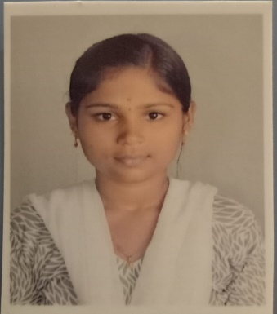

**R.K.LATHIKA**

10/20,Narayanasamy Street,

Upplipalayam,

Coimbatore-641015,

Tamilnadu.

E-mail :  lathikasuvi0811@gmail.com

Mobile : 7418060401

**OBJECTIVE:**

                       To get an opportunity where I can make the best of my potential and contribute to the organization's growth.

**EDUCATIONAL QUALIFICATION:**

|  |  |  |
| --- | --- | --- |
| **Course** | **Institution** | **Board / University** |
| BCA | Sri Ramakrishna College Of Arts & Science For Women.  Coimbatore | Bharathiyar university |
| SSLC | AVM Higher Secondary School, Coimbatore. | Tamil Nadu State Board |
| HSC | PSGR Krishnammal Matric Higher Secondary School, Coimbatore. | Tamil Nadu state Board |

**TECHICAL EXPOSURE:**

* Ms office (word , execel)
* Online courses Learnathon.
* Offline courses 2D Graphics Designing using CorelDraw and Photoshop (organized by      KICE INFOSYSTEMS ).

**WORK EXPERIENCE:**

* I Have worked in medical shop as sales girl and billing incharge.

**PERSONAL SKILLS:**

* Sincere, dedicated and Hardwork.
* Self Motivated Person
* Readiness to learn

**HOBBIES:**

* Listening music
* Watching Movies

**PERSONAL PROFILE:**

Father’s name :   R KANAGARAJ

Date of Birth          :  08-11-2003

Gender :  female

Marital Status         : Unmarried

Nationality :  Indian

Languages known :  English, Tamil.

**DECLARATION:**

     I hereby declare that the above details given by me are true to the best of my knowledge.

**PLACE:** Coimbatore

**DATE:**                                  **(R.K.LATHIKA)**