Kinematics
- A particle is moving along north after moving for 2 sec with a speed of 4 m/s, its speed becomes 5m/s.What is its displacement (in meters) at end of 7 sec

A. | 33
B. | 43
C. | 38
D. | 31

- Which of the following quantity is not a vector quantity ?
A. | Velocity
B. | Current density
C. | Current
D. | Force

- A particle is moving along east with an initial velocity of 10 m/s and acceleration is 3 m/s2 along the west. What its velocity after 5 sec is
A. | 5 m/s along east
B. | 25 m/s along east
C. | 25 m/s along west
D. | 5 m/s along west

- In the cube of side 'a' shown in the figure , the vector from the central point of the face ABOD to the central point of the face BEFO will be:
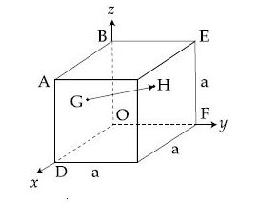
A.
B. | 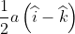
C. | 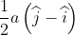
D. | 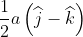

- A vector is rotated by small angle radians to get a new vector .In that case 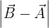 is :
A.
B. | 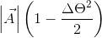
C. | 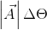
D. | 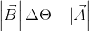

- If 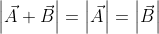 , then angle between is (in degrees)
A. | 1200
B. | 600
C. | 900
D. | 00

- The resultant of two forces 3P and 2P is R. If the first force is doubled, then the resultant is also doubled. The angle beween the forces is
A.
B.
C.
D.

- The ratio of maxium and minimum magnitudes of the resultant of two vectors and is 3:1, Now
A.
B.
C.
D.
- Two vectors have equal magnitudes. The magnitudes of 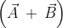 is 'n' times the magnitudes of 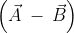. The angle between is :

A. | 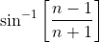
B. | 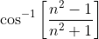
C. | 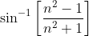
D. | 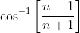

- the magniude and direction of the resultant of two vectors and in terms of their magitudes and angle between them is

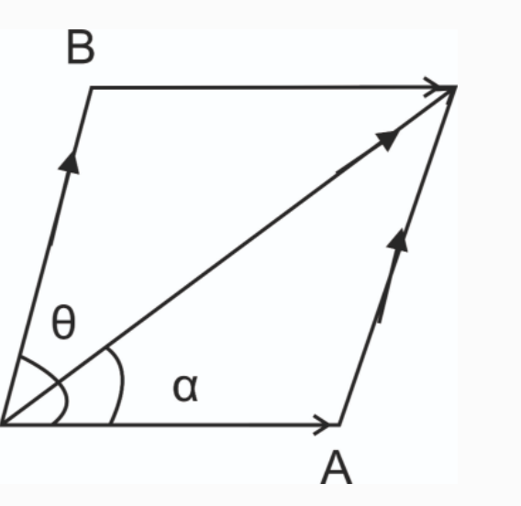

A. | 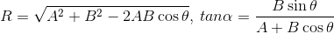
B. | 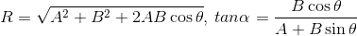
C. | 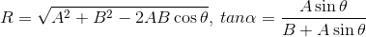
D. | 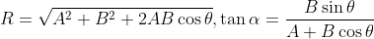

- Two forces are such that the sum of their magnitude is 18N, and their resultant is 12N which is perpendicular to the smaller force. Then the magnitude of the forces are
A.
B.
C.
D.

- Two force P and Q, of magnitude 2F and 3F, respectively, are at an angle with each other. If the force Q is doubled, then their resultant also gets doubled. Then the angle (in degrees) is :

A. | 30
B. | 60
C. | 90
D. | 120

- The sum of two forces and is such that 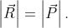 The angle (in degrees) that the resultant of and will make with is ,
A. | 90
B. | 120
C. | 45
D. | 30

- In an octagon ABCDEFGH of equal side, what is the sum of
if
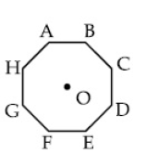
A.
B.
C.
D.

