Assignment #1. HTML Basics

Student: Abylay Latiyev Group: SE 2434

# Part 1. Introduction to HTML

## Step 0. Create a new HTML file named index.html

* + Add the basic HTML boilerplate (<!DOCTYPE html>, <html>,

<head>, <title>, <body>).

* + Title your page as "My First Webpage".

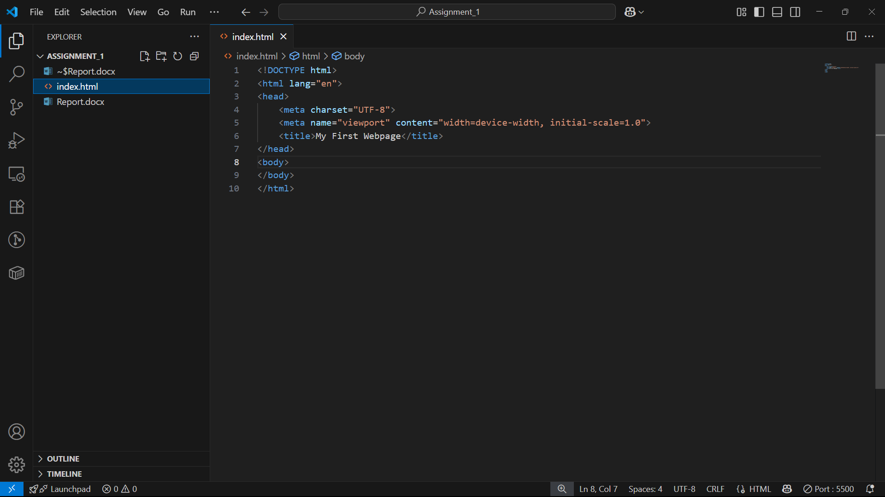

## Step 1. Structure text using HTML tags

* + Add headings <h1> to <h3> with your name, course, and "About Me".
  + Add a short paragraph <p> describing yourself.

## Step 2. HTML Lists

* + Create an ordered list <ol> of your hobbies.
  + Create an unordered list <ul> of your favorite websites.

## Step 3. Images and Links

* + Insert your photo using the <img> tag.
  + Add at least two clickable links with <a> (e.g., to your favorite websites).

## Step 4. HTML Buttons

* + Add a simple button with text "Click Me". (No functionality required yet).

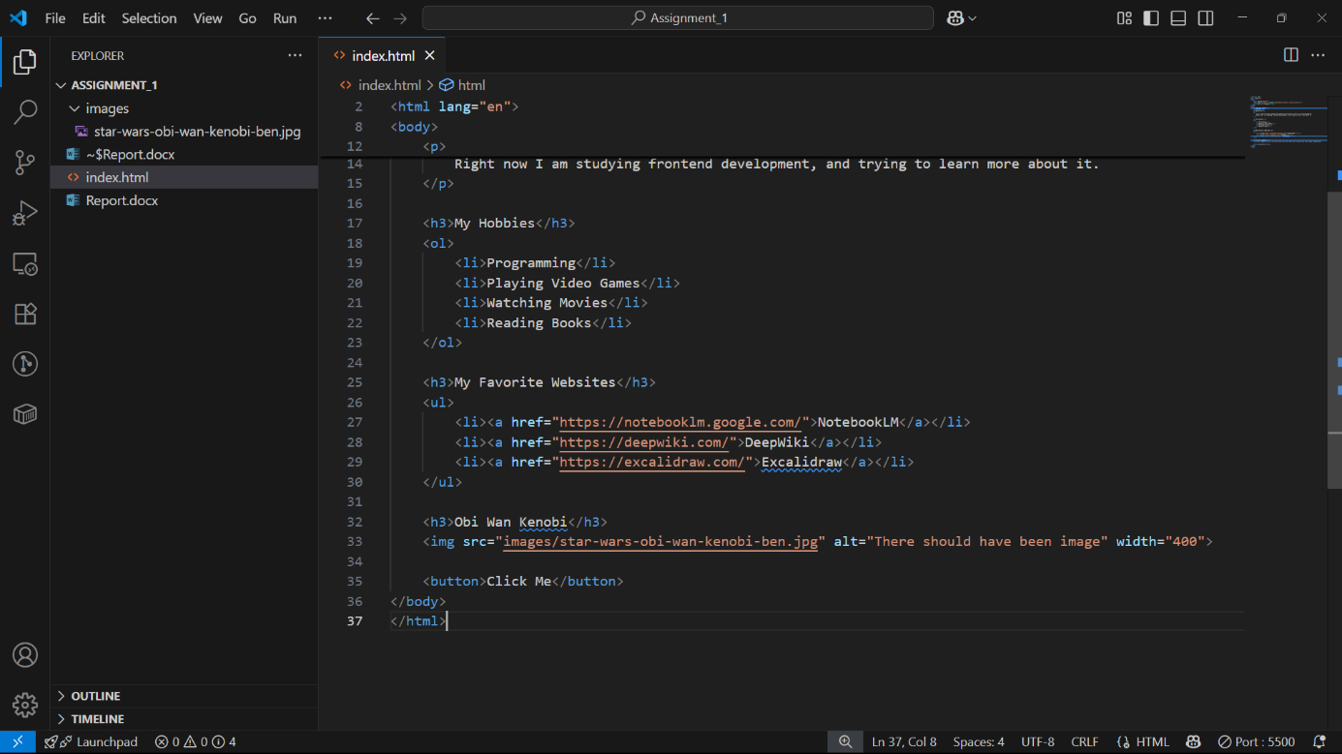

# Part 2. Intermediate HTML

## Step 5. Tables

* + Create a table with 3 columns: "Subject", "Day", "Time".
  + Fill in a simple weekly class schedule.

## Step 6. Using Tables for Layout (Optional Challenge)

* + Create a two-column layout using a table: left column (menu), right column (main content).

## Step 7. Typing Emojis

Add at least 3 emojis inside a paragraph about your mood today.

## Step8. HTML Forms

* + Create a form with the following fields:
    - Name (text input)
    - Email (email input)
    - Favorite Color (color input)
    - A Submit button

## Step 9. Publish Your First Website

* + Use GitHub Pages or Netlify to publish your home.html.
  + Submit the URL link along with your files.

**Summary**

In this assignment we created an html page and with basic html tags and published it via GitHub pages. During this assignment I learned how to create different headings, paragraphs, tables, lists, images, buttons, form input.

## Evaluation Criteria (100 points total):

1. **Functionality (15 points):**
   * Webpage includes correct HTML boilerplate and runs without errors.
   * Text is properly structured with headings, paragraphs, and lists.
   * Images, links, tables, buttons, and forms work as intended.
   * Published webpage link is functional.

## Code Quality (20 points):

* + Correct use of HTML tags and attributes.
  + Code is well-indented, readable, and logically organized.
  + Includes comments where necessary to explain sections of the code.

## User Interface (15 points):

* + Layout is clear and visually structured.
  + Content is easy to navigate (headings, sections, lists).
  + Images and links are displayed and aligned properly.

## Customization (10 points):

* + Page includes personalized content (e.g., hobbies, schedule, emojis).
  + Creativity in design (unique choices of text, images, and structure).

## Defense during Practice Lesson (30 points):

* + Student clearly explains their code and chosen structure.
  + Demonstrates understanding of HTML concepts used.
  + Answers instructor’s questions correctly with confidence.

## Report (10 points):

* + Report is well-written, clear, and concise.
  + Includes objective, description of steps taken, screenshots of webpage, and final reflection.
  + Proper formatting (headings, bullet points, or numbered sections).