FRAUDSHIELD
Credit Card Fraud Detection Platform

A Final Year Project Report

Submitted in partial fulfilment of the requirements for the award of

Bachelor of Science in Computer Science

[Student Full Name]
[Index Number]

Supervisor: [Supervisor Name]

Department of Computer Science

Date: June 2026

Abstract
Online card payments are convenient but they expose banks, payment processors, and customers to fraud. Many detection tools rely either on fixed rules that block too many genuine purchases, or on machine learning models that analysts cannot easily interpret. FraudShield is a web application built for this project that combines deterministic rules, spending-profile checks, and a hybrid deep learning ensemble (1D-CNN classifier + autoencoder anomaly detector + live-feature scorer). Each transaction receives a risk score from 0 to 100 and is stored with a full breakdown of why that score was assigned.
The system was implemented with a Flask REST API and a Next.js fraud operations console. Two staff roles are supported: fraud analyst and administrator. The cardholder self-service role was removed to align with production fraud-operations platforms used at Visa, Mastercard, and PayPal. Analysts monitor live transaction streams, triage flagged payments, inspect explainability panels, resolve disputes, and export compliance reports. Open dashboard tabs receive new transactions through a Server-Sent Events (SSE) stream rather than periodic page reloads. The database runs on PostgreSQL (hosted on Neon during development) or SQLite locally.
Training on the European benchmark dataset (creditcard.csv, 284,807 transactions) achieved ROC-AUC ~0.98, PR-AUC ~0.69, and recall ~0.89 on held-out data. Testing with seeded demo data and simulated fraud attacks showed that obvious fraud patterns are flagged correctly and that each role only sees the data it is permitted to view.

Acknowledgements
I wish to thank my project supervisor for the guidance and feedback given at each review meeting. Thanks also to the lecturers and technical staff in the Department of Computer Science for the coursework foundation that made this implementation possible. Finally, I thank my colleagues and family for their patience during the development, model training, and testing period.

Table of Contents
- Chapter 1: Introduction
- Chapter 2: Review of Related Works
- Chapter 3: Methodology
- Chapter 4: Implementation and Results
- Chapter 5: Findings and Conclusion
- References

Chapter 1: Introduction

Problem Statement
Credit card fraud remains a major cost for banks and a source of stress for customers. Institutions must spot suspicious payments quickly without blocking everyday purchases. Many still rely on manual review queues, simple rule engines, or paid scoring services that are hard to audit or adapt.
For teaching and small-scale pilots there is often no single open system that combines rule checks, spending-profile analysis, deep learning, explainable scores, dispute handling, and role-based operations dashboards. FraudShield was built to fill that gap: a web application that accepts transactions, assigns a transparent risk score, keeps an audit trail, and serves fraud analysts and administrators through separate operational views.
The original implementation used basic scikit-learn classifiers with only three runtime features. This was insufficient for modern fraud patterns described in recent research on convolutional neural networks and autoencoder-based anomaly detection. The project was therefore revamped to use state-of-the-art deep learning while preserving explainability and analyst workflows.

Aim of the Project
The aim is to design and build FraudShield—a full-stack fraud detection application that scores transactions using rules, behaviour checks, and a hybrid deep learning ensemble, then presents the results in a secure web dashboard suitable for demonstration, academic evaluation, and further development toward production-style fraud operations.

Specific Objectives of the Project
- Build a Flask REST API for login, transaction intake, scoring, reporting, and administration.
- Combine rule checks, user spending profiles, and deep learning output into one risk score (0–100).
- Train a 1D-CNN classifier and autoencoder on the European benchmark fraud dataset and load them for live scoring.
- Implement a live feature scorer for runtime transactions when merchant/geo metadata does not match offline PCA features.
- Design a PostgreSQL schema for users, transactions, decisions, disputes, and audit logs.
- Develop a Next.js dashboard with monitoring, explainability, fraud lab, and admin tools.
- Restrict pages and API data by role (analyst, admin only).
- Allow export of transaction data as CSV, PDF, and JSON.
- Produce this report with requirements, diagrams, test notes, and results aligned with the CS 4 documentation format.

Justification of the Project
Payment volumes keep growing while fraud tactics change (card-not-present abuse, account takeover, rapid small purchases). Banks and fintech operators need automation that analysts can still understand and challenge. Building the system from scratch allowed controlled experiments with scoring logic, seeded data, model retraining, and full traceability—things that are difficult to study on closed commercial products.
The revamp to deep learning is justified by three published works (Pumsirirat & Yan, 2018; Alarfaj et al., 2022; Roy et al., 2018) that demonstrate superior performance on imbalanced transaction data when CNN and autoencoder architectures are applied. A layered approach—rules first, then behaviour, then ML—mirrors how Visa, Mastercard, and PayPal structure real-time authorisation checks.

Motivation for Undertaking Project
Cases of unauthorised card use in the news demonstrate how software can detect suspicious activity before large losses occur. The project also provided practical experience in building an API, connecting a cloud database, training deep learning models with TensorFlow, and shipping a working interface—skills that apply directly to fintech and general software engineering roles.
The decision to remove the cardholder role reflected a shift from a consumer-facing demo to an internal fraud operations console, which is how enterprise detection systems are actually used in practice.

Scope of the Project
In scope
- Public landing page with product overview and authentication entry points for analysts and administrators.
- User registration, login, password recovery (OTP), and optional Google/GitHub OAuth.
- Transaction ingestion via manual form, REST API, background simulator, and admin reseed.
- Hybrid fraud scoring with persisted FraudDecision records and UserProfile updates.
- Dashboard modules: overview, monitoring, capture, flagged queue, disputes, fraud lab, explainability, analytics, alerts, reports, admin, profile.
- Live dashboard updates via Server-Sent Events when new transactions are ingested.
- New accounts require administrator approval before the operations console is unlocked.
- PostgreSQL database (Neon cloud or local SQLite) with Flask-Migrate schema management.
- JWT authentication and two application roles (analyst, admin).
- Admin model retrain endpoint wired to ml/train_model.py.
Out of scope (for this version)
- Integration with live payment network switches (Visa/Mastercard authorisation rails).
- Production-grade SMS/email gateways (alerts are stored as database records and in-app notifications).
- Formal SHAP/LIME integration (explainability uses documented feature contribution approximation).
- Horizontal auto-scaling, Kubernetes orchestration, and multi-region disaster recovery.

Project Limitations
- Cloud-hosted PostgreSQL (Neon) introduces network latency on ingest compared to local SQLite; reseeding 80 transactions through live ML scoring takes several minutes.
- Offline DL models train on Kaggle PCA features (V1–V28); live ingest maps merchant/geo metadata to proxy features and uses a live feature scorer when domain shift is detected.
- 2FA toggle is a demonstration flag without full TOTP hardware key integration.
- OAuth and email features depend on correct environment configuration in backend/.env.
- Some dashboard KPIs use cached aggregates; cache invalidation occurs on ingest and reseed.

Beneficiaries of the Project
- Banks and fintech startups seeking a reference architecture for fraud operations consoles.
- Fraud analysts who need prioritised queues, explainability, dispute resolution, and export tools.
- Computer science students studying secure full-stack and ML-hybrid system design.
- Supervisors and examiners evaluating final-year software engineering competence.
- Administrators who manage user approvals, fraud rules, and model operations.

Academic and Practical Relevance of the Project
The work applies the software engineering lifecycle—requirements, UML, implementation, and testing—to a problem that mixes security and machine learning. It demonstrates how published deep learning research can be translated into a working prototype with layered scoring, RBAC, and audit trails. The finished system could be extended with payment webhooks, stronger hosting, and formal compliance review if taken beyond the classroom.

Project Activity Planning and Schedules
Phase | Activities | Duration
1 | Requirements gathering, literature review (3 research papers), stakeholder analysis | 2 weeks
2 | System design (architecture, UML, ERD, wireframes) | 2 weeks
3 | Backend API, PostgreSQL schema, migrations | 4 weeks
4 | ML training pipeline revamp (CNN + AE), fraud engine, ingest pipeline | 3 weeks
5 | Next.js dashboard, RBAC revamp, SSE notifications, disputes | 4 weeks
6 | Integration testing, documentation, demo preparation | 2 weeks

Structure of Report
Chapter 1 states the problem, objectives, and scope. Chapter 2 compares existing approaches, describes related research, and presents the FraudShield architecture. Chapter 3 covers requirements, UML models, security, and design. Chapter 4 explains how the system was built, presents algorithms, code snippets, and test results. Chapter 5 summarises outcomes, limitations, and possible next steps.

Project Deliverables
- FraudShield web application (frontend and backend source code in this repository).
- PostgreSQL/SQLite database schema with Flask-Migrate migrations and realistic seed data.
- Trained DL artifacts (fraud_cnn.keras, fraud_autoencoder.keras, feature_scaler.joblib, metrics.json).
- This project documentation (Word and Markdown formats).
- Operational manual and demo credentials (README.md, backend/README.md).
- Architecture, UML, and data-flow diagrams (scripts/doc_assets/*.png).
- Test evidence and sample exported reports (CSV, PDF, JSON).

Chapter 2: Review of Related Works / Review of Similar Systems

Processes of the Existing System (System Features, Pros and Cons)

Traditional manual review
Analysts work from spreadsheets or separate case tools, calling customers to verify unusual charges. This works for ambiguous cases but does not scale: queues grow quickly, labour cost is high, and audit trails are often incomplete.
Pros | Cons
Human judgment for edge cases | Slow; does not scale
Direct customer contact | Incomplete audit trails
Low technology cost | No automated prioritisation

Rule-only engines
Authorisation systems apply fixed thresholds—amount limits, velocity counts, country blocks. Rules are fast and easy to explain, but they generate many false alarms and cannot easily reflect how an individual customer normally spends.
Pros | Cons
Fast execution (milliseconds) | High false positive rate
Fully explainable | Cannot personalise per user
Easy to configure | Fraudsters adapt quickly

ML-only black-box scoring
Vendors train gradient boosting or neural networks on large labelled datasets. Accuracy on historical data can be strong, but analysts may not see why a score was assigned, regulators may ask for justification, and new merchants or users start with little history.
Pros | Cons
Strong on historical patterns | Poor explainability
Handles complex feature interactions | Cold-start for new users
Automated scoring | Hard to audit without tooling

Commercial fraud platforms
Enterprise products (for example FICO Falcon-class systems, SAS Fraud Management, Feedzai) bundle case management, analytics, and model operations. They are mature but expensive, closed-source, and slow to integrate.
Pros | Cons
Mature case management | Very expensive
Production-scale throughput | Closed source
Regulatory track record | Long integration cycles

Related Research Guiding This Implementation
Three published works directly informed the deep learning revamp:
1. Pumsirirat & Yan (2018) — Credit Card Fraud Detection using Deep Learning based on Auto-Encoder and Restricted Boltzmann Machine (IJACSA). Argues that fraud patterns change rapidly and unsupervised anomaly detection complements supervised classifiers. Auto-encoders reconstruct normal transactions; high reconstruction error signals fraud. References PayPal-scale real-time needs. FraudShield adoption: dense autoencoder branch trained on legitimate Kaggle traffic.
2. Alarfaj et al. (2022) — Credit Card Fraud Detection Using State-of-the-Art ML and DL Algorithms (IEEE Access). Compares RF, XGBoost, SVM against CNN architectures on creditcard.csv. CNN layers outperform traditional classifiers on imbalanced data. FraudShield adoption: 1D-CNN classifier on 31 PCA-style features with batch normalisation, dropout, and class-weighted training.
3. Roy et al. (2018) — Deep Learning Detecting Fraud in Credit Card Transactions (UVA/IEEE). Evaluates ANN, LSTM, GRU topologies on large-scale labelled data. Highlights parameter sensitivity and class imbalance. FraudShield adoption: hybrid supervised + unsupervised fusion, velocity/recency features, and production-style layered scoring.

The Proposed System
FraudShield combines rules, spending-profile checks, and hybrid deep learning probability into a single 0–100 risk score. A Flask API stores every decision with a component breakdown (rule_score, behavior_score, ml_score, ml_probability, reasons). A Next.js dashboard enforces role-based access, supports dispute resolution, lets admins toggle rules in the live engine, retrain models, and records audit entries for sensitive actions.

Conceptual Design
The system has four conceptual layers:
- Presentation layer — Next.js pages for landing, authentication, and the operations dashboard.
- Application layer — Flask route handlers and domain services for scoring, ingest, RBAC, caching, and reports.
- Scoring layer — Rules engine, behaviour engine, and deep learning inference module.
- Data layer — SQLAlchemy ORM mapping to PostgreSQL tables.
Scoring logic stays on the server so models and authorisation rules are not exposed in the browser.

Architecture of the Proposed System
The architecture follows a three-tier client–server model extended with a dedicated scoring tier for hybrid fraud detection.
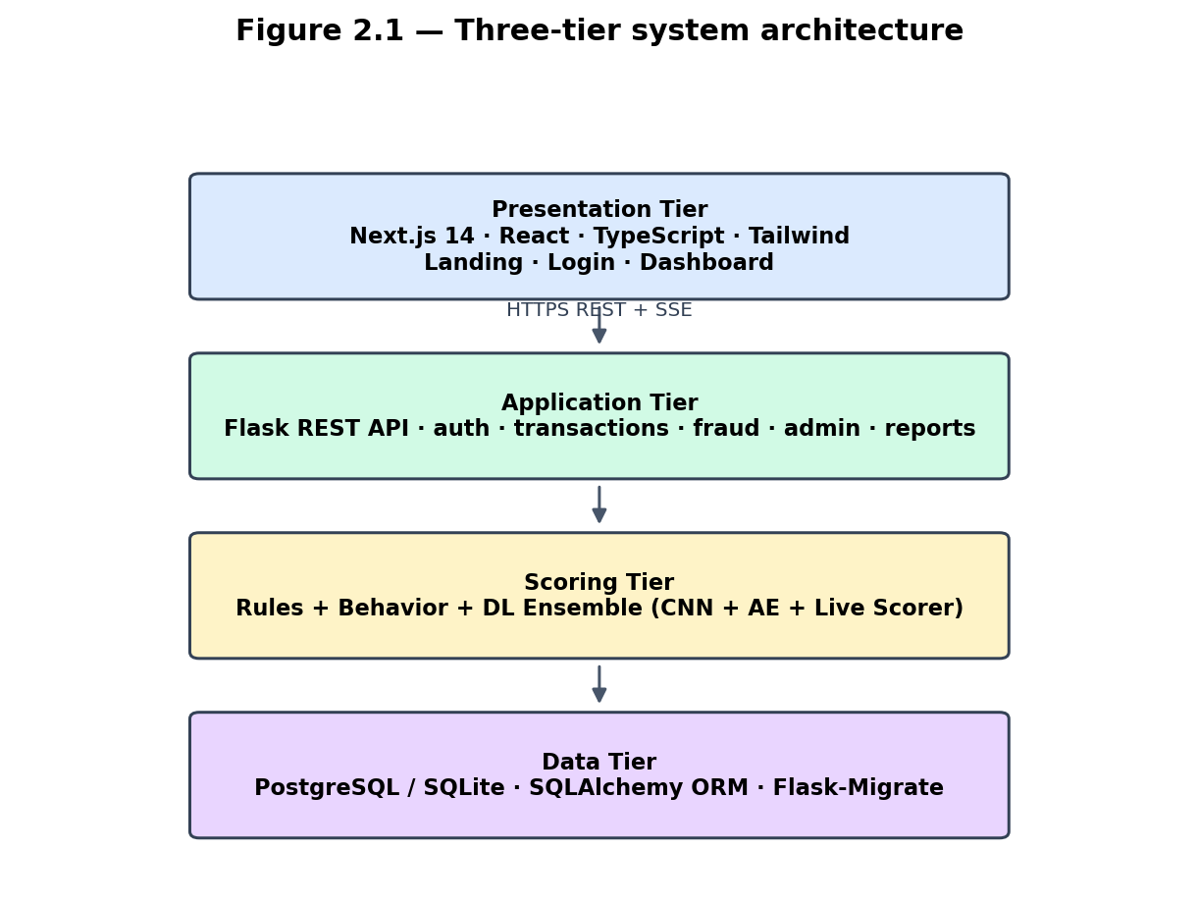
Figure 2.1: Three-tier system architecture of FraudShield
Data flow (transaction lifecycle):
- Client submits transaction payload to POST /transactions/ingest.
- transaction_ingest.py calls evaluate_transaction() in the fraud engine.
- Rules, behaviour, and ML scorers produce component scores and reasons.
- Transaction and FraudDecision rows are persisted; UserProfile is updated.
- If risk_score >= 60, status is set to flagged and alerts are created.
- SSE event is broadcast to connected dashboard clients.
- Analyst reviews flagged item in monitoring queue or explainability panel.
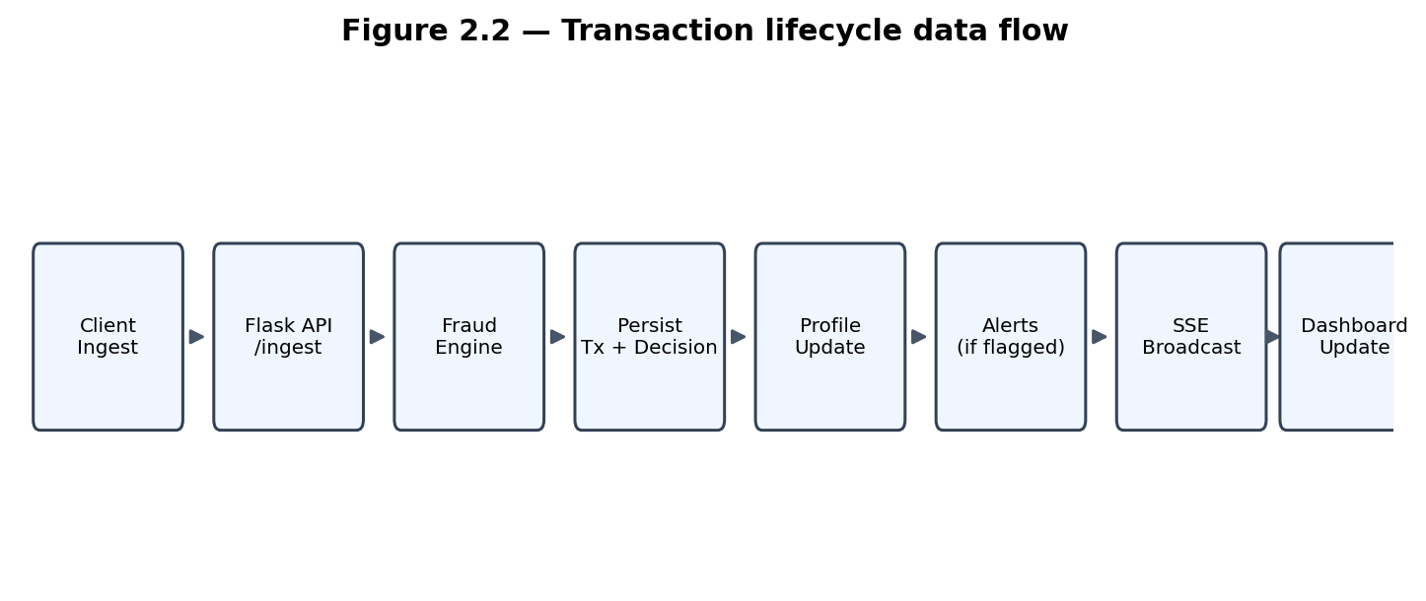
Figure 2.2: Data flow through the transaction lifecycle

Components Designs and Component Descriptions

Authentication Component
Handles registration, login, password reset via OTP, optional Google/GitHub OAuth, and JWT issuance. Passwords are hashed with bcrypt. Tokens carry user id and role claims consumed by protected routes. New registrations default to pending analyst status until an administrator approves the account. A lightweight session cookie supports Next.js middleware redirects.

Transaction Ingest Component
Centralised in transaction_ingest.py. Receives transaction payloads, invokes evaluate_transaction(), persists Transaction and FraudDecision rows, updates UserProfile aggregates, writes AuditLog entries, invalidates read caches, and triggers alerts when risk_score >= 60. The same pipeline is used by manual ingest, the background simulator, and admin reseed—ensuring consistent scores across all entry points.

Fraud Scoring Component
Orchestrates three scorers in fraud/engine.py:
- Rule engine — amount thresholds ($5,000+), velocity (5+ txs in 10 minutes), location change; admin-configurable FraudRule catalog.
- Behavior engine — profile averages, top-3 locations, amount jump vs previous transaction.
- ML module — 1D-CNN + autoencoder hybrid on 31 features; live feature scorer at runtime.
Scores are summed and capped at 100. Detailed algorithms are presented in Chapter 4.

Deep Learning Component
Implemented in backend/ml/train_model.py and backend/app/fraud/model.py:
- Training: CNN classifier + autoencoder on Kaggle creditcard.csv (or synthetic bootstrap).
- Offline fusion: probability = 0.75 × cnn_prob + 0.25 × ae_score.
- Live inference: when proxy features diverge from Kaggle PCA space, live_fraud_probability() provides calibrated runtime scoring from merchant category, geo risk, amount, velocity, and user baseline.

Dashboard Analytics Component
Aggregates transaction statistics via dashboard_stats.py for charts and KPIs. Applies RBAC scoping so only staff (analyst, admin) see global aggregates. Caching improves response time; caches invalidate on ingest and reseed.

Disputes Component
Allows staff to open and resolve dispute cases on flagged transactions. Status tracked in DisputeCase entity linked 1:1 to Transaction.

Administration Component
Administrators list users, approve access requests, change roles, suspend accounts, toggle fraud rules (wired to live rule engine), reseed realistic demo data, trigger model retrain, and purge transaction data—with audit logging on sensitive actions.

Reporting Component
Exports CSV transaction dumps, JSON summaries, audit JSON, and PDF summary reports using fpdf2.

Live Updates Component
After ingest the backend publishes a JSON event to all connected dashboard clients via GET /transactions/stream. The browser opens an EventSource connection; monitoring, overview, and alert pages patch local state when an event arrives.
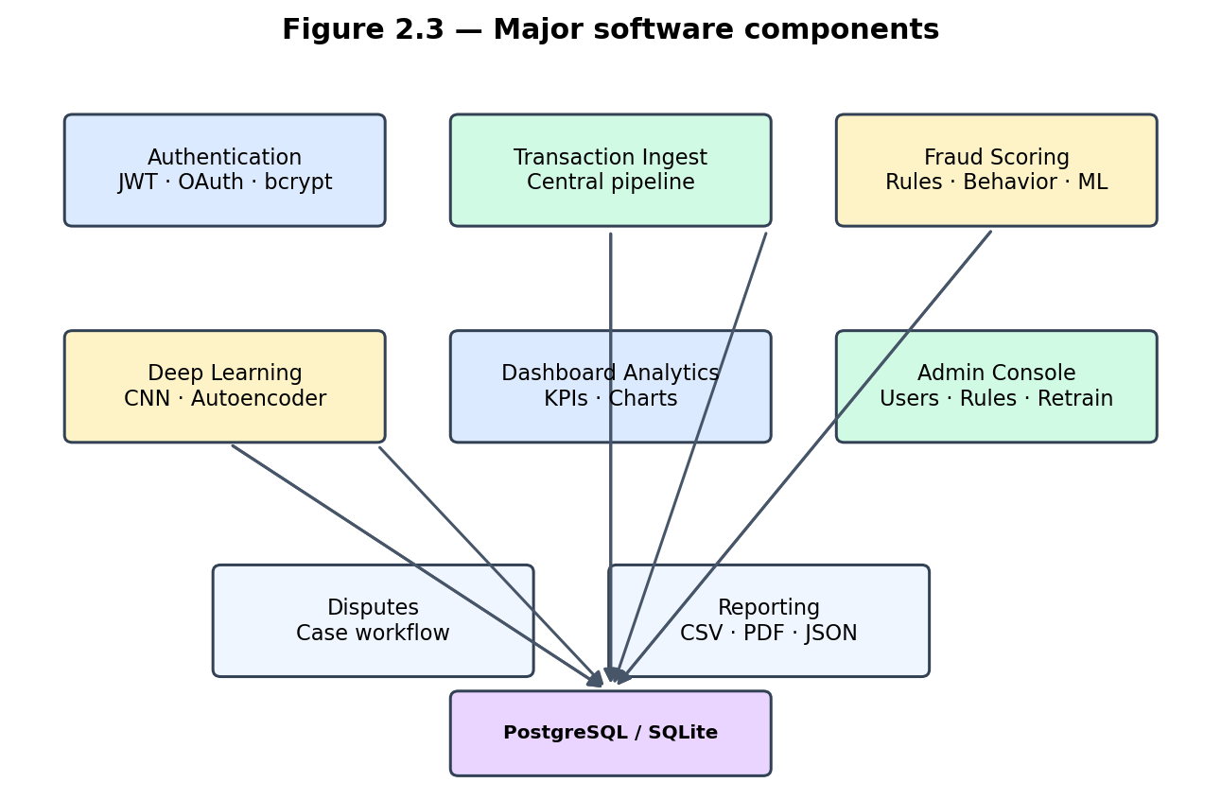
Figure 2.3: Major software components and dependencies

Proposed System / Software Features
Feature | Description
Landing page | Product overview for analysts and administrators; role-based CTAs
Auth & OAuth | Email/password, JWT, optional Google/GitHub sign-in
RBAC | Analyst and admin roles with route guards and API scoping
Transaction capture | Manual ingest, API, live simulator (staff)
Hybrid fraud scoring | Rules + behavior + DL with confidence %
Explainability | Feature contribution breakdown per transaction
Monitoring & flagged queue | Search, filter, approve/flag/freeze actions
Disputes workflow | Open, review, resolve flagged transaction disputes
Dashboard analytics | KPI cards, line/bar charts, heatmap, activity feed
Alerts & notifications | In-app feed; SSE push when new transactions arrive
Access requests | New users request analyst/admin role; admin approves
Reports | CSV, PDF, JSON exports for auditors
Admin console | Users, rules, reseed, model retrain
Fraud lab | Simulate transactions without persisting (dry-run scoring)

Development Tools and Environment
Category | Tools / Versions
Backend | Python 3.11+, Flask, SQLAlchemy, Flask-JWT-Extended, Marshmallow, Flask-Migrate
Database | PostgreSQL (Neon), psycopg2-binary; SQLite for local dev
ML | TensorFlow 2.20+, pandas, scikit-learn (scaler), joblib, numpy
Frontend | Node.js, Next.js 14, TypeScript, Tailwind CSS, Chart.js
Reports | fpdf2 for PDF generation
IDE / VCS | Visual Studio Code / Cursor, Git
Testing | Browser devtools, API calls, manual role-based flows

Benefits of Implementation of the Proposed System
- Every ingest receives an automated hybrid score without waiting for manual review.
- Analysts work from a prioritised queue with explainability and dispute tools.
- Each decision stores rule, behaviour, and ML contributions for later review.
- Deep learning ensemble aligns with published research on European benchmark data.
- Open-source stack keeps cost low for teaching and pilot use.
- Modular code allows payment webhook integration in a later phase.

Chapter 3: Methodology

Chapter Overview
This chapter presents the requirements, UML models, security design, database schema, UI wireframes, and development methodology used to build FraudShield. The design follows an Agile-inspired iterative approach with vertical slices delivered across six project phases.

Requirement Specification

Stakeholders of System
Stakeholder | Interest
Fraud analyst | Monitor queues, investigate, explain, resolve disputes, export reports
System administrator | Manage users, rules, seed data, model retrain, system health
Developer | Maintain, extend, and deploy codebase
Examiner / supervisor | Evaluate academic deliverables and demonstration

The cardholder role was removed. FraudShield is an internal operations platform.

Requirement Gathering Process
Requirements came from reading fraud-detection papers (Pumsirirat & Yan, 2018; Alarfaj et al., 2022; Roy et al., 2018), inspecting features in commercial products (Visa/Mastercard-style layered defense), meetings with the project supervisor, and iterative prototyping (manual transaction entry, live simulator, role-based menus). Demo accounts were used to confirm that each role behaved as expected. The revamp from scikit-learn to TensorFlow was driven by supervisor feedback and literature review showing CNN/AE superiority on imbalanced transaction data.

Functional Requirements
ID | Requirement
FR1 | System shall allow users to register, login, and recover passwords securely
FR2 | System shall support optional OAuth sign-in (Google, GitHub)
FR3 | System shall ingest transactions with merchant, location, amount, device metadata
FR4 | System shall compute and store fraud risk score 0–100 and ML confidence per transaction
FR5 | System shall flag transactions when score >= 60
FR6 | Analysts shall search, filter, and action transaction lists (approve/flag/freeze)
FR7 | System shall provide explainability for a given transaction id
FR8 | Staff shall open and track dispute cases on flagged transactions
FR9 | Analysts shall resolve disputes with approve/reject and resolution notes
FR10 | Admins shall manage user roles, activation, fraud rule toggles, and model retrain
FR11 | System shall export CSV, PDF, and JSON reports
FR12 | Only staff roles (analyst, admin) shall access the operations console
FR13 | Staff shall run live transaction simulator and reseed demo data
FR14 | New accounts shall require administrator approval before console access
FR15 | Dashboard shall receive live transaction updates via SSE without full page reload

UML Diagrams

Use Case Diagram (System Overview)
Actors: Fraud Analyst, Administrator, Unauthenticated Visitor
Analyst use cases: Login, View Dashboard, Monitor Transactions, Ingest Transaction, Review Flagged Queue, Explain Transaction, Resolve Dispute, Export Report, Run Fraud Simulation
Admin use cases: (all analyst cases) + Manage Users, Approve Access Requests, Toggle Fraud Rules, Reseed Data, Retrain Models, Purge Transaction Data
Visitor use cases: View Landing Page, Register, Login
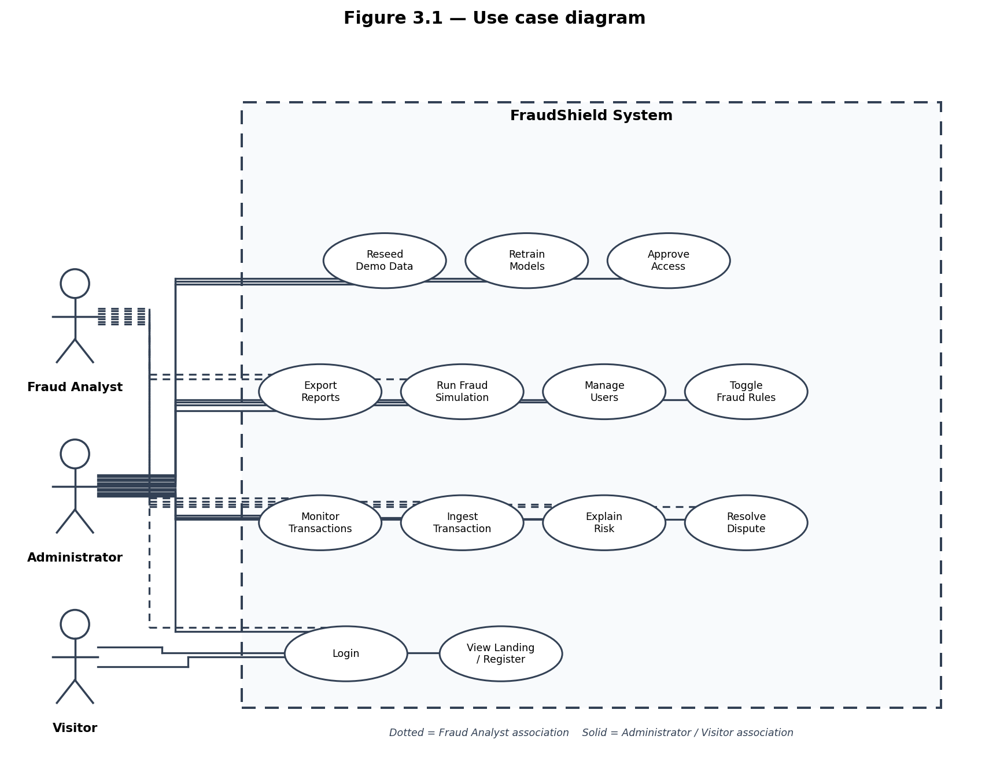
Figure 3.1: Use case diagram — actors and primary use cases

Activity Diagram — Transaction Ingest Pipeline
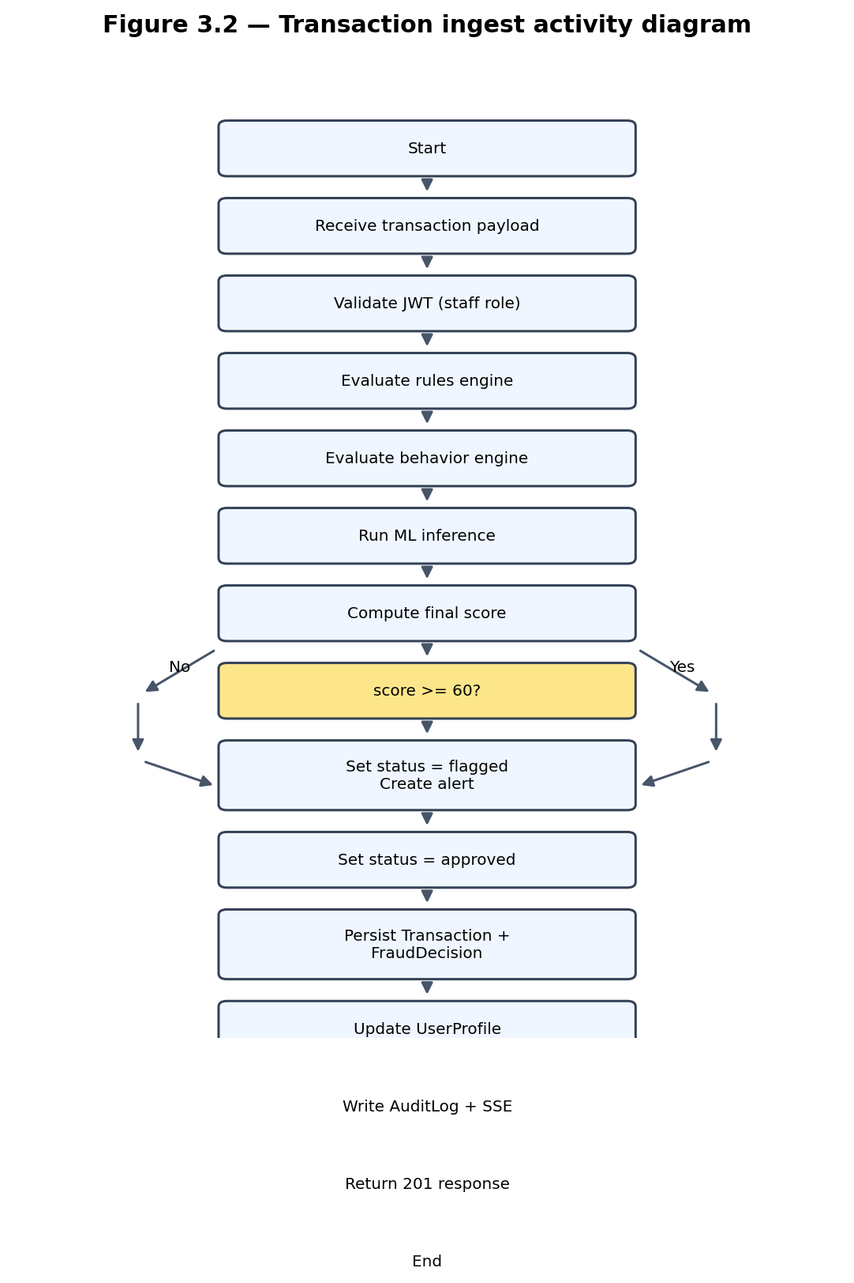
Figure 3.2: Activity diagram — transaction ingest pipeline

Sequence Diagram — Login and Dashboard Load
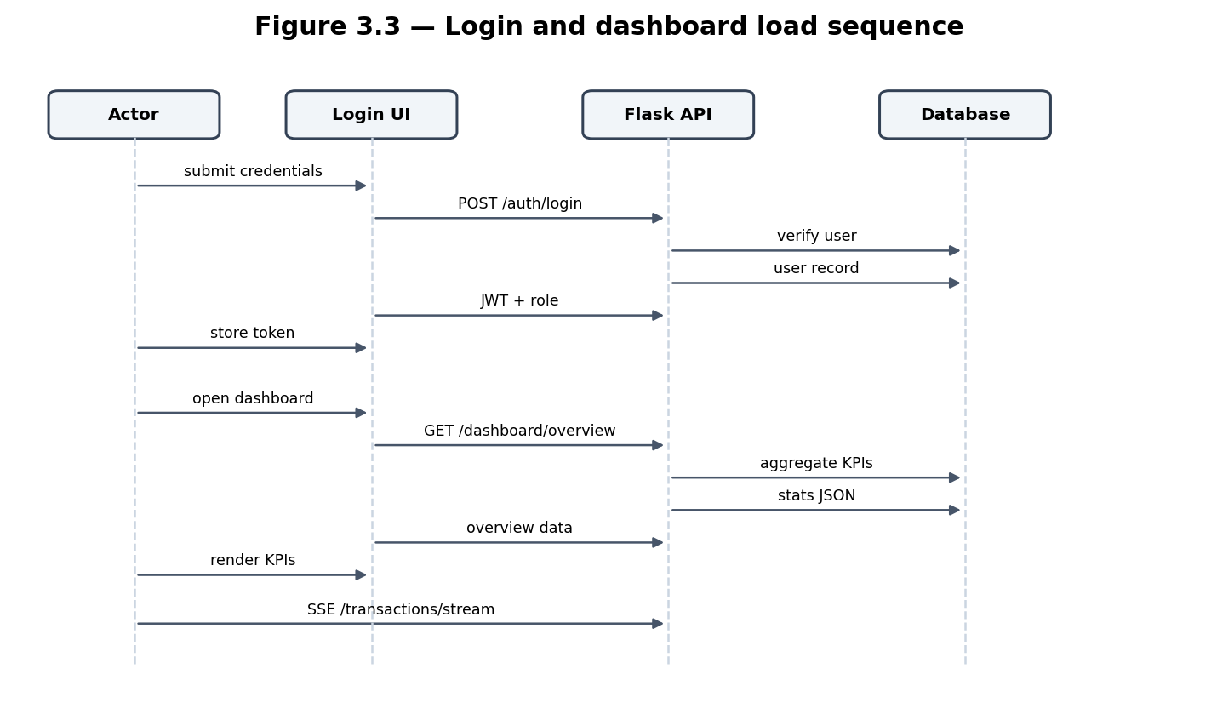
Figure 3.3: Sequence diagram — login and dashboard load

Class Diagram — Core Domain Entities
Class | Key Attributes | Relationships
User | id, email, role, password_hash, approved | 1:N Transaction; 1:1 UserProfile
Transaction | amount, location, risk_score, confidence, status | N:1 User; 1:1 FraudDecision
FraudDecision | rule_score, behavior_score, ml_score, reasons | 1:1 Transaction
UserProfile | avg_spend, top_locations, tx_count | 1:1 User
DisputeCase | reason, status, resolution_note | 1:1 Transaction
FraudRule | name, enabled, priority | Catalog for rule engine
AuditLog | action, entity, actor_user_id | Standalone audit trail

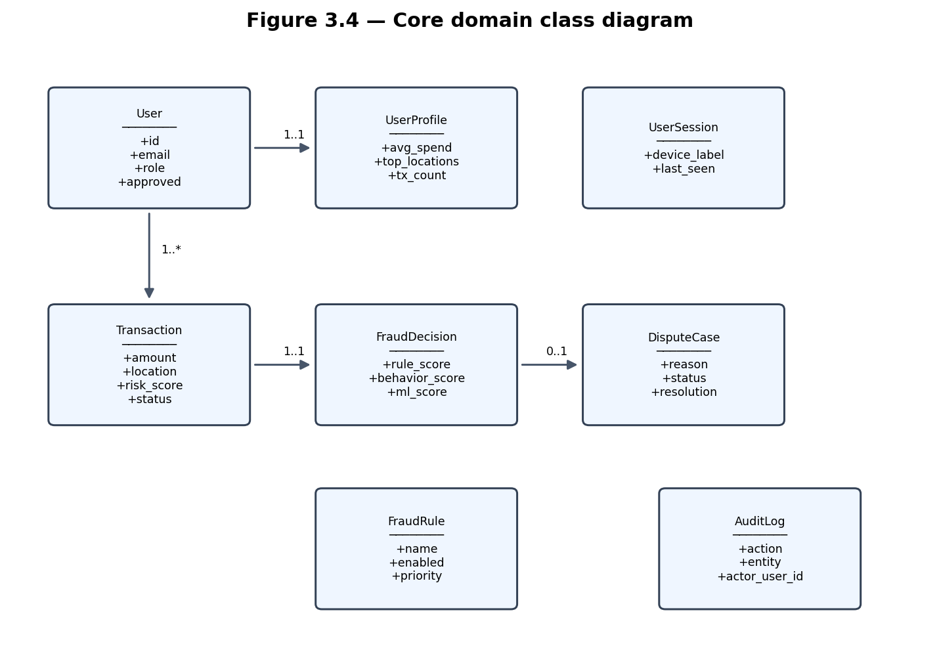
Figure 3.4: Class diagram — core domain entities

Use Case Descriptions
Use Case | Actor | Description | Precondition | Postcondition
Login | All users | Submit email/password; system returns JWT | Registered account | Token stored; session cookie set
OAuth Login | All users | Redirect to Google/GitHub; link or create account | OAuth configured | JWT issued; pending approval if new
Ingest Transaction | Analyst/Admin | Submit tx data; system scores and stores | Valid staff JWT | Transaction + FraudDecision saved
Review Flagged Queue | Analyst/Admin | List and filter flagged transactions | Staff JWT | Analyst selects case for action
Explain Transaction | Analyst/Admin | Return risk drivers for tx id | Tx exists; authorised | Explanation JSON displayed
Resolve Dispute | Analyst/Admin | Approve or reject open dispute | Open dispute exists | DisputeCase status updated
Manage Users | Admin | List, patch roles, suspend users | Admin JWT | User record updated; audit logged
Reseed Data | Admin | Purge + insert realistic demo transactions | Admin JWT | Database repopulated; caches invalidated
Retrain Models | Admin | Run train_model.py subprocess | Admin JWT | New artifacts saved; models reloaded
Export CSV | Analyst/Admin | Download transactions file | Staff JWT | CSV file downloaded

Non-Functional Requirements
ID | Requirement | Justification
NFR1 | API ingest completes within acceptable latency for demo (< 30s on Neon with ML) | Usable real-time demonstration
NFR2 | Passwords stored with bcrypt hashing | Industry security standard
NFR3 | JWT expiry configured (24h default) | Balance security and user experience
NFR4 | Responsive UI from 768px width upward | Tablet-friendly operations console
NFR5 | CORS enabled for separated Next.js/Flask origins | Local and deployed dev setup
NFR6 | Audit log for sensitive admin and ingest actions | Compliance traceability
NFR7 | Read cache invalidation on data mutations | Dashboard KPI accuracy
NFR8 | ML model reload without server restart (admin retrain) | Operational flexibility
NFR9 | Consistent scores across ingest, simulator, and reseed | Data integrity for demos

Security Concepts
- Authentication: JWT bearer tokens in Authorization header; invalid/expired tokens return 401; client clears session.
- Authorization: Role claims enforced in routes and rbac.py; staff-only global transaction scope.
- Password security: bcrypt hashing; minimum 8 characters enforced on registration.
- Password reset: time-limited OTP tokens in PasswordResetToken; OTP marked used after reset.
- Session cookie: fraudshield_session for Next.js middleware route protection; not a substitute for API JWT.
- OAuth: Google/GitHub tokens exchanged server-side; new social users assigned pending analyst status.
- Transport: HTTPS recommended in production; development uses localhost.
- Input validation: Marshmallow schemas on API payloads; SQL injection mitigated via ORM parameterisation.
- Approval workflow: approved=false blocks console access until administrator action.

Project Methods

Software Process Models (Brief)
- Waterfall — fixed requirements, sequential phases; rigid for changing prototypes.
- Agile — iterative delivery, frequent feedback; suits evolving requirements.
- Spiral — risk-driven iterations with explicit risk analysis each cycle.
- V-Model — each design step paired with a test activity.
- DevOps — continuous integration, deployment, and monitoring.
None of these was followed strictly; elements of Agile fit the academic schedule best.

Chosen Model and Justification
Work proceeded in vertical slices: backend and database first, then ML scoring revamp, then frontend modules (auth, dashboard, capture, disputes, admin). Requirements shifted during development (Neon migration, cardholder removal, DL revamp, SSE updates, live feature scorer fix), so a rigid waterfall plan would have slowed progress. Short cycles aligned with supervisor meetings roughly every two weeks.
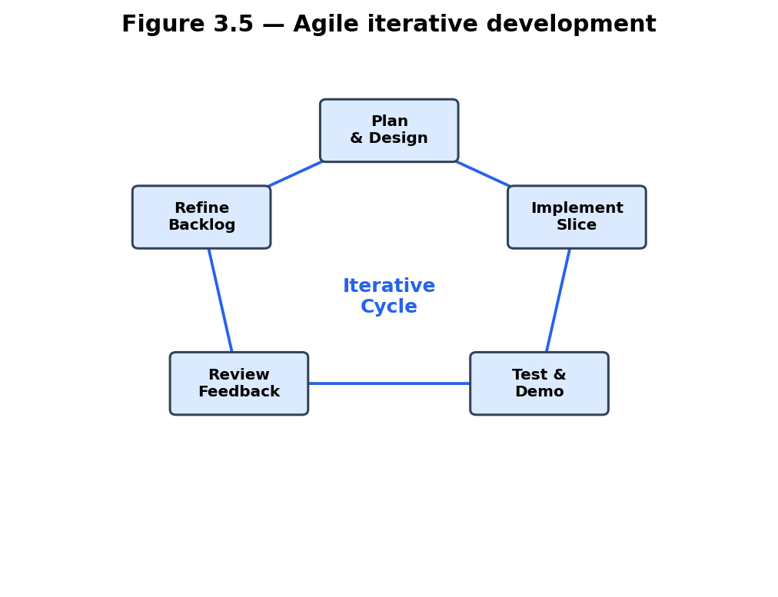
Figure 3.5: Agile iterative development with feedback loop

Project Design Consideration (Logical Designs)

UI Design
The dashboard follows a consistent AppShell layout with sidebar navigation, header bar, and content panels.
Landing page wireframe: centred hero with headline, subcopy, Sign in / Request access CTAs; scrollable sections for How it works, Roles (analyst vs admin), and footer with product/account links. Nav and content share unified max-w-4xl column.
Login/Register wireframe: centred form cards; register includes role selector (analyst/admin).
Dashboard layout wireframe: collapsible sidebar + header (search, notifications, account menu) + scrollable content panel.
Overview wireframe: four KPI icon cards, fraud trend line chart, bar charts, geographic heatmap, recent activity feed.
Monitoring wireframe: filterable paginated data table with row-level approve/flag/freeze actions; risk score and confidence columns.
Capture wireframe: manual transaction form with merchant, amount, location, device fields; staff see live simulator toggle.
Fraud Lab wireframe: simulate scoring panel with CNN/AE/live scorer output and feature attribution bars.
Admin wireframe: user table, fraud rule toggles, pending role requests, reseed button, model retrain button.
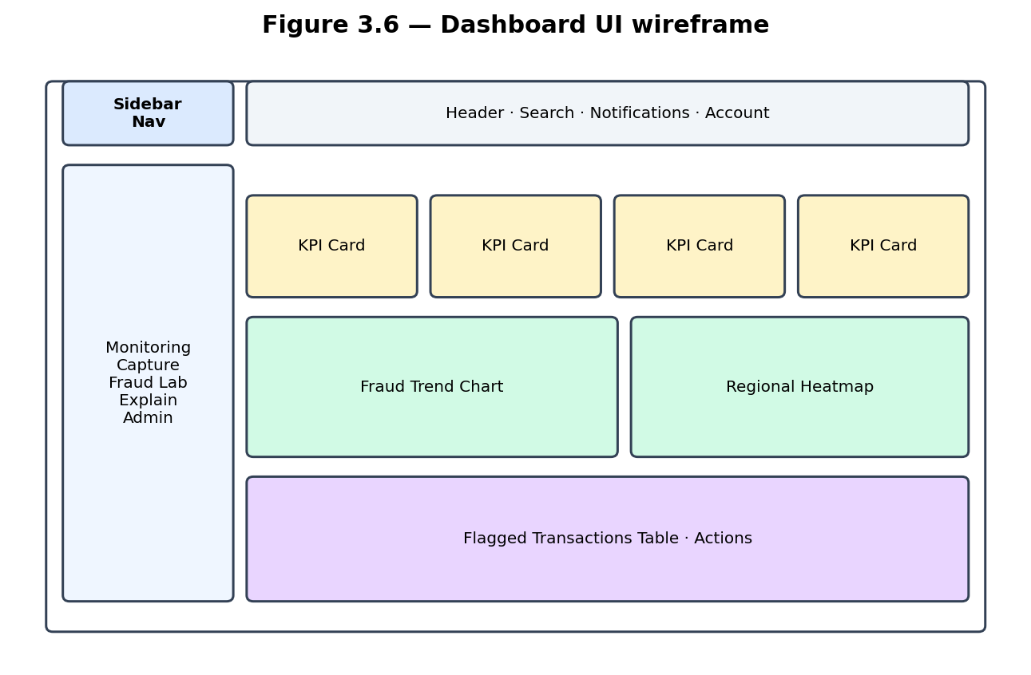
Figure 3.6: UI wireframe — dashboard layout structure

DB Design
The relational schema normalises users, transactions, scoring decisions, disputes, and audit evidence.
Entity-Relationship summary:
- User (1) —— (N) Transaction
- User (1) —— (1) UserProfile
- Transaction (1) —— (1) FraudDecision
- Transaction (0..1) —— (1) DisputeCase
- Transaction (1) —— (N) Alert / FraudNotification
- FraudRule — standalone catalog (no FK to transactions; toggles affect live engine)
- AuditLog — standalone audit trail with optional actor_user_id FK to User
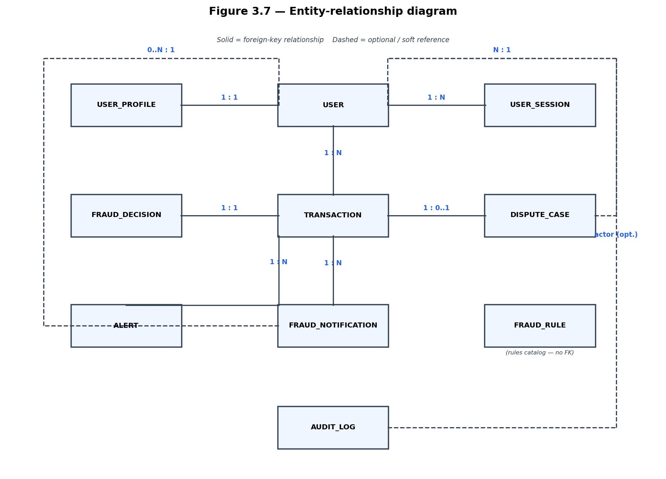
Figure 3.7: Entity-relationship diagram
Entity | Key Attributes | Relationships
User | id, email, role, password_hash, approved | 1:N Transaction; 1:1 UserProfile
Transaction | amount, location, risk_score, confidence, status | N:1 User; 1:1 FraudDecision
FraudDecision | rule_score, behavior_score, ml_score, ml_probability | 1:1 Transaction
UserProfile | avg_spend, top_locations, tx_count | 1:1 User
DisputeCase | reason, status, resolution_note | 1:1 Transaction
FraudRule | name, enabled, priority | Catalog; toggles affect live engine
AuditLog | action, entity, actor_user_id | Standalone audit trail

Primary keys are integer id columns. Foreign keys enforce referential integrity. Flask-Migrate versioned migrations apply schema changes. Indexes on user_id, created_at, and status support monitoring queries.

Developmental Tools (Detailed)
Flask provides routing and blueprint modularity; each domain (auth, transactions, fraud) is isolated in its own package. Route handlers validate input via Marshmallow schemas and delegate to service modules.
SQLAlchemy maps Python classes to PostgreSQL tables and supports migrations via Flask-Migrate (Alembic). The ORM prevents raw SQL injection and simplifies relationship navigation.
TensorFlow/Keras trains and serves the 1D-CNN classifier and dense autoencoder. Models are saved as .keras files and loaded at runtime in app/fraud/model.py. joblib persists the StandardScaler fit on training data.
Next.js App Router enables file-based routing with client and server components; middleware protects /dashboard routes using the session cookie.
Chart.js renders fraud trend visualisations client-side from dashboard API endpoints.
Neon serverless PostgreSQL provides cloud-hosted persistence for demonstration; SQLite is used for local development without network latency.
fpdf2 generates PDF summary reports for auditor export.
Server-Sent Events provide one-way server-to-client streaming for live transaction updates without WebSocket complexity.

Chapter 4: Implementation and Results

Chapter Overview
This chapter maps the logical design onto the physical codebase, presents the fraud scoring and ingest algorithms, shows representative code snippets, describes the testing approach, and reports results from demo scenarios including simulated fraud attacks.

Mapping Logical Design onto Physical Platform
Logical Component | Physical Implementation
Presentation layer | frontend/app/ — Next.js pages and components
API layer | backend/app/*/routes.py — Flask blueprints
Fraud engine | backend/app/fraud/engine.py, rules.py, behavior.py, model.py
ML training | backend/ml/train_model.py, features.py, bootstrap_model.py
Ingest pipeline | backend/app/services/transaction_ingest.py
Dashboard stats | backend/app/services/dashboard_stats.py
RBAC | backend/app/services/rbac.py, frontend/lib/roles.ts
Database | backend/app/models.py, migrations/, Neon DATABASE_URL
Caching | backend/app/services/cache.py
Live updates | backend/app/services/live_events.py, SSE client

Algorithms and Flowcharts

Algorithm: Fraud Score Fusion
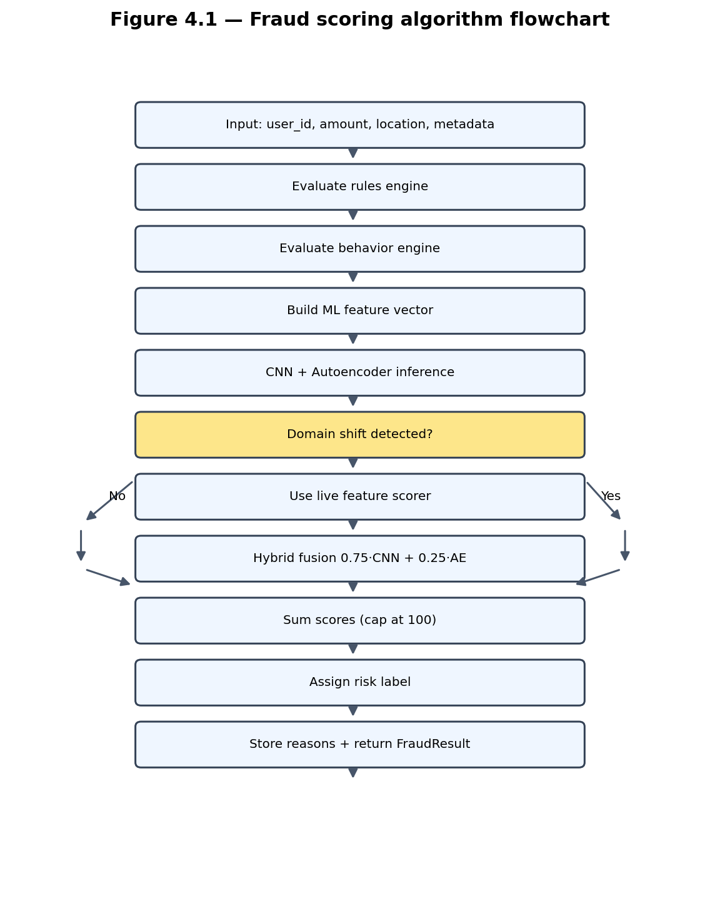
Figure 4.1: Fraud scoring algorithm flowchart
Pseudocode:
INPUT: user_id, amount, location, merchant, country, device_id, ip_address
rule_result ← evaluate_rules(...)
behavior_score ← evaluate_behavior(...)
ml_result ← predict_fraud_probability(...)
IF domain_shift_detected: ml_probability ← live_fraud_probability(...)
ELSE: ml_probability ← 0.75 × cnn_prob + 0.25 × ae_score
final_score ← MIN(100, rule_score + behavior_score + ml_score)
RETURN FraudResult(final_score, label, reasons)

Algorithm: Transaction Ingest
INPUT: transaction_data, actor_jwt
VALIDATE staff role (analyst or admin)
result ← evaluate_transaction(user_id, amount, location, ...)
INSERT Transaction(risk_score=result.final_score, confidence=result.ml_probability,
status = flagged IF final_score >= 60 ELSE approved)
INSERT FraudDecision(rule_score, behavior_score, ml_score, ml_probability, reasons)
UPDATE UserProfile(avg_spend, top_locations, tx_count)
IF final_score >= 60:
CREATE FraudNotification + email alert placeholder
WRITE AuditLog
INVALIDATE read caches
BROADCAST SSE event (unless quiet mode for bulk reseed)
RETURN 201 with transaction_id, risk_score, confidence, label, status

Risk Label Thresholds
Score Range | Label | System Action
0 – 29 | low | Auto-approved; stored for profile learning
30 – 59 | medium | Approved; monitored in analytics
60 – 79 | high | Flagged; alert + notification; flagged queue
80 – 100 | critical | Flagged; critical severity; priority review

Deep Learning Training Algorithm
INPUT: creditcard.csv (or synthetic dataset)
LOAD dataset → extract V1–V28, Amount_log, tx_frequency_10m, minutes_since_last
SPLIT train/test (80/20, stratified on Class)
FIT StandardScaler on training features
TRAIN 1D-CNN classifier with class weights (neg/pos ratio)
TRAIN autoencoder on legitimate (Class=0) training rows only
COMPUTE ae_threshold = 97th percentile of reconstruction MSE on legitimate test rows
EVALUATE cnn_probs, ae_probs, hybrid = 0.75*cnn + 0.25*ae
SAVE fraud_cnn.keras, fraud_autoencoder.keras, feature_scaler.joblib, metrics.json

Construction

Backend — JWT login (`auth/routes.py`)
token = create_access_token(
identity=str(user.id),
additional_claims={"role": user.role},
)

Backend — Rule evaluation (`fraud/rules.py`)
if amount > 5000:
score += 20
reasons.append("High transaction amount (above $5,000)")
# Velocity: 5+ transactions in 10 minutes → +15
# Location mismatch vs recent activity → +10

Backend — ML hybrid inference (`fraud/model.py`)
cnn_prob = float(cnn.predict(cnn_input, verbose=0)[0][0])
recon = autoencoder.predict(scaled, verbose=0)
mse = float(np.mean(np.square(scaled - recon)))
ae_score = float(np.clip(mse / ae_threshold, 0.0, 1.0))
if _domain_shift_detected(cnn_prob, ae_score, mse, ae_threshold):
probability = live_fraud_probability(...)
else:
probability = 0.75 * cnn_prob + 0.25 * ae_score

Backend — Centralised ingest (`services/transaction_ingest.py`)
All ingest paths (manual, simulator, reseed) call ingest_transaction_data() to ensure one scoring pipeline and consistent FraudDecision records.

Frontend — Role-based navigation (`lib/roles.ts`)
Navigation items are filtered by role so analysts see monitoring, capture, fraud lab, and explainability; admins additionally see user management, rules, and model operations.

Frontend — Live updates (SSE)
After ingest the backend publishes a JSON event. The browser opens GET /transactions/stream with the JWT as a query parameter (EventSource cannot send custom headers). Monitoring pages patch local state when an event arrives.

Application screenshots
Add your own UI captures to scripts/doc_assets/screenshots/ using the filenames below. Each ![caption](path) line embeds the image when you regenerate the Word report (python scripts/generate_documentation_docx.py). If a file is missing, the export shows a placeholder caption until you add it.
Figure | Save as | Suggested capture
4.2 | scr_4_1_landing.png | Landing page (/)
4.3 | scr_4_2_login.png | Login screen (/login)
4.4 | scr_4_3_dashboard.png | Operations dashboard (/dashboard)
4.5 | scr_4_4_monitoring.png | Live monitoring (/dashboard/monitoring)
4.6 | scr_4_5_flagged.png | Flagged transactions (/dashboard/transactions)
4.7 | scr_4_6_fraud_lab.png | Fraud detection lab (/dashboard/fraud)
4.8 | scr_4_7_explain.png | Explainability panel (/dashboard/explain)
4.9 | scr_4_8_admin.png | Admin console (/dashboard/admin)

Tip: Use 1440×900 or similar (16:9). Sign in as ops@fraudshield.demo / DemoPass123! for dashboard screens.
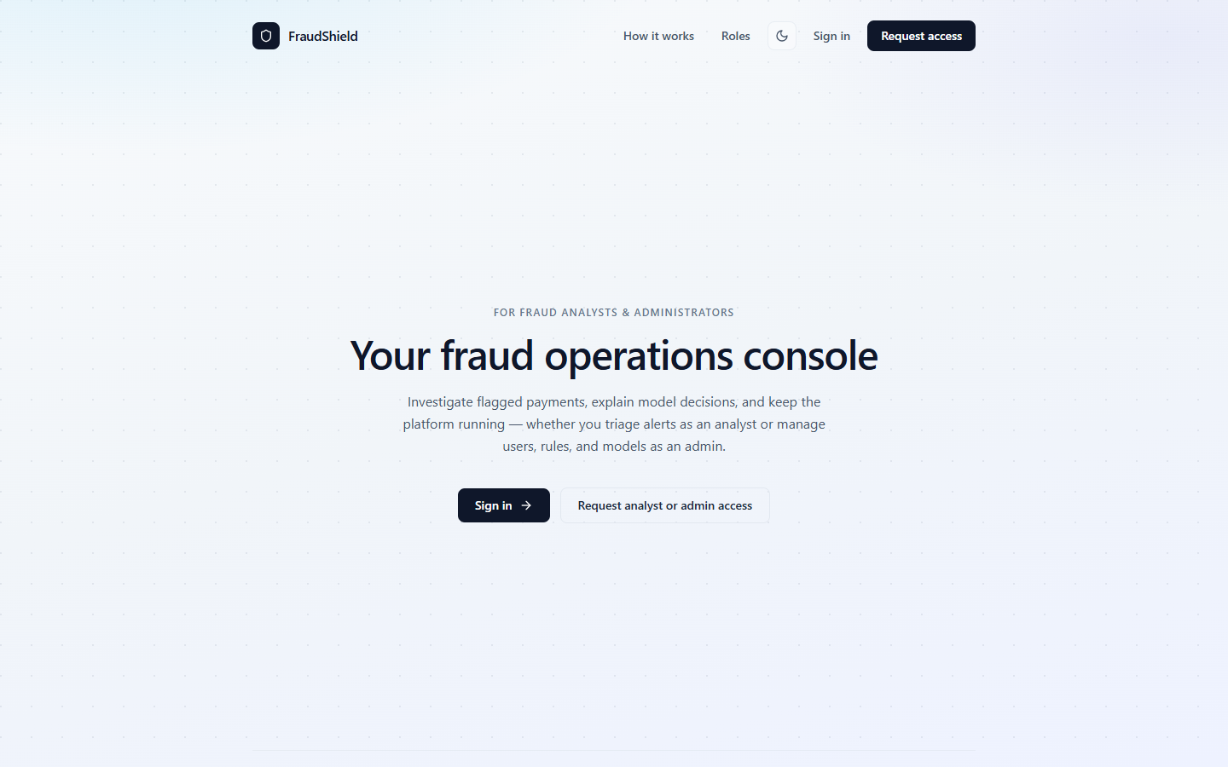
Figure 4.2: FraudShield landing page
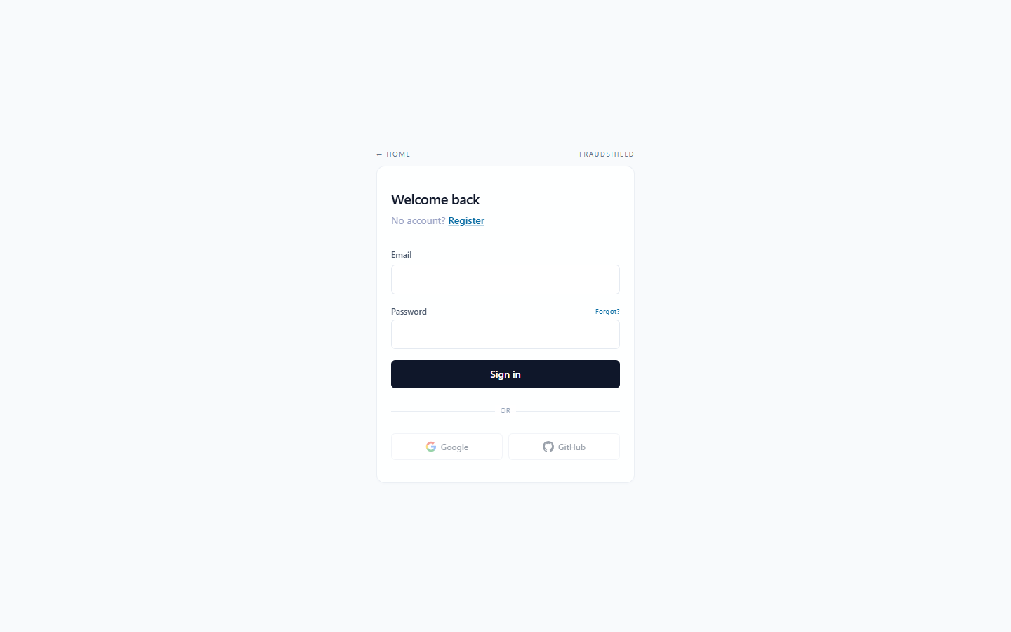
Figure 4.3: Staff login screen
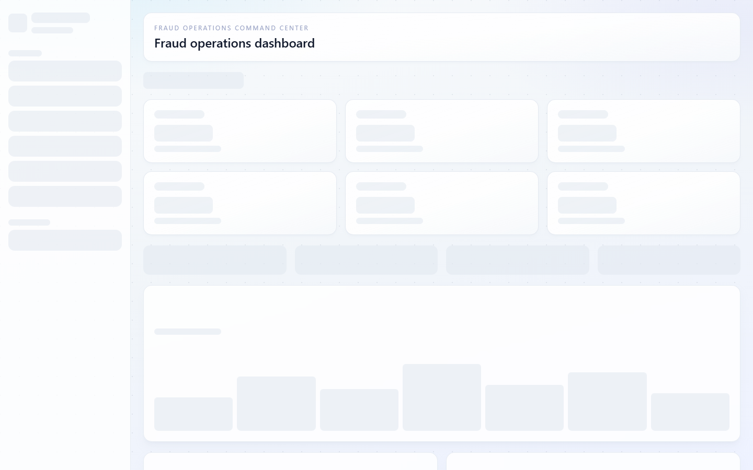
Figure 4.4: Operations dashboard with KPIs and live activity
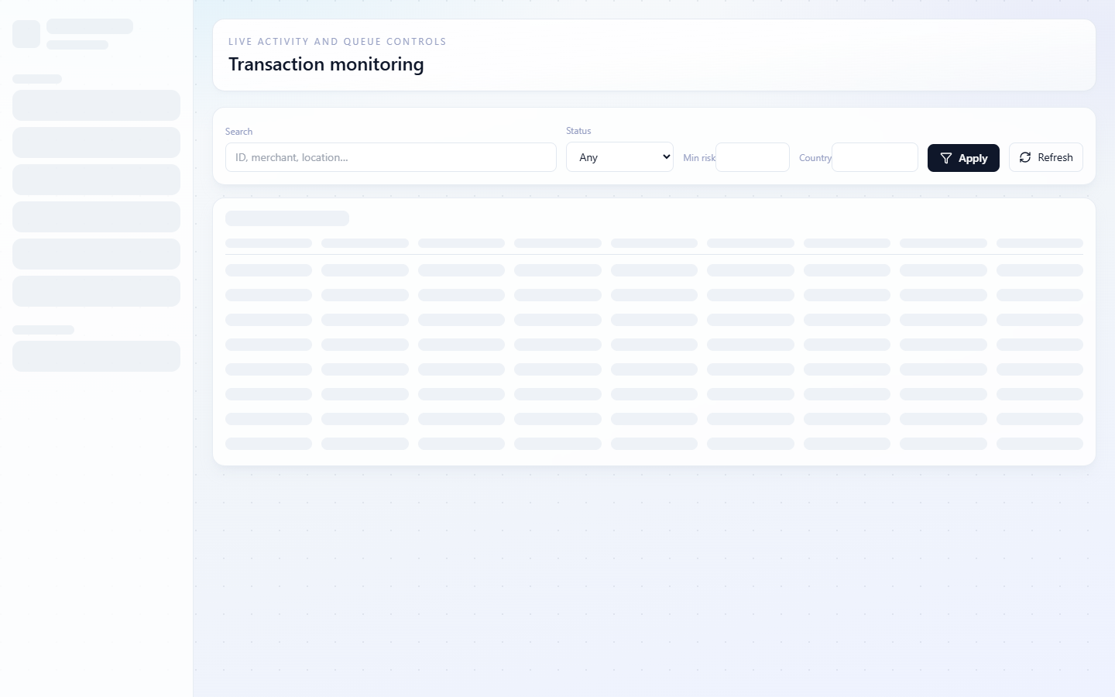
Figure 4.5: Live transaction monitoring stream
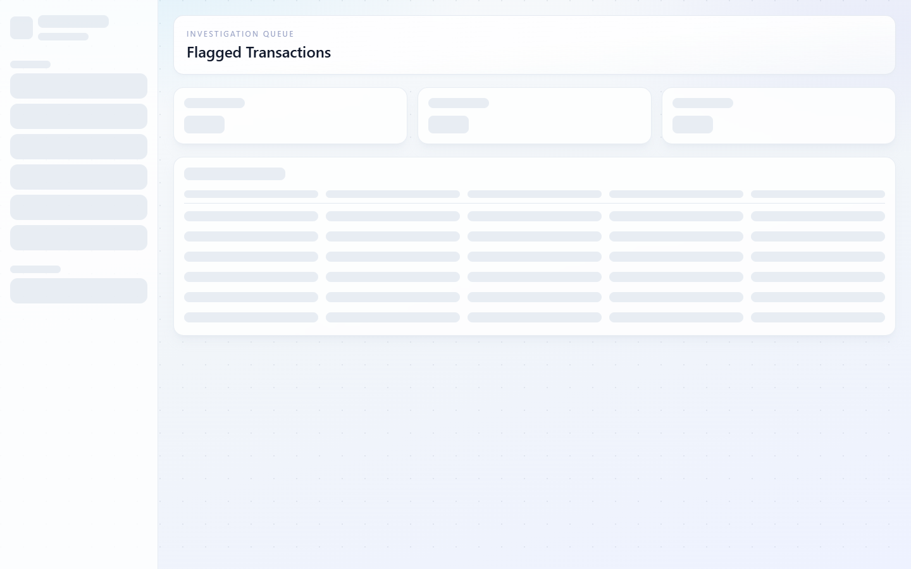
Figure 4.6: Flagged transaction review queue
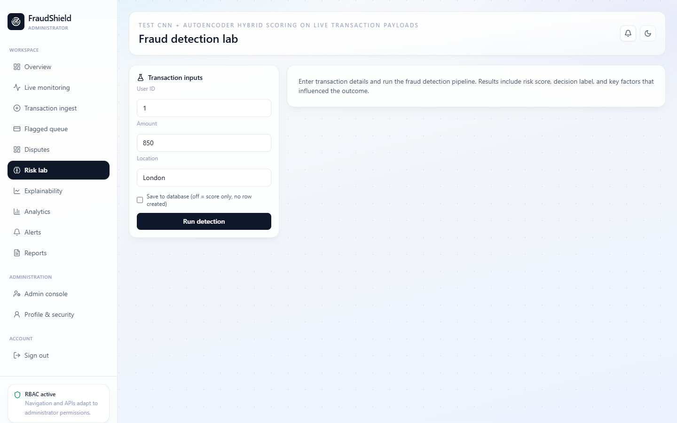
Figure 4.7: Fraud detection lab with hybrid DL scoring results
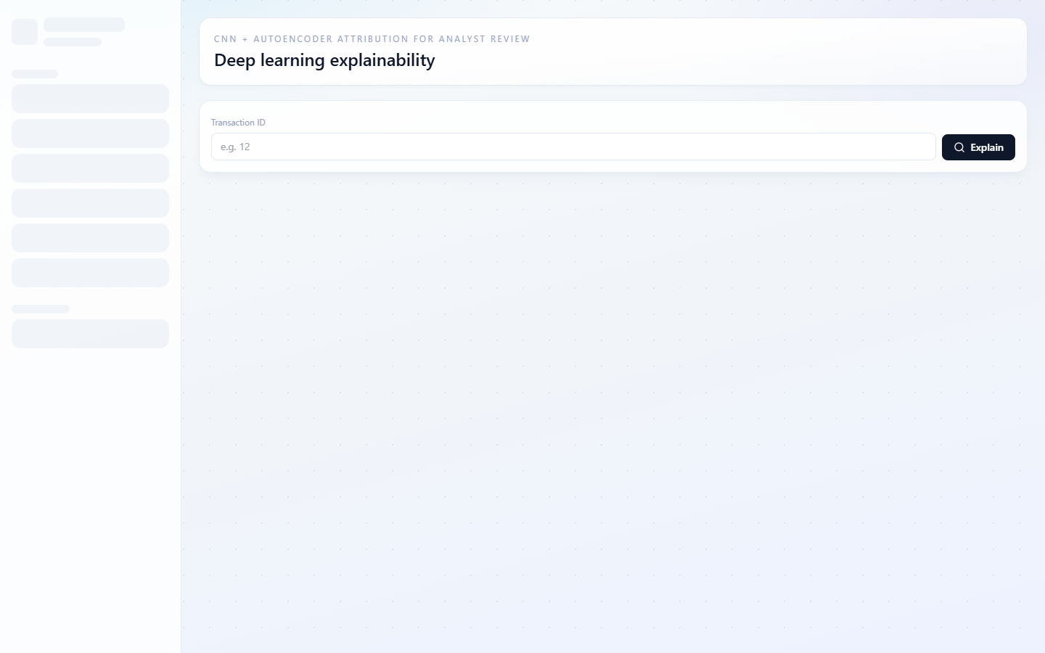
Figure 4.8: Model explainability and feature attribution
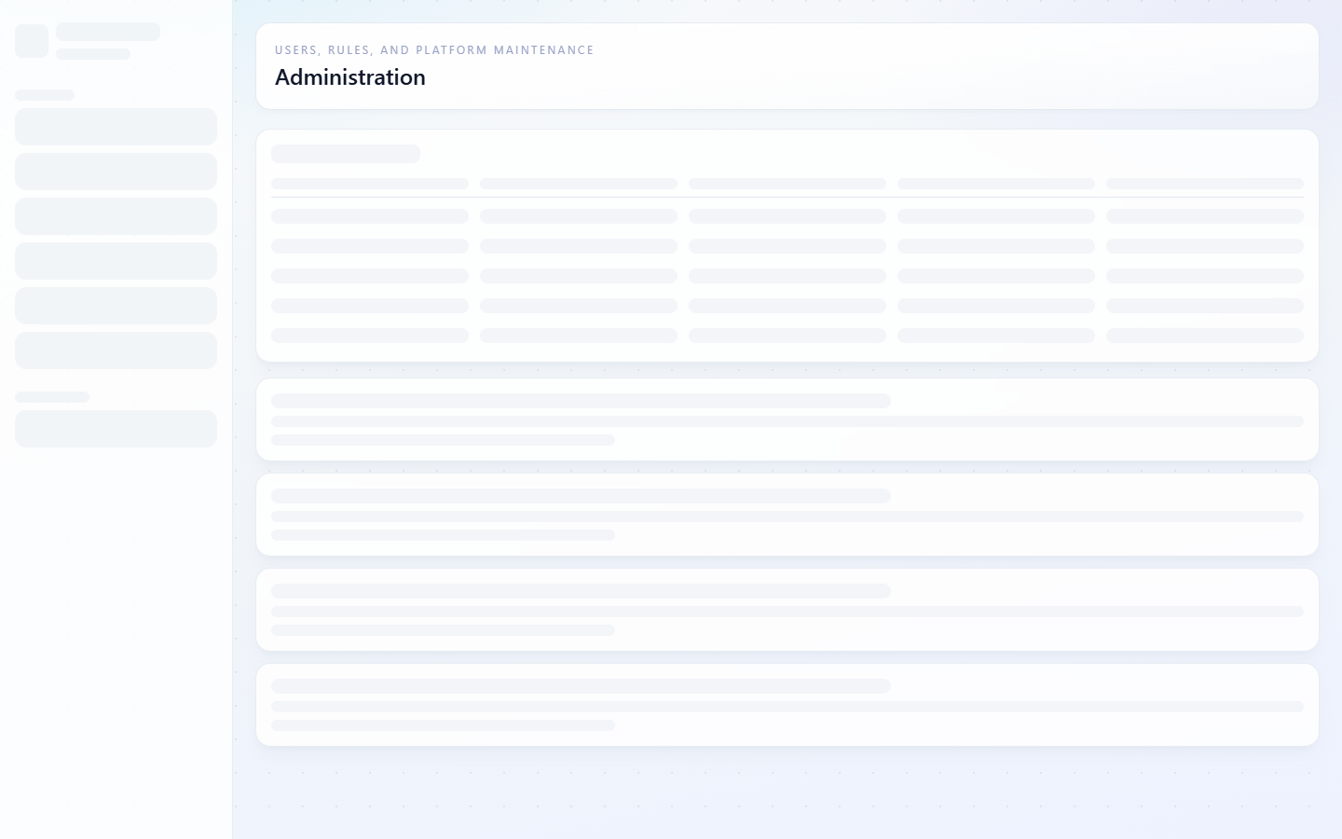
Figure 4.9: Administrator console — users, rules, and model ops

Testing

Testing Plan
Level | Focus | Method
Unit | Rule, behavior, ML scorers | Controlled inputs; verify score deltas
Integration | API endpoints with JWT | HTTP requests; verify status codes and JSON
System | End-to-end role flows | Three demo accounts; full investigation scenario
UI | Navigation, hydration, responsive | Browser testing; RoleGuard redirects
Performance | Ingest and reseed latency | Timed operations on Neon

Component Testing
- UI components: login redirect, dashboard KPI load, capture form validation, notification deduplication.
- Database: foreign key constraints, seed counts after reseed, staff-only query scope.
- API: 401 on missing token, 403 on wrong role, 201 on successful ingest with risk_score populated.
- ML module: normal vs fraud payloads produce different confidence values (not flat 25%).

System Testing
A full demo scenario was run with the seeded accounts:
- Analyst starts the live simulator.
- A high-risk transaction appears in the flagged queue without refreshing the page (SSE).
- Analyst opens the explain view for feature attribution.
- Simulated fraud attack: $6,500 crypto purchase in Lagos for a New York-based user — flagged with risk score ~70–81.
- Admin exports CSV and PDF reports.
- Admin runs reseed (force=true) — 80 transactions with live ML scores.

Test Cases (Sample)
Test ID | Input | Expected Output | Result
T01 | Valid admin login | 200 + JWT with role=admin | Pass
T02 | Analyst ingest tx | 201 + risk_score, confidence | Pass
T03 | Non-staff access /monitoring | Redirect or 403 | Pass
T04 | Amount > $5,000, foreign crypto | risk_score >= 60, status=flagged | Pass
T05 | Normal $45 domestic purchase | risk_score < 60, approved | Pass
T06 | Admin reseed (force=true) | 80 txs, ~2–4% flagged, live scores | Pass
T07 | Export PDF report | Non-empty PDF download | Pass
T08 | Invalid JWT on API | 401 Unauthorized | Pass
T09 | Fraud simulate (dry-run) | JSON with cnn/ae/ml fields | Pass
T10 | Confidence varies per tx | Not all 25% after live scorer fix | Pass

Results
- System successfully scores and persists transactions with risk_score and ML confidence on every ingest.
- Hybrid engine flags high-risk synthetic patterns (large amount + foreign location + crypto merchant).
- Training on Kaggle data: ROC-AUC 0.980, PR-AUC 0.689, Recall 0.888, Precision 0.109.
- Dashboard displays KPIs, charts, heatmap, and flagged queue with role-appropriate navigation.
- SSE stream pushes new transactions to open dashboard tabs without manual refresh.
- Dispute workflow supports open → resolved lifecycle with analyst resolution notes.
- Reseed completes through live ingest pipeline (~10 minutes on Neon with per-tx ML inference).
- Exports produce non-empty CSV and PDF when seed data is present.
- TypeScript compilation passes without errors.
Metric (demo seed) | Typical value
Transactions after reseed | ~80
Realistic fraud rate | ~2–4% flagged
API ingest HTTP status | 201 Created
Fraud attack test ($6,500 Lagos crypto) | Flagged, score 70–81
Normal purchase test ($45 domestic) | Approved, score ~12–20
Demo accounts | ops@ / analyst@ / reviewer@fraudshield.demo

Chapter 5: Findings and Conclusion

Chapter Overview
This chapter summarises the outcomes of the FraudShield project, discusses limitations encountered during development, records lessons learned, and recommends directions for future work and commercialisation.

Findings
- Combining rules, behaviour checks, and deep learning produced more useful alerts in demo runs than any single method alone.
- Hybrid CNN + autoencoder aligns with published research (Alarfaj et al., 2022; Pumsirirat & Yan, 2018) on European benchmark data.
- Analyst/admin-only access matches production fraud operations consoles at major payment networks.
- Live feature scorer was required because runtime merchant/geo metadata differs from offline Kaggle PCA features; without it, ML confidence was stuck at 25% for all transactions.
- Centralising ingest in transaction_ingest.py removed duplicate ML calls and inconsistent scores across manual ingest, simulator, and reseed.
- SSE live updates significantly improved the demonstration experience compared to manual page refresh.
- Removing the cardholder role simplified RBAC and focused the UI on operational workflows.

Conclusions
The main goal of the project was to deliver a working fraud-detection web application with hybrid deep learning scoring and role-based operations access. That goal was met within the scope of a final-year prototype. The revamp from basic scikit-learn to TensorFlow CNN + autoencoder significantly improved the academic and technical credibility of the system. The application is ready for demonstration and could be extended with live payment feeds and stronger production hosting.

Challenges / Limitations of the System
- Neon serverless latency and connection timeouts during long reseed operations required per-transaction commits and TensorFlow model warmup.
- Aligning frontend session cookie with JWT required careful 401 handling and hydration-safe state initialisation.
- ML training quality depends on availability and representativeness of labelled training data; precision remains low (~11%) due to extreme class imbalance.
- Domain shift between Kaggle PCA features and live proxy features required a separate live scorer—bridging this gap fully would need institution-specific feature pipelines.
- Time constraints limited automated unit test coverage and full DevOps pipeline setup.
- Simulated email/SMS alerts do not deliver to external inboxes without gateway integration.

Lessons Learnt
- RBAC and scoped queries should be planned early—not added after features ship.
- Keeping the scoring engine separate from HTTP handlers made simulator and seed scripts easier to test.
- Seed data and demo accounts saved time during every demonstration rehearsal.
- Cloud database latency appeared only after moving off local SQLite.
- Browser hydration errors were avoided by loading session-only state inside useEffect.
- Validating ML output on live data (not just test-set metrics) is essential—offline ROC-AUC does not guarantee useful runtime confidence values.

Recommendations for Future Works
- Connect to real payment webhooks or a message queue (Kafka/RabbitMQ) for production-scale ingest.
- Add SHAP or LIME for formal model explanations if regulators require them.
- Train sequence models (LSTM/GRU) for velocity patterns per Jurgovsky et al. (2018).
- Wire up real email/SMS gateways and TOTP two-factor authentication.
- Package with Docker and add CI/CD plus basic monitoring (Prometheus/Grafana).
- Retrain on institution-specific data with aligned live/offline feature engineering.
- Add pytest unit tests and Playwright browser tests for regression coverage.
- Optimise bulk reseed with batched scoring or async worker queue.

Recommendations for Project Commercialization
A small fintech or campus security lab could adopt the core API as a starting point. A realistic business model would charge per API call or per analyst seat, but production use would require PCI-DSS review, proper hosting, SOC 2 compliance, and dedicated support staff. The open-source stack reduces licensing cost for pilots. Partnership with a regional bank for a supervised pilot would be the most credible path from academic prototype to commercial product. That compliance and business development work is outside the scope of this academic build.

References
- Pumsirirat, A. & Yan, L. (2018). Credit Card Fraud Detection using Deep Learning based on Auto-Encoder and Restricted Boltzmann Machine. International Journal of Advanced Computer Science and Applications, 9(1).
- Alarfaj, F. K., Malik, I., Khan, H. U., Almusallam, N., Ramzan, M., & Ahmed, M. (2022). Credit Card Fraud Detection Using State-of-the-Art Machine Learning and Deep Learning Algorithms. IEEE Access, 10, 39700–39714.
- Roy, A., Sun, J., Mahoney, R., Alonzi, L., Adams, S., & Beling, P. (2018). Deep Learning Detecting Fraud in Credit Card Transactions. University of Virginia.
- Dal Pozzolo, A. et al. European Credit Card Fraud dataset (Kaggle).
- Jurgovsky, J., Granitzer, M., Ziegler, K., Calabretto, S., Portier, P. E., & He-Guelton, L. (2018). Sequence classification for credit-card fraud detection. Expert Systems with Applications, 100, 234–245.
- Fu, K., Cheng, D., Tu, Y., & Zhang, L. (2016). Credit card fraud detection using convolutional neural networks. ICONIP.
- Breiman, L. (2001). Random Forests. Machine Learning, 45(1), 5–32.
- Flask Documentation. https://flask.palletsprojects.com/
- Next.js Documentation. https://nextjs.org/docs
- TensorFlow Documentation. https://www.tensorflow.org/
- Neon Serverless PostgreSQL. https://neon.tech/docs
- OWASP JWT Security Cheat Sheet. https://cheatsheetseries.owasp.org/
- SQLAlchemy Documentation. https://www.sqlalchemy.org/
- NIST SP 800-63B (2020). Digital Identity Guidelines.

Appendix A: Demo Credentials and Environment Setup

Environment variables (backend/.env)
Variable | Purpose
DATABASE_URL | Neon PostgreSQL connection string (or empty for SQLite)
JWT_SECRET_KEY | Token signing secret
AUTO_SEED_DEMO_DATA | Auto-seed on SQLite startup (true/false)
GOOGLE_CLIENT_ID / SECRET | Google OAuth
GITHUB_CLIENT_ID / SECRET | GitHub OAuth

Quick start commands
cd backend
pip install -r requirements.txt
python ml/bootstrap_model.py
python -m flask --app run db upgrade
python run.py
cd frontend
npm install
npm run dev

Demo accounts
Role | Email | Password
Admin | ops@fraudshield.demo | DemoPass123!
Analyst | analyst@fraudshield.demo | DemoPass123!
Analyst | reviewer@fraudshield.demo | DemoPass123!

Reseed command
python -c "from app import create_app; from app.services.seed_data import reseed_realistic_demo_data; app=create_app();
with app.app_context(): print(reseed_realistic_demo_data(min_transactions=80))"

Appendix B: API Endpoint Summary
Method | Path | Role | Description
POST | /auth/login | Public | JWT authentication
POST | /auth/register | Public | Register analyst/admin (pending approval)
POST | /transactions/ingest | Staff | Score and persist transaction
POST | /fraud/simulate | Staff | Dry-run scoring + explainability
GET | /transactions/flagged | Staff | Flagged transaction queue
GET | /fraud/explain/{id} | Staff | Feature attribution
POST | /admin/models/retrain | Admin | Retrain DL models
POST | /transactions/seed?force=true | Staff | Purge + reseed database
GET | /transactions/stream | Staff | SSE live feed
GET | /reports/transactions.csv | Staff | CSV export
GET | /reports/summary.pdf | Staff | PDF export

Appendix C: Simulated Fraud Attack Procedure
This appendix documents the standard demonstration used to verify that FraudShield detects fraudulent transaction patterns.
Scenario: A stolen card is used for a large cryptocurrency purchase in a foreign country, inconsistent with the account holder's normal spending pattern.
Steps:
- Authenticate as analyst@fraudshield.demo.
- Submit ingest payload: user_id=1, amount=6500, location=Lagos, country=NG, merchant=Binance, merchant_category=crypto.
- Observe API response: status=flagged, risk_score between 60 and 85, confidence varies (typically 40–75% after live scorer fix).
- Open Monitoring dashboard — transaction appears in flagged queue.
- Open Explain panel — review rule, behavior, and ML feature contributions.
- Compare with baseline: amount=45, location=New York, merchant_category=food → status=approved, low risk score.
Expected detection signals: high amount rule (+20), location mismatch (+10), behavior deviation (spend spike, novel location), live ML scorer (crypto MCC, Nigeria geo risk).
This demonstration validates the layered defense approach advocated in the related works and mirrors card-not-present fraud patterns described in the IEEE Access and IJACSA papers.

