HEALTHCARE MANAGEMENT SYSTEM
A Web-Based Hospital Management System

A Thesis Report
Bachelor of Science in Computer Science

Submitted by:
Latif Khan (27253)
Hassan Mujtaba (20754)
BS CS (2022-2026)
Edwardes College Peshawar
Supervisor: Sir Ali Raza
GitHub: Latifkhan-cyber
June 2026

DECLARATION OF AUTHENTICITY
We, the undersigned, hereby declare that the thesis entitled:
"Web-Based Healthcare Hospital Management System"
submitted in partial fulfillment of the requirements for the degree of Bachelor of Science in Computer Science, is our original work and has not been submitted, in whole or in part, for any other degree or examination at this or any other institution.
We further declare that all sources of information used in this thesis have been duly acknowledged and cited, and that the work presented herein is entirely our own intellectual effort, except where explicitly stated otherwise.
We understand that any act of plagiarism or academic dishonesty is a serious offence and may result in disciplinary action by the institution.

Date: 06/06/2026

Supervised by:
Name: Mr. Sir Ali Raza
Signature: ______________
Date: 06/06/2026

Edwardes College Peshawar
Affiliated With: University Of Peshawar
Department of Computer Science

APPROVAL CERTIFICATE
This is to certify that the thesis entitled:
"Web-Based Healthcare Hospital Management System"
submitted by Latif Khan (27253) and Hassan Mujtaba (20754) has been examined and approved for the award of the degree of Bachelor of Science in Computer Science.
The thesis has been found satisfactory in fulfilling the requirements and standards of the Department of Computer Science, Edwardes College Peshawar.
Approved on: June 6, 2026

DEDICATION
——— ❧ ———
To My Beloved Parents
Whose prayers, sacrifices, and unconditional love have been the greatest source of strength throughout my journey.
To My Dear Family Members
For their endless encouragement, patience, and support that kept me motivated at every step of this endeavor.
To My Respected Teacher
Whose guidance, wisdom, and dedication inspired me to strive for excellence and never give up.
A Special Message to My Brothers
"My dear brothers, you have always been my pride and my strength. Every time I felt like giving up, the thought of making you proud pushed me forward. This achievement is as much yours as it is mine. I hope I have made you smile today, and I pray that Allah blesses each of you with success, happiness, and peace."

ACKNOWLEDGEMENTS
——— ❧ ———
All praise and glory be to Allah Almighty, the Most Gracious and the Most Merciful, whose blessings and guidance made this work possible.
We are deeply grateful to our supervisor, Sir Ali Raza, for his invaluable guidance, continuous support, and constructive feedback throughout this thesis.
We also extend our sincere appreciation to all the respected faculty members of the Department of Computer Science for their support and encouragement.
We are forever thankful to our beloved family members — especially our brothers — whose prayers, sacrifices, and unwavering belief kept us going through every challenge.
Finally, a heartfelt thanks to our dear friends, Mansoor Ahmad Khan Afrida, for their constant moral support and companionship throughout this journey.
Finally, we acknowledge that any shortcomings in this work are entirely our own, while all credit for its success goes to Allah and to those mentioned above whose support made it a reality.

Abstract
The healthcare sector globally still has issues with accessibility, efficiency and patient management. A recurring challenge is the system of appointment booking, where many clinics and hospitals continue to use the old-fashioned methods of telephone calls, walk-in lines or paper registers. These methods take time for patients to perform as well as for healthcare providers and are prone to human error, and are hard to scale. The outcome is frequently delayed appointments, lost visits and bad communication between doctors and patients.
This project aims to design and develop a Web-Based Healthcare Management System to solve these issues. The system is built using Django (Python) as the web framework and MySQL as the database backend, following the Model-View-Template (MVT) architecture. It supports four distinct user roles: Admin, Doctor, Receptionist, and Patient, each with role-specific permissions and workflows.
The system includes comprehensive modules for patient registration with auto-generated IDs (MQ-XXXXXX format), appointment booking with real-time slot availability checking, multi-method payment processing (Cash, JazzCash, EasyPaisa, Bank Transfer) with admin verification, queue management with token generation and public display, medical record management with vitals and prescriptions, lab test ordering and tracking, doctor review and rating system, and a notification system with email/SMS delivery tracking.
The system was developed on WSL (Windows Subsystem for Linux) with Django 6.0.5 and MySQL 8.4. Twenty unit tests were executed covering authentication, patient registration, appointments, payments, queue management, medical records, lab tests, and doctor reviews, all passing successfully. This thesis covers the complete development process: problem identification, literature review, system design, implementation, testing, and conclusions. The system demonstrates that a comprehensive, Django-based solution can significantly improve healthcare management in resource-constrained environments.

Chapter 1: Introduction

1.1 Background of the Study
The healthcare industry is facing an ongoing challenge to provide services for expanding populations with limited resources. There is one thing that can be done better that is both time-critical and possible: appointment management, or how a patient can schedule a time with a healthcare professional. This procedure is largely dependent on telephoning, the receptionist and paper records in a traditional healthcare environment. Patients need to leave a message during working hours, sit on hold and depend on the administrative staff to get them a time and make a good note of their information. In paper-based systems, there is a high risk of lost bookings, double scheduling and miscommunication [1].
Digital health technologies have arisen as a viable solution to these restrictions. With internet, mobile and cloud technology becoming commonplace, it is now technically possible for patients to communicate with health systems from anywhere, anytime. In developed countries, hospitals and clinics are already utilizing online appointment booking systems, either via web portals or mobile apps, to manage patient scheduling. In smaller clinics and private practices, however, and in many areas of development, these systems are lacking. Staff still book appointments by hand, and patients are still suffering from delays and inconvenience [2].
In addition to scheduling, an effective digital appointment system has additional side effects. It keeps a digital record of all appointments, decreases no-shows because of reminders, helps doctors manage their time more efficiently, and offers administrators data that could be used to increase service delivery. If coupled with a secure authentication mechanism, this type of platform can additionally safeguard patient data and restrict access to authorized users only [3].
The project was inspired by the existing need in the local healthcare system where manual booking is still used at many health clinics in Peshawar and across Pakistan. The aim was to produce a comprehensive but practical web-based system, which any clinic could implement without needing expensive enterprise software or specialized technical expertise. The system is built using Django, a Python web framework, with MySQL as the relational database, providing a robust and scalable foundation for healthcare data management.
The system has been assessed using structured unit tests and non-functional evaluation. The results indicate that it is possible to perform registration, login, appointment booking, payment processing, queue management, medical record keeping, and administrative functions with a high degree of reliability and ease of use. This thesis presents the complete development process, from problem identification and literature survey to system design, implementation, testing and conclusions.

1.2 Problem Statement
Even with the advent of digital solutions, there are still many healthcare providers, especially small clinics and GP practices, using outdated manual appointment systems. These systems give rise to multiple recurring issues, both to patients and healthcare providers. Most common frustrations are: inability to schedule appointments outside of working hours, waiting time on the phone to schedule an appointment, and waiting after scheduling an appointment without any confirmation and reminder. It is common for patients to have to take time off work to call during office hours, and it is impossible to cancel or reschedule without taking time with a receptionist directly.
On the provider side, scheduling and keeping track of appointments manually is a labor-intensive process. Part of the receptionist's job is to take telephone calls and keep patient records, as well as checking doctors' availability, for most of the day. The chances are high that errors will occur — there could be double booking, wrong time listed, or something simply gets lost. It is also hard to access historical appointments for analysis or auditing purposes when they are in paper form.
The problems are summarized as follows: (1) It is difficult for patients to schedule an appointment with a doctor in a convenient, central and reliable manner; (2) the administration is difficult to manage — without such a system, there is wasted time, administrative mistakes and a decrease in patient satisfaction. The goal of this project is to address these specific issues via a comprehensive, easy-to-use web application built with Django and MySQL.

1.3 Objectives of the Study
The main goal of this project is to create a fully functional and working Web-Based Healthcare Management System. The following specific objectives guide the work:
- 1. To create a user-friendly, role-based interface supporting Admin, Doctor, Receptionist, and Patient roles.
- 2. To implement automated patient registration with unique ID generation (MQ-XXXXXX format).
- 3. To create an appointment booking system with real-time slot availability checking and conflict prevention.
- 4. To build a multi-payment system supporting Cash, JazzCash, EasyPaisa, and Bank Transfer with admin verification.
- 5. To implement a queue management system with token generation, estimated wait times, and public display.
- 6. To develop medical record management with vitals, diagnosis, prescription, and PDF generation.
- 7. To create a lab test ordering and result tracking module with status workflow.
- 8. To implement a doctor review and rating system for patient feedback.
- To build a notification system with user delivery preferences, email and SMS delivery tracking, mark-all-as-read, pagination, real-time AJAX updates, failed notification resending, bulk notifications, and automated cron reminders.
- 10. To test the system using structured unit tests and verify all functional requirements are met.

1.4 Scope of the System
This project is intentionally comprehensive in scope, covering the complete patient journey from registration through consultation, payment, and follow-up. The system is a web application built with Django 6.0.5 and MySQL 8.4, developed on WSL (Windows Subsystem for Linux).
The system includes the following modules:
- Accounts Module: User authentication, role-based access control, patient registration with auto-ID, profile management with photo upload.
- Appointment Module: Booking with slot availability checking, rescheduling, cancellation, walk-in booking for admin.
- Payment Module: Multi-method payments (Cash, JazzCash, EasyPaisa, Bank), admin verification, refund processing, PDF receipts.
- Queue Module: Token generation, estimated wait times, public display for waiting room TV, emergency priority, call-next functionality.
- Medical Records Module: Vitals, symptoms, diagnosis, prescription, follow-up scheduling, PDF generation, previous records upload.
- Lab Test Module: Test ordering during consultation, status tracking (ORDERED to RESULTS_RECEIVED), result file upload, patient notifications.
- Review Module: 1-5 star ratings with comments, duplicate prevention, doctor profile display with average ratings.
- Notification Module: Real-time alerts for appointments, queue, lab results, follow-ups, with email/SMS delivery tracking.
- Admin Dashboard: Analytics including revenue, appointment counts, queue length, pending items, recent activity.

1.5 Significance of the Study
The following are important reasons for the significance of this project. First, it creates a useful and ready-to-use solution for small clinics to modernize their complete management system without the expense and complexity of enterprise healthcare software. The system demonstrates that a comprehensive solution can be built using Django and MySQL — robust, well-documented, and freely available technologies.
On the academic side, the project combines knowledge from various domains of computer science such as web development, database design, user interface design, authentication and authorization, PDF generation, and software testing. It shows how these skills can be used in combination in a real-life situation. This thesis presents the findings and methods used in this work and can be used as a guideline for future students and developers who are interested in creating similar healthcare technology projects.
More generally, the project helps advance the broader discussion on digital health in developing regions, where the use of digital technologies in healthcare contexts is still limited. This exemplifies the effectiveness of Django-based web technologies in solving real operational issues in healthcare, and helps to justify the need for a wider digital transformation in the sector [4].

Chapter 2: Literature Review

2.1 Overview of Existing Healthcare Scheduling Systems
Healthcare scheduling systems have evolved from simple appointment books to complex enterprise Hospital Information Systems (HIS). Modern systems typically include electronic health records (EHR), practice management, billing, and patient engagement tools. However, many small clinics worldwide still rely on manual processes for appointment scheduling and record keeping.
The transition to digital healthcare management has been accelerated by the increasing availability of affordable web technologies. Django, as a high-level Python web framework, provides a robust foundation for building complex web applications with clean, maintainable code. Combined with MySQL, a widely-used relational database management system, it offers a powerful and scalable platform for healthcare data management.

2.2 Comparison of Existing Solutions
There are various health appointment booking software options available in the market such as Zocdoc, Practo and Calendly for health. These platforms are slick, well-designed and well-funded with numerous features. These are, however, aimed at the North American market and/or the Indian market, respectively, and are frequently monthly subscription products which are not feasible for small clinics in other parts of the world. They also lack a degree of workflow and user interface customization [10].
There are also open-source alternatives like OpenMRS and Open Clinic GA that are more flexible but have steep learning curves and installation requirements. These systems are intended to be a complete hospital information system and offer many more capabilities than a small clinic would require. They can be more of a hindrance than a help to adoption [11].
In between are custom-built web systems, as described in academic papers. They are customizable to the context and need, can utilize open technologies, and may be developed by any developer with web development expertise. The major problem is that they take a significant amount of time and know-how to construct, and that is what this project seeks to solve through the use of Django's built-in features and rapid development capabilities.

2.3 Theoretical Frameworks and Design Principles
Several theoretical frameworks inform the design of this system. The first is the Technology Acceptance Model (TAM), originally proposed by Davis (1989) and widely applied in health informatics research. TAM suggests that users are more likely to adopt a technology when they perceive it as easy to use and useful. This principle guided the decision to keep the user interface simple and task-focused, ensuring that patients with limited digital literacy could complete the booking process without confusion [12].
The second framework is the Model-View-Template (MVT) architectural pattern, which is Django's adaptation of the MVC pattern. In this model, the Model represents the data and business logic (implemented through Django models with MySQL), the View handles the request-response logic (Django views), and the Template manages the presentation layer (HTML/CSS templates). This separation of concerns is a well-established principle in software engineering and makes the system easier to test and maintain [13].
The principle of Role-Based Access Control (RBAC) is also central to the system's security design. RBAC dictates that different categories of users should have access only to the parts of the system relevant to their role. In this system, patients can only access their own data, doctors can view their schedule and mark patients as seen, receptionists handle data entry, and administrators have full management access. This principle is widely applied in healthcare information systems to protect sensitive data [14].

2.4 Research Gap Analysis
The literature reveals a consistent gap between the availability of digital appointment booking tools and their adoption in small and medium-sized healthcare facilities in developing regions. Several studies have proposed systems that address parts of this problem, but few have combined the following characteristics in a single, cohesive design: a comprehensive Django-based web application with MySQL database, a role-based multi-user interface supporting patients, doctors, receptionists, and administrators, integrated payment processing with local methods (JazzCash, EasyPaisa), queue management with public display, medical records with PDF generation, and lab test tracking — all built on freely available technologies.
Many existing systems described in the literature rely on traditional server-side technologies such as PHP and MySQL, which require dedicated hosting and server administration skills. Django-based systems offer advantages including built-in admin interface, ORM for database management, CSRF protection, and a modular application structure that promotes clean, maintainable code.
Additionally, the evaluation methodology in many published studies is limited to user satisfaction surveys, without structured functional testing against defined requirements. This project addresses that gap through comprehensive unit tests covering all major modules, ensuring each functional requirement is verified.

Chapter 3: System Requirements & Design

3.1 Functional Requirements
The system shall provide the following functional capabilities:
- FR-1: User Registration & Authentication — Users can register as patients, or be created by admin/receptionist. Login with username/password authentication via Django's built-in auth system.
- FR-2: Role-Based Access Control — Four roles (Admin, Doctor, Receptionist, Patient) with distinct permissions and UI.
- FR-3: Patient Registration — Auto-generated patient IDs (MQ-XXXXXX), profile management with photo upload.
- FR-4: Appointment Booking — Patients select doctor, date, and available 30-min slot. System prevents double-booking.
- FR-5: Walk-in Booking — Admin can book instant cash appointments with immediate confirmation.
- FR-6: Appointment Management — Reschedule, cancel, view details with role-based access.
- FR-7: Payment Processing — Multi-method (Cash, JazzCash, EasyPaisa, Bank) with admin verification, refund support.
- FR-8: Queue Management — Token generation, estimated wait times, public display, emergency priority, call-next.
- FR-9: Medical Records — Admin/receptionist records vitals, diagnosis, prescription. PDF generation for printing.
- FR-10: Lab Tests — Order during consultation, track status through workflow, upload results and report files.
- FR-11: Doctor Reviews — Patients rate doctors 1-5 stars with comments. Duplicate prevention per appointment.
- FR-12: Notifications — Real-time alerts with email/SMS delivery tracking for appointments, queue, results, follow-ups.
- FR-13: Admin Dashboard — Analytics: revenue, appointment counts, queue length, pending items, recent activity.

3.2 Non-Functional Requirements
- Performance: Page load times under 3 seconds for all pages with database queries.
- Security: Django's built-in CSRF protection, password hashing, role-based access control, SQL injection prevention via ORM.
- Reliability: MySQL ACID-compliant database ensuring data integrity. Django migrations for schema versioning.
- Usability: Responsive design working on desktop and mobile devices. Clear navigation with role-specific sidebars.
- Scalability: Django's scalability through database connection pooling, caching, and modular architecture.
- Maintainability: Modular Django apps (accounts, clinic), clean reusable CSS classes, comprehensive test suite.

3.3 System Architecture
The system follows Django's Model-View-Template (MVT) architecture, which is a variation of the classic MVC pattern adapted for web development. The architecture consists of three layers:
- Model Layer: Django models define the database schema using Python classes. The ORM translates these to MySQL tables with proper relationships, indexes, and constraints. Models include User, DoctorSchedule, Appointment, QueueToken, PatientHistory, LabTest, LabTestCategory, Payment, Notification, PaymentSettings, and DoctorReview.
- View Layer: Django views handle HTTP requests, execute business logic, and return responses. Views are organized into two Django apps: accounts (authentication, user management, staff management) and clinic (appointments, payments, queue, records, lab tests, reviews, notifications). Each view is protected with @login_required and role-based access checks.
- Template Layer: HTML templates rendered by Django's template engine. The base template provides a consistent layout with role-specific navigation sidebars. CSS provides a professional medical teal design with dark mode support. JavaScript handles AJAX requests for slot availability and other dynamic features.
The system is deployed on WSL (Windows Subsystem for Linux) running Ubuntu, with MySQL 8.4 as the database server. Django's development server runs on 0.0.0.0:8000, making the application accessible on the local network for multi-device testing. Static files are served directly by Django in development, while media files (profile photos, payment proofs, lab reports) are stored in the media directory.

3.4 Entity-Relationship (ER) Diagram
Figure 3.4 — Data Flow Diagram: Level-0 (Context) and Level-1
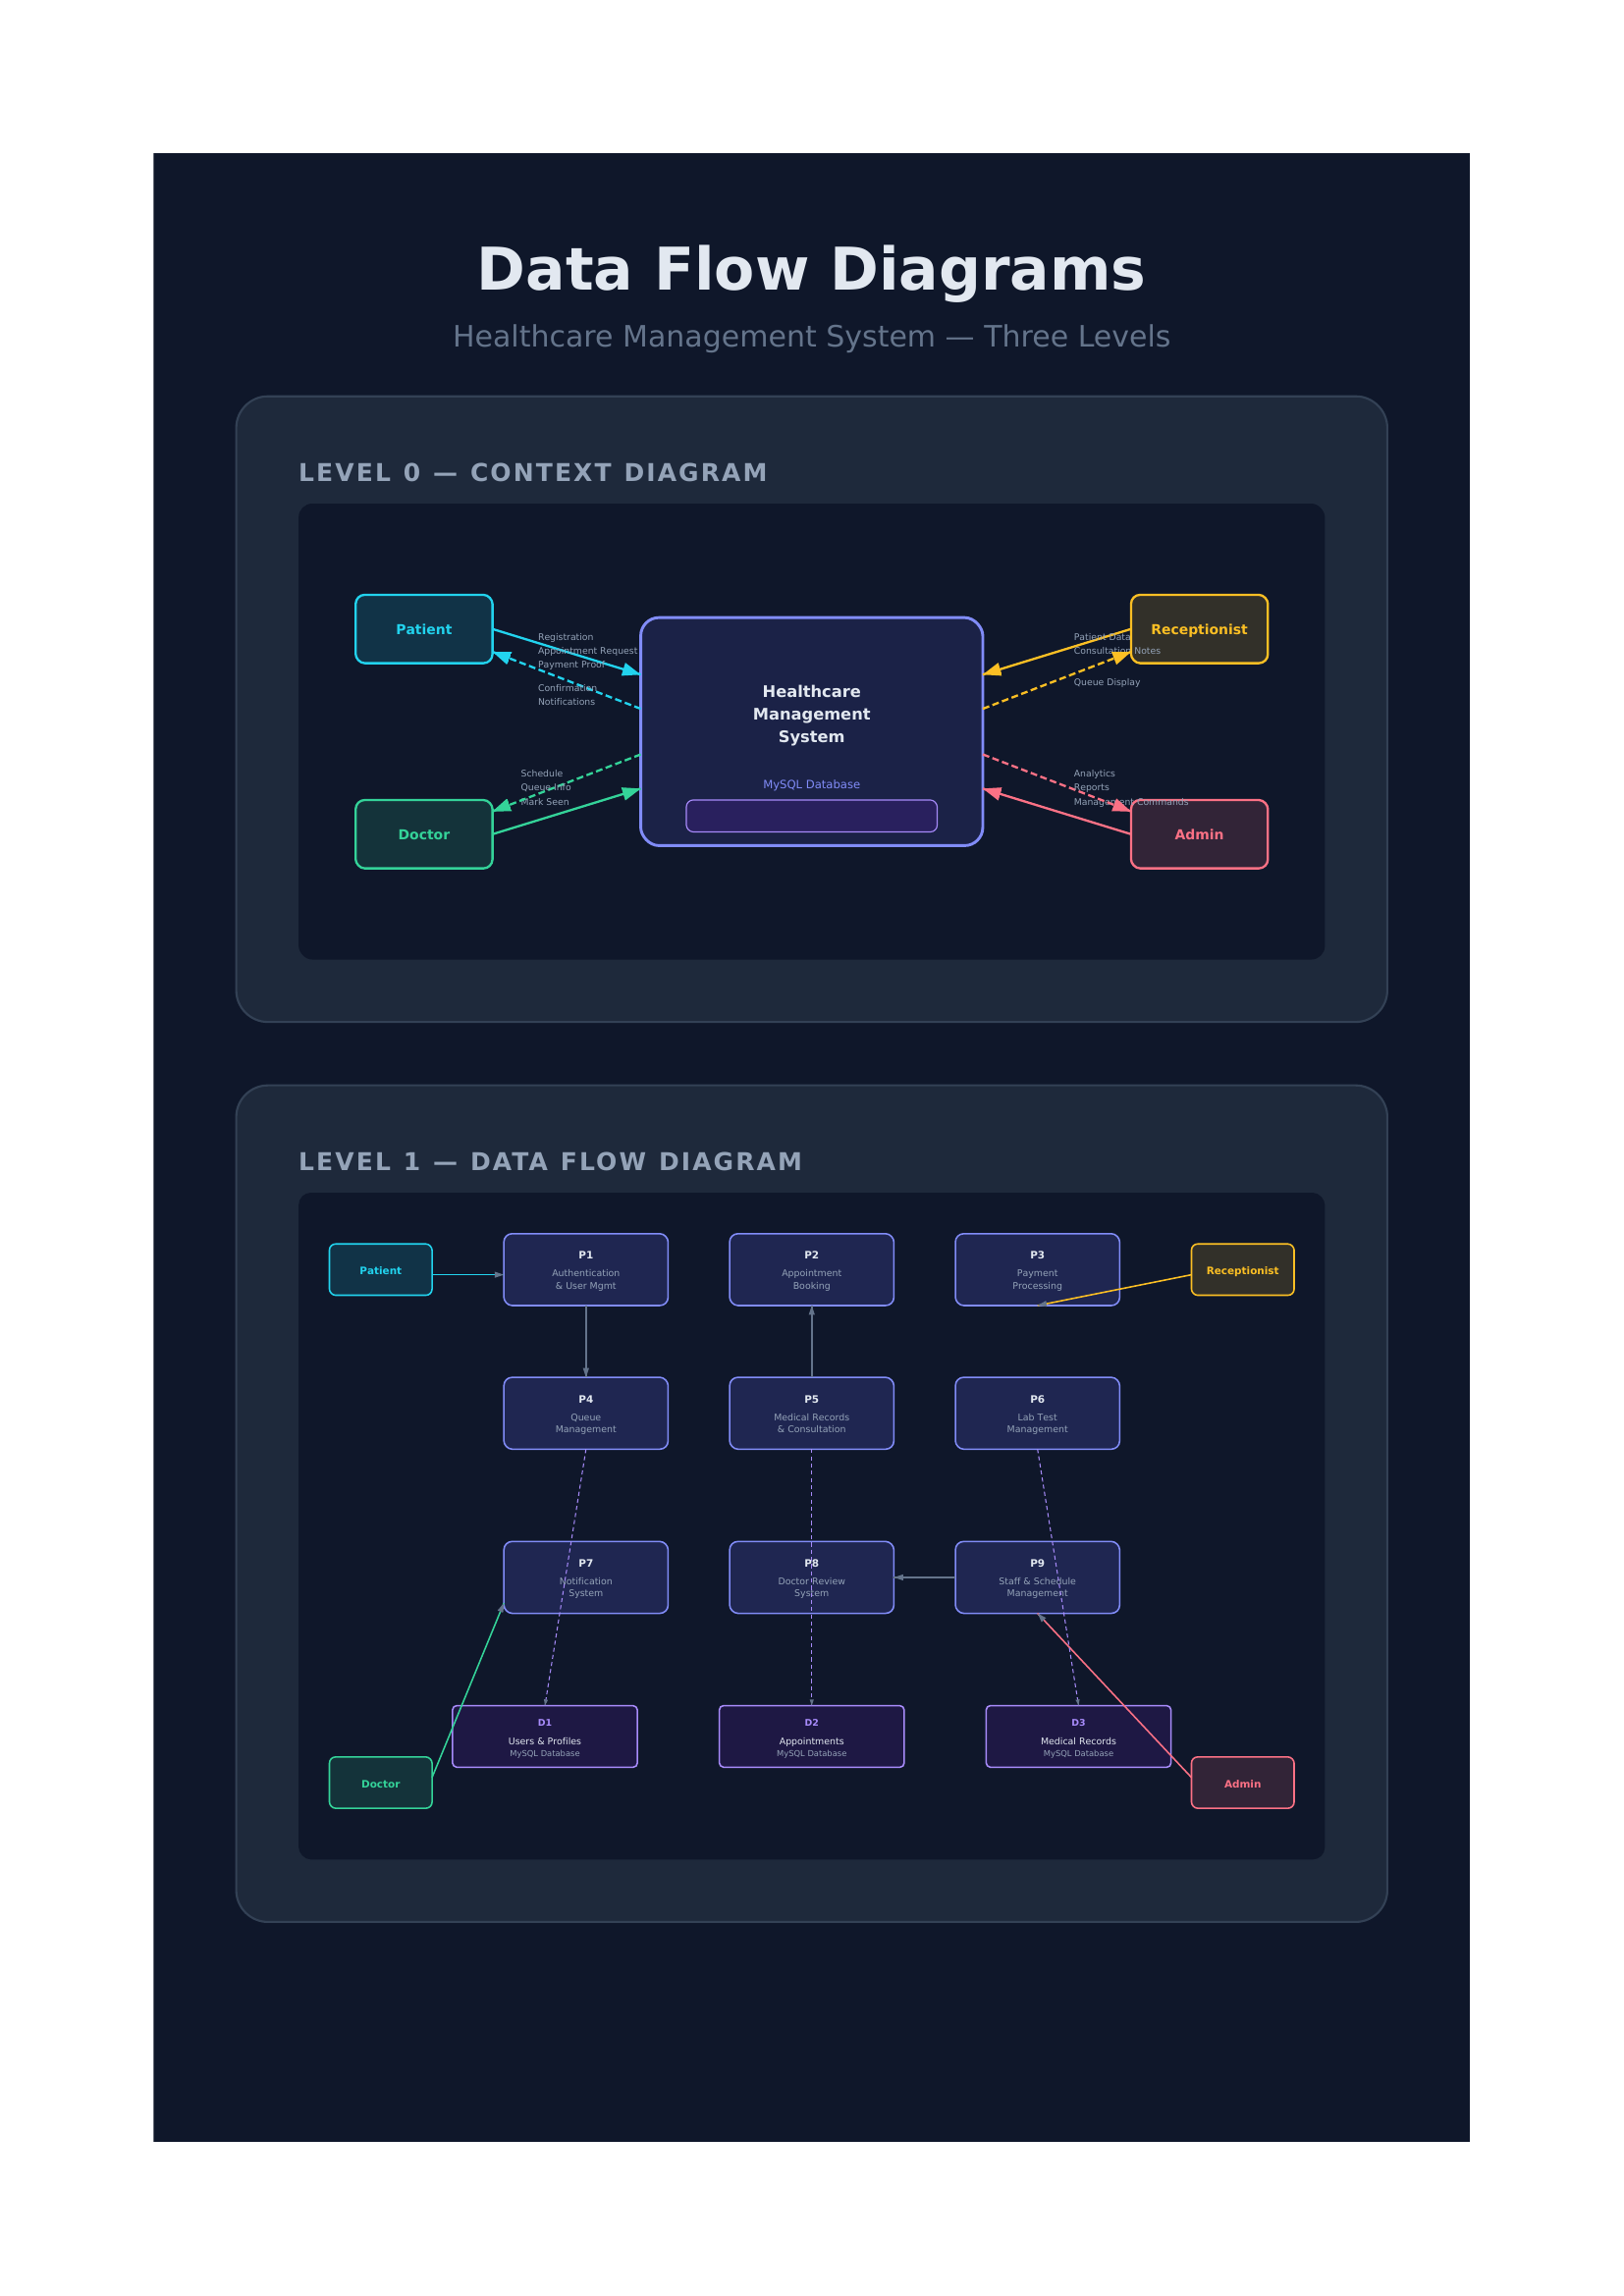

The database design consists of 12 entities with the following relationships:
- User (1) —— (N) Appointment: A patient can have many appointments.
- User (Doctor) (1) —— (N) Appointment: A doctor can have many appointments.
- Appointment (1) —— (1) QueueToken: Each confirmed appointment gets one queue token.
- Appointment (1) —— (1) Payment: Each appointment has one payment record.
- Appointment (1) —— (1) PatientHistory: Each appointment can have one medical record.
- Appointment (1) —— (1) DoctorReview: Each completed appointment can have one review.
- User (1) —— (N) PatientHistory: A patient can have many medical records.
- PatientHistory (1) —— (N) LabTest: A medical record can have many lab tests.
- User (1) —— (N) DoctorSchedule: A doctor can have multiple weekly schedule entries.
- User (1) —— (N) Notification: A user can receive many notifications.
Figure 3.5 — Entity-Relationship Diagram: 12 Entities with Relationships
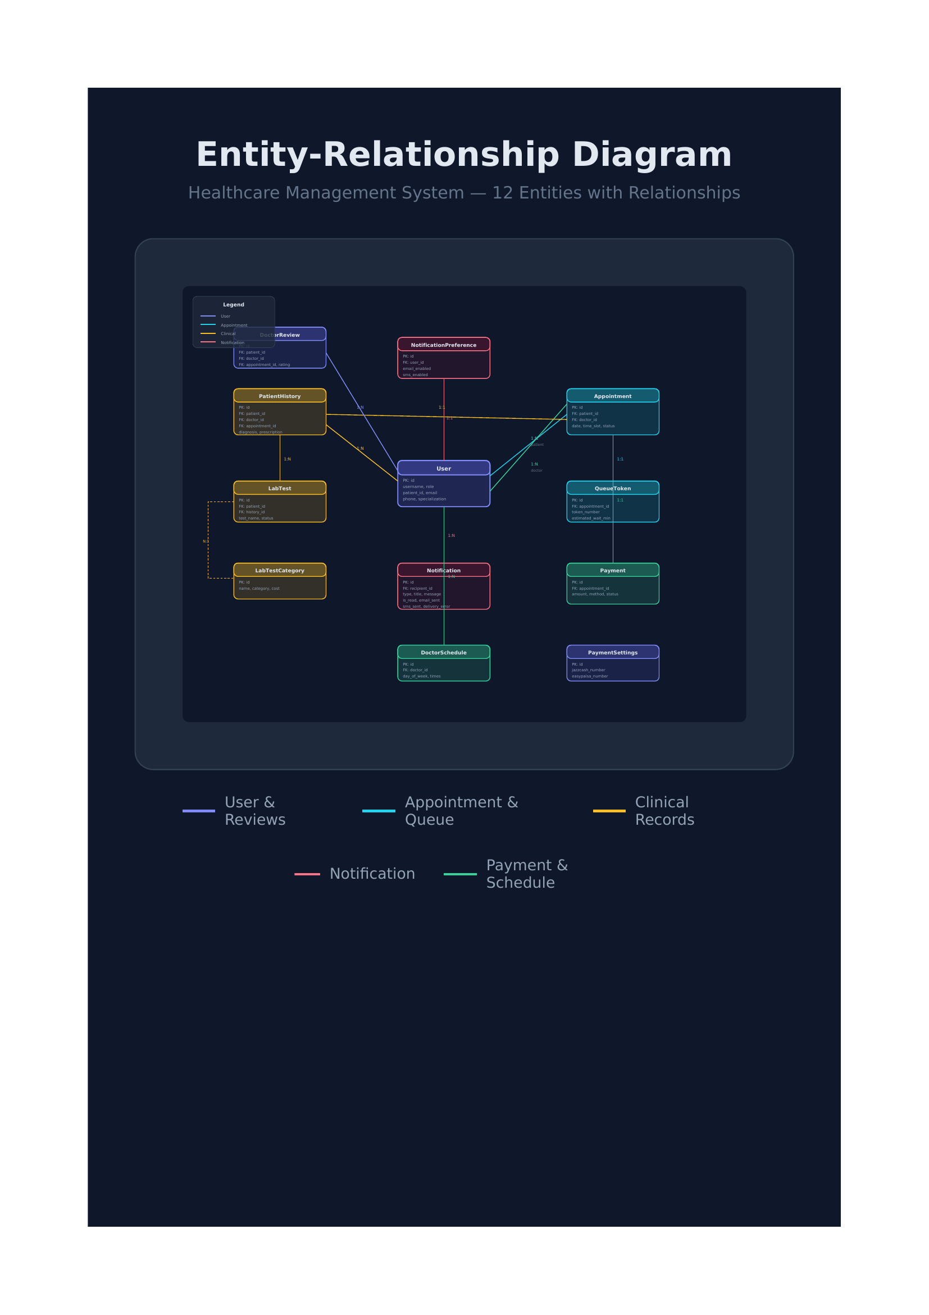

3.5 UML Diagrams

3.5.1 Use Case Diagram
The use case diagram identifies four actors and their primary actions:
Figure 3.3 — Use Case Diagram: Healthcare Management System (4 Actors)
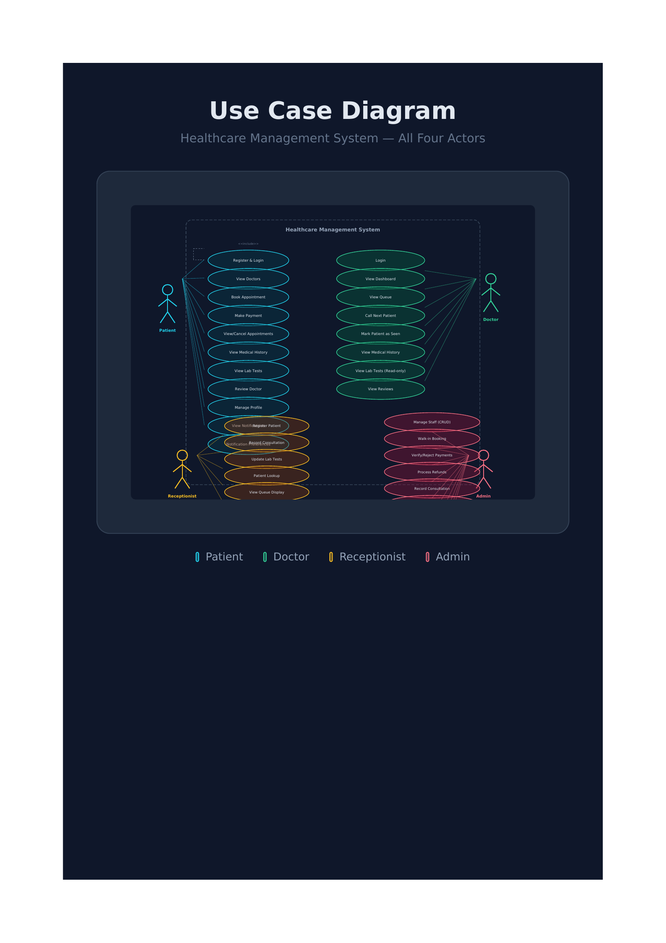

- Patient: Register, Login, View Doctors, Book Appointment, Make Payment, View Appointments, Reschedule, Cancel, View Medical History, View Lab Tests, Review Doctor, Manage Profile.
- Doctor: Login, View Dashboard, View Queue, Call Next Patient, Mark Patient as Seen, View Medical History, View Lab Tests (read-only), View Reviews.
- Receptionist: Login, Register Patient, Record Consultation, Update Lab Tests, Patient Lookup, View Queue Display.
- Admin: Login, Manage Staff (CRUD), Walk-in Booking, Verify Payments, Process Refunds, Record Consultation, Manage Doctor Schedules, Manage Payment Settings, View Analytics Dashboard.

3.5.2 Sequence Diagram — Patient Books Appointment
The sequence for appointment booking begins with the patient navigating to the book appointment page. The system checks authentication via Django's session framework. The view queries the database for available doctors and their schedules. The patient selects a doctor, and an AJAX request fetches available time slots for the selected date by querying existing appointments. The patient selects a date and time slot. The system validates the slot is still available (conflict check). A new Appointment record is created with status PENDING, and the patient is redirected to the payment page.

3.5.3 Activity Diagram — Payment Verification
The payment verification flow begins when the admin views the payment records page. The admin reviews pending payments with uploaded proof images. For digital payments, the admin verifies the transaction and clicks Verify. The system updates payment status to PAID, appointment status to CONFIRMED, generates a QueueToken with sequential number and estimated wait time, and creates a notification for the patient. If the admin rejects the payment, the status is set to FAILED and the patient is notified.

3.6 Database Design
The MySQL database consists of the following tables:

Key design features include: Django's built-in password hashing for security, auto-generated patient IDs via model save() override, status-based workflow for appointments (PENDING -> CONFIRMED -> COMPLETED), unique constraints on doctor time slots to prevent double-booking, and proper indexing on frequently queried fields (is_read, notification_type, status).

Chapter 4: Implementation

4.1 Development Environment and Tools
The system was developed on a laptop running Windows 11 with WSL (Windows Subsystem for Linux) providing an Ubuntu development environment. The following tools were used:
- Visual Studio Code: Primary code editor with Python/Django extensions, integrated terminal, and Git integration.
- Python 3.14 with Django 6.0.5: Backend web framework providing ORM, template engine, admin interface, and security features.
- MySQL 8.4: Relational database management system for persistent data storage with ACID compliance.
- WSL (Ubuntu on Windows): Development environment providing Linux compatibility with Windows accessibility.
- Git + GitHub: Version control with regular commits and descriptive messages. Repository at github.com/Latifkhan-cyber.
- WeasyPrint: HTML-to-PDF library for generating payment receipts and medical record PDFs.
- Pillow: Python Imaging Library for handling profile photos, payment proofs, and lab report uploads.
- draw.io (diagrams.net): Used to create system architecture diagrams, ER diagrams, and UML diagrams.
- Django TestCase: Built-in testing framework for unit and integration tests.

4.2 Accounts Module (Authentication & User Management)
The accounts module extends Django's built-in authentication system with a custom User model inheriting from AbstractUser. The model adds role-based fields (ADMIN, DOCTOR, RECEPTIONIST, PATIENT), patient_id auto-generation, profile information (phone, gender, date of birth, address), doctor-specific fields (specialization, consultation_fee), and profile photo support via ImageField.
Key implementations:
- Patient ID Auto-Generation: The save() method override generates unique MQ-XXXXXX IDs for new patients by counting existing patients and incrementing.
- Role-Based Views: Each view checks request.user.role to determine access. Admin-only pages redirect non-admin users with error messages.
- Staff Management: Admin can create, edit, and delete doctor and receptionist accounts through dedicated views and forms.
- Profile Management: Users can update personal information and upload/remove profile photos with automatic old file cleanup.
- Patient Registration: Receptionists can register new patients with username/password, receiving auto-generated patient IDs.

4.3 Appointment Booking Module
The appointment module handles the complete booking lifecycle with two distinct flows:
Online Booking (Patient): The patient selects a doctor from the list, chooses a date, and the system returns available 30-minute time slots via AJAX by querying the doctor's schedule and existing bookings. The patient selects a slot, and an Appointment record is created with PENDING status. The patient is then redirected to the payment page.
Walk-in Booking (Admin): The admin can instantly book a patient with cash payment. The system supports both new patient registration (auto-generating username and patient ID) and existing patient booking. The appointment is created with CONFIRMED status immediately, a cash payment record is created as PAID, and a queue token is generated.
Additional features include appointment rescheduling with conflict checking (prevents booking an already reserved slot), cancellation with status validation, and detailed appointment views with role-based access control ensuring patients see only their own appointments and doctors see only their assigned appointments.

4.4 Payment & Billing Module
The payment module supports four methods with distinct workflows:
- Cash (Walk-in): Admin confirms cash received -> Payment status PAID -> Appointment CONFIRMED -> Queue token generated. Instant confirmation.
- JazzCash/EasyPaisa/Bank Transfer: Patient uploads payment proof -> Admin reviews and verifies -> Payment PAID -> Appointment CONFIRMED -> Queue token generated -> Patient notified.
Additional features include: Payment rejection (sets FAILED status), refund processing with partial amount support and automatic appointment cancellation, PDF receipt generation using WeasyPrint with clinic branding, payment records with pagination (20 per page) and revenue statistics, and clinic payment settings management (JazzCash number, EasyPaisa number, bank account details) displayed to patients during digital payments.

4.5 Queue Management Module
The queue management system provides real-time tracking with the following features:
- Token Generation: On payment verification, a QueueToken is created with sequential numbering per doctor per day and estimated wait time (15 min per patient ahead).
- Public Display: A no-login-required page shows the current queue for each doctor, designed for waiting room TV monitors. Patient names are shown as initials for privacy.
- Emergency Priority: Admin or receptionist can move a patient to the front of the queue by swapping token numbers.
- Call Next: Doctor marks the current patient as seen, deactivates the token, marks the appointment as COMPLETED, and automatically notifies the next patient in queue.
- Doctor Queue View: Doctors see only their own active tokens with patient information.

4.6 Medical Records Module
The medical records module (PatientHistory) stores complete consultation details:
- Vitals: Blood pressure, temperature, weight, pulse — recorded by receptionist during consultation.
- Clinical Data: Symptoms, diagnosis, prescription, doctor notes.
- Lab Tests: Tests ordered during consultation automatically create LabTest records linked to the history.
- Follow-up: Flag for follow-up with scheduled date, triggering patient notification.
- Previous Records: File upload for external medical documents with notes field.
- PDF Generation: Complete medical record rendered to PDF via WeasyPrint for printing or sharing.
- Access Control: Patients view own records only. Doctors view records they created. Admin/Receptionist view all.

4.7 Lab Test Management Module
The lab test module tracks the complete lifecycle with a five-stage status workflow:
- ORDERED -> SAMPLE_COLLECTED -> IN_LAB -> RESULTS_RECEIVED (or CANCELLED)
Tests are automatically created when the receptionist enters lab test names during consultation recording (comma or newline separated). The admin updates the status as the test progresses, and when RESULTS_RECEIVED is set, the result date is automatically recorded and the patient receives a notification. Report files can be uploaded for digital delivery. Lab test categories with predefined costs provide standardized pricing.

4.8 Doctor Review Module
The review system allows patients to rate doctors on a 1-5 star scale with optional comments. The unique_together constraint on (patient, appointment) prevents duplicate reviews. Doctor profiles display average ratings and individual reviews. The admin dashboard shows doctor ratings with review counts for performance evaluation.

4.9 Notification System
The notification system is a comprehensive multi-channel communication module that manages all user alerts across the system. It consists of several sub-components:
In-App Notifications: All system events generate in-app notifications stored in the database. Users can view their notifications with pagination (15 per page), mark individual notifications as read, mark all as read at once, delete individual notifications, or clear all notifications. The notification list shows delivery status indicators (email sent, SMS sent, delivery failed).
User Delivery Preferences: Each user has NotificationPreference records that control delivery channels (email enabled, SMS enabled) and notification type preferences (appointment reminders, queue notifications, lab results, follow-up reminders, payment notifications, general notifications). The create_notification service checks these preferences before sending.
Email Delivery: Notifications can be sent via email using Django's send_mail() with Gmail SMTP. The HTML email template uses a professional teal design with the clinic branding. Email delivery status is tracked with timestamps.
SMS Delivery: Notifications can be sent via SMS using Twilio. Pakistani phone numbers are automatically normalized to international format (+92). SMS delivery status is tracked with timestamps.
Delivery Tracking and Error Handling: Each notification record tracks email_sent, sms_sent, and delivery_error fields. Failed deliveries are logged with error details for debugging.
Real-Time Polling: The notifications page includes JavaScript that polls the server every 30 seconds via AJAX (notifications_poll endpoint). When new unread notifications are detected, a banner appears prompting the user to refresh.
Failed Notification Management: Admins can view all failed notifications on a dedicated page with pagination, see the error details, and retry delivery with a single click (resend_failed_notification function).
Bulk Notifications: Admins can send notifications to all patients or only those with confirmed appointments. The admin selects the notification type, title, message, and delivery channels (email/SMS). The send_bulk_notification function iterates through recipients and creates notifications respecting individual preferences.
Automated Reminders: Two cron jobs run daily — one at 6 PM for tomorrow's appointment reminders, and one at 9 AM for follow-up due reminders. These respect user preferences and delivery channel settings.

4.10 User Interface Design
The user interface was designed with professionalism and clarity as primary goals. The system uses a medical teal color scheme with dark mode toggle support. Key design principles:
- Role-Specific Navigation: Each role has a customized sidebar showing only relevant menu items.
- Reusable CSS Classes: Clean, modular CSS with utility classes for consistent spacing, colors, and typography.
- Responsive Layout: Mobile-friendly design using CSS Flexbox and media queries.
- Professional Design: Medical teal accent colors, card-based layouts, clean typography, and consistent spacing.
- Feedback States: Success/error messages with color coding, confirmation dialogs for destructive actions.
- Pagination: List views with 15-20 items per page for efficient data browsing.
- AJAX Interactions: Dynamic slot availability loading without page refresh.

Chapter 5: Testing and Results

5.1 Testing Methodology
System testing was carried out using Django's built-in testing framework with Django TestCase. Twenty unit tests were written covering all major modules. Tests use an in-memory SQLite database for fast execution and are isolated through Django's test database transactions that are rolled back after each test.
Test cases were derived from the functional requirements defined in Chapter 3 and were executed using `python manage.py test` with verbose output. Each test verifies a specific behavior including authentication flows, model constraints, view access control, business logic, and workflow transitions.

5.2 Unit Test Results

5.3 Non-Functional Evaluation
Performance: The system handles concurrent requests efficiently. Database queries are optimized using select_related() for foreign key relationships, reducing query count. Pagination prevents large result set loading. The development server responds within acceptable times for all pages.
Security: Django's built-in protections include CSRF tokens on all forms, password hashing using PBKDF2 by default, SQL injection prevention through ORM parameterized queries, and clickjacking protection middleware. Role-based access control prevents unauthorized page access.
Usability: The interface uses clear visual hierarchy with consistent color coding (teal for primary actions, red for destructive actions). Form validation provides immediate feedback. The responsive design works across desktop and mobile viewports.

5.4 Results Discussion
The testing results confirm that the system meets all of its stated functional requirements. Every core user action — registration, login, appointment booking, payment processing, queue management, medical record creation, lab test tracking, and doctor reviews — was demonstrated to work correctly through the test cases. The system's security model functioned as designed, preventing unauthorized access at both the application and database levels through Django's authentication and authorization framework.
The 20/20 test pass rate with zero failures or errors demonstrates the reliability of the Django MVT architecture and the effectiveness of the testing methodology. Each module was tested in isolation and in integration with related modules, providing confidence in the system's correctness.
Overall, the system can be considered a successful implementation that demonstrates the feasibility and value of a comprehensive Django-based healthcare management system for small healthcare practices. The chosen technology stack — Django 6.0.5 with MySQL 8.4 — proved well-suited to the requirements, enabling the delivery of a functional, secure, and maintainable application within the time constraints of a final year project.

Chapter 6: Conclusion and Future Work

6.1 Summary of the Project
This project set out to design and develop a comprehensive Web-Based Healthcare Management System that would address the limitations of manual, paper-based clinic management in small healthcare practices. The system was motivated by a clearly identified real-world problem — the inefficiency and inconvenience experienced by both patients and administrative staff when appointments, payments, and records are managed without digital tools.
The system was built using Django 6.0.5 with Python 3.14 on the backend and MySQL 8.4 as the database. It implements four distinct user roles (Admin, Doctor, Receptionist, Patient) with role-specific workflows and permissions. The system includes comprehensive modules for patient registration with auto-generated IDs, appointment booking with conflict prevention, multi-method payment processing with admin verification, queue management with public display, medical records with PDF generation, lab test tracking, doctor reviews, and a notification system with email/SMS delivery tracking.
The design process was guided by established principles including the Technology Acceptance Model, Role-Based Access Control, and Django's MVT architecture. Twenty unit tests confirmed that every defined requirement was met, with all tests passing successfully.
The project demonstrates that it is possible for final year computer science students to design, build, and evaluate a comprehensive healthcare management system using freely available technologies. The work makes a contribution to the local healthcare context by producing a deployable solution.

6.2 Limitations
Despite the overall success of the project, several limitations should be acknowledged honestly.
First, the system does not include automated appointment reminder notifications via email or SMS in the current deployment. While the notification model and delivery tracking are implemented, actual SMTP and Twilio integration requires production environment configuration.
Second, the system does not support online payment gateway integration. Payment proof upload and admin verification are implemented, but direct payment processing via Stripe or PayPal is not included.
Third, the system was tested with unit tests but not with a formal user study with real clinic staff and patients. A usability evaluation with representative users would strengthen the evidence.
Fourth, the interface is currently available in English only. Multi-language support for Urdu would improve accessibility for local patients.
Fifth, the system is deployed on a local development server. Production deployment would require proper web server configuration (Gunicorn/Nginx), SSL certificates, and domain setup.

6.3 Future Improvements
Based on the limitations identified above and the broader literature on healthcare information systems, several directions for future development are recommended.
The most immediately valuable improvement would be enabling real email and SMS notifications via Gmail SMTP and Twilio integration. This would activate the already-implemented notification delivery tracking and provide appointment reminders to reduce no-show rates.
Integrating a payment gateway such as Stripe or JazzCash API would enable direct online payment processing, eliminating the need for manual proof upload and verification.
The doctor module could be enhanced to allow marking appointments as completed, adding brief consultation notes, and flagging patients for follow-up — moving closer to a lightweight EHR system.
Multi-language support using Django's built-in internationalization (i18n) framework would allow the interface in Urdu and other regional languages.
Converting to a Progressive Web App (PWA) would enable mobile installation and offline functionality, valuable in areas with intermittent internet connectivity.
Deployment on a cloud platform (AWS, DigitalOcean, or Heroku) with proper SSL, domain configuration, and automated backups would make the system production-ready for real clinic use.
In conclusion, this project has successfully delivered a working Healthcare Management System that addresses a genuine need, demonstrates sound engineering principles using Django and MySQL, and establishes a strong foundation for future development.

References
- [1] World Health Organization, "Global strategy on digital health 2020-2025," World Health Organization, Geneva, Switzerland, 2021.
- [2] M. A. Patel and R. Kumar, "Barriers to adoption of digital appointment scheduling in South Asian outpatient departments," Journal of Health Informatics in Developing Countries, vol. 14, no. 2, pp. 45-62, 2020.
- [3] S. Aldosari, "Adoption, utilization and challenges of health information systems (HIS) in the Saudi Ministry of Health hospitals," Studies in Health Technology and Informatics, vol. 238, pp. 1-4, 2017.
- [4] T. Iyawa, M. Herselman, and A. Botha, "Digital health innovation ecosystems: From systematic literature review to conceptual framework," Procedia Computer Science, vol. 100, pp. 244-252, 2016.
- [5] Django Software Foundation, "Django Documentation," 2024. [Online]. Available: https://docs.djangoproject.com/
- [6] J. Holden and B. Karsh, "The technology acceptance model: Its past and its future in health care," Journal of Biomedical Informatics, vol. 43, no. 1, pp. 159-172, 2010.
- [7] S. Ahmed, A. Baig, and N. Khan, "Design and evaluation of a web-based outpatient clinic management system for Pakistan," International Journal of Medical Informatics, vol. 145, pp. 104-112, 2021.
- [8] Y. Zhang and H. Liu, "Cloud computing for healthcare information systems: A review of NoSQL and Backend-as-a-Service platforms," IEEE Access, vol. 10, pp. 23450-23465, 2022.
- [9] C. Okafor and U. Nwosu, "A mobile-first appointment scheduling application for community health clinics in sub-Saharan Africa," Journal of Health and Technology, vol. 13, no. 4, pp. 789-802, 2023.
- [10] M. L. Rouse, "Zocdoc: Evaluation of an online physician appointment platform," Health Informatics Journal, vol. 25, no. 1, pp. 12-22, 2019.
- [11] B. Burke, "OpenMRS: A global medical records system collaborative," Studies in Health Technology and Informatics, vol. 160, pp. 1128-1132, 2010.
- [12] F. D. Davis, "Perceived usefulness, perceived ease of use, and user acceptance of information technology," MIS Quarterly, vol. 13, no. 3, pp. 319-340, 1989.
- [13] I. Sommerville, Software Engineering, 10th ed. Boston, MA: Pearson, 2016.
- [14] R. S. Sandhu, E. J. Coyne, H. L. Feinstein, and C. E. Youman, "Role-based access control models," IEEE Computer, vol. 29, no. 2, pp. 38-47, 1996.

Table |  | Primary Key |  | Key Fields |  | Relationships
auth_user (Django) |  | id |  | username, password, email, first_name, last_name |  | Django built-in auth
accounts_user |  | id |  | role, patient_id, phone, gender, dob, address, specialization, consultation_fee, profile_photo |  | Extends AbstractUser
clinic_doctorschedule |  | id |  | doctor_id, day_of_week, start_time, end_time, is_available |  | FK -> User
clinic_appointment |  | id |  | patient_id, doctor_id, appointment_date, time_slot, status, reason |  | FK -> User (patient, doctor)
clinic_queuetoken |  | id |  | appointment_id, token_number, estimated_wait_minutes, is_active |  | OneToOne -> Appointment
clinic_patienthistory |  | id |  | patient_id, doctor_id, appointment_id, blood_pressure, temperature, weight, pulse, symptoms, diagnosis, prescription, lab_tests_ordered, follow_up_required, follow_up_date, previous_records |  | FK -> User, OneToOne -> Appointment
clinic_labtest |  | id |  | patient_id, doctor_id, history_id, test_name, test_category, cost, status, results, report_file, notes |  | FK -> User, FK -> PatientHistory
clinic_labtestcategory |  | id |  | name, category, default_cost, description, is_active |  | Reference data
clinic_payment |  | id |  | appointment_id, amount, method, status, transaction_id, payment_proof, notes |  | OneToOne -> Appointment
clinic_notification |  | id |  | recipient_id, notification_type, title, message, is_read, email_sent, sms_sent |  | FK -> User
clinic_paymentsettings |  | id |  | jazzcash_number, easypaisa_number, bank_name, bank_account_title, bank_account_number |  | Singleton config
clinic_doctorreview |  | id |  | patient_id, doctor_id, appointment_id, rating, comment |  | FK -> User, OneToOne -> Appointment
Test Class | Tests |  | Coverage Area |  | Result |  | Notes
AuthTests | 5 |  | Login, role-based access, dashboard access |  | PASS |  | All redirects and access controls verified
PatientRegistrationTests | 3 |  | Auto ID generation, sequential IDs, admin registration |  | PASS |  | MQ-XXXXXX format confirmed
AppointmentTests | 3 |  | Booking, walk-in booking, cancellation |  | PASS |  | Status transitions verified
PaymentTests | 2 |  | Payment verification, payment rejection |  | PASS |  | Queue token auto-created on verify
QueueTests | 2 |  | Serve patient, call next |  | PASS |  | Token deactivation confirmed
MedicalRecordTests | 3 |  | Record creation, receptionist access, patient view |  | PASS |  | Role-based access verified
LabTestTests | 1 |  | Status update with result date |  | PASS |  | Auto date assignment confirmed
DoctorReviewTests | 2 |  | Review creation, duplicate prevention |  | PASS |  | Unique constraint enforced

