Steps for camel project with database

step1:-Add maven camel blueprint project

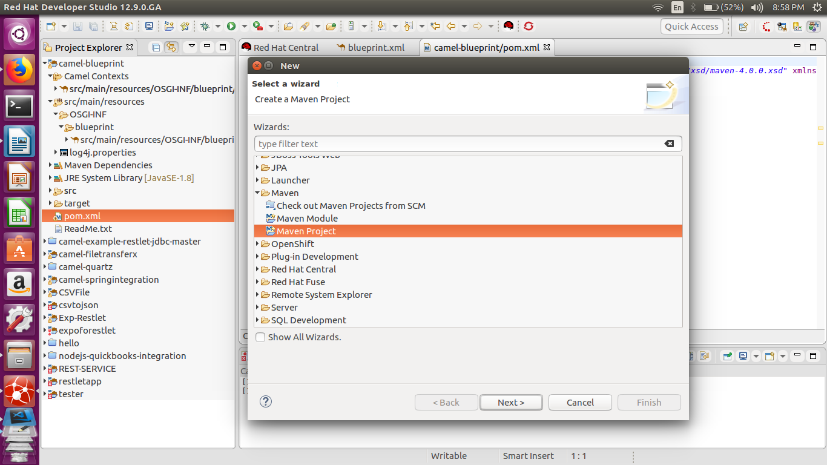
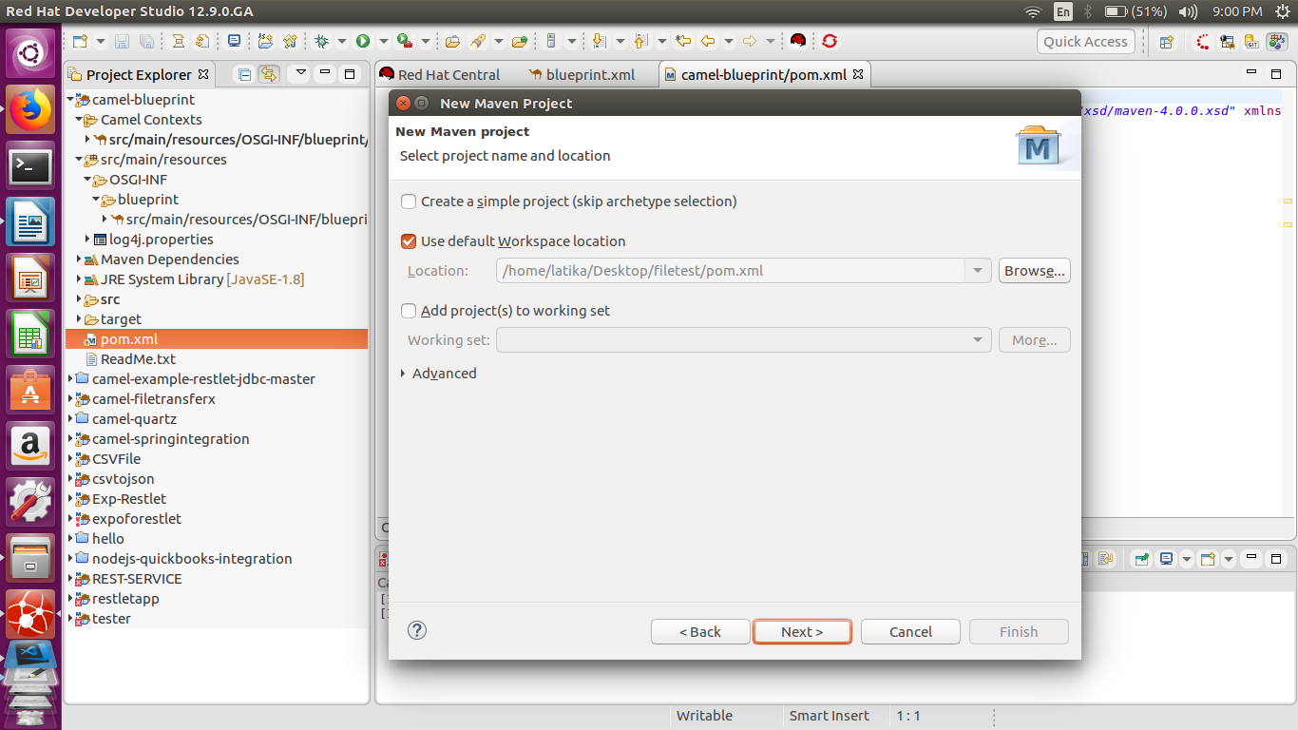
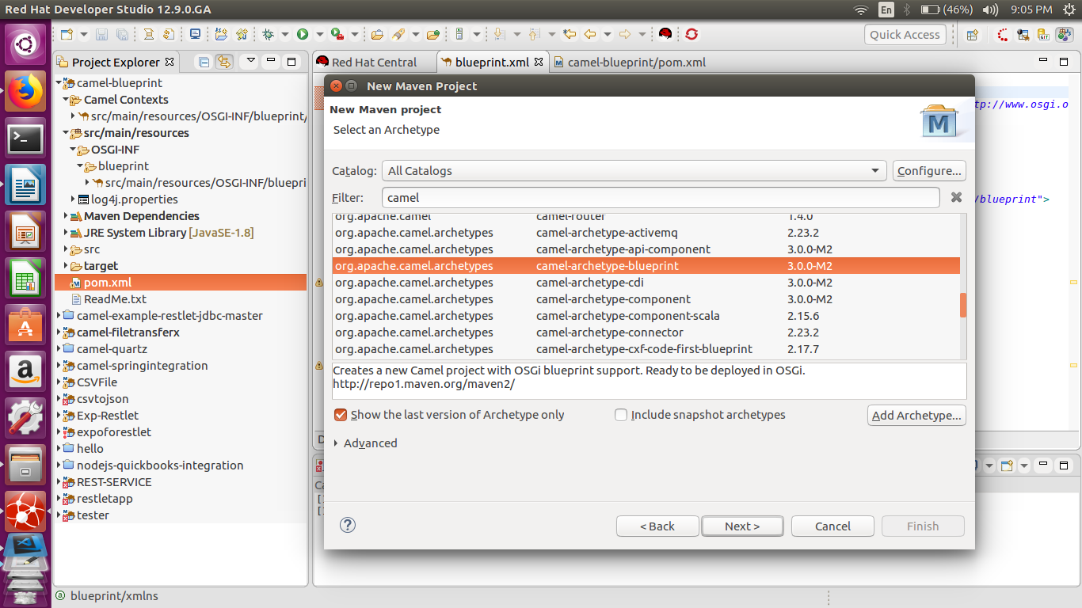
then press finish button.

Step2:-then write a code in blueprint page

<?xml version="1.0" encoding="UTF-8"?>

<blueprint xmlns="http://www.osgi.org/xmlns/blueprint/v1.0.0"
xmlns:xsi="http://www.w3.org/2001/XMLSchema-instance" xsi:schemaLocation="http://www.osgi.org/xmlns/blueprint/v1.0.0 https://www.osgi.org/xmlns/blueprint/v1.0.0/blueprint.xsd http://camel.apache.org/schema/blueprint http://camel.apache.org/schema/blueprint/camel-blueprint.xsd">
//this is required for connect with database
<bean class="org.apache.commons.dbcp.BasicDataSource"
destroy-method="close" id="dataSource">
<property name="driverClassName" value="com.mysql.jdbc.Driver"/>
<property name="url" value="jdbc:mysql://localhost:3306/user"/>
<property name="username" value="root"/>
<property name="password" value="admin"/>
</bean>
//this is default property
<camelContext id="_context1" xmlns="http://camel.apache.org/schema/blueprint">
//Create route for execute for data
<route id="_route2">
//It will use foe set body for show data
<from id="_from2" uri="timer://timer1?period=5s"/>
<setBody id="_setBody1">
//it is use for add query in project
<constant>
select * from employee
</constant>
</setBody>
//It will set path from where data can retrived
<to id="_to1" uri="jdbc:dataSource?"/>
<log id="_log5" message="table ${body}"/>

</route>
</camelContext>
</blueprint>

Step3:- Now add dependency in POM.XML file

<dependency>
<groupId>org.apache.camel</groupId>
<artifactId>camel-jdbc</artifactId>
</dependency>
<!-- https://mvnrepository.com/artifact/commons-dbcp/commons-dbcp -->
<dependency>
<groupId>commons-dbcp</groupId>
<artifactId>commons-dbcp</artifactId>
<version>1.4</version>
</dependency>

<dependency>
<groupId>mysql</groupId>
<artifactId>mysql-connector-java</artifactId>
<version>5.1.45</version>
</dependency>

step4:- Then run program in local camel context

