**INTRODUCTION TO DATABASE EXERCISE**

**Problem Statement:** There can be multiple customers, who can place multiple orders on the site. Now a sales person can handle these orders will distribute into multiple sales persons (One order will be assign to one salesperson only). So a sales person can have multiple orders of multiple customers

**QUES 1:** Create Database

**SOLUTION:-**

Create Database:



Use Database:



Show Database:

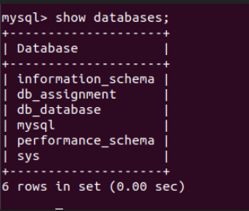

**QUES 2:** Design Schema

**SOLUTION:-**

Schema for Customer:

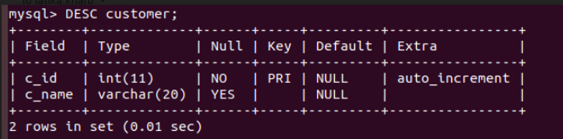

Schema for Sales Person:

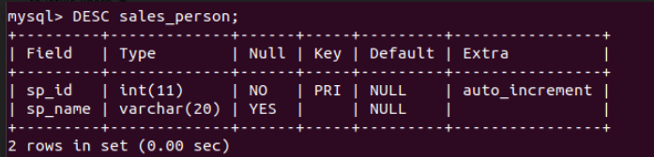

Schema for Orders:

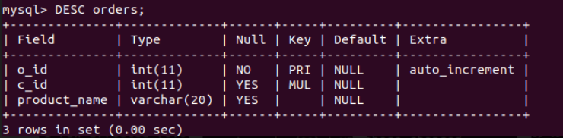

Schema for orders-assigned:

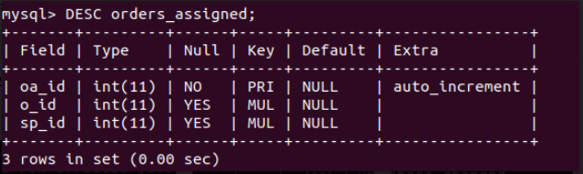

**QUES 3:**Create tables

**SOLUTION:-**

Create table: customer

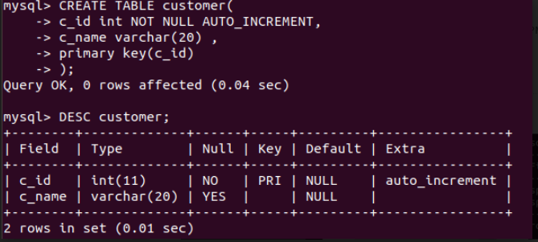

Create table: sales person

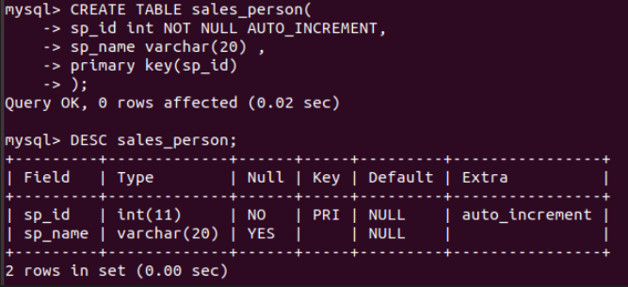

Create table: orders

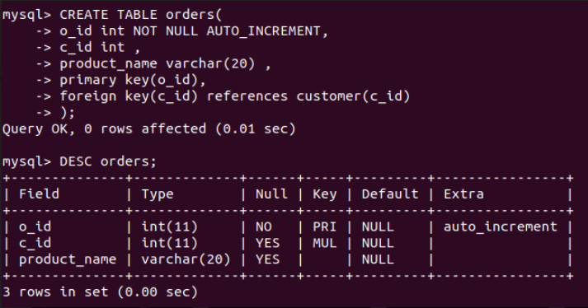

Create table: orders-assigned

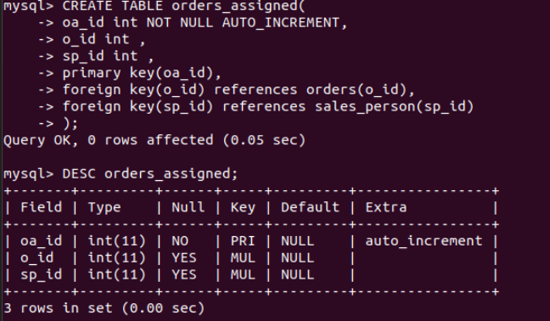

**QUES 4:**Insert sample data

**SOLUTION:-**

Insert values into : customer

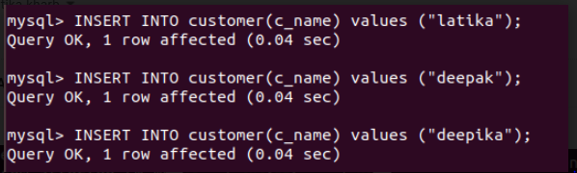

Insert values into : sales person

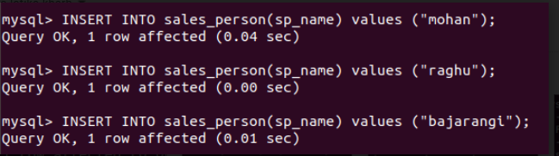

Insert values into : orders

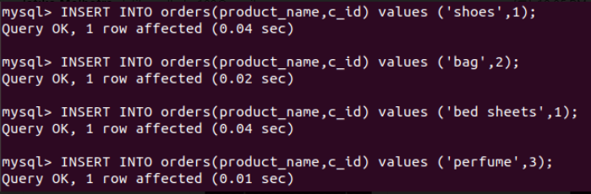

Insert values into : orders-assigned

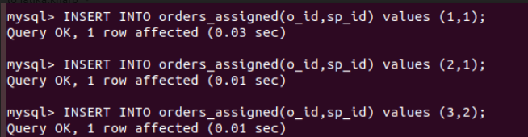

Values of table customer and sales_person

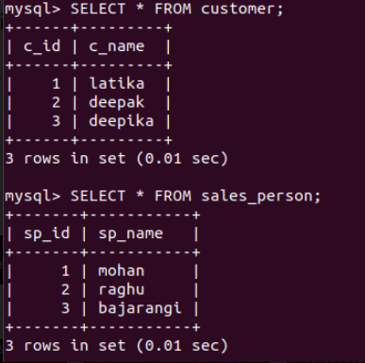

Values of table orders and orders_assigned

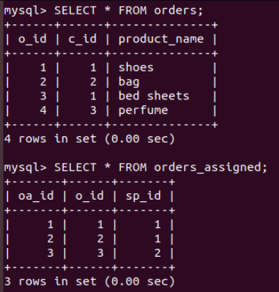

**QUES 5:**Find the sales person have multiple orders.

**SOLUTION:-**

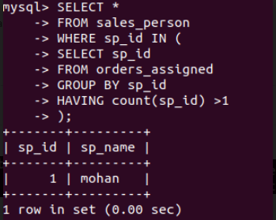

**QUES 6:**Find the all sales person details along with order details

**SOLUTION:-**

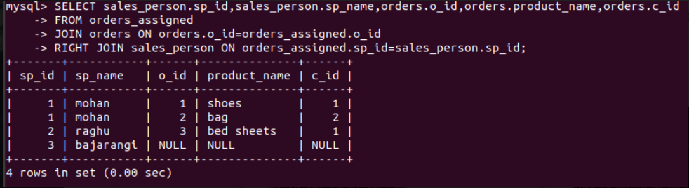

**QUES 7:**Create index

**SOLUTION:-**

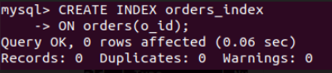

**QUES 8:**How to show index on a table

**SOLUTION:-**

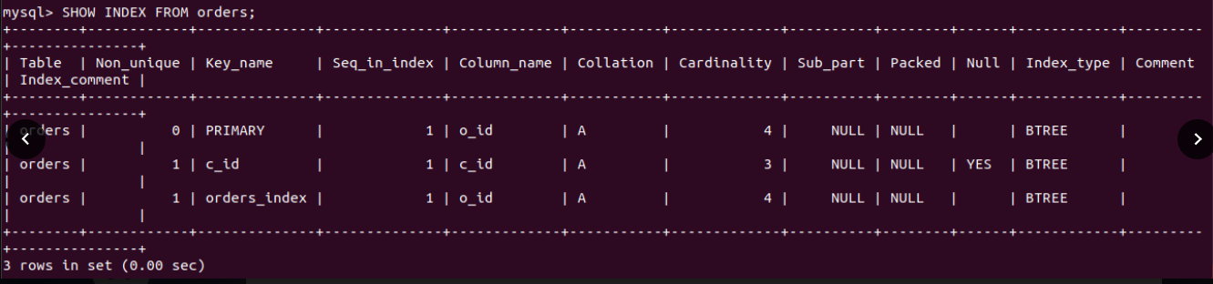

**QUES 9:**Find the order number, sale person name, along with the customer to whom that order belongs to

**SOLUTION:-**

