**ASSIGNMENT-Web Hosting**

**Ques 1:-What is the role of IIS and how IIS Server works? Please describe properly about working with proper steps and explain Architecture.**

**Role of IIS:-**

IIS fulfills the role of the Web server, responding to requests for files from Web clients such as IE, and [logging activity](https://docs.microsoft.com/en-us/previous-versions/iis/6.0-sdk/ms524845(v=vs.90)).IIS maintains information about the location of content files, what security identities have access to those files, how content files are separated into applications, and what URLs are mapped to those applications. This information can be configured manually or programmatically by using one of the [IIS administration technologies](https://docs.microsoft.com/en-us/previous-versions/iis/6.0-sdk/ms525806(v=vs.90)). IIS can communicate with software such as [Microsoft SharePoint](http://go.microsoft.com/fwlink/?linkid=6011), [Microsoft Visual Studio.NET](http://msdn.microsoft.com/vstudio/), and [Web Distributed Authoring and Versioning (WebDAV)](http://msdn.microsoft.com/library/en-us/wss/wss/_exch2k_http_webdav_access.asp?frame=true) to make Web content creation fast and easy.

**Working Of IIS Server is explained in the following steps:-**

1. When a client browser initiates an HTTP request for a resource on the Web server, HTTP.sys intercepts the request.
2. HTTP.sys contacts WAS to obtain information from the configuration store.
3. WAS requests configuration information from the configuration store, applicationHost.config.
4. The WWW Service receives configuration information, such as application pool and site configuration.
5. The WWW Service uses the configuration information to configure HTTP.sys.
6. WAS starts a worker process for the application pool to which the request was made.
7. The worker process processes the request and returns a response to HTTP.sys.
8. The client receives a response.

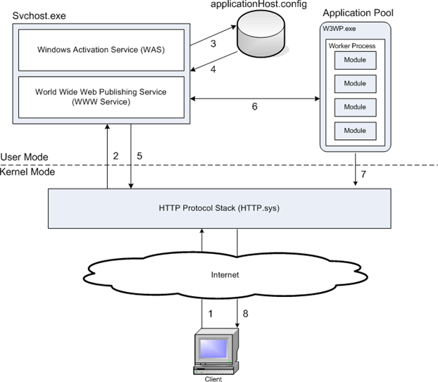

**Ques2:-What is Application pool in IIS and how to create and assign Application pool to a website. Please explain in detail with example**

**Application Pool in IIS:-**

Application pools are used to separate set of IIS worker processes that share the same configuration. Application pools enable us to isolate our web application for better security, reliability, and availability. The worker process serves as the process boundary that separates each application pool so that when one worker process or application is having an issue, other applications or worker processes are not affected.

**Steps to Create an Application Pool**

Step 1: Right Click on Application Pool and give the name of your pool. Here, I have given "ApplicationPoolDemo_Ques2" and select Framework and click on OK. As shown in the below screen shoot

Step 2: If you are writing some thing on the server [may be writes Error Events Logs], you need to change the Pool Identity to Local System. Right click on Pool Identity setting as shown in the following image.

Illustration in shown below in the image

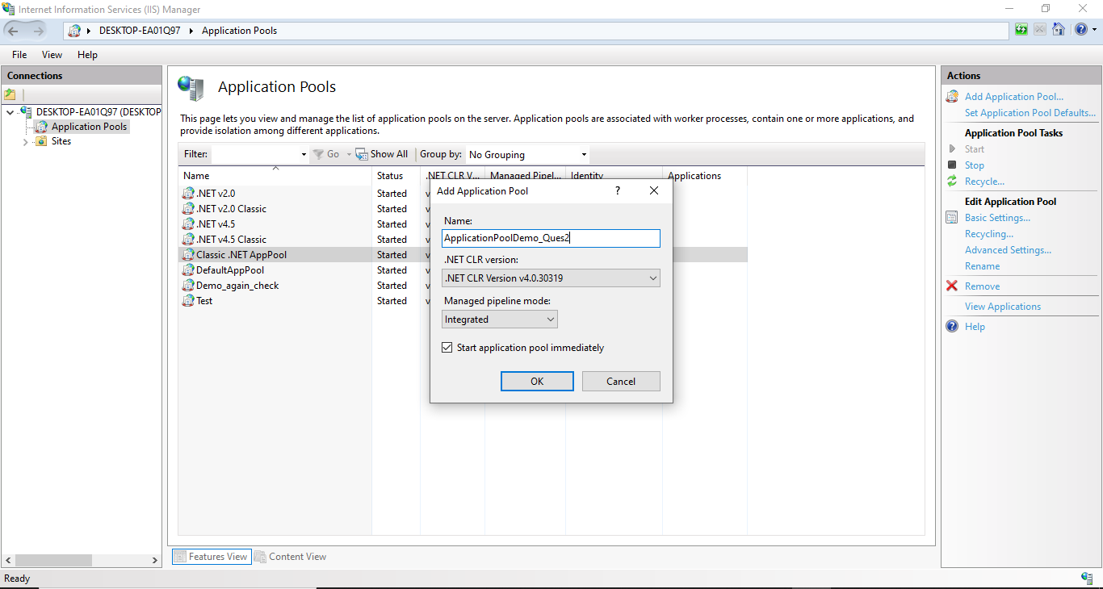

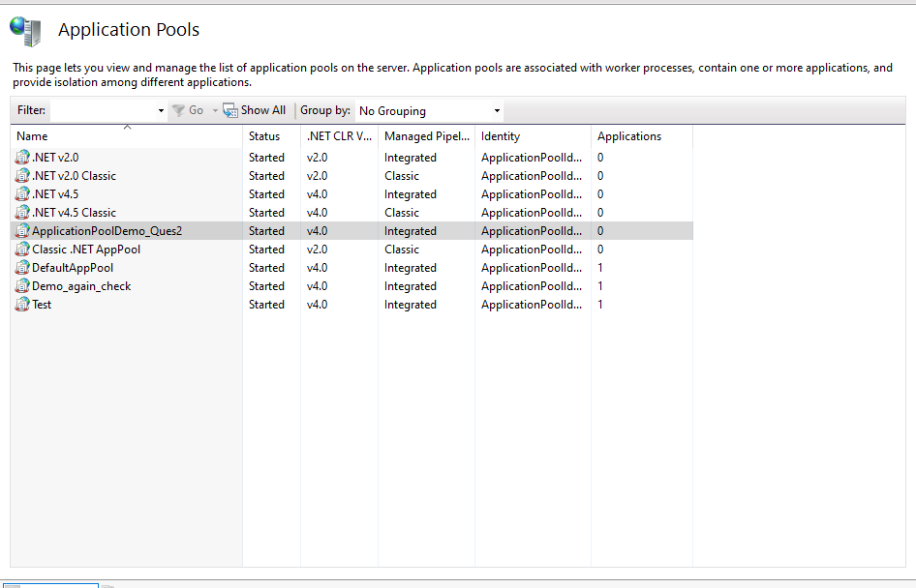

**Steps to assign application pool to a website:-**

Step 1: Right Click on "Demo_Again_Check" Application and Select "Advanced Settings".

Step 2: Finally assign your created Application Pool "ApplicationPoolDemo_Ques2" to "Demo_Again_Check" Application.

Now you can run your application by just typing http:\\localhost\Demo_Again_Check and it can be accessible on network by IP also.

Illustration is given below:-

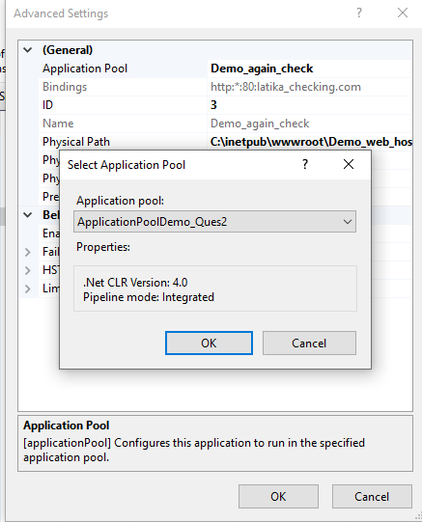

**Ques3:-**What are the different ways of deploying Asp .net application on IIS. Describe briefly.

**Different ways to deploy Asp .Net application are as follows:-**

**Approach 1:** Web Deployment Package from visual studio.

In visual studio you can create a web Deployment Package which you can import from IIS to deploy you web application. Follow these steps to accomplish this:

1, Right click you asp.net web application project and select "package/Publish Setting".

2, Provide a few basic data in the configuration from (you may not want to change any setting in the first attempt).Select the project and click on properties.

3, Right click on the project and select "Build Deployment Package". Visual studio will build the deployment package (zip file) and will store in the default location.

4, Open IIS manager(type "inetmgr" in Run command), Right click on the target website (where you want to deploy you Asp.net application),Select deploy=>Import application

5, Browse the deployment package file (the Zip file) to select it and select "Next" buttons on wizard steps and click the "**finish**" button on the last step. You can alter the connection string in wizards steps.

6, Now Browse your website from the IIS.

**Approach 2:** Publish option from Visual studio.

You need to create simple website in IIS, but careful about Application Pool version if your application version is less than 4.0 then Pool version should be 2.0.

Then from VS Right click on application and select **publish** Option

A form will appear where you need to provide some basic information

click on the "Publish" button to publish the web application.

**Ques4:-**What is virtual directory and what is its role? What Are The Execution Permission For Virtual Directory? Deploy website with Virtual Directory

**Virtual Directory:-**

A virtual directory is a friendly name, or alias, either for a physical directory on your server hard drive that does not reside in the home directory.

Because an alias is usually shorter than the path of the physical directory, it is more convenient for users to type.

**Role Of Virtual Directory:-**

A **virtual directory** receives queries and directs them to the appropriate data sources by abstracting and virtualizing data. The **virtual directory** integrates identity data from multiple heterogeneous data stores and presents it as though it were coming from one source.

**There are three execution permission available:-**

1.None

2.scripts only

3.Scripts and executable

**Deploy website with Virtual Directory :-**

1. Add your application files.
2. Add your Website
3. Configure Web Site Bindings
4. Configure Access Flags for your Web Site
5. Set up default documents for your application
6. Enable FTP access
7. Configure Virtual Directory
8. Configure global IIS settings (optional)
9. Run the project

**Ques5:-**Create a asp .net core web application and deploy on the IIS Server by using host Name as of your name. Explain all the steps in document

**Steps to deploy are as follows:-**

1. Create a MVC Application using DotNet Core 3.0 in Visual Studio
2. Deploy/Publish into a folder by right clicking on the project and selecting publish and then selecting the appropriate physical path to publish the project as shown below.Also at the end first build your project and then publish it.

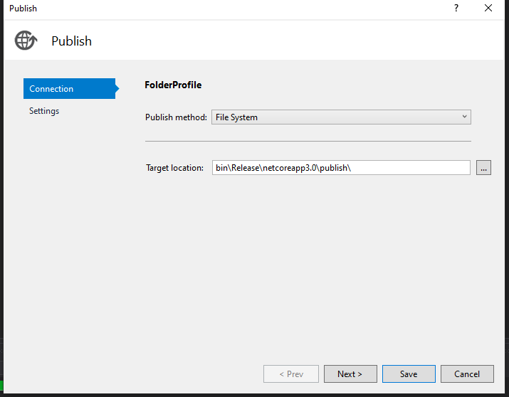

1. Create website inside IIS.

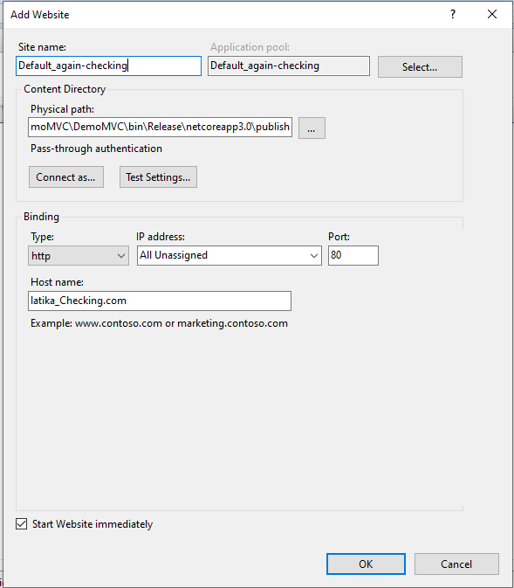

1. Make host entry to browse from browser

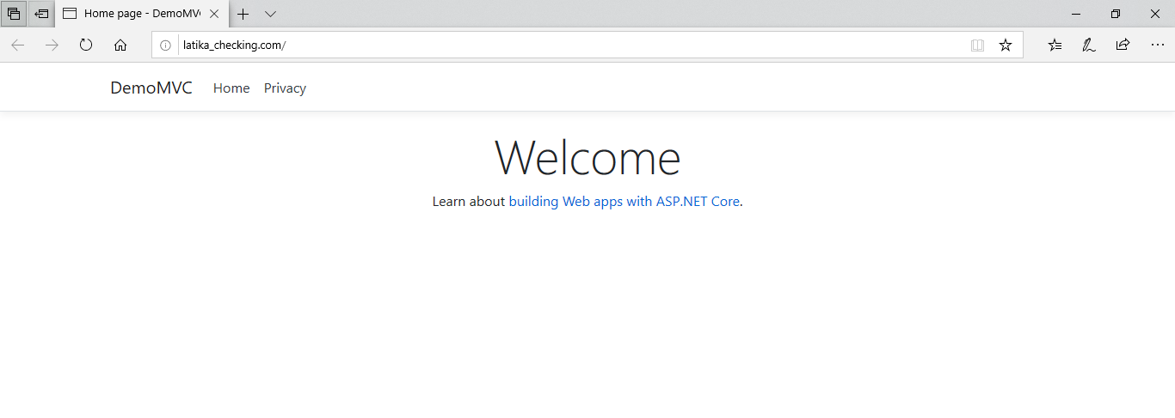

**Ques6:-**Deploy website using Web Deploy package OR Web Deployment with database. Explain the steps with explanations

**Follow the following steps for Web Deployment:-**

1. Make Application Pool with CLR version 4.0(As I have created test in the following screen_shot)

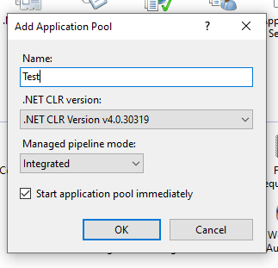

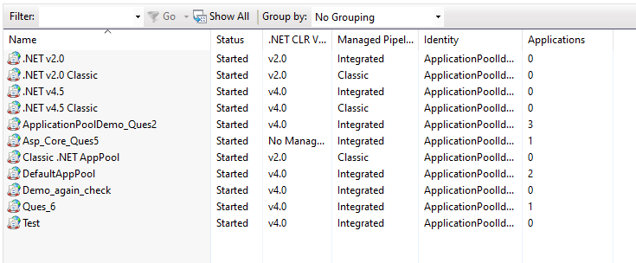

1. Create a data connection in server explorer

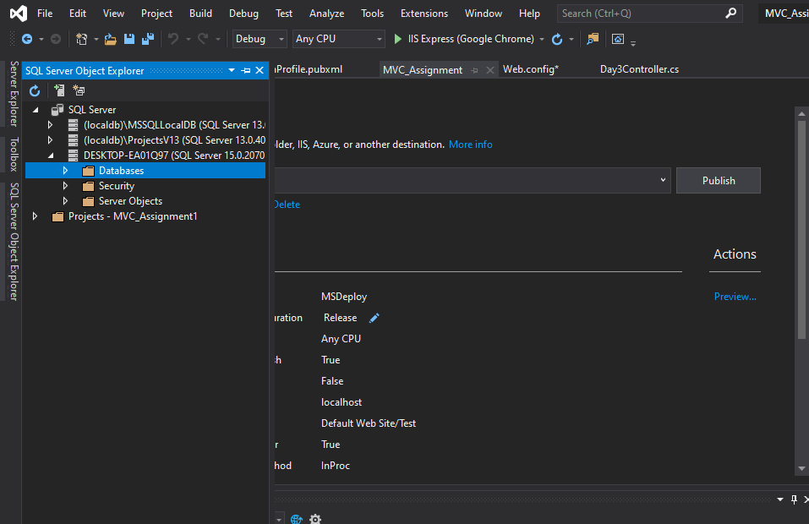

3. Write click on the project and publish it.

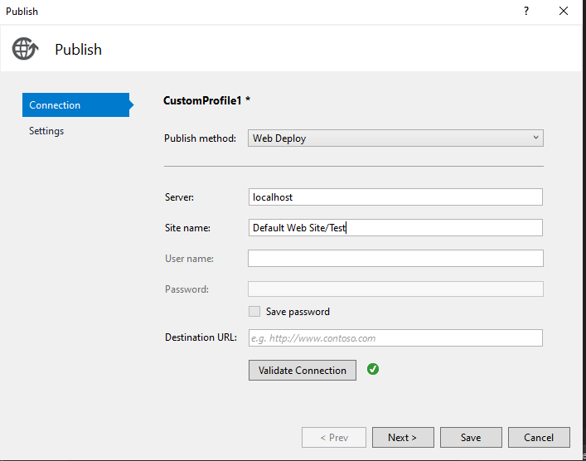

1. Select web deploy and follow the screen

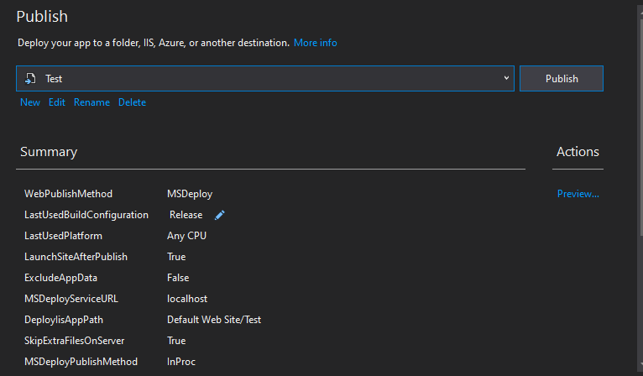

1. Then do the publish in IIS

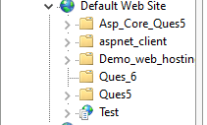

1. Below is the website published

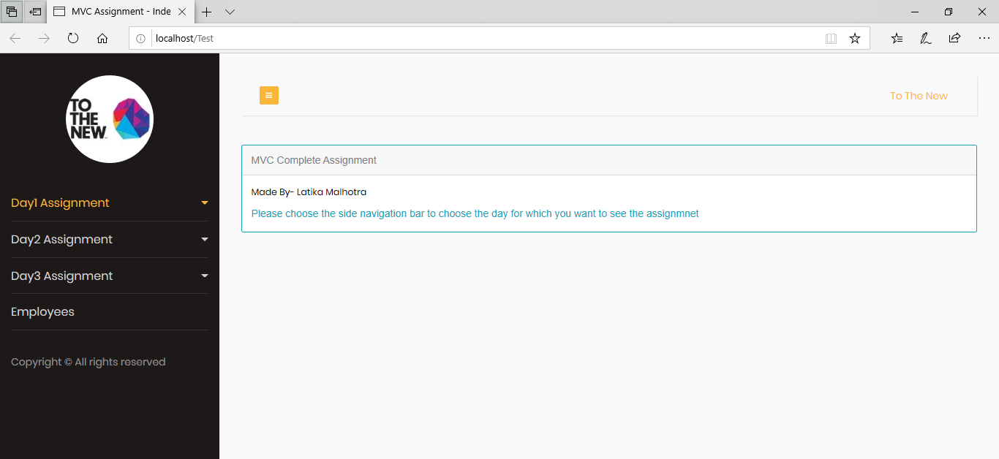

**Follow the following steps for Web Deployment Package:-**

1. Make Application Pool with CLR version 4.0(As I have created test in the following screen_shot)





1. Create a data connection in server explorer



1. Write click on the project and publish it using web deployment package.

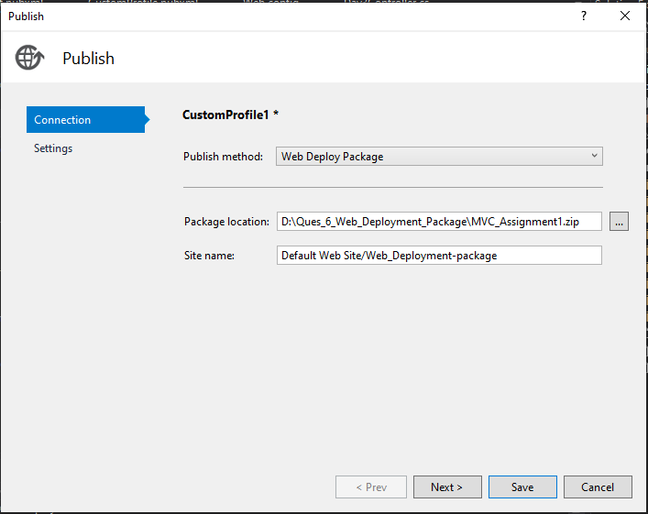

1. Select the appropriate database connection.

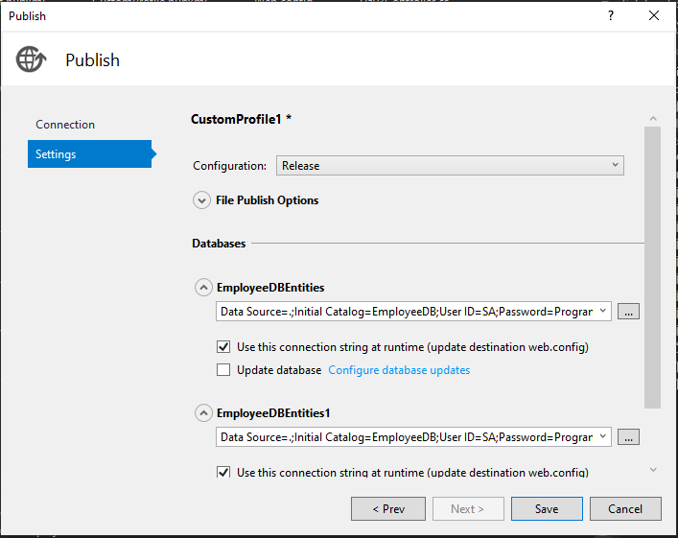

1. As files would be saved as zip so to extract them properly . run the following commands in cmd

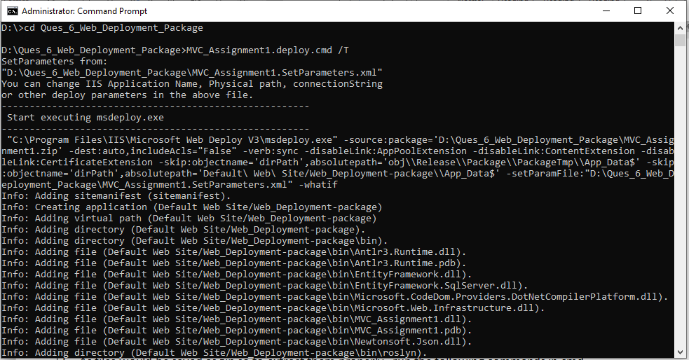

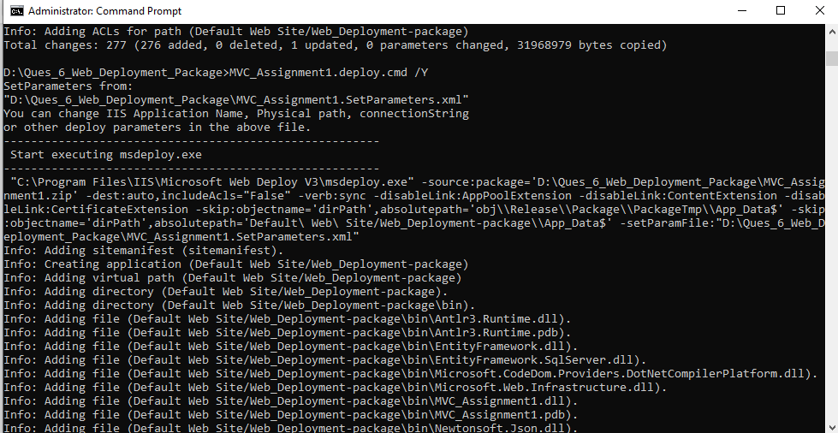

1. Now. Go to IIS your website is in Default Web Site Section as shown below

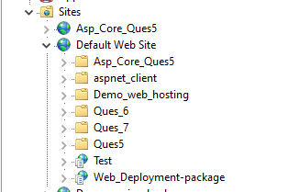

1. Below is the website published

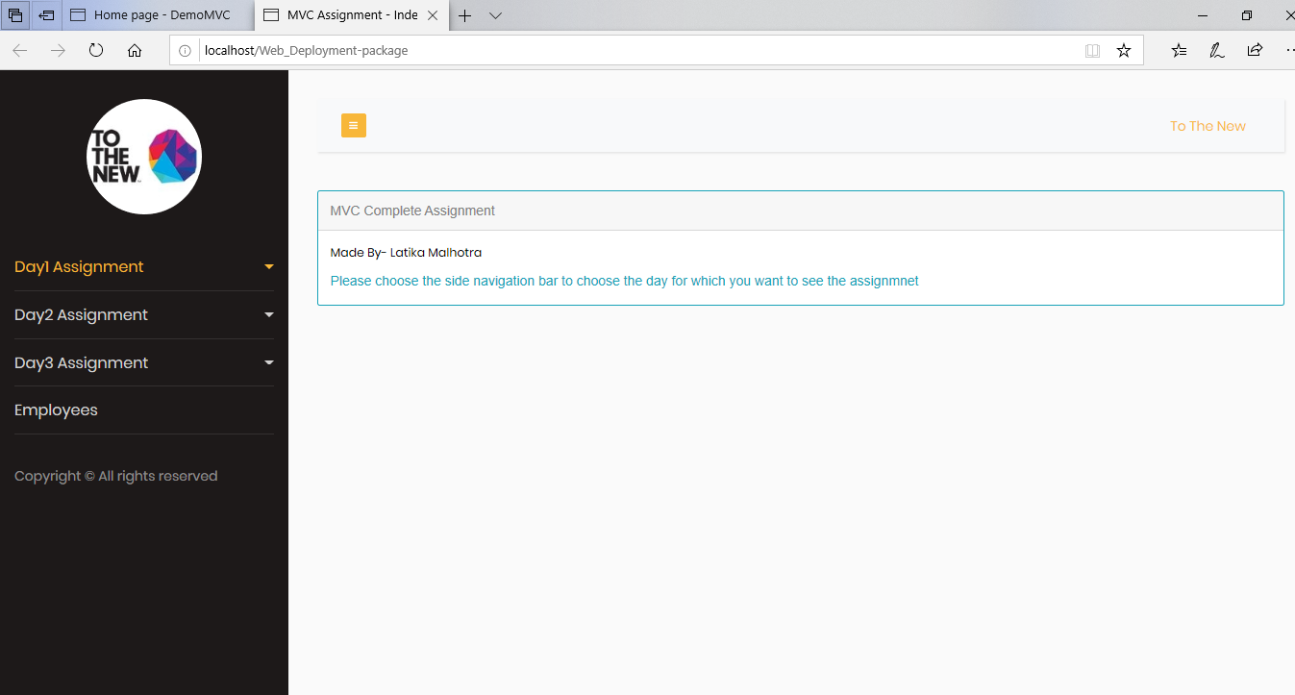

**Ques7:-**Deploy website using File system OR folder with SSL certificate. Explain all the steps in document.

**Steps to be followed are as follows:-**

1. Open your Visual studio project and right click on your project and click on publish button.
2. Create a profile using folder as shown below.

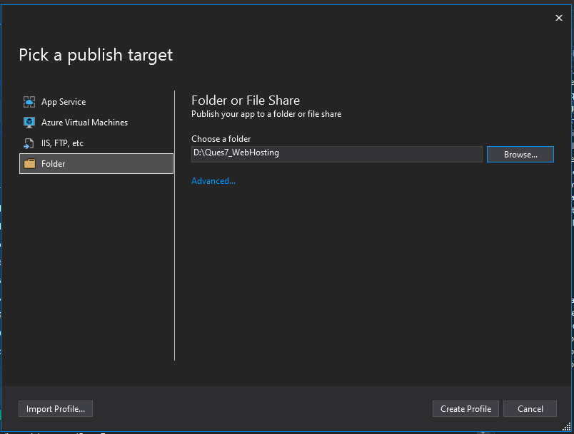

1. Now, click publish as shown below,the folder woud then be created.

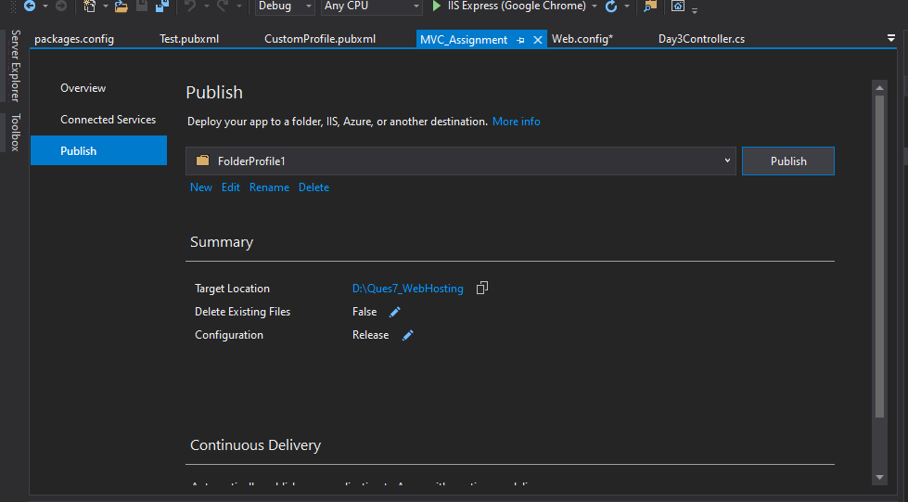

1. Now, go to IIS ,create the website using SSL Certificate as shown below

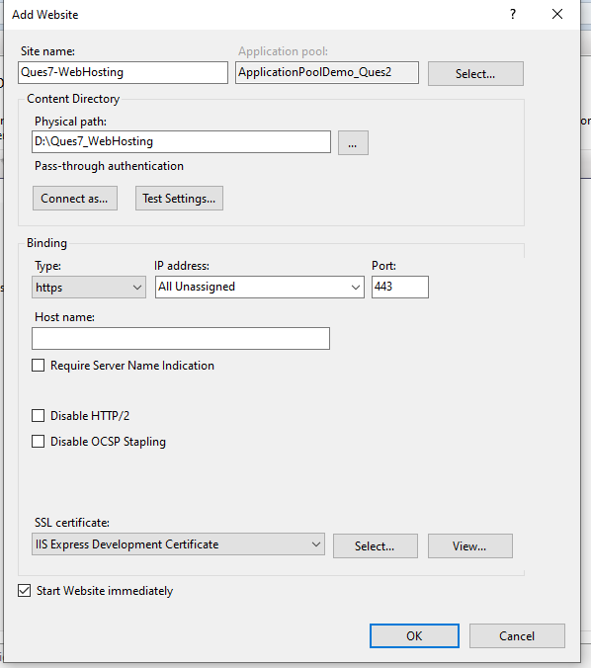

1. You website is then hosted. Go and browse the website you would get the desired result.