INTRODUCTION TO DATABASE EXERCISE
Problem Statement: There can be multiple customers, who can place multiple orders on the site. Now a sales person can handle these orders will distribute into multiple sales persons (One order will be assign to one salesperson only). So a sales person can have multiple orders of multiple customers
QUES 1. Create Database
SOLUTION- sdfds
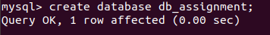

ferf
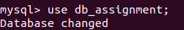
asdfs

QUES 2.Design Schema
SOLUTION-
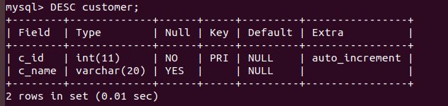
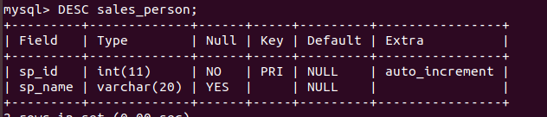

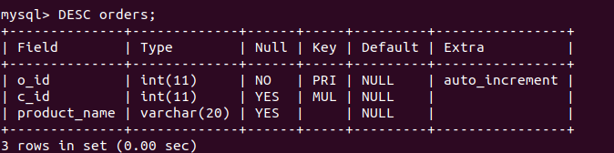
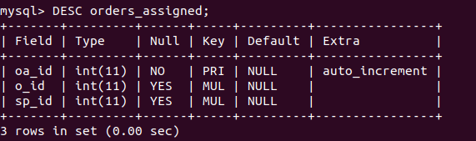
QUES 3.Create tables
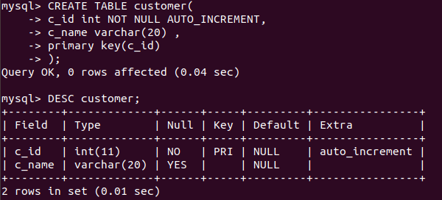
SOLUTION-

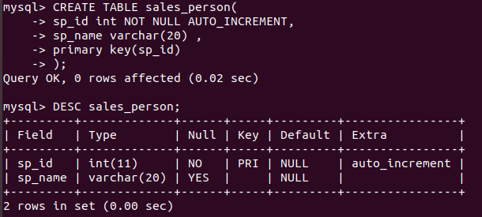
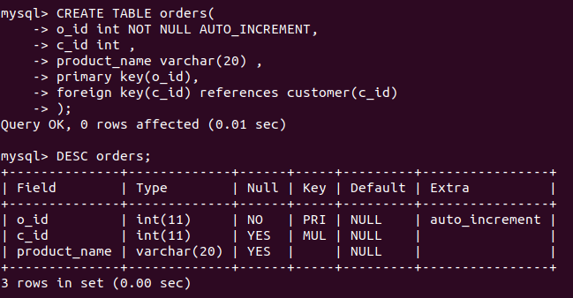
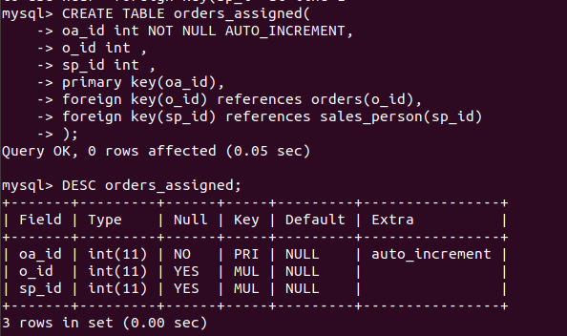

QUES 4.Insert sample data
SOLUTION-
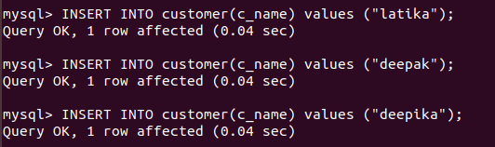
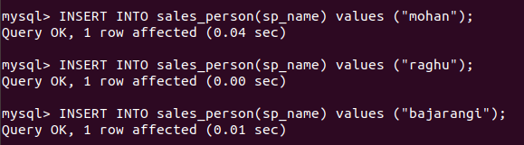
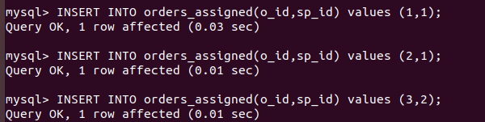
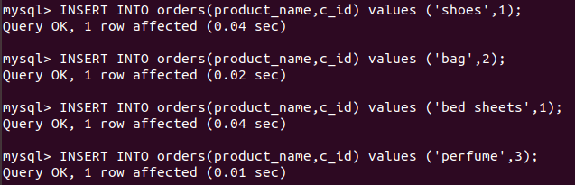

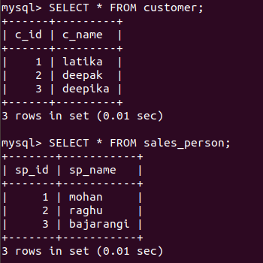

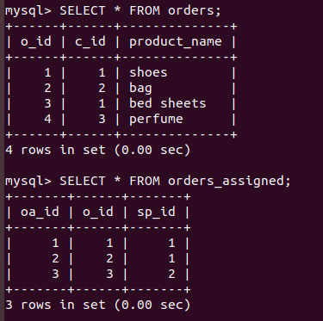

QUES 5.Find the sales person having multiple orders.
SOLUTION-
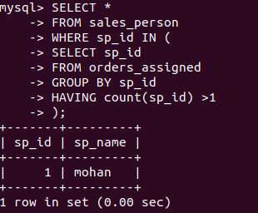

QUES 6.Find the all sales person details along with order details
SOLUTION-
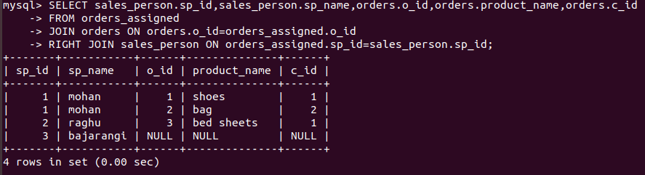
QUES 7.Create index
SOLUTION-
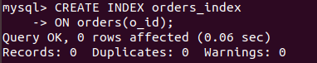

QUES 8.How to show index on a table
SOLUTION-
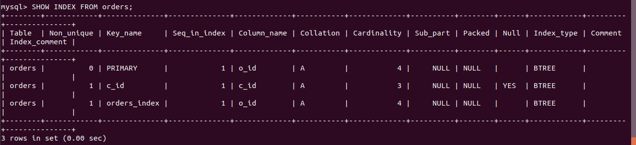
QUES 9.Find the order number, sale person name, along with the customer to whom that order belongs to
SOLUTION-
