##### **Common Stand Exam**

Summary Protocols

##### **I. Plot Data Sheet**

Note: the headings relate to the input boxes on the forms.

##### Plot # - Date - GPS Coordinates (Easting & Northing)

**Slope (maximum of 3 numbers)**

This is the angle of slope across the setting. Slope is determined by sighting the clinometer along a line parallel to the average incline (or decline). This angle is measured along the shortest pathway down slope before the drainage direction changes. To measure Slope, Observer 1 should stand at the uphill edge and sight Observer 2, who stands at the downhill edge. Sight Observer 2 at the same height as the eye-level of Observer 1. Read the slope directly from the percent scale of the clinometer.

* If slope changes gradually across the setting, record an average slope.
* If slope changes across the setting but the slope is predominately of one direction, code predominate slope percentage rather than the average.
* If the setting falls directly between two side hills, code the average slope of the side hill(s).
* If the setting falls on a canyon bottom or on a narrow ridge top, but most of the area lies on one side hill, code the slope of the side hill.

**Aspect (maximum of 3 numbers)**

This is the predominant setting aspect in degrees, 0° to 360°. Record true north (i.e. always set the declination on your compass). Aspect may be determined from contour maps. Aspect is determined along the direction of slope for land surfaces with at least 5 percent slope in a generally uniform direction. Aspect is measured with a hand compass along the same direction used to determine slope.

* If aspect changes gradually across the setting, record an average aspect.
* If aspect changes across the setting but is predominately of one direction, code predominate direction, rather than the average.
* If the setting falls on or straddles a canyon bottom or narrow ridge top, code the aspect of the ridgeline or canyon bottom.
* If the setting falls on a canyon bottom or on a narrow ridge top, but most of the area lies on one side hill, code the aspect of the side hill.
* Use a code of zero for flat.
* Use a code of 999 for indeterminate, no predominant aspect, or undulating

**Slope Position (exactly 2 characters)**

Record the position of the setting on the landscape. The definitions are from: Soil survey Staff. 1993. National Soil Survey Handbook (Title 430-VI) USDA Soil Conservation Service.

| **Code** | **Description** |
| --- | --- |
| SU | **Summit/Ridgetop/Plateau**. The topographically highest hillslope position of a hillslope profile and exhibiting a nearly level surface. |
| SH | **Shoulder**. The hillslope position that forms the uppermost inclined surface near the top of a hillslope. It comprises the transition zone from backslope to summit. |
| BS | **Backslope**. The hillslope position that forms the steepest inclined surface and principle element of many hillslopes. In profile, backslopes are commonly steep, linear, and bounded by a convex shoulder above and descending to concave footslope. They may or may not include cliff segments. Backslopes are commonly erosional forms produced by mass movement and running water. |
| FS | **Footslope**. The hillslope position that forms the inner, gently inclined surface at the base of a hillslope. In profile, footslopes are commonly concave. It is a transition zone between upslope sites of erosion and transport. |
| TS | **Toeslope**. The hillslope position that forms the gently inclined surface at the base of a hillslope. Toeslopes in profile are commonly gentle and linear, and are constructional surfaces forming the lower part of a hillslope continuum which grades to a valley bottom. |
| VB | **Valley Bottom**. Wide valley bottom beyond influence of toeslope. |

**Slope Horizontal Shape and Vertical Shape**

| **Code** | **Description** |
| --- | --- |
| BR | **Broken**. Cliffs, knobs, and/or benches interspersed with steeper slopes generally characterized by sharp, irregular breaks. A marked variation of topography, or an irregular and rough piece of ground. |
| CC | **Concave.**  The gradient decreases down the slope. Runoff tends to decelerate as it moves down the slope, and if it is loaded with sediment the water tends to deposit the sediment on the lower parts of the slope. The soil on the lower part of the slope also tends to dispose of water less rapidly than the soil above it. |
| CV | **Convex**. The gradient increases down the slope and runoff tends to accelerate as it flows down the slope. Soil on the lower part of the slope tends to dispose of water by runoff more rapidly than the soil above it. The soil on the lower part of a convex slope is subject to greater erosion than that on the higher parts. |
| LL | **Linear or Planar.** Substantially a straight line when seen in profile at right angles to the contours. The gradient does not increase or decrease significantly with distance (level or little relief). |
| PA | **Patterned**. A general term for any ground surface exhibiting a discernibly ordered, more-or-less symmetrical, morphological pattern of ground (i.e. micro relief of hummock and swales of several feet). |
| UN | **Undulating**. One or more low relief ridges or knolls and draws within the plot area. |
| UA | Unable to Assess. |

**Capable Growing Area (maximum of 3 numbers)**

Estimate the percent of the setting capable of supporting trees. Deduct areas such as roads, creeks, swamps, rock outcrops, unimproved dirt lanes, small streams, sites with standing or running water, a high water table, a rock outcropping, severe soil compaction (i.e. an old landing), or mass soil movement (slips, slides, or slumps) etc. For example, if an area contains 5% rock outcropping and 10% road, record a capable growing area of 85%. This field is used in the Forest Vegetation Simulator (FVS) as the “stockability” value. If this field is left null, FVS assumes 100% stockability.

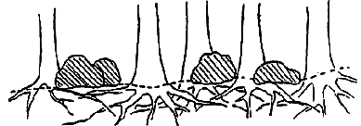

**Capable Growing Area Example 1:** Large, scattered boulders cover 25 percent of the setting. However, tree roots can fully utilize the space beneath the boulders. The boulders thus have no effect on potential tree stocking. Capable growing area is thus 100%.

**Example 2:** A swampy meadow covers 10% of the setting. Capable growing area is thus 90%.

##### **Plot Existing Vegetation Composition Type (maximum of 8 characters and/or numbers)**

Record the dominant existing vegetation composition. Dominance is based on plurality of basal area. Existing vegetation reflects plant species currently present.

##### **Plot Potential Vegetation (maximum of 8 characters and/or numbers)**

Record the potential vegetation composition code. Potential vegetation is the plant community that would become established if all successional sequences were completed without interference by man and under the present climatic and edaphic conditions, including those created by man.

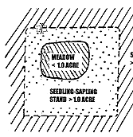

**Fuel Model (maximum of 2 numbers)**

This is the predominant setting fuel model determined by the plurality of sample plot fuel model codes. Refer to Appendix N for more information on the Fuel Models.

| **Code** | **Detailed Description – Andersons 13 fuel models** |
| --- | --- |
| 1 | Contains fine, very porous, and continuous herbaceous fuels that have cured or are nearly cured. Generally less than one-third of the area contains shrubs or timber. Grasslands and savanna are represented along with stubble, grass-tundra, and grass-shrub combinations. Annual and perennial grasses are included in this fuel model |
| 2 | Herbaceous material with litter and dead-down stem wood from the open shrub or timber overstory  Open shrub lands and pine stands or scrub oak stands that cover one-third to two-thirds of the area  Stand may include clumps and may include pinyon-juniper |
| 3 | Stands are tall, averaging about three feet, but considerable variation may occur. Approximately one-third or more of the stand is considered dead and cured. May include cultivated grains that have not been harvested, tall prairie, and marshland grasses |
| 4 | Stands of mature shrubs, 6 feet or more tall such as California mixed chaparral, the high pocosin along the east coast, the pine barrens of New Jersey, or the closed jack pine stands of the north-central states. Besides flammable foliage, stand may contain dead woody material. May contain a deep litter layer. |
| 5 | Shrubs are young with little dead material, and the foliage contains little volatile material. Usually shrubs are short and almost totally cover the area. Young, green stands with no dead wood qualify: laurel, vine maple, alder, or even chaparral, manzanita, or chamise. |
| 6 | The shrubs are older, but not as tall as model 4, nor do they contain as much fuel as model 4. This model covers a broad range of shrub conditions: intermediate stands of chamise, chaparral, oak brush, low pocosin, Alaskan spruce taiga, and shrub tundra. May include hardwood slash that has cured. Pinyon-juniper shrub lands may be represented. |
| 7 | Stands of shrubs are generally between 2 and 6 feet high. Palmetto-galliberry understory, with a pine overstory, are typical. Low pocosin may be represented. Black spruce shrub combinations in Alaska may also be represented. |
| 8 | Contains closed canopy stands of short needle conifers or hardwoods that have leafed out. The compact litter layer is mainly needles, leaves, and occasionally twigs because little undergrowth is present. Representative conifer types are white pine, lodgepole pine, spruce, fir, and larch. |
| 9 | Both long-needle conifer stands and hardwood stands, especially the oak-hickory types, are typical. Closed stands of long-needled pine like ponderosa, Jeffrey, red pines, or southern pine plantations are grouped in this model. May contain concentrations of dead-down woody material. |
| 10 | Dead-down fuels include quantities of 3-inch or larger limb wood resulting from over maturity or natural events that create a large load of dead material on the forest floor. Any forest type may be considered if heavy down material is present; examples are insect- or disease-ridden stands, wind thrown stands, overmature situations with deadfall, and aged light thinning or partial cut slash. |
| 11 | Contains slash and herbaceous material intermixed with slash. Light partial cuts or thinning operations in mixed conifer stands, hardwood stands, and southern pine harvests are considered. Clearcuts generally produce more slash than represented here. The less than 3-inch material load is less than 12 tons per acre. The greater than 3 inch is represented by not more than 10 pieces, 4 inches in diameter, along a 50 foot transect |
| 12 | The visual impression is dominated by slash and much of it is less than 3 inches in diameter. The fuels are well distributed. Heavily thinned conifer stands; clearcuts, and medium or heavy partial cuts are represented. The material larger than 3 inches is represented by encountering 11 pieces, 6 inches in diameter along a 50 foot transect |
| 13 | There is a continuous layer of slash. Large quantities of material larger than 3 inches are present. Clearcuts and heavy partial cuts in mature and over mature stands are depicted where the slash load is dominated by the greater than 3 inch diameter material. Fuels less than 3 inches are generally only 10 percent of the total load. May include situations where the slash still has “red” needles attached. |

**Distance to Seed Wall (maximum of 3 numbers)**

This is the distance, in feet, from the plot center to the boundary of an adjoining stand where there are seed-producing trees, or a seed wall. Typically, this value is recorded where most of the overstory has been removed or destroyed within the last 20 years. If the distance is over 999 feet, record a value of 999.

**Take one measurement for conifers and another for hardwoods**.

c=

h=

**Vegetation Covers**

On this form, cover percent is always taken to the nearest 1%.

Modal height of each size class.

**Layer Code Definitions (exactly 2 characters) Required**

| **Code** | **Description** |  | **Code** | **Description** |
| --- | --- | --- | --- | --- |
| TV | Total cover of all vegetation |  | TOH | Total cover of all herbs |
| TOT | Total cover of all trees |  | TAL | Total cover of all algae |
| TOV | Total cover of trees greater than or equal to 6.1 feet tall |  | TLC | Total cover of all lichens |
| TSA | Total cover of trees less than or equal to 6.0 feet tall |  | TFU | Total cover of all fungi |
| TOS | Total cover of all shrubs |  | TLI | Total cover of all woody lianas |
| ST | Total cover of all shrubs greater than or equal to 6.1 feet tall |  | TSS | Total cover of all subshrubs |
| SM | Total cover of all shrubs between 1.6 and 6.0 feet tall |  | TVI | Total cover of all herbaceous vines |
| SL | Total cover of all shrubs less than 1.6 feet tall |  | TNP | Total cover of all nonvascular plants |
| TOF | Total cover of all forbs |  | TUN | Total cover of all unknown lifeforms |
| TOG | Total cover of all graminoids |  | TVP | Total cover of all vascular plants |

**Cover By Species and Layer (cont.)**

| **Step** | **Direction** |
| --- | --- |
| 1 | Record the canopy cover for each tree species over 6.1 feet tall. |
| 2 |  |
| 3 | Record the canopy cover for each tree species less than 6.1 feet tall. |
| 4 |  |
| 5 | Record the canopy cover for each shrub species over 6.1 feet tall. |
| 6 |  |
| 7 | Record the canopy cover for each shrub species between 1.6 and 6.0 feet tall. |
|  |  |
| 9 | Record the canopy cover for each shrub species less than 1.6 feet tall. |
| 10 |  |

**Ground Surface Cover Percent (maximum of 3 numbers; may include one decimal) Required**

This is the estimated percent ground cover at the soil surface plane for each ground surface cover type. Cover is defined as that portion of the horizontal surface layer intersected by ground surface features. Total ground surface cover of all features **must equal 100%** (foliar canopy cover above the soil surface plane is not considered to be ground surface cover).

Whether moss covering a rock is recorded as "moss" or "rock" depends on the exam objective. Record the code that describes the soil surface and meets the exam objective. Record moss that is growing directly on the soil surface as "moss."

| **Code** | **Description** | **Definition** |
| --- | --- | --- |
| **ROCKS** | | |
| ROCK | Rock | Relatively hard, naturally formed mineral or petrified matter >1/8 inch in dia. appearing on soil surface as small to large fragments or as rel. large bodies, cliffs, outcrops or peaks. Includes bedrock. |
| GRAV | Gravel (2-75 mm) | Rock fragments between 2 and 75 mm in diameter. |
| FIGR | Fine gravel (2-5 mm) | Rock fragments between 2 and 5 mm in diameter. |
| MEGR | Medium gravel (5-20 mm) | Rock fragments between 5 and 20 mm in diameter. |
| COGR | Course gravel (20-75 mm) | Rock fragments between 20 and 250 mm in diameter. |
| COBB | Cobbles (70-250 mm) | Rock fragments between 75 and 250 mm in diameter. |
| STON | Stones (round and flat) |  |
| ROST | Round stone (250-600 mm) | Rock fragments between 250 and 600 mm in diameter. |
| BOUL | Boulders (round and flat) | Rock > 600 mm in diameter or length. Generic term for use when boulders are not differentiated by round and flat. |
| ROBO | Round Boulder (>600 mm) | Round Rock fragments >600 mm in diameter. |
| CHAN | Channers (2-150 mm long) | Long, thin rock fragments up to 150 mm in length, as determined by National Cooperative Soil Survey. |
| FLAG | Flag stones (150-380 mm long) | Flag Rock fragments 150-380 mm long. |
| FLBO | Flat boulders (>600 mm long) | Flat Rock fragments >600 mm long. |
| FLST | Flat Stone (380-600mm long) | Flat Rock fragments between 380 and 600 mm long. |
| BEDR | Bedrock | A general term for the rock, usually solid, that underlies soil or other unconsolidated, superficial material. |
| PAVE | Pavement | A natural concentration of closely packed and polished stones at the soil surface in a desert (may or may not be an erosional lag). |
| RROC | Rock fragments | Rock fragments >19.1 mm (3/4 inch) in diameter. |
| **WATER, SNOW, AND ICE** | | |
| WATE | Water | Where the water table is above the ground surface during the growing season, such as streams, bogs, swamps, marshes and ponds (FIA definition). |
| TRIC | Transient Ice | Ice covering the surface; the ice will melt during the growing season. |
| TRSN | Transient Snow | Snow covering the surface; the snow will melt during the growing season. |
| TRIS | Transient Ice and Snow | Surface area covered by ice and snow at the time of plot measurement, considered transient. For use when permanent ice and snow are not differentiated. |
| PEIC | Permanent Ice | Ice covering the surface. Does not melt during the growing season. The surface is ice-covered for the entire year (i.e., glaciers). |
| PESN | Permanent Snow | Snow covering the surface; does not melt during the growing season. The surface is snow-covered for the entire year. |
| PEIS | Permanent Ice and Snow | Surface area covered with ice and snow at the time of plot measurement, considered permanent. For use when permanent ice and snow are not differentiated. |
| **WOODY PIECES** | | |
| WOOD | Wood | Woody material, slash and debris; any woody material, small and large woody debris, regardless of depth. Litter and non-continuous litter are not included (for example, scattered needles over soil is classified as BARE). |

**Ground Surface C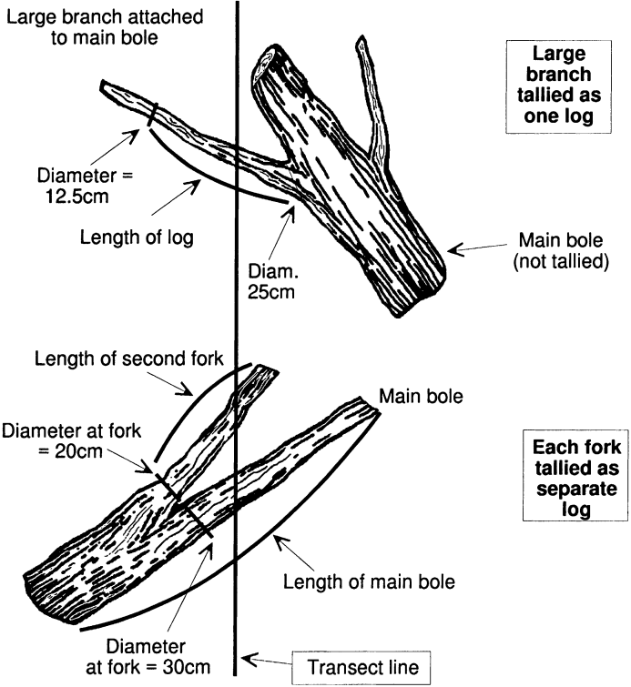over Type (cont.)**

| **Code** | **Description** | **Definition** |
| --- | --- | --- |
| **MOSS, LICHEN, FUNGI** | | |
| CRYP | Cryptogam | Thin, biotically dominated ground or surface crusts on soil in dry rangeland conditions, e.g. cryptogamic crust (algae, lichen, mosses or cyanobacteria). |
| CML | Cryptogams, mosses, and lichens | For situations where information is not further differentiated. |
| LICH | Lichen, fungi, algae | Lichens: an organism generally recognized as a single plant that consists of a fungus and an alga or cyanobacterium living in a symbiotic association. For lichen growing on bare soil in dry rangeland conditions, see cryptogamic crusts. |
| MOSS | Moss | Nonvascular, terrestrial green plants including mosses, hornworts and liverworts - always herbaceous. This code does not apply to moss growing on bare soils in dry rangeland conditions. For rangeland conditions, see cryptogamic crusts. |
| **DUFF AND LITTER** | | |
| LITT | Litter and duff | Leaf and needle litter, and duff not yet incorporated into the decomposed top humus layer. Non-continuous litter is not included (for example, scattered needles over soils is classified a BARE). |
| **BASAL VEGETATION** | | |
| BAVE | Basal vegetation | Basal vegetation not differentiated by life form. For use when basal vegetation is not separated into more detailed codes (BAFO, etc.). |
| BATR | Basal tree | Basal (cross-sectional area at or near the ground level) cover of trees. (Definition adapted from definition of basal area in National Range & Pasture Handbook) |
| BASH | Basal shrub | Basal (cross-sectional area at or near the ground level) cover of shrubs. |
| BAFO | Basal Forb | Basal (cross-sectional area at or near the ground level) cover of forbs. |
| BAGR | Basal graminoid | Basal (cross-sectional area at or near the ground level) cover of grasses or grass-like plants. |
| **OTHER** | | |
| ASH | Ash (organic, from fire) | Remaining residue after all combustible material has been burned off. |
| BARE | Bare Soil (soil particles < 2 mm) | Bare soil, not covered by rock, cryptogams or organic material. Does not include any part of a road (see definition for road). |
| BARR | Barren | Areas naturally devoid of vegetation, such as intermittent lakebeds and saline flats. Does not include areas denuded of vegetation. |
| DEVP | Developed surface (other than road) i.e. buildings or other structures | Surface area occupied or covered by any man-made structure other than a road, such as a building, dam, parking lot, electronic site/structure. |
| ROAD | Road | Improved roads, paved roads, gravel roads, improved dirt roads and off-road vehicle trails regularly maintained or in long-term continuing use. Generally constructed using machinery. Includes cutbanks and fills. |
| TEPH | Tephra Volcanic | A general term for all material formed by volcanic explosion or aerial expulsion (as opposed to flow) from volcanic vent. |
| UNKN | Unknown | Other covers not defined elsewhere. |

Note: Basal Vegetation is the soil surface occupied by the live basal or root crown portion of vascular plants. This includes live trees. This is not the foliar cover of plants. Typical basal plant cover ranges between 3-7 percent; 15 percent is very high and rarely encountered.

##### **Plot History (maximum of 2 numbers)**

Record the activities that occurred on, or affected the plot. Multiple codes may be entered if more than one event is observed. For each additional event, record the plot number and history code on the next consecutive line.

##### **Plot History Date (exactly 4 numbers)**

Record the 4-digit year in which a disturbance/activity occurred based on field observations. If a history code is entered, a date is required. Record to nearest decade.

| **Code** | **History Description** | **Code** | **History Description** |
| --- | --- | --- | --- |
| 1 | Site Preparation | 14 | Mining |
| 2 | Artificial Regeneration | 15 | Clear cut |
| 3 | Natural Regeneration | 16 | Heavy partial cut (≥20% removed) |
| 4 | Stand Improvement | 17 | Light partial cut (<20% removed) |
| 5 | Tree cutting | 18 | Firewood or local use cut |
| 6 | Fire | 19 | Incidental cut |
| 7 | Other Silvicultural Treatments | 20 | Pre-commercial thin |
| 8 | Other Human Disturbance | 21 | Improvement cut |
| 9 | Natural Disturbance | 22 | Planting throughout the stand |
| 10 | Land Clearing | 23 | Planting within non-stocked holes in the stand |
| 11 | Insect/Disease outbreak | 24 | Under-planting |
| 12 | Animal Damage | 25 | Clean and release |
| 13 | Type Conversion | 26 | Chaining |

**II. Tree Data Sheet**

##### **Tree Status (exactly 1 character) Required**

| **Code** | **Description** |
| --- | --- |
| L | **Live** - includes all standing trees that have at least one green point of growth. This includes deciduous trees that have lost their foliage for the season, and trees that have recently lost their leaves to defoliators, but will re-flush. |
| D | **Dead** - standing trees 4.5 feet or taller, without a green point of growth. Note: many of the tree fields are not used if the tree is a dead tree. If dead trees are recorded, a snag decay class is required for extensive and intensive exam levels. |
| S | **Stump** - woody base of a tree left in the ground less than 4.5 feet tall. Note: many tree form fields are not used for stumps. |
| X | **Down dead** - includes all dead trees that have their main stem lying on the ground, or are supported by branch wood. A tree is considered down if it is not self-supporting. Record any broken trees as one tree. If down dead trees are recorded, a log decay class is required for extensive and intensive exam levels. Only trees in decay class 1 or 2 should be recorded here. |
| Y | **Down live** – Includes all live trees that have their main stem lying on the ground or are supported by branch wood. A tree is considered down if it is not self-supporting. Record any broken trees as one tree. |

##### **Site/Growth Trees (exactly 1 character)**

Record if a tree is a Site or Growth Sample Tree. If tree is neither, leave blank.

| **Code** | **Description** |
| --- | --- |
| G | Growth Sample Tree |
| S | Site Tree on Plot |
| F | Site Tree off Plot |
| B | Both a growth sample tree and an on-plot site tree |

**Total Tree Height**

Measure from the base of the tree on the high ground side to the tip of the tree leader. Measure height from a point uphill or on the same contour line as the tree. Record the total tree height to the nearest foot.

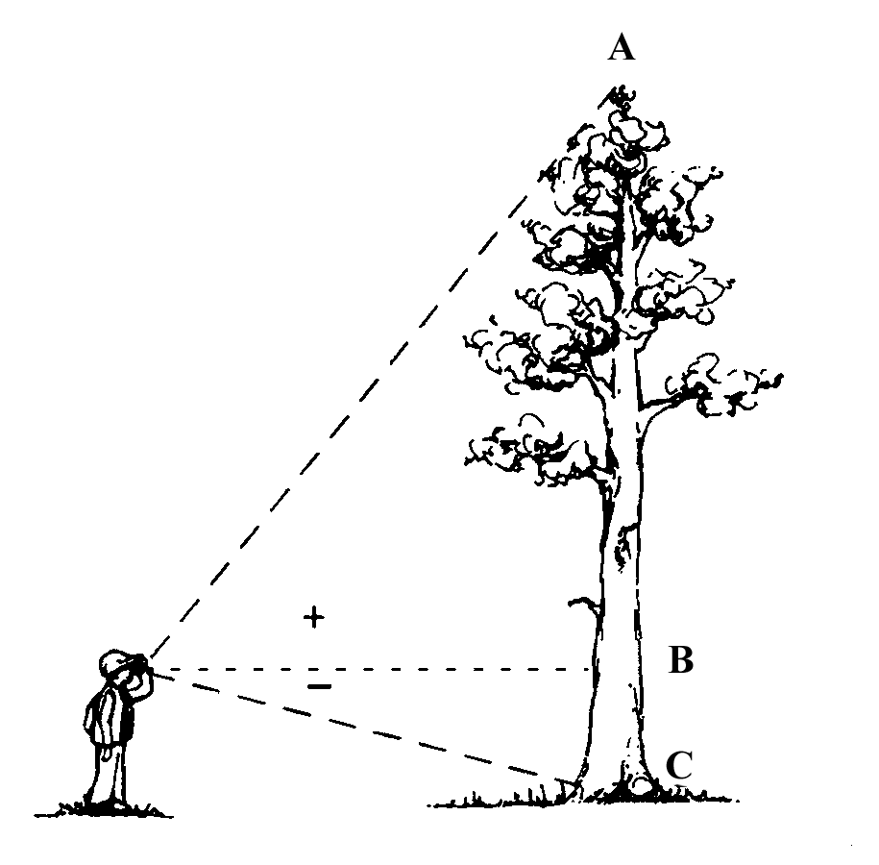

##### **Height to Crown (maximum of 3 numbers)**

Record crown height, in feet, on the uphill side of the tree, from the ground line to the base of the live crown (the lowest branch whorl with live branches in at least two quadrants exclusive of epicormic branches and whorls not continuous with the main crown).

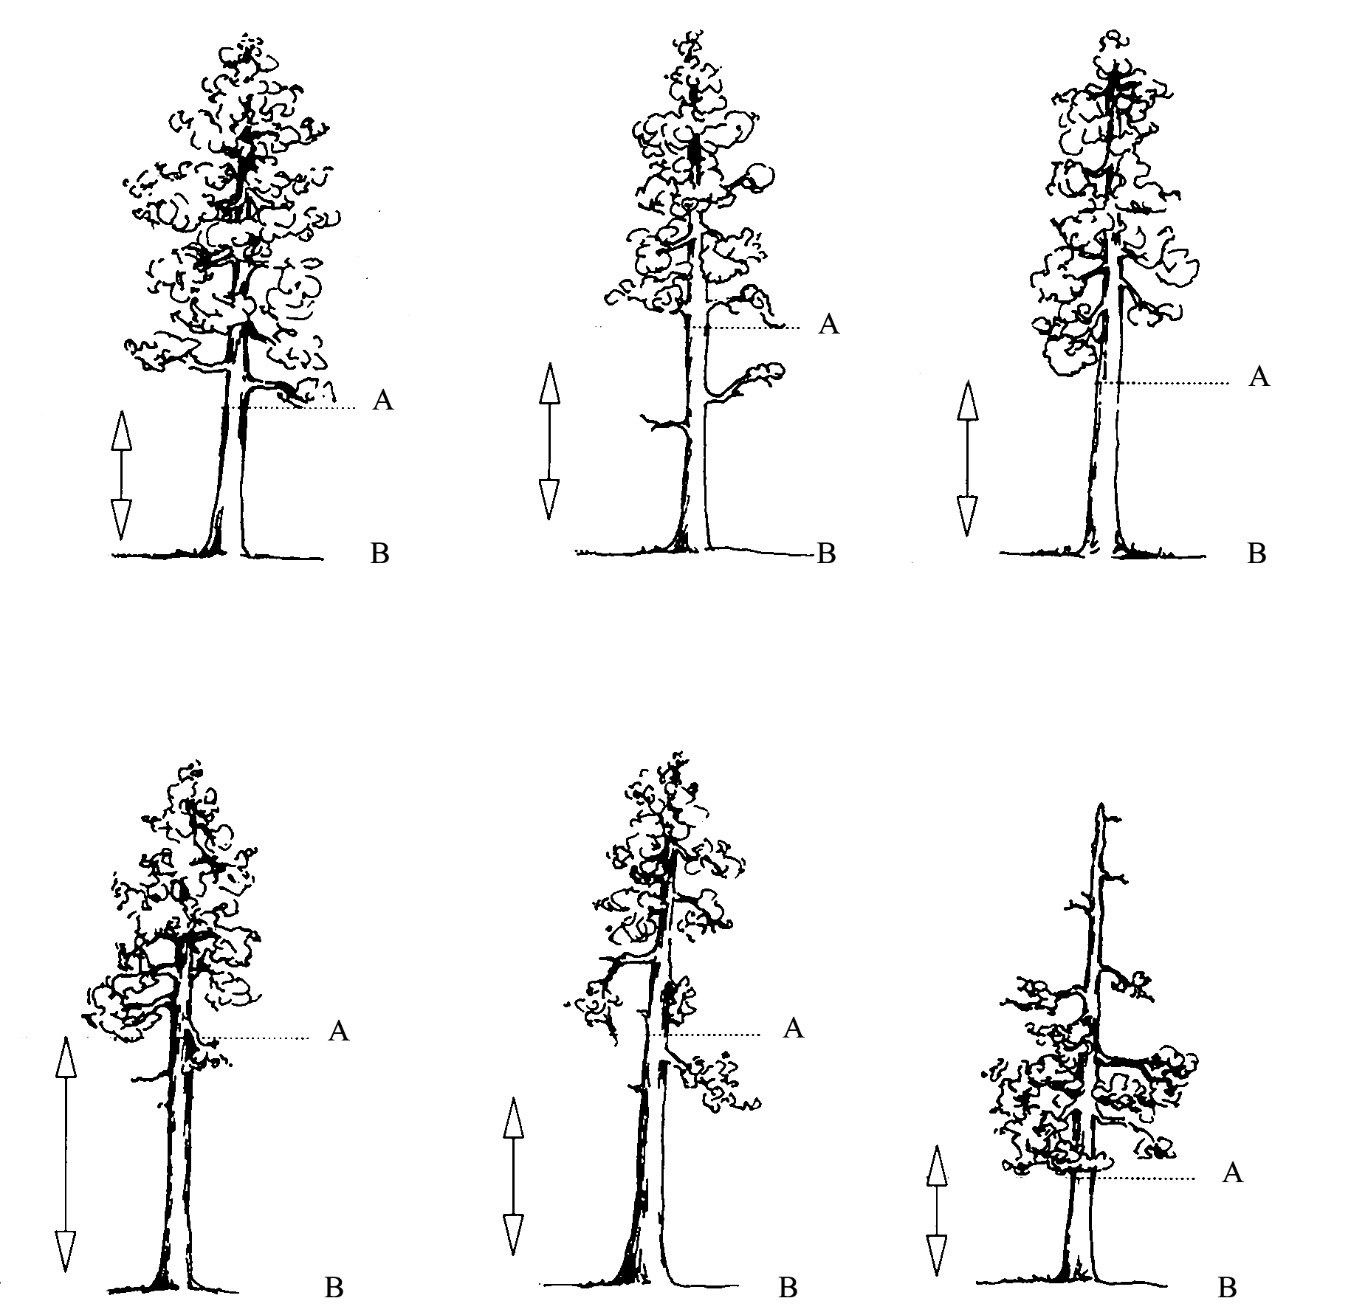

Measure the height from the base of the tree on the uphill side (B) to the base (A) of the live crown. Base of the live crown is the lowest branch whorl with live branches in at least two quadrants exclusive of epicormic branching and of whorls not continuous with the main crown.

| 1 |  | 0.1 - 1.4 feet. This includes crowns that touch the ground. |
| --- | --- | --- |
| 23 |  | 22.5 - 23.4 feet |
| 151 |  | 150.5 - 151.4 feet |

**Crown Class** (exactly 2 characters)

Record the crown class for all live trees. Crown class is the description of the relative position of the tree crown with respect to competing vegetation surrounding the tree. Classifications are more difficult to assign in uneven-aged stands or in plots where more than one stand is present. In these situations, classify the tree based on its immediate environment. Base your classification on how much light the tree's crown is receiving, not its position in the canopy. The intermediate and overtopped crown classes are meant to include trees seriously affected by direct competition with adjacent trees. For example, a young, vigorous tree that is considerably shorter than other trees in the stand but not overtopped by other trees, and receives full light from above and partly from the side, is classified as dominant.

| **Code** | **Name** | **Description** |
| --- | --- | --- |
| **OP** | **Open-grown or Isolated** | Tree crowns receive full light from above and from all sides. In even-aged stands, these trees have their crowns well above the general canopy. |
| **DO** | **Dominant** | Tree crowns receive full light from above and partly from the sides. Crowns extend above the general level of the crown cover of others of the same stratum and are not physically restricted from above, although possibly somewhat crowded by other trees on the sides. |
| **CO** | **Codominant** | Tree crowns receive full light from above, but comparatively little from the sides. Crowns form a general level of crown stratum, are not physically restricted from above and are crowded by other trees from the sides. |
| **IN** | **Intermediate** | Tree crowns occupy a definitely subordinate position and are subject to strong lateral competition from crowns of dominants and codominants. They receive little direct light from above through small holes in the canopy, but no light from the sides. |
| **OV** | **Overtopped** | Tree crowns receive no direct light from above or from the sides and are entirely below the general level of dominant and codominant trees. |
| **RE** | **Remnant** | Trees that remain from a previous management activity or catastrophic event. The tree is significantly older than the surrounding vegetation. Remnant trees do not form a canopy layer and are usually isolated individuals or small clumps. This definition is from the Region 6 Inventory and Monitoring System field procedures for the Current Vegetation Survey. |
| **AB** | **Leader Above Brush** | The terminal leader of the tree is above the surrounding brush while the middle or lower crown may be within the brush canopy. |
| **IB** | **Leader Within Brush** | The terminal leader and upper crown of the tree is within the brush canopy. |
| **UB** | **Leader Overtopped by Brush** | The crown of the tree is completely overtopped by the surrounding brush. Brush cover crown classes only apply to isolated or dominant trees with brush competition; therefore, brush cover crown class codes are used as modifiers for open-grown or dominant trees. Competition from adjacent trees is more important than competition from shrubs if they both occur. Generally, brush cover crown codes are used in stands where overstory tree competition is absent. |

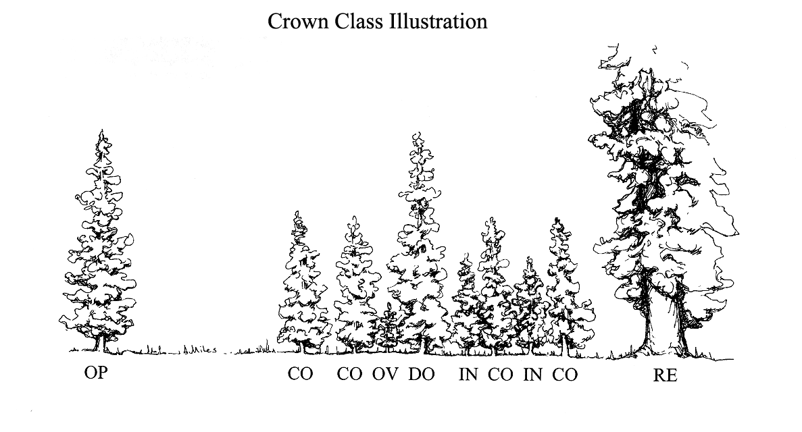

##### **Crown Width (maximum of 3 numbers)**

Record the average crown width, in feet. Crown width is the average of two measurements: 1) widest distance anywhere in the crown between the outer ends of two live branches (the drip line); and 2) the distance perpendicular to the widest measurement. Abnormally long branches sticking out beyond the edge of the crown are not used in establishing the extent of a crown**.**

**Counting Branch Whorls** - Counting branch whorls to determine tree age should only be done on western white pine or other species where the distinction between annual branch whorls and false branch whorls can be clearly recognized. False branch whorls are recognized as whorls that have shorter branches and never have budscale scars at the node. The presence of budscale scars guarantees that the branch whorl represents an annual growth increment, but as a tree ages, budscale scars become masked by bark development. Western red cedar does not have budscale scars and false whorls are common, so counting branch whorls is never appropriate for cedar.

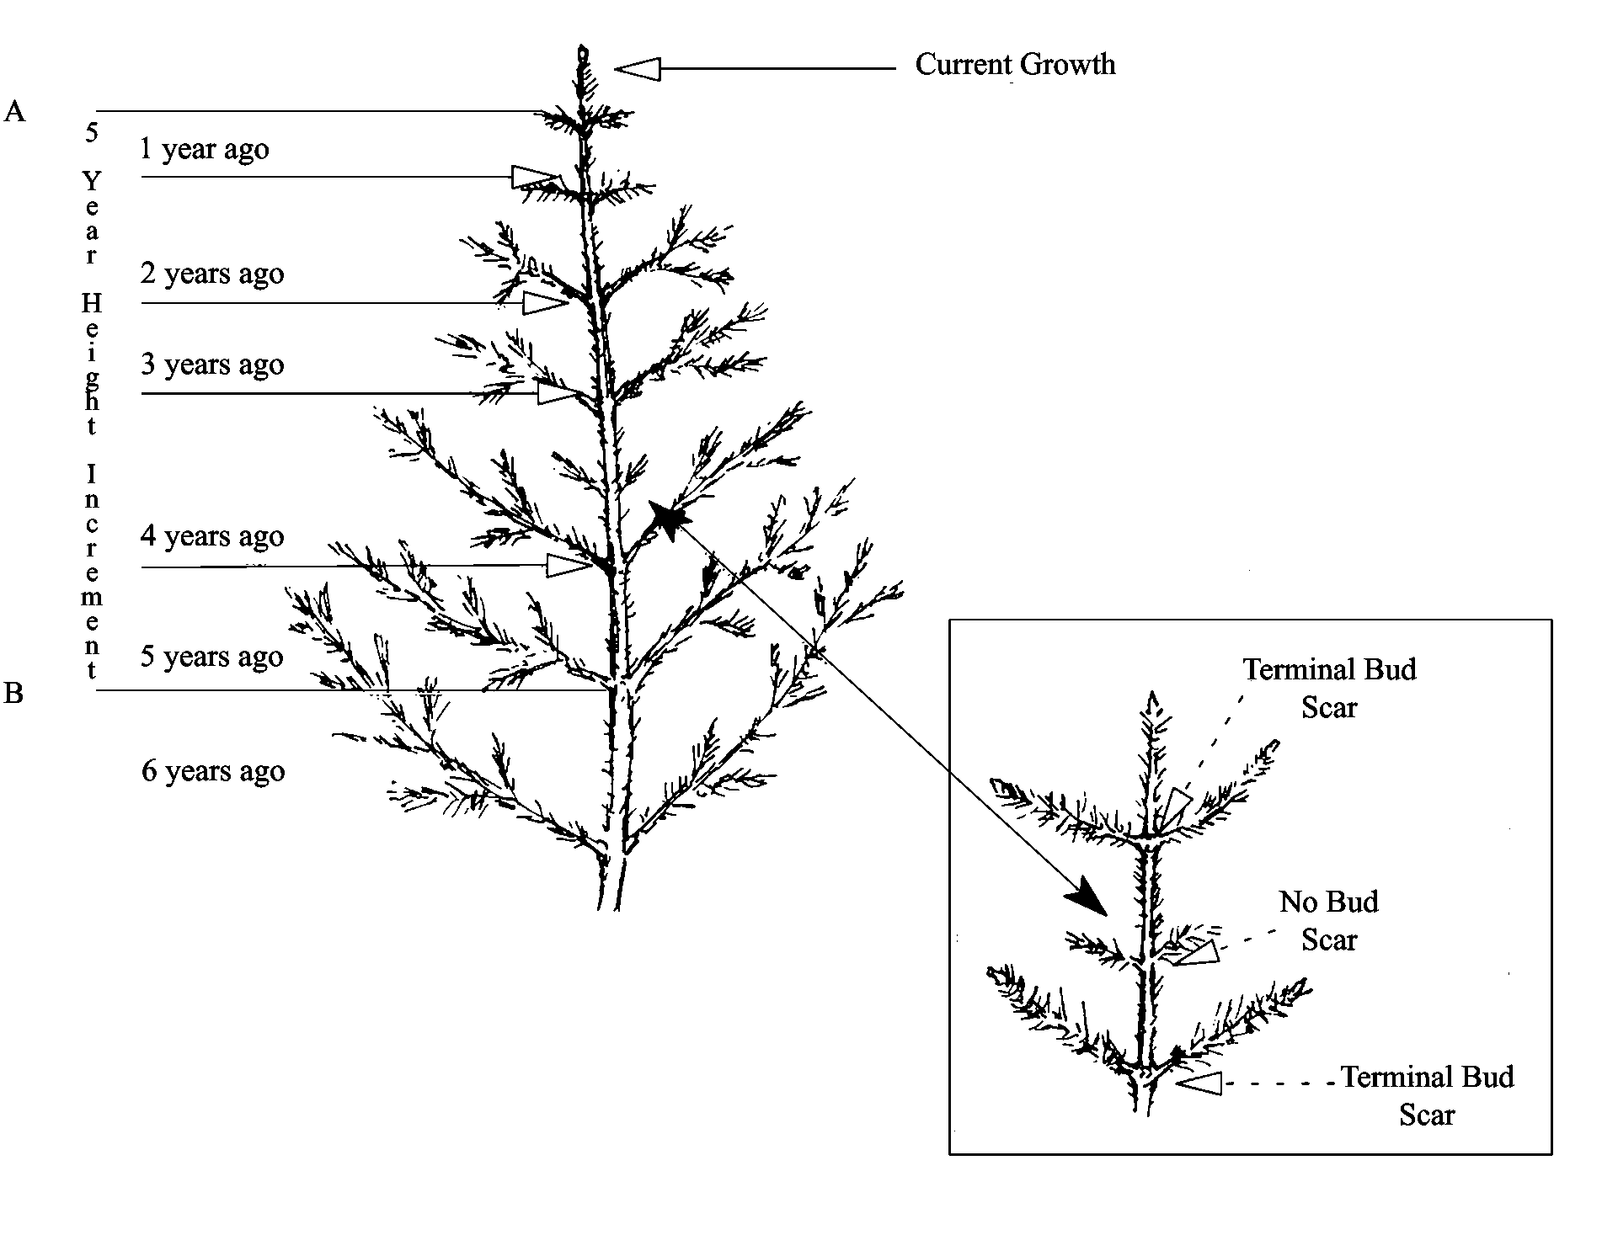

##### **Damage Category (maximum of 2 numbers) Required**

Record the damage category for both live and dead trees, based on physical evidence. Multiple damage categories may be recorded for each tree. See Appendix L for a complete listing of damage categories.

##### **Damage Agent (maximum of 3 numbers) Required**

Record the damage agent for each damage category. If the actual agent is not known, record an agent code of “000” for unknown agent within a category. See Appendix L for a complete listing of damage agents

##### **Damage Severity (maximum of 5 characters and/or numbers) Required**

Record the damage severity for each category. If category is recorded, severity is required. See Appendix L for a complete listing of damage severity codes.

**CrowLog/Snag Decay (exactly 1 number)**

This is the condition of standing dead (snag) or down dead trees (log). Figure 3-5-3 and the corresponding descriptions are adapted from "Wildlife Habitats in Managed Forests of the Blue Mountains of Oregon and Washington" by Jack Ward Thomas, Agriculture Handbook No. 553, USDA Forest Service, September,, 1979.

**Snag Decay**

| **Code** | **Bark** | **Heartwood Decay** | **Sapwood**  **Decay** | **Limbs** | **Top**  **Breakage** | **Bole Form** | **Time**  **Since**  **Death** |
| --- | --- | --- | --- | --- | --- | --- | --- |
| 1* | Tight, intact | Minor | None to incipient | Mostly Present | May be present | Intact | ≤5 years |
| 2 | 50% loose or missing | None to advanced | None to incipient | Small limbs missing | May be present | Intact | >5 years |
| 3 | 75% missing | Incipient to advanced | None to 25% | Few remain | Approx. 1/3 | Mostly intact | >5 years |
| 4 | 75% missing | Incipient to advanced | 25%+ | Few remain | Approx. 1/3 to ½ | Losing form, soft | >5 years |
| 5 | 75%+ missing | Advanced to crumbly | 50%+ advanced | Absent | Approx. ½+ | Form mostly lost | >5 years |

* Implies recent mortality, within the last 5 years.

**Snag Decay Classes**

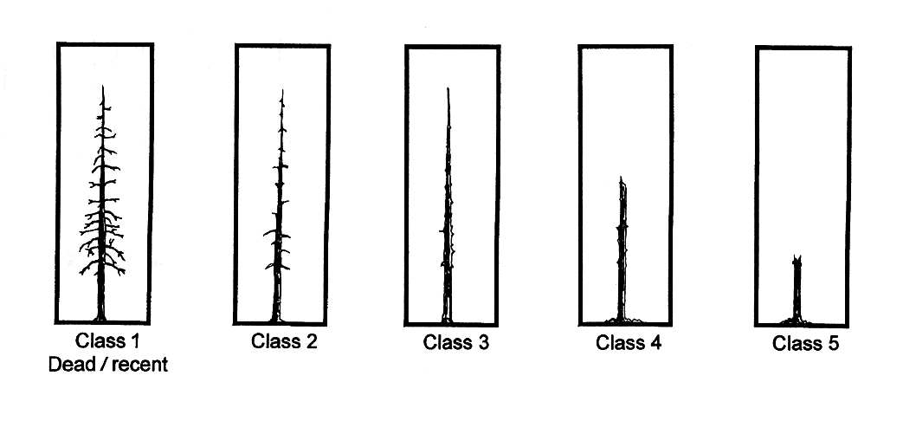

**III. Species Composition and Cover Data Sheet**

There are five different ways to measure vegetation composition. Each of these methods is discussed in detail below:

1. Total cover
2. Cover broken out by life form
3. Cover broken out by life form and layer
4. Cover broken out by layer and species
5. Cover broken out by species

**Cover By Species (cont.)**

| **Step** | **Directions** |
| --- | --- |
| 1 | Record canopy cover for each tree species. |
| 2 | Record canopy cover for each shrub species. |
| 3 | Record canopy cover for each forb species. |
| 4 | Record canopy cover for each graminoid species. |

**Life Form Definitions (exactly 2 characters) Required**

These definitions are consistent across all of the NRIS modules, and are approved national codes.

| **Code** | **Description** | **Definition** |
| --- | --- | --- |
| TR | Woody Tree | Perennial, woody plant with a single stem (trunk), normally greater than 4 to 5 meters or 13 to 16 feet in height; under certain environmental conditions, some tree species may develop a multi-stemmed or short growth form (less than 4 meters or 13 feet in height). |
| SH | Woody Shrub | Perennial, multi-stemmed woody plant that is usually less than 4 to 5 meters or 13 to 16 feet in height. Shrubs typically have several stems arising from or near the ground, but may be taller than 5 meters or single-stemmed under certain environmental conditions. |
| FB | Herbaceous forb/herb | Vascular plant without significant woody tissue above or at the ground. Forbs and herbs may be annual, biennial, or perennial but always lack significant thickening by secondary woody growth and have perennating buds borne at or below the ground surface. |
| GR | Herbaceous graminoid | Grass or grass-like plant, including grasses (Poaceae), sedges (Cyperacea), rushes (Juncaceae), arrow-grasses (Juncaginaceae), and quillworts (Isoetes). |
| HB | Herbs | Combination of all graminoids and forbs. This is required for FGDC Vegetation Classification Standard (1997). |
| AL | Algae | A general name for the single-celled plant plankton, sea weeds, and their freshwater allies. |
| LC | Lichen | Organism generally recognized as a single plant that consists of a fungus and an alga or cyanobacterium living in symbiotic association. Often attached to solid objects such as rocks or living or dead wood rather than soil. |
| FU | Fungus | A non-flowering plant of the kingdom Fungi, all lacking chlorophyll. |
| LI | Woody Liana | Climbing plant found in tropical forests with long, woody rope-like stems of anomalous anatomical structure. |
| SS | Woody Subshrub/half-shrub | Low-growing shrub usually under 0.5 meters or 1.5 feet tall (never exceeding 1 meter or 3 feet tall) at maturity. |
| VI | Herbaceous Vine | Twining/climbing plant with relatively long stems can be woody or herbaceous. |
| NP | Nonvascular plant | Nonvascular, terrestrial green plant, including mosses, hornworts, and liverworts. Always herbaceous, often attached to solid objects such as rocks or living or dead wood rather than soil. |
| UN | Unknown | Growth form is unknown. |
| VP | All vascular plants |  |

**IV. Fine Fuels and Coarse Woody Debris Data Sheets**

We will install four 37’ (11.3 m radius) fuels transects per plot, radiating out from plot center in the 4 cardinal directions (N, E, S, W)

On each transect, we will record transect azimuth and slope.

**Fine Woody Debris sampling procedure:**

1 hour fuels (0-0.25” or 0-0.64 cm) sampled along 10’ of transect, starting at end away from plot center

10 hour (0.25-1” or 0.64-2.54 cm) sampled along 10’ of transect, starting at end away from plot center

100 hour (1-3” or 2.54-7.62cm) sampled along 37’ of transect, starting at end away from plot center

Litter and Duff depths are measured at 37’ and 30’ away from plot center on each transect.

**Coarse Woody Debris (CWD, >3” or > 7.62 cm) sampling procedure:**

CWD includes dead tree boles, large limbs, and other large wood pieces either lying on the ground or elevated off the ground up to 45°, but no longer supported by roots (i.e. dead trees hung up or leaning on other vegetation). CWD does not include live material, standing dead trees, stumps, dead foliage, separated bark, nonwoody pieces, roots, or the part of the bole below the root collar. A piece of CWD is measured if it meets the following specifications:

1. the central longitudinal axis of the piece intersects the transect;
2. the diameter at point of intersection is at least 3” (7.62 cm)
3. the piece length is at least 1 meter (3.3 feet)

For every woody fragment meeting these criteria, we record: the diameter at intersection, diameter at small end (or 3”, whichever is larger), diameter at large end, and piece length. If the log has a decay class of 5, we record only diameter at intersection.

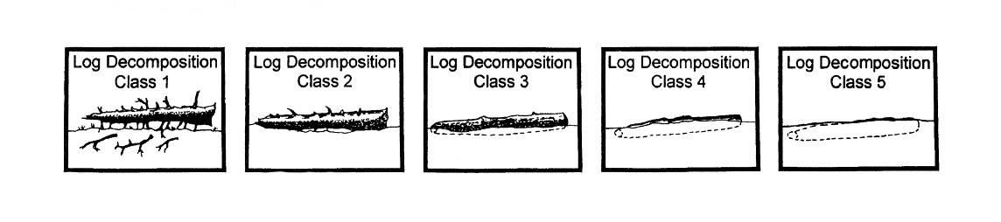

**Log Decay classes**

| **Code** | **Bark** | **Twigs** | **Texture** | **Shape** | **Wood Color** | **Portion of log on ground** |
| --- | --- | --- | --- | --- | --- | --- |
| 1* | Intact | Present | Intact | Round | Original | None, elevated on supporting points |
| 2 | Intact | Absent | Intact to soft | Round | Original | Parts touch, still elevated, sagging slightly |
| 3 | Trace | Absent | Hard large pieces | Round | Original to  faded | Bole on ground |
| 4 | Absent | Absent | Soft blocky pieces | Round to oval | Light brown to faded brown | Partially below ground |
| 5 | Absent | Absent | Soft, powdery | Oval | Faded light yellow or gray | Mostly below ground |