SCOOTERBOOSTER
Community Manager
Handoff
Site intelligence, live data, and an eight-week social angle bank
20 JULY - 19 SEPTEMBER 2026
Built from: Live scooterbooster.uy pages, the current application repository, and a read-only Firestore snapshot. Personal contact details and booking notes were excluded.
Prepared 19 July 2026 · Montevideo, Uruguay
INTERNAL WORKING GUIDE

01 · EXECUTIVE SNAPSHOT

What the community manager needs to know
Strategic read: ScooterBooster has a clear niche and credible early proof, but its social content should now broaden demand beyond deslimitación while tightening factual, pricing, testimonial, and legal language.

Current operating snapshot
Area | Current fact
Catalog | 4 active services · 29 active models · 5 brands with models live
Supply | 1 active, approved technician · Unión, Montevideo
Demand | 10 bookings from 9 booking users · 100% deslimitación
Payment | 7 paid · current online reservation fee configured at $150 UYU
Proof | 3 visible reviews · 5.0/5 average · no hidden reviews
Audience base | 27 accounts: 25 users, 1 technician, 1 admin
Data window | Bookings created 10 May-26 June 2026; snapshot 19 July 2026

Three immediate priorities
- Convert existing proof into trustworthy education: show the work, explain compatibility, and avoid speed guarantees.
- Create demand for maintenance, firmware, and cruise control; all recorded bookings currently cluster around deslimitación.
- Use social to grow supply: the public marketplace currently has one active technician and a clear technician application path.

Reading rule
Labels used throughout:
- PUBLIC-SAFE — supported by the live site/current data, with the stated qualifier.
- INTERNAL SIGNAL — useful for strategy, but not a public claim because the sample is small or private.
- HOLD / CORRECT — do not publish until product, legal, or operations resolves the inconsistency.

02 · BRAND AND PRODUCT FOUNDATIONS

The platform story
Mission: Connect scooter owners in Uruguay with specialized technicians who can update, modify, and maintain their scooters.
Market: Uruguay-first, Spanish-language, prices in Uruguayan pesos, with direct coordination through WhatsApp.
Marketplace: Owners search by model and service; technicians publish availability and model-specific pricing; ScooterBooster manages discovery, booking, the online reservation payment, and reviews.
Primary promise: A clearer and safer path from 'I need help with my scooter' to a verified technician with visible prices and reviews.

Messaging assets already on the site
- Potenciá tu scooter.
- Hecho en Uruguay · Técnicos verificados.
- Todo en un lugar.
- Tres pasos. Sesenta segundos.
- Sin sorpresas.
- Reservá hoy. Andá mañana. (Use only when availability supports it.)

Distinctive reasons to believe
- Local relevance: Uruguay locations, UYU pricing, Mercado Pago, and WhatsApp coordination.
- Model-first discovery: 29 cataloged models expose specifications and service compatibility.
- Human trust: public technician profiles, published base prices, schedules, and post-service reviews.
- Compliance intent: deslimitación requires a mandatory private-property / closed-circuit acknowledgment.

Core audiences
Audience | Need state | Best social entry point
Daily commuter | Reliability, safety, convenience | Maintenance checks, booking clarity, technician proximity
Performance-curious owner | Compatibility and realistic outcomes | Model-specific firmware/deslimitación explainers
New scooter owner | What to service and when | Starter checklists, model cards, FAQs
Experienced technician | Qualified local demand | How verification, pricing, and bookings work

03 · CURRENT SITE MESSAGING AND CONVERSION PATH

What the live site asks people to do
- Find a scooter by brand or model and confirm the service is compatible.
- Choose one of four services and review duration, range, preparation, and disclaimers.
- Select a verified technician based on location, rating, availability, and published price.
- Create the booking and pay the reservation online through Mercado Pago.
- Coordinate final details and the technician's service payment directly, typically via WhatsApp.
- After completion, leave a public review that contributes to the technician's rating.

Trust messages currently used
Site message | What it should mean in social
Técnicos verificados | The profile was reviewed and approved before being listed; show the human review process only when operations can substantiate it.
Precios publicados | Show the technician's actual base price or label site ranges as orientative; do not merge them.
Reserva con seña | Only the online reservation is paid through ScooterBooster; the service itself is paid directly to the technician.
Contacto directo | WhatsApp is used after booking confirmation to coordinate details, not as a substitute for the marketplace flow.
Reseñas | Reviews come from booking-linked users; exact quotes need truthful reproduction and permission for promotional reuse.

CTA ladder
- Low intent: 'Guardá esta guía', 'Comentá tu modelo', '¿Qué síntoma tiene tu scooter?'.
- Mid intent: 'Buscá tu modelo', 'Compará servicios', 'Mirá el perfil y los precios'.
- High intent: 'Reservar ahora', 'Elegí fecha y técnico', 'Postularme como técnico'.
Content principle: The social feed should reduce uncertainty one question at a time, then send people into the model-first booking flow.

04 · SERVICE PORTFOLIO

Four active services
Service | Live duration | Site range UYU | Current tech base | Key qualifier
Deslimitación | 45 min | $1.500-$4.000 | $2.800 | Private use notice required
Firmware | 40 min | $1.000-$3.000 | $2.800 | Official or compatible custom firmware
Control crucero | 60 min | $1.200-$3.500 | $2.800 | Compatibility varies by model
Mantenimiento | 90 min | $800-$5.000 | $1.800 | Parts may be extra

Site ranges are orientative. The only current public technician's base prices are higher than the site's minimums.

Eliminación de límite de velocidad
What it includes: Firmware backup, limit adjustment, and post-change validation.
Best content territories: Model/battery/controller reality; why outcomes differ; what the legal acknowledgment means.
Guardrail: Never promise a specific final speed or suggest public-road use.

Actualización de firmware
What it includes: Version review and backup, official or compatible custom update, configuration, and test.
Best content territories: Official vs. custom; error codes; when an update can restore functions.
Guardrail: Do not promise more autonomy or performance without a model-specific diagnosis.

Control crucero
What it includes: Compatibility review, activation or hardware assessment, threshold setup, and cutoff test.
Best content territories: Comfort on longer trips; how activation/cutoff works; compatibility myths.
Guardrail: Do not frame as hands-free riding or a reason to reduce attention.

Mantenimiento general
What it includes: Mechanical/electrical diagnosis, brakes, steering/folding, tires, and safety review.
Best content territories: Winter wear; noises/vibration; preventive care; pre-sale checklist.
Guardrail: Clarify that replacement parts and extra work require a separate quote.

05 · LIVE CATALOG INTELLIGENCE

29 live models across five brands
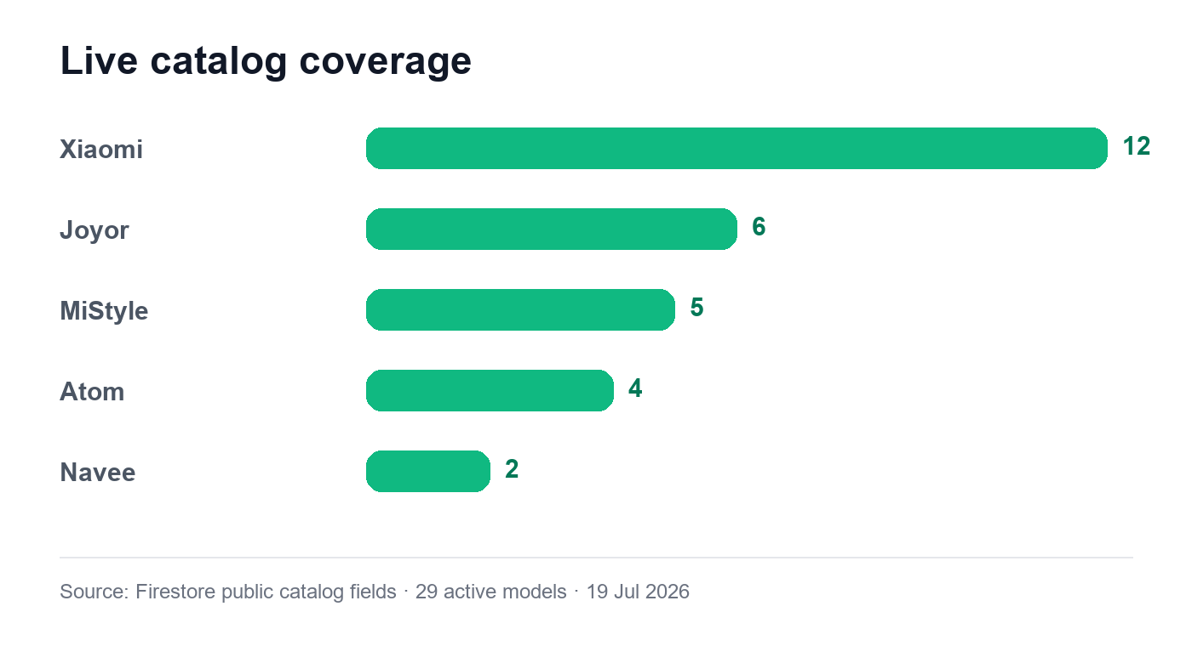
Active model count in the live Firestore-backed catalog, 19 July 2026.
Brand | Models currently live | Spec range in catalog
Xiaomi · 12 | 4 Ultra; 4 Lite/Pro 2nd Gen; 5, 5 Max/Plus/Pro; 6, 6 Lite/Pro; Elite; M365 | 25 km/h · 25-70 km range · 250-500W
Joyor · 6 | S10-S, S5, S8, X1, Y5, Y8 | 25 km/h · 30-100 km · 350-2000W
MiStyle · 5 | ME1000, ME500, ME800, T1, T1 Max | 25-32 km/h · 35-65 km · 350-1000W
Atom · 4 | Energy, Kaizen Pro, Tenacity, Vitality | 25-35 km/h · 30-55 km · 350-600W
Navee · 2 | GT3 Pro, ST3 Pro | 25 km/h · 65-75 km · 600-700W

What not to infer
- The database contains six additional active brand records with no live models: Dualtron, Inokim, Kaabo, Segway-Ninebot, VSETT, and Zero. Do not advertise these as currently bookable coverage.
- Every live model record lists all four services, but the technician's model-specific matrix can still exclude an option. The public bio explicitly says Xiaomi 6 repro is not offered yet.
- Catalog specs are reference attributes, not real-world outcome guarantees. Range, speed, and compatibility vary by condition, firmware, rider, and service diagnosis.
Best model-led opportunity: Xiaomi owns 12/29 catalog slots and 7/10 recorded bookings. Navee has only two catalog models but generated 3/10 bookings, making it a disproportionately strong secondary content lane.

06 · SUPPLY AND SOCIAL PROOF

Current public technician profile
Technician: Jonathan Denis · verified · Unión, Montevideo
Public rating: 5.0/5 from 3 visible reviews
Hours: Monday-Friday, 10:00-20:00; unavailable Saturday and Sunday
Brands: Atom, Joyor, MiStyle, Navee, and Xiaomi
Published base prices: Mantenimiento $1.800 UYU; deslimitación, firmware, and control crucero $2.800 UYU each
Specialty language: Repairs, maintenance, parts, reprogramming, and automotive electrical/electronic work; model-specific limitations apply.

Visible review evidence
Rating | Anonymized live comment | Content theme
5/5 | 'Lleve el 5pro y me quedo a 35, todo ok!' | Outcome + Xiaomi 5 Pro
5/5 | 'Muy buen servicio, cumplió con el plazo de la entrega y me resolvió dudas sobre el trabajo que hacía' | Punctuality + explanation
5/5 | 'Lleve a deslimitar un Xiaomi 5 estándar, quedó pronto en una hora, todo impecable' | Speed + turnaround

These comments are public on the profile, but promotional reuse should preserve the exact words and follow a consent/approval process. Names are omitted here intentionally.

Supply-side content opportunity
- Profile story: show how a technician diagnoses before changing firmware or replacing parts.
- Verification story: explain the application, admin review, pricing setup, availability, and go-live steps without overstating identity/reference checks that are not documented per applicant.
- Recruitment story: '¿Trabajás con scooters?' — the network is open to technicians across Uruguay, subject to review.
- Capability story: turn one technician's model-specific exceptions into an honest education format: 'qué hago, qué no hago todavía, y por qué'.

07 · LIVE DEMAND AND OPERATING SIGNALS

Early-stage data, used carefully
Sample warning: The database is small: 10 bookings, 9 booking users, 3 reviews, and one active technician. Use the patterns to choose what to test, not to claim market leadership or broad consumer behavior.
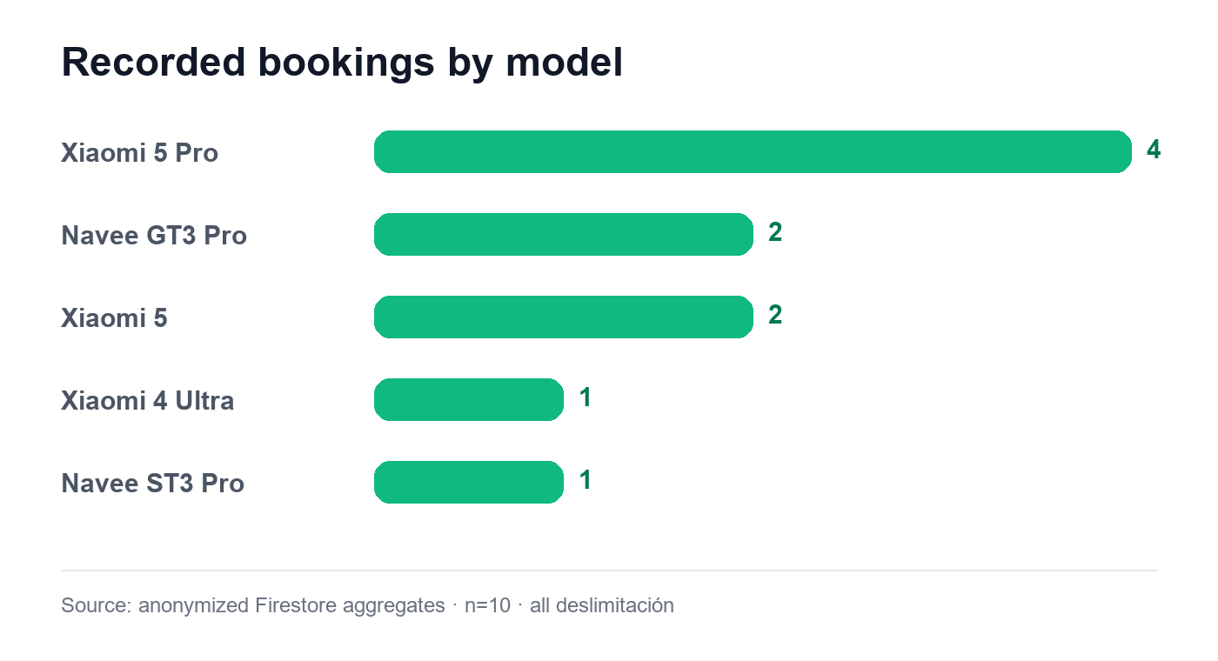
Recorded booking count by model. All 10 bookings are for deslimitación; n=10.

Observed facts
Signal | Value | Strategic use
Service mix | 10/10 deslimitación | Broaden demand; use it as the attention hook, not the whole brand.
Brand mix | Xiaomi 7 · Navee 3 | Lead with Xiaomi; build a strong Navee secondary series.
Top model | Xiaomi 5 Pro · 4 bookings | Create model-specific FAQs and proof-led explainers.
Payments | 7 paid · 3 pending | Clarify the reservation flow and remove price ambiguity.
Status | 5 confirmed · 2 completed · 3 pending | Use process/status education; avoid completion-rate claims.
Repeat | 1 of 9 booking users booked twice | Too small for loyalty claims; useful prompt for aftercare content.
Paid value | $20.650 UYU total on 7 paid bookings | Internal only; average recorded total is $2.950 UYU.
Last booking | 26 June 2026 | Use the next eight weeks for reactivation and fresh demand generation.

Data-derived hypotheses to test
- Model-specific content should outperform generic service content because bookings cluster in three named models/generations.
- Safety and maintenance content can widen the audience beyond people already seeking speed changes.
- Price/process clarity should reduce friction because the site mixes fixed-fee and percentage language.
- Technician-led education can strengthen trust while also recruiting additional supply.

08 · EIGHT-WEEK CONTENT STRATEGY

The strategic shift
Keep deslimitación as the high-interest doorway, then move the audience into four broader ideas: model literacy, safety/maintenance, technician credibility, and booking clarity.

Recommended content mix
Pillar | Share | Role
Model + service education | 30% | Searchable, saveable explanations tied to live catalog models
Maintenance + safety | 25% | Broaden relevance and build responsible brand trust
Technician + process | 20% | Human proof, behind-the-work, verification, and recruitment
Reviews + outcomes | 15% | Credibility, with exact wording and realistic qualifiers
Community prompts | 10% | Questions, polls, model requests, symptom triage, and UGC

Suggested weekly rhythm
- 2 Reels: one technician/process, one model or symptom explainer.
- 1 carousel: checklist, comparison, myth/fact, or step-by-step booking guide.
- 3-5 Story sequences: polls, question stickers, availability, FAQs, and post follow-ups.
- 1 community prompt: ask for a model, symptom, or misconception to fuel the next week.

Creative system
Voice: Rioplatense Spanish, direct, technically confident, useful, and never macho or reckless.
Visual anchors: Emerald brand accent, close-up mechanical/firmware details, model names on screen, clear UYU amounts, real technician context.
Hook formula: Specific model or symptom + tension + honest constraint. Example: '¿Tu Xiaomi 5 quedó limitado después de una actualización?'.
Proof formula: Show the check, explain the decision, state what varies, and end with the correct booking step.

09 · TWO-MONTH ANGLE BANK

Week 1 · 20-26 July
What ScooterBooster actually does — Reset the value proposition and make the booking/payment flow easy to understand.
Angle | Hook / story | Format | CTA | Guardrail
60-second booking, explained | 'Elegís modelo, servicio y técnico: la reserva queda online; el servicio se paga al técnico.' | Reel screen-record + voiceover | Buscar mi modelo | Use 'reserva online vía Mercado Pago'; do not say the whole service is paid on-platform.
Four services, four problems | Match a symptom or goal to maintenance, firmware, cruise control, or deslimitación. | Carousel | Guardá la guía | Keep deslimitación private-use only.
Comment your model | Ask owners to comment brand + model + what they want to solve. | Stories + feed prompt | Comentá tu scooter | Do not diagnose or quote a price from comments.

Week 2 · 27 July-2 August
Xiaomi 5 generation: the current demand signal — Use the strongest observed model cluster without turning a small sample into a market claim.
Angle | Hook / story | Format | CTA | Guardrail
Why the Xiaomi 5 Pro keeps coming up | Internally, it is the most-booked model (4/10); publicly, frame it as a current community FAQ. | Reel with model card | Ver compatibilidad | Do not publish the 40% share unless clearly labeled as ScooterBooster's first 10 bookings.
35 km/h? What changes the result | Battery, controller, firmware, and model condition matter; one review reported 35 km/h, but it is not a promise. | Myth/fact carousel | Consultá tu modelo | Never guarantee speed.
Gen 4, Gen 5, Gen 6 are not the same | Use the technician's own exception: Xiaomi 6 repro is not offered yet. | Technician Q&A Reel | Preguntá antes de reservar | Prioritize precise compatibility over 'all models'.

09 · TWO-MONTH ANGLE BANK

Week 3 · 3-9 August
Winter maintenance before failure — Create demand for maintenance, currently at zero recorded bookings.
Angle | Hook / story | Format | CTA | Guardrail
Three winter symptoms not to ignore | Weak braking, vibration, and unusual noises are reasons to book a check. | Carousel checklist | Reservar mantenimiento | Do not diagnose the cause remotely.
What a 90-minute maintenance visit checks | Mechanical/electrical diagnosis, brakes, steering/folding, tires, and safety review. | Bench-style Reel | Ver qué incluye | State that parts and extra work may cost separately.
Preventive vs. expensive | Show how early checks can surface wear before it becomes a larger repair. | Before/after Story | Mandanos tu síntoma | Avoid unverified savings claims.

Week 4 · 10-16 August
Meet the technician and the method — Humanize the marketplace and recruit more technicians without diluting trust.
Angle | Hook / story | Format | CTA | Guardrail
Before touching firmware | Backup, inspect, change, validate: the four-part method behind a responsible job. | POV Reel | Ver perfil | Film real steps; do not stage fake diagnostics.
What 'verified' should look like | Application, admin review, service/brand setup, pricing, schedule, public profile. | Carousel process | Conocer al técnico | Only state checks that operations can document.
¿Trabajás con scooters? | Invite qualified technicians in Uruguay to apply and expand local coverage. | Recruitment Reel/post | Postularme | Say 'subject to review'; never promise approval or bookings.

09 · TWO-MONTH ANGLE BANK

Week 5 · 17-23 August
Firmware without jargon — Build an education lane for a service with zero current bookings but strong relevance.
Angle | Hook / story | Format | CTA | Guardrail
Official vs. custom firmware | Stability versus configuration flexibility, with a model-specific assessment first. | Split-screen Reel | Consultar compatibilidad | Do not imply custom is always faster or better.
Three signs to ask about firmware | Dashboard errors, lost functions, or a bad prior update. | Carousel | Guardá y consultá | Encourage a technician diagnosis; do not prescribe a file/version publicly.
Backup is part of the service | Explain why current settings/version should be recorded before an update. | Close-up Reel | Ver el servicio | Avoid claiming all changes are reversible.

Week 6 · 24-30 August
Catalog intelligence: Xiaomi + Navee — Turn the live catalog into a repeatable, searchable content franchise.
Angle | Hook / story | Format | CTA | Guardrail
Navee punches above its catalog size | Two live models generated three of the first ten bookings; use GT3 Pro and ST3 Pro FAQs. | Model spotlight Reel | Ver Navee | Treat the booking share as an internal editorial cue unless qualified.
Xiaomi lineup in one swipe | Organize the 12 live Xiaomi models by generation and key published specs. | Carousel | Encontrá tu Xiaomi | Specs are catalog references, not real-world guarantees.
What model should we add next? | Invite requests from owners of brands/models not currently live. | Poll + comments | Mandanos marca y modelo | Do not imply unsupported brands are already bookable.

09 · TWO-MONTH ANGLE BANK

Week 7 · 31 August-6 September
Control crucero: comfort with conditions — Separate cruise control from speed culture and position it as a compatibility-led service.
Angle | Hook / story | Format | CTA | Guardrail
Control crucero is not hands-free | Explain activation, threshold, and how braking/cutoff should be tested. | Safety-first Reel | Consultar tu modelo | Never suggest reduced attention or unsafe use.
Firmware or hardware? | Some models support activation; others need hardware; some are not compatible. | Decision-tree carousel | Ver compatibilidad | Do not generalize across brands.
Would you use it? | Poll the community on trip length and comfort pain points. | Stories | Responder encuesta | Keep the conversation about comfort and control, not speed.

Week 8 · 7-13 September
Trust, proof, and responsible riding — Close the cycle with social proof, correct process claims, and safety leadership.
Angle | Hook / story | Format | CTA | Guardrail
What three 5-star reviews actually praised | Outcome, punctuality, and explanations — paraphrase themes, then ask permission for quote-led creative. | Carousel | Ver reseñas | No embellished quotes.
Private property means private property | Explain the deslimitación acknowledgment and that public-road rules still apply. | Direct-to-camera Reel | Leer aviso legal | Use verified local rules and legal review; do not cite 348/020 or 118/021.
Your scooter safety checklist | Lights, brakes, tires, steering, battery condition, and local circulation rules. | Saveable checklist | Guardá y compartí | Separate technical advice from legal advice.

10 · REUSABLE COPY BANK

Public-safe proof lines
- 29 modelos activos de Xiaomi, Joyor, MiStyle, Navee y Atom, al 19 de julio de 2026.
- Cuatro servicios activos: deslimitación, firmware, control crucero y mantenimiento.
- Un técnico verificado disponible actualmente en el catálogo, con precios base y horarios publicados.
- 5,0/5 en tres reseñas visibles, al 19 de julio de 2026.
- La reserva se paga online por Mercado Pago; el servicio se coordina y paga directamente al técnico.
- La deslimitación requiere aceptar un aviso para uso exclusivo en propiedad privada o circuitos cerrados.

Hooks
- ¿Tu scooter hace este ruido? No lo tapes con música.
- Tu modelo importa más de lo que parece.
- Antes de tocar el firmware, un técnico debería hacer esto.
- ¿Oficial o custom? La respuesta corta: depende de tu objetivo.
- 25 km/h de fábrica no significa el mismo resultado en todos los modelos.
- No todo lo que parece firmware se arregla con firmware.
- El mejor upgrade a veces es un buen mantenimiento.
- ¿No encontrás tu modelo? Decinos marca, modelo y año.

CTA bank
Intent | CTA options
Save/share | Guardá esta guía · Mandásela a quien tiene ese modelo · Compartí el checklist
Comment | Comentá marca + modelo · Contanos el síntoma · ¿Qué mito querés que revisemos?
Explore | Buscá tu modelo · Ver compatibilidad · Mirá precios y horarios
Convert | Reservar ahora · Elegí tu técnico · Postularme como técnico

Words to prefer
Use: compatible, orientativo, precio base, diagnóstico, respaldo, validación, reserva online, técnico verificado, uso privado.
Avoid: garantizado, todos los modelos, sin riesgo, legal en Uruguay, más potencia asegurada, pagás todo online, resultado idéntico.

11 · COMMUNITY RESPONSE PLAYBOOK

Answer without overpromising
Question | Approved response skeleton
¿A cuánto queda mi scooter? | Depende del modelo, firmware, batería y controlador. Pasanos marca y modelo exactos y confirmamos compatibilidad; no podemos garantizar una velocidad sin diagnóstico.
¿Es legal deslimitarlo? | El servicio está destinado únicamente a propiedad privada o circuitos cerrados. Para circular en vía pública rigen normas nacionales y departamentales; consultá la normativa de tu zona.
¿Cuánto cuesta? | El precio final lo publica cada técnico según modelo y servicio. En el perfil vas a ver el precio base; repuestos o trabajos extra se confirman antes de avanzar.
¿Pago todo por la web? | No. Pagás la reserva online por Mercado Pago. El servicio se coordina y paga directamente al técnico.
¿Atienden mi marca? | Hoy el catálogo tiene modelos de Xiaomi, Joyor, MiStyle, Navee y Atom. Decinos modelo y año para revisar la matriz del técnico.
¿Por qué no aparece mi modelo? | Mandanos marca, modelo y año. Lo registramos como pedido y te confirmamos si algún técnico puede evaluarlo.
¿Me pueden diagnosticar por DM? | Podemos orientarte, pero un diagnóstico responsable necesita modelo, síntomas y revisión técnica. Evitamos indicar cambios de firmware o piezas sin verificar.
Quiero ser técnico | Completá la postulación en la web. El equipo revisa experiencia, marcas, servicios, ubicación y perfil antes de aprobar la publicación.

Escalate instead of improvising
Topic | Escalation
Legal interpretation | Send to product/legal; use only the approved private-property wording meanwhile.
Accident or safety incident | Move to private support; preserve facts; do not assign fault publicly.
Refund / technician no-show | Move to support with booking reference; never request payment or personal data in comments.
Specific firmware file/version | Refer to a technician; do not distribute files or step-by-step bypass instructions.
Complaint about a technician | Acknowledge publicly, move to private support, and avoid debating the user.
Media / partnership request | Capture contact and route to the business owner; do not negotiate publicly.

12 · CORRECTION AND APPROVAL QUEUE

Hold these claims before social reuse
High priority: The live site and internal knowledge base contain legal, pricing, count, and testimonial inconsistencies. Social content should use the corrected wording below while product/legal aligns the website.
Current claim | Evidence problem | Safe action
31 modelos catalogados | Firestore and the live catalog currently show 29 active models. | Publish 29 with date; update homepage constant.
Homepage testimonial adds 'Ya volví dos veces más por mantenimiento' | The live review ends at 'todo impecable'; all recorded bookings are deslimitación. | Remove the added sentence; obtain quote approval.
Decreto 348/020 as scooter law | Official IMPO record concerns import tariffs for two medicines. | Remove citation; legal review current mobility rules.
Decreto 118/021 as VMP law in knowledge base | Official IMPO record is the 2021 BCU budget. | Do not use; replace with verified national/departmental sources.
Reservation is generally/minimum 10% | Current app logic and Firestore config use a fixed $150 UYU amount. | Say 'reserva online' without percentage until site/legal copy is aligned.
100% pago vía MercadoPago | Only the reservation is paid online; the technician service payment is direct. | Use 'reserva online vía Mercado Pago'.
Desde prices imply current availability | Current technician bases are $1.800 or $2.800; site minimums are orientative ranges. | Label ranges as orientative or show the profile's actual base price.
Todos los modelos / 4 servicios for every model | The technician excludes Xiaomi 6 repro and model-level matrix rules can differ. | Use 'consultá compatibilidad'.
Reservá hoy. Andá mañana. | Availability depends on the one technician's schedule and open slots. | Use only with verified near-term availability.

Responsible-riding baseline
- For Montevideo, current departmental rule D.709.8 states a 25 km/h maximum for monopatines on public roads; D.709.7 directs them to the roadway or dedicated cycling infrastructure where present.
- Regulation varies by department. Social content should not translate a Montevideo rule into a nationwide legal conclusion.
- A current UNASEV report records VMP injury cases rising from 26 in 2020 to 191 in 2025 and identifies electric scooters as the category with the largest increase. This supports a strong safety/maintenance pillar.
- This guide is not legal advice. Final legal claims and disclaimers require review by qualified Uruguayan counsel.

13 · MEASUREMENT, METHODOLOGY, AND SOURCES

Eight-week measurement plan
Objective | Primary measure | Decision after 2 weeks
Increase relevant reach | Non-follower reach and 3-second Reel views by pillar | Keep hooks that name a model or symptom; rewrite generic intros.
Create intent | Model-page/service-page visits and booking starts | Double down on posts that produce catalog clicks, not only likes.
Broaden demand | Booking starts by service | If maintenance/firmware remain at zero, add direct technician-led offers/FAQs.
Build trust | Saves, shares, profile opens, review-page visits | Turn highest-save FAQ into a recurring series.
Grow supply | Technician application starts/completions | Repeat recruitment in new locations and show application steps.
Learn from community | Qualified comments/DM themes by model and symptom | Feed the top three questions into the next content sprint.

Create a simple weekly log with: post URL, pillar, model/service, format, hook, CTA, reach, saves, shares, profile visits, site clicks, booking starts, and technician applications.

Snapshot methodology
- Live public pages were inspected directly on 19 July 2026: home, services, catalog, technicians, technician profile, and FAQ.
- Firestore was queried read-only at 19 July 2026 13:45 UYT. Credentialed project ID: scooterbooster-dev. The live site's public catalog/profile matched this snapshot.
- Only aggregates and already-public catalog/profile fields were used. Emails, phone numbers, WhatsApp numbers, exact coordinates, user IDs, booking notes, and payment URLs were excluded.
- All percentages are derived from small counts and are presented as editorial signals, not market statistics.

Primary sources
Live site — Open source
Live services — Open source
Live catalog — Open source
Live technicians — Open source
Repository overview — D:\Coding\ScooterBooster\README.md
Service catalog notes — D:\Coding\ScooterBooster\knowledge-base\services\catalog.md
Technician onboarding notes — D:\Coding\ScooterBooster\knowledge-base\technicians\onboarding.md
Montevideo D.709.7 — Open source
Montevideo D.709.8 — Open source
IMPO Decreto 348/020 — Open source
IMPO Decreto 118/021 — Open source
IMPO Ley 18.331 — Open source
UNASEV VMP injury report — Open source
Handoff complete: Start with Week 1, log community questions by model/service, and treat the correction queue as a publishing gate until the site copy is aligned.

