SERVLET EXERCISES
For the following web page design, add the design of each of the articles below into the corresponding content (yellow).
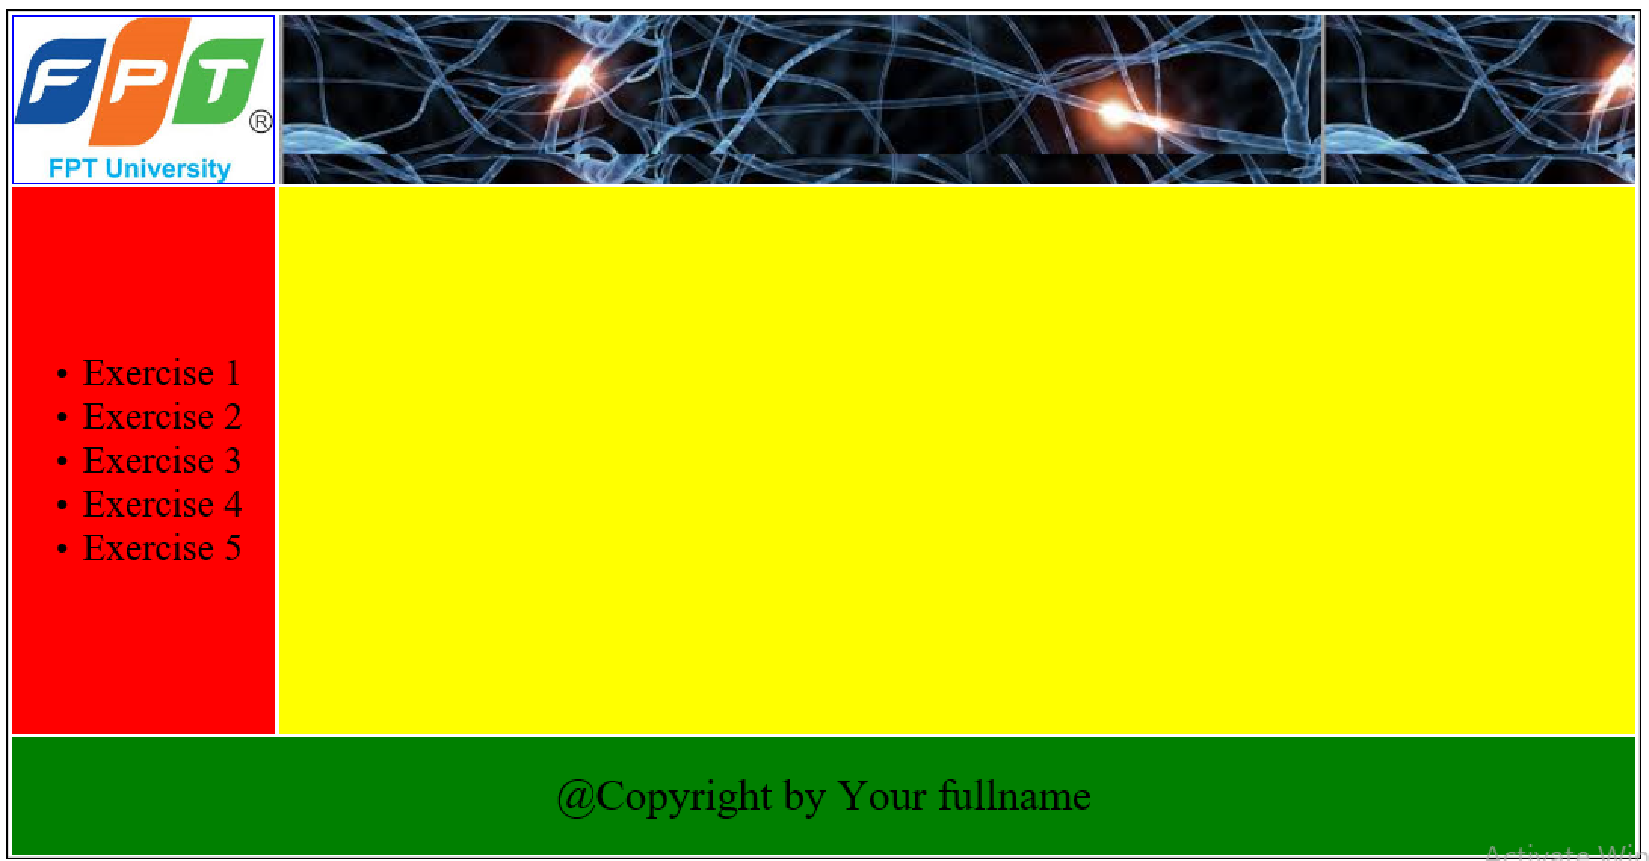
Exercise 1: Create the JSP file, named Exercise1.jsp and servlet file execute the requests from JSP file , then output the result at the jsp file.
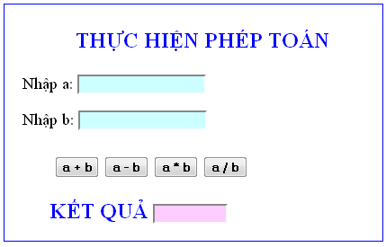
Exercise 2: Create the JSP file, named Exercise2.jsp and servlet file execute the requests from JSP file , then output the result at the jsp file.
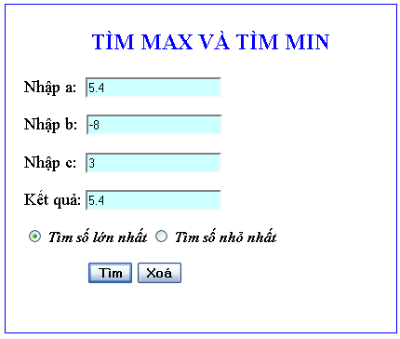

Exercise 3: Create the JSP file, named Exercise3.jsp and servlet file execute the requests from JSP file , then output the result at the jsp file.

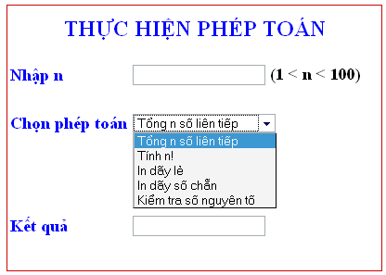

Exercise 4: Create the JSP file, named Exercise4.jsp and servlet file execute the requests from JSP file , then output the result at the jsp file.

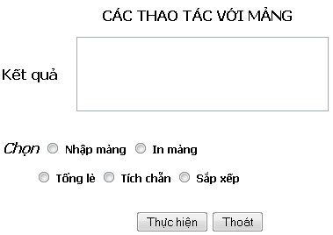

Exercise 5: Create the JSP file, named Exercise5.jsp and servlet file execute the requests from JSP file , then output the result at the jsp file.

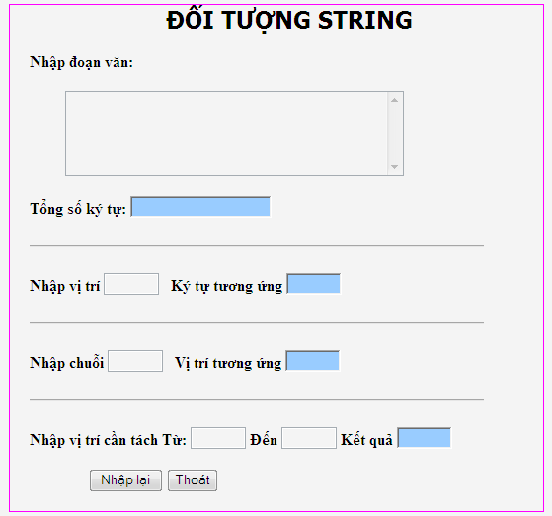

Exercise 6: Solve the equation: ax + b=0;
