June, 2020
Team
Anna
Latyr
Lujane
Prajakta
Stephen

Internet Disparity
User Guide & Steps
Contents
Internet Disparity 0
1 Extract 2
1.1 Notebook 2
1.2 Complementary files 2
2 Transform 3
2.1 Create a PgAdmin (SQL) database 3
2.2 Jupyter Notebook 3
3 Load 4
3.1 PgAdmin (SQL) 4
4 Flask app 5
4.1 Python code 5
5 Api 5
5.1 Default url 5
5.2 Example using a specific route 5
6 Json files 6
6.1 Jupyter Notebook & Create Json Files 6
7 Create the python server to render the html pages 7
7.1 Terminal & Server 7
7.2 Localhost 8

Extract

Notebook
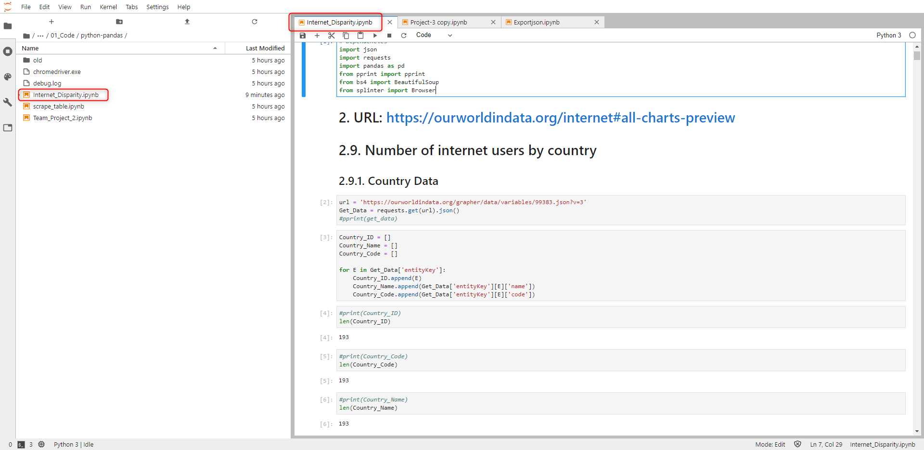
Path:
…\17_Global_Digital_Divide_Project_2\Project Work\02 - Analysis\01_Extraction\01_Code\python-pandas\ Internet_Disparity.ipynb

Complementary files
All files are automatically downloaded using the python/pandas code.
2 files out of 16 are stored in the default download folder.
Users will have to copy/paste those 2 files into folder below.
Path:
…\17_Global_Digital_Divide_Project_2\Project Work\02 - Analysis\01_Extraction\02_Data_Output
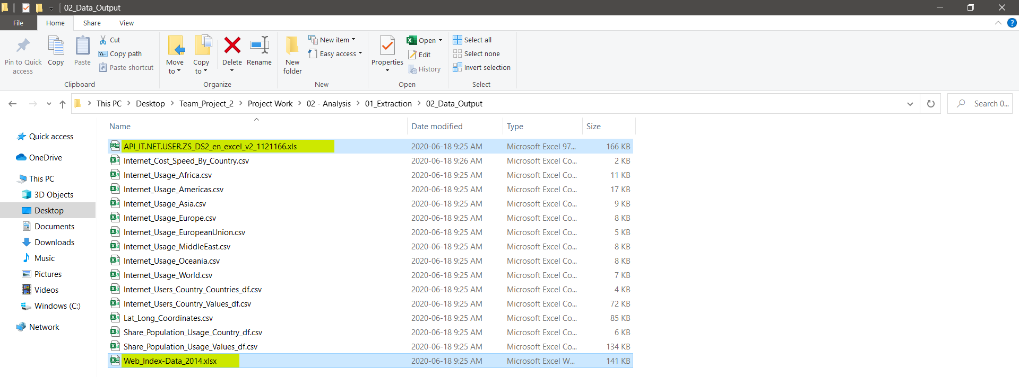

Transform

Create a PgAdmin (SQL) database
Later in the process, Jupyter Notebook will connect to the database and insert the data automatically.
Prior to that, create a database and update its name to ‘Internet_DB’, your username to ‘localhost’ & your password to ‘localhost’.
Use these credentials to connect to the database.
It is highly suggested to change them at the end of the project to make them more personal.
Create a query to create the table by using this code located here:
…\17_Global_Digital_Divide_Project_2\Project Work\02 - Analysis\03_Load_Analyze_SQL\Analysis.sql

Jupyter Notebook
Pre-requisite:
User must have created a database named ‘Internet_DB’, prior to connecting to running this code.
Run this file that contains the code to load the data included in the database.
Path:
…\17_Global_Digital_Divide_Project_2\Project Work\02 - Analysis\02_Transform\Project-3 copy.ipynb

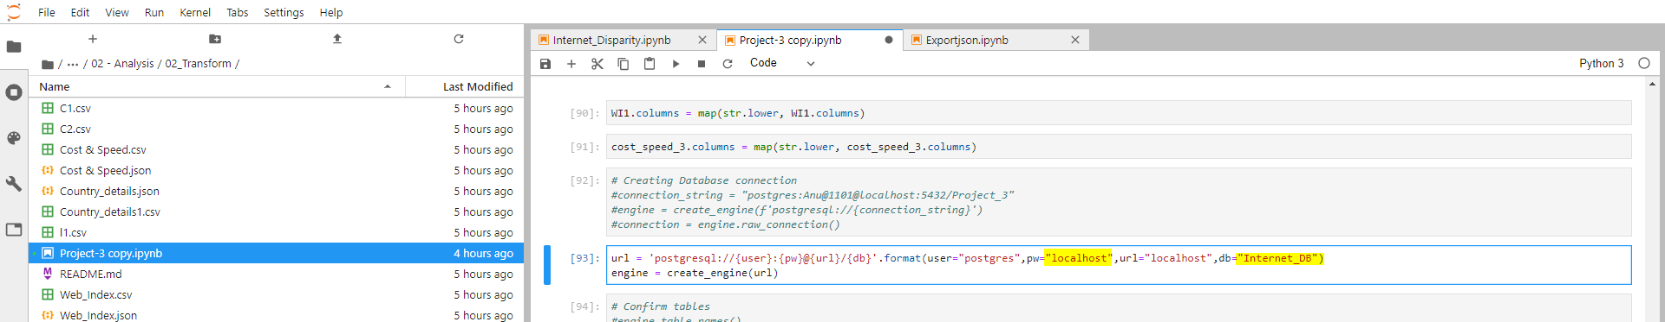

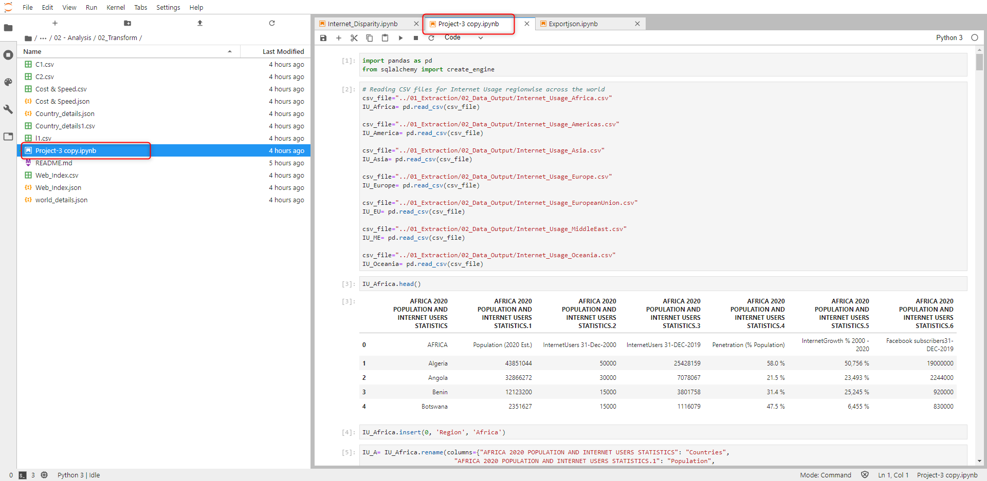

Load

PgAdmin (SQL)
Pre-requisite:
User must have created a database named ‘Internet_DB’, prior to connecting to running this code.
The database was loaded at the end of the previous step by Jupyter Notebook, automatically.
Verify that tables are populated by running queries below.
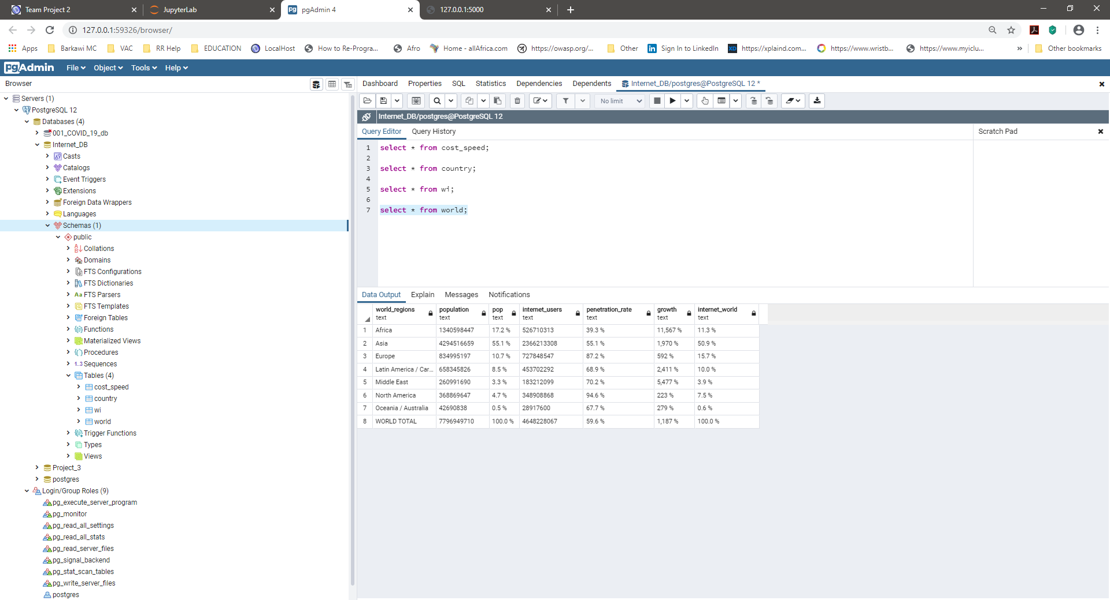

Flask app

Python code
Pre-requisite:
User must have created a database named ‘Internet_DB’, prior to connecting to running this code.
Run the .py file to get data from the database.
Use credentials defined previously.
Path:
… \17_Global_Digital_Divide_Project_2\Project Work\02 - Analysis\04_Flask_SQLAchemy\ readcsv.py
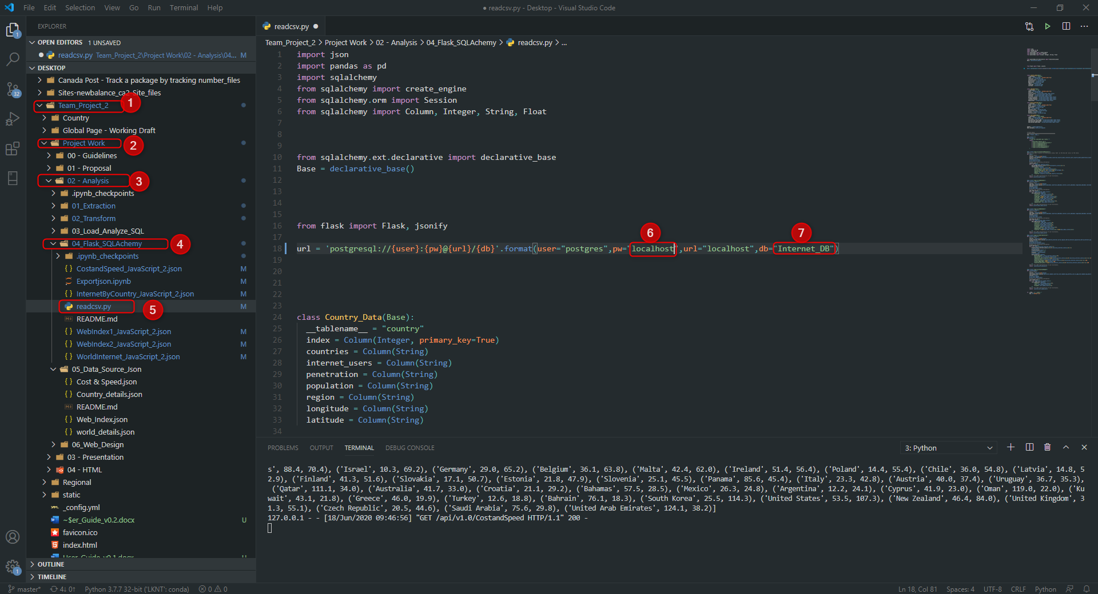
Please don’t be mislead by the file name ‘readcsv.py’ .

Api

Default url
The API is created ath the following address url = http://127.0.0.1:5000/ .
Copy/paste the url above in your browser to see JSON data.
Below are the routes available.
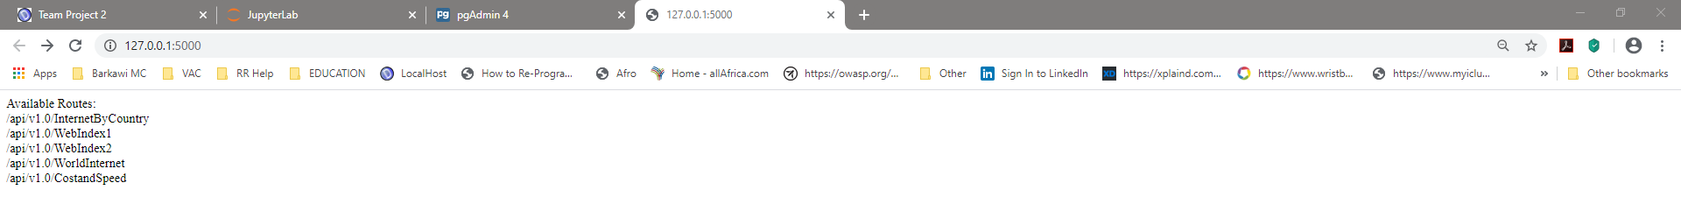

Example using a specific route
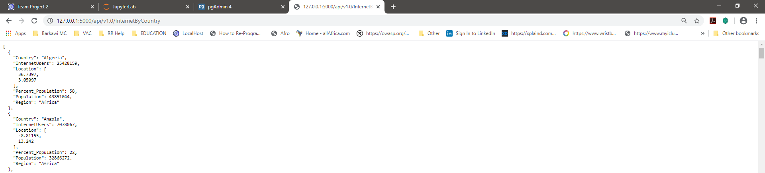

Json files

Jupyter Notebook & Create Json Files
Run Jupyter Notebook to generate JSON files.
Path:
…\17_Global_Digital_Divide_Project_2\Project Work\02 - Analysis\04_Flask_SQLAchemy\Exportjson.ipynb

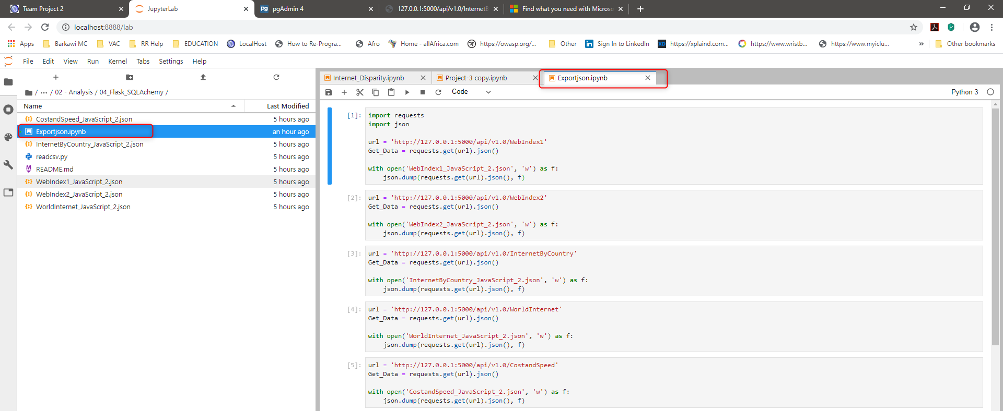

See files generated within the same folder.
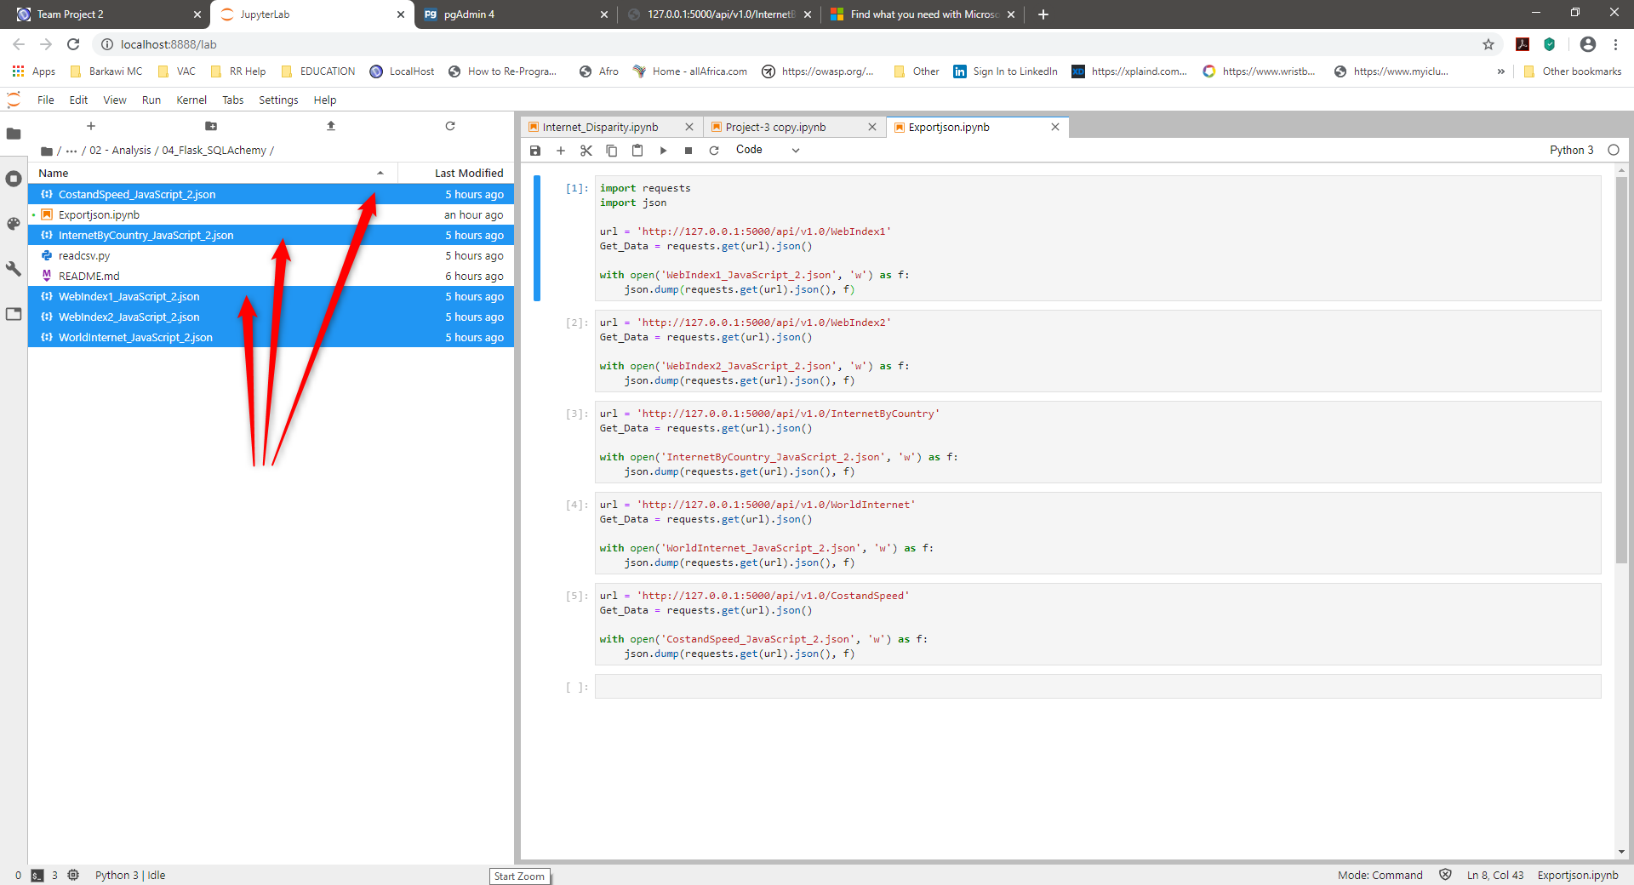

Create the python server to render the html pages

Terminal & Server
- Download this entire project from Github
- Open VS Code or your IDE
- Choose 'File > Open Folder'
- Select the path to the folder located 1 level above the folder where the index.html is located.
  - Example if your index file is located: Documents/.../Folder_Level_1_Above/ 17_Global_Digital_Divide_Project_2/index.html
  - Select: Folder_Level_1_Above
- Right click the folder that contains your index.html, it should be named: 17_Global_Digital_Divide_Project_2
- Select: Open in integrated terminal
- It should open the terminal
- In the terminal do the following:
  - Type the command 'conda activate Your_Environment_Name' ; Your_Environment_Name is the name of your Python environment you defined
  - Run the server by typing the following: 'Python -m http.server'
  - Then, copy/paste this url (http://localhost:8000/) into your browser and press enter
- The page should load the charts and you can now selection menu or dropdown list to show the desired information
- Don't forget to shut down the server by closing your Python terminal in VS Code
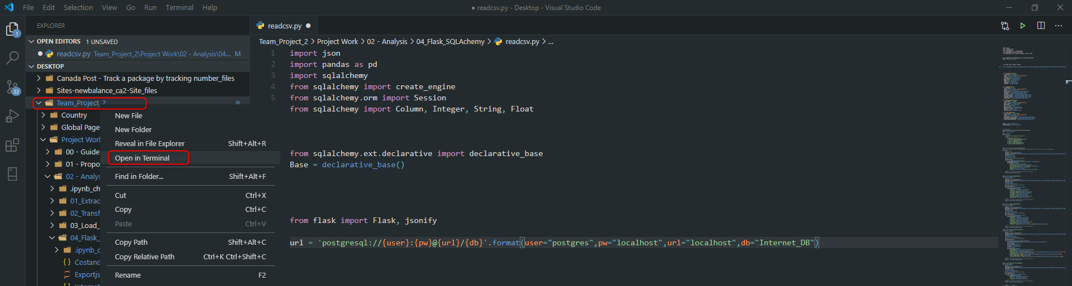
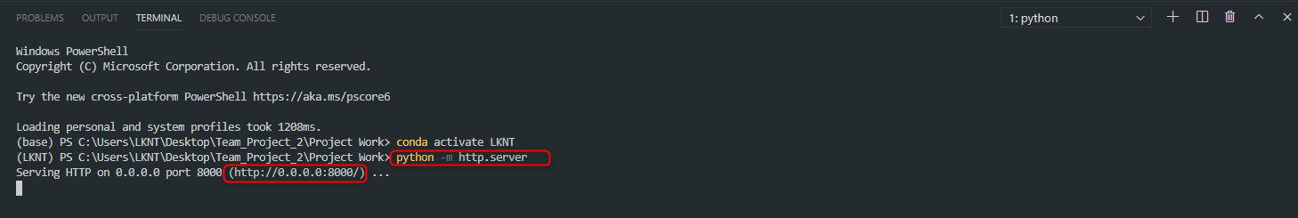

Localhost
Use your browser and go to the following url: http://localhost:8000/
Go to the website, see result below:
