# Create the default charts to be displayed when the page opens

## Select all data

## Select the sample data

## Get the sample data for the 1st ID 🡺 slice

## Sort data set by Sample values / Descending

## Create the charts (see requirements above)

### Bar chart

#### Filter to show only 10 first values 🡺 slice

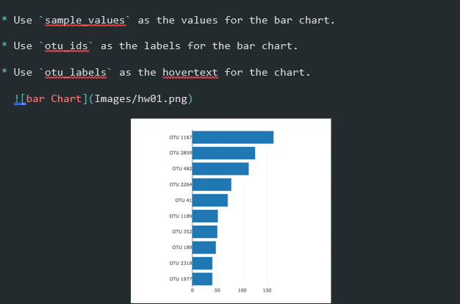

### Bubble chart

No filter 🡺 all values

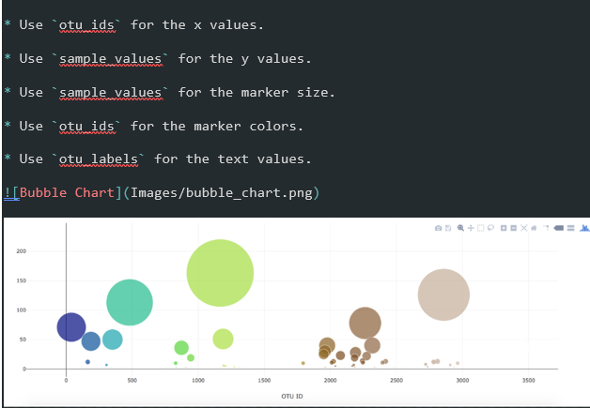

X values = uto_ids

Y values = sample_values

Marker size = sample_values

Colors = out_ids

Text values = out_labels

### Display the metadata

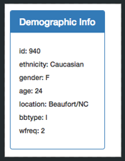

### Bonus 🡺 Gauge Chart

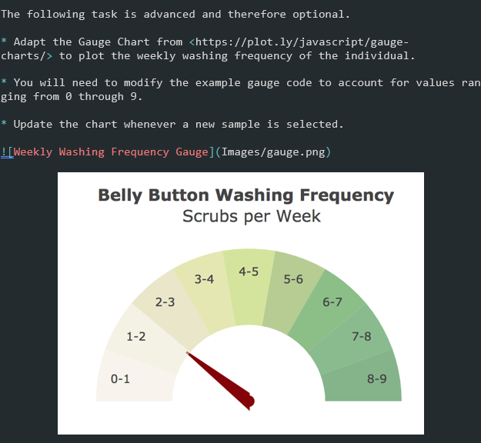

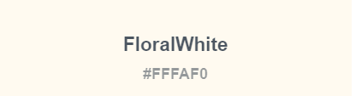

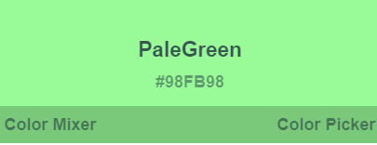

# Create the filtered charts

## Create a selection list with dropdown

## Create handler on change of the dropdown list value

## Create a filter by pulling the data from the selection list

## Compare the value to that of the dataset ID

## Retrieve corresponding value

## Create the charts (see requirements above)

# Deployment

Deploy your app to a free static page hosting service, such as GitHub Pages. Submit the links to your deployment and your GitHub repo.

# Grading

