June, 2020

**Team**

**Anna  
Latyr  
Lujane  
Prajakta  
Stephen**

# Internet Disparity

**User Guide & Steps**

**Contents**

Internet Disparity 0

1 Extract 2

1.1 Notebook 2

1.2 Complementary files 2

2 Transform 3

2.1 Create a PgAdmin (SQL) database 3

2.2 Jupyter Notebook 3

3 Load 4

3.1 PgAdmin (SQL) 4

4 Flask app 5

4.1 Python code 5

5 Api 5

5.1 Default url 5

5.2 Example using a specific route 5

6 Json files 6

6.1 Jupyter Notebook & Create Json Files 6

7 Create the python server to render the html pages 7

7.1 Terminal & Server 7

7.2 Localhost 8

# Extract

## Notebook

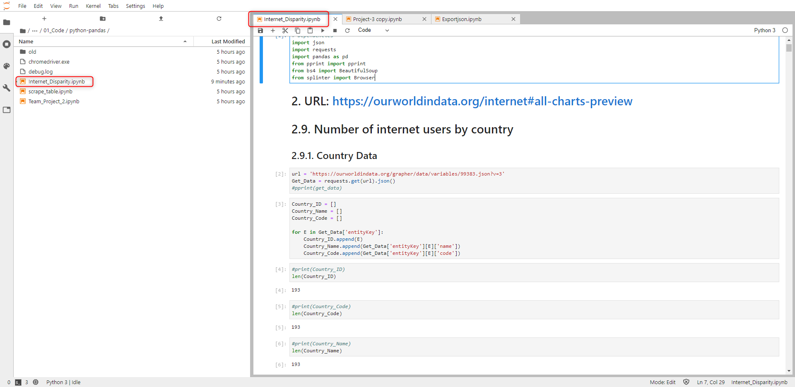

Path:

…\17_Global_Digital_Divide_Project_2\Project Work\02 - Analysis\01_Extraction\01_Code\python-pandas\ Internet_Disparity.ipynb

## Complementary files

All files are automatically downloaded using the python/pandas code.

2 files out of 16 are stored in the default download folder.

Users will have to copy/paste those 2 files into folder below.

Path:

…\17_Global_Digital_Divide_Project_2\Project Work\02 - Analysis\01_Extraction\02_Data_Output

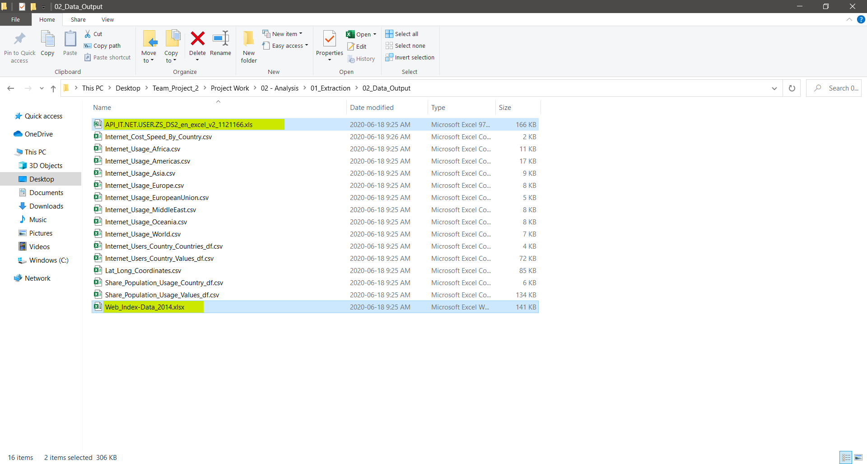

# Transform

## Create a PgAdmin (SQL) database

Later in the process, Jupyter Notebook will connect to the database and insert the data automatically.

*Prior to that, create a database and update its name to ‘Internet_DB’, your username to ‘localhost’ & your password to ‘localhost’.*

Use these credentials to connect to the database.

It is highly suggested to change them at the end of the project to make them more personal.

Create a query to create the table by using this code located here:

…\17_Global_Digital_Divide_Project_2\Project Work\02 - Analysis\03_Load_Analyze_SQL\Analysis.sql

## Jupyter Notebook

***Pre-requisite:***

*User must have created a database named ‘Internet_DB’, prior to connecting to running this code.*

Run this file that contains the code to load the data included in the database.

Path:

…\17_Global_Digital_Divide_Project_2\Project Work\02 - Analysis\02_Transform\Project-3 copy.ipynb

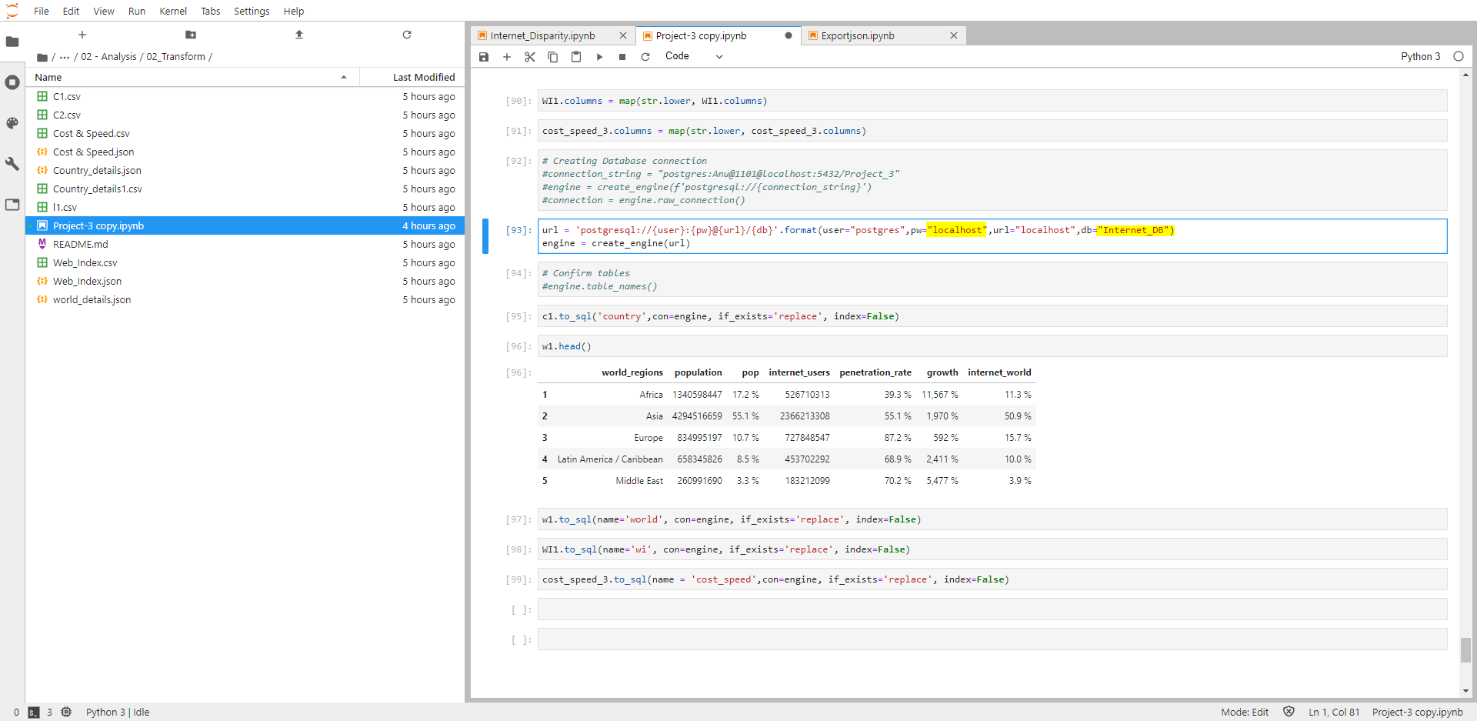

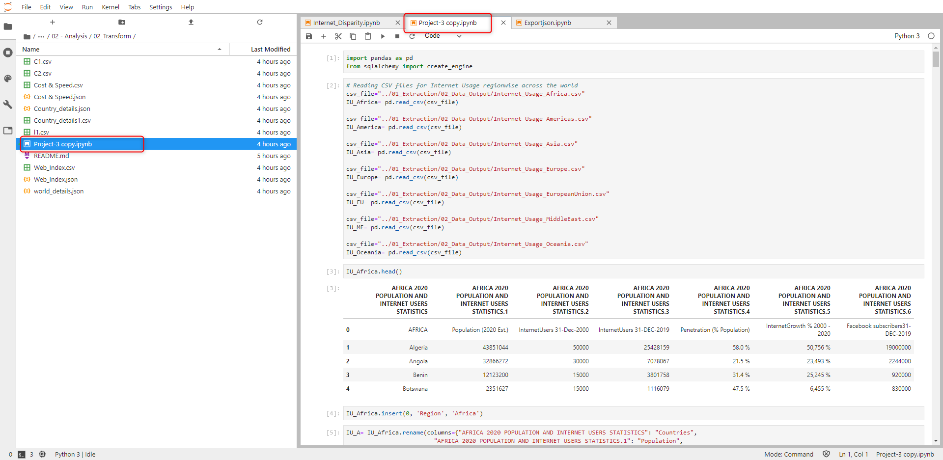

# Load

## PgAdmin (SQL)

***Pre-requisite:***

*User must have created a database named ‘Internet_DB’, prior to connecting to running this code.*

The database was loaded at the end of the previous step by Jupyter Notebook, automatically.

Verify that tables are populated by running queries below.

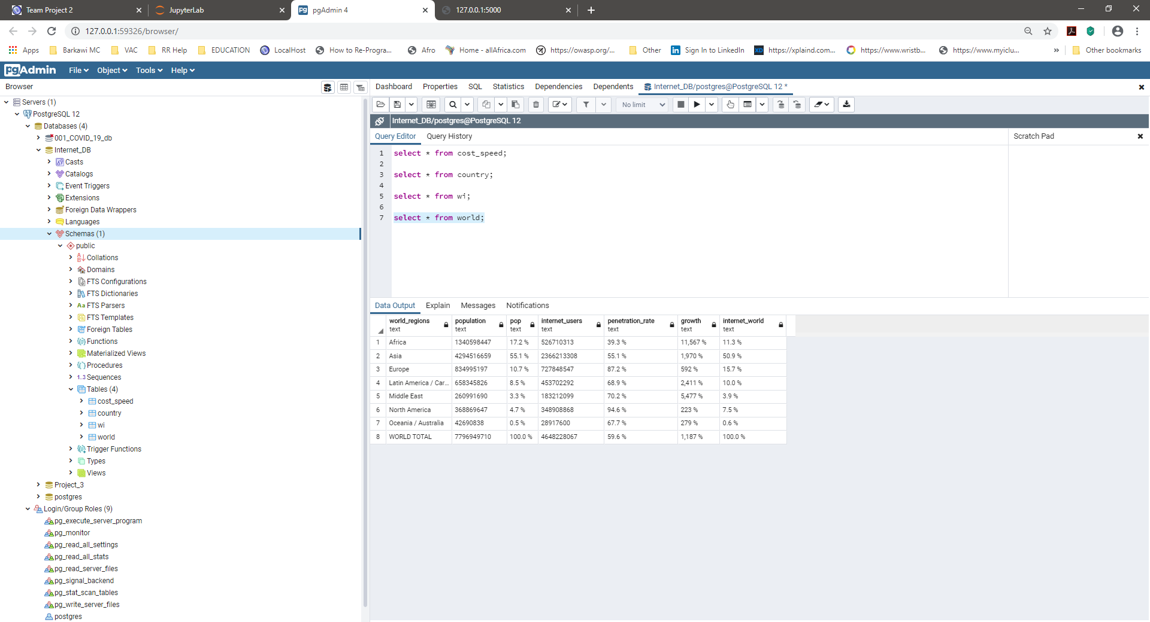

# Flask app

## Python code

***Pre-requisite:***

*User must have created a database named ‘Internet_DB’, prior to connecting to running this code.*

Run the .py file to get data from the database.

Use credentials defined previously.

Path:

… \17_Global_Digital_Divide_Project_2\Project Work\02 - Analysis\04_Flask_SQLAchemy\ readcsv.py

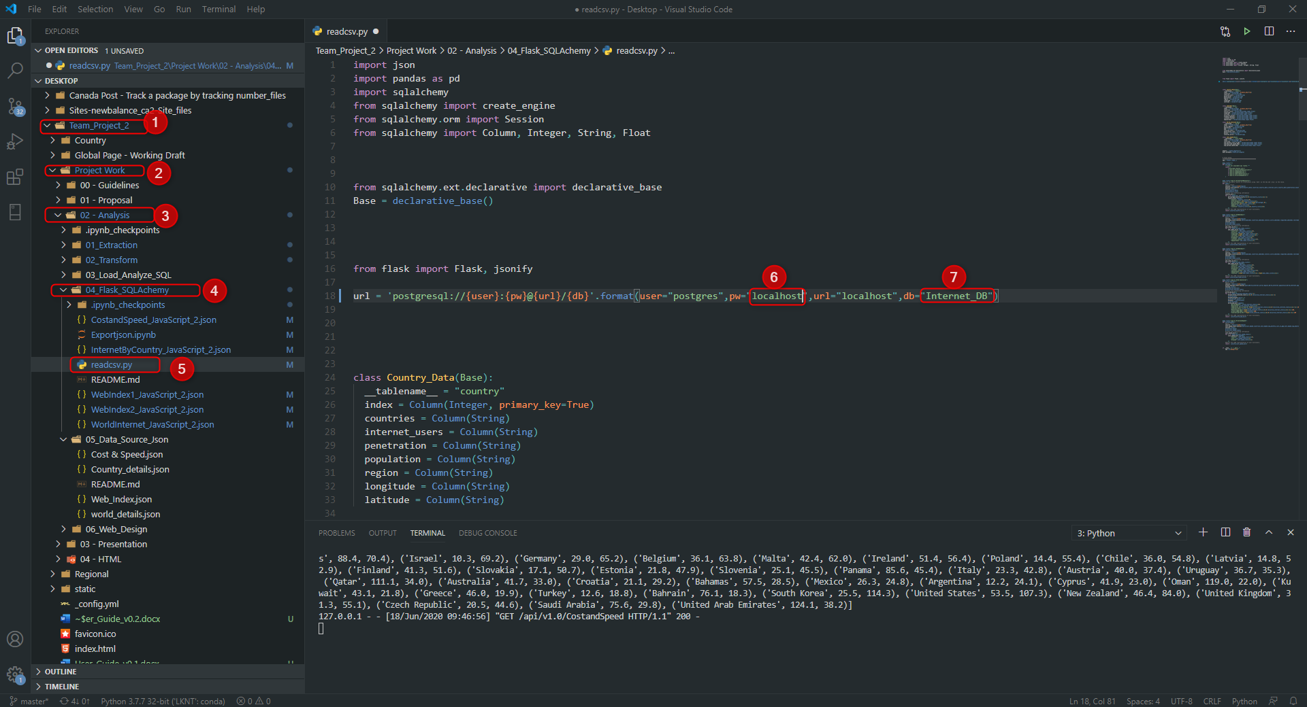

Please don’t be mislead by the file name ‘readcsv.py’ .

# Api

## Default url

The API is created ath the following address 🡺 url = <http://127.0.0.1:5000/> .

Copy/paste the url above in your browser to see JSON data.

Below are the routes available.

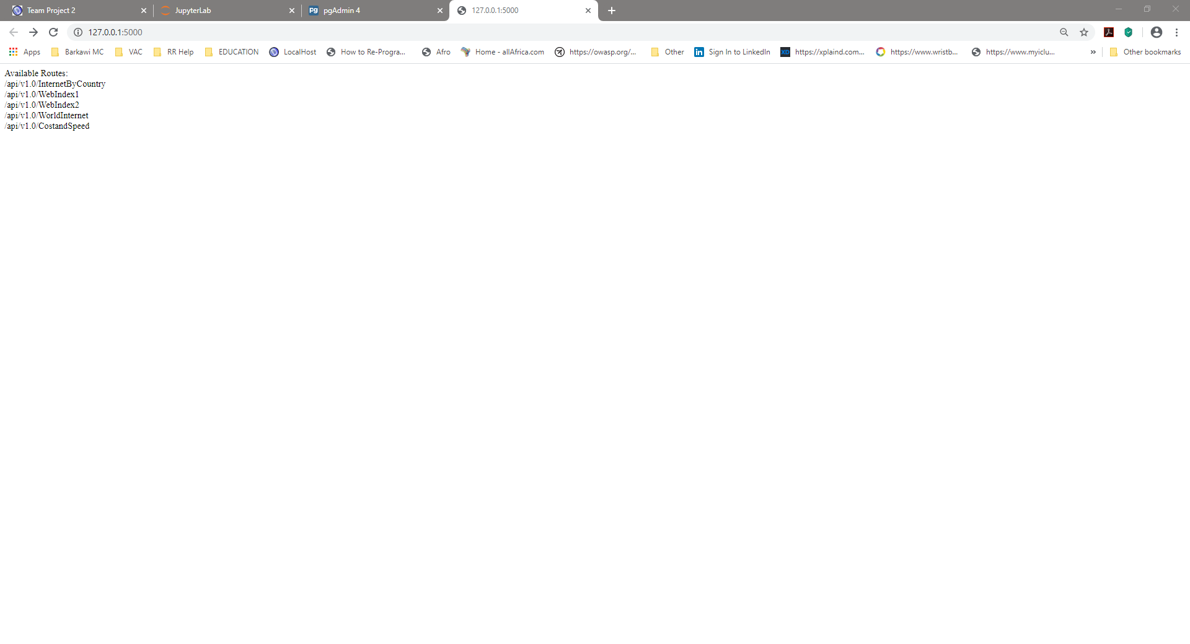

## Example using a specific route

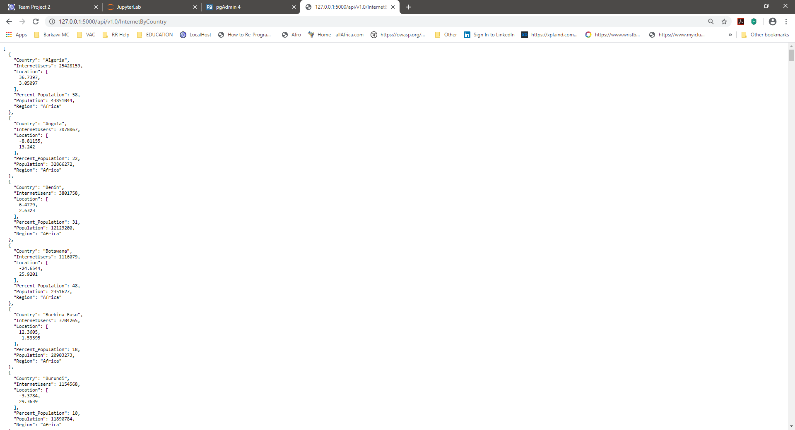

# Json files

## Jupyter Notebook & Create Json Files

Run Jupyter Notebook to generate JSON files.

Path:

…\17_Global_Digital_Divide_Project_2\Project Work\02 - Analysis\04_Flask_SQLAchemy\Exportjson.ipynb

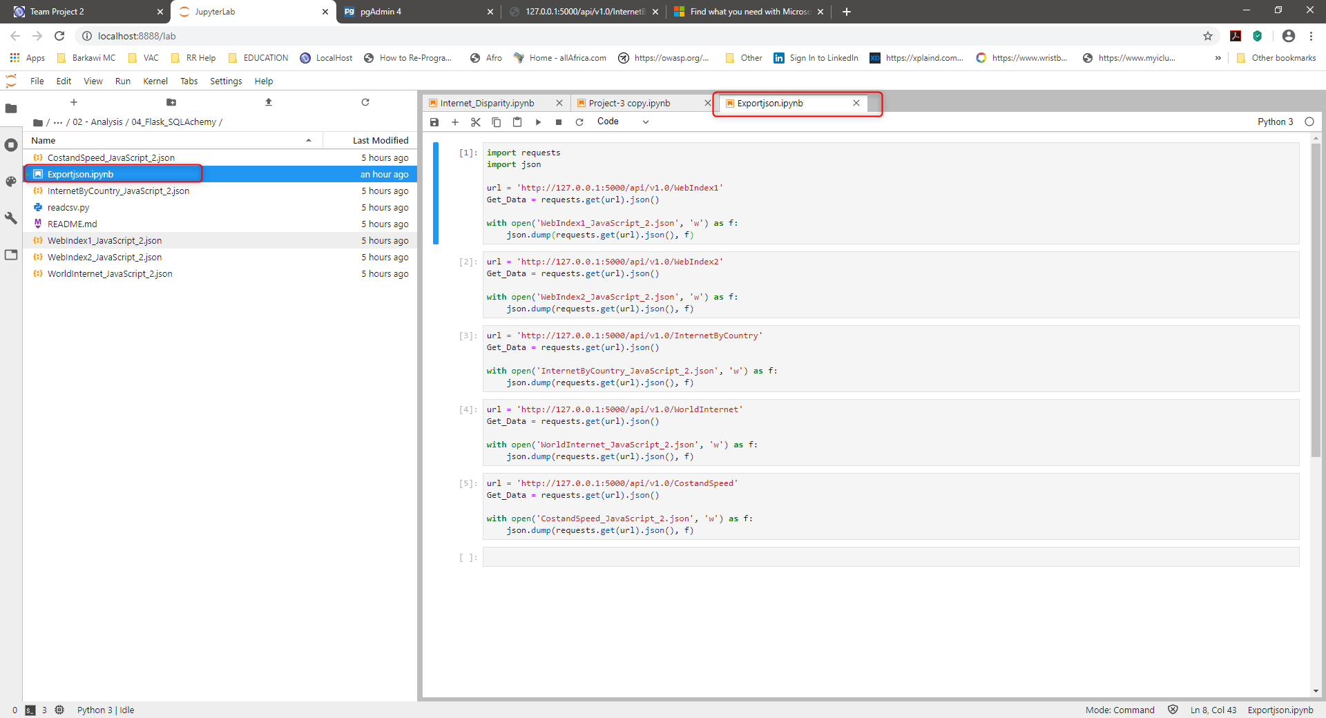

See files generated within the same folder.

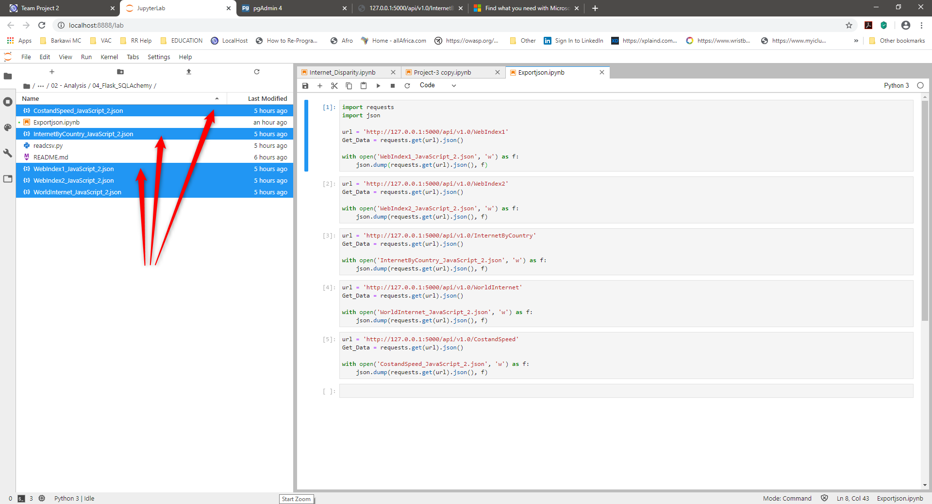

# Create the python server to render the html pages

## Terminal & Server

* Download this entire project from Github
* Open VS Code or your IDE
* Choose 'File > Open Folder'
* Select the path to the folder located 1 level above the folder where the index.html is located.
  + Example if your index file is located: Documents/.../Folder_Level_1_Above/ 17_Global_Digital_Divide_Project_2/index.html
  + Select: Folder_Level_1_Above
* Right click the folder that contains your index.html, it should be named: 17_Global_Digital_Divide_Project_2
* Select: Open in integrated terminal
* It should open the terminal
* In the terminal do the following:
  + Type the command 'conda activate Your_Environment_Name' ; Your_Environment_Name is the name of your Python environment you defined
  + Run the server by typing the following: 'Python -m http.server'
  + Then, copy/paste this url (<http://localhost:8000/>) into your browser and press enter
* The page should load the charts and you can now selection menu or dropdown list to show the desired information
* Don't forget to shut down the server by closing your Python terminal in VS Code

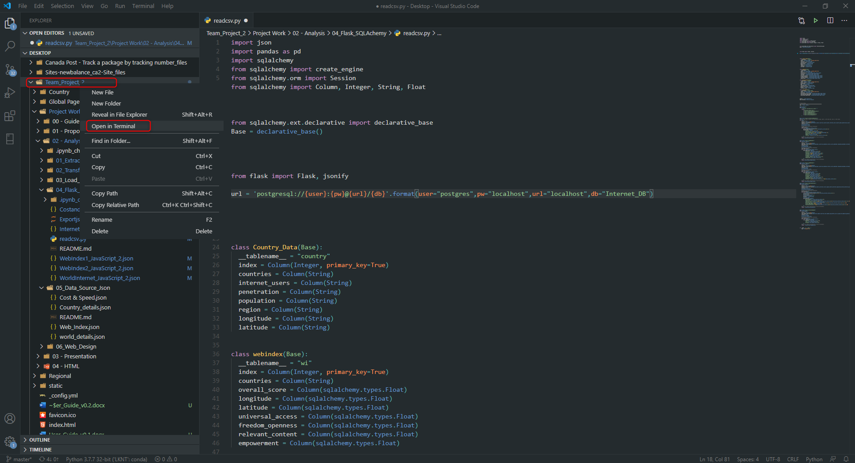

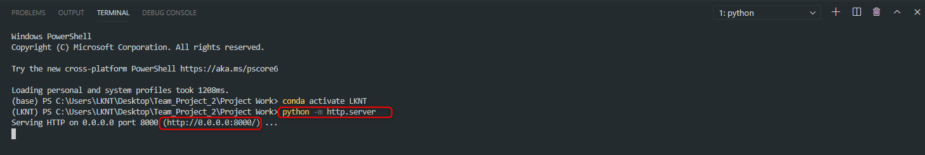

## Localhost

Use your browser and go to the following url: <http://localhost:8000/>

Go to the website, see result below:

