1. Right click on Bluetooth icon > Add a Bluetooth Device

1. Add Bluetooth or Other device > Bluetooth > Select Connect-1 > Done

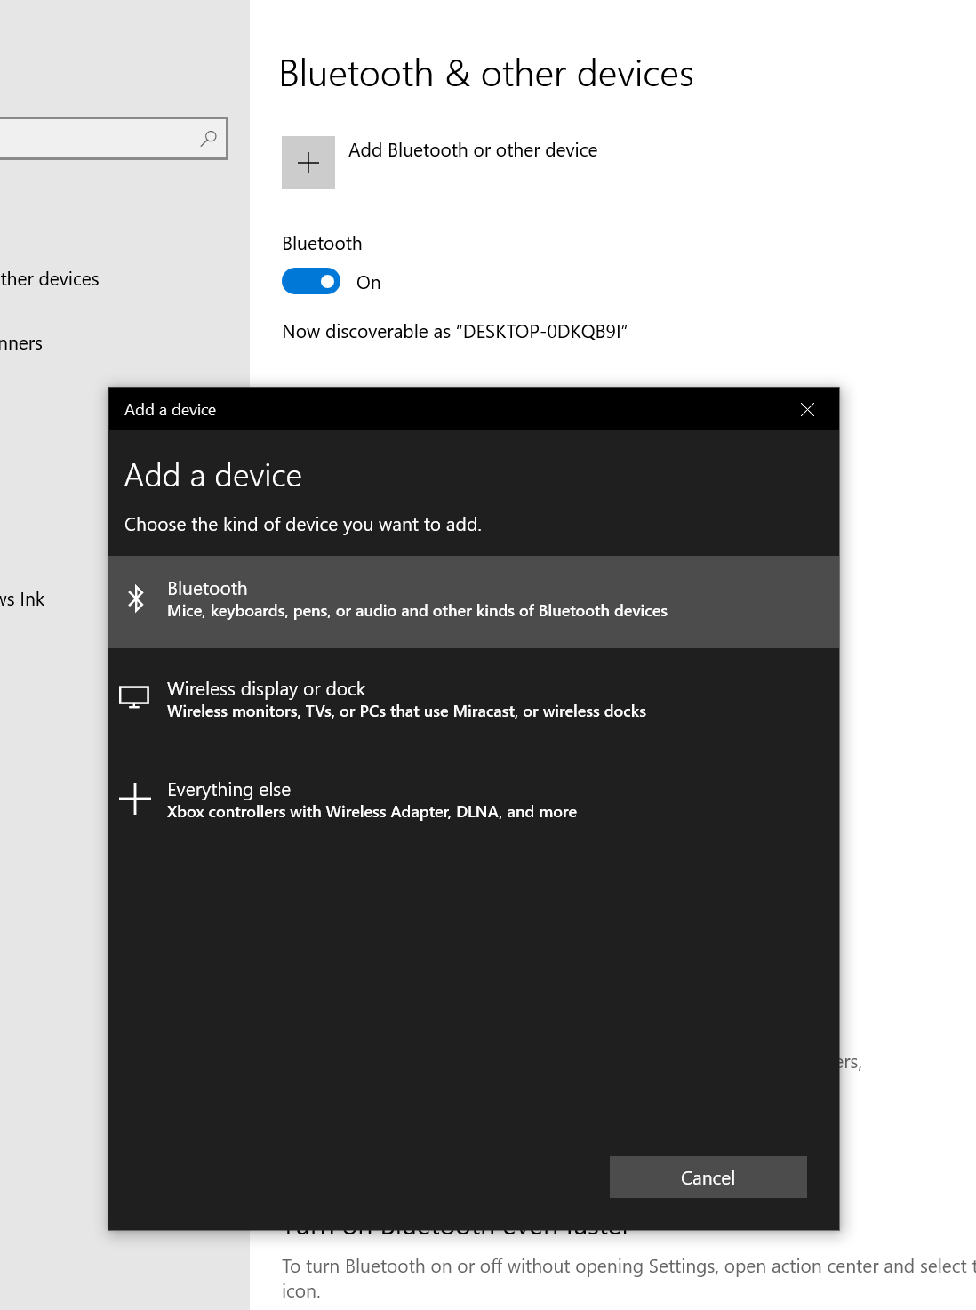

1. Change the baudrate

In Bluetooth settings > More Bluetooth options > COM Ports > Ougoing port it’s the port in use

Start > Device Manager > Ports > Select both COM ports > Port settings > Bits per second > Select 115200

