` **Lab Test 1 (sample)**

**SAS code:**

**LAB1 15%**

**Question 1: (90 marks)**

**Stage 1:** Problem statement:

Design and develop a C++ program to compute either the area or volume of a truncated cone depending on user’s choice. If user’s choice is 1, it will compute the area, otherwise, it will compute the volume.

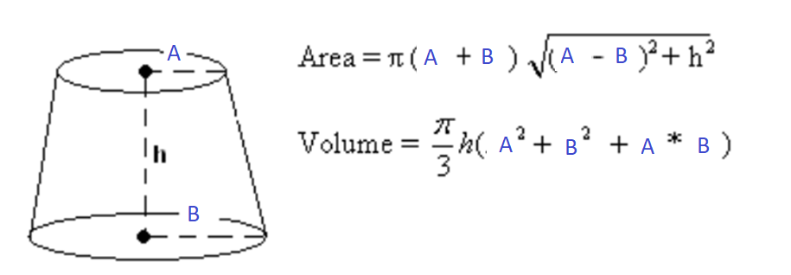

* Notes: The values of A, B, h and user’s choice are to be entered from the keyboard by the user when the program is executed. And the computed value will be displayed in the console window.

**a) Stage 2:** Give suitable input and output variable names with their data type and computations needed.

|  |  |  |
| --- | --- | --- |
|  | Input(s): | Output(s): |
| Suitable Variable Names and their appropriate Data Type:  Use the format, **name/data type** e.g. age / int, height / double, .etc. |  |  |

|  |  |  |
| --- | --- | --- |
|  | If user’s choice is 1: | If user’s choice is not 1: |
| Computation: |  |  |

**b) Stage 3:** Generate two sets of test data by hand calculations.

(Total marks for stage 2 and 3 are around 20 marks)

|  |  |  |  |  |  |  |
| --- | --- | --- | --- | --- | --- | --- |
| User’s choice | A | B | h | Area | Volume |  |
| 1 |  |  |  |  | **-** |  |
| Any other number |  |  |  | - |  |  |

**c) Stage 4:** Design the flowchart (20 marks).

**d) Stage 5:** Code your program using information from stages 1, 2, 3 and 4. Type your program **directly** into the computer. (35 marks)

**Remember to add comment line(s) to write your name, admin number and class at the top of your program file.**

**e) Stage 6:** Compile, run and debug any errors in your program. You may demonstrate the program to your lecturer **Remember to save and submit the source code file** according to your lecturer’s instruction. (15 marks)

**Question 2: (10 marks)**

Fill in the missing code in the following code segment. (**x** is a variable of **int** type.)

cin >> x;

while (___________________________________)

{

cout << "Invalid! Please enter a number divisible by 7: ";

____________________________;

}