Backward Proof Search in First-Order Logic:
Baseline and Improved Algorithm Using LK′
Lauchlan Blewitt
Griffith University, School of ICT, Gold Coast QLD, Australia
lauchlan.blewitt@griffithuni.edu.au
Abstract. Automated theorem proving is a core part of computer science, especially for things like formal verification and AI. For this project, I implemented and evaluated Algorithm 2 from Hou, a straightforward backward proof search for first-order logic using the LK’s sequent calculus.

The baseline algorithm just applies inference rules backwards from a goal, following a strict priority order, breaking down formulas until branches close or it gets stuck. To make it run more efficiently, I built three targeted improvements into the architecture:
- Loop detection: I set it up to track visited sequents, so the program stops getting caught in infinite cycles on universally quantified formulas.

- Iterative deepening: This incrementally bumps up the search depth, so it catches short proofs faster without diving down deep, useless paths.

- Smart term ordering: I tweaked the quantifier instantiation, prioritising the terms that are most likely to close a branch.

The baseline and the improved prover were assessed against 120 benchmark formulas across four difficulty tiers. Both versions achieved 100% accuracy. The key discovery was seeing the performance trade-offs in action. On hard formulas that were provable, the improved prover was faster (with a median of 0.97ms vs 1.16ms) due to the loop detection eliminating wasted search time. However, on unprovable inputs, the baseline rose above. Iterative deepening forces the system to re-run the search at every depth, which adds massive overhead when a proof simply doesn't exist. It was a clear lesson that optimisations for finding proofs can make exhaustive failures more expensive.

1 Introduction

Automated reasoning, the art of getting a computer to logically derive a conclusion from a premise, is a core component of artificial intelligence and program verification. At its core, it comes down to automated theorem proving, taking a formula and determining whether it’s a tautology. Building a First-Order-Logic (FOL) prover is a foundational exercise in the world of Computer Science, due to it being the industry standard for expressing computational properties.

The sequent calculus, introduced by Gentzen [2] and used in the LK′
system of Hou [1], provides a proof-theoretic framework particularly amenable to backward search. A sequent Γ ⊢ ∆ asserts that given assumptions Γ, at least one formula
in ∆ holds. Proof search applies inference rules backwards, decomposing goal
sequents into simpler sub-goals until all branches are closed by axioms.
This report covers the implementation and evaluation of that baseline, alongside three custom architectural optimisations. The core contributions of this work are:
- A complete Python implementation of Algorithm 2 from Hou [1], including an SMT-LIB 2 [6] parser, immutable formula data structures, and all LK′ inference rules applied backwards.
- Three improvements: loop detection, iterative deepening, and smart term ordering for quantifier instantiation.
- A 120-formula benchmark suite across three sources and four difficulty tiers, with 10-trial median timing evaluation and CSV output.

2 Proposed Approach

2.1 System Architecture
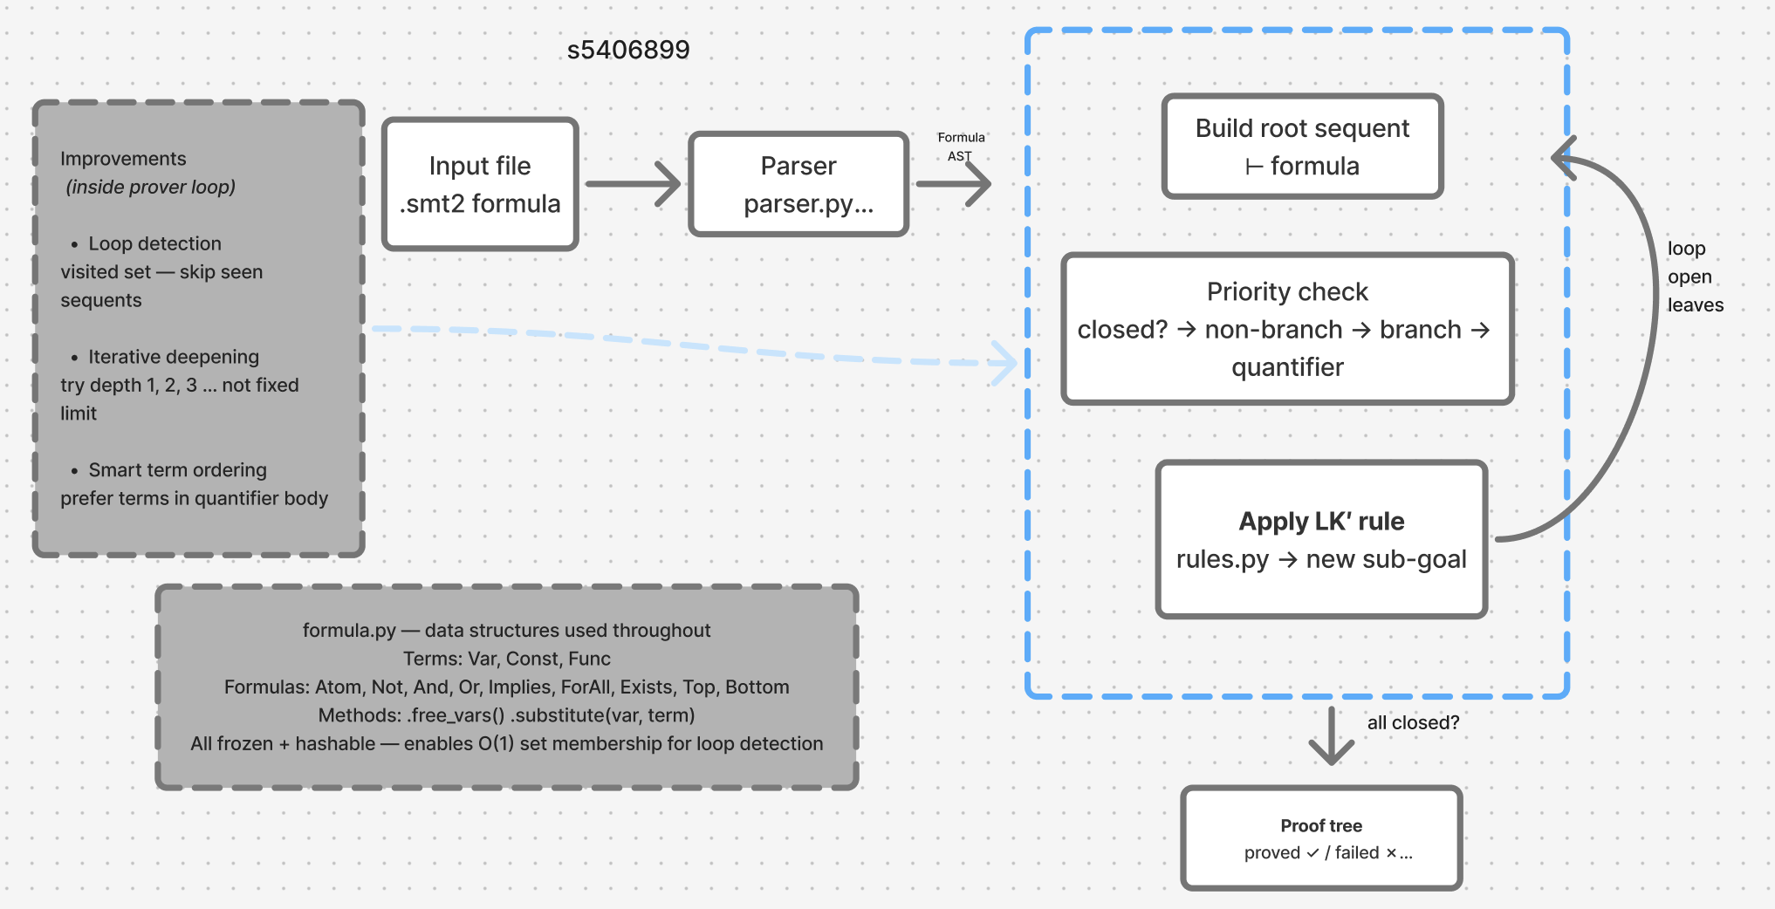
The system operates as a streamlined pipeline: a custom SMT-LIB 2 parser (parser.py) produces an abstract syntax tree (AST); this AST is passed to the execution engine (prover.py), which maintains a proof tree of immutable sequent nodes (formula.py); finally, LK' rules are applied recursively backwards to open leaves until all branches are closed or the search depth limit is reached
Fig. 1. System architecture showing the execution flow from parsing to the recursive prover loop.

2.2 Baseline algorithm

The baseline directly implements Algorithm 2 from Hou [1]. Sequents are represented as immutable tuples of Formula objects, enabling set membership tests for loop detection. Rule application follows a strict priority order to minimise unnecessary branching:

1. Axiom rules. Close the branch immediately if the same formula appears on both sides (id), ⊤ is on the right (⊤R), or ⊥ is on the left (⊥L).

2. Non-branching rules. Apply ¬R, ¬L, →R, ∨R, ∧L, ∃L — each yields exactly one sub-goal.

3. Branching rules. Apply ∧R, ∨L, →L — each yields two sub-goals.

4. Quantifier rules with known terms. Instantiate ∀L and ∃R with terms already present in the sequent.

5. Quantifier rules with fresh constants. Introduce a new constant for ∀R and ∃L.

6. Stop if no rule applies.

2.3 Improvements

Three improvements are implemented, each targeting a specific weakness.

First Improvement – Loop Detection
Without cycle prevention, the baseline could get stuck infinitely instantiating universally quantified formulas. To fix this, a visited set that tracks seen sequents was implemented. Before applying any rule, the current sequent is checked against this set; if it has already been processed, the branch is immediately abandoned. This set is passed non-destructively (via set union) so that backtracking correctly restores the state.

Sam

ple Heading (Third Level). Only two levels of headings should be numbered. Lower level headings remain unnumbered; they are formatted as run-in headings.

Sample Heading (Forth Level). The contribution should contain no more than four levels of headings. The following Table 1 gives a summary of all heading levels.
Table 1. Table captions should be placed above the tables.
Heading level | Example | Font size and style
Title (centered) | Lecture Notes | 14 point, bold
1st-level heading | 1 Introduction | 12 point, bold
2nd-level heading | 2.1 Printing Area | 10 point, bold
3rd-level heading | Run-in Heading in Bold. Text follows | 10 point, bold
4th-level heading | Lowest Level Heading. Text follows | 10 point, italic
Displayed equations are centered and set on a separate line.
x + y = z (1)
Please try to avoid rasterized images for line-art diagrams and schemas. Whenever possible, use vector graphics instead (see Fig. 1).

Fig. 2. A figure caption is always placed below the illustration. Short captions are centered, while long ones are justified. The macro button chooses the correct format automatically.
For citations of references, we prefer the use of square brackets and consecutive numbers. Citations using labels or the author/year convention are also acceptable. The following bibliography provides a sample reference list with entries for journal articles [1], an LNCS chapter [2], a book [3], proceedings without editors [4], as well as a URL [5].
Acknowledgments. A third level heading in 9-point font size at the end of the paper is used for general acknowledgments, for example: This study was funded by X (grant number Y).
Disclosure of Interests. It is now necessary to declare any competing interests or to specifically state that the authors have no competing interests. Please place the statement with a third level heading in 9-point font size beneath the (optional) acknowledgments, for example: The authors have no competing interests to declare that are relevant to the content of this article. Or: Author A has received research grants from Company W. Author B has received a speaker honorarium from Company X and owns stock in Company Y. Author C is a member of committee Z.

References
- Author, F.: Article title. Journal 2(5), 99–110 (2016)
- Author, F., Author, S.: Title of a proceedings paper. In: Editor, F., Editor, S. (eds.) CONFERENCE 2016, LNCS, vol. 9999, pp. 1–13. Springer, Heidelberg (2016)
- Author, F., Author, S., Author, T.: Book title. 2nd edn. Publisher, Location (1999)
- Author, F.: Contribution title. In: 9th International Proceedings on Proceedings, pp. 1–2. Publisher, Location (2010)
- LNCS Homepage, http://www.springer.com/lncs, last accessed 2023/10/25

