Bobby Laudeman
005705423
CSE 460
Tong Yu
Homework #1

1.) The following piece of code creates 8 processes because the first fork call creates a child from the parent, then the second one creates a child from that child and another parent, so now there are 4 processes. Then fork is ran once more on each of the children and the parent, leading to 8 processes.

2.)

a.)
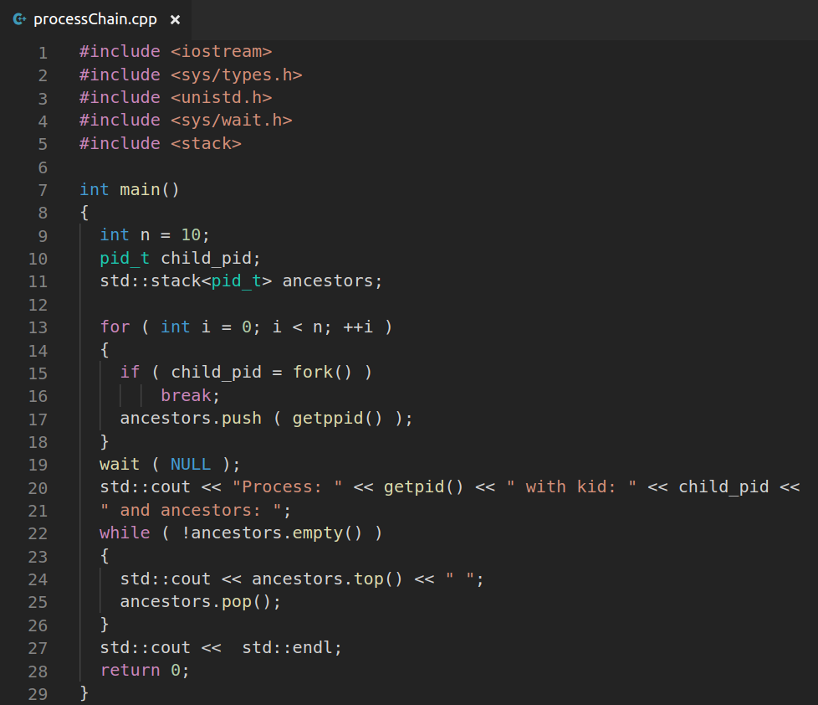
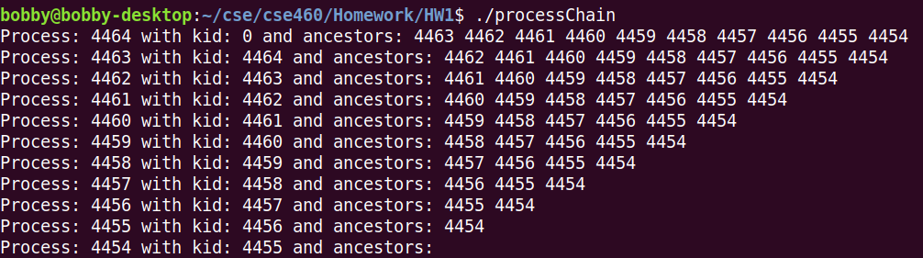

b.)

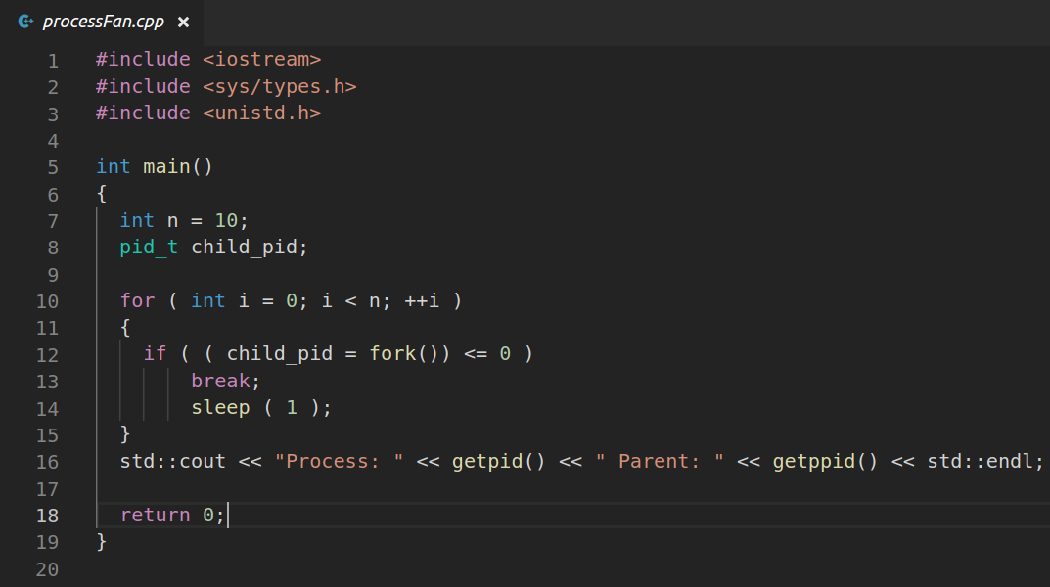
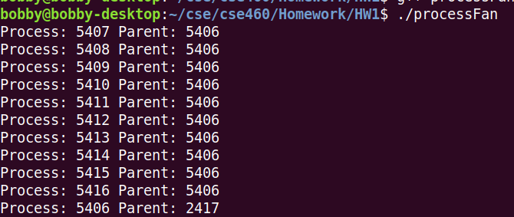
3.)

a.)
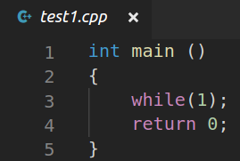

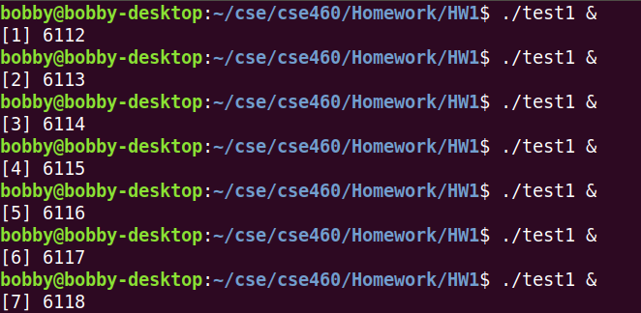

b.)

