Investigating how administrative burden and search costs affect social inequalities in early childcare access, a randomised controlled trial

Manuscript submitted to Nature Human Behaviour

Abstract

Access to high-quality early childcare for low socioeconomic status (SES) households has the potential to mitigate socioeconomic inequalities. Yet, there is an SES-based gap in early childcare enrolment. While low-SES households would benefit the most from attending early childcare, they access early childcare the least. This study tackles cognitive and behavioural barriers behind this access gap. We test the effectiveness of informational interventions and personalised support to enhance early childcare application and access for low-SES households through a multi-arm experiment. Results reveal that the information-only treatment had minimal impact while adding personalised support significantly bridged the SES-gap in early childcare applications. However, despite large impacts on application rates, we found limited impacts on access rates for low-SES households. By identifying key obstacles to early childcare access for low-SES households, our research underscores the need for effective strategies to promote equal opportunities in early childhood education.

# 1 Introduction

Access to high-quality early childcare for low-socioeconomic status (SES) households has the potential to reduce social inequalities1,2. Early childcare facilitates women’s employment, which leads to increased family income and reduced gender inequalities3–7, and it helps mitigate SES-based gaps in children’s development when the quality of care is high1,2,8,9. However, access to early childcare remains significantly lower among low-SES households in most OECD countries, limiting its potential to mitigate inequalities9,10. Facilitating access to early childcare for those who would benefit the most is therefore of paramount importance from a policy perspective.

Low-SES households are less inclined to use early childcare for a range of reasons, including different cultural or gender norms11. However, even when these households intend to access early childcare, structural factors, alongside with cognitive and behavioural factors can hinder access11. Structural factors include affordability (i.e. direct and indirect costs) and accessibility (e.g. availability of early childcare slots, eligibility criteria)12–14. Cognitive and behavioural factors cover information access, friction costs and a range of biases13,11,15–17. Firstly, low-SES households typically have limited access to accurate information about early childcare availability, costs, eligibility criteria, and application procedures18–21. Secondly, friction costs, such as the administrative burden associated with the application process, act as additional behavioural barriers22–25. Finally, poverty and economic insecurity may divert parental cognitive resources away from early childcare decision-making. Low-SES parents may thus rely on heuristics such as sticking to the default option of caring for the child at home19,26. Temporal discounting is stronger among low-SES populations27–30, which can delay the application process because the immediate administrative burden is perceived as outweighing uncertain future benefits.

While structural factors have been extensively studied as determinants of unequal access cognitive and behavioural factors have received much less attention despite recent research in psychology and behavioural economics highlighting their role in various non-take-up dynamics, such as access to higher education, healthcare, and welfare programs11,31.

France is a compelling case study to examine the role of cognitive and behavioural barriers because structural barriers to early childcare enrolment are comparatively small. France offers larger access to high-quality early childcare than many OECD countries, and affordability issues are mitigated by financial aid provided by the state8,32–34. For low-SES households, a full-time slot in daycare costs around €70 per month ($75 per month), which includes diapers and meals. Despite these favourable conditions, access to early childcare is highly unequal in France, with a 65 percentage points gap in attendance between the third and first income tertiles in 201432. In 2017, the government invested €3.4 billion to further increase the number of early childcare slots in France. However, this investment had a very limited impact on early childcare enrolment, particularly among low-SES households35,36. Cognitive and behavioural factors may hinder low-SES households from applying for early childcare even if early childcare is affordable, easily accessible, and of good quality, thus limiting the effectiveness of public policies that solely target structural factors.

In this study, we test the impact of two scalable interventions targeting cognitive and behavioural factors to mitigate SES-based gaps in early childcare access. France has a dual system that differentiates early childcare from kindergarten. The former is accessible from as early as two months and a half after birth, which marks the end of the French maternity leave. Kindergarten is free and mandatory for children above the age of three37. Our study therefore focuses on access to early childcare for children under three years old. Early childcare options include childminders, and a variety of daycare centres managed by municipalities, associations, and private firms. We conducted a randomised controlled trial (RCT) in France to evaluate the effectiveness of two interventions that aimed to increase households’ application to and enrolment in early childcare. We targeted pregnant women between their 4th and 9th month of pregnancy whom we approached during their check-up visits in 8 maternity wards in the Paris region. The final sample consisted of 1849 households, of which 729 were from a low-SES background, as primarily defined by households in which the mother did not attend any kind of post-secondary education (more details about the sample characteristics and recruitment are provided in the Methods section). Both interventions targeted all participants, regardless of their socioeconomic status, but were specifically designed to address the barriers low-SES households face when applying for early childcare, based on prior qualitative fieldwork. To increase the external validity of our findings, we implemented the trial across 84 cities located in three districts of the Paris metropolitan area (Paris, Val-de-Marne, and Seine-Saint-Denis), each with different application processes and availability of early childcare slots, but similar early childcare costs.

The RCT had two treatment arms and a control arm. The first treatment (‘information-only treatment’ henceforth) delivered information via five text messages, each containing a link to a short video. The videos presented the different types of early childcare services, provided detailed estimates of childcare costs as well as information on childcare centres near households’ homes, and detailed application procedures. We also provided additional tips, such as the importance of applying early and to multiple early childcare services to improve admission chances. Additionally, participants received three personalised reminders at three-month intervals. All messages and videos were presented in plain language and translated into English and Arabic. The cost of this treatment was minimal, at 5.5€ ($6) per participant. The mothers received the videos between their 4th and 9th month of pregnancy.

The second treatment (‘information + support treatment’ henceforth), aimed to alleviate the administrative burden of early childcare application. It included the same information as the first treatment, together with personalised application support through phone calls. These calls were conducted by trained interviewers two to five months after households had received the videos. This intervention was tailored to address the different stages of the decision-making process. For parents who were undecided about applying for a childcare spot, we mentioned criteria such as accessibility and affordability through cost simulations. Once parents had made their choice, we offered tailored assistance, ranging from helping them select an appropriate early childcare facility to providing support in completing application forms. The cost of this treatment was 55€ ($60) per participant, with 15 minutes spent per household on average (median:6).

We collected baseline data through face-to-face interviews conducted immediately after recruitment in the maternity wards and endline data through computer-assisted telephone interviews one year later (see Figure 1 for a detailed timeline of the study). We chose the timing of the endline to coincide with the closure of most early childcare admissions for the birth cohort included in the study. Each survey included comprehensive data on households’ demographic characteristics, early childcare preferences, intentions to use early childcare, knowledge about early childcare, past experience with early childcare facilities, and mothers’ temporal preferences. In addition, the endline survey included the pre-registered primary outcome variable on application, i.e. whether households had applied to early childcare, and the secondary outcome variable on access, i.e. whether households had accessed early childcare.

We predicted that both the information-only treatment and the information + support treatment would increase early childcare applications ( $H_{1a}$ and $H_{1b}$ respectively) and access ( $H_{1c}$ and $H_{1d}$) compared to an active control condition in which households received unrelated information about maternal and child health. Additionally, we predicted that the information + support treatment would have a stronger effect on applications ($H_{2a}$) and access ($H_{2b}$) than the information-only treatment. Finally, since the treatments brought particular attention to daycares, which are preferred by parents, less expensive for low-SES households than other types of childcare such as private childminders or nannies, and also more common in our catchment area, we predicted that the effect of both treatments would be stronger for daycare applications ( $H_{3a}$ and $H_{3b}$ respectively) and access ( $H_{3c}$ and $H_{3d}$ respectively)38.

Given the goals of this study, we were particularly interested in treatment heterogeneity. Following the pre-analysis plan, we explored four primary dimensions of treatment heterogeneity across households: (a) SES, (b) migration background, primarily gauged by whether the mother was born in France or not, (c) level of baseline knowledge about early childcare, and (d) prior use of early childcare. We predicted that both treatments would have a greater impact on: (a) low-SES households, (b) households with a migration background, (c) households with limited baseline knowledge, and (d) households that had never used early childcare before. Given that the treatments enhanced the salience of early childcare application and mitigated friction costs, we also pre-registered heterogeneous effects based on mother’s temporal orientation, measured through an intertemporal choice task, as exploratory analyses.

|  |
| --- |
| Figure 1: Study design and timeline |

Figure 1: Study design and timeline

# 2 Results

## 2.1 The intention-to-action gap in early childcare application and access

We found a systematic pattern of outcome differences among households in the control group across the main dimensions of heterogeneity. Low-SES households, present-orientated households, and households with a lower baseline knowledge of early childcare were less likely to intend to use early childcare at baseline, to submit an application, and to eventually secure access to early childcare (see Figure 2.1). Mothers born abroad were just as likely as mothers born in France to intend to use early childcare, yet they applied less often for a childcare spot and secured it less often. Moreover, these gaps increased from intention to application and from application to access. This suggests the existence of social gradients in intention-to-action gaps. It also highlights additional barriers faced after applications are submitted, further limiting access for underprivileged groups.

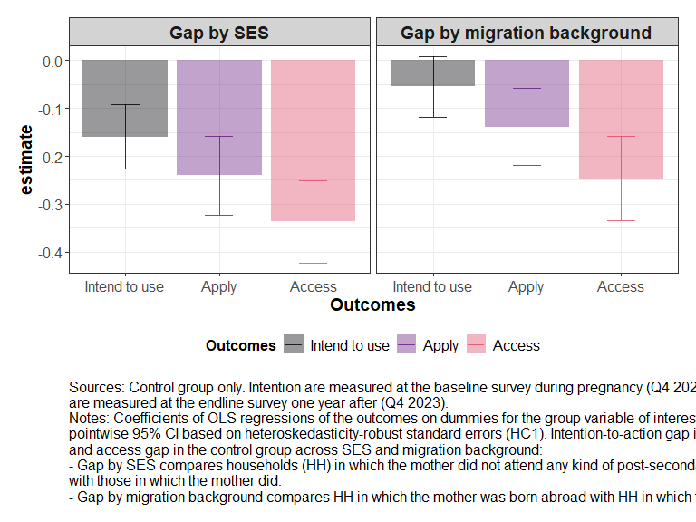

Figure 2.1: The intention-to-action gap in early childcare application and access in the control group across four dimensions of heterogeneity. Intention to use early childcare is measured at the baseline survey during pregnancy. Early childcare application and early childcare access are measured at the endline survey one year after.

## 2.2 Main effects of the two interventions

Table 2.1: Intention-to-treat effects on the main outcomes

|  | **Application** | | **Access** | |
| --- | --- | --- | --- | --- |
| *Early childcare* | *Daycare* | *Early childcare* | *Daycare* |
| *Information-only vs Control* | -0.01 (0.02) | 0.01 (0.03) | -0.02 (0.03) | -0.01 (0.02) |
| [-0.06, 0.04] | [-0.06, 0.07] | [-0.08, 0.04] | [-0.07, 0.05] |
| adj.p.val. = 0.762 | adj.p.val. = 0.787 | adj.p.val. = 0.679 | adj.p.val. = 0.694 |
| *Information + Support vs Control* | 0.04** (0.02) | 0.08*** (0.03) | 0.02 (0.03) | 0.05** (0.02) |
| [-0.01, 0.09] | [0.02, 0.14] | [-0.05, 0.08] | [0.00, 0.10] |
| adj.p.val. = 0.100 | adj.p.val. = 0.003 | adj.p.val. = 0.679 | adj.p.val. = 0.036 |
| *Information + support vs Information-only* | 0.05** (0.02) | 0.07** (0.03) | 0.04 (0.03) | 0.07** (0.03) |
| [-0.01, 0.10] | [0.00, 0.14] | [-0.02, 0.11] | [0.01, 0.13] |
| adj.p.val. = 0.100 | adj.p.val. = 0.029 | adj.p.val. = 0.297 | adj.p.val. = 0.027 |
| *Mean control group* | 0.75 (0.03) | 0.59 (0.03) | 0.57 (0.04) | 0.21 (0.02) |
| [0.68, 0.82] | [0.52, 0.65] | [0.48, 0.65] | [0.17, 0.26] |
| *Num.Obs.* | 2906 | 2906 | 2906 | 2906 |
| *R2* | 0.364 | 0.228 | 0.315 | 0.122 |
| *R2 Adj.* | 0.304 | 0.154 | 0.250 | 0.039 |
| *Fixed effects* | X | X | X | X |
| *Chi 2* | 6.92 | 11.42 | 2.71 | 13.76 |
| *P-value* | 0.074 | 0.010 | 0.439 | 0.003 |
| *= p<.1, **= p<.05, ***= p<.01 based on pointwise p-value. Sources: stacked database of pairwise comparisons.  Each column jointly estimates the average differences between arms using fully-saturated stacked OLS regressions. Control means estimated separately by OLS. Standard errors are cluster-heteroskedasticity robust adjusted at the block level. Adjusted p-values and confidence intervals account for simultaneous inference using the Westfall method.  Joint significance test of null effect using Chi-2 tests and p-values are reported at the bottom of the table. | | | | |

In Table 2 of the Methods section and in Extended Data Table 10, we report evidence that treated and control groups were equivalent at baseline and not affected by differential attrition. First, intention-to-treat estimates without covariates revealed that the information + support group was 4 percentage points more likely to apply for early childcare than both the control group and those receiving information only. However, accounting for multiple testing, we cannot rule out 0 from the simultaneous confidence intervals (Table ??, first column; control mean = 0.75; ß = 0.04; Standard Error (SE) = 0.02; 95% Simultaneous Confidence Interval (SCI), (-0.01, 0.09); P = 0.042; adjusted p-value = 0.10). As pre-registered, we used post-lasso regressions to select and adjust covariates. The resulting estimates, presented in Extended Data Table 1, are closely aligned and exhibit greater precision. They confirmed the overall pattern of a positive impact of the information + support treatment on applications (ßpost-lasso = 0.048; SE = 0.019; 95% CI, (0.01, 0.086); P = 0.015; H1b supported). In contrast, the information-only treatment had no impact on applications (ß = -0.01; SE = 0.02; 95% SCI, (-0.06, 0.04); P = 0.762; adjusted p-value = 0.762; H1a not supported; H2a supported). Second, there was no impact of either treatment on the probability of accessing early childcare (see Table 1; H1c, H1d, H2b, and H3c not supported).

Third, the effects of offering information + support on daycare applications specifically were twice as large as the effects on early childcare applications, which suggests that the effects on applications were driven by this specific type of childcare. Households assigned to the information + support treatment were 8 percentage points more likely to apply for daycare centres, which corresponds to a 14% increase (control mean = 0.59; ß = 0.08; SE = 0.03; 95% SCI, (0.02, 0.14); P = 0.002 ; adjusted p-value = 0.003; H3c supported); and 5 percentage points more likely to access a daycare centre, which corresponds to a 24% increase (control mean = 0.21; ß = 0.05; SE = 0.02; 95% SCI, (0.00, 0.10); P = 0.027; adjusted p-value = 0.036; H3d supported). The information-only treatment on daycare did not impact applications or access (H3a and H3c not supported). The post-lasso estimates confirmed these patterns (Extended Data Table 1).

Finally, since we recorded whether parents assigned to the second treatment accepted to receive personalised support, we used instrumental variable analyses to estimate the average treatment effects on the treated45. As shown in Extended Data Table 2, the information + support treatment resulted in an 8 percentage-point increase in the probability of applying for compliers (average counterfactual = 0.82; ß = 0.08; SE = 0.04; 95% SCI, (-0.01, 0.17); P = 0.042; adjusted p-value = 0.068). However, we did not find any effect on access (average counterfactual = 0.56; ß = 0.03; SE = 0.05; 95% SCI, (-0.08, 0.14); P = 0.56; adjusted p-value = 0.56). When restricting our analyses to daycares, the information + support treatment led to a 15 percentage-point increase in daycare applications for compliers, which corresponds to a 22% increase (average counterfactual = 0.69; ß = 0.15; SE = 0.05; 95% SCI, (0.05, 0.26); P = 0.0016; adjusted p-value = 0.002) as well as a 10 percentage points increase in daycare access, which corresponds to a 53% increase of the counterfactual average (average counterfactual = 0.19; ß = 0.10; SE = 0.04; 95% SCI, (0.00, 0.19); P = 0.02; adjusted p-value = 0.022).

## 2.3 Heterogeneity of the treatment effects

### 2.3.1 Information-only treatment

In line with analyses in the general population, we did not find any statistically significant effect of the information-only treatment on the four subgroups of interest: low-SES households, households with a migration background, households with a lower baseline knowledge, and present-orientated households (see Extended Data Fig. 1, and Supplementary Table 2.1).

### 2.3.2 Information + support

#### 2.3.2.1 Early childcare applications

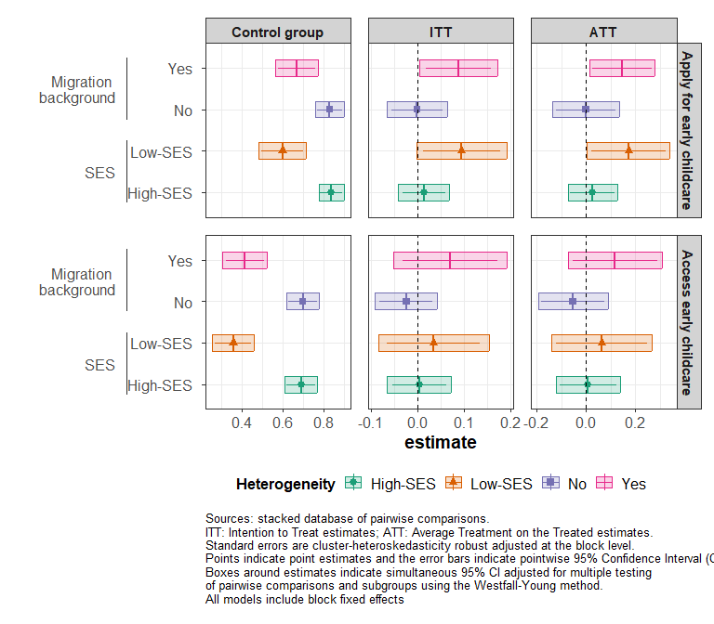

Figure 2.2: Heterogeneous effects of the information + support treatment on early childcare applications and access - Intention-to-treat estimates (ITT) and Average Treatment effects on the Treated (ATT).

The information + support treatment increased the probability that households apply for early childcare across all dimensions of heterogeneity, as shown in Figure ??. The average treatment effects on the treated were substantial. Indeed, this intervention nearly closed the application gap for all dimensions. For instance, as shown in Extended Data Table 4, we found a 17 percentage point increase in the probability that low-SES households apply for early childcare (average counterfactual = 0.60; ß = 0.17; SE = 0.08; 95% SCI, (0.00, 0.034); P = 0.024; adjusted p-value = 0.043), and a 42 percentage point increase in the probability that households with low baseline knowledge of early childcare apply for it (average counterfactual = 0.36; ß = 0.42; SE = 0.20; 95% SCI, (-0.02, 0.86); P = 0.034; adjusted p-value = 0.061).

However, as shown in Figure ?? and Extended Data Table 4, effects on access to early childcare remained limited, with significant improvements observed only among households with low baseline knowledge of early childcare. Their probability of accessing early childcare increased by 48 percentage points (average counterfactual = 0.05; ß = 0.48; SE = 0.11; 95% SCI, (0.22, 0.73); P = 0.000; adjusted p-value = 0.000). This suggests that additional barriers hinder low-SES households and households with a migration background from accessing early childcare slots, even after submitting applications.

## 2.4 Distribution across early childcare types: daycare access

We investigated heterogeneous impacts of the treatments for daycare access. In line with our overall findings, there was no effect of the information-only treatment on application and access to daycare centres (see Extended Data Figure 2 and Supplementary Table 2.2).

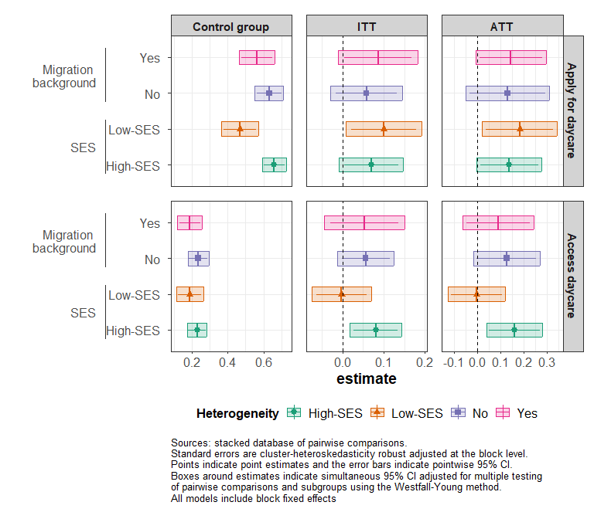 As shown in Extended Data Table 6, the information + support intervention increased the probability of applying for daycare for both low- and high-SES households, by 18 and 14 percentage points respectively, which corresponds to a 38% and a 21% increase (average counterfactual Low-SES = 0.47; ß = 0.18; SE = 0.06; 95% SCI, (0.02, 0.34); P = 0.015; adjusted p-value = 0.025; average counterfactual High-SES = 0.66; ß = 0.14; SE = 0.07; 95% SCI, (0.00, 0.28); P = 0.032; adjusted p-value = 0.056). However, the impacts on access were limited to high-SES households, which experienced a 16-percentage point increase (average counterfactual High-SES = 0.23; ß = 0.16; SE = 0.05; 95% SCI, (0.04, 0.28); P = 0.005; adjusted p-value = 0.007), as depicted in Figure ?? and shown in Extended Data Table 6. This increase in daycare access was associated with a 68% reduction in the probability that mothers in these households would decrease their activity levels (average counterfactual = 0.38; ß = -0.23; SE = 0.07; 95% SCI, (-0.38, -0.09); P = 0.0007; Extended Data Table 7). Furthermore, as observed for early childcare generally, this intervention also led to a 36-percentage point increase in the probability that households with low baseline knowledge accessed daycare specifically (average counterfactual = 0.03; ß = 0.36; SE = 0.10; 95% SCI, (0.13, 0.50); P = 0.0008; adjusted p-value = 0.001).

## 2.5 Mechanisms: knowledge of the system, feeling of legitimacy, and admission criteria

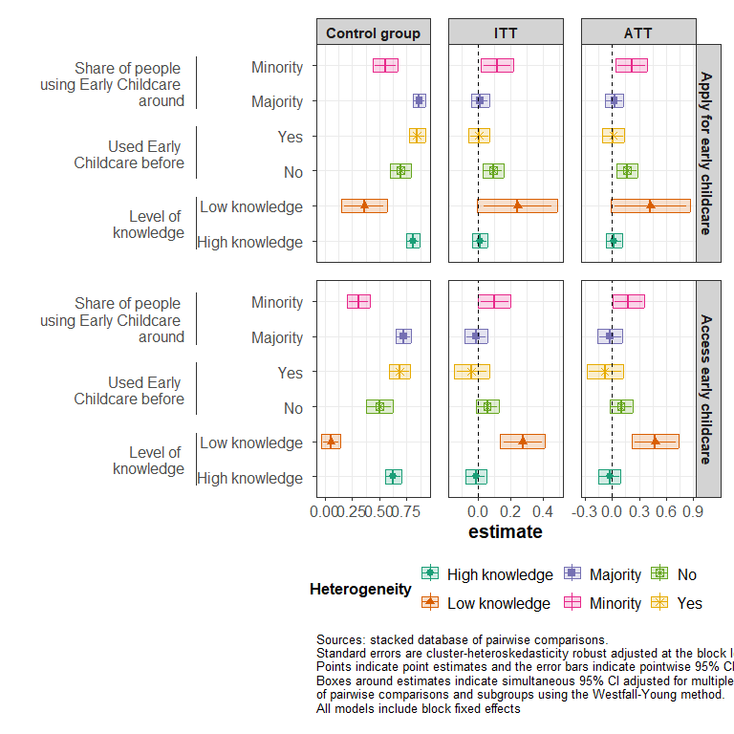

Figure 2.4: Heterogeneous effects of the information + support treatment on early childcare applications - Intention-to-Treat estimates (ITT) and Average Treatment Effects on the Treated (ATT).

The effects of the information + support treatment on early childcare applications, and specifically on daycare applications, were stronger among households that had not previously accessed early childcare (Figure ?? and Extended Data Table 8). For this group, the information + support treatment increased the probability of applying for any early childcare option by 21% (average counterfactual = 0.69; β = 0.16; SE = 0.05; 95% SCI (0.05, 0.28); P = 0.001; adjusted p-value = 0.003), and the probability of applying for daycare specifically by 37% (average counterfactual = 0.59; β = 0.22; SE = 0.05; 95% SCI, (0.1, 0.33); P = 0.000; adjusted p-value = 0.000). These findings suggest that participants who were new to the system and received support were helped in learning “the rules of the game” and navigating the early childcare system. However, we did not observe any effect of the treatment on knowledge of the early childcare system (e.g. the different types of early childcare), as shown in Supplementary Table 3.1.

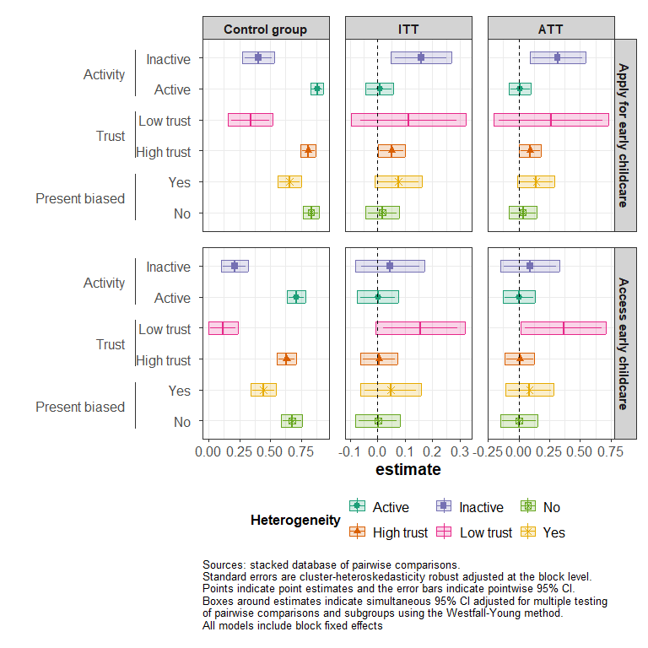

Figure 2.5: Heterogeneous effects of the information + support treatment on early childcare applications - Intention-to-Treat estimates (ITT) and Average Treatment Effects on the Treated (ATT).

Mothers who were inactive at baseline also applied more. For this subgroup, the information + support treatment increased the probability of applying for any early childcare by 80% (Figure ??, average counterfactual = 0.4; ß = 0.32; SE = 0.1; 95% CI, (0.09, 0.54); P = 0.001; adjusted p-value = 0.004). For daycare, additional analyses in Extended Data Table 9 showed a similar pattern, regardless of their SES (average counterfactual Inactive & Low-SES = 0.33; ß = 0.25; SE = 0.011; 95% SCI, (-0.01, 0.50); P = 0.025; and average counterfactual Inactive & High-SES= 0.36; ß = 0.48; SE = 0.25; 95% SCI, (-0.08, 0.99); P = 0.036). However, the effects on access to daycare were concentrated among high-SES households in which the mother was active at baseline (average counterfactual = 0.27; ß = 0.16; SE = 0.07; 95% SCI, (0.00, 0.31); P = 0.027; adjusted p-value = 0.045).

## 2.6 Robustness checks

To ensure the robustness of the findings, we tested alternative definitions of socioeconomic status. Specifically, we considered mother’s occupation using the International Socio-Economic Index of Occupational Status (ISEI) and a composite SES score that accounts for the highest occupation score and the highest education level in the household. These alternative measures yielded similar results compared to using the level of education of the mother (see Supplementary Information Section 4.1). Additionally, we replicated our analyses using logistic regressions and found that the conclusions remained consistent (see Supplementary Information Section 4.2).

# 3 Discussion

This study aimed to address socioeconomic disparities in access to early childcare through two scalable interventions. We conducted a randomised controlled trial to evaluate the effectiveness of an information treatment provided *via* videos and text messages, and of a second intervention that included personalised application support *via* telephone calls in addition to information provision. This experimental design allowed us to assess the effects of a low-cost information intervention and of a more expensive but still scalable support intervention, which increased costs from $6 to $60 per household.

The results reveal large intention-to-action gaps among low-SES households and households with a migration background when comparing their intention to use early childcare services during pregnancy and their actual application rates. The information-only treatment failed to bridge this intention-to-action gap. However, the information + support treatment significantly increased application rates among low-SES households and households with a migration background. For compliers, the intervention entirely closed the application gaps by households SES and migration background. The same conclusions hold for households with limited baseline knowledge of early childcare and present-orientated households.

These results provide insight into the factors that contribute to social gradients in early childcare application and access. First, our results indicate that cultural factors, such as traditional gender norms, have a minimal impact on socioeconomic gaps in early childcare access within the context of our study39 . Most low-SES households and households with a migration background in our sample expressed a preference for using early childcare facilities but faced several hurdles in doing so. Secondly, while the information-only treatment was ineffective in bridging the intention-to-action gap, adding personalised administrative support significantly boosted application rates. This suggests that the primary mechanism at play is not a lack of information but rather the administrative burden that underprivileged groups face when navigating the application process. These findings highlight the potential of light-touch, highly scalable, cost-effective behavioural interventions in alleviating administrative burdens. Finally, the increase in applications was primarily driven by households in which the mother was inactive at the start of the study. In France, childcare access has historically prioritised children of dual-earner couples. This suggests that the intervention empowered inactive mothers who felt more confident in applying, even if they did not view themselves as the primary beneficiaries of early childcare services40.

However, while addressing administrative burdens is necessary to bridge the intention-application gaps, it is not sufficient to tackle socioeconomic disparities in early childcare access. Despite a substantial increase in application rates, neither intervention impacted access for most subgroups, except for households with limited baseline knowledge of early childcare. This suggests that structural barriers also play a significant role. In particular, while the information + support intervention increased the probability that both low- and high-SES households apply for daycare, only high-SES dual-earner households experienced increased access to these facilities. Although national guidelines state that dual-earner households should no longer be prioritised, these results suggest that the allocation criteria used to assign the available slots further exacerbate inequalities by still prioritising such factors48. While the support intervention did not enhance overall access to early childcare for high-SES households, it did help them to secure their preferred type of care, namely daycare centres, over alternative care options.

Our findings contrast with those of Hermes et al. (2021), who conducted the only previous RCT on access to childcare and observed large impacts on both application and access rates for low-SES households in Germany. There are two potential explanations for these discrepant findings31. On the one hand, there are important structural differences between France and Germany. In France, in addition to the priority given to dual-earner households, territorial disparities in early childcare availability may have diluted the impact of our interventions on early childcare access. Indeed, to enhance external validity, we included areas with low early childcare coverage, where our demand-side interventions may have had limited effects on access (see Methods section and Supplementary Information Section 1). On the other hand, the designs of the two studies are different. Our study aimed to enhance scalability by delivering all interventions remotely. This approach likely resulted in lower parental engagement compared to the in-person support used by Hermes et al. which for instance ensured that all households watched the information videos31.

Our study makes several significant contributions to the existing literature. It is the first to differentiate between the causal effects of information provision and of personalised support in mitigating SES-based disparities in access to early childcare. Additionally, it contributes to the literature on administrative burden and non-take-up of social programmes, revealing the importance of behavioural barriers also for early childcare access23,24. Moreover, it offers valuable insights into the intergenerational transmission of inequalities by examining mechanisms operating during early childhood41.

Our findings provide critical insights for policymakers. While the dissemination of information through videos and text messages is a cheap strategy, we provide strong evidence that this strategy is insufficient to bridge the gaps in applications to childcare. This aligns with previous research demonstrating the limited impact of information provision in various areas, such as tax credits42, indoor pollution43, and college enrolment15. Additional barriers, such as the administrative burden of applying for early childcare, prevent households from acting on their intentions even when informed. In parallel, we developed and tested an easily scalable intervention that proved effective in closing social gradients in application behaviour. Moreover, we showed that increased application rates did not translate into higher access rates for most subgroups, which indicates the persistence of structural barriers in the French context. If policymakers want to equalize access to early childcare they need to address cognitive and behavioural barriers as well as structural barriers. For example, in the absence of universal coverage, prioritising dual-earners and the order of application in slot allocation may perpetuate inequalities48. To ensure equitable access, it is crucial to design applications and slot allocation systems that consider the challenges faced by low-SES households in their decision-making and application process.

It is important to note some limitations of our study. First, our RCT mainly focuses on urban areas. Further research is needed to understand the dynamics in rural regions where certain types of early childcare, such as childminders, are more common. Additionally, the support provided to households in our study was presented as part of a research project, rather than being offered by well-known institutions like government services. If similar interventions were delivered by recognised institutional figures, the results might differ. Finally, further research is necessary to identify and address the structural barriers that persist after households submit their applications. Investigating allocation criteria, territorial disparities in early childcare availability, and the long-term effects of early childcare access on child development can provide deeper insights into effective policy measures.

# 4 Methods

This project has been pre-registered. Its detailed pre-registration is available on the AEA Social Science Registry ([RCT ID AEARCTR-0009901](www.socialscienceregistry.org/trials/9901)).

## 4.1 Ethics information

This experiment was approved by the Institutional Review Board of the Paris School of Economics (IRB Number: 2022-015). The participants explicitly consented to the study at the beginning of each survey. Participants were compensated for their time.

## 4.2 Design

### 4.2.1 Study setting

Our study takes place in the Paris metropolitan area, and includes 84 cities across 3 districts, called *départments* in France (Paris, Val de Marne, and Seine Saint Denis). Despite being geographically close and having similar high population densities, these three Departments differ in terms of the availability of early childcare slots and application processes. In Paris, daycare slots are allocated at the sub-district level (*arrondissement*), and the availability of early childcare slots is the highest of the country (80 early childcare slots for 100 less than 3-years-old children in 2021 in the area, 70 in our sample)44. In Val-de-Marne, the application process is most often centralised at the city level, and the availability of early childcare slots is about the same as the national average (52.6 slots per 100 children in the area, 48.5 in our sample, national average of 59.4). Importantly, in this region, all applications for public daycare have to go through a website with no mobile version. Seine-Saint-Denis has one of the lowest coverage rates of early childhood services in the country (34.6 slots per 100 children in the area, 40.1 in our sample). Application processes are mostly organised at the municipality level with sharp territorial inequalities. In Supplementary Information Section 1, we provide a more detailed description of the early childcare supply in these areas, and we compare it to national averages.

### 4.2.2 Research design

Between September and December 2023, we contacted pregnant mothers (4 to 9 months of pregnancy) during their visits to maternity wards of hospitals in the Paris metropolitan area and administered a baseline questionnaire to collect information on socio-demographic characteristics, knowledge of the French early childcare system, and intentions to use early childcare. 2027 questionnaires were administered, but only 1849 were retained for the study because of inclusion criteria: 103 respondents were undocumented, 70 declined to provide their phone number, and an additional 9 participants had to be excluded from the study due to various reasons, such as non-functioning phone numbers.

One year later, between October and December 2023, participants were called back to answer the endline questionnaire through assisted telephone interviews. Of the 1849 households that had been randomised, 79 % of them completed the Endline survey (1455 out of 1849). Robustness analyses and balance checks show that the experimental results are not affected by selective attrition (see Extended Data Table 10).

Map 1 illustrates the distribution of the endline sample across the Paris metropolitan area.

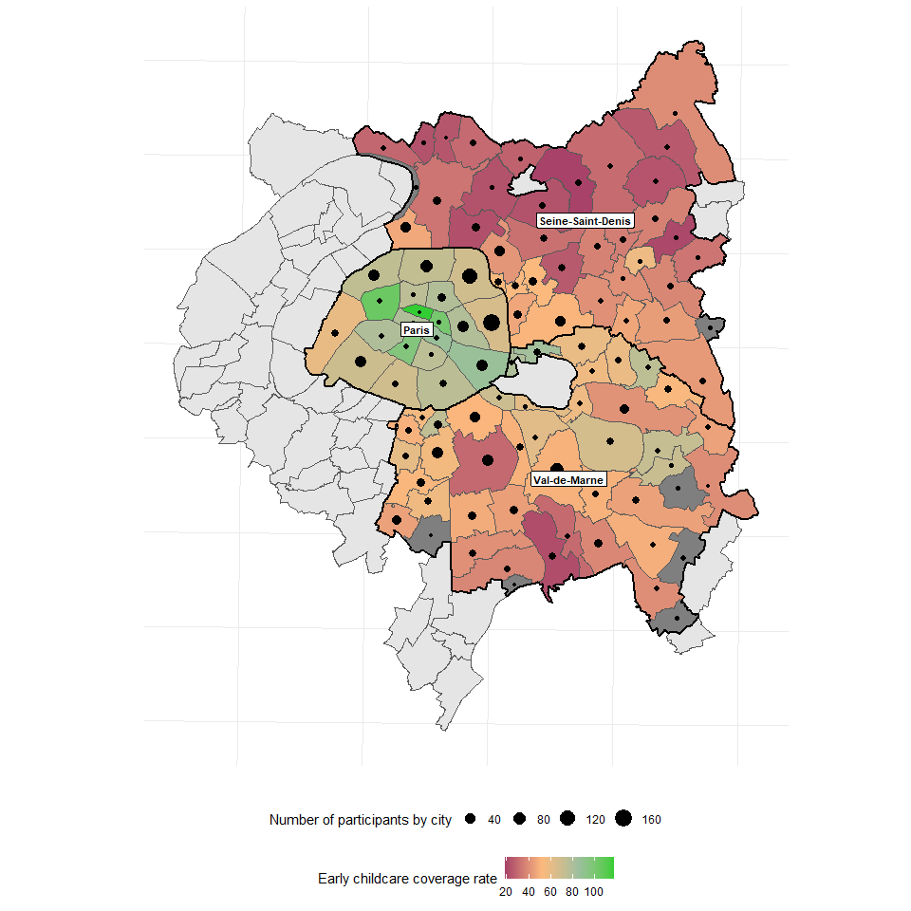

Figure 4.1: Distribution of the sample across the Paris metropolitan area

### 4.2.3 Intervention design

Neither the information-only nor the information + support treatments were prescriptive about childcare choices. Our goal was to help households to make informed choices on their own with or without guidance and assistance with formal applications. The treatment arms are as follows:

* ***Information treatment***: *October-December* 2022: this treatment involves two clusters of contents
  + *Information about early childcare types*: information aimed at helping households to identify which type of early childcare fits best with their preferences and constraints. Treated households received a text message linking to a short video presenting information about the availability and characteristics of different early childcare options and how they fit different preferences and needs. In the following days, a second text message linked to a second short video presenting early childcare eligibility criteria and costs and a third video presenting less well-known early childcare options (halte-garderies), which may be particularly well-suited to low-SES households (collective but less intensive care, less restrictive criteria of access, easier application procedures and more flexible time schedules).
  + *Information about the application process*: information aimed at understanding the application process. As for the information about early childcare types, this involved sending text messages linking to videos presenting information on the calendar of applications, application procedures, and tips to maximise one’s chances of success, such as applying for multiple early childcare options. The content of the first video  was tailored to the area in which households live, because each area has a specific application process. We also gave households access to a website with resources to help them navigate the application process (e.g. checklists, detailed information on the application process at the city level, contract templates).
  + *Reminders*: Reminders were sent by text messages in the third week of treatment. Around February 2023, households received a personalised reminder to watch the video and our content to maximise applications for the June commission, where most of the slots get allocated. The content of the message was personalised according to their planned early childcare choices (if and when they were willing to use early childcare) collected at Baseline. We also sent generic reminders to apply shortly before the deadline for the 2023 applications to early childcare (May 2023).
* ***Information + support treatment***: *February-April 2023*: This treatment involved the same intervention as the information-only treatment according to the same timeline, but also one or several phone calls with parents between February and April 2023 to deliver personalised assistance, as well as personalised application reminders. Between February and April, every two weeks, we randomly allocated the household of this treatment arm to one of the 7 trained research assistants for personalised assistance. Research assistants then called each household as many times as necessary to reach them. The personalised administrative support was then delivered according to a systematic procedure, in French, English or Arabic. The first step was to present the various types of support we could offer to parents. When parents showed interest, we first established a diagnosis of their choices, intentions, and needs after birth. Households were at very different stages of their decision making and we adapted the intervention accordingly. When they had not decided yet, we helped them identify the early childcare solution that best fitted their needs, including how accessible each solution was given their situation, and how affordable each solution was through cost simulations. When they had identified the type of early childcare they wanted, we assisted them according to their demands. Some parents just needed help to identify the early childcare facilities they could apply to, while others needed us to fill the application forms with them.
* ***Control group***: Households assigned to the control group received a placebo treatment. Our goal was to maintain some contact with these households in order to minimise attrition at endline. Placebo messages were also sent to the two intervention groups for the same reason. The placebo messages were about events throughout the year (e.g. welcoming text, winter and summer holidays, new year), and useful tips not affecting the outcomes of interest (e.g. flea markets around Paris). Moreover, the households in the control group also received videos, but not about early childcare. The content of these videos referred to emotions and well-being during pregnancy and other health-related topics.

## 4.3 Sample characteristics

In France, early childcare services welcome children from 3 months to 3 years and many settings accept registrations long before birth. We thus targeted pregnant women in their fourth through ninth months of pregnancy. We recruited expectant mothers through face-to-face interviews in 8 maternity wards in the Paris metropolitan area. Figure 6 shows the distribution of our endline sample across the Paris region. Our sampling strategy resulted in a low refusal rate, with 99.51% of mothers accepting to participate in the study. To be eligible, parents needed to be at least 18 years old (99.7% of the interviewed individuals), have at least one partner allowed to stay on French territory (96%), possess a smartphone (98.9%), and demonstrate a basic level of comprehension and communication in French, English, or Arabic (98% of the population in these areas).

Table 4.1: Baseline balance by treatment groups

|  | | **Assignment group** | | |  | |
| --- | --- | --- | --- | --- | --- | --- |
| **Variable** | Overall1 | Information only1 | Information + support1 | Control1 | **p-value**2 | **q-value**3 |
| *Single-parent family* | 8.6% (159) | 9.0% (56) | 9.3% (57) | 7.5% (46) | 0.460 | >0.999 |
| *Age of the mother* | 32.28 (5.62) | 32.39 (5.66) | 32.11 (5.60) | 32.32 (5.61) | 0.662 | >0.999 |
| *Number of children in the household* |  |  |  |  | 0.949 | >0.999 |
| *0* | 42% (784) | 42% (263) | 42% (257) | 43% (264) |  |  |
| *1* | 31% (573) | 32% (199) | 30% (186) | 31% (188) |  |  |
| *2 or more* | 26% (489) | 26% (159) | 27% (167) | 27% (163) |  |  |
| *The mother is born in France* | 47% (865) | 45% (279) | 46% (279) | 50% (307) | 0.167 | >0.999 |
| *The mother has a post-secondary education (high-SES)* | 61% (1,120) | 60% (376) | 61% (371) | 61% (373) | 0.986 | >0.999 |
| *The household earns less than €2,500 per month* | 36% (606) | 34% (195) | 37% (204) | 36% (207) | 0.658 | >0.999 |
| *The mother is present orientated* | 47% (861) | 43% (268) | 49% (297) | 48% (296) | 0.091* | >0.999 |
| *The mother is active at baseline* | 70% (1,291) | 73% (452) | 69% (422) | 68% (417) | 0.162 | >0.999 |
| *The mother wants to work after maternity leaves* | 89% (1,641) | 91% (565) | 87% (532) | 88% (544) | 0.142 | >0.999 |
| *The household has ever used early childcare* | 40% (745) | 40% (247) | 40% (242) | 42% (256) | 0.735 | >0.999 |
| *The mother wants to use early childcare* | 81% (1,491) | 80% (499) | 81% (494) | 81% (498) | 0.914 | >0.999 |
| *The household has access to a computer* | 85% (1,564) | 85% (532) | 86% (523) | 83% (509) | 0.254 | >0.999 |
| *The mother lives in Paris* | 37% (692) | 38% (239) | 36% (219) | 38% (234) | 0.631 | >0.999 |
| *Early childcare coverage is high* | 41% (750) | 40% (252) | 41% (249) | 40% (249) | 0.988 | >0.999 |
| *Child is a girl* | 52% (774) | 50% (257) | 53% (257) | 52% (260) | 0.655 | >0.999 |
| 1% (n); Mean (SD) | | | | | | |
| 2*p<0.1; **p<0.05; ***p<0.01 | | | | | | |
| 3Benjamini & Yekutieli correction for multiple testing | | | | | | |
| Sources:Baseline database. Proportions and number of observations in parentheses for categorical and dichotomous variables and Pearson's Chi-squared test. We report averages and standard deviations in parentheses for continuous variables and use a Kruskal-Wallis rank sum test. Q-value control for the false discovery rate (FDR) using the Benjamini and Hocheberg method. | | | | | | |

## 4.4 Variable description

### 4.4.1 Main outcomes

The endline survey included our primary outcome variable, which is a binary variable that takes the value 1 if the household has applied to at least one early childcare facility, and 0 otherwise. Our secondary outcome variable is about access. It takes the value 1 if the family has secured a slot in any early childcare facility, indicating that the child is currently enrolled or about to enrol in a facility. To ensure the reliability of our findings, we asked parents to provide the name(s) and address(es) of the early childcare facilities to which they applied or in which their child is enrolled. We excluded responses where parents were unable to provide this information. Additionally, we incorporated the questions on early childcare access within a broader questionnaire that covered various aspects of maternal and newborn care unrelated to early childcare, such as breastfeeding, health behaviours during pregnancy, newborn health, and maternal mental health.

### 4.4.2 Heterogeneity

All treatment heterogeneity variables were measured during the baseline survey. SES was primarily assessed based on mother’s level of education. Our main indicator of SES was a binary variable indicating whether the mother completed tertiary education. We conducted robustness checks using alternative measures of SES, including: 1) Mother’s occupation, coded according to the International Standard Classification of Occupations (ISCO-08) using the 3-digit level and then, recoded into a numerical score using the International Socio-Economic Index of Occupational Status (ISEI) with the R software package occupar. Finally, we constructed a variable that takes the value 1 if the ISEI score of the mother is above the median ISEI score in the sample, and 0 otherwise; 2) A composite SES score that takes into account the highest occupation level in the households and the highest education level in the household, using a method similar to the one used by the OCDE for the PISA survey45,46. Each mother and father’s level of education was converted into equivalent years of education ranging from 0 (no degree) to 17 (Master’s degree and above). Mother’s and father’s occupations were both coded according to the aforementioned procedure. Migration background was measured by a variable that takes the value 1 if the mother was born outside of the French territory, and 0 otherwise. The baseline level of knowledge was primarily initially coded as a categorical variable with four levels: poor, fair, good or excellent level of knowledge. As preregistered, we used this initial variable to create a binary variable that takes the value 1 if the family has a poor level of knowledge at baseline, and 0 otherwise. The activity level of the mother was also measured using a binary variable, with a value of 1 indicating that she was employed or a student at the time of the baseline interview, and a value of 0 indicating otherwise. Another binary variable was used to assess previous early childcare access, with a value of 1 indicating that one of the parents had accessed early childcare services in the past for any of their children, and a value of 0 indicating otherwise. Lastly, following the approach of Reimers et al. (2009), temporal orientation was measured by asking mothers to choose between a hypothetical reward of 50€ in three days or 80€ in three months47. The resulting variable, present orientation, was coded as 1 if the mother chose the 50€ reward.

## 4.5 Analysis plan

### 4.5.1 Randomisation protocol

To improve precision and ensure balance on a set of characteristics likely to affect our main outcomes, we used a block-random assignment procedure based on the cross product of: i) Education of the mother (“tertiary”/“secondary or lower”), ii) Intention to use early childcare (“no”/“yes but has never used early childcare before”/“yes and already has used early childcare before”), and iii) Supply (early childcare coverage rate higher/lower than the average in the department).

We collected data over a three-month period and defined “waves” of two-weeks periods over which we performed the assignment procedure. Ultimately, our design was built on 6 randomisation waves with three assignment conditions in the 12 blocks of each lottery.

### 4.5.2 Assignment probabilities

Each individual from the baseline sample had a 1/3 probability of being assigned to one of three groups: control, information-only, or information + support. Since our analyses compared pairs of assignment conditions (e.g. information-only vs. control), our analyses relied on conditional assignment probabilities that exclude one treatment arm. However, some blocks had a small or odd number of observations, potentially resulting in slight variations in assignment probabilities across groups. To account for this, we estimated a probit model of assignment based on block-fixed effects in subsamples of pairwise comparisons. We then used the predicted probabilities from these models as propensity scores, denoted as $p_{ibs}$, where ibs denotes the household $i$ of block $b$ in sub-sample of pairwise comparison $s$. With these, we define inverse propensity score weights $w_{ibs}=\frac{Z_{ibs}}{p_{ibs}}+\frac{\left(1−Z_{ibs}\right)}{\left(1−p_{ibs}\right)}$ and centered assignment ${\tilde{Z}}_{ibs}=Z_{ibs}−p_{ibs}$ where $Z_{ibs}$ is a dummy that equals 1 when the household $i$ of block b has been assigned to the treatment group in sub-sample $s$.

## 4.6 Intention to treat : main average effects

Because we have two treatment arms, we followed Goldsmith-Pickham (2024) and used stacked regressions to estimate the average difference between each pair of assignment condition $S_{i}∈\{\text{’Information only-Control’},\text{’Information + support-Control’},\text{‘Information + support-Information only’}\}$, while avoiding contamination bias in our estimates. We used the following equation:



Where Y denotes the outcome of individual $i$ of block $b$ in sub-sample $s$; $B_{ibs}$ denotes block-wave dummies and are interacted with $S_{is}$, a factor variable of sub-sample pairs of treatment arms. $Z_{ibs}$ is a dummy that equals 1 when the household $i$ of block $b$ has been assigned to the treatment group in sub-sample $s$. The estimates of $β_{s}$ correspond to the average intention to treat effect48. Following Chaisemartin-Ramirez (2022) and Abadie Et. Al. (2022), we used cluster-heterosckedasticity-robust standard errors adjusted at the block level49,50.This adjustment is very conservative as shown by Abadie Et. Al. (2022), and the detected effects correspond to the lower bound one could expect given these treatments50.

### 4.6.1 Robustness checks

As pre-registered, we assessed the robustness of our results using a data-driven selection of potential confounders with post-lasso and estimated both pooled and fully-interacted regressions following Negi Wooldrige (2021) and Lin (2013), allowing heterogeneous treatment effects within blocks. We estimated Pooled regressions51,52. We used the following equation:



And Lin regressions:



With $\dot{X}$, the matrix of covariates selected by the lasso method and previously centred.

Lasso selection and estimations were performed separately for each comparison pair and inference was based on point-wise standard errors clustered at the block-level.

We also reproduced our main analyses using a linear probability model with one dummy for each treatment arm and strata fixed effects, and logistic regressions.

## 4.7 Local average treatment effect of administrative support

In our setting, administrative support was only offered to those assigned to the information + support treatment group, making non-compliance one-sided. Out of the households that were offered the support, 52% opted for it (See Extended Data Table 2). Thus, under exclusion restriction, an instrumental variable strategy using assignment to the information + support treatment group to predict compliance with support can retrieve the Local average treatment effect (LATE), which can have, an “average treatment effect on the treated” interpretation53,54. We denoted $D_{ib}=1\left(\text{received support}\right)$ the compliance status and estimated the average treatment effect on the treated through the following system of equations using weighted TSLS:



using cluster robust standard errors adjusted at the block level.

## 4.8 Conditional average treatment effects

We estimated average treatment effects by pre-specified subgroups following the same estimation strategy as the main models presented above. We retrieved conditional average effects using fully saturated stacked regressions interacting all right hand side variables with subgroup dummies (see Goldsmith-Pinkham et Al. (2022))55. In the two stage least squares models, we estimated one first stage for each sub-group.

# 5 Inference and tests

We adjusted p-values and confidence intervals to account for the Family-wise error rates using the Young-Westfall method using the R package multcomp56. Our multiple testing procedure adjusted, for each outcome, the p-values and confidence intervals for simultaneous inference on the 3 comparisons (information - control, information + support - control, information + support - information only).

When we estimate conditional average treatment effects, the

All analyses were performed using R 4.3.0 and R studio 2023.12.1.

# Bibliography

1. Ghirardi, G., Baier, T., Kleinert, C. & Triventi, M. Is early formal childcare an equalizer? How attending childcare and education centres affects children’s cognitive and socio-emotional skills in Germany. *European Sociological Review* jcac048 (2022) doi:[10.1093/esr/jcac048](https://doi.org/10.1093/esr/jcac048).

2. Schmutz, R. [Is universal early childhood education and care an equalizer? A systematic review and meta-analysis of evidence](https://doi.org/10.1016/j.rssm.2023.100859). *Research in Social Stratification and Mobility* **89**, 100859 (2024).

3. d’Albis, H., Gobbi, P. & Greulich, A. Having a Second Child and Access to Childcare: Evidence from European Countries. (2017).

4. Hermes, H., Krauß, M., Lergetporer, P., Peter, F. & Wiederhold, S. Early Child Care and Labor Supply of Lower-SES Mothers: A Randomized Controlled Trial. *CESifo Working Paper* (2022).

5. Kimmel, J. [Child Care Costs as a Barrier to Employment for Single and Married Mothers](https://doi.org/10.1162/003465398557384). *Review of Economics and Statistics* **80**, 287–299 (1998).

6. Martinez, C. & Perticara, M. The Impact of Extending Childcare on Female Labor in Chile The Abdul Latif Jameel Poverty Action Lab. *The Abdul Latif Jameel Poverty Action Lab (J-PAL)* (2022).

7. Humphries, J. E., Neilson, C., Ye, X. & Zimmerman, S. D. Parents’ Earnings and the Returns to Universal Pre-Kindergarten. (2024) doi:[10.3386/w33038](https://doi.org/10.3386/w33038).

8. Berger, L. M., Panico, L. & Solaz, A. The Impact of Center-Based Childcare Attendance on Early Child Development: Evidence From the French Elfe Cohort. *Demography* 8977274 (2021).

9. Waldfogel, J. [Child care, women’s employment, and child outcomes](https://doi.org/10.1007/s001480100072). *Journal of Population Economics* **15**, 527–548 (2002).

10. OECD. [*How can the comparability of early childhood education and care statistics be improved?*](https://doi.org/10.1787/9ac255e5-en) vol. 70 (2019).

11. Carbuccia, L., Thouzeau, V., Barone, C. & Chevallier, C. Unequal access to early childcare: What role do cognitive and behavioral factors play? A PRISMA systematic review. (2022) doi:[10.31234/osf.io/r8a4k](https://doi.org/10.31234/osf.io/r8a4k).

12. Archambault, J., Côté, D. & Raynault, M.-F. Early Childhood Education and Care Access for Children from Disadvantaged Backgrounds: Using a Framework to Guide Intervention. *Early Childhood Education Journal* (2019) doi:[10.1007/s10643-019-01002-x](https://doi.org/10.1007/s10643-019-01002-x).

13. Lazzari, D. A. *Literature Review of the Participation of Disadvantaged Children and Families in ECEC Services in Europe*. 127 (2012).

14. Pennerstorfer, A. & Pennerstorfer, D. [Inequalities in Spatial Accessibility of Childcare: The Role of Non-profit Providers](https://doi.org/10.1017/S0047279419000990). *Journal of Social Policy* **50**, 122–147 (2021).

15. Bettinger, E. P., Long, B. T., Oreopoulos, P. & Sanbonmatsu, L. The Role of Application Assistance and Information in College Decisions: Results from the H&R Block Fafsa Experiment. *Quarterly Journal of Economics* **127(3)**, 1205–1242 (Sun, 2012-04-01 00:00).

16. Dynarski, S., Libassi, C., Michelmore, K. & Owen, S. [Closing the Gap: The Effect of Reducing Complexity and Uncertainty in College Pricing on the Choices of Low-Income Students](https://doi.org/10.1257/aer.20200451). *American Economic Review* **111**, 1721–1756 (2021).

17. Herd, P. & Moynihan, D. P. *Administrative Burden: Policymaking by Other Means*. (Russell Sage Foundation, 2019).

18. Bell, A. V. [‘I Think About Oprah’: Social Class Differences in Sources of Health Information](https://doi.org/10.1177/1049732314524637). *Qualitative Health Research* **24**, 506–516 (2014).

19. Chaudry, A., Henly, J. & Meyers, M. *Conceptual Frameworks for Child Care Decision-Making*. (2010).

20. Radey, M. & Randolph, K. A. [Parenting Sources: How Do Parents Differ in Their Efforts to Learn About Parenting?](https://doi.org/10.1111/j.1741-3729.2009.00573.x) *Family Relations* **58**, 536–548 (2009).

21. Rothbaum, F., Martland, N. & Beswick, J. [Parents’ reliance on the Web to find information about children and families: Socio-economic differences in use, skills and satisfaction](https://doi.org/10.1016/j.appdev.2007.12.002). *Journal of Applied Developmental Psychology* **29**, 118–128 (2008).

22. Christensen, J., Aarøe, L., Baekgaard, M., Herd, P. & Moynihan, D. P. [Human Capital and Administrative Burden: The Role of Cognitive Resources in Citizen-State Interactions](https://doi.org/10.1111/puar.13134). *Public Administration Review* **80**, 127–136 (2020).

23. Herd, P., Hoynes, H., Michener, J. & Moynihan, D. [Introduction: Administrative Burden as a Mechanism of Inequality in Policy Implementation](https://doi.org/10.7758/RSF.2023.9.4.01). *RSF: The Russell Sage Foundation Journal of the Social Sciences* **9**, 1–30 (2023).

24. Sunstein, C. R. Sludge Audits. *Behavioural Public Policy* 1–20 (2019) doi:[10.1017/bpp.2019.32](https://doi.org/10.1017/bpp.2019.32).

25. Vandenbroeck, M. & Lazzari, A. [Accessibility of early childhood education and care: A state of affairs](https://doi.org/10.1080/1350293X.2014.912895). *European Early Childhood Education Research Journal* **22**, 327–335 (2014).

26. Kahneman, D. *Thinking, fast and slow*. (Farrar, Straus and Giroux, 2013).

27. Harrison, G. W., Lau, M. I. & Williams, M. B. [Estimating Individual Discount Rates in Denmark: A Field Experiment](https://doi.org/10.1257/000282802762024674). *American Economic Review* **92**, 1606–1617 (2002).

28. Ludwig, R. M., Flournoy, J. C. & Berkman, E. T. [Inequality in personality and temporal discounting across socioeconomic status? Assessing the evidence](https://doi.org/10.1016/j.jrp.2019.05.003). *Journal of Research in Personality* **81**, 79–87 (2019).

29. Pepper, G. V. & Nettle, D. [The behavioural constellation of deprivation: Causes and consequences](https://doi.org/10.1017/S0140525X1600234X). *Behavioral and Brain Sciences* **40**, e314 (2017).

30. Yesuf, M. & Bluffstone, R. Wealth and Time Preference in Rural Ethiopia. (2008).

31. Hermes, H., Lergetporer, P., Peter, F. & Wiederhold, S. Application Barriers and the Socioeconomic Gap in Child Care Enrollment. *CESifo Working Papers* (2021).

32. OECD. Who uses childcare? Background brief on inequalities in the use of formal early childhood education and care (ECEC) among very young children. (2016).

33. Collombet, C. [Les inégalités sociales d’accès aux modes d’accueil des jeunes enfants. Une comparaison européenne](https://doi.org/10.3406/caf.2018.3289). *Revue des politiques sociales et familiales* **127**, 71–82 (2018).

34. Gomajee, A. R. *et al.* Early childcare and developmental delay risk at 3.5 years: Insights from the French ELFE cohort. *European Journal of Pediatrics* (2024) doi:[10.1007/s00431-024-05742-w](https://doi.org/10.1007/s00431-024-05742-w).

35. Pora, P. *Keep Working and Spend Less? Collective Childcare and Parental Earnings in France*. 81 (2020).

36. Cnaf. *COG Convention d’objectifs et de gestion entre l’état et la Cnaf 2018-2022 - Branche famille*. (2018).

37. Eurydice. Early Childhood Education and Care (ECEC) systems in Europe : Key Issues. (2019).

38. Cartier, M. *et al.* [Pourquoi les parents préfèrent-ils la crèche ? Les représentations hiérarchisées des modes de garde professionnels](https://doi.org/10.3917/rfas.172.0247). *Revue française des affaires sociales* **1**, 247 (2017).

39. Van Lancker, W. & Pavolini, E. [Understanding the immigrant-native gap in childcare use: An empirical exploration for 21 European countries](https://doi.org/10.1177/00016993221102506). *Acta Sociologica* **66**, 74–95 (2023).

40. CREDOC. *Quels sont les besoins des familles en situation de pauvreté en matière d’accueil du jeune enfant et d’aide à la parentalité ?* (2023).

41. García, J. L., Heckman, J. J. & Ronda, V. [The Lasting Effects of Early-Childhood Education on Promoting the Skills and Social Mobility of Disadvantaged African Americans and Their Children](https://doi.org/10.1086/722936). *Journal of Political Economy* **131**, 1477–1506 (2023).

42. Linos, E., Prohofsky, A., Ramesh, A., Rothstein, J. & Unrath, M. [Can Nudges Increase Take-Up of the EITC? Evidence from Multiple Field Experiments](https://doi.org/10.1257/pol.20200603). *American Economic Journal: Economic Policy* **14**, 432–452 (2022).

43. Abdel Sater, R., Perona, M., Huillery, E. & Chevallier, C. *The effectiveness of personalised versus generic information in changing behaviour: Evidence from an indoor air quality experiment*. (2021) doi:[10.31235/osf.io/kw3tn](https://doi.org/10.31235/osf.io/kw3tn).

44. Cnaf. Taux de couverture global - Accueil jeune enfant - Taux de couverture global 2020 - Cafdata. (2020).

45. OECD. *Construction of indices. In PISA 2018 Results (Volume III): What School Life Means for Students’ Lives*. (2020).

46. Avvisati, F. [The measure of socio-economic status in PISA: A review and some suggested improvements](https://doi.org/10.1186/s40536-020-00086-x). *Large-scale Assessments in Education* **8**, 8 (2020).

47. Reimers, S., Maylor, E. A., Stewart, N. & Chater, N. [Associations between a one-shot delay discounting measure and age, income, education and real-world impulsive behavior](https://doi.org/10.1016/j.paid.2009.07.026). *Personality and Individual Differences* **47**, 973–978 (2009).

48. Athey, S. & Imbens, G. W. [Chapter 3 - the econometrics of randomized experiments](https://doi.org/10.1016/bs.hefe.2016.10.003). in *Handbook of field experiments* (eds. Banerjee, A. V. & Duflo, E.) vol. 1 73–140 (North-Holland, 2017).

49. de Chaisemartin, C. & Ramirez-Cuellar, J. At What Level Should One Cluster Standard Errors in Paired Experiments, and in Stratified Experiments with Small Strata? *SSRN Electronic Journal* (2020).

50. Abadie, A., Athey, S., Imbens, G. W. & Wooldridge, J. M. [When Should You Adjust Standard Errors for Clustering?](https://doi.org/10.1093/qje/qjac038) *The Quarterly Journal of Economics* **138**, 1–35 (2022).

51. Negi, A. & Wooldridge, J. M. Revisiting Regression Adjustment in Experiments with Heterogeneous Treatment Effects. *Econometric Reviews* **40**, 504–534 (2021).

52. Lin, W. Agnostic Notes on Regression Adjustments to Experimental Data: Reexamining Freedman’s Critique. *The Annals of Applied Statistics* **7**, 295–318 (2013).

53. Frölich, M. & Melly, B. Identification of Treatment Effects on the Treated with One-Sided Non-Compliance. *Econometric Reviews* **32**, 384–414 (2013).

54. Imbens, G. W. & Angrist, J. D. Identification and Estimation of Local Average Treatment Effects. 12 (1994).

55. Goldsmith-Pinkham, P., Hull, P. & Kolesár, M. *Contamination bias in linear regressions*. (2022).

56. Bretz, F., Hothorn, T. & Westfall, P. *Multiple Comparisons Using R*. (Chapman and Hall/CRC, 2010). doi:[10.1201/9781420010909](https://doi.org/10.1201/9781420010909).

**Data availability** This study used primary outcome data collected through surveys. The data will be anonymised and made available for replication on OSF.

**Code availability** The code to replicate analysis and tables will be made publicly available on OSF.

# Extended Data

# 6 Post-Lasso estimates of the main outcomes

Table 6.1: Early childcare application - Intention-to-treat estimates

|  | *Information + support vs. Control* | | *Information + support vs. Information-only* | | *Information-only vs. Control* | |
| --- | --- | --- | --- | --- | --- | --- |
| Basic | Post-Lasso | Basic | Post-Lasso | Basic | Post-Lasso |
| *Z* | 0.044** (0.021) | 0.034* (0.019) | 0.046** (0.022) | 0.016 (0.018) | -0.006 (0.021) | -0.007 (0.018) |
|  | [0.001, 0.086] | [-0.003, 0.071] | [0.001, 0.090] | [-0.020, 0.052] | [-0.048, 0.035] | [-0.042, 0.029] |
| *Num.Obs.* | 987 | 987 | 959 | 959 | 960 | 960 |
| *R2* | 0.371 | 0.529 | 0.368 | 0.545 | 0.354 | 0.799 |
| *R2 Adj.* | 0.312 | 0.499 | 0.307 | 0.505 | 0.293 | 0.729 |
| The dependent variable equals 1 if the household applied for at least one early childcare facility at endline. Basic specification run OLS on a treatment dummy and block fixed effects. Post-lasso use coefficients of an OLS regression of the outcome on a treatment dummy, the demeaned covariates and interactions. Covariates were selected by a lasso regression with lambda minimising the RMSE chosen by 10-fold cross validation.  Cluster-robust standard errors adjusted at the block level in parenthesis ; pointwise 95% confidence intervals in brackets | | | | | | |

Table 6.1: Early childcare access- Intention-to-treat estimates

|  | *Information + support vs. Control* | | *Information + support vs. Information-only* | | *Information-only vs. Control* | |
| --- | --- | --- | --- | --- | --- | --- |
| Basic | Post-Lasso | Basic | Post-Lasso | Basic | Post-Lasso |
| *Z* | 0.015 (0.026) | 0.010 (0.021) | 0.041 (0.028) | 0.003 (0.024) | -0.020 (0.027) | 0.004 (0.020) |
|  | [-0.037, 0.068] | [-0.032, 0.052] | [-0.014, 0.096] | [-0.044, 0.051] | [-0.075, 0.034] | [-0.035, 0.044] |
| *Num.Obs.* | 987 | 987 | 959 | 959 | 960 | 960 |
| *R2* | 0.328 | 0.598 | 0.299 | 0.672 | 0.319 | 0.733 |
| *R2 Adj.* | 0.265 | 0.543 | 0.232 | 0.600 | 0.254 | 0.653 |
| The dependent variable equals 1 if the household accessed early childcare at endline. Basic specification run OLS on a treatment dummy and block fixed effects. Post-lasso use coefficients of an OLS regression of the outcome on a treatment dummy, the demeaned covariates and interactions. Covariates were selected by a lasso regression with lambda minimising the RMSE chosen by 10-fold cross validation.  Cluster-robust standard errors adjusted at the block level in parenthesis ; pointwise 95% confidence intervals in brackets. | | | | | | |

Table 6.1: Daycare application - Intention-to-treat estimates

|  | *Information + support vs. Control* | | *Information + support vs. Information-only* | | *Information-only vs. Control* | |
| --- | --- | --- | --- | --- | --- | --- |
| Basic | Post-Lasso | Basic | Post-Lasso | Basic | Post-Lasso |
| *Z* | 0.081*** (0.025) | 0.090*** (0.022) | 0.071** (0.029) | 0.040 (0.033) | 0.007 (0.027) | 0.009 (0.025) |
|  | [0.030, 0.131] | [0.046, 0.134] | [0.013, 0.130] | [-0.024, 0.104] | [-0.047, 0.062] | [-0.040, 0.058] |
| *Num.Obs.* | 987 | 987 | 959 | 959 | 960 | 960 |
| *R2* | 0.229 | 0.514 | 0.233 | 0.489 | 0.218 | 0.366 |
| *R2 Adj.* | 0.157 | 0.443 | 0.160 | 0.411 | 0.144 | 0.320 |
| The dependent variable equals 1 if the household applied to at least one daycare center at endline. Basic specification run OLS on a treatment dummy and block fixed effects. Post-lasso use coefficients of an OLS regression of the outcome on a treatment dummy, the demeaned covariates and interactions. Covariates were selected by a lasso regression with lambda minimising the RMSE chosen by 10-fold cross validation.  Cluster-robust standard errors adjusted at the level in parenthesis ; pointwise 95% confidence intervals in brackets. | | | | | | |

Table 6.1: Daycare access - Intention-to-treat estimates

|  | *Information + support vs. Control* | | *Information + support vs. Information-only* | | *Information-only vs. Control* | |
| --- | --- | --- | --- | --- | --- | --- |
| Basic | Post-Lasso | Basic | Post-Lasso | Basic | Post-Lasso |
| *Z* | 0.050** (0.021) | 0.046** (0.021) | 0.066** (0.026) | 0.047* (0.026) | -0.009 (0.024) | -0.005 (0.025) |
|  | [0.008, 0.092] | [0.006, 0.086] | [0.015, 0.117] | [-0.004, 0.098] | [-0.057, 0.038] | [-0.055, 0.044] |
| *Num.Obs.* | 987 | 987 | 959 | 959 | 960 | 960 |
| *R2* | 0.117 | 0.284 | 0.117 | 0.120 | 0.132 | 0.048 |
| *R2 Adj.* | 0.035 | 0.234 | 0.032 | 0.104 | 0.049 | 0.043 |
| The dependent variable equals 1 if the household accessed early childcare at endline. Basic specification run OLS on a treatment dummy and block fixed effects. Post-lasso use coefficients of an OLS regression of the outcome on a treatment dummy, the demeaned covariates and interactions. Covariates were selected by a lasso regression with lambda minimising the RMSE chosen by 10-fold cross validation.  Cluster-robust standard errors adjusted at the block level in parenthesis ; pointwise 95% confidence intervals in brackets. | | | | | | |

# 7 Average Treatment Effects on the Treated (ATT) of the main outcomes

Table 7.1: Average treatment effect on the treated on the main outcomes

|  |  | *Application* | | *Access* | |
| --- | --- | --- | --- | --- | --- |
| First Stage | Early childcare | Daycare | Early childcare | Daycare |
| *Information + Support vs Control* | 0.52*** (0.03) | 0.08** (0.04) | 0.15*** (0.05) | 0.03 (0.05) | 0.10** (0.04) |
|  | [0.47, 0.58] | [-0.01, 0.17] | [0.05, 0.26] | [-0.08, 0.14] | [0.00, 0.19] |
|  | adj.p.val. = 0.000 | adj.p.val. = 0.068 | adj.p.val. = 0.002 | adj.p.val. = 0.560 | adj.p.val. = 0.022 |
| *Information + support vs Information-only* | 0.52*** (0.03) | 0.09** (0.04) | 0.14** (0.05) | 0.08 (0.05) | 0.13** (0.05) |
|  | [0.47, 0.58] | [-0.01, 0.18] | [0.02, 0.26] | [-0.04, 0.20] | [0.02, 0.23] |
|  | adj.p.val. = 0.000 | adj.p.val. = 0.068 | adj.p.val. = 0.012 | adj.p.val. = 0.236 | adj.p.val. = 0.017 |
| *Average counterfactual* |  | 0.82 (0.04) | 0.69 (0.05) | 0.56 (0.05) | 0.19 (0.04) |
|  |  | [0.73, 0.91] | [0.58, 0.81] | [0.45, 0.67] | [0.10, 0.28] |
| *Num.Obs.* | 1946 | 1946 | 1946 | 1946 | 1946 |
| *R2* | 0.419 | 0.378 | 0.255 | 0.314 | 0.120 |
| *R2 Adj.* | 0.364 | 0.319 | 0.184 | 0.248 | 0.037 |
| *Fixed effects* | X | X | X | X | X |
| *Chi 2* | 394.60 | 5.94 | 12.03 | 2.25 | 8.11 |
| *P-value* | 0.000 | 0.051 | 0.002 | 0.325 | 0.017 |
| Sources: stacked database of pairwise comparisons.  *= p<.1, **= p<.05, ***= p<.01 based on pointwise p-value. Standard errors are cluster-heteroskedasticity robust adjusted at the block level. Adjusted p-values and confidence intervals account for simultaneous inference using the Westfall method.  Joint significance test of null effect using Chi-2 test and p-value are reported at the bottom of the table. First stage reports OLS estimates of offering support on actual support on both comparison groups. Average treatment effects on the treated estimated jointly for both comparison by instrumenting administrative support in each comparison sample by assignment to T2 (centred by the pairwise instrument propensity score) interacted with the comparison sample dummy and block x wave x comparison fixed effects instrumenting themselved. Avg. Cfct. indicates the untreated compliers' average and is estimated by TSLS with (1-D)*Y as an outcome, (1-D) as the treatment variable instrumented by the centred assignment. | | | | | |

# 8 Heterogeneous effects of the information-only treatment on early childcare applications and access

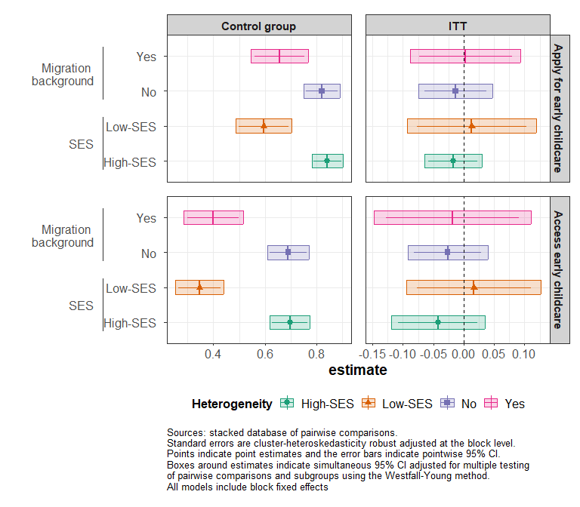

Figure 8.1: Heterogeneous effects of the information-only treatment on early childcare applications and access - Intention-to-treat estimates (ITT) estimates.

# 9 Heterogeneous effects of the information + support treatment on early childcare applications and access

Table 9.1: Average gaps and heterogeneous treatment effects by SES and migration background

|  | ***Variable*** | ***Group*** | ***Early childcare application*** | | | ***Early childcare access*** | | |
| --- | --- | --- | --- | --- | --- | --- | --- | --- |
|  | Avg. control | Conditional ITT | Conditional ATT | Avg. control | Conditional ITT | Conditional ATT |
| *Information + support vs control* | SES | High-SES | 0.84*** (0.03) | 0.01 (0.02) | 0.03 (0.05) | 0.69*** (0.04) | 0.00 (0.03) | 0.01 (0.06) |
|  | [0.78, 0.90] | [-0.04, 0.07] | [-0.07, 0.13] | [0.61, 0.77] | [-0.06, 0.07] | [-0.12, 0.14] |
| adj.p.val. = 0.000 | adj.p.val. = 0.586 | adj.p.val. = 0.554 | adj.p.val. = 0.000 | adj.p.val. = 0.887 | adj.p.val. = 0.888 |
| Low-SES | 0.60*** (0.05) | 0.09** (0.04) | 0.17** (0.08) | 0.36*** (0.05) | 0.03 (0.05) | 0.06 (0.09) |
| [0.48, 0.71] | [0.00, 0.19] | [0.00, 0.34] | [0.25, 0.46] | [-0.08, 0.15] | [-0.14, 0.27] |
| adj.p.val. = 0.000 | adj.p.val. = 0.058 | adj.p.val. = 0.043 | adj.p.val. = 0.000 | adj.p.val. = 0.725 | adj.p.val. = 0.582 |
| Migration background | Yes | 0.67*** (0.05) | 0.09** (0.04) | 0.15** (0.06) | 0.41*** (0.05) | 0.07 (0.05) | 0.12 (0.09) |
| [0.56, 0.77] | [0.00, 0.17] | [0.01, 0.28] | [0.30, 0.52] | [-0.05, 0.19] | [-0.07, 0.31] |
| adj.p.val. = 0.000 | adj.p.val. = 0.036 | adj.p.val. = 0.026 | adj.p.val. = 0.000 | adj.p.val. = 0.285 | adj.p.val. = 0.173 |
| No | 0.83*** (0.03) | 0.00 (0.03) | 0.00 (0.06) | 0.70*** (0.03) | -0.02 (0.03) | -0.05 (0.06) |
| [0.76, 0.90] | [-0.07, 0.06] | [-0.14, 0.13] | [0.62, 0.78] | [-0.09, 0.04] | [-0.19, 0.09] |
| adj.p.val. = 0.000 | adj.p.val. = 0.976 | adj.p.val. = 0.976 | adj.p.val. = 0.000 | adj.p.val. = 0.631 | adj.p.val. = 0.620 |
| *Fixed effects* |  |  | X | X | X | X | X | X |
| Sources: stacked database of pairwise comparisons.  *= p<.1, **= p<.05, ***= p<.01 based on pointwise p-value. Standard errors are cluster-heteroskedasticity robust adjusted at the block level. Models are jointly estimating conditional averages in each pair of treatment arm. Adjusted p-values and confidence intervals account for simultaneous inference across treatment arms. | | | | | | | | |

Table 9.1 presents the heterogeneous treatment effects on the treated and the intention to treat estimates for application and access to early childcare according to our four dimensions of heterogeneity.

* *SES*: We see that the effects on applications to early childcare are concentrated on low-SES households. For them, the information + support intervention increased the probability to apply by 28% for treated households, closing the gap in early childcare application by socio-economic background. However, we see no detectable effect on early childcare access. Even though they applied more, low-SES households were not more likely to access early childcare.
* *Migration background*: The information + support intervention increased the probability that households with a migration background apply for early childcare by 22% for treated households, while not affecting households with no migration background.Therefore, it closed the gap in early childcare application between both types of households for treated households.

# 10 Heterogeneous effects of the information-only treatment on daycare applications and access

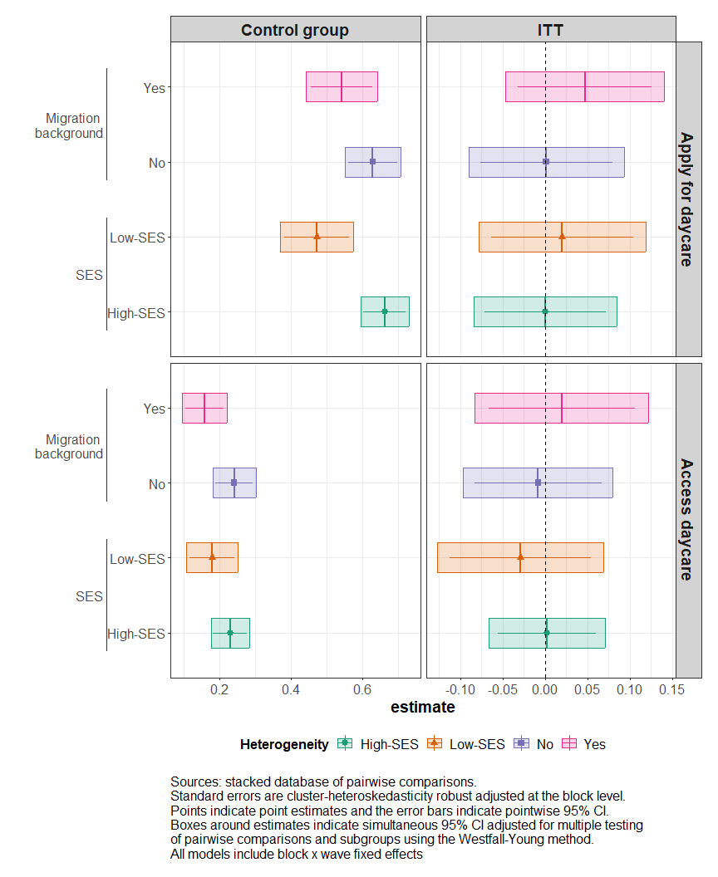

Figure 10.1: Heterogeneous effects of the information-only treatment on daycare applications and access - Intention-to-treat estimates (ITT) estimates.

# 11 Heterogeneous effects of the information + support treatment on daycare applications and access

Table 11.1: Average gaps and heterogeneous treatment effects by SES and migration background (Yes = Migration background, No = Without migration background)

|  | ***Variable*** | ***Group*** | ***Daycare application*** | | | ***Daycare access*** | | |
| --- | --- | --- | --- | --- | --- | --- | --- | --- |
|  | Avg. control | Conditional ITT | Conditional ATT | Avg. control | Conditional ITT | Conditional ATT |
| *Information + support vs control* | SES | High-SES | 0.66*** (0.03) | 0.07** (0.03) | 0.14** (0.06) | 0.23*** (0.02) | 0.08*** (0.03) | 0.16*** (0.05) |
|  | [0.59, 0.73] | [-0.01, 0.15] | [0.00, 0.28] | [0.17, 0.28] | [0.02, 0.14] | [0.04, 0.28] |
| adj.p.val. = 0.000 | adj.p.val. = 0.091 | adj.p.val. = 0.056 | adj.p.val. = 0.000 | adj.p.val. = 0.007 | adj.p.val. = 0.007 |
| Low-SES | 0.47*** (0.05) | 0.10** (0.04) | 0.18** (0.07) | 0.19*** (0.03) | 0.00 (0.03) | 0.00 (0.06) |
| [0.36, 0.57] | [0.01, 0.19] | [0.02, 0.34] | [0.11, 0.26] | [-0.07, 0.07] | [-0.13, 0.12] |
| adj.p.val. = 0.000 | adj.p.val. = 0.031 | adj.p.val. = 0.025 | adj.p.val. = 0.000 | adj.p.val. = 0.942 | adj.p.val. = 0.942 |
| Migration background | Yes | 0.56*** (0.04) | 0.09** (0.04) | 0.14** (0.07) | 0.19*** (0.03) | 0.05 (0.04) | 0.09 (0.07) |
| [0.46, 0.66] | [-0.01, 0.18] | [-0.01, 0.29] | [0.12, 0.26] | [-0.04, 0.15] | [-0.06, 0.24] |
| adj.p.val. = 0.000 | adj.p.val. = 0.092 | adj.p.val. = 0.066 | adj.p.val. = 0.000 | adj.p.val. = 0.317 | adj.p.val. = 0.193 |
| No | 0.63*** (0.03) | 0.06 (0.04) | 0.13 (0.08) | 0.24*** (0.03) | 0.06* (0.03) | 0.13* (0.06) |
| [0.55, 0.71] | [-0.03, 0.15] | [-0.05, 0.31] | [0.18, 0.29] | [-0.01, 0.12] | [-0.02, 0.27] |
| adj.p.val. = 0.000 | adj.p.val. = 0.269 | adj.p.val. = 0.196 | adj.p.val. = 0.000 | adj.p.val. = 0.130 | adj.p.val. = 0.098 |
| *Fixed effects* |  |  | X | X | X | X | X | X |
| Sources: stacked database of pairwise comparisons.  *= p<.1, **= p<.05, ***= p<.01 based on pointwise p-value. Standard errors are cluster-heteroskedasticity robust adjusted at the block x wave level. Models are jointly estimating conditional averages in each pair of treatment arm. Adjusted p-value and confidence intervals account for simultaneous inference across treatment arms. | | | | | | | | |

Table 11.1 presents the heterogeneous treatment effects on the treated and the intention to treat estimates for application and access to daycare according to our four dimensions of heterogeneity.

* *SES*: For treated households, the bundle information + support increased the probability to apply for daycare by 38% for low-SES households, but also by 21% for highly-SES households. However, turning to access to daycare, this treatment increased by 70% the probability that highly-SES households accessed daycare, but had no effect on the probability that low-SES households did.
* *Migration background*: The information + support treatment increased the probability that households with a migration background apply for daycare by 22% for treated households. Turning to access, the results suggest that the treatment increased the probability that households without a migration background access daycare by 50% for treated households, but the results are only marginally significant.

# 12 Average effects of the information + support treatment on the probability that the mother reduces her activity by SES

Table 12.1: Average effects of the information + support treatment on the probability that the mother reduces her activity by SES

|  | ***Group*** | ***Reduced their activity*** | | |
| --- | --- | --- | --- | --- |
| Control mean | ITT | ATT |
| *Information + Support vs Control* | High-SES | 0.38*** (0.04) | -0.12*** (0.04) | -0.23*** (0.07) |
|  | [0.29, 0.47] | [-0.21, -0.04] | [-0.38, -0.09] |
| adj.p.val. = 0.000 | adj.p.val. = 0.001 | adj.p.val. = 0.001 |
| Low-SES | 0.26*** (0.05) | 0.06 (0.06) | 0.10 (0.11) |
| [0.15, 0.38] | [-0.09, 0.21] | [-0.14, 0.33] |
| adj.p.val. = 0.000 | adj.p.val. = 0.638 | adj.p.val. = 0.545 |
| *Num.Obs.* |  | 1490 | 1490 | 1007 |
| *R2* | 0.327 | 0.164 | 0.147 |
| *R2 Adj.* | 0.213 | 0.023 | 0.005 |
| *Fixed effects* | X | X | X |
| *Mean F-stat 1st stage* |  |  | 173 |
| Sources: stacked database of pairwise comparisons.  *= p<.1, **= p<.05, ***= p<.01 based on pointwise p-value. Standard errors are cluster-heteroskedasticity robust adjusted at the block x wave level. Adjusted p-value and confidence intervals account for simultaneous inference.  Joint significance test of null effect using Chi-2 test and p-value are reported at the bottom of the table. | | | | |

# 13 Mechanims: Average effects of the information + support treatment on daycare application and access by activity of the mother at baseline and SES

Table 13.1: Average effects on application and access to daycare by SES and mothers' activity at baseline

|  | ***Activity*** | ***SES*** | ***Daycare application*** | | | ***Daycare access*** | | |
| --- | --- | --- | --- | --- | --- | --- | --- | --- |
| Control mean | ITT | ATT | Control mean | ITT | ATT |
| *Information + Support vs Control* | Active | High | 0.72*** (0.03) | 0.06 (0.04) | 0.11 (0.07) | 0.27*** (0.03) | 0.09** (0.04) | 0.16** (0.07) |
|  | [0.65, 0.79] | [-0.03, 0.15] | [-0.04, 0.26] | [0.21, 0.34] | [0.00, 0.17] | [0.00, 0.31] |
| adj.p.val. = 0.000 | adj.p.val. = 0.203 | adj.p.val. = 0.196 | adj.p.val. = 0.000 | adj.p.val. = 0.042 | adj.p.val. = 0.045 |
| Low | 0.58*** (0.05) | 0.05 (0.06) | 0.09 (0.12) | 0.23*** (0.04) | -0.04 (0.05) | -0.08 (0.09) |
| [0.46, 0.69] | [-0.09, 0.18] | [-0.17, 0.35] | [0.13, 0.33] | [-0.15, 0.06] | [-0.28, 0.12] |
| adj.p.val. = 0.000 | adj.p.val. = 0.634 | adj.p.val. = 0.629 | adj.p.val. = 0.000 | adj.p.val. = 0.603 | adj.p.val. = 0.596 |
| Inactive | High | 0.36*** (0.08) | 0.19** (0.09) | 0.48* (0.25) | 0.08* (0.04) | 0.04 (0.06) | 0.10 (0.17) |
| [0.19, 0.54] | [-0.01, 0.39] | [-0.08, 1.05] | [-0.01, 0.18] | [-0.10, 0.18] | [-0.28, 0.48] |
| adj.p.val. = 0.000 | adj.p.val. = 0.066 | adj.p.val. = 0.108 | adj.p.val. = 0.066 | adj.p.val. = 0.756 | adj.p.val. = 0.778 |
| Low | 0.33*** (0.07) | 0.14** (0.06) | 0.25** (0.11) | 0.14*** (0.05) | 0.04 (0.06) | 0.07 (0.11) |
| [0.18, 0.49] | [0.00, 0.27] | [-0.01, 0.50] | [0.03, 0.25] | [-0.10, 0.18] | [-0.18, 0.32] |
| adj.p.val. = 0.000 | adj.p.val. = 0.045 | adj.p.val. = 0.060 | adj.p.val. = 0.012 | adj.p.val. = 0.532 | adj.p.val. = 0.539 |
| *Num.Obs.* |  |  | 1946 | 1946 | 1946 | 1946 | 1946 | 1946 |
| *R2* | 0.580 | 0.321 | 0.330 | 0.269 | 0.200 | 0.198 |
| *R2 Adj.* | 0.495 | 0.183 | 0.195 | 0.121 | 0.038 | 0.035 |
| *Fixed effects* | X | X | X | X | X | X |
| *Mean F-stat 1st stage* |  |  | 141 |  |  | 141 |
| Sources: stacked database of pairwise comparisons.  *= p<.1, **= p<.05, ***= p<.01 based on pointwise p-value. Standard errors are cluster-heteroskedasticity robust adjusted at the block x wave level. Adjusted p-value and confidence intervals account for simultaneous inference using the method.  Joint significance test of null effect using Chi-2 test and p-value are reported at the bottom of the table. | | | | | | | | |

# 14 Attrition

Table 14.1: Model of the probability of responding to the follow-up survey

|  | *Reference  mean* | *Differential  Attrition* |
| --- | --- | --- |
| *Information-only vs Control* | 0.79 (0.02) | -0.03 (0.02) |
|  | [0.75, 0.83] | [-0.08, 0.02] |
|  | adj.p.val. = 0.000 | adj.p.val. = 0.351 |
| *Information + Support vs Control* | 0.79 (0.02) | 0.01 (0.02) |
|  | [0.76, 0.83] | [-0.04, 0.06] |
|  | adj.p.val. = 0.000 | adj.p.val. = 0.907 |
| *Information + support vs Information-only* | 0.76 (0.02) | 0.04 (0.02) |
|  | [0.73, 0.80] | [-0.02, 0.09] |
|  | adj.p.val. = 0.000 | adj.p.val. = 0.257 |
| *Num.Obs.* | 3698 | 3698 |
| *R2* | 0.670 | 0.077 |
| *R2 Adj.* | 0.646 | 0.009 |
| *Fixed effects* | X | X |
| *Chi 2* |  | 4.41 |
| *P-value* |  | 0.220 |
| * p < 0.1, ** p < 0.05,*** p < 0.01 using pointwise p-value. Adjusted p-value and confidence intervals account for simultaneous inference using the Holm–Bonferroni correction. Standard errors are cluster-heteroskedasticity robust adjusted at the block x wave level. Notes: | | |

The baseline sample is composed of 1849 pregnant mothers of whom, 1453 answered our endline survey. Table 14.1 presents the pairwise comparison of answer rates in the endline by assignment group. Column 1 gives the mean answer rate in the relevant comparison group and Column 2 shows the difference by treatment arm. Models are estimated by OLS with block waves pairwise fixed effect and cluster robust standard error adjusted at the block wave level. On average, 79% of the baseline sample answered the endline survey. The lowest answer rate is the Information-only treatment group with 76% while the highest is among the Information + Support treatment with 80% answers. We use a Chi-2 test of the null hypothesis that all pairwise comparisons are 0 and conclude that answer rates are no different between treatment arms.