# One Brick Newsletter Builder Instructions

[*SebastianA@onebrick.org*](mailto:SebastianA@onebrick.org)

## Step 1: Choose your region, template, and dates

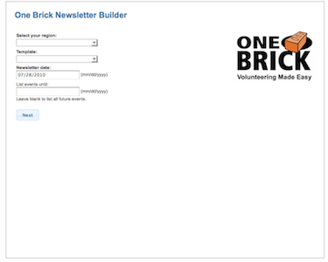

1. Select your region.
2. When your templates are loaded, select your template. Your template looks something like this:

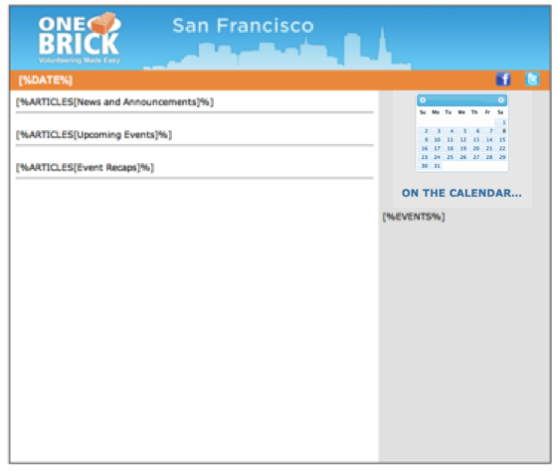

**In general, it will not be necessary to modify your template** unless your chapter needs to change the format in some way, like by adding or removing an article section. If you need to, click ‘Manage templates’ and see the optional step at the end.

1. If you wish, select a previous newsletter to load its articles.
2. Select date of the newsletter. This will also be the starting date for events to be listed. If you use the date of an existing newsletter, you will be updating its articles.
3. Select the cut-off date for events to be listed.

## Step 2: Set up your events

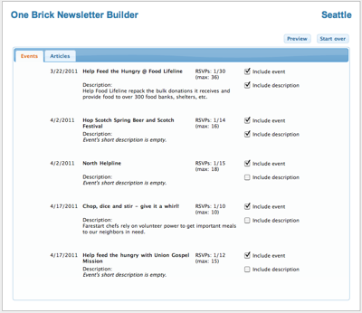

1. Uncheck any events or descriptions you do not want to include.
2. Descriptions can be modified, but **the changes will not be saved** if you reload the article at a later time. Therefore its is preferable to edit the description by going to the web admin and editing the event’s short description field.

## Step 3: Create your articles

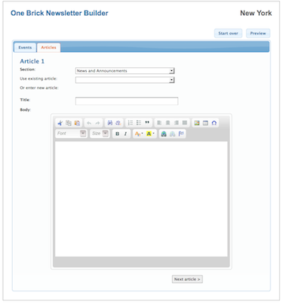

1. Select the section for your article (the sections are defined in the template and automatically will populate the dropdown list).
2. If desired, choose an existing article. Selecting this dropdown will cause the articles to load and may take a moment.
3. Enter/modify article title.
4. Enter/modify article body using the HTML editor. **Do not paste in text from a word processor like Word.** It is okay to paste in from a text editor like TextEdit on the Mac or Notepad on the PC.
5. To add images click the image icon, which will bring up the image and file browser.

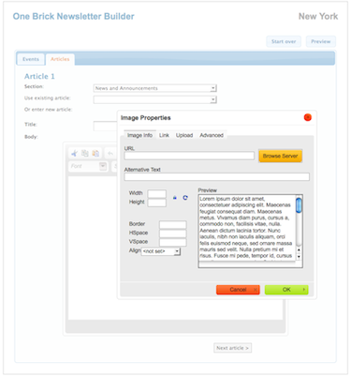

**To make article text flow around image:**

Click the ‘Advanced’ tab and set the ‘Style’ field. If the image is to be on the left, enter ‘float:left;’ (without quotes). If the image is to be on the right, enter ‘float:right;’ (without quotes).

**A note about adding links:**

The link style should automatically be set to match the rest of the newsletter. There is a bug in Firefox where the color setting for the link is changed once you go back to the text area. To fix this, click the editor’s Source button and change the link’s style to ‘color: #de712c’.

1. Add as many articles as needed. You can scroll between your articles with the next and previous buttons.

## Step 4: Preview your template

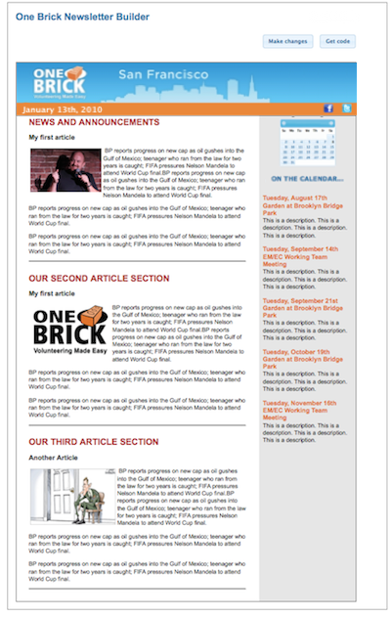

1. You can make any modifications by clicking “Make changes” and then previewing again.
2. When you are satisfied click “Get HTML.”

## Step 5: Get your newsletter’s HTML

*Note: this is a temporary step until this application gets built in to the main system. Eventually you will be able to email your newsletter to volunteers directly.*

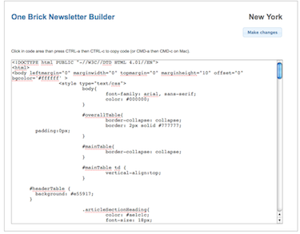

1. Test send to yourself by entering your email address in the box below the code area.
2. If your test email looks okay, copy your code by clicking inside the code area and:
   1. On PC: click CTRL-a then CTRL-c
   2. On Mac: click CMD-a then CMD-c
3. Go to the web admin’s messenger area for sending emails. **Make sure that HTML is selected first, and do NOT click the Visual tab.** Paste the code into the text area.
4. Send to your volunteers.

## Accessing previously created newsletters

1. Go to the /newsletters folder in your browser. You will see all previously created newsletters. You can view one by clicking it, or save it by right-clicking on it.

## Optional: modifying your template

1. If you don’t already have the original template on a file you can get by going to the /defaultTemplates folder in your browser, right-clicking on your chapter’s template and saving it.
2. You can modify the template as you wish, but the parts added by the tool (in brackets and parentheses) must be in this exact format. To add another article section follow the same format: [%ARTICLES[Name of our section]%].
3. **A note about CSS:** Gmail only supports inline styles. So do not add any CSS in the head section nor an external CSS file. Gmail will ignore it.
4. It is also recommended that you validate your HTML before uploading it.
5. On the first screen click ‘Manage templates’. There you will be able to upload your new template, choose which is your default template, and delete other templates.

## For site administrators: Adding a new chapter

When a new chapter is added to the system, it will immediately be available in the newsletter tool. All the remains to be done is:

1. If it hasn’t already been done, go to the image browser (imageBrowser.php or from link from Wiki), and create the chapter’s image folder by Control-clicking on main image folder and selecting ‘Add subfolder’.
2. Create the chapter’s default template and upload it in Manage Templates. Click the checkbox to set as the default.