你的任务是根据提供的草图描述、风格指南和技术文本，生成一份用于图片生成的英文prompt。请严格遵循以下规则：

首先，阅读技术文本以理解核心概念：

<technical_text>
Global Geometric Guidance Field
To alleviate the training burden on the neural network,
we construct a Multiresolution Boundary-Constrained Neu-
ral Field (MBCNF), denoted as umbcn f , which is intrinsically
defined by the normal vectors of the inner boundary (ninner).
This field dynamically modulates the strength of spatial con-
straints via a distance function f (d). Specifically, it imposes
a strong orthogonal prior in the near-wall region to guarantee
the quality of the generated boundary layer. Conversely, in the
far-field region, it serves as a baseline field that couples with
the residual field predicted by the neural network to asymptot-
ically approach the target direction of the outer boundary. This
formulation bypasses the necessity for the model to approxi-
mate complex geometric manifold features from scratch. In-
stead, it casts the prediction objective into a residual learning
paradigm, wherein the neural network is solely tasked with
learning and predicting the local residuals between the geo-
metric prior field and the target field.
The construction procedure for umbcn f is detailed as fol-
lows: For an arbitrary spatial point p located on or outside
the inner boundary, a KD-Tree spatial index is employed to
retrieve its K nearest triangular faces on the inner boundary.
We compute the exact projection of point p onto each re-
spective face along with its corresponding barycentric coor-
dinates. Subsequently, incorporating the Euclidean distances
between point p and these K adjacent faces, an Inverse Dis-
tance Weighting (IDW) scheme is applied to seamlessly fuse
the discrete normal information from these faces. This proce-
dure establishes a globally continuous initial reference field.
Finally, by superimposing the corrective vector predicted by
the neural network onto this initial field, the definitive growth
normal vector is obtained (as formulated in Section 3.4).Multiresolution Boundary-Constrained Ne
</technical_text>

然后，参考风格指南确定视觉呈现：

<style_guide>

干净、专业的科学流程图和架构图，专门用于描述涉及3D几何和物理模拟的复杂深度学习模型。风格是精确、逻辑化和矢量化的，具有两种主要变体：黑色背景的发光数字风格和白色背景的更传统的学术绘图风格，这两种风格都集成了详细的3D几何可视化。

整体风格： 专业的学术和科学架构图，注重逻辑流、数据流和过程的可视化。它结合了传统的块图和更具体的3D几何表示。风格是精确、干净、矢量化的。有两种主要的视觉呈现方式：

变体A（黑色背景发光数字风格）： 在黑色背景上使用发光的、半透明的电蓝色和紫色框。连接线也是发光的。这种风格强调数字和技术感。

变体B（白色背景传统学术风格）： 在白色背景上使用固体框和清晰的矢量线条。这种风格更倾向于传统的学术出版物，具有更详细、更具体的3D物体和网格。

色彩特征：

核心编码： 使用一个共同的调色板（蓝色、紫色、绿色和橙色）作为核心颜色编码。蓝色通常用于表示物理场、层或令牌；紫色也用于类似的编码；绿色通常与特定令牌或连接线有关；橙色用于特定令牌或特定后处理步骤。

3D几何： 3D几何（网格、汽车）普遍使用伪彩色映射（例如，从紫色到黄色，或从蓝色到绿色）来表示物理场，具有平滑的色彩渐变。

背景差异： 变体A使用黑色背景；变体B使用白色背景。

发光和渐变： 变体A中的元素具有发光和渐变效果；变体B中的框通常是固体或具有非常轻微的渐变。

构图特征：

明确的逻辑流： 逻辑流通常从左到右，清晰地标记输入和输出。

层和堆叠： 使用垂直和水平堆叠的层块（例如，Normalize Layers, Layer L, Transolver Layer），形成清晰的架构布局。

分区和分区： 变体B（学术图）经常使用字母（a, b, c）进行水平和垂直分区，以在同一个 Figure 中展示不同的过程和视角。

复杂的3D几何集成： 不仅集成3D物体（如汽车），还集成了3D数据的聚合、切片（Slice）和去切片（DeSlice）过程的详细3D可视化。3D构图是分层的，具有多个平行的处理流。

连接线： 使用具有清晰箭头的连接线，带有特定的标签（聚合、广播、切片、去切片），表明数据流和过程流。

笔触与质感特征：

矢量线： 干净、精确的矢量线条用于所有框、箭头和网格结构。

质感差异： 变体A具有发光的、平滑的数字质感；变体B具有更详细、纹理化的3D网格质感。

清晰文本： 文本是清晰、精确的无衬线字体，具有数学符号和技术标签。

学术 Figure 标题： 变体B具有清晰的学术 Figure 标题（“Figure 2. Geometry scaling...”, “Figure 3. Decoupled inference...”）。

主题与氛围特征：

技术与复杂： 强烈的技术和数学氛围，涉及深度学习、3D几何、物理模拟和损失函数。

学术严谨： 清晰的标签、数学符号（n_x, n_y, n_z， $\oplus$, $\otimes$）。

特定物理和几何： 专门针对物理注意力机制、几何缩放和训练优化，涉及特定物体（汽车）和特定的物理损失函数。

关键标签和图形元素：

图形： 清晰的3D网格、矢量图（箭头）、高斯混合图、汽车网格、子集网格。

标签： 数学符号, 层名称 (Normalize Layer, Physics-Attention, Feed-Forward), 令牌类型 (Physics-aware Token, Aggregate, Broadcast), 损失类型 (Angle loss, PDE loss), 过程标签 (Slice, DeSlice)。
</style_guide>

生成prompt时需遵守以下规则：

1. 保留草图中所有英文标注的全称及下标，不得修改

2. 对标注“补图”的区域进行合理创作，可修改颜色、布局、图片内容

3. 可根据风格指南调整整体风格（变体A或B）、色彩搭配和构图，但不得引入新的英文概念

4. 需体现KD-TRee、Guidance Field、Correction Field的生成过程，并附带"Global Geometric Guidance Field"的英文说明

5. 遵循风格指南中的色彩特征（蓝色/紫色表示物理场，绿色/橙色表示特定步骤）、构图特征（逻辑流从左到右，分层布局）和笔触要求（矢量线条、清晰文本）

- 最终生成的效果图的分辨率为4k
- 最终生成的效果图下面不要附带例如figurex一类的有图片的标注
- 需要体现生成的Upred和Ucor进入归一化层的过程
- 注意Correction Field Ucor是直接用于Inner Boundary Angle loss 和 拉普拉斯pdeloss的计算，而不用于Outer Boundary Angle loss 的计算，而Normal Field Upred则是只用于Outer Boundary Angle loss 的计算，不用于Inner Boundary Angle loss 和 拉普拉斯pdeloss的计算

请生成一份详细的英文prompt，包含以下要素：

- 整体风格选择（变体A或B，需匹配<STYLE_GUIDE>中指定的变体）

- 核心元素布局（严格遵循<STYLE_GUIDE>的逻辑流、层结构要求）

- 色彩编码方案（完全参照<STYLE_GUIDE>的色彩特征）

- 3D几何可视化细节（结合<TECHNICAL_TEXT>的核心概念进行准确呈现）

- 标注保留说明（保留草图内所有英文标注全称及下标）

- 补图区域创作描述（基于<SKETCH_DESCRIPTION>的补图标注进行合理创作）

将最终的英文prompt放在<image_prompt>标签内。

<image_prompt>
An academic, professional scientific schematic diagram presented in a clean white background, traditional academic plotting style (Variant B). The diagram has a precise, logic-driven, vectorized composition with clear data flow from left to right, featuring a standard wide 16:9 aspect ratio. Main components are laid out in distinct, stacked blocks: Input (Left): Three separate nodes for $x, y, z$. The data flow splits into two paths: one to the top process block and one to the bottom process block. Top Process Block: Labeled "Global Geometric Guidance Field". Focuses purely on abstract KD-Tree indexing visualization: spatial point $p$ outside a complex boundary surface, a hierarchical KD-Tree index linked to K nearest surface faces. Shows discrete normal vector blending. Output: $n_x, n_y, n_z$ (Guidance Field). A lead line from this output is merged with a line from the neural field and the combined lead line enters the Normal Field. Bottom Process Block: Labeled "Multiresolution Boundary-Constrained Neural Field". Detailed Multi-resolution HashGrid (layered grids, finer/coarser tessellation) leads to Tiny MLP. Direct input of $x, y, z$. Output: $m_x, m_y, m_z$ (Correction Field). From this output point, a main blue lead line combines with a line from the geometric guidance field and the combined line enters the Normal Field. Furthermore, from the same output point of the Correction Field, a separate lead line is branch off, and these branches, as orange lines, directly enter the Inner Boundary Angle loss and Laplacian PDE Loss blocks. Normal Field (Center): Labeled "Normal Field Upred". Receives combined lead lines from the Guidance Field and Correction Field. Shows $\oplus$ of vectors. Lists combined math: $\vec{n}_x+\gamma\vec{m}_x, \vec{n}_y+\gamma\vec{m}_y, \vec{n}_z+\gamma\vec{m}_z$. Sends a single direct blue line to Outer Boundary Angle loss. Right-Side Blocks: Stacked, minimal text, compact. Top ("Outer Boundary Angle loss"): Receives blue line. Uses partial boundary layer grids to act as cases for the inner and outer boundary examples. The partial outer boundary layer grid is explicitly highlighted. Math elements: peak contrast plots and conceptual 3D angle arc (theta visual). Integrated explicit loss formula: \mathcal{L}{\text{outer}} = \frac{1}{N{\text{outer}}} \sum_{i=1}^{N_{\text{outer}}} \left(1 - \frac{\mathbf{n}{\text{net}i} \cdot \mathbf{n}{\text{target}i}}{|\mathbf{n}{\text{net}i}| |\mathbf{n}{\text{target}i}|}\right). Middle ("Inner Boundary Angle loss"): Receives first orange line. Identical visualization style with partial boundary layer grids as inner and outer boundary examples. The partial inner boundary layer grid is explicitly highlighted. Math elements: preserved peak contrast plots, 3D angle arc, exactly like the top block. Integrated explicit loss formula: \mathcal{L}{\text{inner}} = \frac{1}{N{\text{inner}}} \sum_{i=1}^{N_{\text{inner}}} \left(1 - \frac{\mathbf{n}{\text{net}i} \cdot \mathbf{n}{\text{target}i}}{|\mathbf{n}{\text{net}i}| |\mathbf{n}{\text{target}i}|}\right). Bottom ("Laplacian PDE Loss"): Receives second orange line. Conceptual 3D surface plot of Laplacian residual field (color gradients). Integrated explicit loss formula: \mathcal{L}{\text{smooth}} = \frac{1}{N} \sum{i=1}^{N} \left( \Delta u(\mathbf{x}_i) \right)^2]}. No internal text. All labels from the original are preserved, with precise math formulas. Font is precise sans-serif, using math symbols. The color palette uses blues/purples for fields and greens/oranges for connections, with flow strictly enforced (Normal Field connects only to Outer; direct orange paths from Correction Field only go to Inner and PDE). The overall composition avoids excessive width.
</image_prompt>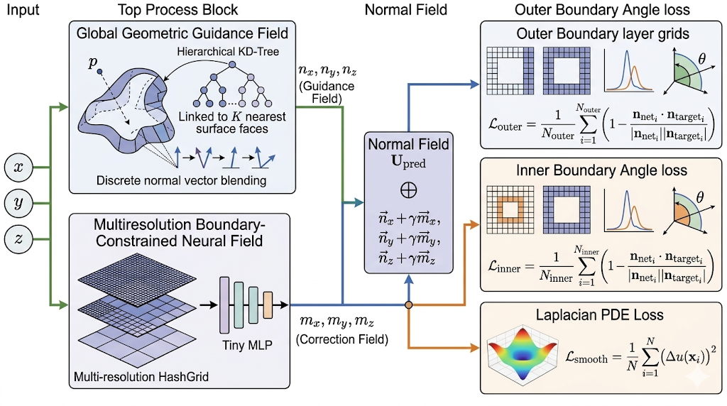

<image_prompt>
An academic, professional scientific schematic diagram presented in a clean white background, traditional academic plotting style (Variant B). The diagram has a precise, logic-driven, vectorized composition with clear data flow from left to right, featuring a standard wide 16:9 aspect ratio. Main components are laid out in distinct, stacked blocks: Input (Left): Three separate nodes for $x, y, z$. The data flow splits into two paths: one to the top process block and one to the bottom process block. Top Process Block: Labeled "Global Geometric Guidance Field". Focuses purely on abstract KD-Tree indexing visualization: spatial point $p$ outside a complex boundary surface, a hierarchical KD-Tree index linked to K nearest surface faces. Shows discrete normal vector blending. Output: $n_x, n_y, n_z$ (Guidance Field). **A single, direct blue lead line from this output enters the Normal Field.** Bottom Process Block: Labeled "Multiresolution Boundary-Constrained Neural Field". Detailed Multi-resolution HashGrid (layered grids, finer/coarser tessellation) leads to Tiny MLP. Direct input of $x, y, z$. Output: $m_x, m_y, m_z$ (Correction Field). From this output point, **no connection or data flow is directed from this output point to the Normal Field.** Instead, separate lead lines are branch off, and these branches, as **multiple distinct orange lines**, enter the Inner Boundary Angle loss and Laplacian PDE Loss blocks. Normal Field (Center): Labeled "Normal Field Upred". **It receives only one arrow input, coming directly from the Guidance Field.** It still shows the conceptual $\oplus$ of vectors and lists the combined mathematical descriptions: $\vec{n}_x+\gamma\vec{m}_x, \vec{n}_y+\gamma\vec{m}_y, \vec{n}_z+\gamma\vec{m}_z$. Sends a single direct blue line to Outer Boundary Angle loss. Right-Side Blocks: Stacked, minimal text, compact. Top ("Outer Boundary Angle loss"): Receives blue line. Uses partial boundary layer grids to act as cases for the inner and outer boundary examples. The partial outer boundary layer grid is explicitly highlighted. Math elements: peak contrast plots and conceptual 3D angle arc (theta visual). Integrated explicit loss formula: \mathcal{L}{\text{outer}} = \frac{1}{N{\text{outer}}} \sum_{i=1}^{N_{\text{outer}}} \left(1 - \frac{\mathbf{n}{\text{net}i} \cdot \mathbf{n}{\text{target}i}}{|\mathbf{n}{\text{net}i}| |\mathbf{n}{\text{target}i}|}\right). Middle ("Inner Boundary Angle loss"): Receives first orange line. Identical visualization style with partial boundary layer grids as inner and outer boundary examples. The partial inner boundary layer grid is explicitly highlighted. Math elements: preserved peak contrast plots, 3D angle arc, exactly like the top block. Integrated explicit loss formula: \mathcal{L}{\text{inner}} = \frac{1}{N{\text{inner}}} \sum_{i=1}^{N_{\text{inner}}} \left(1 - \frac{\mathbf{n}{\text{net}i} \cdot \mathbf{n}{\text{target}i}}{|\mathbf{n}{\text{net}i}| |\mathbf{n}{\text{target}i}|}\right). Bottom ("Laplacian PDE Loss"): Receives second orange line. Conceptual 3D surface plot of Laplacian residual field (color gradients). Integrated explicit loss formula: \mathcal{L}{\text{smooth}} = \frac{1}{N} \sum{i=1}^{N} \left( \Delta u(\mathbf{x}_i) \right)^2]}. No internal text. All labels from the original are preserved, with precise math formulas. Font is precise sans-serif, using math symbols. The color palette uses blues/purples for fields and greens/oranges for connections, with flow strictly enforced (Normal Field connects only to Outer; direct orange paths from Correction Field only go to Inner and PDE). The overall composition avoids excessive width. **The generated diagram is in 4K resolution.**
</image_prompt>
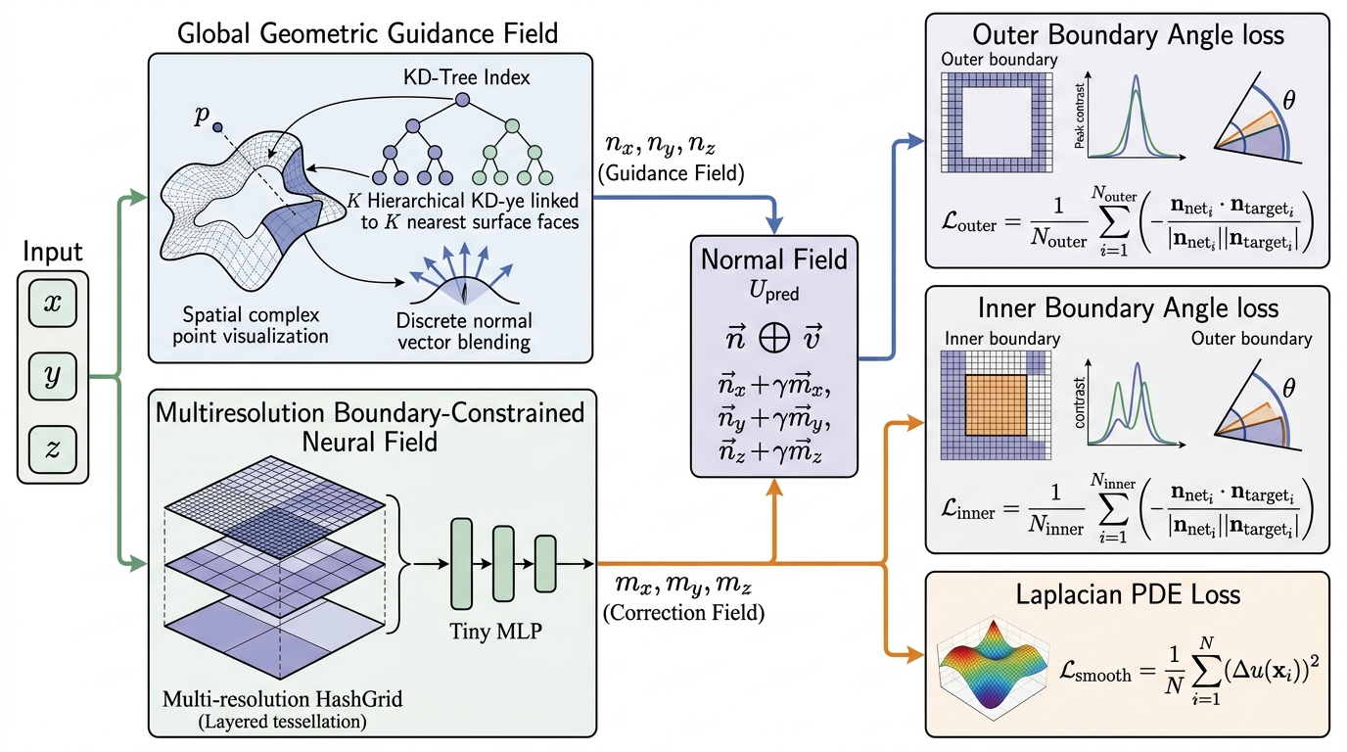
A technical diagram titled 'Global Geometric Guidance Field'. On the left, a box details 'KD-Tree Search & Inverse Distance Weighting' with a simple tree index diagram and text: 'KD-Tree index'. A green arrow connects this to a center piece. The center piece is a perspective 3D triangle mesh surface with a highlighted central green region. This region has a green 'IDW' label and internal green arrows. Point 'p' floats above the mesh, connected to the IDW region by an orange dotted line and green solid lines. 'p' has a label. From the mesh, blue arrows lead to the right. From the IDW region, a green arrow leads to the right. The right box is purple-tinted, titled 'Guidance Field' with a vector list: [nx, ny, nz] in boxes, labeled \vec{u}_{guide}. Blue arrows from mesh lead to nx and ny, green arrow from IDW leads to nz. All labels are clear and professional
<image_prompt>
An academic, professional scientific schematic diagram presented in a clean white background, traditional academic plotting style (Variant B). The diagram has a precise, logic-driven, vectorized composition with clear data flow from left to right, featuring a standard wide 16:9 aspect ratio. Main components are laid out in distinct, stacked blocks: Input (Left): Three separate nodes for $x, y, z$. The data flow splits into two paths: one to the top process block and one to the bottom process block. Top Process Block: Labeled "Global Geometric Guidance Field" and presented as a complete technical schematic. On its far left, an inner box details 'KD-Tree Search & Inverse Distance Weighting' with a simple tree index diagram and the text: 'KD-Tree index'. A green arrow connects this inner box to a center piece. The center piece is a detailed perspective 3D triangle mesh surface with a central region highlighted in green. This highlighted region features a green 'IDW' label and internal green arrows. Point 'p' floats precisely above the mesh surface, connected to the green IDW region by an orange dotted line and solid green lines; point 'p' is labeled. Within the block, from the mesh surface, distinct blue arrows lead to the right; from the IDW region, a distinct green arrow leads to the right. The block's final internal output on the right is a purple-tinted, stacked vector list box titled 'Guidance Field', featuring component boxes [nx], [ny], [nz], collectively labeled \vec{u}_{guide}. Internal blue arrows from the mesh specifically lead to component boxes nx and ny; the internal green arrow from the IDW region leads to component box nz. All labels clear and professional. The final output of this entire multi-part stacked block is $n_x, n_y, n_z$ (Guidance Field). A single, direct blue lead line from this entire combined Guidance Field output enters the Normal Field. Bottom Process Block: Labeled "Multiresolution Boundary-Constrained Neural Field". Detailed Multi-resolution HashGrid (layered grids, finer/coarser tessellation) leads to Tiny MLP. Direct input of $x, y, z$. Output: $m_x, m_y, m_z$ (Correction Field). From this output point, no connection or data flow is directed from this output point to the Normal Field. Instead, separate lead lines are branch off, and these branches, as multiple distinct orange lines, enter the Inner Boundary Angle loss and Laplacian PDE Loss blocks. Normal Field (Center): Labeled "Normal Field Upred". It receives only one arrow input, coming directly from the Guidance Field. It still shows the conceptual $\oplus$ of vectors and lists the combined mathematical descriptions: $\vec{n}_x+\gamma\vec{m}_x, \vec{n}_y+\gamma\vec{m}_y, \vec{n}_z+\gamma\vec{m}_z$. Sends a single direct blue line to Outer Boundary Angle loss. Right-Side Blocks: Stacked, minimal text, compact. Top ("Outer Boundary Angle loss"): Receives blue line. Uses partial boundary layer grids to act as cases for the inner and outer boundary examples. The partial outer boundary layer grid is explicitly highlighted. Math elements: peak contrast plots and conceptual 3D angle arc (theta visual). Integrated explicit loss formula: \mathcal{L}{\text{outer}} = \frac{1}{N{\text{outer}}} \sum_{i=1}^{N_{\text{outer}}} \left(1 - \frac{\mathbf{n}{\text{net}i} \cdot \mathbf{n}{\text{target}i}}{|\mathbf{n}{\text{net}i}| |\mathbf{n}{\text{target}i}|}\right). Middle ("Inner Boundary Angle loss"): Receives first orange line. Identical visualization style with partial boundary layer grids as inner and outer boundary examples. The partial inner boundary layer grid is explicitly highlighted. Math elements: preserved peak contrast plots, 3D angle arc, exactly like the top block. Integrated explicit loss formula: \mathcal{L}{\text{inner}} = \frac{1}{N{\text{inner}}} \sum_{i=1}^{N{\text{inner}}} \left(1 - \frac{\mathbf{n}{\text{net}i} \cdot \mathbf{n}{\text{target}i}}{|\mathbf{n}{\text{net}i}| |\mathbf{n}{\text{target}i}|}\right). Bottom ("Laplacian PDE Loss"): Receives second orange line. Conceptual 3D surface plot of Laplacian residual field (color gradients). Integrated explicit loss formula: \mathcal{L}{\text{smooth}} = \frac{1}{N} \sum{i=1}^{N} \left( \Delta u(\mathbf{x}_i) \right)^2]}. No internal text. All labels from the original are preserved, with precise math formulas. Font is precise sans-serif, using math symbols. The color palette uses blues/purples for fields and greens/oranges for connections, with flow strictly enforced (Normal Field connects only to Outer; direct orange paths from Correction Field only go to Inner and PDE). The overall composition avoids excessive width. The generated diagram is in 4K resolution.
</image_prompt>

Top Process Block: Labeled "Global Geometric Guidance Field", focusing purely on a detailed visual representation of the KD-Tree indexing and visual-spatial relationship. This includes a detailed 3D visualization showing a spatial point $p$ outside a complex 3D boundary surface. A KD-Tree index (symbolically represented as a hierarchy) retrieves the K nearest triangular faces. Highlighting from the hierarchy is visually linked to the corresponding highlighted K nearest triangular faces on the 3D surface. All detailed text descriptions of the indexing process or IDW logic are removed, leaving only a few key, visually linked labels like $p$. Discrete normal vectors are shown blending on these K faces, and the output vectors are clearly grouped and labeled as $n_x, n_y, n_z$ within the Guidance Field. The entire visual is more abstract and clean, replacing lengthy explanations with clear visual links.

<image_prompt>

An academic, professional scientific schematic diagram presented in a clean white background, traditional academic plotting style (Variant B). The diagram has a precise, logic-driven, vectorized composition with clear data flow from left to right, featuring a standard wide 16:9 aspect ratio. Main components are laid out in distinct, stacked blocks: Input (Left): Three separate nodes for $x, y, z$. The data flow splits into two paths: one to the top process block and one to the bottom process block. Top Process Block: Labeled "Global Geometric Guidance Field", focusing purely on a detailed visual representation of the KD-Tree indexing and visual-spatial relationship. This includes a detailed 3D visualization showing a spatial point $p$ outside a complex 3D boundary surface. A KD-Tree index (symbolically represented as a hierarchy) retrieves the K nearest triangular faces. Highlighting from the hierarchy is visually linked to the corresponding highlighted K nearest triangular faces on the 3D surface. All detailed text descriptions of the indexing process or IDW logic are removed, leaving only a few key, visually linked labels like $p$. Discrete normal vectors are shown blending on these K faces, and the output vectors are clearly grouped and labeled as $n_x, n_y, n_z$ within the Guidance Field. The entire visual is more abstract and clean, replacing lengthy explanations with clear visual links. Output: $n_x, n_y, n_z$ (Guidance Field). A single, direct blue lead line from this output enters the Normal Field. Bottom Process Block: Labeled "Multiresolution Boundary-Constrained Neural Field". Detailed Multi-resolution HashGrid (layered grids, finer/coarser tessellation) leads to Tiny MLP. Direct input of $x, y, z$. Output: $m_x, m_y, m_z$ (Correction Field). From this output point, no connection or data flow is directed from this output point to the Normal Field. Instead, separate lead lines are branch off, and these branches, as multiple distinct orange lines, enter the Inner Boundary Angle loss and Laplacian PDE Loss blocks. Normal Field (Center): Labeled "Normal Field Upred". It receives only one arrow input, coming directly from the Guidance Field. It still shows the conceptual $\oplus$ of vectors and lists the combined mathematical descriptions: $\vec{n}_x+\gamma\vec{m}_x, \vec{n}_y+\gamma\vec{m}_y, \vec{n}_z+\gamma\vec{m}_z$. Sends a single direct blue line to Outer Boundary Angle loss. Right-Side Blocks: Stacked, minimal text, compact. Top ("Outer Boundary Angle loss"): Receives blue line. Uses partial boundary layer grids to act as cases for the inner and outer boundary examples. The partial outer boundary layer grid is explicitly highlighted. Math elements: peak contrast plots and conceptual 3D angle arc (theta visual). Integrated explicit loss formula: \mathcal{L}{\text{outer}} = \frac{1}{N{\text{outer}}} \sum_{i=1}^{N_{\text{outer}}} \left(1 - \frac{\mathbf{n}{\text{net}i} \cdot \mathbf{n}{\text{target}i}}{|\mathbf{n}{\text{net}i}| |\mathbf{n}{\text{target}i}|}\right). Middle ("Inner Boundary Angle loss"): Receives first orange line. Identical visualization style with partial boundary layer grids as inner and outer boundary examples. The partial inner boundary layer grid is explicitly highlighted. Math elements: preserved peak contrast plots, 3D angle arc, exactly like the top block. Integrated explicit loss formula: \mathcal{L}{\text{inner}} = \frac{1}{N{\text{inner}}} \sum_{i=1}^{N_{\text{inner}}} \left(1 - \frac{\mathbf{n}{\text{net}i} \cdot \mathbf{n}{\text{target}i}}{|\mathbf{n}{\text{net}i}| |\mathbf{n}{\text{target}i}|}\right). Bottom ("Laplacian PDE Loss"): Receives second orange line. Conceptual 3D surface plot of Laplacian residual field (color gradients). Integrated explicit loss formula: \mathcal{L}{\text{smooth}} = \frac{1}{N} \sum{i=1}^{N} \left( \Delta u(\mathbf{x}_i) \right)^2]}. No internal text. All labels from the original are preserved, with precise math formulas. Font is precise sans-serif, using math symbols. The color palette uses blues/purples for fields and greens/oranges for connections, with flow strictly enforced (Normal Field connects only to Outer; direct orange paths from Correction Field only go to Inner and PDE). The overall composition avoids excessive width. The generated diagram is in 4K resolution.

</image_prompt>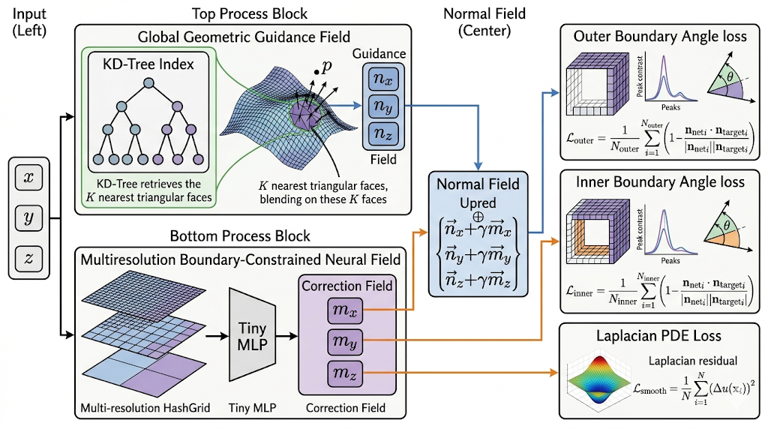

<image_prompt>
An academic, professional scientific schematic diagram presented in a clean white background, traditional academic plotting style (Variant B). The diagram has a precise, logic-driven, vectorized composition with clear data flow from left to right, featuring a standard wide 16:9 aspect ratio. Main components are laid out in distinct, stacked blocks: Input (Left): Three separate nodes for $x, y, z$. The data flow splits into two paths: one to the top process block and one to the bottom process block. Top Process Block: Labeled "Global Geometric Guidance Field", focusing purely on a detailed visual representation of the KD-Tree indexing and visual-spatial relationship. This includes a detailed 3D visualization showing a spatial point $p$ outside a complex 3D boundary surface. A KD-Tree index (symbolically represented as a hierarchy) retrieves the K nearest triangular faces. Highlighting from the hierarchy is visually linked to the corresponding highlighted K nearest triangular faces on the 3D surface. All detailed text descriptions of the indexing process or IDW logic are removed, leaving only a few key, visually linked labels like $p$. Discrete normal vectors are shown blending on these K faces, and the output vectors are clearly grouped and labeled as $n_x, n_y, n_z$ within the Guidance Field. The entire visual is more abstract and clean, replacing lengthy explanations with clear visual links. Output: $n_x, n_y, n_z$ (Guidance Field). A single, direct blue lead line from this output enters the Normal Field. Bottom Process Block: Labeled "Multiresolution Boundary-Constrained Neural Field". Detailed Multi-resolution HashGrid (layered grids, finer/coarser tessellation) leads to Tiny MLP. Direct input of $x, y, z$. Output: $m_x, m_y, m_z$ (Correction Field). From this output, specifically the overall Correction Field stacked block boundary itself, and not from the individual $m_x, m_y, m_z$ component boxes, no connection or data flow is directed to the Normal Field. Instead, multiple distinct orange lines are drawn directly from the Correction Field block boundary, and these branches enter the Inner Boundary Angle loss and Laplacian PDE Loss blocks. Normal Field (Center): Labeled "Normal Field Upred". It receives only one arrow input, coming directly from the Guidance Field. It still shows the conceptual $\oplus$ of vectors and lists the combined mathematical descriptions: $\vec{n}_x+\gamma\vec{m}_x, \vec{n}_y+\gamma\vec{m}_y, \vec{n}_z+\gamma\vec{m}_z$. Sends a single direct blue line to Outer Boundary Angle loss. Right-Side Blocks: Stacked, minimal text, compact. Top ("Outer Boundary Angle loss"): Receives blue line. Uses three-dimensional partial boundary layer grids to act as cases, emphasizing that these are the inner layer and outer layer of a single boundary layer mesh. The partial outer boundary layer grid is explicitly highlighted. Math elements: peak contrast plots and conceptual 3D angle arc (theta visual). Integrated explicit loss formula: $\mathcal{L}_{\text{outer}} = \frac{1}{N_{\text{outer}}} \sum_{i=1}^{N_{\text{outer}}} \left(1 - \frac{\mathbf{n}_{\text{net}i} \cdot \mathbf{n}_{\text{target}i}}{|\mathbf{n}_{\text{net}i}| |\mathbf{n}_{\text{target}i}|}\right)$. Middle ("Inner Boundary Angle loss"): Receives first orange line. Identical visualization style with three-dimensional partial boundary layer grids as inner and outer boundary cases, emphasizing that they are the inner and outer layers of a single boundary layer mesh. The partial inner boundary layer grid is explicitly highlighted. Math elements: preserved peak contrast plots, 3D angle arc, exactly like the top block. Integrated explicit loss formula: $\mathcal{L}_{\text{inner}} = \frac{1}{N_{\text{inner}}} \sum_{i=1}^{N_{\text{inner}}} \left(1 - \frac{\mathbf{n}_{\text{net}i} \cdot \mathbf{n}_{\text{target}i}}{|\mathbf{n}_{\text{net}i}| |\mathbf{n}_{\text{target}i}|}\right)$. Bottom ("Laplacian PDE Loss"): Receives second orange line. Conceptual 3D surface plot of Laplacian residual field (color gradients). Integrated explicit loss formula: $\mathcal{L}_{\text{smooth}} = \frac{1}{N} \sum_{i=1}^{N} \left( \Delta u(\mathbf{x}_i) \right)^2$. No internal text. All labels from the original are preserved, with precise math formulas. Font is precise sans-serif, using math symbols. The color palette uses blues/purples for fields and greens/oranges for connections, with flow strictly enforced (Normal Field connects only to Outer; direct orange paths from Correction Field overall block only go to Inner and PDE). The overall composition avoids excessive width. The generated diagram is in 4K resolution.
</image_prompt>

