**Practice 2**

The HR department needs your assistance with creating some queries.

1. Because of budget issues, the HR department needs a report that displays the last name and salary of employees who earn more than $12,000. Place your SQL statement in a text file named lab_02_01.sql. Run your query.

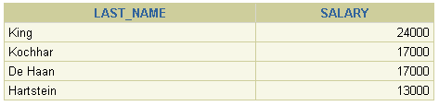

2. Create a report that displays the last name and department number for employee number 176.

D:\Temp\02.GIF

**3. The HR department needs to find high-salary and low-salary employees. Modify lab_02_01.sql to display the last name and salary for any employee whose salary is not in the range of $5,000 to $12,000. Place your SQL statement in a text file named lab_02_03.sql.**

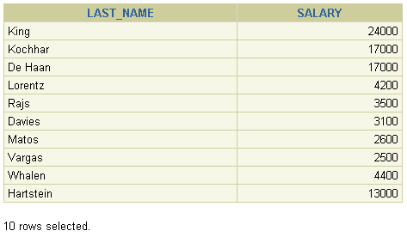

4. Create a report to display the last name, job ID, and start date for the employees with the last names of Matos and Taylor. Order the query in ascending order by start date.

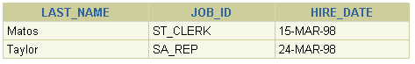

**5. Display the last name and department number of all employees in departments 20 or 50 in ascending alphabetical order by name.**

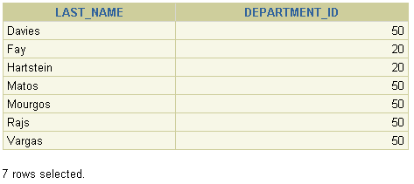

6. Modify lab_02_03.sql to display the last name and salary of employees who earn between $5,000 and $12,000 and are in department 20 or 50. Label the columns Employee and Monthly Salary, respectively. Resave lab_02_03.sql as lab_02_06.sql. Run the statement in lab_02_06.sql.

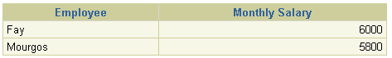

**7. The HR department needs a report that displays the last name and hire date for all employees who were hired in 1994.**

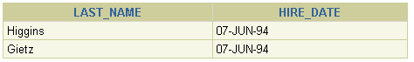

8. Create a report to display the last name and job title of all employees who do not have a manager.

D:\Temp\08.GIF

**9. Create a report to display the last name, salary, and commission of all employees who earn commissions. Sort data in descending order of salary and commissions.**

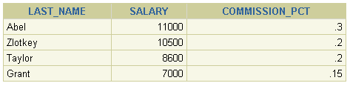

10. Members of the HR department want to have more flexibility with the queries that you are writing. They would like a report that displays the last name and salary of employees who earn more than an amount that the user specifies after a prompt. (You can use the query that you created in practice exercise 1 and modify it.) Save this query to a file named lab_02_10.sql. If you enter 12000 when prompted, the report displays the following results:

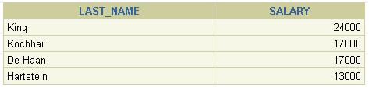

**11. The HR department wants to run reports based on a manager. Create a query that prompts the user for a manager ID and generates the employee ID, last name, salary, and department for that manager’s employees. The HR department wants the ability to sort the report on a selected column. You can test the data with the following values:**

**manager ID = 103, sorted by employee last name:  
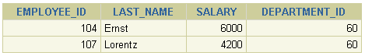  
  
  
  
  
  
manager ID = 201, sorted by salary:  
  
D:\Temp\24.GIF  
  
  
  
manager ID = 124, sorted by employee ID:**

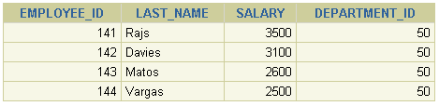

If you have time, complete the following exercises:

12. Display all employee last names in which the third letter of the name is *a*.

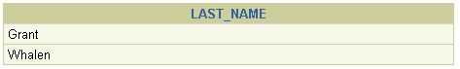

13. Display the last names of all employees who have both an *a* and an *e* in their last name.

If you want an extra challenge, complete the following exercises:

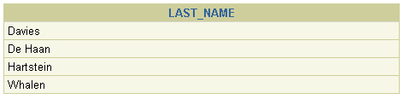

14. Display the last name, job, and salary for all employees whose jobs are either sales representative or stock clerk and whose salaries are not equal to $2,500, $3,500, or $7,000.

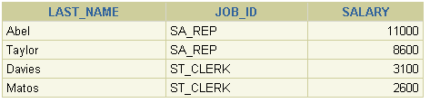

15. Modify lab_02_06.sql to display the last name, salary, and commission for all employees whose commission amount is 20%. Resave lab_02_06.sql as lab_02_15.sql. Rerun

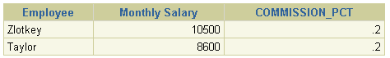

1. 현재 날짜를 **출력하는 query문을 작성하시오 .**설명: D:\Temp\01.GIF

2. Employees 테이블의 사원의 번호, 이름, 급여와 15.5% 인상된 급여를 **출력하는 query문을 작성하시오 .** (컬럼 heading은 아래 보기와 같이 처리하시오)

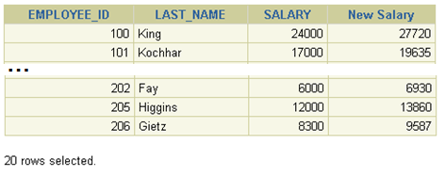

3. 2번의 출력결과에 현재 급여와 인상된 급여의 증가된 차이를 **출력하는 query문을 작성하시오 .** (컬럼 heading은 아래 보기와 같이 처리하시오)

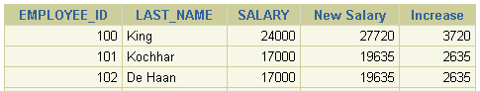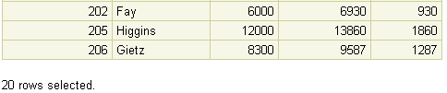

**5. Employees 테이블의 사원 data중 last name 컬럼값의 시작문자가 *J, A,* 또는 *M*로 시작하는 사원이름과 lastName 이름 길이를 출력하는 query문을 작성하시오 .  
  
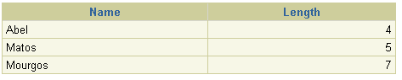**

**query 를 재작성하여 시작문자를 입력받고, 입력받은 문자로 시작하는 lastname과 lastname의 길이를 query문을 작성하시오 . (아래 보기는 H를 입력했을때 결과임)**

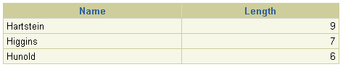

7. 다음의 형식으로 출력하는 query를 작성하시오  
 <employee last name> earns <salary> monthly but wants <3 times salary>.

컬럼 타이틀은 Dream Salaries.

**…**

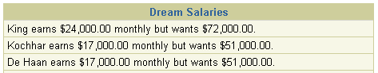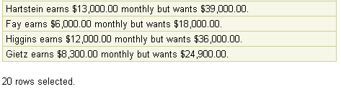

6. **Employees 테이블의 사원 data중 last name과 입사한 이후, 근무한 개월수를 아래 보기 형식으로 출력하는 query를 작성하시오** 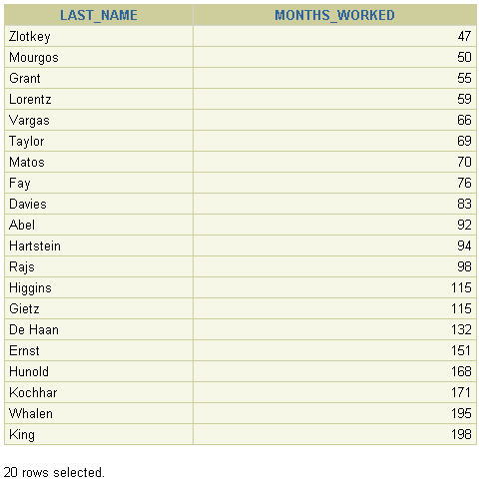

**8. employees 테이블의 모든 사원의 last name 과 salary를 다음의 형식으로 출력하는 query를 작성하시오**

**…**

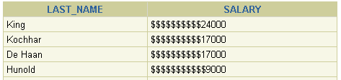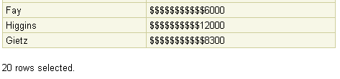

9  **employee’s last name, hire date, 급여 인터뷰 날짜를 다음의 형식으로 출력하시오**

**입사후 6개월 후 월요일 “Monday, the Thirty-First of July, 2000.”**

**…**

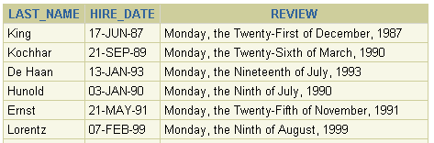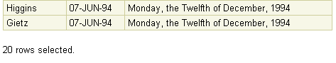

**10. 각 사원별로 입사날짜의 요일을 출력하시오**

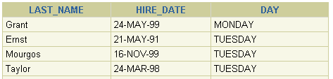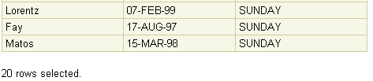

**11. the employees’ last names 과 commission 을 출력하시오**

**커미션을 받지 않은 사원은 “No Commission.” 으로 출력하시오**

**…**

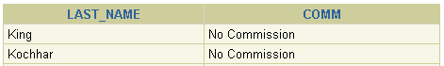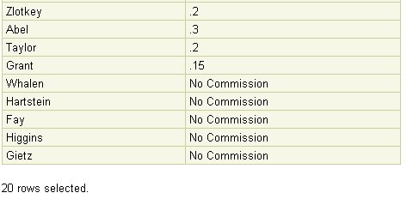

**12. employees’ last name과 급여를 1000달러 단위로 asterisks를 함께 단일 컬럼값으로 출력하시오**

**컬럼heading은 EMPLOYEES_AND_THEIR_SALARIES.**

**…**

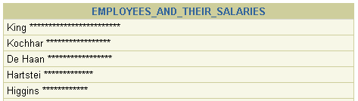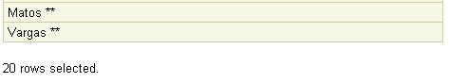

13. DECODE 함수와 case 표현식을 사용해서 다음 표처럼 직무별로 grade를 출력하시오

***Job Grade***

AD_PRES A

ST_MAN B

IT_PROG C

SA_REP D

ST_CLERK E

None of the above 0

