I. PLC Recognition with Mask R-CNN

1.1 Pipeline
Fig. 1 show the pipeline of PLC recognition.
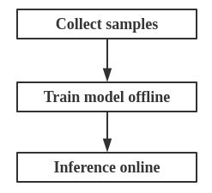
Fig. 1 Pipeline

The PLC recognition task is divide into three steps:
(1) Collect samples, which means get the samples and labels for training. In general way, labels are always generated by hand. Fortunately, we find some ways to label the samples automatically.
(2) Train model offline. We choose Mask R-CNN as the base model in our task. After training the model, we can get a weight file, which is use to inference.
(3) Inference. In this step, we just need to load the weight and configuration into the model. Then run the inference function, we can get the recognition result.

1.2 Collect samples
1.2.1 Data source
In our case, we can collect samples from video or CAD model of PLC. Note that we need get the 3D information of PLC before labeling, which is obtained through 3D reconstruction. All the labels are generated based on the mapping from 3D to 2D. The polygon of object is calculated according to the posture of camera and the location of object at each frame.
1.2.2 Automatically labeling
To train Mask R-CNN, we need label many samples, which means we should extract the contour of each object contained in images. In traditional way, we would cost about 1 minute to manually label each image, which is time-consuming. This is why we want to automatically label samples. In our way, we can automatically label thousands of samples in short time, actually, it’s more accurate than manual way. And plenty of experiments have demonstrate its efficiency.

Following shows how it works:
(1) For video
i. Reconstruct 3D scenario for the video, and save the posture information of camera at each frame.
ii. Find all the corners of object in 3D point cloud, and save the corners, which will be mapped into 2D images.
iii. For each frame, calculate the 2D coordinates of every corner according to the posture of camera and the 3D coordinates of the corner.
iv. Connect all corners of a object successively, we can get a polygon, which is just the label information of the object.
v. Write the label information into a txt file(label_data.txt, as shown in Fig.2), which is just the input of Mask R-CNN. And following shows the structure of label_data.txt(each line for each image):

"image_name number_of_object name_of_first_object number_of_point x1,x2,x3,...,y1,y2,y3,... name_of_second_object number_of_point x1,x2,x3,...,y1,y2,y3,…"

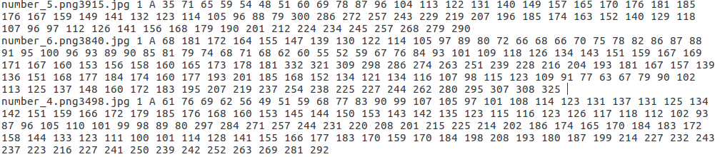
Fig. 2 Content of label_data.txt
* Note that the code of this part has been integrated into iVision3D project.
(2) For CAD model
i. Make some transformation on the model to generate plenty of samples. The transformation contain rotation, shift, zoom in, zoom out and so on.
ii. All the samples are binary images, we can easily use edge detection algorithm the detect the contours of objects. Here we use the function "skimage.measure.find_contours()" to detect all the contours of a object, and the outmost contour can accurately locate the object, which is just what we need in Mask-RCNN(as shown in Fig.3).

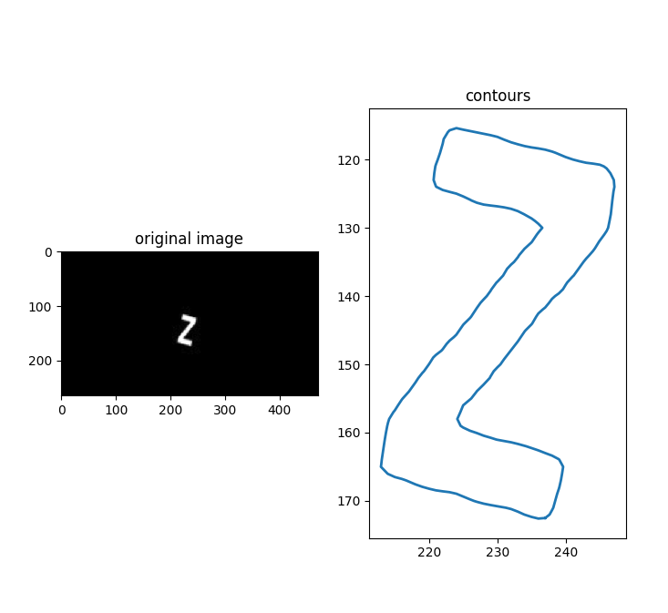
Fig.2 Detect contourFollowing is the script for detecting contours and writing label information:
-------------------------------------------detect contours-------------------------------------------------------
'''
script for detecting contours and writing label information
'''
from skimage import measure,data,color
import cv2
import os

output_label_txt = './label_data_train.txt'
f_output = open(output_label_txt,'w')
img_path = './imgs/'
imgs = os.listdir(img_path)
for img_name in imgs:
a=cv2.imread(img_path+'/'+img_name)
img=color.rgb2gray(a)

# detect all contours
contours = measure.find_contours(img, 0.5)
if len(contours)<1:
continue
edge = contours[0]

# write .txt
print(img_name)
f_output.writelines(img_name)
f_output.writelines(' 1')
curClass=img_name[9]
f_output.writelines(' '+curClass+' ')
f_output.writelines(str(pts_num))
f_output.writelines(' ')
for i in range(len(edge)):
# sampling in the edge
if i % 5==0:
f_output.writelines(str(int(edge[i,1])))
f_output.writelines(' ')
for i in range(len(edge)):
# sampling in the edge
if i % 5 == 0:
f_output.writelines(str(int(edge[i,0])))
f_output.writelines(' ')
f_output.writelines('\n')
f_output.close()
--------------------------------------------detect contours------------------------------------------------------
iii. Write the label information into a txt file, which is same with For video.

1.3 Training model
* Code: /home/Myproject/Mask_Rcnn/Mask_RCNN_master/PLC_train.py
i. Main function come out at line 1043. Change mode(train or inference) at line 75 and line 76.
ii. Set some parameters of Mask R-CNN model in class PLCConfig(line 86). The NUM_CLASSES must match with the task. And ‘resnet50’ is faster than ‘resnet101’ for BACKBONE.
iii. Create a Mask R-CNN model at line 1104 according to the configuration.
iv. Load pre-trained weight into model. We can use the weight of coco dataset as the pre-trained weight(line 1135), if so we must exclude the last layers because they require a matching the number of classes. We can also use the weight saved in previous training(line 1132), in this way, we don’t need to exclude the last layers.
iv. Run train(). In the function train(), firstly, the label information will be load into the model through the function load_PLC(), where shows how to parse the label information, and load them into model. Next, callback the training function of the model, model will start to train.
v. After training, all the weight files are written into the folder ‘home/jianfenghuang/Myproject/Mask_Rcnn/Mask_RCNN-master/logs’. One weight file for one epoch.

*Note
Instead of .json file, we use the label_data.txt as the input of Mask R-CNN, which is easyer. However, to do that we need modify some codes for parsing the label_data.txt. The parsing function has been written into load_PLC().

1.4 Inference
* Code: /home/Myproject/Mask_Rcnn/Mask_RCNN_master/PLC_train.py
i. Main function come out at line 1043. Change mode(train or inference) at line 75 and line 76.
ii. Set some parameters of Mask R-CNN model in class PLCConfig(line 86). The NUM_CLASSES must match with the task. And ‘resnet50’ is faster than ‘resnet101’ for BACKBONE.
iii. Create a Mask R-CNN model at line 1108 according to the configuration.
iv. Load trained weight into model.
v. Set the data source for inferencing, which can be a image, a image folder, a video, or camera. Then just add the data source as parameters of function detect().
iv. Run detect(). In the function detect(), firstly, the image will be transformed as the input of the model. Next, callback the detect function of the model, we can get the result of inference. Finally, according to the result, we can get the bounding box, mask and class of object.
II. C++ Inference from Python-trained Model
This part will show how to inference on C++. Inferencing on C++ is more efficient than on Python, and it’s important for integrating codes to iVision project. Following is the key steps for Inferencing on C++:
(1) Configure environment.
(2) Train model on python, and save the weight file(.h5).
(3) Transform the h5 model to protobuff model(.pb).
(4) Callback the protobuff model and inference on C++.

2.1 Configure environment
1. Install protobuff.
Download from https://github.com/google/protobuf/archive/v3.6.0.zip. Then run “./configure && make && make install“.
2. Install Bazel.
Download form https://github.com/bazelbuild/bazel/releases. Then run “sh bazel-0.5.0-installer-linux-x86_64.sh”.
3. Compile and install tensorflow from source code.
Download from https://github.com/tensorflow/tensorflow/releases. Then run “bazel build //tensorflow:libtensorflow_cc.so”.

2.1 Train model on python
When training on python, we need save the weight file to h5 file, which has been saved into the folder “./logs” in our project.
2.1 Transform model
If we want to callback the trained model on C++, we need transform the format of weight file to protobuff(.pb). The following code shows how to transform the h5 model to protobuff model.
--------------------------------------------transform model----------------------------------------------------
from keras import backend as K
from tensorflow.python.framework import graph_util
import tensorflow as tf

def transform_to_pb(model,model_path):
# model_path :path of h5 weight file
print("Loading weights from ", model_path)
model.load_weights(model_path, by_name=True)
# All new operations will be in test mode from now on.
K.set_learning_phase(0)
# The filename is built from concantenating the decoders
filename = os.path.splitext(os.path.basename(model_path))[0] + ".pb"
# Get the TF session
sess = K.get_session()
# Get keras model and save
model_keras = model.keras_model
# Get the output heads name
output_names_all = [output.name.split(':')[0] for output in model_keras.outputs]
# Getthe graph to export
graph_to_export = sess.graph
# Freeze the variables in the graph and remove heads that were not selected
# this will also cause the pb file to contain all the constant weights
od_graph_def = graph_util.convert_variables_to_constants(sess,
graph_to_export.as_graph_def(),
output_names_all)
model_dirpath = os.path.dirname(model_path)
pb_filepath = os.path.join(model_dirpath, filename)
print('Saving frozen graph {} ...'.format(os.path.basename(pb_filepath)))
frozen_graph_path = pb_filepath
with tf.gfile.GFile(frozen_graph_path, 'wb') as f:
f.write(od_graph_def.SerializeToString())
print('{} ops in the frozen graph.'.format(len(od_graph_def.node)))
--------------------------------------------transform model----------------------------------------------------

2.1 Inference on C++
Run inference using the file inference_cc.cc, where we need designate the path of .pb file, the names of input layers, and the names of output layers.
For examples:
Protobuff file:
string graph = "/home/jianfenghuang/Myproject/Mask_Rcnn/mask_rcnn_C++/label_image/label_image/data/mask_rcnn_plc_0150.pb"

Names of input layers:
string input_layer = "input_image"
string input_layer2 = "input_image_meta"
string input_layer3 = "input_anchors"

Names of output layers:
string output_layer_mask = "mrcnn_mask/Reshape_1"
string output_layer_bbox = "mrcnn_bbox/Reshape"
string output_layer_detection = "mrcnn_detection/Reshape_1"
string output_layer_class = "mrcnn_class/Reshape_1"

Following is the key steps in inference_cc.cc:
(1) Generate input tensor from the inputted image, including image tensor, meta tensor, and anchors tensor, which are just the input layers of Mask R-CNN model.
(2) Run inference using “session->Run”.
(3) Parse the output tensor, which contain all the information of classes, boxes, and scores.

