**White**

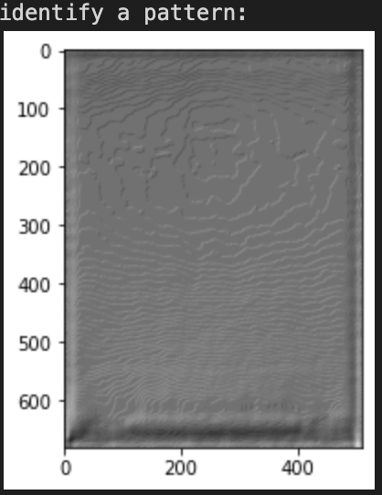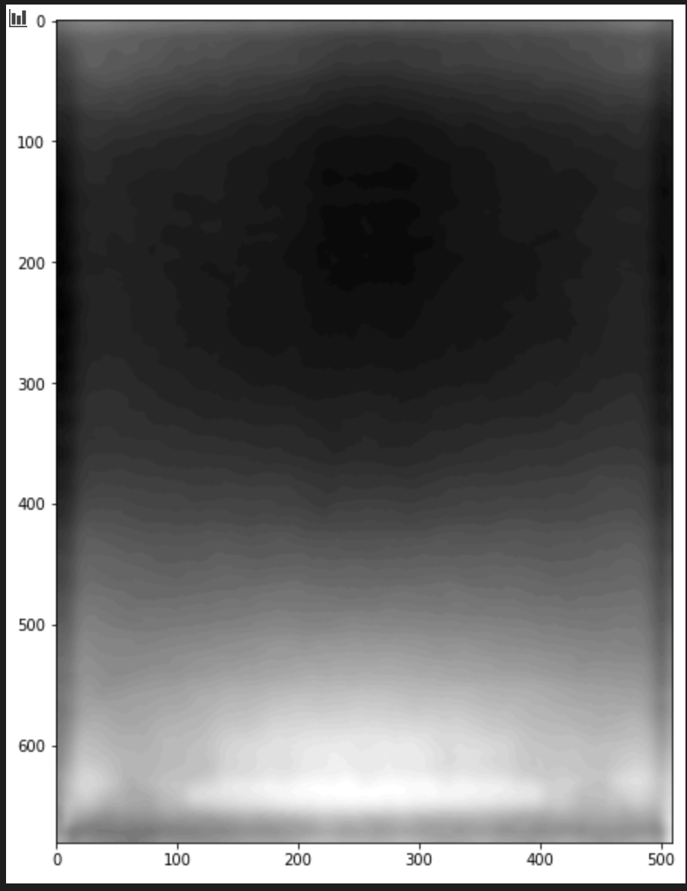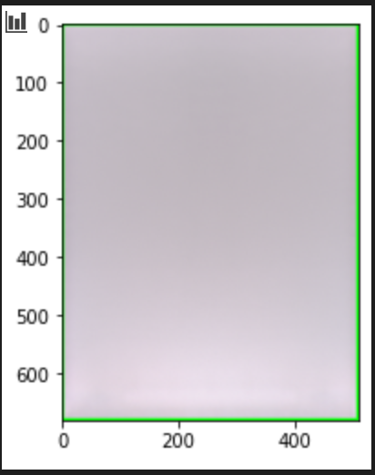

**Left image (scipy.signal):** 2D Convolution + Scharr kernel

**Middle image (openCV + SciPy):** 2DConvolution + Scharr kernel + Bilateral Filter (LPF ) + BGR2Gray

**Right image (openCV):** RGB 🡪 BGR

**Mixed**

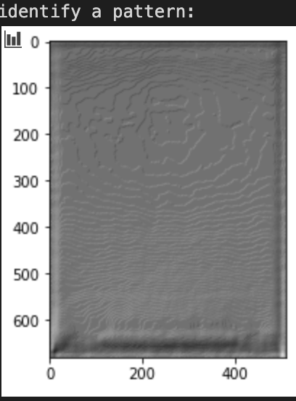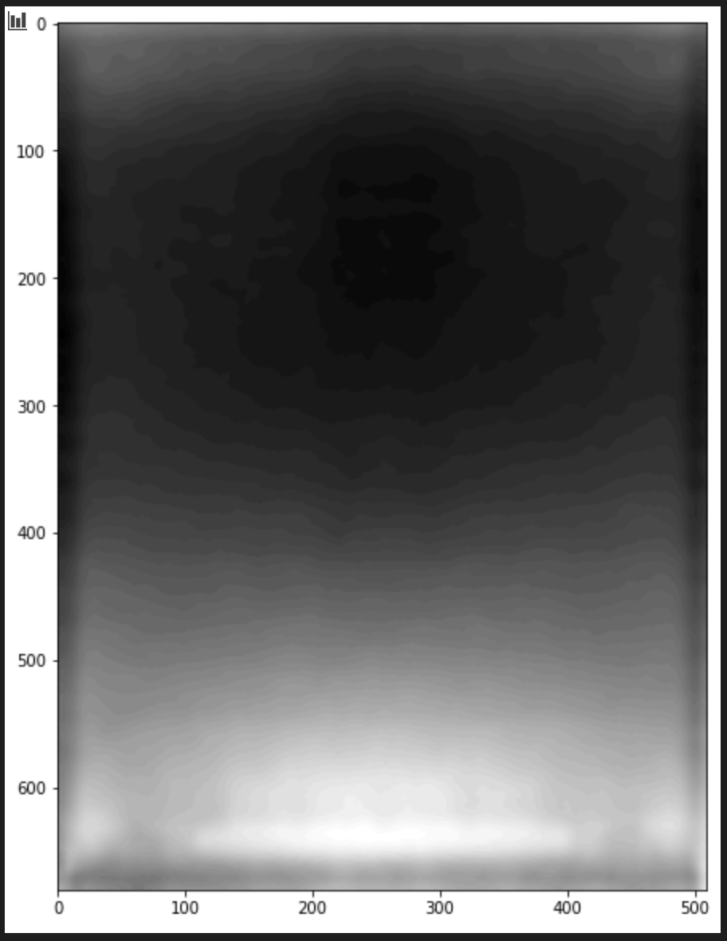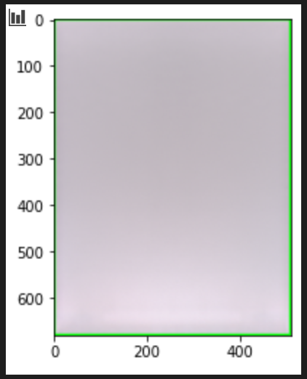

**Amber:**

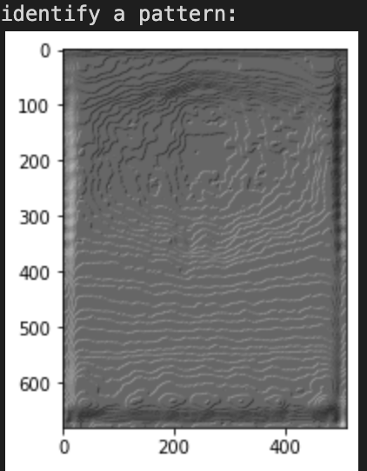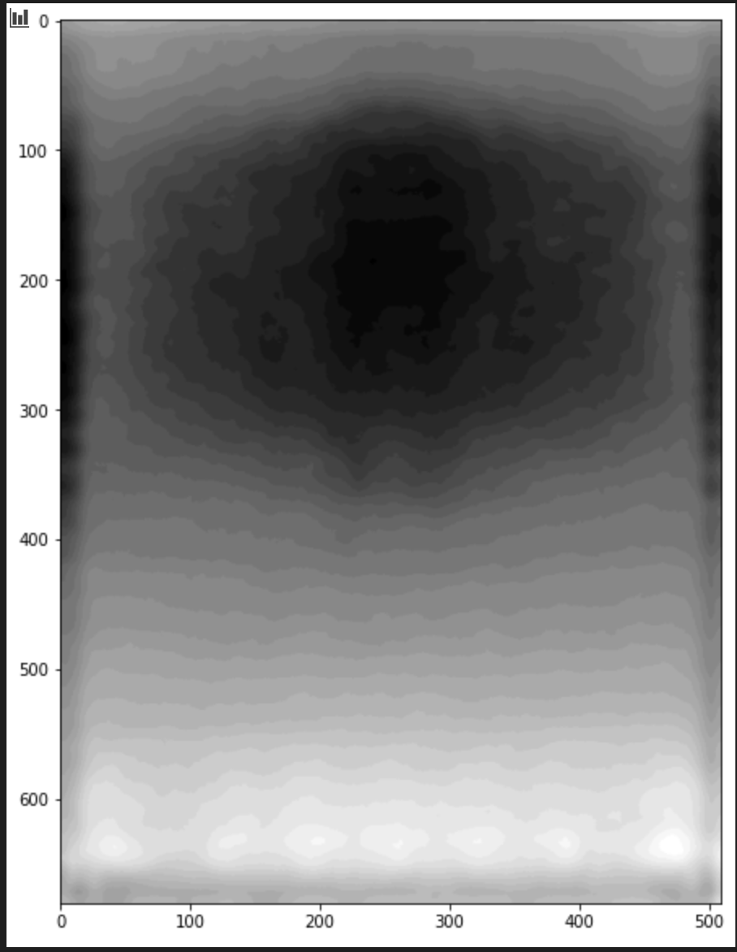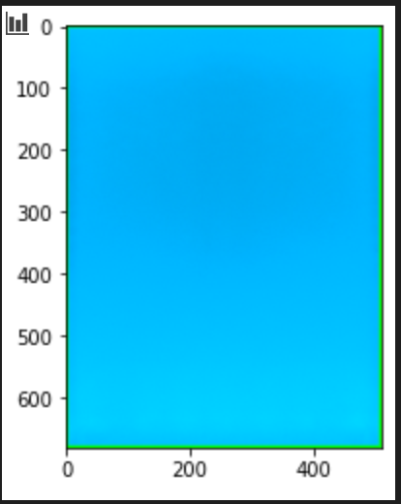

**Left Edge Defect:**

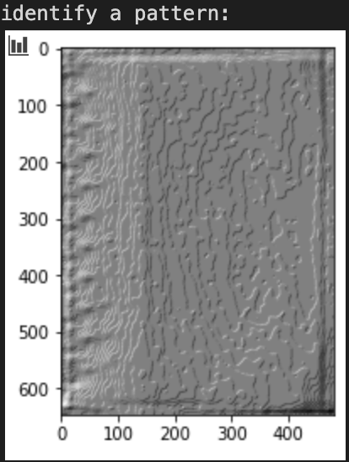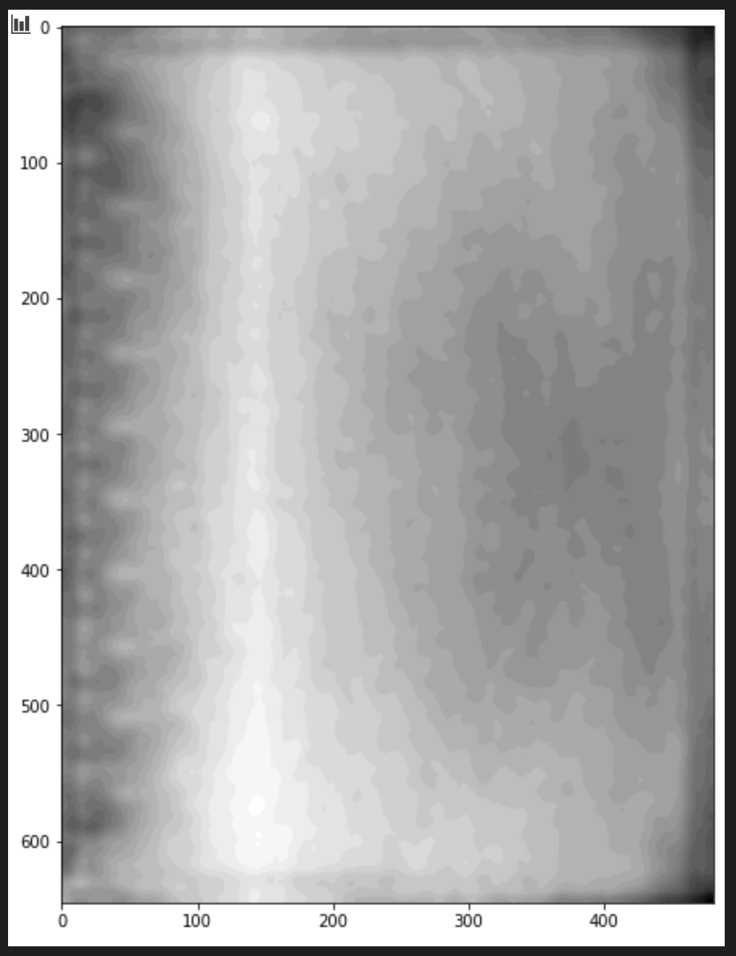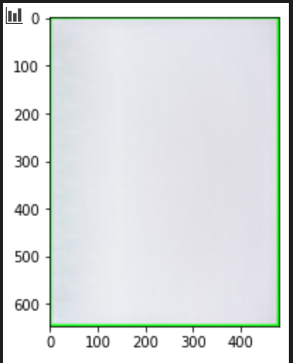

**Left image (scipy.signal):** 2D Convolution + Scharr kernel

**Middle image (openCV + SciPy):** 2DConvolution + Scharr kernel + Bilateral Filter (LPF ) + BGR2Gray

**Right image (openCV):** RGB 🡪 BGR

<https://pythonawesome.com/overview-of-the-peaks-dectection-algorithms-available-in-python/>

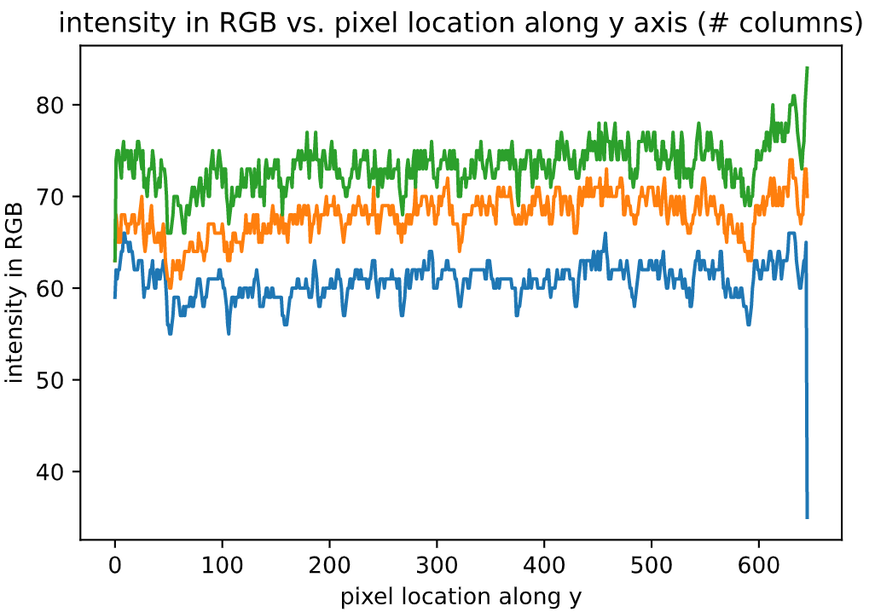

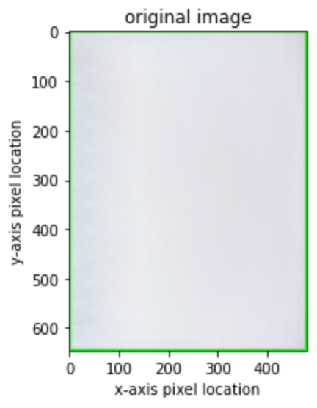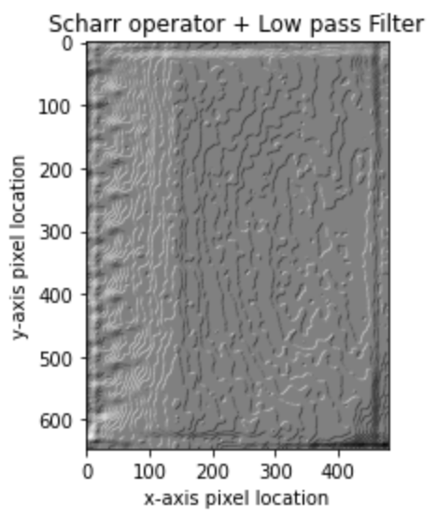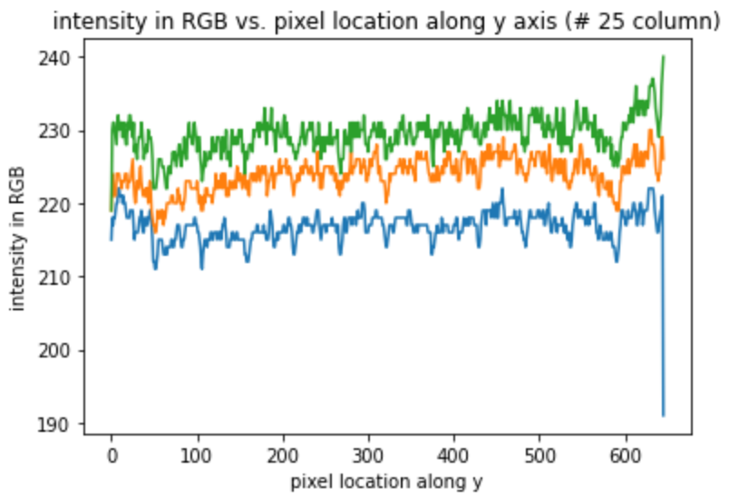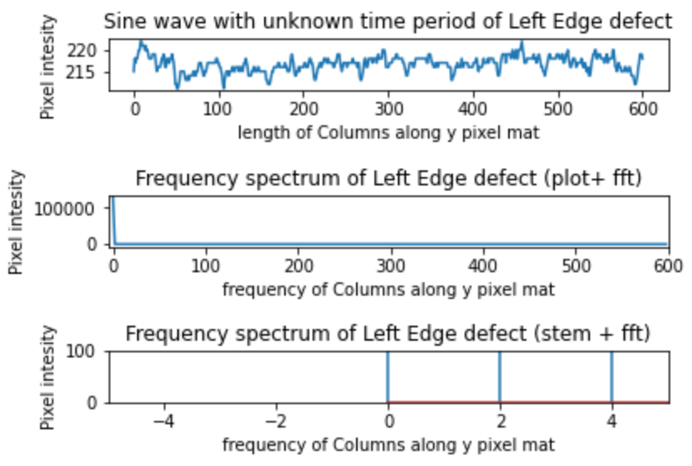

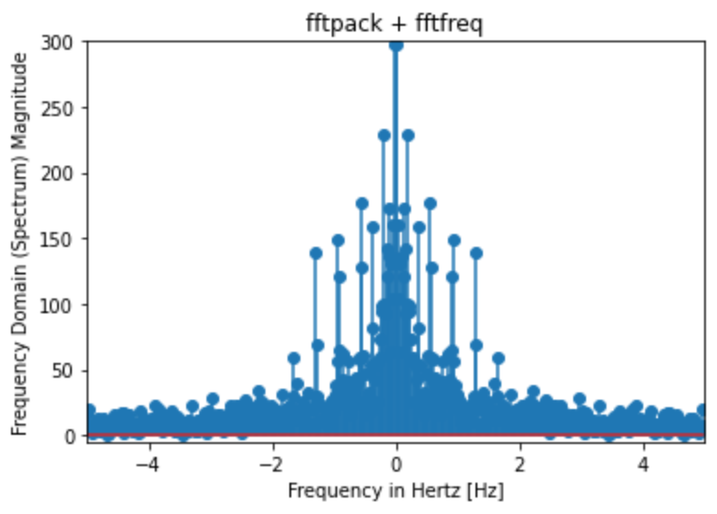

* Condor is AR glasses. Kb is hired for this, trying to catch with magicLeap and apple
* Started April, but now defining display waveguide architecture and designing PRFAQ
* Disabled from meeting face to face, makes it hard to maintain momentum
* OP cycle, operational planning
* HOME AR PROJECTOR, color reflective display
  + Energy harvesting display by jack
  + Liquid crystal lens, bob and suchit
  + Backplane microLED display for glasses, approved by alex
    - Using own Condor intersect
    - Lindo approves then moves to dave
    - 10 headcount to work on this
* 2 MTI, ambient adaptive display
  + MTK thia
  + Ouya, not MTK but mLogic
  + Algo would be to ensure display color matches what we see
  + We doing this with off the shelf Mediatech, need to develop our own algorithms. Hardware team develop display and
* Dot metrics MTI, john
  + Not approved yet, but have bee working on it
  + Instead of 7 segment, we don’t exceed power budget on 7 seg display, maintain form factors by not exploding power in thermal, but vector display
  + 2022 echo headless products
  + Entrance in miniLED market. Lots of players in this market

z