CIEE Productivity and Reproducibility Mini Project

# Food availability or genetic drift: Palmer penguins vary in mass island by island.

Laura Dutheil1*

1. Department of Integrative Biology, University of Guelph, Ontario, Canada

*Corresponding Author:

email: [ldutheil@uoguelph.ca](mailto:ldutheil@uoguelph.ca)

# Abstract

This mini project explores whether the average mass of penguins differs depending on the island they’re from (Lescroël et al., 2021). Here is another source used for this project (Emslie et al., 1998).

# Introduction

Penguins of the same species can have different body masses. Using the palmer penguin dataset, we wanted to test our hypothesis that body masses would be different for each island, as island size and resource availability can contribute to increased penguin body mass.

# Methods

Using the palmer penguin dataset and RStudio, we calculated the average body mass of penguins for each separate island (Biscoe, Dream, and Torgersen). These were then plotted using the package ggplot2.

# Results

The results demonstrated that the Biscoe island had an increased average body mass compared to the two other islands, who were themselves quite similar.

# Discussion

We believe that this difference in body mass is consistent with our hypothesis that body mass would vary depending on the island type. We suspect the increase in mass seen in Biscoe is likely related to a larger island size which would provide increased habitat space for the penguins living there, and thus increased access to resources.

# References

Emslie, S.D., Fraser, W., Smith, R.C., Walker, W., 1998. Abandoned penguin colonies and environmental change in the Palmer Station area, Anvers Island, Antarctic Peninsula. Antarctic Science 10, 257–268. <https://doi.org/10.1017/S0954102098000352>

Lescroël, A., Schmidt, A., Elrod, M., Ainley, D.G., Ballard, G., 2021. Foraging dive frequency predicts body mass gain in the Adélie penguin. Scientific Reports 11, 22883. <https://doi.org/10.1038/s41598-021-02451-4>

# Figures

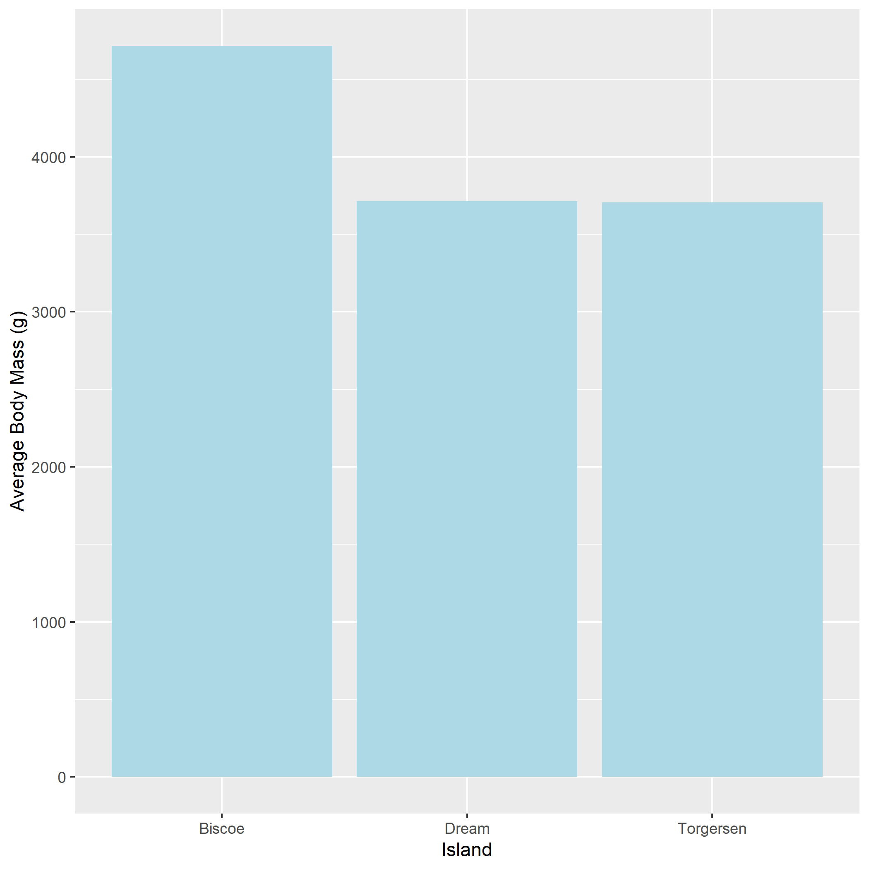

Average body mass of Palmer Penguins by Island