Playing with multiple datasets
  - A reproducible student report
Laura Bettencourt 63515
26 October 2026
Abstract
Replace this with a short summary of your question, method, main finding, and conclusion. Write it after completing the report.
Table of contents

# DO NOT TOUCH THIS CODE
#| label: setup
#| include: false
knitr::opts_chunk$set(
fig.align = "center",
fig.width = 6,
fig.height = 4
)
library(knitr)

Important messages
Before event starying, check this .qmd compiles. Render it to .html and . docx. It should work.
For this to compile you have to have in the same folder the:
- Week7Data00000.qmd - the quarto dynamic report itself
- biblio.bib - the .bib file that contains the references to cite
- mee.csl - this is a file that formats references using the style for the journal Methods in Ecology and Evolution
- pch_in_R.png - an image to be included in the report (see details below)

Introduction
In this week the plan is for you to get used to work with different datasets. A useful read to help guide your data exploration is Zuur et al. (2009). Another source of helpful general guidance regarding Ecologia Numérica, or broadly Statistical Ecology, is Popovic et al. (2024).
You will use 5 (sets of) datasets, one dataset (or sets of datasets) from each of your practicals teachers, namely:
- for TAM: obs_data and seg_data; data used in Martins et al. (2026); You are only receiving part of the massive 1.9 Gb dataset. Check here for the full data if you like to see it all https://zenodo.org/records/18711398
- for ASR: coleopteros.csv, pseudoescorpioes.csv and ligiaoceanica.csv; o documento ASR Ficha de trabalho de Ecologia Numérica 2026.pdf descreve o contexto ecológico. Não sendo trabalhado em aula, será ainda adicionado um conjunto de dados associado a uma publicação que poderá ser trabalhado de forma independente.
- for SF: Species richness_fishes_estuaries.xlsx; dados usados em França et al. (2012)
- for RL: soon to be added
- for HR: soon to be added Não sendo trabalhado em aula, será ainda adicionado um conjunto de dados associado a uma publicação que poderá ser trabalhado de forma independente.
and with those you will:
- read it in
- explore/understand what the data is about
- identify possible response variables vs. explanatory variables
- do some data manipulation
- do some data exploration
  - summary statistics
  - data visualizations
- based on all your findings, report about what you learned from these different ecological settings

An example tip
Just to help you out, here are the different values for plotting symbols in R. This is also an example on how to include an external image in a Quarto dynamic report! (try to include at least one additional image yourself)
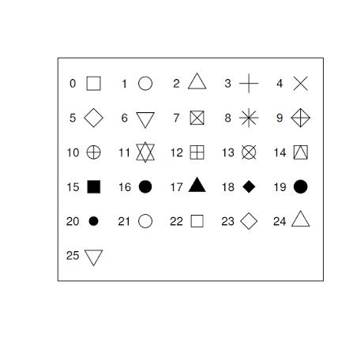
You are challenged to to add your own tips and tricks to this document, making it a much more useful study document. Remember, ultimately that is what these documents should be, much more that something you submit in moodle.

Dataset worked in class
 Tip
Read the material provided for context, so that you can understand what the different columns are.

The paper and its methods
Tip
Describe in your own words what the data is about.

Read the data
Tip
Here you should read the data in

#quando eu der import do dataset, vou a consola e copio aquela parte q esta aqui em baixo para eu ler os dados aqui no documento
obs_data<- read.csv("obs_data.csv")
These are the names of the variables
names(obs_data)
[1] "object" "distbegin" "distend" "lat" "lon"
[6] "x" "y" "size" "Sample.Label" "Seastate"
[11] "Visibility" "Day" "Month" "Year" "ID"
to know what these columns are, i could check on the online data repository zenodo https://zenodo.org/records/18711398
Tip
Just to check, confirm how many records and how many columns (variables you have).

# replace the NA with an expression that corresponds to the correct value
# how many rows
nr <- nrow((obs_data))
# how many columns
nc <- ncol(obs_data)
We have 737 rows and 15 columns.

Exploratory data analysis
Tip
Provide an exhaustive exploratory data analysis. Use both location and dispersion summary statistics, and also extensive data visualization to explore the data. Manipulate and modify data. Calculate summary statistics of a (response) variable for the different levels of a given (exploratory) variable.

Key variables in the data include:
object - a sighting ID
distbegin - lower bound of the distance bin associated with the detection
distend - upper bound of the distance bin associated with the detection
lat - latitude lon - longitude x - easting (projected latitude) y - northing (projected longitude) size - group size Sample.Label - the segment the detection occurred at (allows to link to seg_data) Seastate - sea state (Beaufort scale) Visibility - measure of visibility (A = <2 km; B = 2 – 5 km; C = 6 – 9 km; D = >10 km) Day - day of the sighting Month - month of the sighting Year - year of the sighting *ID - an identifier of the sighting (this actually repeats “object”!)
Como posso saber quais os valores dos limites das classes de distância consideradas:
unique(obs_data$distbegin)
[1] 100 200 0 50
#ou
with(obs_data,unique(distend))
[1] 200 300 50 100
Vamos agora calcular o valor médio do intervalo em que cada observação se encontrava
#dm é distância média
obs_data$dm <- (obs_data$distbegin + obs_data$distend)/2
unique(obs_data$dm)
[1] 150 250 25 75
Assumindo que as distâncias médias dos extremos da classe de distância são uma boa aproximação do que era a distância real, a distância média global é 87.82
Vamos ver quantas distâncias temos em cada classe:
table(obs_data$dm)
25 75 150 250
385 116 126 110
#ou
knitr::kable(table(obs_data$dm),col.names=c("Distancia","Frequencia"))
Distancia | Frequencia
25 | 385
75 | 116
150 | 126
250 | 110
Vamos ver esta informação do ponto de vista gráfico
hist(obs_data$dm, main="Histograma das distâncias",breaks=c(0,50,100,200,300))
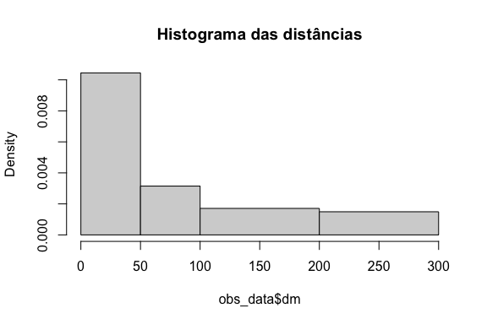
barplot(table(obs_data$dm),ylab="Número de observações",xlab="Distância (m)")
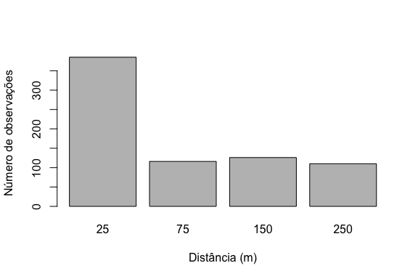
Como a distância média varia em função do grupo, do seastate e da visibilidade:
Como varia a distância em função do seastate:
#boa representação grafica para isto (fatores) - boxplot
with(obs_data,boxplot(dm~Seastate))
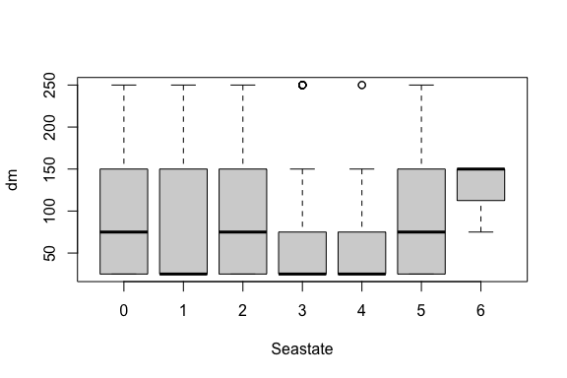
Interessante o facto de como o pior estado do mar parece ter distâncias maiores…
obs_data[obs_data$Seastate==6,]
object distbegin distend lat lon x y size Sample.Label
357 216781 100 200 39 -10 564436 20872.64 2 14.02.2013.17.25
415 216900 100 200 39 -10 564436 20872.64 3 14.02.2013.17.25
667 217458 50 100 39 -10 564436 20872.64 6 14.02.2013.17.25
Seastate Visibility Day Month Year ID dm
357 6 D 14 2 2013 216781 150
415 6 D 14 2 2013 216900 150
667 6 D 14 2 2013 217458 75
table(obs_data$Seastate)
0 1 2 3 4 5 6
23 201 314 121 53 22 3
Se eu quiser saber o valor médio da distância por cada classe de estado do mar:
dm.by.seastate <- tapply(X=obs_data$dm, INDEX = obs_data$Seastate, FUN=mean)
Representar isto de cima num gráfico:
par(mfrow=c(2,2))
unique(obs_data$Seastate)
[1] 2 1 3 5 4 0 6
plot(sort(unique(obs_data$Seastate)),dm.by.seastate, type="p",ylim=c(0,150))
#o type quer dizer p->point l->line e b->both
plot(sort(unique(obs_data$Seastate)),dm.by.seastate, type="l",ylim=c(0,150))
plot(sort(unique(obs_data$Seastate)),dm.by.seastate, type="b",ylim=c(0,150))
plot(sort(unique(obs_data$Seastate)),dm.by.seastate, type="n",ylim=c(0,600),xlab="",ylab="", xaxt="n",yaxt="n")
#type n nao aparece lá nada
text(3,200,"banana")
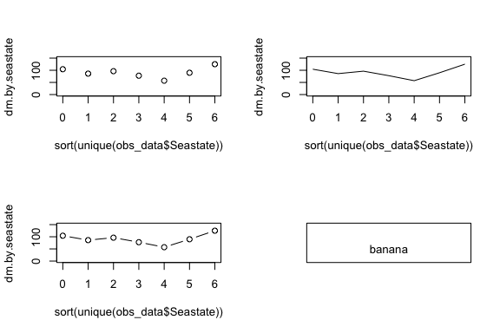
dm.by.vis <- tapply(X=obs_data$dm, INDEX = obs_data$Visibility, FUN=mean)
par(mfrow=c(1,1))
plot(1:4,dm.by.vis, type="p",ylim=c(0,150),xaxt="n",xlab="Visibility")
#adicionamos o eixo à mao:
axis(side=1, at=1:4, labels=c("A","B","C","D"))
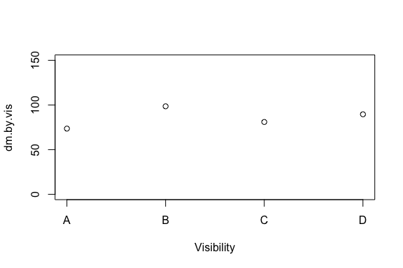
Vamos agora ver um gráfico do tamanho do grupo no espaço Figure 1:
#vou por um label na figura e consigo me referir a figura em todo o documento; nao posso por um comentario acima destes labels, nao acima dos # q estao aí
with(obs_data,plot(lon,lat,cex=log(size)))
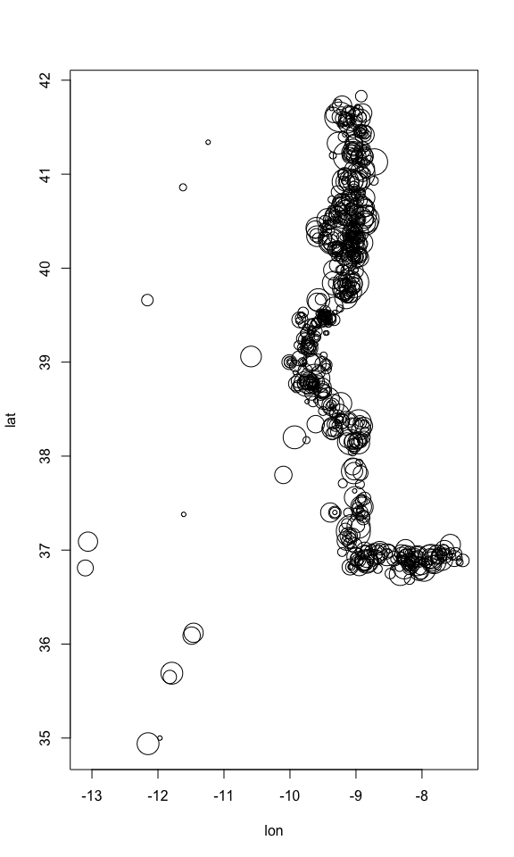
Figure 1: Distribuição no espaço
#ou podemos fazer de outras formas:
with(obs_data,plot(lon,lat,cex=size/100))
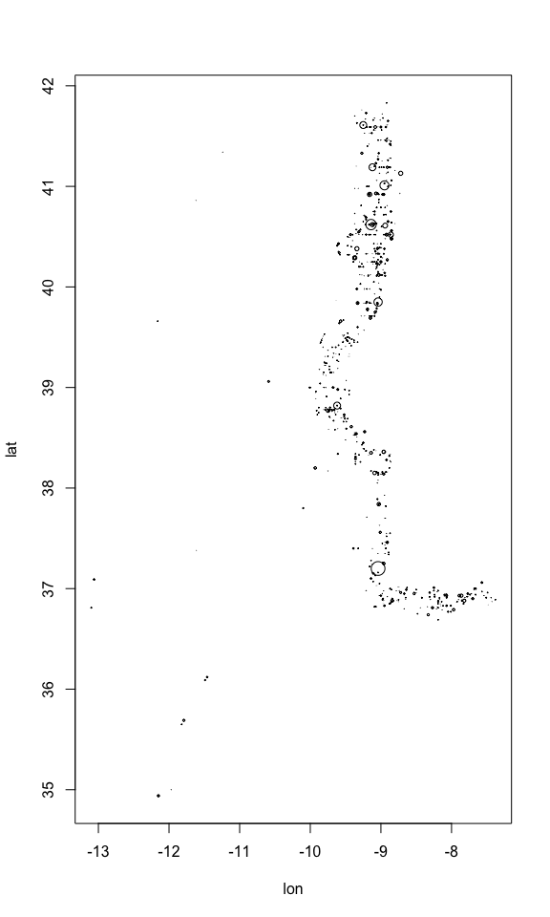
Figure 2: Distribuição no espaço
with(obs_data,plot(lon,lat,cex=size/100, xlab="Longitude",ylab="Latitude"))
legend("topleft",inset=0.05,title="Group size",legend=c(1,5,10,50,200),pch=1,pt.cex=c(1,5,10,50,200)/100)
legend("bottomleft",legend="Lanche", inset=0.1,pch=1,col="blue")
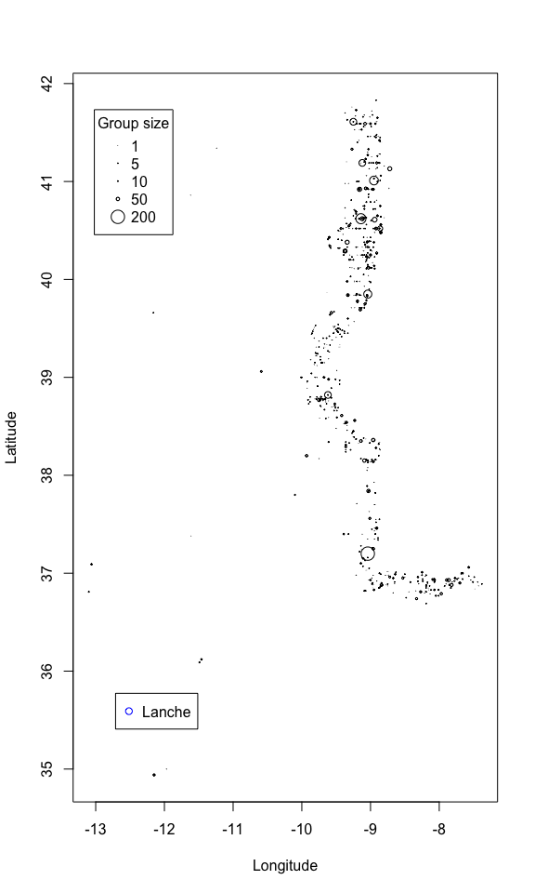
Figure 3: Distribuição no espaço, tamanho proporcional ao sexo
Como variou a distribuiçao de observaçoes no tempo
barplot(table(obs_data$Year))
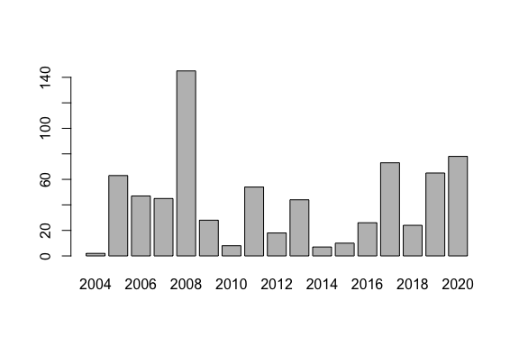
Olhando para o esforço:
seg_data <- read.csv("seg_data.csv")
with(seg_data,plot(lon,lat))
with(obs_data,points(lon,lat,col="red",pch=19))
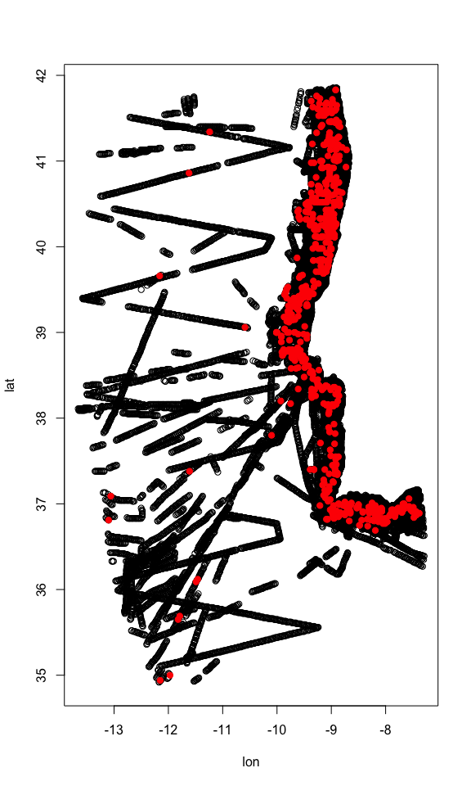

Final challenges
- Describe in your own words the main patterns found and their corresponding ecological relevance
- do additional data manipulation

Other datasets
Repeat the above process for additional datasets, or, even better, for all five datasets (creating one section for each dataset with the same structure of the material for the dataset you did in class).
This would be an endless task, as you could find new datasets to explore. You must practice R as much as possible, with as many datasets as possible.
If you complete this “Other datasets” task, submit the complete .qmd and the corresponding .docx (=Word file) in moodle here. You can submit work till the end of the semester.
Remember, this is your way of studying, and getting credit for it!

References
França, S., Vasconcelos, R.P., Fonseca, V.F., Tanner, S.E., Reis-Santos, P., Costa, M.J. & Cabral, H.N. (2012). Predicting fish community properties within estuaries: Influence of habitat type and other environmental features. Estuarine, Coastal and Shelf Science, 107, 22–31.
Martins, M.P., Fernandez, M., Marçalo, A., Oliveira, N. & Marques, T.A. (2026). Seasonal and interannual variation of common dolphin, Delphinus delphis, density in Portuguese waters. Marine Mammal Science, 42, e70160.
Popovic, G., Mason, T.J., Drobniak, S.M., Marques, T.A., Potts, J., Joo, R., Altwegg, R., Burns, C.C.I., McCarthy, M.A., Johnston, A., Nakagawa, S., McMillan, L., Devarajan, K., Taggart, P.L., Wunderlich, A., Mair, M., Martínez‐Lanfranco, J.A., Lagisz, M. & Pottier, P. (2024). Four principles for improved statistical ecology. Methods in Ecology and Evolution, 15, 266–281.
Zuur, A.F., Ieno, E.N. & Elphick, C.S. (2009). A protocol for data exploration to avoid common statistical problems. Methods in Ecology & Evolution, 1, 3–14.

