Looking at polar bear data
  - A reproducible student report
Tiago MArques 19549
18 October 2026
Abstract
Replace this with a short summary of your question, method, main finding, and conclusion. Write it after completing the report.
Table of contents

Introduction
This exercise is based on the data from Aars et al. (2026).
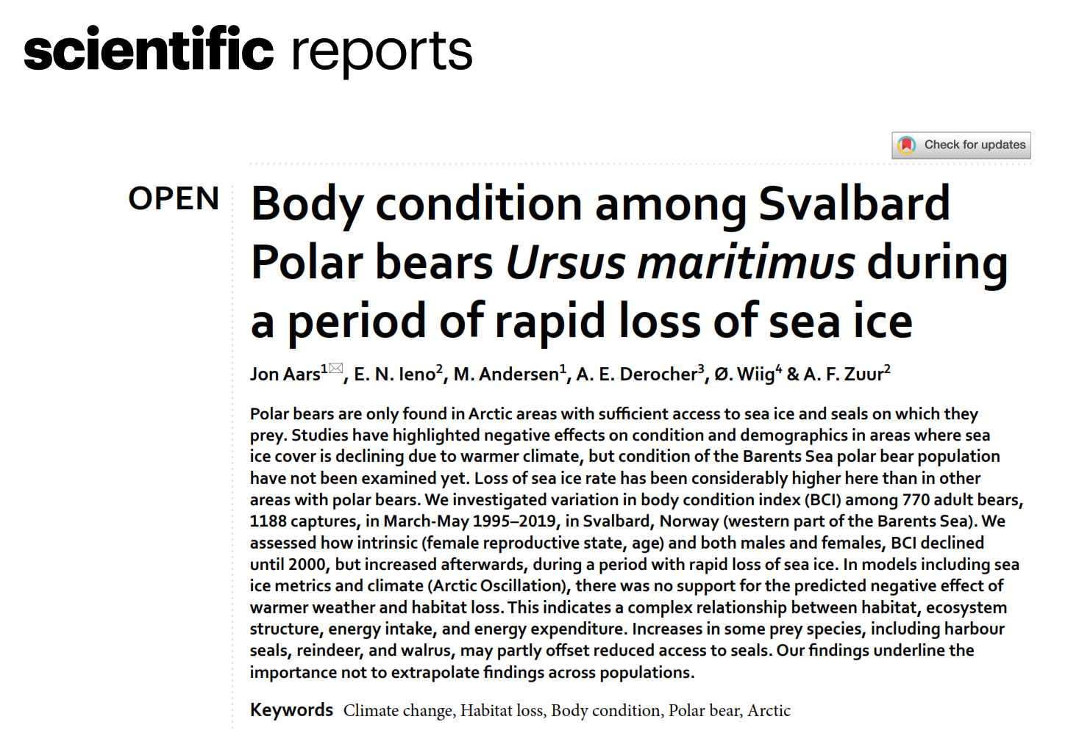
 Tip
Read the abstract and the methods section of the paper, so that you can understand what the different columns are. The paper is freely available here https://www.nature.com/articles/s41598-025-33227-9 and also provided in moodle.

The paper and its methods
Describe in your own words what the data is about, what were the statistical methods used for analysis. In particular, describe what is the main response variable and what are the main predictors the authors expect to explain the response
 Important
The response is body condition, BCI. There are many predictors, including year, sex, age, location, presence of cubs, etc

Read the data
Here you should read the data in
#this assumes that the dataset is in the same folder as the .qmd report
Just to check, confirm how many records and how many columns (variables you have).

Exploratory data analysis
Provide an exhaustive exploratory data analysis, describing in your own words the main patterns found.
#possible example plots

Sampling
Pretend that the dataset is the entire population of bears that you want to sample from.

Simple random sampling
Estimate, based on random samples of size 5, 10, …. 100 what is the mean body condition for polar bears around Svalbard.
Create a plot where you have sample size on the x axis, and the mean estimate on the y axis. Add an horizontal dashed blue line of width 3 with the population mean (i.e. the mean for all bears)
In your own words, what happens as the sample size increases?

Stratified random sampling
Next, repeat the procedure treating each sex as a stratum. Do a separate plot for each sex and then contrast with a single plot with all bears.
and now plot
Compare the estimated mean by sex and the corresponding overall mean using the sex as strata vs not using the sex as strata.
Compute: The overall mean The mean for females the mean for males the overall mean using the strata means

Systematic sample
In random sampling you can get very unbalanced samples (over space, over time, etc). Here consider using a systematic sample to select records with the best possible temporal coverage. Select a systematic sample of size 90.
How does it compare with the overall mean? Discuss

Years as strata
Treating the year as strata, check how many bears you have per strata, and then estimate the mean BCI per year, and then an overall BCI, comparing the two estimates
Plot BCI over time
Separate this plot for males and females. First separate data by males and females
What is the correlation between these two time series? (tip: the function cor calculates correlation between two time series)

What is, really, our population
Check out how many records you have, and how individual bears you have. What does that mean? (tip: function unique might come in handy)

Independent work for extra points!
If you complete this task, send the complete .qmd and the corresponding .docx (=Word file) to tamarques@ciencias.ulisboa.pt
Can you find a way to add the data in these two plots in the same plot, using a plot with two y axis? Check out example here https://r-graph-gallery.com/145-two-different-y-axis-on-the-same-plot.html
Explore the contents in https://www.data-to-viz.com/caveats.html regarding things you should consider carefully when using plots

References
Aars, J., Ieno, E.N., Andersen, M., Derocher, A.E., Wiig, ?. & Zuur, A.F. (2026). Body condition among svalbard polar bears ursus maritimus during a period of rapid loss of sea ice. Scientific Reports, 16.

