The Overview Effect: Changing Perspectives on the Earth

**Part One: Your perception now:** What do you think of when someone says ‘earth’ to you? Write down two or three sentences you’d use to describe earth to a friend.

Part Two: History: Yuri Gagarin first observed the overview effect in 1961. He said “…I saw for the first time the earth's shape. I could easily see the shores of continents, islands, great rivers, folds of the terrain, large bodies of water. The horizon is dark blue, smoothly turning to black. . . the feelings which filled me I can express with one word—joy. …” Gagarin had become the first human into space, and was describing what he saw through his spacecraft’s window. This was the first observation of the overview effect, but certainly not the last. “The Earth was absolutely round . . . I never knew what the word round meant until I saw Earth from space,” said fellow cosmonaut Alexei Leonov. Leonov would be the first human to do a spacewalk in 1965.

America’s first moonwalker, Neil Armstrong, had this to say about seeing the earth from the surface of the moon: “It suddenly struck me that that tiny pea, pretty and blue, was the Earth. I put up my thumb and shut one eye, and my thumb blotted out the planet Earth. I didn't feel like a giant. I felt very, very small.”

Many astronauts have similar experiences upon seeing the earth as a discrete object outside their vehicle’s window.

Here is a picture of earth rising over the moon:

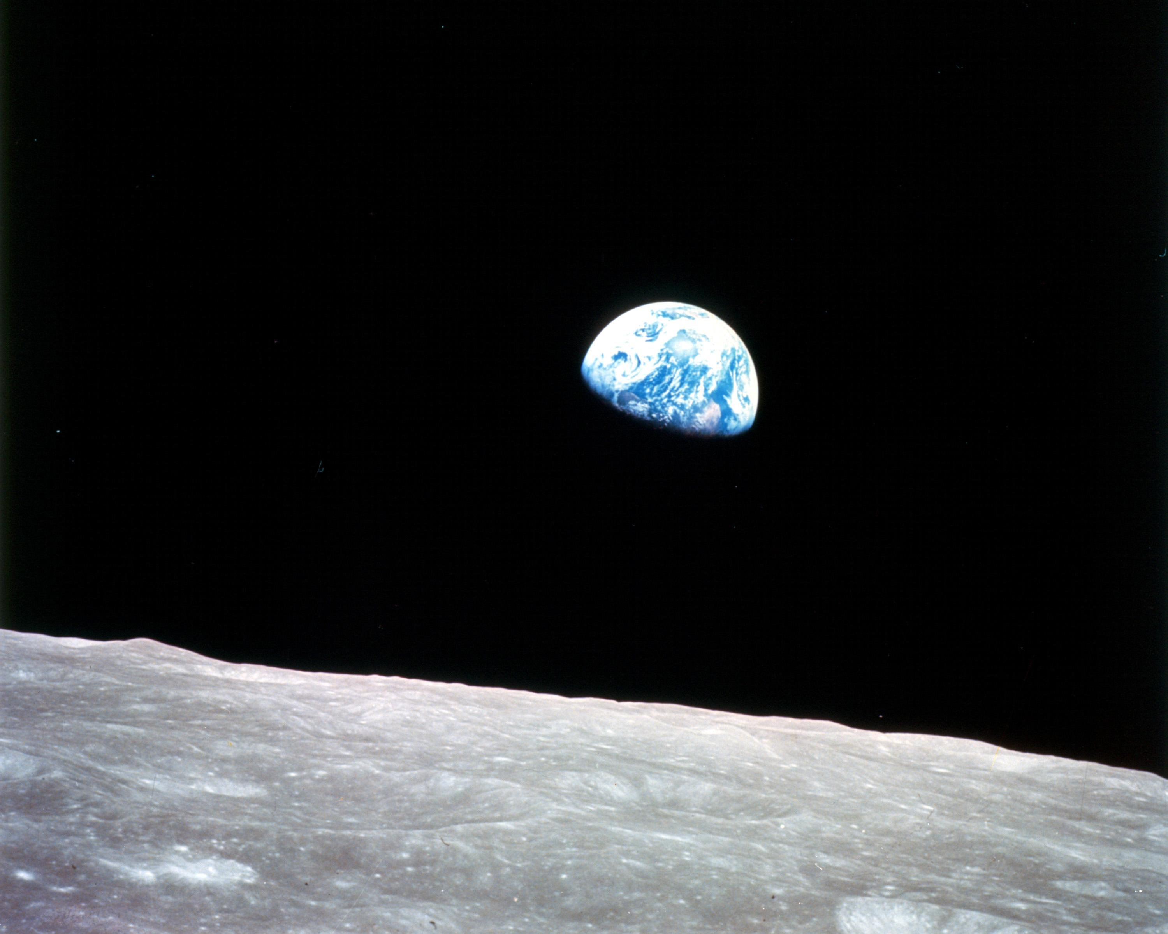

http://www.nasa.gov/multimedia/imagegallery/image_feature_1249.html

How would you describe this image?

One famous astronomer who wrote about this was Carl Sagan. He ordered a probe, named Voyager Two, to take a picture of the earth from beyond Neptune.

Here is that picture. Note the arrow pointing to a dot on the image

-that’s earth!

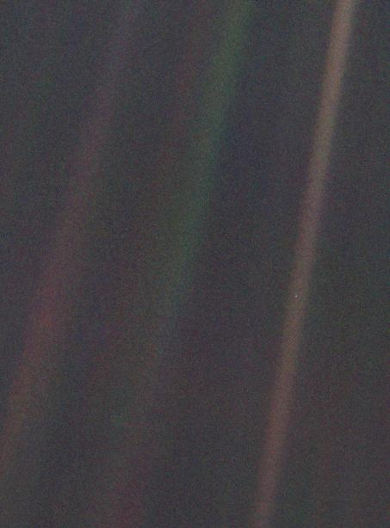

How does this image make you feel?

Sagan wrote a great deal about this image. You can read his quote here:

“…The Earth is the only world known so far to harbor life. There is nowhere else, at least in the near future, to which our species could migrate. Visit, yes. Settle, not yet. Like it or not, for the moment the Earth is where we make our stand.

It has been said that astronomy is a humbling and character-building experience. There is perhaps no better demonstration of the folly of human conceits than this distant image of our tiny world. To me, it underscores our responsibility to deal more kindly with one another, and to preserve and cherish the pale blue dot, the only home we've ever known.

-- Carl Sagan, Pale Blue Dot, 1994