

Data Technician

Name: Alaa Mostafa
Course Date: 16/12/24
Table of contents

Day 1: Task 1 2
Day 2: Task 1 2
Day 2: Task 2 3
Day 2: Task 3 4
Day 3: Task 1 4
Day 3: Task 2 5
Dataset: 5
Step 1: Create a Pivot Table 5
Step 2: Use the SWITCH Function 5
Submission: 6
Day 3: Task 3 6
Day 4: Task 1 7
Course Notes 9
Additional Information 10

Day 1: Task 1

Please complete the below boxes on commons laws and regulations that must be followed when working with customers data, use the below bulleted list to support your answers.

- What is it
- Why is it important
- Provide a real-world example of how you can follow it
- How does it impact working with data
- What could happen if you breached it

Data Protection Act | The Data Protection Act 2018 is legislation that governs how personal data is gathered, processed and stored. This ensures that data is being handled, lawfully, securely and within GDPR framework.  It is important as it guides how personal data is used, collected and stored. It protects peoples privacy and ensures the data is being handled responsibly and safely.  In the real world this can be shown by an ex-spouse calling the GP’s offices asking for results of their ex-partner. This information should not be shared with out the patents explicit permission. This information cannot be shared to a third party as it is personal data.  Removing details from a persons information to ensure it complies with the data protection act can limit how the data is used as it limits what the data can be used for, limits who has access to the data, this also helps prevent fraud by limiting who has access to what.  If you breach the conditions of the act it can lead to fines for the company you work for, there can be criminal prosecution and/or civil action.
GDPR | GDPR stands for General Data Protection Regulation, this means that anyone who uses personal data must make sure that the information is used fairly, lawfully and is transparent on what it will be used for. It also states that data should not be kept longer than what it is needed for. It is used with the data protection act in the UK.  It is important as it ensures that you have rights over your own data, including the right to be informed how your data is being used, to be able to access your data (and who has access to this data), freedom to update your data, stop the use of your data, restricting the use of your data and to be able to erase your data, as well as reusing your personal data on other platforms.  One way that data is used is when you go on to websites and it asks you about what cookies you accept. This is mostly used for analytics and marketing. You can unknowingly agree to your data being sold on to companies by using the website and agreeing to cookies.  GDPR gives individuals more power over their own data and aims to give less power to organisations who may use that data to sell on to other companies.  Such as breaching the data act, breaching GDPR also can include large fines and criminal prosecution and/or civil action.
Freedom of Information Act | The Freedom of Information Act gives the public a legal right to request information access from most UK public authorities, in which anyone can make a request.  This is important is it helps promote accountability towards public authorities and aims for transparency in how governing bodies make decisions.  One way that the FOIA has been used is in showing the delay times in which patients are left waiting in ambulances for considerably longer times than the recommended 15 minutes. This can be used to show how public services are performing, and how this wait in impacting the NHS.  The impact that FOIA has on working with data effects how data is managed, such as where it is stored, how accessible it is, if it meets current UK laws, it is time sensitive to how long records are kept. It also has to manage other legislations such as GDPR where it cannot release personal data unless it is met by exemptions.  If a member of the public authority fails to meet its obligations, corrective action maybe required, a stronger legal directive where legal proceedings can take place.
Computer Misuse Act | The Computer Misuse Act makes the unauthorised access to a computer, unauthorised access to computer materials with intent to commit a further crime, unauthorised manipulation or modification of data illegal.  The CMA helps protect people, organisations and governments from cyber crimes by making a set consequence if you misuse access or illegally obtained data punishable.  A real world example of where the CMA is followed is when ethical hackers are asked to penetration test a network with permission of the organisation. You can help fix any vulnerabilities for the organisation. If you do not have permission to do this, or if you exploit those vulnerabilities for personal gain, you can end up with a prison sentence or fine.  How this impacts working with data is that you can only access data you are authorised to view or process. This act also helps structure how audit trails and access controls are implemented, such as role-based access being introduced.  If you breach the CMA, the unauthorised access to computer material is upto six months in prison and/or up to a £5000 fine. Where as breaching the other stipulations are up to a 5 year or ten year imprisonment and/or an unlimited fine.

Day 2: Task 1

Please research and complete the following tasks within the retail-sales_dataset.xlsx document, paste a print screen into the provided boxes below:

- In the sheet ‘retail_sales_dataset’ add all available data between columns A –J into a ‘table’
- Using the ‘sort’ function, sort ‘Age’ to ‘largest to smallest’
- Using the ‘SUM’ function, show me the commission total in cell ‘L10’
- Using the ‘AVERAGE’ function, show me the average commission in cell ‘L11’

Print screen 1 | 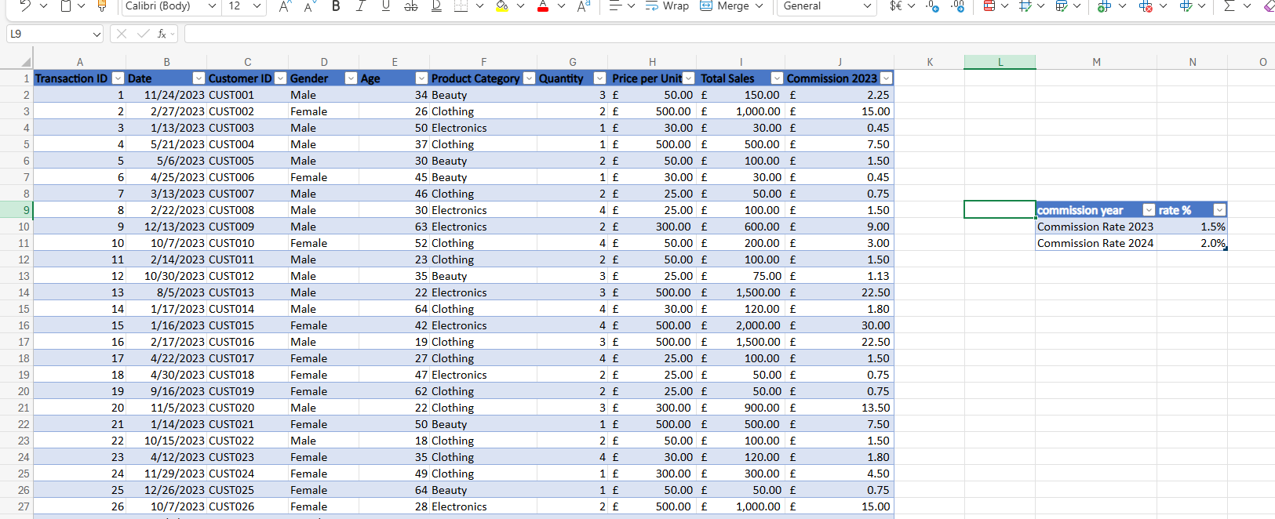
Print screen 2 | 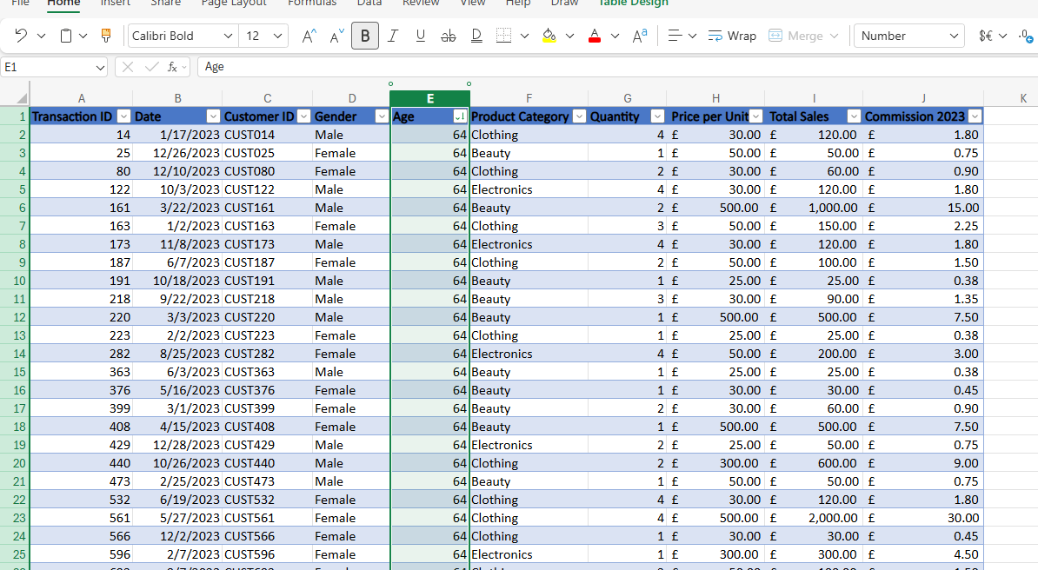
Print screen 3 | 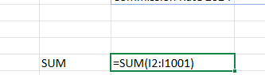
Print screen 4 | 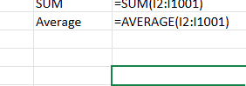

Day 2: Task 2

Please research and complete the following tasks within the retail-sales_dataset.xlsx document, paste print screens into the provided box below:



Print screen 1 | 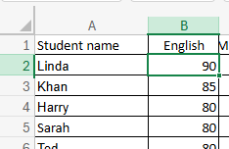  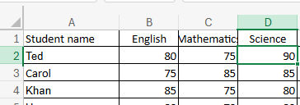  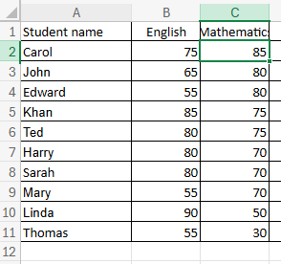  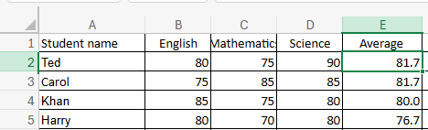  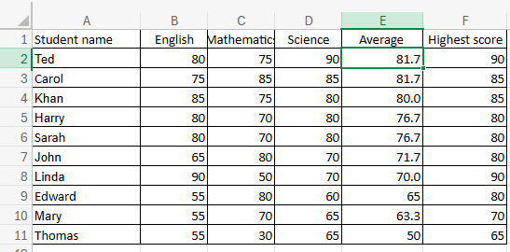  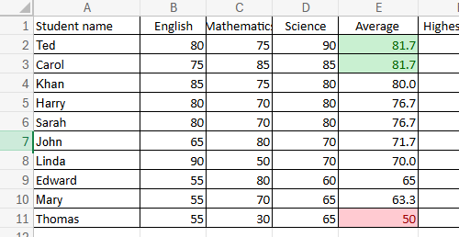

Day 2: Task 3

Using the skills developed today, have some fun with the data set you have imported. Paste your work below and enjoy!

Print screen 1 | 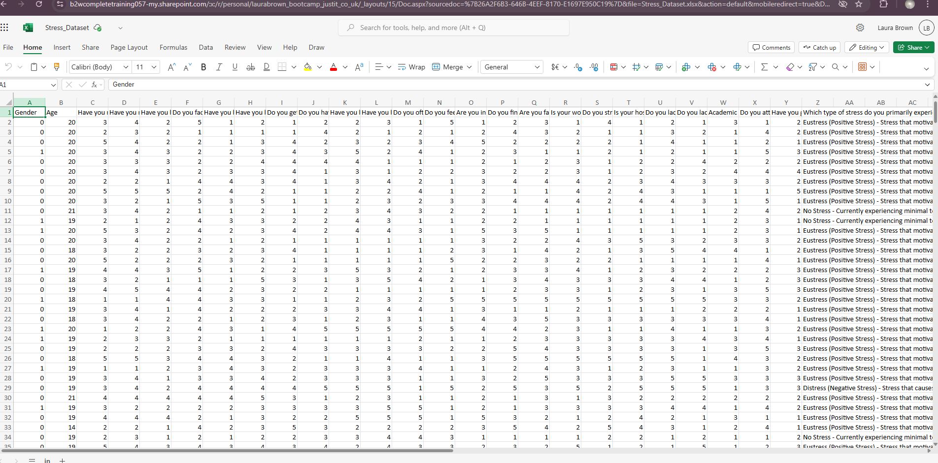Figure 1: unedited file  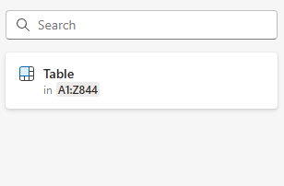Figure 2: table  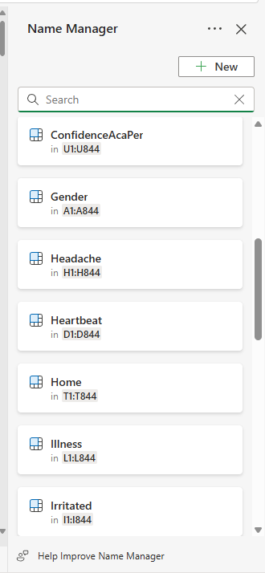  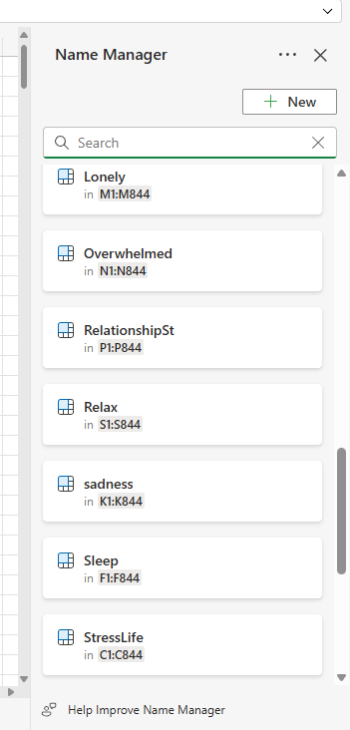  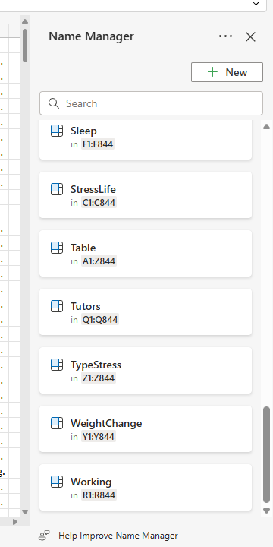  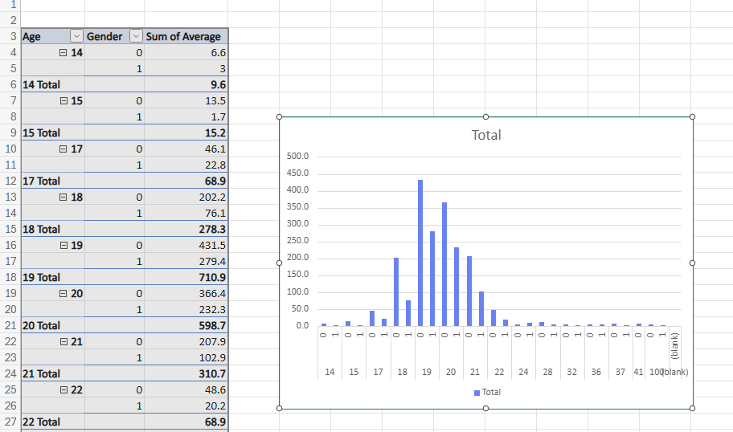  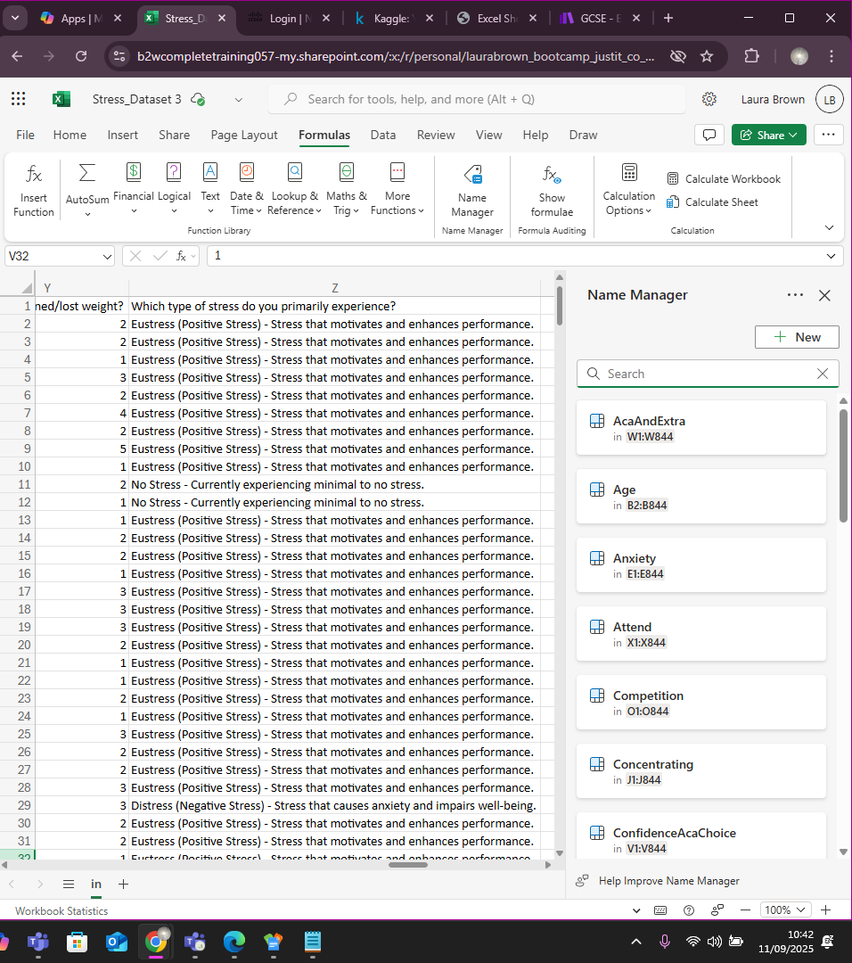Figure 3: NameManager  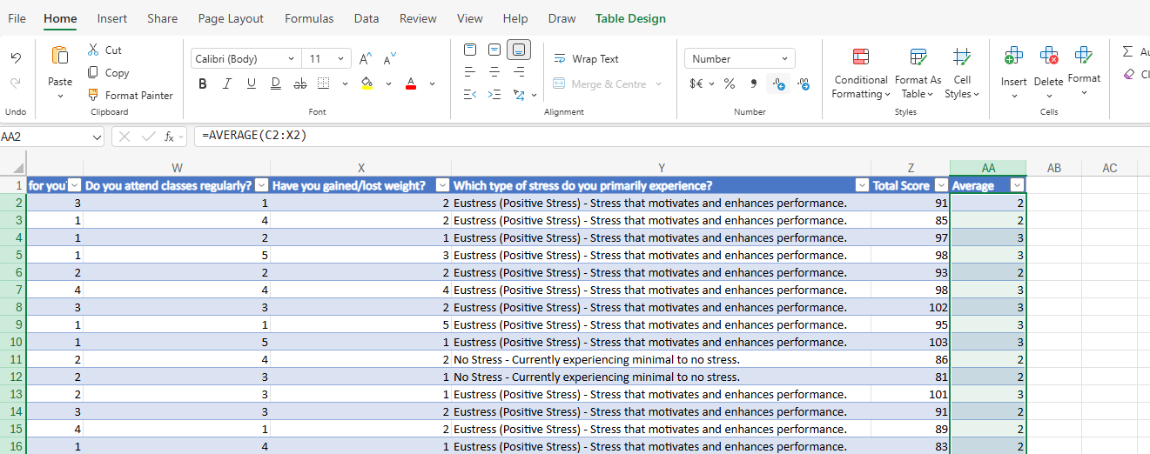  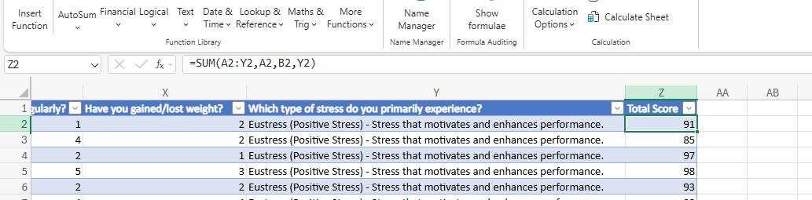

Day 3: Task 1

Please download the dataset ‘Day_3_Task_1_Bike_Sales_Pivot_Lab.xlsx’ and the lab instructions.

Do not worry if you do not complete the lab, just working with data and playing with the pivot table will be good experience.

Please paste your final pivot table below and complete the reflection questions:

Print screen 1 | 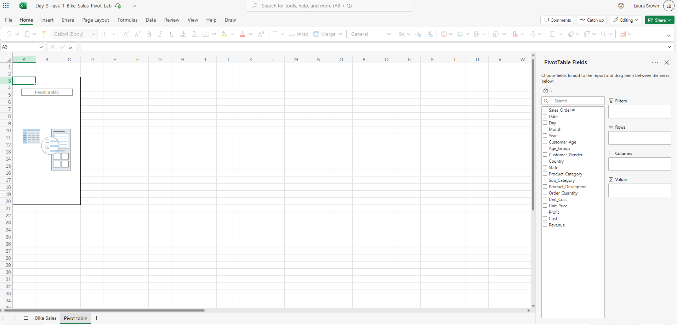
In which markets does Germany have customers? | 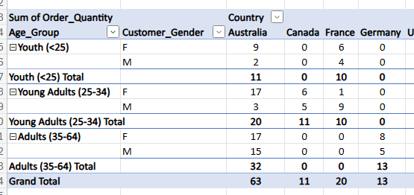  Adults (35-64)
What country has sales in all markets? | 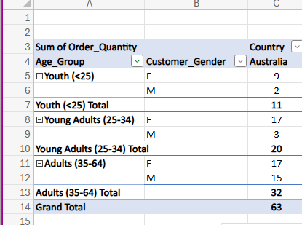  Australia
What are the most profitable markets by country, age group, and gender? | 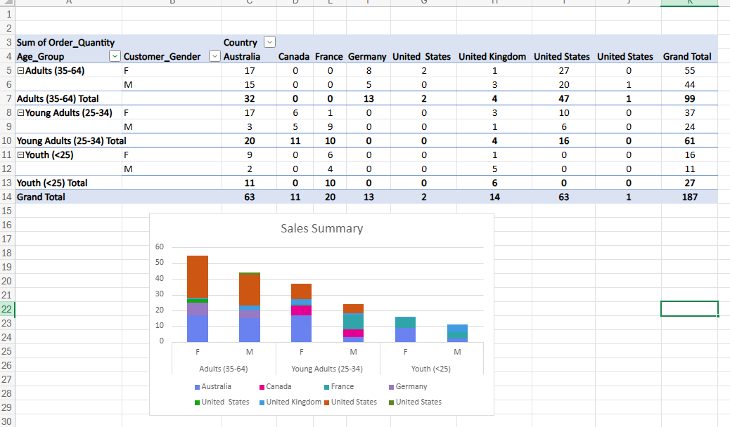
Any other findings? | 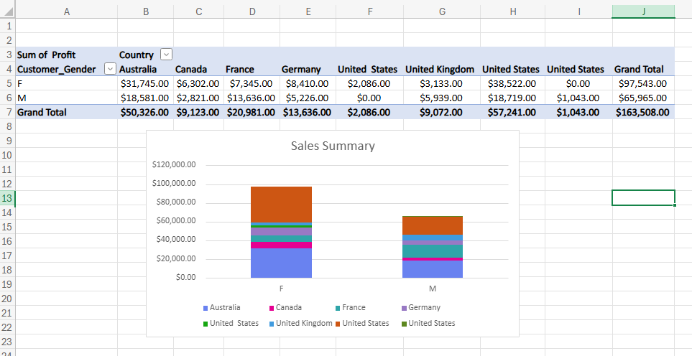  No men bought anything in the US

Day 3: Task 2

The dataset below tracks the sales performance of different products in various counties in England. Please paste the dataset into a blank Excel workbook. Your task is to:
- Create a Pivot Table to summarise the data by county and product.
- Use the SWITCH function to categorise products based on their sales volume.

Dataset:
County | Product | Sales Volume
Yorkshire | Laptops | 500
Yorkshire | Smartphones | 200
Cornwall | Laptops | 700
Cornwall | Printers | 400
Lancashire | Smartphones | 150
Lancashire | Laptops | 600
Essex | Printers | 800
Essex | Smartphones | 300
Durham | Laptops | 250
Durham | Printers | 300
Greater Manchester | Smartphones | 600
Greater Manchester | Laptops | 400

Step 1: Create a Pivot Table
- Select the dataset (columns A to C).
- Insert a Pivot Table to summarise the data by County in the rows and Products in the columns. Use Sales Volume as the value to be summarised.

Step 2: Use the SWITCH Function
In a new column next to your data, use the SWITCH function to categorise products based on Sales Volume as follows:
  - For sales greater than 600: "High"
  - For sales between 300 and 600: "Medium"
  - For sales less than 300: "Low"
SWITCH Function Example:
=SWITCH(TRUE, C2 > 600, "High", C2 >= 300, "Medium", "Low")
- Apply this formula to each row, and check if the products are categorised correctly.

Submission:
- A completed Pivot Table summarising sales by county and product.
- A new column in the dataset categorising products by sales volume using the SWITCH function.
  - Please paste your completed work below

Print screen 1 | 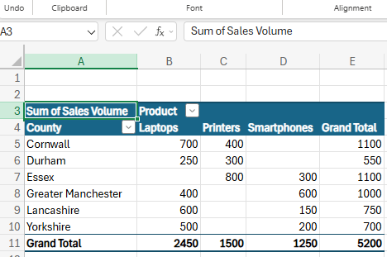  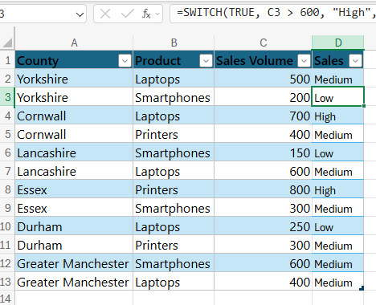

Day 3: Task 3

Please download the dataset ‘Day_3_Task_3_Bike_Sales_Visualisations_Lab.xlsx’ and the lab instructions. Do not worry if you do not complete the lab, just working with data and playing with the charts will be good experience.

Please paste your results below:

Print screen 1 | 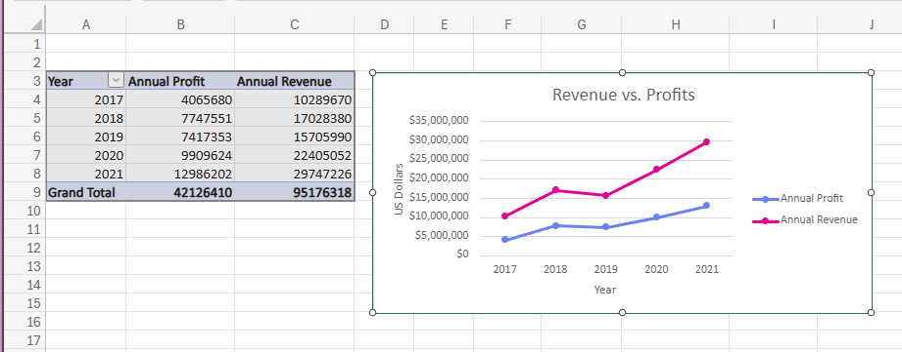  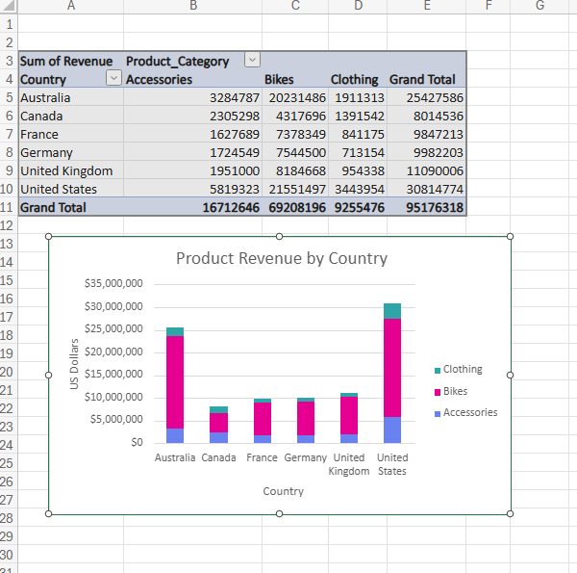  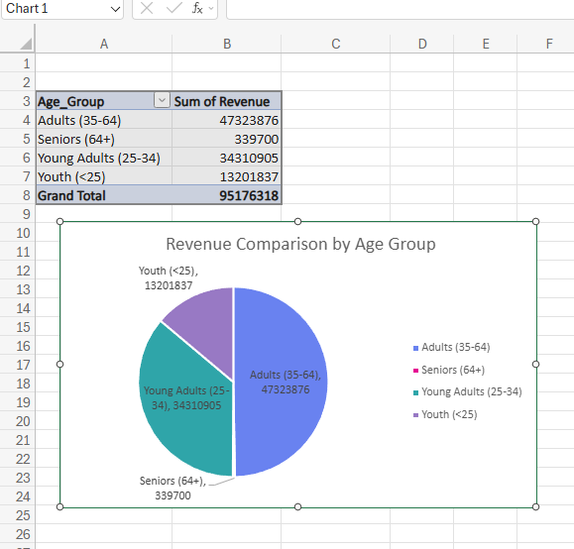

Day 4: Task 1

You have been asked to deliver your analysis findings to the board of directors, with your analysis you have identified that customers are leaving your company at the 12-month point, this is typically when they receive their renewal price.

Conduct research and complete the below questions:

How would you prepare for the delivery? | I would research who the board of directors are, to be able to define how I should present my findings to them, whether I can use more technical speech or to be able to tell it more simply as it is a story. I would build what narrative needs to be told about my findings, I would structure it as costumers do not return when they receive their renewal prices, then provide a potential solution and what impact that could have (returning customers). I would talk to my peers and to be able to ask questions, help anticipate questions that may come up, especially if any one has worked with this company or the board members before.
What tools would you use for the delivery? | Tools that can be used for the delivery are, Powerpoint, Google slides, PowerBI, Tableau, Canva, Visme, Teams or zoom (for remote if a remote delivery is needed).
What is prospecting and why would you complete this before your delivery? | Prospecting is where you identify who the stakeholders are, what information the different stakeholders need (if any) and research them. This will help identify what they want to be told at the meeting, what they may object to so I can provide anticipated responses and have data to back up what I am saying to them.
Tell me best practices for public speaking and providing updates to senior leaders | Confidence is key when public speaking. Rehearse the presentation, so you know what you are going to say without stumbling, practice with peers. Do not ramble, be concise with what you are telling them. Have a strong concise, introduction. Have a main body of what you are you presenting, and have a strong conclusions, open the floor for questions at the end. Look in to the eyes of the people who are viewing the presentations, keep it brief (finish a thought) and look at everyone in the room. Keep slides simple and easy to follow. Speak to the back of the room. Keep stance still, if you need to move, move with a purpose.  To implement this I would start with Renewal prices are turning customers away. Make sure slides are clear and uncluttered, to be easy to follow.  Tell a story, even better if I am able to humanise the data with customers feedback, to give more body to the data. Focus on desired outcomes towards the end and open the floor to questions.
What will you show the board in your delivery? | I would show a clear overview of what I have found from the data and what implications that has. I would structure what I was going to say based around a story, I.e beginning (problem), middle(data) and end (solution). With a structured journey that you guide the listeners through. I would show graphs to show this customer drop off at the 12 months mark.  I would show competitors prices (if applicable) compared to the companies. Feedback from customers in surveys to give more body to the data, with the addition of quotes from customers to humanise the data. I would then give the financial implications of customers leaving, what my proposed solutions is, such as giving discounts to returning customers, maybe more discount for the more years they have been a customer). Show my predicted solutions in a graph for potential future revenue. I would give my conclusion. Then open up the floor for any questions.
How will you articulate the changes that are needed? | I will have graphs with predicted outcomes, potentially other data what loyalty systems work for returning customers. This will help back up what I am saying.  Say simply “I propose having renewal offers that are loyalty based, based on how many years the customer has been with us. Hold a testing phase to the rollout to help validate results and protect from any fallen revenue.”
Provide a list of online resources and videos that will support your preparation for public speaking | Toastmasters International  Coursera – Public Speaking Courses  MindTools – Public Speaking Guide  Presentation Zen  The Speaker Lab  7 Public Speaking Tips for Beginners  The public speaking lesson you never had | DK . | TEDxNelson  How to Prepare for a Speech in Less Than a Minute  PUBLIC SPEAKING TIPS FOR BEGINNERS THAT WORK!  How to Prepare for a Speech | Public Speaking  Public Speaking For Beginners
Evaluate tools that provide visualisation.  Tell me what they are.  Tell me what you would choose when delivering your presentation and why | PowerBi is easily interated with excel and teams but it is limited for visual and storytelling. Tableau is good for advanced anyalitics it is also very good for visuals, however this is a cost to use. Excel is limited and slows down for large data, hard to track changes with shared files when there are multiple users in a team, opens up for human errors.  I would personally use Canva for presentations and infographics, to help with visually telling the board about what the issues I came across, potential solutions and the potential outcome. Tableau or PowerBI to be able to present interactive dashboards and show trends. I would use teams for remote delivery, to ease screen sharing.

Course Notes

It is recommended to take notes from the course, use the space below to do so, or use the revision guide shared with the class:

sort
SUM
Average
max
best
worst
highest and lowest scores

A client has approached you with several workbooks full of raw data, and they ask you to analyse it. How do you approach this task?
What they want to get out of analysing the data, names, revenue, projected sales, etc., scale of the data and responsibilities team, define Requirements. Where is the data coming from, and what is the format of the data,
When are the deadlines?
security requirements, password protection, and encryption.
formats, and duplicates
clean data, condense the data/consolidate, create tables

What features and functions would we use?
pivot tables, named ranges and tables, validate data, sumifs, charts, xlookup/vlookup

Excel is great, but what are the limitations and alternative choices?
slows down for larger data, hard to track changes with shared files for multiple people working on the files, human errors can and do happen.
Power BI, Google Sheets, SQL Databases, Python, Tableau

Additional Information

We have included a range of additional links to further resources and information that you may find useful, these can be found within your revision guide.

END OF WORKBOOK

Please check through your work thoroughly before submitting and update the table of contents if required.

Please send your completed work booklet to your trainer.

