

Data Technician

Name: Laura Brown
Course Date:
Table of contents

Day 1: Task 1 3
Day 1: Task 2 3
Day 3: Task 1 4
Day 4: Task 1: Written 6
Day 4: Task 2: SQL Practical 9
Course Notes 19
Additional Information 19

Day 1: Task 1

Please research and complete the below questions relating to key concepts of databases.

What is a primary key? | A Primary Key is a unique identifier that identifies a row. This is often a CustomerID and is ideally created by having a natural key, if there is not natural key it is ideal to create a unique number or use a GUID (globally unique identifier). Natural keys are based off information that already exists, this could be something such as phone number or email address.
How does this differ from a secondary key? | Secondary keys are not necessary but the use of them helps in data retrieval and data efficiency. Secondary keys are identified by columns that identify rows but are not the primary key.
How are primary and foreign keys related? | The primary key is a unique identifier on a table. Different tables all have a Primary Key for that specific table. The way to link different tables are to use foreign keys, this is the use of other tables primary keys in a table. The foreign keys link the other tables to a specific table. However a composite primary key does not have its own key as it uses foreign keys as identifiers.
Provide a real-world example of a one-to-one relationship | One person has one National insurance number.  One person has one NHS number.  One person has one Passport  One person has one Driving license.  Husband and wife.
Provide a real-world example of a one-to-many relationship | One mother can have many children  One customer has many orders  One country has many cities.
Provide a real-world example of a many-to-many relationship | Many students have many courses  musicians to bands  events and volunteers  actor and film  recipe and ingredients

Day 1: Task 2

Please research and complete the below questions relating to key concepts of databases.

What is the difference between a relational and non-relational database? | The differences between a Relational Database (RDBMS) and a  Non-Relational Database AKA Not only SQL (NoSQL) are that they scale differently, RDBMS scales vertically i.e. bigger servers and NoSQL scales horizontally more servers. RDBMS is schema based so it has fixed relationships and NoSQL’s can be in many formats so it is easier to change data.
What type of data would benefit off the non-relational model?  Why? | Unstructured data would benefit from this type of model as it has many different file types and it can be stored without changing any information or the file, and if more data needs to be added on at a later date it can be changed without changing the original information.

Day 3: Task 1

Please research the below ‘JOIN’ types, explain what they are and provide an example of the types of data it would be used on.

Self-join | Compares rows within the same table, could be used for students who have the same teacher.
Right join | All right table rows and matched left rows, could be used for showing all suppliers.
Full join | Combines everything both matched and unmatched, could be used for, creating contact lists.
Inner join | INNER JOIN returns only the matching rows from both tables, could be used for customers and their orders.
Cross join | Matches every row from one table with every row in another table, could be used for employees and shirt time.
Left join | Matches all left table rows even if there is no match on the right, leaving potential null values, could be used for showing all products as would include not sold.

Day 4: Task 1: Written

In your groups, discuss and complete the below activity. You can either nominate one writer or split the elements between you. Everyone however must have the completed work below:

Imagine you have been hired by a small retail business that wants to streamline its operations by creating a new database system. This database will be used to manage inventory, sales, and customer information. The business is a small corner shop that sells a range of groceries and domestic products. It might help to picture your local convenience store and think of what they sell. They also have a loyalty program, which you will need to consider when deciding what tables to create.

Write a 500-word essay explaining the steps you would take to set up and create this database. Your essay should cover the following points:
- Understanding the Business Requirements:
  - What kind of data will the database need to store?
  - Who will be the users of the database, and what will they need to accomplish?
- Designing the Database Schema:
  - How would you structure the database tables to efficiently store inventory, sales, and customer information?
  - What relationships between tables are necessary (e.g., how sales relate to inventory and customers)?
- Implementing the Database:
  - What SQL commands would you use to create the database and its tables?
  - Provide examples of SQL statements for creating tables and defining relationships between them.
- Populating the Database:
  - How would you input initial data into the database? Give examples of SQL INSERT statements.
- Maintaining the Database:
  - What measures would you take to ensure the database remains accurate and up to date?
  - How would you handle backups and data security?

Your essay should include specific examples of SQL commands and explain why each step is necessary for creating a functional and efficient database for the retail business.

Please write your 500-word essay here | The database for a small shop needs to store the following information, for the store to be able to have accurate and up-to-date records, inventory(products), which will include, itemID, item name, stock level, cost, quantity, category, date imported, item status. Then sales will need to include the following information, sale id, sales date, customer id and item id. Also customer information, customer id, name, email address, phone number and password. With clubcard id, creation date, expiry date, customer, id, and clubcard points. And sales, sale id, profit, sale date and purchase id. The users of the database, shop manager update stock and prices, sales assistant (view, record transactions) and IT support (full access).  I would use a snowflake schema to link the primary and foreign keys of each table. This will allow addition of other tables in the future for is the shop expands or get many more suppliers that it needs to keep track of. The Sales would link to purchases via purchase id, purchase would link to inventory via item ID, Customer would link to purchase via purchase id. Then club card id would link to customer via customer id. This will link the different information together between the tables.  To create the new database I would run the following codes one after the other  DROP DATABASE IF EXISTS corner_shop_records CREATE DATABASE corner_shop_records; Then to create table I would use CREATE TABLE products (purchaseID INT, itemID INT, purchase_cost DEC, clubcard_used CHAR (3), date_purchased DATETIME );  I would INSERT INTO products (purchaseID, itemID, purchase_cost, clubcard_used, date_purchased) VALUES (“5432”, “347990”, 1.00, “yes”, “2025-01-25 11:10:23”)  Ensuring the database is regularly its very important it is important, that it is updated semi frequently at the end of the day, also that the software is updated for when new versions are released. It is important that the database is kept as a hard copy as well as online copy, in case any information is lost, corrupted or hacked. I would also suggest a hard copy of the database that in updated separately once a week and is stand alone, as in it is not connected any network. I would suggest stock is updated after each sale to be able to buy new items as needed. I would employ role based access across access to the database, such as the manager, being able to update stock and prices, staff would only be able to records sales transactions and tech support would have full access. I would create a password for the data base and encrypt sensitive customer data. SQL queries being created using this data would be very useful as emails could be sent to customers meeting certain criteria. This would also be useful to be able to keep track of customer loyalty as the ability to be able to send emails to customers with discounts or weekly and monthly bargains for them, it could include, personalised or store wide deals. For potential shop expansion or more staff needed I would suggest database auditing be implemented as this can help keep track of who made what additions and when to the database.

Day 4: Task 2: SQL Practical

In your groups, work together to answer the below questions. It may be of benefit if one of you shares your screen with the group and as a team answer / take screen shots from there.

Setting up the database:

- Download world_db(1)
- Follow each step to create your database

For each question I would like to see both the syntax used and the output.

- Count Cities in USA: Scenario: You've been tasked with conducting a demographic analysis of cities in the United States. Your first step is to determine the total number of cities within the country to provide a baseline for further analysis.

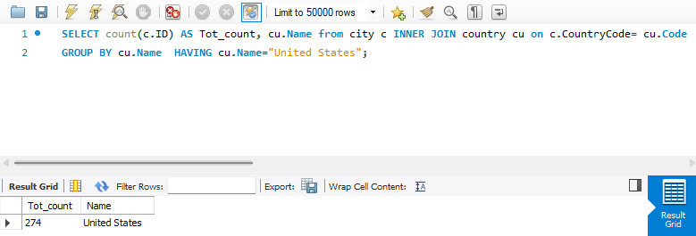
- Country with Highest Life Expectancy: Scenario: As part of a global health initiative, you've been assigned to identify the country with the highest life expectancy. This information will be crucial for prioritising healthcare resources and interventions.

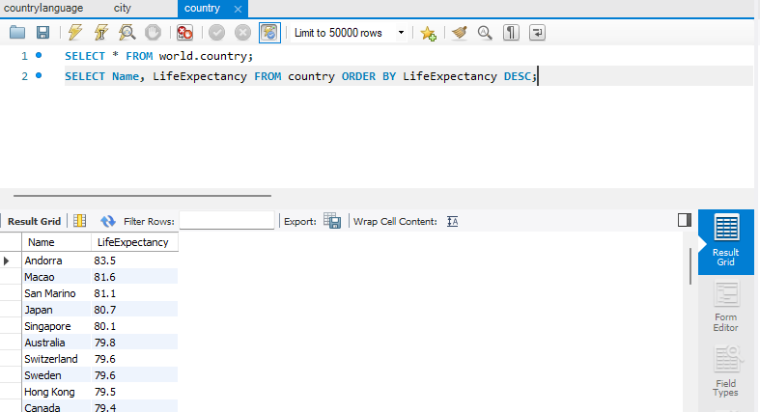

- "New Year Promotion: Featuring Cities with 'New : Scenario: In anticipation of the upcoming New Year, your travel agency is gearing up for a special promotion featuring cities with names including the word 'New'. You're tasked with swiftly compiling a list of all cities from around the world. This curated selection will be essential in creating promotional materials and enticing travellers with exciting destinations to kick off the New Year in style.

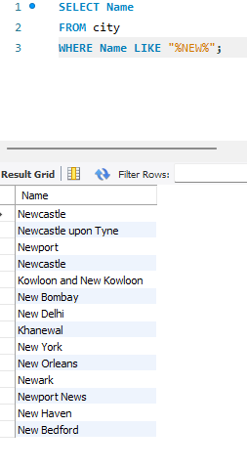

- Display Columns with Limit (First 10 Rows): Scenario: You're tasked with providing a brief overview of the most populous cities in the world. To keep the report concise, you're instructed to list only the first 10 cities by population from the database.

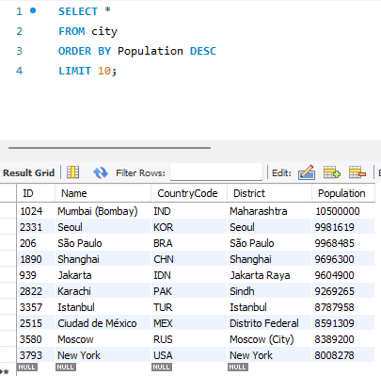

- Cities with Population Larger than 2,000,000: Scenario: A real estate developer is interested in cities with substantial population sizes for potential investment opportunities. You're tasked with identifying cities from the database with populations exceeding 2 million to focus their research efforts.

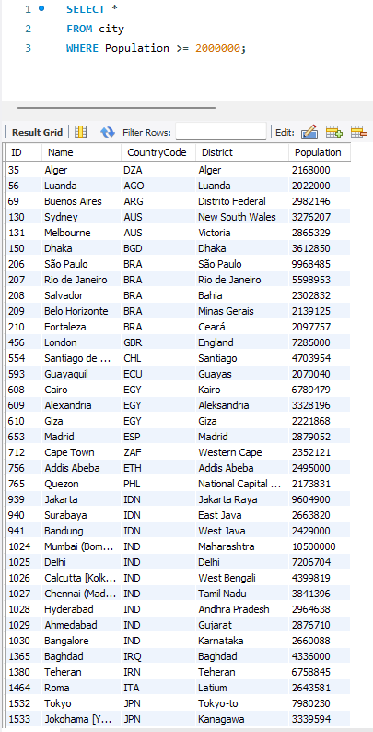
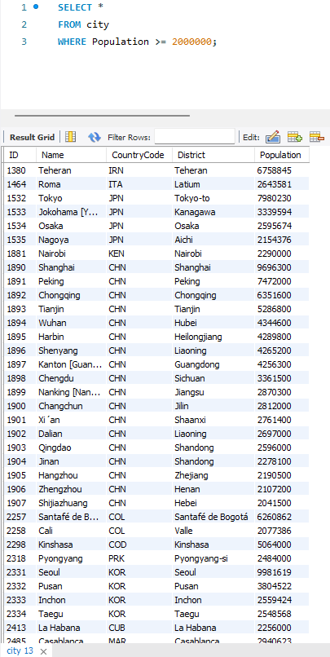

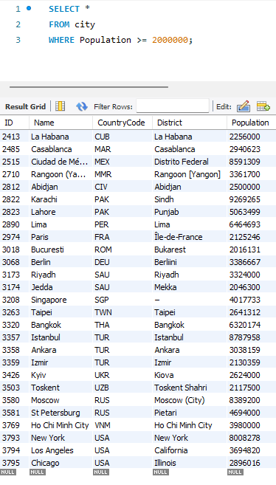

- Cities Beginning with 'Be' Prefix: Scenario: A travel blogger is planning a series of articles featuring cities with unique names. You're tasked with compiling a list of cities from the database that start with the prefix 'Be' to assist in the blogger's content creation process.

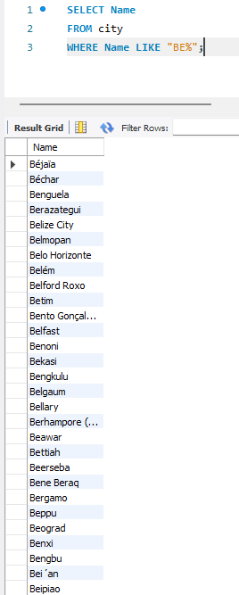

- Cities with Population Between 500,000-1,000,000: Scenario: An urban planning committee needs to identify mid-sized cities suitable for infrastructure development projects. You're tasked with identifying cities with populations ranging between 500,000 and 1 million to inform their decision-making process.

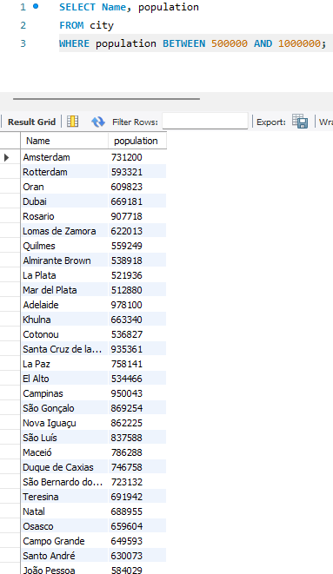

- Display Cities Sorted by Name in Ascending Order: Scenario: A geography teacher is preparing a lesson on alphabetical order using city names. You're tasked with providing a sorted list of cities from the database in ascending order by name to support the lesson plan.

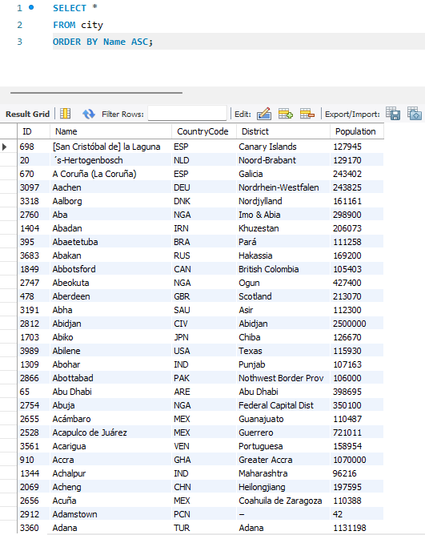

- Most Populated City: Scenario: A real estate investment firm is interested in cities with significant population densities for potential development projects. You're tasked with identifying the most populated city from the database to guide their investment decisions and strategic planning.

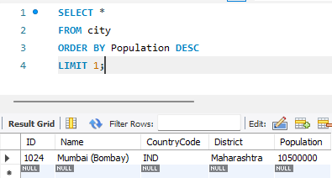

- City Name Frequency Analysis: Supporting Geography Education Scenario: In a geography class, students are learning about the distribution of city names around the world. The teacher, in preparation for a lesson on city name frequencies, wants to provide students with a list of unique city names sorted alphabetically, along with their respective counts of occurrences in the database. You're tasked with this sorted list to support the geography teacher.

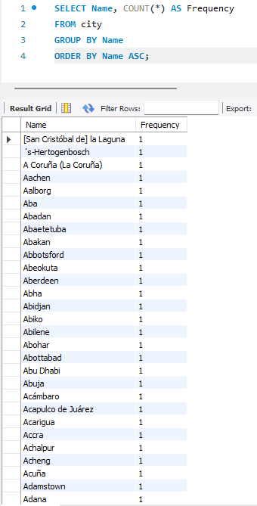

- City with the Lowest Population: Scenario: A census bureau is conducting an analysis of urban population distribution. You're tasked with identifying the city with the lowest population from the database to provide a comprehensive overview of demographic trends.

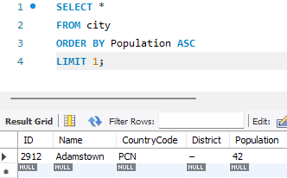

- Country with Largest Population: Scenario: A global economic research institute requires data on countries with the largest populations for a comprehensive analysis. You're tasked with identifying the country with the highest population from the database to provide valuable insights into demographic trends.

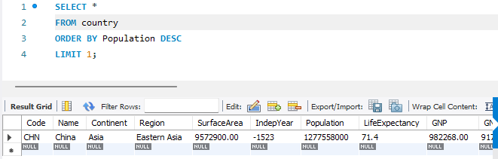
- Capital of Spain: Scenario: A travel agency is organising tours across Europe and needs accurate information on capital cities. You're tasked with identifying the capital of Spain from the database to ensure itinerary accuracy and provide travellers with essential destination information.

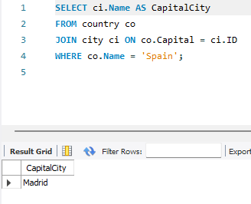

- Country with Shortest Life Expectancy: Scenario: A healthcare foundation is conducting research on global health indicators. You're tasked with identifying the country with the highest life expectancy from the database to inform their efforts in improving healthcare systems and policies.

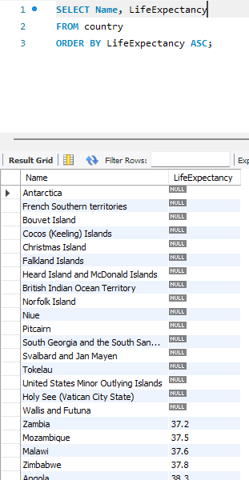

- Cities in Europe: Scenario: A European cultural exchange program is seeking to connect students with cities across the continent. You're tasked with compiling a list of cities located in Europe from the database to facilitate program planning and student engagement.
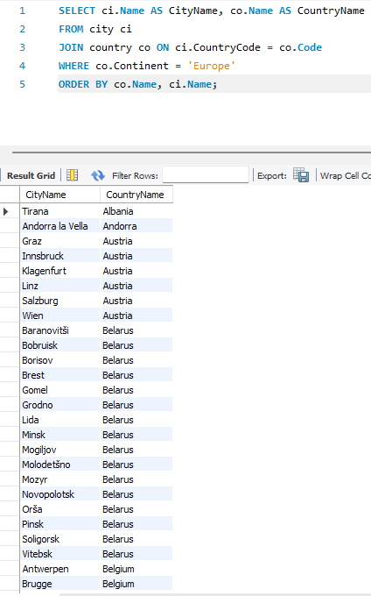

- Average Population by Country: Scenario: A demographic research team is conducting a comparative analysis of population distributions across countries. You're tasked with calculating the average population for each country from the database to provide valuable insights into global population trends.

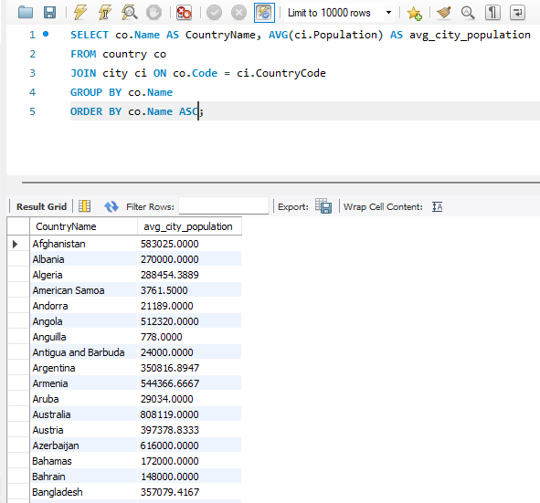

- Capital Cities Population Comparison: Scenario: A statistical analysis firm is examining population distributions between capital cities worldwide. You're tasked with comparing the populations of capital cities from different countries to identify trends and patterns in urban demographics.

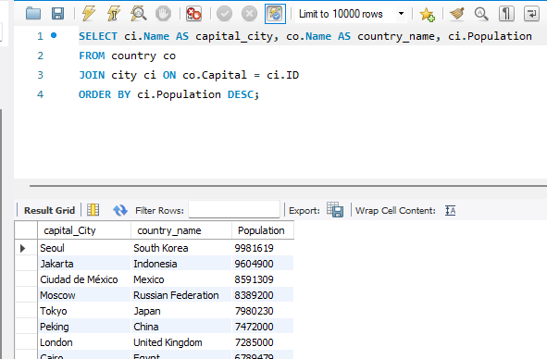

- Countries with Low Population Density: Scenario: An agricultural research institute is studying countries with low population densities for potential agricultural development projects. You're tasked with identifying countries with sparse populations from the database to support the institute's research efforts.

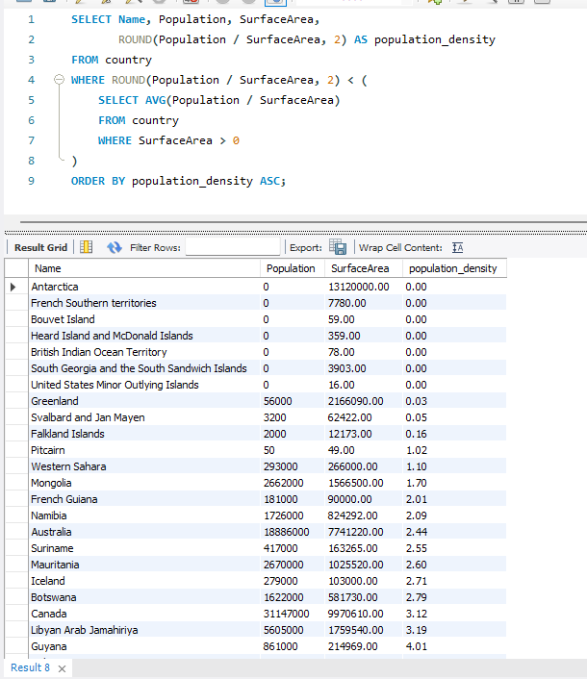

- Cities with High GDP per Capita: Scenario: An economic consulting firm is analysing cities with high GDP per capita for investment opportunities. You're tasked with identifying cities with above-average GDP per capita from the database to assist the firm in identifying potential investment destinations.

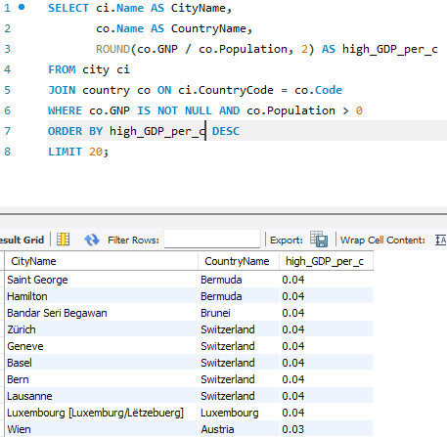

- Display Columns with Limit (Rows 31-40): Scenario: A market research firm requires detailed information on cities beyond the top rankings for a comprehensive analysis. You're tasked with providing data on cities ranked between 31st and 40th by population to ensure a thorough understanding of urban demographics.

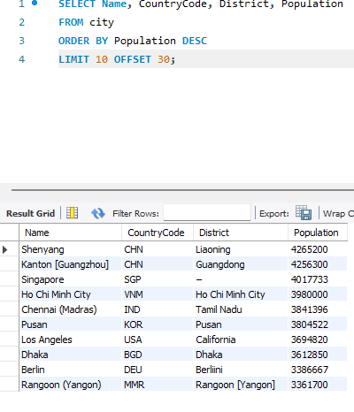

Course Notes

It is recommended to take notes from the course, use the space below to do so, or use the revision guide shared with the class:

Additional Information

We have included a range of additional links to further resources and information that you may find useful, these can be found within your revision guide.

END OF WORKBOOK

Please check through your work thoroughly before submitting and update the table of contents if required.

Please send your completed work booklet to your trainer.

