

Data Technician

Name: Laura Brown
Course Date: 08/09/25
Table of contents

Day 1: Task 1 3
Day 1: Task 2 3
Day 1: Task 3 4
Day 2: Task 1 5
Day 3: Task 1 9
Day 3: Task 2 10
Day 3: Task 3 11
Day 4: Task 1 12
Day 4: Task 2 13
1. Scenario Background 13
2. Data Laws and Regulations 14
3. Azure Service Recommendations 14
4. Data Types and Data Modelling 14
5. Data Storage Formats and Structures in Azure 14
6. Additional Considerations 15
Submission Guidelines: 15
Course Notes 17
Additional Information 17

Day 1: Task 1

Please research and complete the below questions relating to key concepts of cloud.

Be prepared to discuss the below in the group following this task.

What can cloud computing do for us in the real-world? | Cloud computing can give us storage for files and images, such as one drive for files and google photos for images. This keeps them safe and enables us to not worry personally about these files being lost on our own hard drives. There is software that is available through cloud services such as Microsoft 365 which is used by a lot of professional and students. There are tools that are available such as Trello that are online and their services are used through cloud.
How can it benefit a business? | It can benefit a business by cutting costs as they offer pay as you go services. This is useful for data storage as you only pay what you use and need. Security on cloud computing is at a high end as they have set up security and has been tested, as a business, especially smaller businesses, this is can be an issue in securing your own hard drives and storage, if you don’t have the knowledge yourself or the money to pay somebody to implement security measures for you. The cloud storage is a way wound this as it is has already been done by the company you are paying for the storage.
What’s the alternative to cloud computing? | The alternatives to cloud computing are to have their own hard drives and security, which is costly, and hard drives can be unreliable as all the information is saved on the one drive. On the cloud the same information can be split over many so if a server get corrupted or hacked, it is only one part of that information is lost. It can also mean paying for software that you use, all of this is costly especially is you dont need to use it all the time.
What cloud providers can we use, what are their features and functions?
  Features | AWS | Azure | GCP
  Database options | RDS (Relational Database Service, DynamoDB, Redshift | SQL Database, Cosmos DB | Cloud SQL, BigQuery
  Security & IAM (Identity and Access Management) | IAM, Shield, WAF (Web Application Firewall) | Azure AD, Security Center | IAM, Cloud Armor, Security Command Center
  Best For | Broadest service range, enterprise | Microsoft ecosystem, hybrid setups | Big data, analytics, AI/ML

Day 1: Task 2

Please research the below cloud offerings, explain what they are and examples of use cases.

Cloud Offerings | Explain what it is | When / how might you use this service in the real-world?
IaaS (Infrastructure as a service) | You can use virtual machines, storage and networks on a pay as you go basis.  Ideal for when you need to control all aspects but you don’t need to buy the hardware. | For hosting websites and secure databases.
PaaS (Platform as a service) | Is a platform that enables users to build and test applications. You don’t need to manage servers or Operating System updates. | Developers building apps, automating work flows.
SaaS (Software as a service) | Is a ready made software that is available direct to use online. For when you need access anywhere, at home or work. Everything is managed for you. | Using services such as Canva and emails.

Day 1: Task 3

Please research the below terms and explain what they are, when they would be appropriate and a real-world example of where it could be implemented (i.e. what type of organisation).

Public Cloud | This is cloud services such as AWS, Azure and Google Cloud that are shared for customers to use, it is ideal for E-commerce to handle intermittent traffic spikes.
Private Cloud | Is used by a single business or organisation.  It is not shared by others and is private, it is used by organisations such as banks.
Hybrid Cloud | Hybrid is a mix of both public and private cloud. It is used by organisations such as healthcare, as data from patients is private but needs to be access by certain members such as Dr’s to review the patients files.
Community Cloud | A community cloud is when multiple organisations work together for a more cost effective and shared structure. Places that would use this are organisations such as universities.

Day 2: Task 1

Describe, with examples, the three major areas that the Computer Misuse Act deals with.

Area | Description | Example
Unauthorised Access  to Computer Material | The means accessing a computer or system without permission. It is illegal to do so. | Guessing a password to someone’s account and logging in. Even if nothing is done, accessing the account itself is illegal.
Unauthorised Access  with Malicious Intent | This is when access is gained and they go on to commit a crime such as, steal information, money or commit fraud. | Once access is gained to a bank, using the persons details, using that account and then stealing money.
Unauthorised Modification of Computer Material | This is about deleting files, adding files, introducing viruses or changing data without permission. | Someone fired from their job installs malware on the system before leaving.

The computer misuse act 1990 is an act where an individual can be criminalised because of computer related offense. Describe three extra powers that the Police and Justice Act 2006 (Computer Misuse) has added.

Description
Denial of Service (DoS) attacks are now illegal, as it was not clear that it was a specific offense previously.

Sentencing for cybercrime can now lead up to 10 years in prison.

Police and Law enforcement were given powers to investigate and prevent cybercrime.

Look at the below website to answer the questions:
https://www.gov.uk/personal-data-my-employer-can-keep-about-me

Write down three items of data which a company can store about an employee.
Any accidents connected with work.

Sex.

National Insurance number.

Give three more examples of data that an employer can only store if they first get the employee’s permission.
Biometrics, for example if your fingerprints are used for identification.

Sexual history or orientation.

Trade union membership.

Conduct further research to answer the below questions.

Question | Answer
Provide one example of: Copyright infringement | Sharing pirated software.
Provide one example of: Plagiarism | Copying a new article and publishing it as your own work.
What are two consequences of copyright infringement and software piracy? | Up to a £5,000 fine and jail time of up to 10 years.
Give three possible consequences for individuals when using pirated software | The software could actually be a trojan horse, spyware or ransomware, so information could be stolen, users can be locked out of systems, systems could be corrupted and rendered useless. It can miss patches and updates from the official provider. The software wont be supported by technical support from the official vendor for issues that occur

Listed below are some laws which we have covered today:

1. Computer Misuse Act 1990
2. Police and Justice Act 2006 (Computer Misuse)
3. Copyright, Designs and Patents Act 1988
4. Copyright (Computer Programs) Regulations 1992
5. The Health and Safety (Display Screen Equipment) Regulations 1992
6. Data Protection Act 2018
7. Consumer Rights Act 2015

- Insert a number in the first column of each row to match each of the statements with one of the above Acts.

- One of statements is incorrect and not illegal. For this statement, write ‘Not illegal’.

Act number | Clause
4 | With some exceptions, it is illegal to use unlicensed software
7 | Any product, digital or otherwise, must be fit for the purpose it is supplied for
1 | Unauthorised modification of computer material is illegal
Not illegal | It is illegal to create or use a hacking tool for penetration testing
6 | Personal data may only be used for specified, explicit purposes
5 | Employers must provide their computer users with adequate health and safety training for any workstation they work at
2 | It is illegal to distribute hacking tools for criminal purposes
3 | It is illegal to distribute an illicit recording
6 | Personal data may not be kept longer than necessary
1 | Gaining unauthorised access to a computer system is illegal
Not illegal | Employers must ensure that employees take regular and adequate breaks from looking at their screens
1 | It is illegal to prevent or hinder access (e.g. by a denial-of-service attack) to any program or data held in any computer
6 | Personal data must be accurate and where necessary kept up to date

Day 3: Task 1

Please complete the below lab (3) ‘Explore relational data in Azure’ and paste evidence of the completed lab in the box provided.



Completed lab | 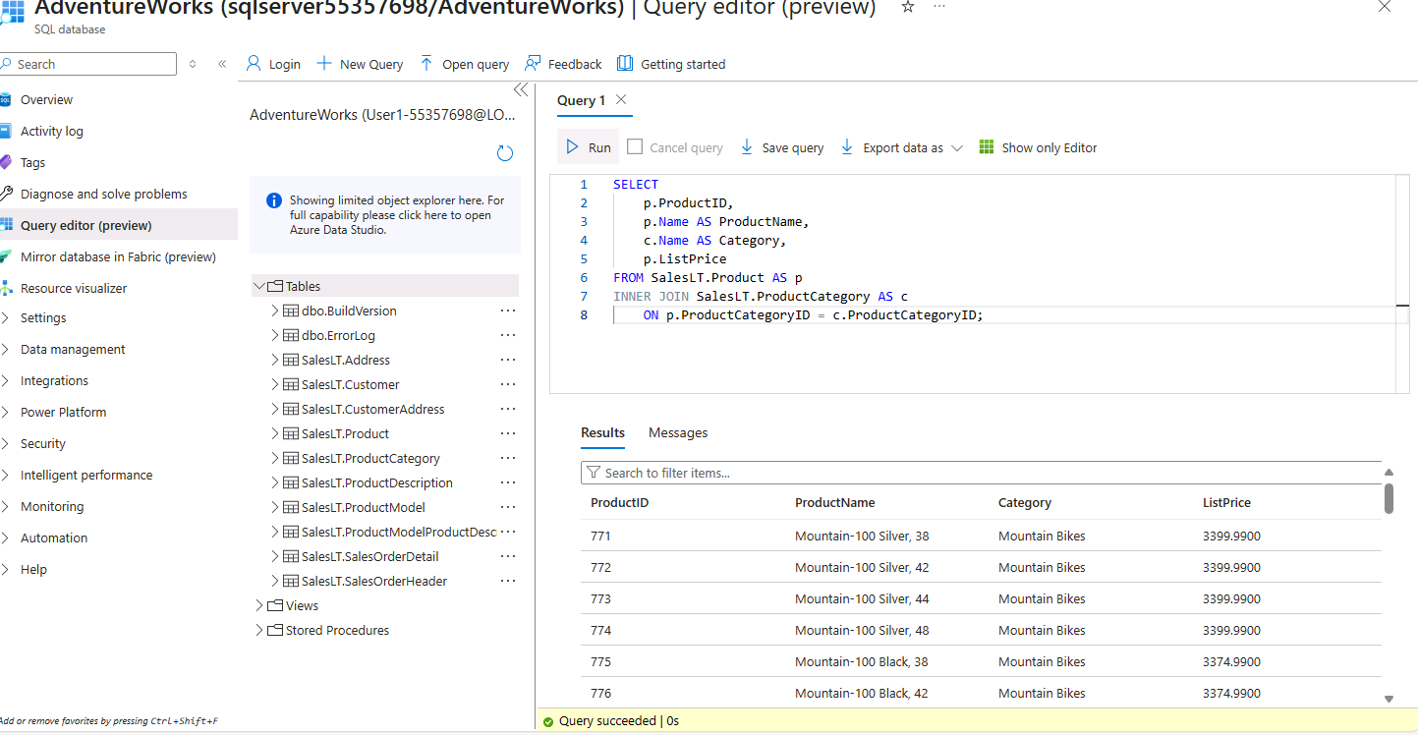

Day 3: Task 2

Please complete the below lab (4) ‘Explore non-relational data in Azure’ and paste evidence of the completed lab in the box provided.



Completed lab | 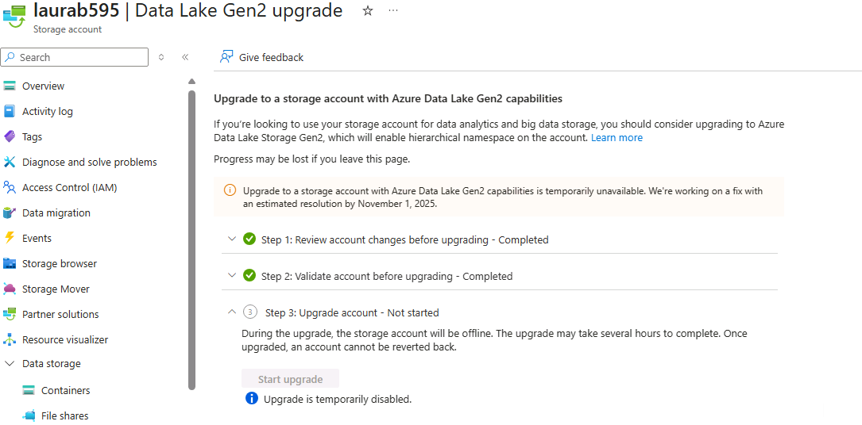  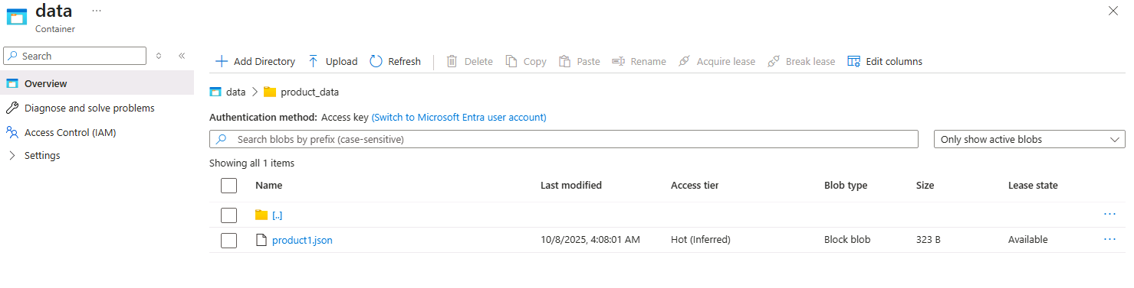  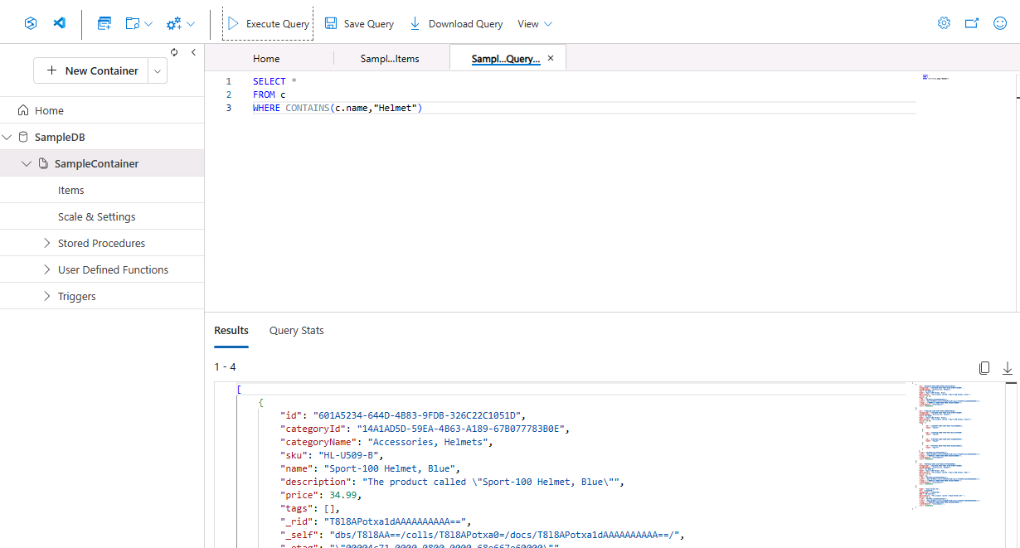  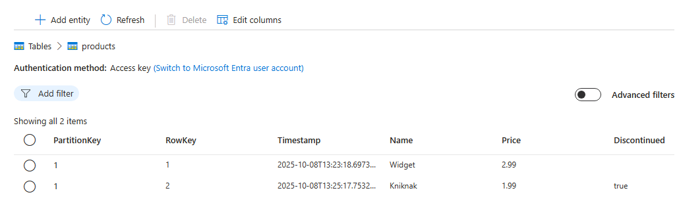  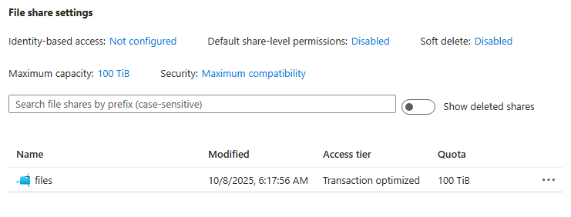

Day 3: Task 3

Please complete the below lab (5) ‘Explore data analytics in Azure’ and paste evidence of the completed lab in the box provided.

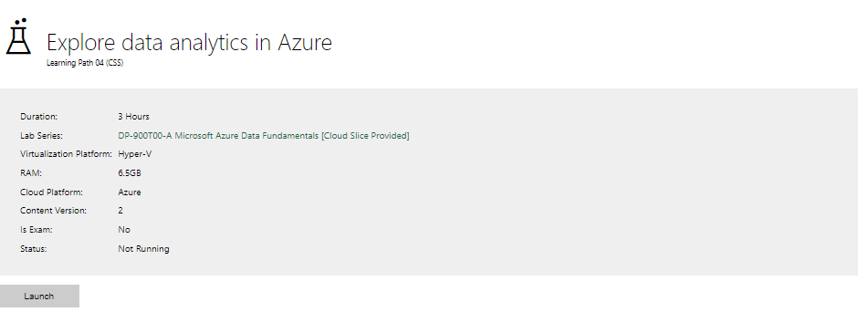

Completed lab | 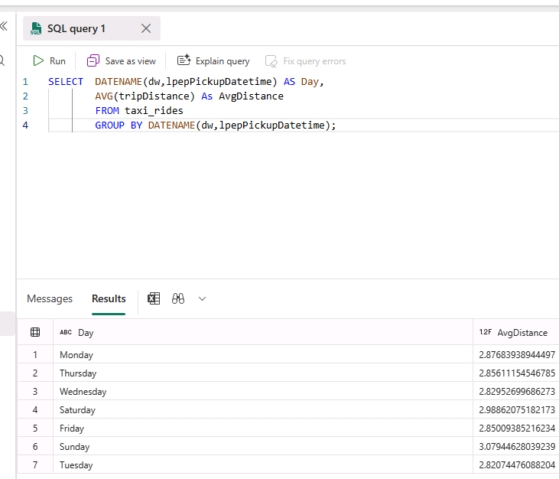  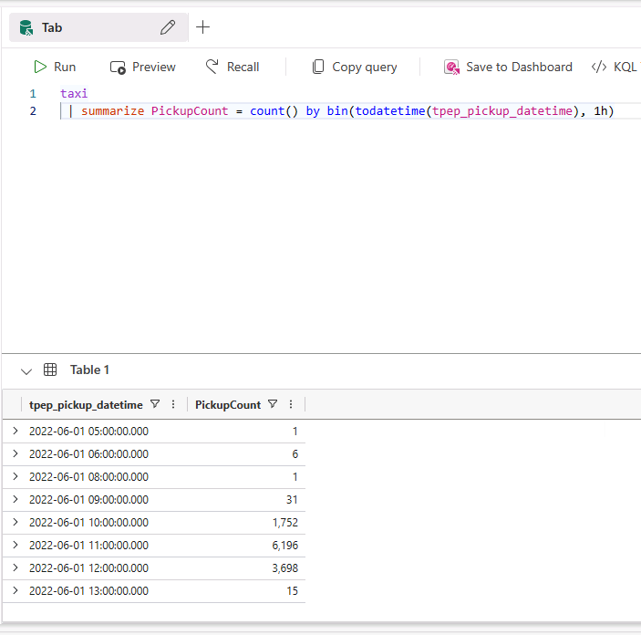  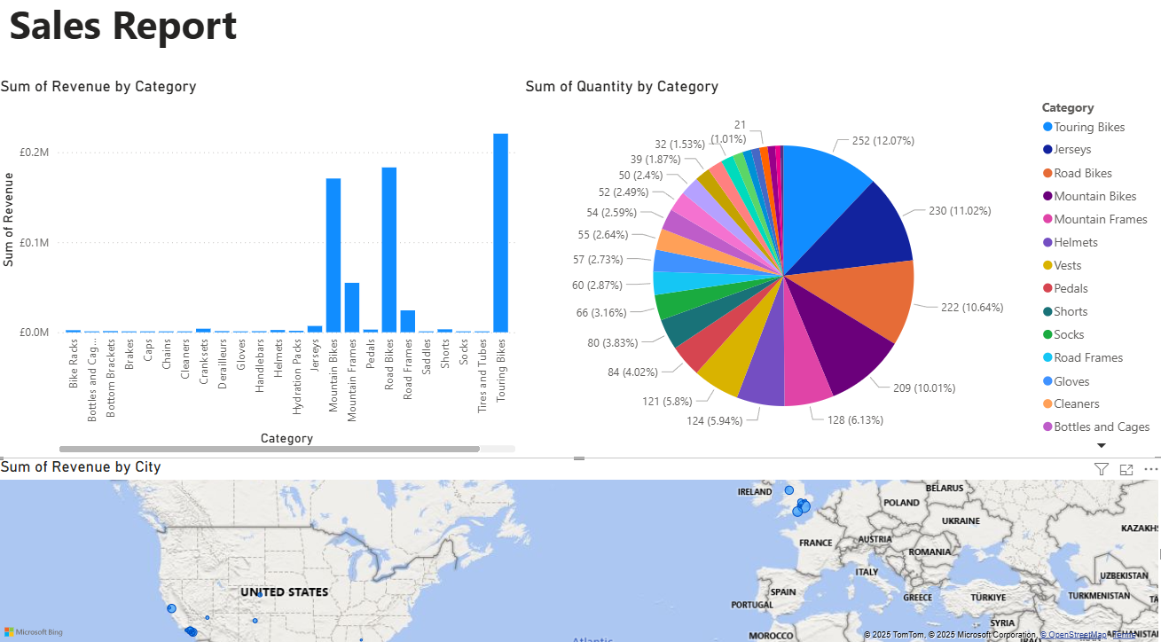

Day 4: Task 1

In your teams, complete the Azure DP-900 practice exam and paste your result below – this is open book and please research and discuss your answers as a team.


Result | 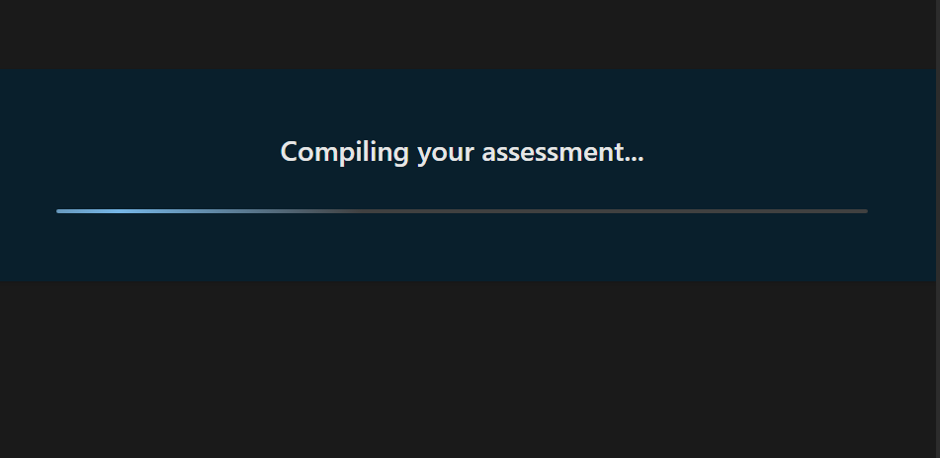  Placeholder, will try again this evening or on friday if I have a chance  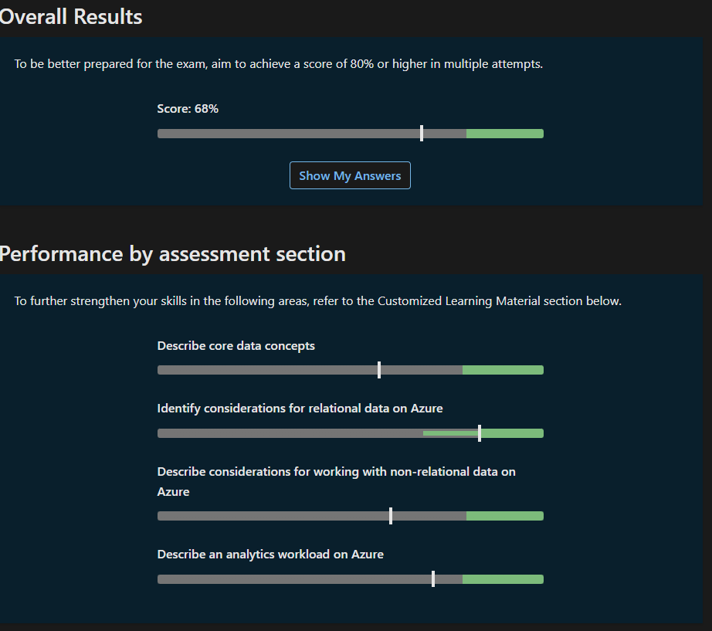  completed it in the evening.

Day 4: Task 2

1. Scenario Background
"Paws & Whiskers" is a growing pet shop that aims to improve its business by analysing sales, customer information, and inventory data. Currently, the data is collected manually or stored in spreadsheets. Management is interested in transitioning to Microsoft Azure to streamline data storage, analysis, and reporting, enabling them to make data-driven decisions.

2. Data Laws and Regulations
Identify and explain the data laws and regulations relevant to handling customer data within the proposal. Ensure you cover the following points:
- GDPR Compliance: Highlight the importance of adhering to the General Data Protection Regulation (GDPR), particularly as it relates to storing and processing customer information.
- Data Protection Act (DPA) 2018: Outline how the DPA 2018 may affect the way "Paws & Whiskers" collects and stores data, ensuring compliance with UK laws on data privacy.
- Other Industry Standards: Research any additional data protection standards or regulations that may apply to pet shop data, particularly if they involve sensitive or payment information.

3. Azure Service Recommendations
Recommend Microsoft Azure services that would suit the company’s data analysis needs and explain why these services are suitable. Your recommendations should include:
- Data Storage: Identify suitable storage options, such as Azure Blob Storage or Azure SQL Database, and discuss the benefits of each for storing large datasets, including inventory, sales transactions, and customer details.
- Data Analysis Tools: Recommend tools such as Azure Machine Learning for customer behaviour analysis or Azure Synapse Analytics for analysing sales trends.
- Data Integration and Automation: Explain how services like Azure Data Factory could automate data collection and integration processes, improving efficiency.

4. Data Types and Data Modelling
Define the types of data "Paws & Whiskers" will need to work with and describe your approach to data modelling:
- Data Categories: Identify key data types, such as customer demographics, transaction history, pet inventory, and product categories.
- Data Modelling Approach: Outline how you would structure this data using a relational model or a data warehouse approach, considering factors like tables, entities, relationships, and primary keys.

5. Data Storage Formats and Structures in Azure
Discuss how you would store data within Azure and the formats you would recommend:
- Data Formats: Specify recommended formats (e.g., CSV for raw data imports, JSON for structured data, Parquet for analytics) and explain why these formats are suitable for specific data types.
- Data Security and Encryption: Include recommendations for securing data using Azure’s built-in encryption features and access controls to ensure compliance with data privacy regulations.

6. Additional Considerations
Provide any other considerations that might enhance data handling and efficiency in Azure, such as:
- Backup and Disaster Recovery: Outline a backup plan using Azure Backup or Azure Site Recovery to safeguard against data loss.
- Data Visualisation: Discuss potential use of Power BI within Azure for creating dashboards that provide management with real-time insights into sales and customer trends.
- Future Scalability: Comment on how Azure services can scale as the business grows, accommodating larger datasets and more complex analyses.

Submission Guidelines:
- Structure: Ensure your report is well-organised, with sections for each task (e.g., Data Laws, Azure Services, Data Types, etc.).
- Formatting: Include headings, bullet points where appropriate, and any visuals or diagrams that support your explanations.
- References: Cite any resources or regulations referenced in the report.
- Length: Aim for 1500-2000 words.

With increasing competition in today’s retail world, it’s not just the largest retailers who are realising that data is a strategic asset. The pet shop, Paws and Whiskers (P&W) has hit a point, where collecting data manually or storing it in spreadsheets is not enabling them to meet their goals. As the number of sales transactions grows, as does customer data and more challenging stock management requirement, the company is migrating to a modern cloud-based system. The original spreadsheet set up has several issues as it is easy for their to be human errors in creating the tables and fields. It is also not very secure as if someone has a copy of the file it could be viewed quite easily. It can also be very slow to access specific information, especially as the store continues to grow in size.

With its broad offering of storage, integration, analytics and reporting services Microsoft Azure is the perfect scaleable platform for this business transformation. The tactical roadmap is the path outlined here to modernize with a move toward data maturity using a secure Data Lakehouse design. It revolves around three key priorities – achieving regulatory compliance through Compliance-by-Design, harnessing advanced analytics for predictive analysis and having a robust and cost-effective infrastructure.
Data Laws and Regulatory Compliance Framework
This end-to-end perspective covers the legal and regulations landscape, guidance for recommended Azure services, data types and modelling approaches, storage patterns and security - making sure to account for operational aspects such as backup, visualising or future scaling.
Before any tech solution can be in place a legal framework for how customer and business data is treated in the UK needs to fall into place.
P&W has to abide by some major legal and industry standards. The basic is the GDPR/DPA 2018 which practically contains seven principles about personal data:
Azure supports GDPR by aligning features with its seven principles: DSR tools, Policy, and RBAC ensure lawful, fair, and purpose-limited use; classification and retention policies enforce minimisation and storage limits; AAD updates and audit logs maintain accuracy; encryption, Key Vault, and Defender protect integrity and confidentiality; and Compliance Manager dashboards evidence accountability. Under the UK’s DPA 2018, the ICO regulates data protection, investigates breaches, issues fines, and provides guidance, with UK-specific exemptions and post-Brexit obligations. For PCI DSS, Azure secures cardholder data through network segmentation with VNets, Azure Firewall, NSGs, encryption, monitoring, RBAC, MFA, and vulnerability management.
The company must be transparent with what information it keeps and why. This should be used fairly and with clarity. All clients must be aware of what information (names, purchases) is being kept and how it’s used. Collect only what’s needed. The shop is to collect the minimum amount of data. When using data for analysis, personal identifiers must be removed and masked before adding them to large reports. Keep it accurate. All customer records are to be kept correct and up-to-date; old or wrong information is to be quickly fixed. Do not retain it perpetually: Data ought not to be kept beyond its period of use. Automated rules in Azure shall support the organization in disposing of old information thereby averting unneeded risk. Secure it; data ought to be safeguarded against breaches. The primary line of defence shall be Microsoft Entra ID (the shop’s digital identity system), since it acts as the only door to all sensitive data.
Besides general data protection, two specific obligations fall on P&W. Being a pet shop, it falls under the Animal Welfare Regulations, requiring records to be kept in detail and securely on every animal regarding health and history. Since it also takes card payments, the shop falls under an obligation to follow the PCI DSS standard. This means payment data has to be heavily protected with the use of firewalls; encryption for online payments and a "need-to-know" access enforced through specific user permissions. All these mandatory standards can be met by using features existing in Azure.
To manage all its various information-from protected client files, P&W will employ a mixture of Azure instruments, commonly referred to as a Data Lakehouse architecture.
P&W will use a combination of secure storage choices for different uses.
Azure Blob Storage is the huge, cheap Data Lake where it keeps big amounts of raw, unclean data (such as old spreadsheets and audit logs). <break> Azure Cosmos DB works for flexible quick-changing data, like social media comments or complex product details.
Azure Blob Storage tiers balance cost and access: Hot for active data, Cool for infrequent access with lower storage but higher retrieval costs, and Archive for long-term retention with minimal cost but slow recovery. Cosmos DB outperforms Azure SQL for scenarios like user reviews and complex product hierarchies, offering global distribution, schema flexibility, and elastic scaling. Azure Machine Learning drives business value with churn prediction (customer retention), recommendation models (personalization and sales uplift), and forecasting (demand and resource planning). Azure Synapse unifies data lake, warehouse, and big data processing, enabling efficient Parquet ingestion and optimized star schema analytics.
Azure Synapse Analytics is considered to be the main analysis engine. It enables the store to review all historical sales data for trends and calculations, such as stock reorder timing. Azure Machine Learning (Azure ML) is seen as the future predictor. Presumably, it will forecast what customers might want to buy next ("Next Best Offer") or recognise those who are about to stop shopping at P&W.
Reviews help in quick measurement of customer satisfaction. Azure Cognitive Services does the analysis.
Data Flow plus Automation
Azure Data Factory (ADF) is the pipeline that keeps moving the raw data for storage, cleaning it, reformatting it, and importantly removing personal info by masking personal identifiable information before storing it ready for analysis.
Azure Logic Apps handle simple automated actions, such as an alert when stock in low.
P&W handles several types of data: customer details, sales transactions, product inventory, and detailed pet health records. For analysis, this data will be organised using a Star Schema within Synapse. This approach separates measurable sales figures (Fact tables) from descriptive details like the customer's name and the product's colour (Dimension tables). This simple structure makes reports run much faster, simplifying complex business questions. Fact Table example below as Figure 1 and Dim Table example as Figure 2. The star schema works well because it balances simplicity and performance: a central fact table holds numeric measures, while dimension tables provide descriptive context. Queries become intuitive—business terms map directly to dimensions—and joins are minimal, reducing complexity. This design speeds aggregation, improves readability, and scales efficiently for analytics and reporting.

To ensure fast and cheap analysis, all data stored in the Data Lake must be converted into the Parquet format. Parquet organises data into columns, which is much more efficient than traditional row-based formats. This allows the analysis engine (Synapse) to look at just the necessary fields (e.g., only the date of purchase) without having to load entire customer records, cutting down on time and cost.
JSON is often preferred over CSV for POS transactions because it naturally handles hierarchical data, such as multiple items, discounts, and payment methods within a single sale, without needing multiple flat files. For analytics, Parquet is highly efficient: it stores data by column, so queries only scan the needed fields, compresses repeated values to save storage, and uses metadata for data skipping, which avoids scanning irrelevant blocks. This reduces both cost and query time. Security is enforced with RBAC: a Data Analyst might have read-only access to curated datasets and dashboards, while a Data Engineer has write and transform permissions to manage raw data, pipelines, and schemas. Together, these choices balance efficiency, scalability, and secure access.

Security

All data, whether in storage or being sent over the internet, is encrypted. For the most sensitive data, P&W will control the digital keys to the lock using Azure Key Vault.
Access is strictly managed by Microsoft Entra ID. Permissions are granted only to specific users for specific tasks, a system called Role-Based Access Control (RBAC).
All users accessing sensitive data must prove their identity using more than just a password (e.g., a code on their phone), adding a critical layer of protection.
Planning for the Unexpected
To guarantee that the data is always safe and the business can keep running, P&W needs a robust plan:

Azure Backup will protect against accidental data deletion, and Azure Site Recovery (ASR) can move the entire system to a different data centre if a disaster knocks out the main one. This ensures business continuity.
Azure Backup and Azure Site Recovery (ASR) serve different resilience needs: Backup enables point-in-time recovery of files, VMs, or databases, protecting against accidental deletion or corruption, while ASR ensures business continuity by replicating workloads to a secondary region for rapid failover during large-scale outages. ASR is critical for minimizing downtime and meeting compliance in disaster scenarios. On the growth side, Power BI dashboards transform raw data into actionable insights. An Inventory Alert dashboard highlights low or excess stock, prompting timely supplier orders or redistribution, while a Churn Risk dashboard identifies at-risk customers, enabling targeted retention campaigns. Together, these tools strengthen operational resilience, reduce risk, and support proactive, data-driven decision-making.

Finally, the shop will use Power BI to create simple dashboards that turn complex data into visual reports, giving managers real-time insights into sales, inventory, and predictive forecasts.

Images used below:
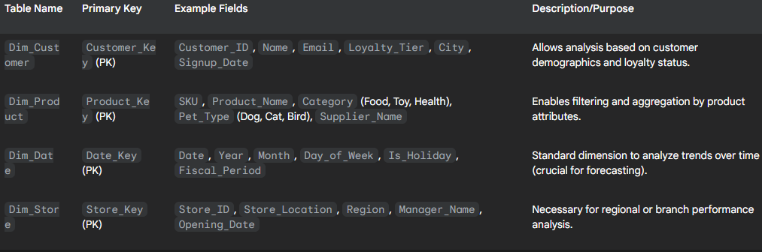Figure 2: Example of Dim Table to use
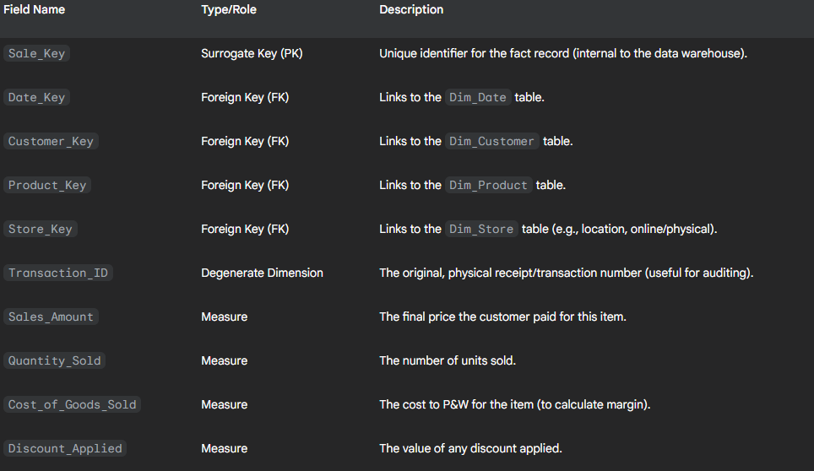Figure 1: Sales_Table example of Fact Table to use for star schema

References:
1) relating to GDPR; UK General Data Protection Regulation (UK GDPR) accessed on Dated 09/10/2025 at 14:03
2) relating to GDPR; Data Protection Act 2018 accessed on Dated 09/10/2025 at 14:06
3) relating to information kept on animals; Selling animals as pets licensing: statutory guidance for local authorities - GOV.UK accessed on Dated 09/10/2025 at 14:13
4) relating to store payments; PCI Security Standards Council – Protect Payment Data with Industry-driven Security Standards, Training, and Programs accessed on Dated 09/10/2025 at 14:23
5) relating to GDPR FSB | Complete guide to UK GDPR compliance for small businesses accessed on Dated 09/10/2025 at 15:42
6) relating to storage; Azure Data Lake Storage Gen2 overview in HDInsight | Microsoft Learn accessed on Dated 09/10/2025 at 15:44
7) relating to storage; Configure a lifecycle management policy - Azure Blob Storage | Microsoft Learn accessed on Dated 09/10/2025 at 17:37

Course Notes

It is recommended to take notes from the course, use the space below to do so, or use the revision guide shared with the class:

Microsoft Azure SQL database for customer information, transactions and inventory data.
Azure Blob storage for photos receipts.
Big data and analytics Azure data lake storage gen 2.
Historical reporting and data warehousing Azure synapse Analytics (SQL Pool).
Data integration Azure data factory.
workflow and automation Azure logic apps and Azure Functions.

Additional Information

We have included a range of additional links to further resources and information that you may find useful, these can be found within your revision guide.

END OF WORKBOOK

Please check through your work thoroughly before submitting and update the table of contents if required.

Please send your completed work booklet to your trainer.

