

***Introduction***

This curriculum, a joint project of TASC, Hive Learning Network NYC and Mozilla, is a remix of the [Hackasaurus Hacktivity kit](http://hackasaurus.org/en-US/). It provides educators in expanded learning time, after-school and other out-of-school time settings with a free, engaging, web-based model to teach kids how to move from digital consumers to active web producers.

This is a turnkey model that can be quickly disseminated among established after-school and other networks. The materials needed to implement this curriculum are:

* A computer for each student or team of participants
* Internet access
* The most recent version of one of the following browsers installed on each computer:
  + Firefox
  + Google Chrome
  + Safari
* The Hackasaurus X-Ray Goggles installed on the bookmark bar (don’t worry—we’ll tell you how to do this); and
* Kids and a facilitator with basic computer skills. These individuals should know how to operate a computer (turn it on and off), browse the Internet and be familiar with the “copy” and “paste” commands.

The curriculum offers lesson plans for three 45-minute sessions which can be implemented in or out of school. Each lesson plan is preceded by a “How to Begin” section that gives educators information on how to prepare and set up classrooms.

Lesson One introduces participants to hacking. Lesson Two has them dive into manipulating HTML. Lesson Three challenges them to create a STEM-focused webpage. All the lessons may be extended into more than one session, especially the last one. Feel free to use the lessons as written or to tinker with them — that’s what hacking is all about, as you’ll see.

***What is TASCasaurus?***

TASCasaurus is a partnership between TASC, a nonprofit intermediary organization, and Hive Learning Network NYC and Mozilla, the two creators of Hackasaurus. Our goal is to:

* Prepare and motivate community educators to deliver technology-enabled, student-driven learning opportunities using the Hackasaurus tools.
* Use technology to engage youth in a project that will increase both their **digital literacy** and interest in **STEM** (science, technology, engineering, and mathematics[1]).

A pilot project was implemented in six New York City after-school programs to engage kids in 4th to 8th grades to re-mix websites and research STEM content. This curriculum is a result of that collaboration.

Ready? Let’s begin!

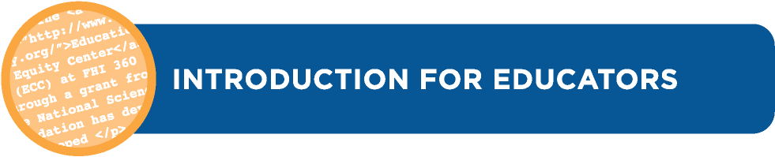

***What is Hackasaurus?***

Designed as an **open educational resource (OER)** and an **open source project**, Hackasaurus promotes skills, attitudes and ethics that help youth thrive in today’s **digital age**. By making it easier for tweens and teens to experiment with the building blocks that make up the web, Hackasaurus enables them to move from **digital consumers** to **active producers** who view the web as something that can be constantly remixed and improved.

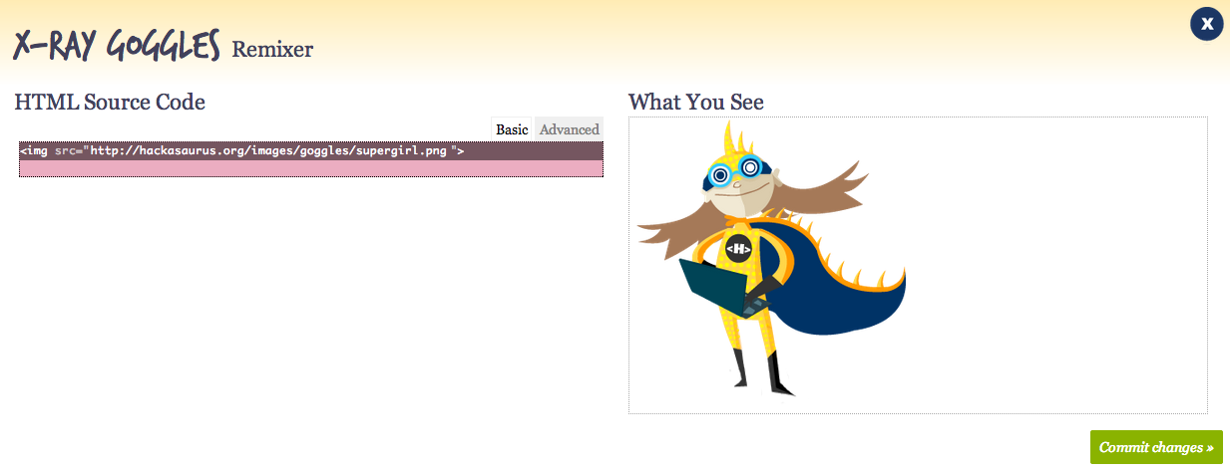

Instead of using “kid-ified” **sandboxes** or **artificial languages**, Hackasaurus lets youth **hack** their favorite web pages using real **programming code**. The **X-Ray Goggles bookmarklet** enables learners to visit any webpage and inspect the code, with **WebPad** (shown above) then allowing learners to take the next step by creating a copy of the **webpage** instantly which can be remixed to alter how it looks.

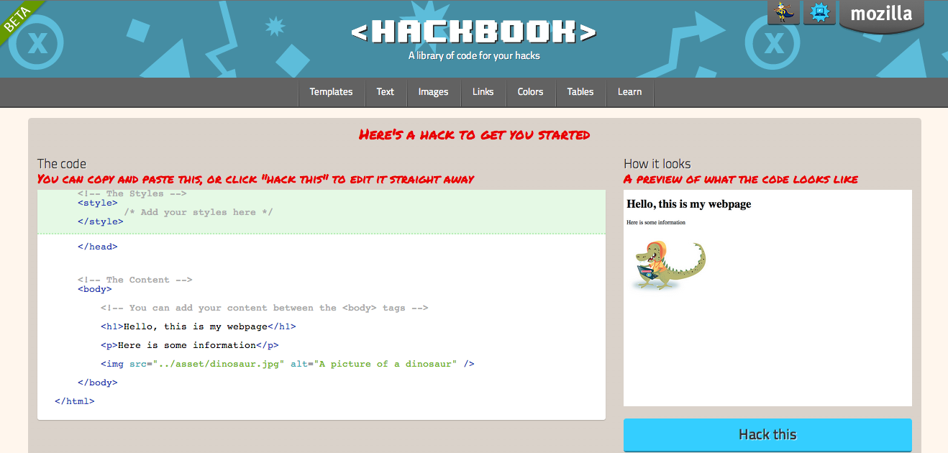

Lastly, the Hackbook (shown above) provides bits of commonly used code for learners to copy and paste. This is only the beginning though, as there are more tools being developed.

***Acknowledgements***

TASCasaurus is a joint effort of [TASC](http://www.expandedschools.org), the [Hive Learning Network NYC](http://www.explorecreateshare.org) and Mozilla. This curriculum is a remix of the [Hackasaurus Hactivity Kit](http://hackasaurus.org/en-US/). We thank the Mozilla Foundation   
and the Joan Ganz Cooney Center for Educational Media and Research for their support of   
this project.

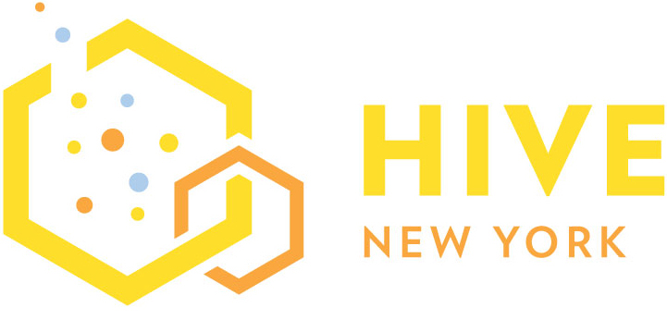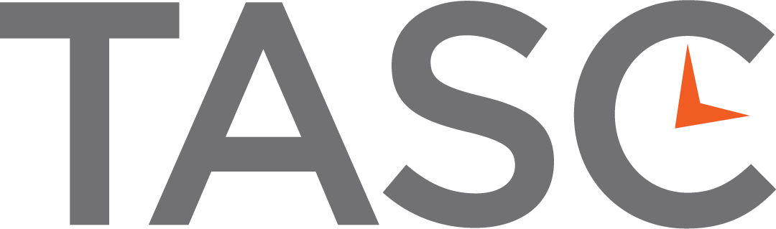

[www.expandedschools.org](http://www.expandedschools.org) [www.explorecreateshare.org](http://www.explorecreateshare.org)

1. *What is STEM?*

   “STEM” is an acronym of science, technology, engineering, and mathematics. It encompasses a wide array of topics and professional fields. An official list of STEM disciplines does not exist, but the [U.S. Immigration and Customs Enforcement](http://en.wikipedia.org/wiki/U.S._Immigration_and_Customs_Enforcement) lists disciplines including:

   |  |  |  |
   | --- | --- | --- |
   | * Physics * [Actuarial Science](http://en.wikipedia.org/wiki/Actuarial_Science) * [Chemistry](http://en.wikipedia.org/wiki/Chemistry) * [Mathematics](http://en.wikipedia.org/wiki/Mathematics) * [Statistics](http://en.wikipedia.org/wiki/Statistics) * [Computer Science](http://en.wikipedia.org/wiki/Computer_Science) * [Psychology](http://en.wikipedia.org/wiki/Psychology) * [Biochemistry](http://en.wikipedia.org/wiki/Biochemistry) * [Robotics](http://en.wikipedia.org/wiki/Robotics) * [Computer Engineering](http://en.wikipedia.org/wiki/Computer_Engineering) | * [Electrical Engineering](http://en.wikipedia.org/wiki/Electrical_Engineering) * [Electronics](http://en.wikipedia.org/wiki/Electronics) * [Mechanical Engineering](http://en.wikipedia.org/wiki/Mechanical_Engineering) * [Industrial Engineering](http://en.wikipedia.org/wiki/Industrial_Engineering) * [Civil Engineering](http://en.wikipedia.org/wiki/Civil_Engineering) * [Aerospace Engineering](http://en.wikipedia.org/wiki/Aerospace_Engineering) * [Chemical Engineering](http://en.wikipedia.org/wiki/Chemical_Engineering) * [Astrophysics](http://en.wikipedia.org/wiki/Astrophysics) * [Astronomy](http://en.wikipedia.org/wiki/Astronomy) * [Optics](http://en.wikipedia.org/wiki/Optics) | * Nuclear Physics * Mathematical Biology * Operations Research * Neurobiology * Biomechanics * Bioinformatics * Acoustical Engineering * Geographic information Systems * Atmospheric Sciences * Nanotechnology |

   The National Science Teachers Association (NSTA) explains that “STEM education is an interdisciplinary approach to learning where rigorous academic concepts are coupled with real-world lessons as students apply science, technology, engineering, and mathematics in contexts that make connections between school, community, work, and the global enterprise enabling the development of STEM literacy and with it the ability to compete in the new economy.”

   The United States Department of Education is encouraging more students, teachers, and practitioners to specialize in the STEM fields. NSTA states that “American industries need more workers in these fields due to an aging workforce and an increasingly innovative world market.” TASCasaurus aims to bridge the gap between STEM education and professional applications through hands-on engagement and fun activities.