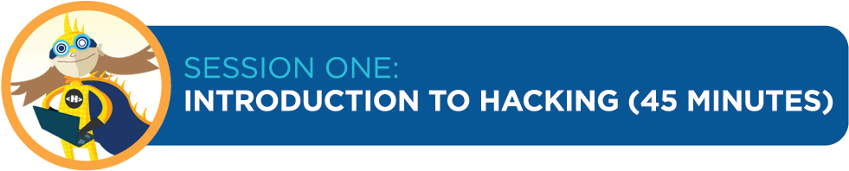

***Lesson Overview***

Participants will “hack a dance” to understand that hacking is a key element of the creative process. Next, they will explore what website code looks like and will try hacking it with the X-Ray Goggles. This helps with future lessons because participants will become comfortable with the idea of hacking and using the goggles.

***Teaching Objective***

Participants will learn:

* That hacking is a key element of the creative process and is a collaborative and constructive activity
* What the code behind a website looks like; how they can change the site using the X-Ray Goggles; and how a website changes when its code is altered

***Materials***

* Chart paper and markers
* One computer per student or small team of students with up-to-date browsers and high-speed Internet access (see *Tips for Classroom Preparation* section)
* X-Ray Goggles installed on each computer; and
* Music for dancing (optional)

***How to Begin – Background and Prep Tips***

1. **FAMILIARIZE YOURSELF WITH RELEVANT TERMS**
   * **Hacking** In this context, hacking refers to remixing content to make new things for the web. Hacking is creative and collaborative. It is not used here to refer to actions that are malicious or illegal.
   * **HTML** Hyper Text Markup Language, one of the codes used to tell computers how to build webpages for human consumption.
2. **UPDATE YOUR BROWSER**
   * Access a computer with high-speed Internet and check to make sure it has the latest version of one of the browsers (to download a browser, click on the link and follow the directions).
     1. Google Chrome (Mac or PC): <https://www.google.com/intl/en/chrome/browser/>
     2. Firefox (Mac or PC): <http://www.mozilla.org/en-US/firefox/new/>
     3. Safari (Mac): <http://safari.soft32.com/free-download?gclid=CPHwkrqntbECFYtV4god0AUAPQ>
3. **INSTALL THE X-RAY GOGGLES**
   * Go to: <http://hackasaurus.org/en-US/goggles/>
   * Try the first hack as shown (optional, but fun!)
   * Scroll down and look for the word “Install “on the left (you may have to hit “Esc” to turn off the goggles first)
   * Click the link and follow it to an installation page. From there, click on the video that shows you how to add the bookmark bar to your browser and follow directions

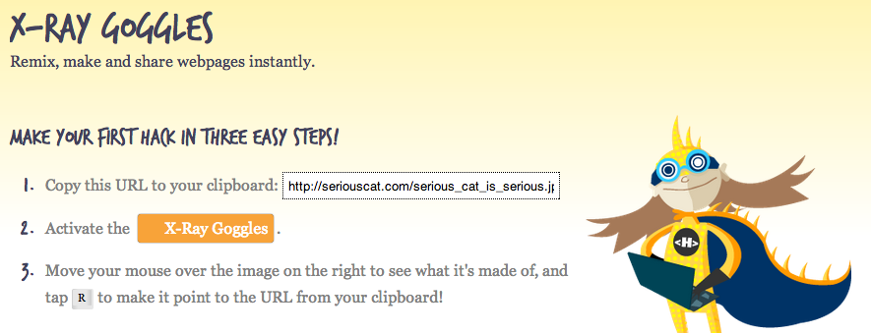

Feel free to play with the Goggles to see how they work. If you wish to teach yourself **HTML** or **CSS** (the basic building blocks of websites), click here: <https://developer.mozilla.org/en/HTML/>. You’ll also learn about these in Session Two.

Work through the lessons, which teach you how to hack and provide you with the opportunity to practice the skills before facilitating your kids' explorations (this is important as it will allow you to try out the various instructions and become familiar with everything.) Don’t worry about not being an expert — everyone will learn and grow together.

Note: For all lessons, you should use websites built with HTML and CSS, because those are the codes you can hack with the Goggles. A few sites you can use:

* + Queens Museum of Art: <http://www.queensmuseum.org/>
  + Brooklyn Arts Council: <http://brooklynartscouncil.org>
  + Prospect Park Zoo: <http://www.prospectparkzoo.com/>

**FOLLOW THESE TIPS FOR CLASSROOM PREPARATION**

* Set up a welcome table in the front of the room:
  1. The table should include helpful handouts; sign in sheets; guide sheets; posters; a workshop schedule; and other materials you feel are necessary.
* Set-up participant computers:
  1. Make sure you have enough computers available for participants or teams of participants.
  2. Test the computers to make sure they work.
  3. Make sure all computers are fully charged and/or have a power source.
  4. Make sure the room has a stable Internet connection that can support the number of participants expected.
  5. If necessary, install the most up-to-date version of Firefox, Chrome or Safari on every computer (please note that Hackasarus DOES NOT work on Internet Explorer).
  6. Pre-install the X-Ray Goggles. If the Goggles do not work, it is because the browser you are using is outdated. You may ask students to help you with this.
* Set-up instructor’s computer:
  1. Install X-Ray Goggles and open all necessary webpages/files for the lesson.
  2. Connect instructor computer to a projector or smart board for teacher intro and demonstration (if available). Note: YOU DO NOT have to have a projector/smart board for the lesson, but it can be helpful.
* Guide sheets and Resources:
  1. Photocopy guide sheets as required for each lesson (see lesson plans for details)
  2. Identify and have available resources as required for each lesson

***Lesson Outline***

|  |  |  |  |
| --- | --- | --- | --- |
| **Procedure** | **Time** | **Class Configuration** | **Activity** |
| Warm Up | 5 minutes | Entire Class | * Elicit and document participants’ favorite websites and what they would change * Elicit definition of hacking |
| Teach | 10 minutes | Entire Class | * “Hack the Dance” demonstration and discussion |
| Practice | 20 minutes | Partners or in Small Groups | * Practice using X-Ray Goggles with participants partners/small groups |
| Wrap-Up | 5 minutes | Entire Class | * Discuss what hacking is and preview next lesson |
| Extension | If time allows | Partners or in Small Groups | * Participants look up unknown terms and share with class |

***Procedure***

|  |  |
| --- | --- |
| **Warm Up**  *5 minutes*  Gather students on rug or in meeting area | 1. Participants will learn about hacking, be introduced to the X-Ray Goggles and learn to use a tool that enables them to create their own websites.    * Ask participants to raise their hands if they use the Internet, ask what their favorite web page is and chart responses.    * In teams of 2-4, ask participants to take turns bringing up their favorite web page on their computer.    * Have participants tell the group what they like about the page.    * Ask participants if there is something they would change about the page and chart responses.    * Ask participants if they have ever heard of the term hacking, what they think it means and explain that they are going to experience hacking through dance. |
| **Teach**  *10 minutes*  Model what you need students to learn and do.  Keep students on rug or in meeting area | 1. Hack the Dance:    * Have everyone form a circle; turn on music if available.    * Tell the group the name of the dance you are starting with. Show them your step, and have everyone try it. Tell them to think about how they might add to or change the step.    * Ask for a volunteer to add or change the dance, and demonstrate the hacked dance for the other participants.    * Have the person to his/her left hack the dance, and then demonstrate the new dance (it is fine if they need to see a new move again).    * Repeat until everyone in the circle has danced.    * When the last person in the circle has had a chance to hack, everyone should try out the new, completed dance. 2. Discussion questions:    * *Was the end dance the same as the beginning dance?*    * *What should we name our dance now?*    * *Is the original dance destroyed?*    * *What actions were you doing while hacking? (Answers: looked at dance and learned it, changed a step and learned it, changed bits and pieces until it became a new dance, etc.)*    * *What do you think was the goal of the activity? (Answers: creating a new dance by hacking)*    * *What made the dance fun? (Answers: creativity and co-developing the project)*    * *How do you think hacking a dance will be similar to hacking a website? (Answers: changing bits, working together, creating something new)* |
| **Practice**  *20 minutes*  Students move to computers to work independently, in partners or in groups. | 1. Try your X-Ray Goggles:    * Have participants go to their computers and bring up a website they looked at earlier.    * Tell them to look at the toolbar near the top of the screen. Ask them to raise their hands if they see the X-Ray Goggles. Have them help each other if needed.    * Tell them to click once on the Goggles.    * Ask them to move the cursor over part of the page. *Is there a transparent overlay of color?* (If not, the Goggles are not on.) Have them move the cursor around and explore the way things are divided into boxes.    * Look at the edges of the boxes. *What do you see?* (black rectangles with angle brackets{<>} and text) Put your cursor over an image. *What’s in the black rectangle?* (<img>) *What do you think that’s telling you?* (there is an image/picture in this space)    * Have them hover over a piece of text and hit “R” on the keyboard (or click the mouse). *What do they see now?* (The space should expand, and they should now see all the code for that space.)    * *What does it say above the box on the left?* (HTML source code). *What about the box on the right?* (What you see. They might also notice that the box on the left has two tabs—basic and advanced. Tell them we’ll be exploring the advanced tab later.    * In the source code box, highlight the same words you see in the box on the right. Delete them. Now type something else. *What do you see in the box on the right?* (What you have just typed.)    * Click on the “commit changes” button on the lower right. *What happened?* (Your changes now show up on the website.)    * Ask: *Does anyone know what HTML stands for?* (Hyper Text Markup Language.) *What do you think it’s made of? What do you see in the HTML source code box?* (Angle brackets with letters and numbers in them, sometimes also slashes, text, quotation marks.) *What do you think the code does?* (Tells the computer what to put in that space.)    * If there is time, let participants attempt this a few more times. They may also have questions like whether their hacks affect the original website. Remind them of their dance. The original dance still exists, along with the hacked dances. |
| **Wrap-Up**  *5 minutes*  Students come back to meeting area to discuss what was learned. | * Review how you turn on the X-Ray Goggles (click on them), how you know when they are on (there is a transparent overlay of color when the cursor is placed over an area), what was in the box on the left after you hit ‘R’ (HTML source code), how you make the changes show up on your website (click on ‘commit changes’ button) and how it feels to remix the site. * Tell participants in the next session, they will learn more about HTML and how to change pictures. Ask them to think more about how they would like to change a website. |
| **Extension**  *Time as needed*  Students who are finished can work together on this activity or it can be continued another day. | * Ask participants to come up with questions about what they learned during the lesson or on Hackasaurus in general. * Hand out FAQ’s and have participants try to answer them. * If the answers aren’t in the FAQ’s, have participants research the answers on the Internet. * Have students share their information. |