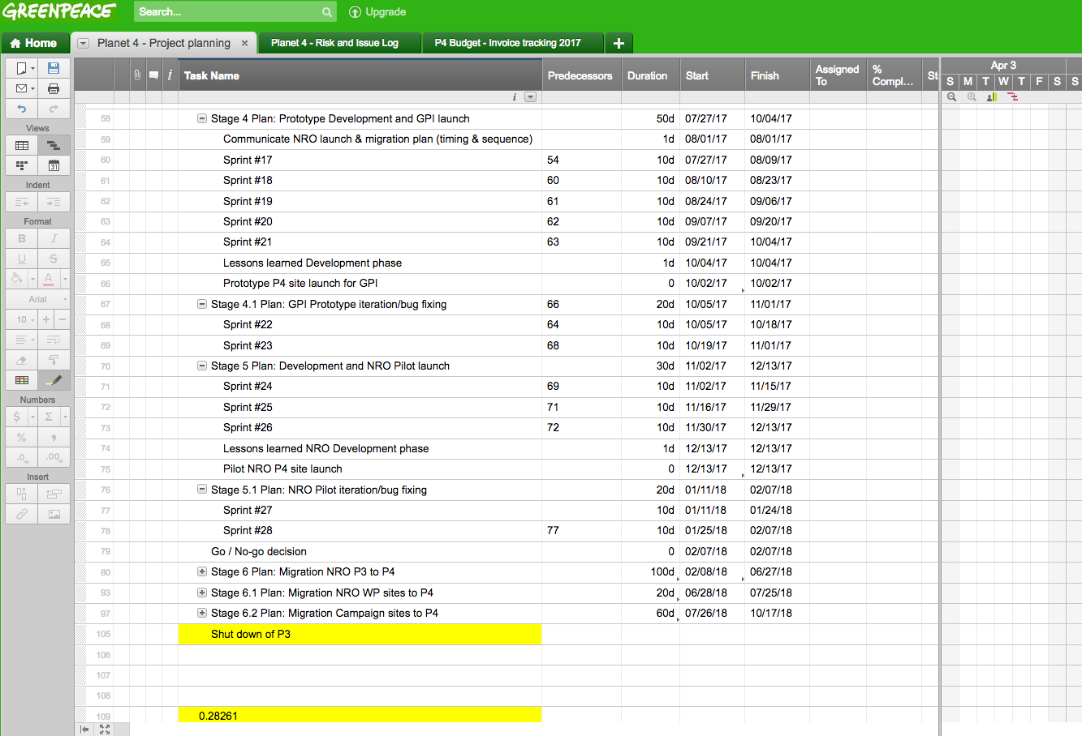

Account creation info to enter/edit/submit
http://support.sxsw.com/hc/en-us/articles/206427125-Do-I-need-to-have-an-account-to-enter-a-proposal-in-PanelPicker-

Eco panel picker 2016
file:///C:/Users/amoreoferrall/Downloads/SXSW-Eco-PanelPicker-2016.pdf

Here are the key requirements from the 2016 picker, though they may change for 2018, let’s base our submission on this. Some of the fields are drop-down selects, so I’ve left them out.

Title <50 characters>

Intended audience

Description <700 characters>

Distill session description <200 characters>

Questions that your session will answer regarding the topic proposed:
Objective 1 <150 characters>
Objective 2 <150 characters>
Objective 3 <150 characters>

Resources (videos & visual aides)

