**Quiz 5**

1. **An array is a collection of variables, all of which must be of the same _______.**
2. **Write the code that declares that an unpopulated array of type String named daysOfWeek contains seven elements.**
3. **Write one line of code that declares and populates the String array daysOfWeek by using an array initializer.**
4. **Write a for each loop that prints the Strings in the daysOfWeek array.**
5. **Why does this program crash?**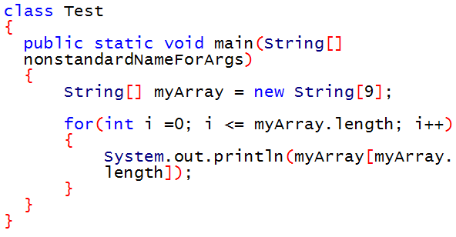
6. **Based on the evidence in ReplaceDemo.java and StringImmutabilityDemo.java, if you reassign the value of a String   
   String myString = "hello";    
   myString = "goodbye";   
   does Java   
   (a) modify the original myString object, or   
   (b) create a new myString object?**
7. **What is the return type of String.equals(String str) method?**
8. **In the main method:**

**(a) What does args contain?**

**(b) Where does args *initially* get its contents?**

**(c) Can args be empty?**

**(e) Is it possible to change the value of args[0] ?**

1. **The name of the ? operator is: (a) the ornery operator, (b) the thorny operator, (c) the ternary operator**
2. **Rewrite the following Java code using if and else:  
   x < 0 ? y = 10 : y = 20;**
3. **The ? operator executes its third clause, which begins with semicolon (:), if the first clause, which ends with ?, evaluates to a boolean _________.**
4. **Which method of the String class indicates how many characters are in the String object? Note: The list of methods (and their return values) is at** [**http://docs.oracle.com/javase/8/docs/api/java/lang/String.html#method.summary**](http://docs.oracle.com/javase/8/docs/api/java/lang/String.html#method.summary)
5. **Which method of the String class returns the character at the location you specify?**
6. **Which method of the String class indicates whether the return value of length() is 0?**
7. **Which method of the String class cuts a String into two Strings if the specified character is present?: _______**
8. **Which method of the String class removes any leading and trailing white space from a String?: ________**
9. **True or false: To get a new String that contains letters from the middle of a word,   
            use the** [**single parameter overload of the substring method**](http://docs.oracle.com/javase/8/docs/api/java/lang/String.html#substring-int-)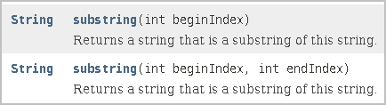
10. **Which method of the String class tests whether or not a substring is present in a String? Hint: it is not substring()._________**
11. **Which method of the String class allows you to substitute '!' wherever the String currently has '?'  ________**
12. **The first code example tonight uses the overloaded String constructor version that allows for   
            String creation from an array of type _______.**
13. **What is the return type of the equals() method? _______**
14. **Which String method indicates whether you have passed in the correct suffix to the String?**
15. **Which String method indicates whether you have passed in the correct prefix to the String?**
16. **Fill in the blanks: "to"._______("get").____________("her") such that the result is "together"**