MOD12

Apply CSS Transitions to HTML Elements

Transitions.html.
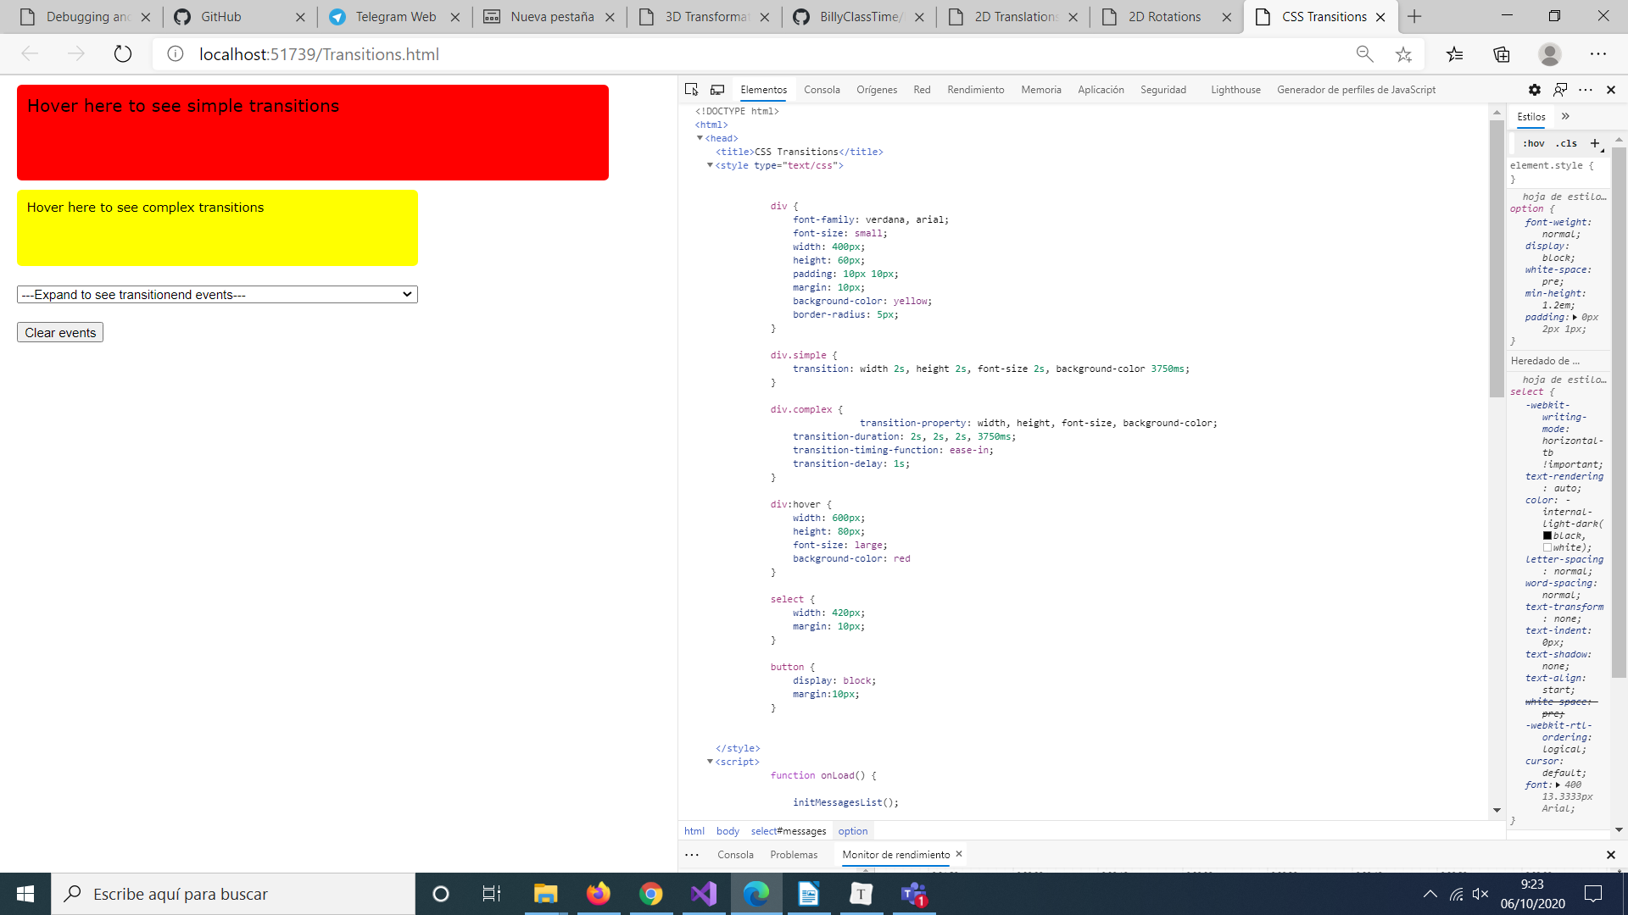
The first div rule defines default CSS properties for all the <div> elements.
- The div.simple rule defines a transition property that applies to transitions on the width, height, font-size, and background-color CSS properties.

- The div.complex rule defines similar transitions, but it uses separate transition-property, transition-duration, transition-timing-function, and transition-delay properties.

- The div:hover rule defines the final values for the width, height, font-size, and background-color CSS properties when the user places the mouse pointer over a <div>

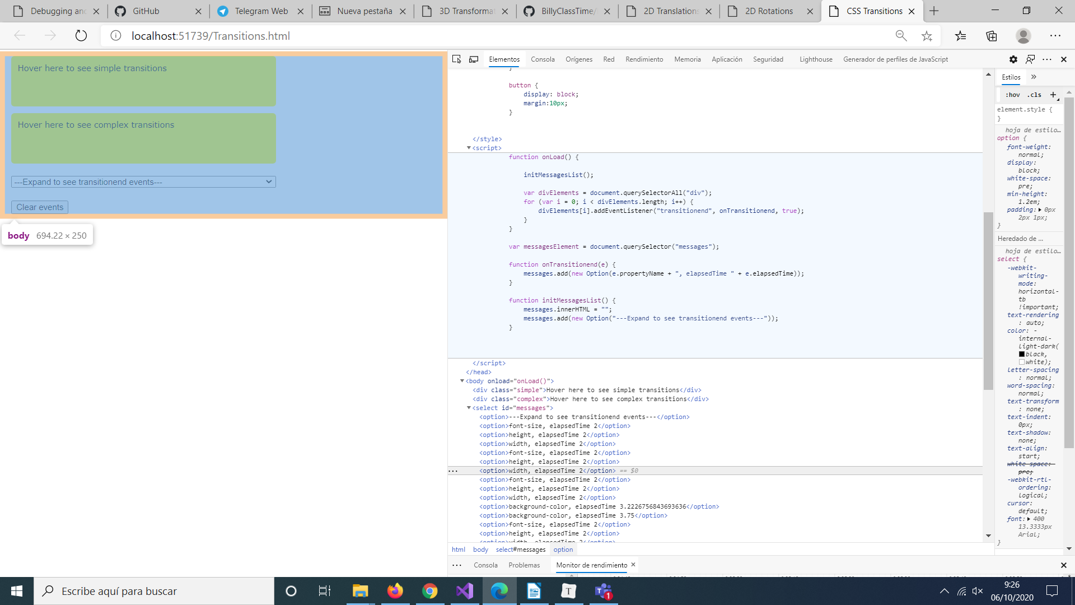

In the JavaScript code, note that:
- The onLoad() function sets up event-handlers that call the onTransitionend() function when the transitionend event is raised on all the <div> elements.

- The onTransitionend() function displays information about the transitionend event, by using the propertyName and elapsedTime properties of the event argument.

Lesson 2:Transforming Elements

Perform 2D Translations

2DTranslations.html
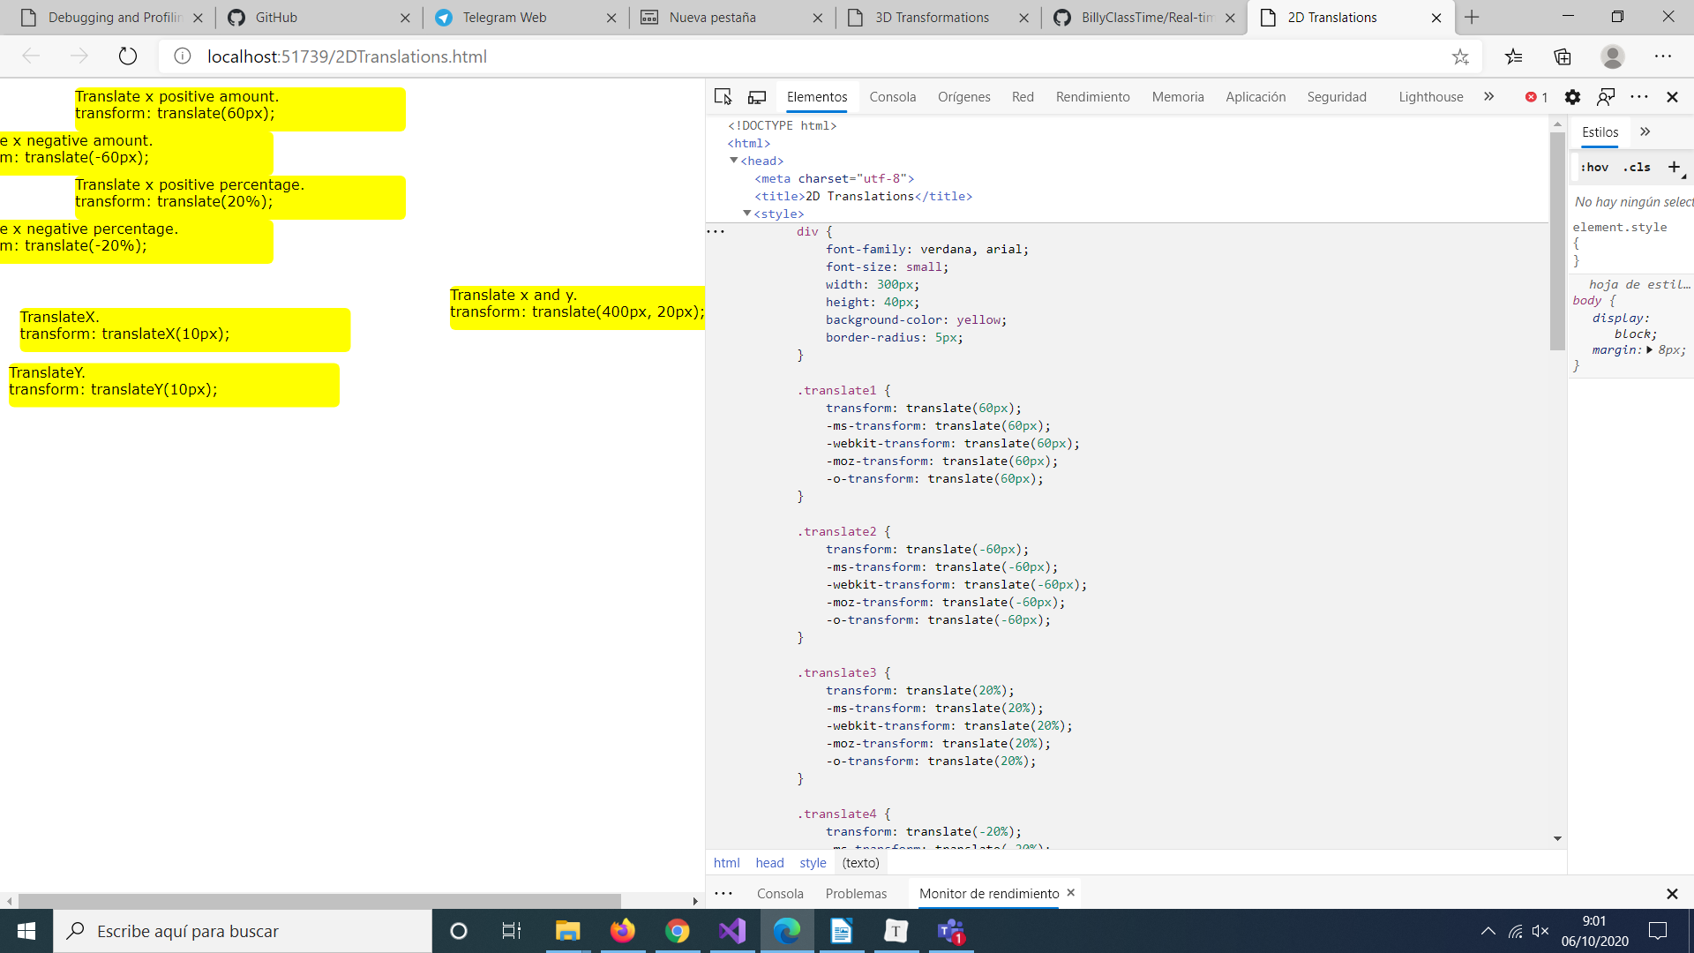
- -ms-transform: Perform a transformation on Microsoft Edge 9.
- webkit-transform: Perform a transformation on Webkit-based browsers such as Chrome and Safari.
- moz-transform: Perform a transformation on Mozilla browsers.

- -o-transform: Perform a transformation on Opera browsers.

Perform 2D Scaling Transformations

2DScaling.html
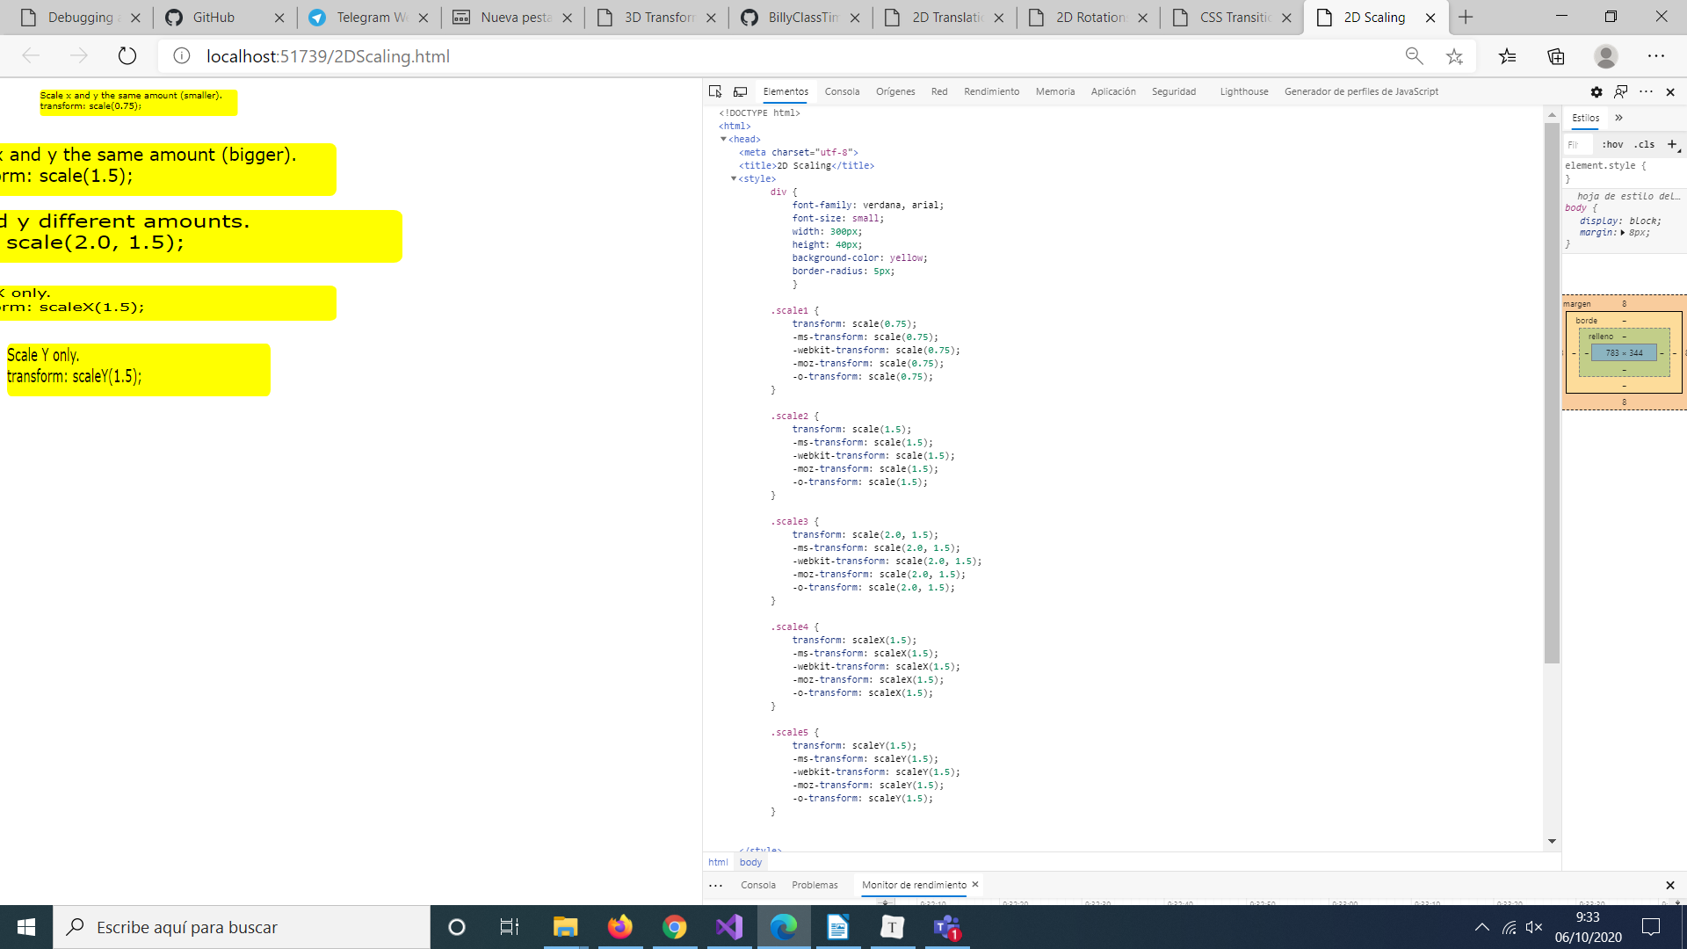
The CSS rules implement scaling transformations for all the **&lt;div&gt;** elements. The CSS rules set the standard **transform** property as well as vendor-specific properties.

Perform 2D Rotations

2DRotations.html
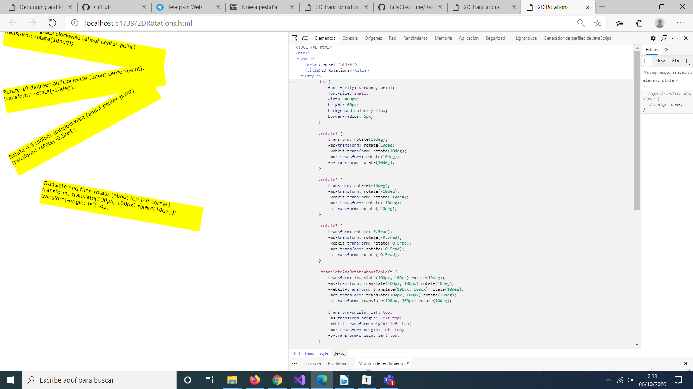
The CSS rules implement rotations for all the <div> elements. The CSS rules set the standard transform property as well as vendor-specific properties. The final CSS rule shows how to apply multiple transformations, specifically a translation followed by a rotation. The final CSS rule also shows how to set change the origin of the transformation by setting the transform-origin property and its vendor-specific equivalent properties.

Perform 2D Skewing Transformations

2DSkewing.html
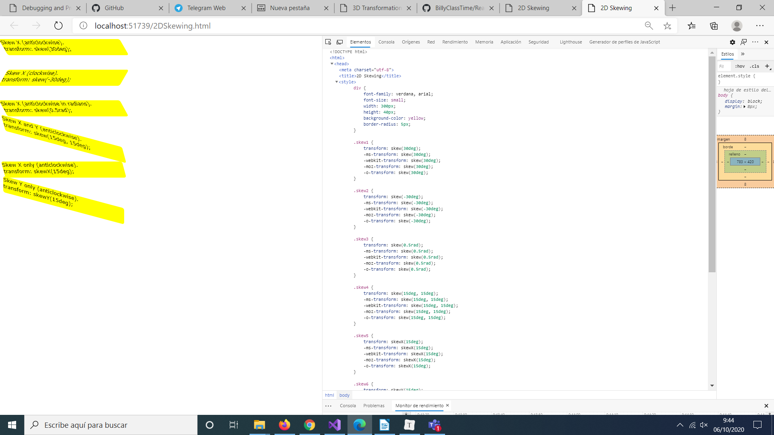
The CSS rules implement skewing transformations for all the <div> elements.

Performing 3D Transformations

Perform 3D Transformations that Include Transitions

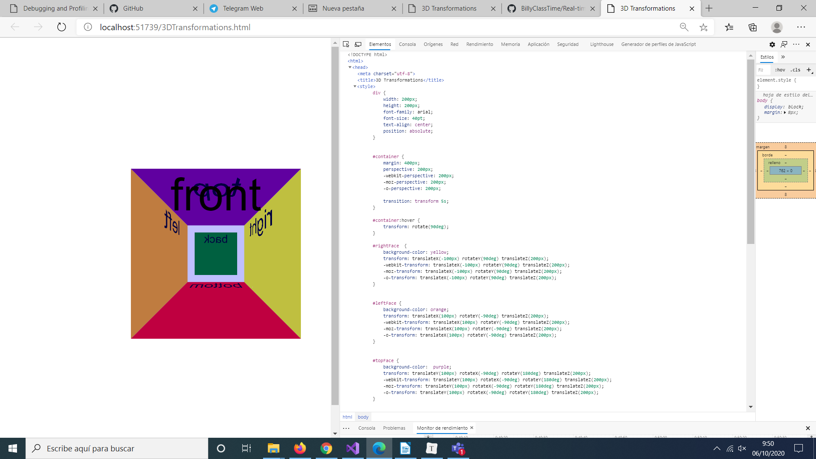
3DTransformations.html

Note the following CSS rules:
- #container: Specifies a perspective for all the child elements of the container element, and a transition of five seconds for transformations.
- #container:hover: Specifies a rotation of 90 degrees when the user places the mouse pointer over the container element.
- #rightFace: Transforms the rightFace element in 3D space, so that it appears on the right side of the cube.
- #leftFace: Transforms the leftFace element in 3D space, so that it appears on the left side of the cube.
- #topFace: Transforms the topFace element in 3D space, so that it appears on the top of the cube.
- #bottomFace: Transforms the bottomFace element in 3D space, so that it appears on the bottom of the cube.
- #backFace: Transforms the backFace element in 3D space, so that it appears at the back of the cube.
- #frontFace: Transforms the frontFace element in 3D space, so that it appears at the front of the cube. The background color is partially transparent.

Lesson 3: Applying CSS Keyframe Animations

Demonstration: Implementing Keyframe Animations
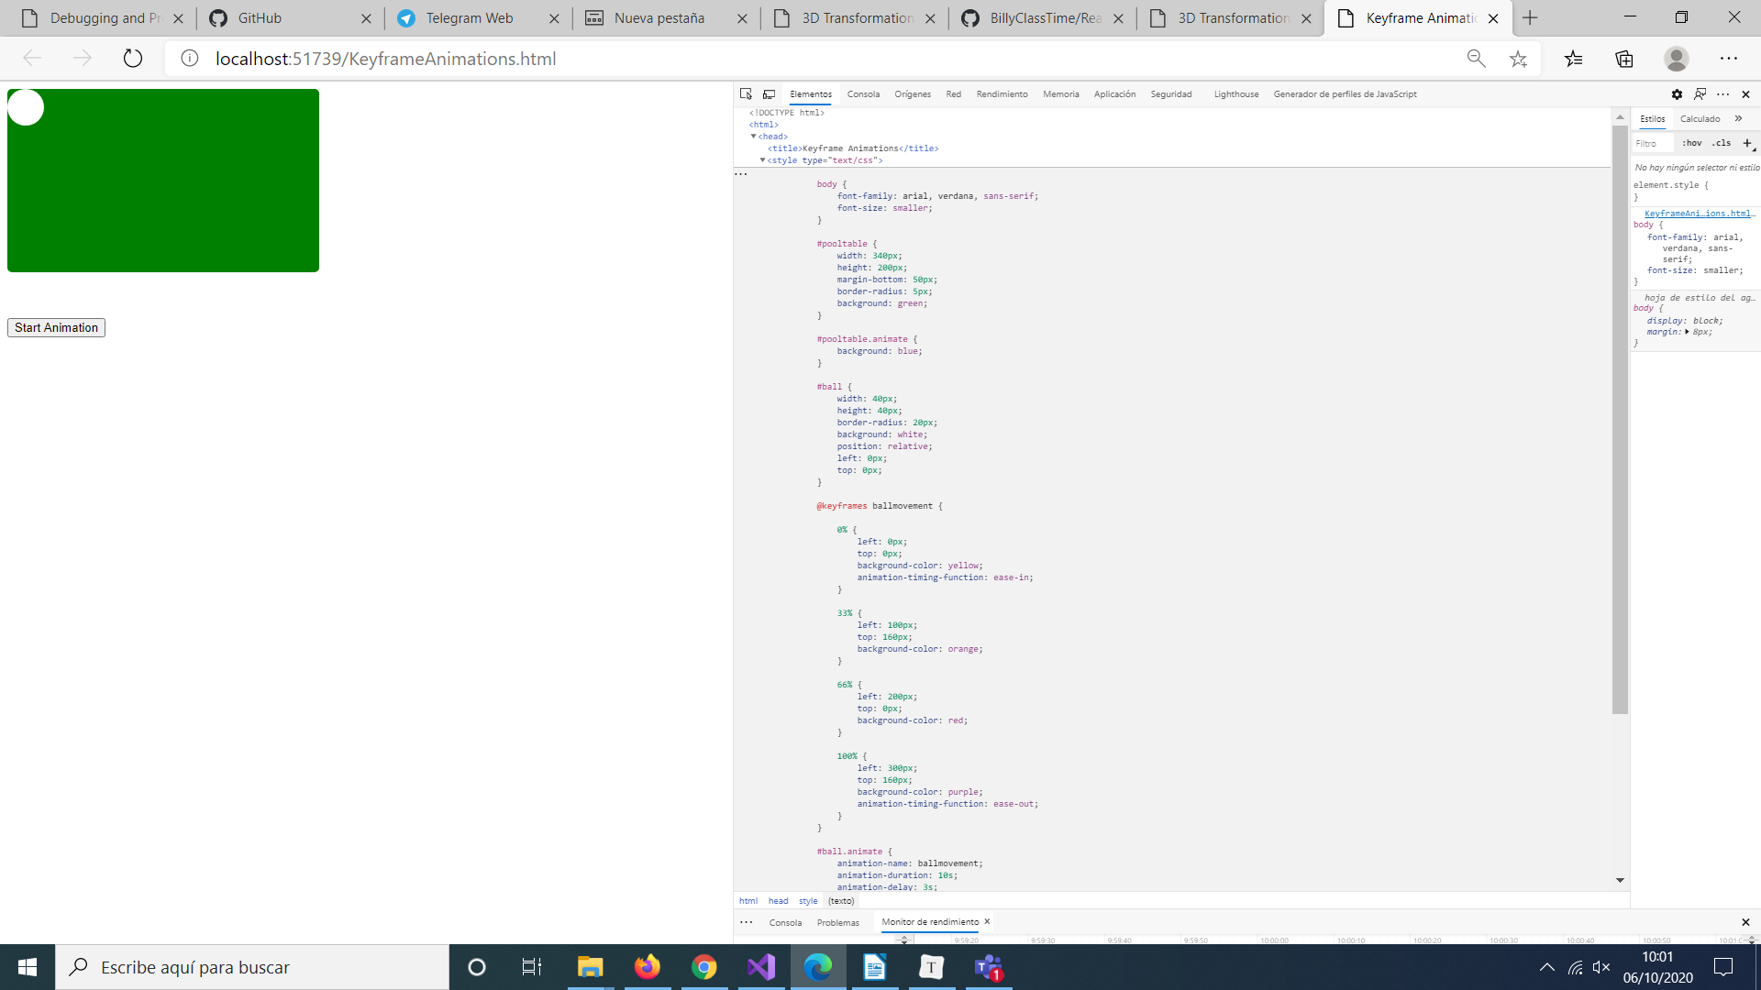
Note that the body of the document has a <div> element named pooltable that represents the pool table and a nested <div> named ball that represents the ball on the pool table. There is also a <button> element to start the animation, and a <div> named messageLabel where messages are displayed.

the <style> element. Note the following CSS rules:
- #pooltable: Specifies the initial appearance of the pool table.
- #pooltable.animate: Specifies a different color for the pool table during an animation. There is JavaScript code elsewhere in the document that programmatically adds the animate class to the pooltable element when an animation starts to cause the pool table to turn blue during an animation.
- #ball: Specifies the initial appearance of the ball.
- @-ms-keyframes ballmovement: Defines a keyframe animation named ballmovement. The first rule-set specifies the original color and location of the ball. Each subsequent rule-set simulates the ball hitting one of the sides of the pool table and causes the ball to change color during each part of its journey. The final rule-set specifies the final color and location of the ball.
- #ball.animate: Applies the ballmovement keyframe animation to a ball when the ball has the animate class. There is JavaScript code elsewhere in the document that programmatically adds the animate class to the ball element when the user clicks the Start Animation button to trigger the animation.

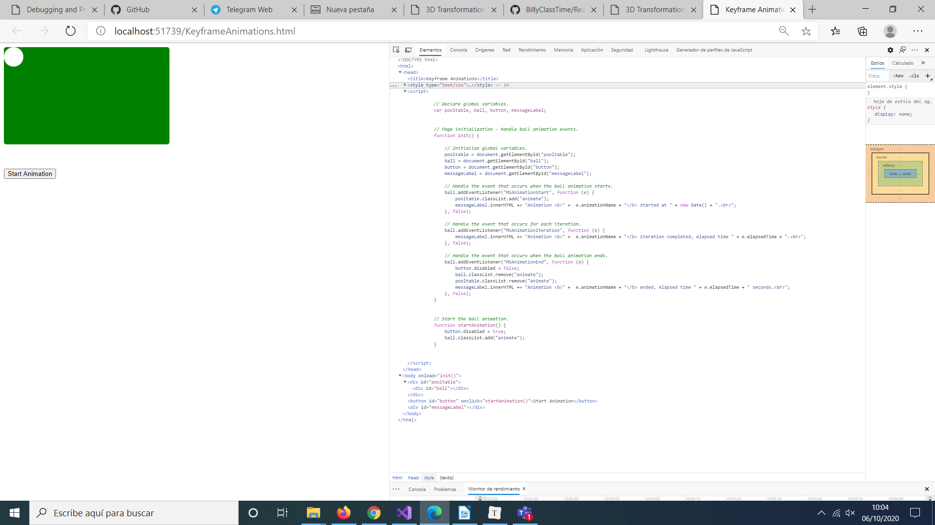
The <script> shows:
- The init() function, invoked as soon as the page has loaded, establishes event-handler functions for the MSAnimationStart, MSAnimationIteration, and MSAnimationEnd events on the ball element:
- The MSAnimationStart event-handler function is called when an animation starts on the ball element. The function adds the animate class to the pool table so that the pool table becomes blue. The function also displays a message to indicate the time when the animation started.
- The MSAnimationIteration event-handler function is called when each iteration of the animation has completed. The function displays a message to indicate the elapsed time of the animation.
- The MSAnimationEnd event-handler function is called when an animation ends on the ball element. The function enables the button, removes the animate class from the ball and the pool table, and then displays a message to indicate the elapsed time of the animation.

- The startAnimation() function is Invoked when the user clicks the Start Animation button. The function disables the button and adds the animate class to the ball to trigger the animation. The animation starts three seconds later, due to the -ms-animation-delay: 3s; property in the #ball.animate CSS rule.

Demonstration: Animating the User Interface

ContosoConf.sln
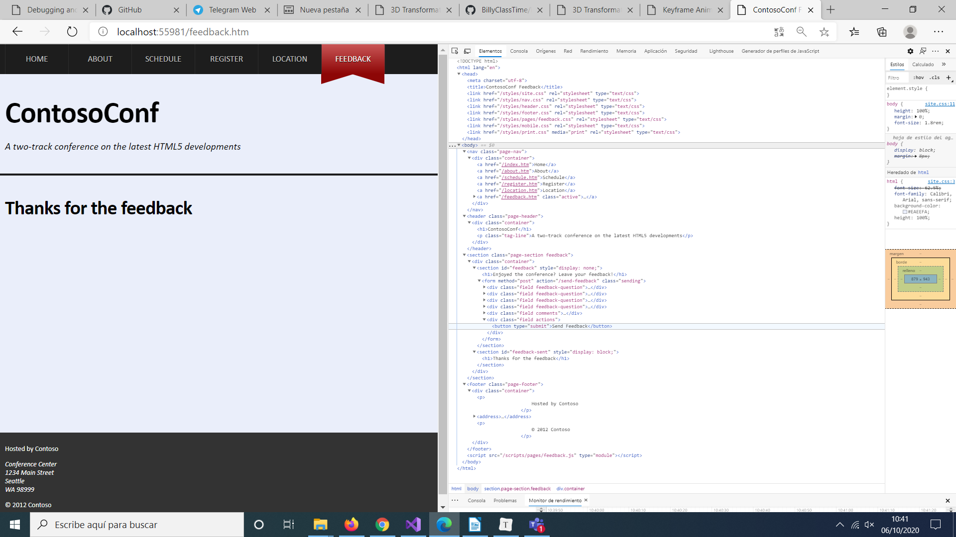
In the Code Editor window, find the header.page-header .register:hover rule, and then draw students' attention to the transform and transition properties in this rule. These properties rotate and scale the Register Free link over a period of one second.

header.css
header.page-header .register:hover {
color: #fff;
background: -ms-linear-gradient(#bc0101, #8c0909);
background: linear-gradient(#bc0101, #8c0909);

/* TODO: rotate to 16 degrees and scale by 1.1 */
transform: rotate(16deg) scale(1.1,1.1);

/* TODO: Transition the transform property over 1 second */
transition: transform 1s;

These are the transformations and transitions that occur when the user places the mouse pointer over the stars on the Feedback page.

Feedback.css.
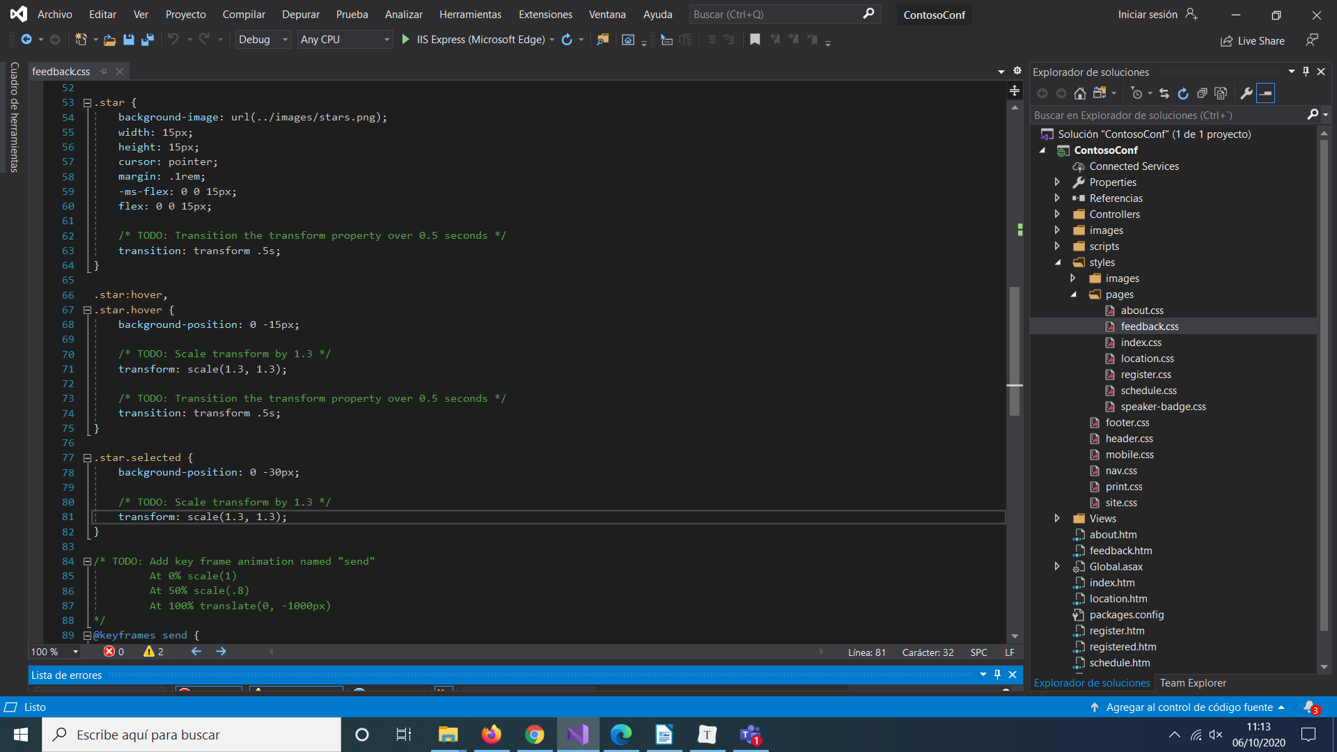
These are the CSS rules that animate the feedback form, causing it to fly off the page when the user clicks Send Feedback.

feedback.css
@keyframes send {
0% {
transform: scale(1);
}
50% {
transform: scale(.8);
}
100% {
transform: translate(0, -1000px);
}
}

.sending {
background-color: #EAEEFA;
border: 1px solid #888;
box-shadow: 0px 3px 3px rgba(0,0,0,.8);

/* TODO: Use the "send" animation
iteration-count: 1
fill-mode: forwards
*/
animation-name: send;
animation-duration: 1s;
animation-iteration-count: 1;
animation-fill-mode: forwards;

This statement adds the sending class to the feedback form, which triggers the animation defined by the .sending rule in the feedback.css stylesheet:

feedback.js
const sent = document.getElementById("feedback-sent");

function formSubmitting(event) {
event.preventDefault();
// TODO: Trigger the animation by adding the "sending" CSS class to the form
form.classList.add("sending");

