MOD13

Implementing Real-time Communication by Using Web Sockets

Lesson 2: Using the WebSocket API
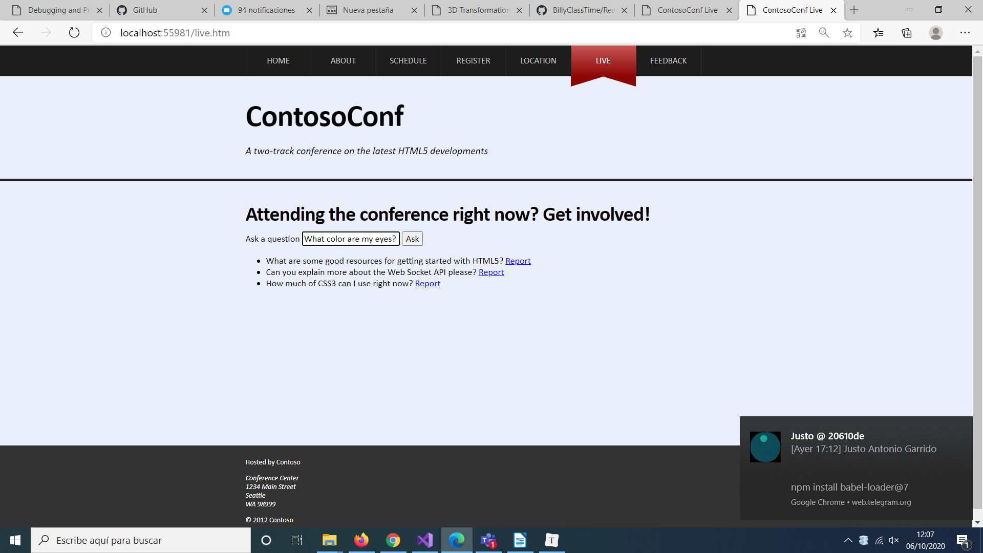
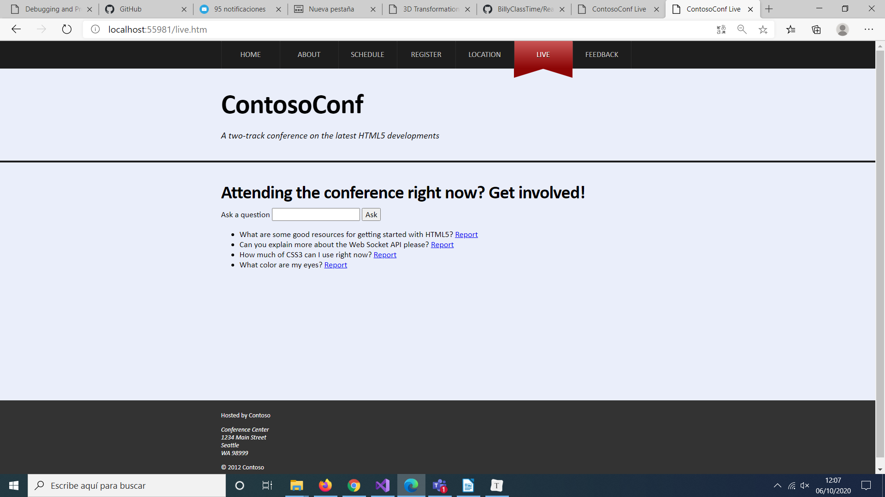
Point out that the question is posted to a server, which then sends a response back to the browser and the question appears in the list on this page.

the text of the link to Reported while the question is evaluated by the web server. The web server removes the question, all browsers displaying the Live page are updated and the question disappears.

LivePage.js
constructor(socket, sectionElement) {
this.initializeSocket(socket);
this.initializeUI(sectionElement);
}

initializeSocket(socket) {
this.socket = socket;
// TODO: Assign a callback to handle messages from the socket.
this.socket.onmessage = this.handleSocketMessage.bind(this);
}

initializeSocket: This method arranges to handle the onmessage event of the socket and call the handleSocketMessage() method whenever a message arrives.

LivePage.js
askQuestion(text) {
// TODO: Create a message object with the format { ask: text }
const message = {
ask: text
};
// TODO: Convert the message object into a JSON string
const json = JSON.stringify(message);
// TODO: Send the message to the socket
this.socket.send(json);

// Clear the input ready for another question.
this.questionInput.value = "";

askQuestion. This method runs when the user has typed a question and clicked Ask. The text is formatted as a message and serialized as JSON before being sent to the web server for processing

LivePage.js
handleSocketMessage(event) {
// TODO: Parse the event data into message object.
const message = JSON.parse(event.data);
if (message.questions) {
this.handleQuestionsMessage(message);
} else if (message.remove) {
this.handleRemoveMessage(message);
}
}

handleQuestionsMessage(message) {
// message has the form:
// { questions: [
// { text: "...", id: 1 },
// { text: "...", id: 2 }
// ] }

// TODO: Display each question in the page, using the displayQuestion function.
message.questions.forEach(this.displayQuestion, this);
}

handleRemoveMessage(message) {
const listItems = this.questionListElement.querySelectorAll("li");
for (let i = 0; i < listItems.length; i++) {
if (listItems[i].questionId === message.remove) {
this.questionListElement.removeChild(listItems[i]);
break;
}
}
}

handleSocketMessage: This method runs when the web server sends a message back to the browser. The method examines the incoming message, and if it contains questions it calls the handleQuestionsMessage() method to display the questions on the web page. If the message contains a remove request, the method calls the handleRemoveMessage() method to remove the question from the web page.
handleQuestionsMessage. This method parses a message and displays the questions that it contains on the web page.

LivePage.js
reportQuestion(questionId) {
// TODO: Send socket message { report: questionId }
this.socket.send(JSON.stringify({ report: questionId }));

reportQuestion: This method runs when the user clicks the Report link; it sends a report message to the web server that contains the id of the question to be removed.

